ITEA ARTEMIS-IA high-level vision 2030 officially presented to EC Vice-President Neelie Kroes
Press Release, 14 March 2014

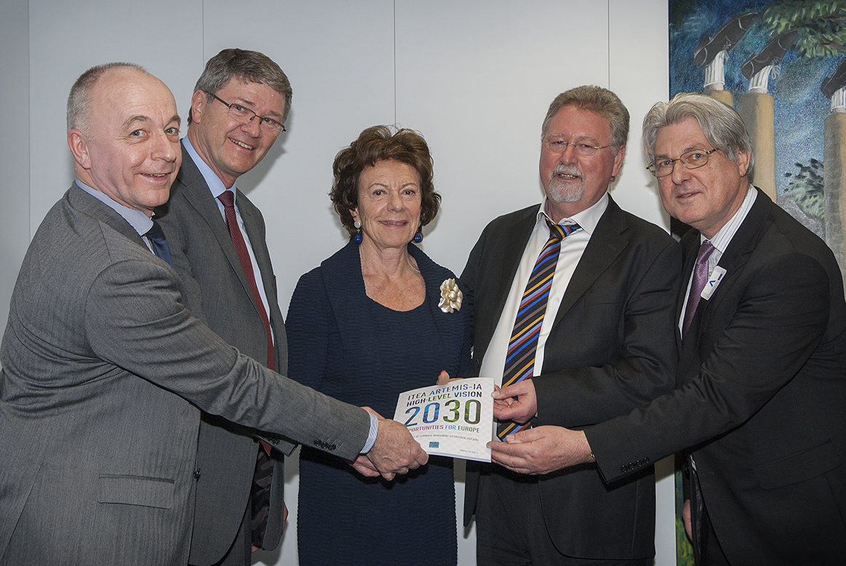

In this picture (from left to right):
Fopke Klok (ITEA Office director), Heinrich Daembkes (President ARTEMIS-IA), Neelie Kroes (Vice-president European Commission), Rudolf Haggenmüller (ITEA Chairman), Jan Lohstroh (Secretary General ARTEMIS-IA).

On 13 March, Neelie Kroes, Vice-president of the European Commission, welcomed a delegation representing industry in the ARTEMIS Industry Association and the EUREKA Cluster ITEA. The leaders of the delegation, Heinrich Daembkes, President of the ARTEMIS Industry Association, and Rudolf Haggenmüller, Chairman of ITEA, officially presented the ITEA ARTEMIS-IA high-level vision 2030 which was revealed during the ARTEMIS & ITEA Co-summit in December 2013.

The key message delivered was that European industry needs a balanced approach to electronics innovation and software innovation. A recent statement by the German automotive manufacturer BMW declared that “90% of the innovation today is coming from electronics and software“. It is the right combination of intelligent electronics and innovative software that keeps European industry in the lead in the global competitive arena.

The message and the Vision 2030 report was well received by Ms Kroes and her supporting team including Khalil Rouhana, director Components and Systems. Ms Kroes confirmed that Digital Technology is vital to employment in Europe. In answer to a question from Ms Kroes about concrete proposals, Rudolf Haggenmüller and Heinrich Daembkes stressed that she should promote software innovation with the same passion as electronics innovation. Ms Kroes welcomed the enthusiasm and this sparked an open discussion on how to concretely support software innovation. As one of the conclusions from this discussion, the intention was expressed of organising a high-level working session on concrete challenges for Digital Technology identified by the actual end users and customers, for example hospitals or smart cities. The list of challenges identified by this proposed working session will guide Cooperative Research & Innovation programmes like H2020, ECSEL Joint Undertaking and EUREKA Clusters, like ITEA. For Digital Innovation the ARTEMIS Industry Association and the EUREKA Cluster ITEA will be instrumental to mobilising Europe’s key players as users or suppliers of Digital Technology.

The report ‘ITEA ARTEMIS-IA HIGH-LEVEL VISION 2030 OPPORTUNITIES FOR EUROPE’ coins the term “Digital Technology” to encompass the notions of hardware, software, IT services, internal IT and embedded software. The global market of Digital Technology is estimated at USD 3,300 billion, corresponding to around 50 million jobs. The share of Europe in digital technologies is about 9.1 million jobs. In Europe there are 0.2 million jobs in hardware, including 0.1 million in semiconductors, and 8.9 million jobs in software and services. Of these, 1.1 million are working in Embedded Systems. Within Digital Technology, ARTEMIS and ITEA are addressing innovation in Software, IT Services, Internal IT and Embedded Software, collectively denoted as ‘software innovation’. In other words, software innovation thus addresses a global market of around USD 2,600 billion, corresponding to 44 million jobs.

With the arguments presented in this Vision 2030 report, ITEA and ARTEMIS Industry Association collectively recommend a balanced approach for innovation in electronics and software, mirroring the job distribution in Digital Technology. A combined European initiative on electronics and software innovation building on European strengths will lead to smart systems and services with high impact on revenues and jobs.

About ITEA
ITEA is the EUREKA Cluster programme supporting innovative, industry-driven, pre-competitive R&D projects in the area of Software-intensive Systems & Services (SiSS). SiSS are a key driver of innovation in Europe’s most competitive industries, such as automotive, communications, healthcare, aerospace and consumer electronics.
There is a wide consensus that from now to 2030 change and disruption will be permanent features in society, with the way of living and doing business becoming fundamentally different from what it is today. Digital Technology, encompassing the notions of hardware, software, IT services, internal IT and embedded software, has a major role to play in mastering the changes. For Europe, an industry strong in software innovation is a prerequisite for maintaining global competitiveness and in securing high-value jobs in Digital Technology and in other, more traditional industries that are dependent on Digital Technology.
ITEA stimulates projects in an open community of large industry, SMEs, universities, research institutes and user organisations active in SiSS. As ITEA is a EUREKA Cluster, the community is founded in Europe based on the EUREKA principles and is open to participants worldwide.
Each year, ITEA issues a Call for projects starting with a two-day brokerage event. Each Call follows a two-step procedure, in which the quality of the project proposal is evaluated and improved, finally leading to a selection of high quality project proposals that receive the official ITEA label.
ITEA’s mission is to be the recognised partner for European industry, optimising support for companies and R&D actors active in ITEA projects in the area of SISS, thus making best use of funding made available by the ITEA supporting countries. Following the EUREKA structure, each ITEA project partner can apply for national funding in their own country – allowing a project idea to attract funding from all participating countries.
More information: https://itea3.org

Contact person
Kay van Ham, Tel. +31 88 003 6136, kay.van.ham@itea3.org

About ARTEMIS
“Research and innovation are critical for creating new, sustainable jobs and economic growth, to improve quality of life and to boost Europe's global competitiveness. Partnerships between EU Member States, EU-industry and European Commission, implemented as Joint Technology Initiatives (JTIs), are the most effective way of boosting Europe’s electronics design and manufacturing capabilities in economic sectors such as transport modes, medical equipment, home appliances, energy networks and security systems. Between 2008 and 2012, the ARTEMIS JTI has achieved; 52 projects worth €935 million with public funding of €448 million (EU + Member states) involving more than 720 organisations (with more than 1200 project participations) of which around 39% are SMEs, 33% large enterprises and 28% research organisations. In 2014 the JTI’s ARTEMIS, ENIAC and EPoSS will join forces and merge into, one stronger JTI on Electronic Components and Systems called ECSEL (Electronic Components and Systems for European Leadership).”
In recognition of the strategic importance of embedded computing systems the European Union launched the ARTEMIS Joint Technology Initiative (JTI) as a Joint Undertaking (JU), or public-private partnership, between:
> The European Commission
> Member States (23 countries)
> ARTEMIS Industry Association
ARTEMIS aims to tackle the research and structural challenges faced by European industry by defining and implementing a coherent strategic research agenda for embedded computing systems. Its ambition is to help European industry consolidate and reinforce its world leadership in embedded computing technologies.
ARTEMIS Industry Association is a non-profit Industry Association under Dutch law for European R&D&I actors in embedded and cyber physical systems, and private partner in the ARTEMIS Joint Undertaking. ARTEMIS Industry Association creates the meeting place where key industry players and other R&D&I actors identify strategic high priority topics for collaborative R&D&I projects. The Industry Association supports the formation of consortia and the initiation of project proposals for joint collaboration. It represents an influential network of organisations focused on the innovation and development of embedded systems in Europe. About 200 members, being Large Enterprises, Small and Medium Enterprises, Institutes and Universities, joined the ARTEMIS Industry Association.

More information about ARTEMIS:
www.artemis-ia.eu |www.artemis-ju.eu | www.artemis.eu

Contact person:
Iris Hamelink, Tel: +31 88 003 6188, iris.hamelink@artemis.ia.eu

