ITEA Press release
SYMPHONY delivers the right health data at the right time
15 September 2026, Istanbul (Türkiye) - The ITEA project SYMPHONY has received the ITEA Award of Excellence 2026 in the category Exceptional Excellence. The award recognises the project’s outstanding contribution to improving healthcare through artificial intelligence, interoperability and international collaboration.

Delivering the right information at the right time
Healthcare professionals increasingly face a common challenge: critical patient information is often scattered across different systems, departments and organisations. This fragmentation makes clinical decision-making more difficult, increases administrative burden and limits the effective use of healthcare data.
To address this challenge, the ITEA project SYMPHONY brought together hospitals, technology companies and research institutes from five countries to create open, interoperable healthcare ecosystems that connect data, clinical workflows and AI-powered decision support. By combining interoperability standards, clinical pathway modelling and advanced AI technologies, the project enables healthcare professionals to access the information they need when they need it.
Transforming data into clinical insights
The project focused on four complex healthcare domains – prostate cancer, aortic aneurysm, atrial fibrillation and multiple sclerosis – to demonstrate how data from multiple sources can be brought together to support faster, better-informed clinical decisions.
The consortium developed 44 AI algorithms, models and decision-support tools. Together, these innovations provide clinicians with integrated patient insights, automated risk assessments and improved support for multidisciplinary care.
The impact is already visible in clinical practice. At Karolinska University Hospital in Sweden, digital workflows developed within SYMPHONY have replaced paper-based reporting in prostate cancer care, reducing administrative burden and ensuring patient information is readily accessible throughout the care process. In multiple sclerosis and aortic aneurysm care, mature SYMPHONY demonstrators have shown how integrated data and AI solutions can give care teams a complete view of a patient’s condition, helping them make better-informed and more coordinated treatment decisions. Similar capabilities have also been demonstrated for atrial fibrillation care, providing confidence in their future clinical use.

An open, interoperable healthcare ecosystem
Several innovations are already progressing towards market deployment. Philips has obtained FDA clearance and CE marking for vascular imaging functionalities developed within SYMPHONY. The technology is now being commercialised, bringing advanced AI-supported analysis of radiological images into everyday clinical workflows. This can bring several advantages as AI can, for example, help identify abnormalities and flag scans that show critical findings. Other project results are being brought to market through telemedicine, remote patient monitoring and clinical decision-support solutions that help healthcare organisations detect problems earlier, improve continuity of care and reduce unnecessary hospital visits.
Beyond the individual innovations, SYMPHONY’s most significant achievement is the creation of an open, vendor-neutral framework that enables healthcare organisations to integrate data, applications and AI solutions in a standardised way. The framework can be used as a blueprint for interoperable digital care platforms, helping them connect existing systems, adopt innovative applications and AI tools, and provide clinicians with a more complete view of their patients.

Sharing the blueprint openly
To help the wider healthcare community build on these results, the consortium has published a public white paper, “Building the Foundations for Standardized Clinical AI: The SYMPHONY Contributions”. It sets out, in practical terms, how hospitals and vendors can combine existing standards – HL7 FHIR, openEHR, DICOM and IHE profiles – into one coherent, vendor-neutral architecture and shares the concrete lessons learned across the four clinical use cases. Rather than inventing new standards, SYMPHONY shows how to make those we already have work together – a reusable reference that others can adopt directly.
The project has demonstrated that solutions developed for one clinical domain can be adapted and reused across others, reducing duplication and accelerating implementation. This gives healthcare organisations greater flexibility to introduce new technologies, connect existing systems and make better use of the data already available to them.
This project received funding from:

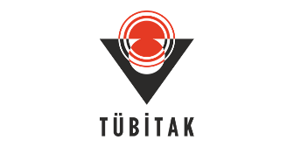
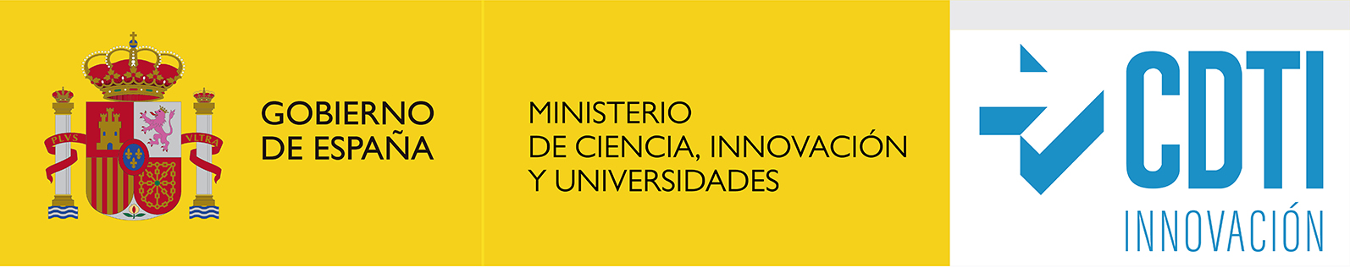



Note for editors, not for publication

For interview requests, questions and additional information about SYMPHONY and ITEA, please contact:
SYMPHONY Contact person ITEA Contact person
Saurav Kumar Baidya (Project leader Philips) Régis Cazenave (ITEA Vice-chairman)
Saurav.Baidya@philips.com regis.cazenave@itea4.org
SYMPHONY Project partners
https://itea4.org/project/symphony.html
https://symphony-iteaproject.eu/

About ITEA
ITEA is the Eureka Cluster on software innovation, enabling a large international community to collaborate in funded projects that turn innovative ideas into new businesses, jobs, economic growth and benefits for society. https://itea4.org

