ITEA Press release
  - The IVVES project has developed methods for verification and validation of AI in strictly regulated domains
13 September, Berlin – The use of artificial intelligence (AI) is rapidly increasing and in many domains, we experience the strong benefits of AI, including reduction in human error, 24/7 availability, unbiased decisions and faster decision-making. On the other side, more and more questions are raised concerning the use of AI on how to make sure it is safe and correct. This is especially the case for fields like transportation, finance, healthcare, industrial automation, and cyber security which are strictly regulated domains as a mistake can have huge consequences. The ITEA project IVVES has developed new verification and validation methods, ensuring the trustworthiness and reliability of AI and ML in these environments. For these achievements the IVVES consortium was awarded the 2023 ITEA Award of Excellence for Innovation.
In 2019, Philips and their clinical research partners convincingly demonstrated that the application of artificial intelligence could significantly reduce MRI scan times [reference: Results of the first fastMRI image reconstruction challenge (meta.com)]. However, it was not clear how to assure the correctness of the results and how to release AI algorithms under the strict regulations of healthcare. Since these issues were not unique for healthcare the cross-domain IVVES project was set-up.
The IVVES project gathered 26 use case owners, tool providers and research organisations from Canada, Finland, the Netherlands, Spain and Sweden and developed new methods for verification and validation of AI in these strictly regulated domains.
Thanks to IVVES, Philips can now use a new AI method in its SmartSpeed MR software, speeding up the MRI examination; FDA approval was provided end of 2022. Philips expects this method to be used in 97% of future clinical examinations. For cyber security, WithSecure has developed a tool suite to automatically analyse test results and feedback provision to increase confidence in its product releases and for Alstom the results led to improved maintenance of legacy train fleets which do not have data collection infrastructure by design.
“Before SmartSpeed, we examined about 160 to 170 patients a week and now we can manage up to 200 patients a week. SmartSpeed is the absolute gamechanger.”
- Dr. med. Tobias Schröter, MR radiologist, MRT Praxis Potsdam

Test AI with AI
The IVVES project developed methods for applying AI to speed up the verification and validation process. In a long-term vision this will lead to testing AI with AI. This innovation will be part of a future project.

This project has received funding from:
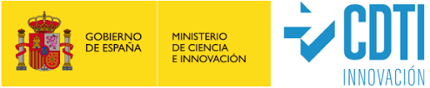
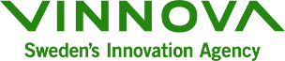
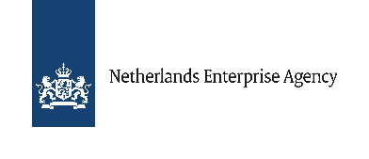

Note for editors, not for publication
* The acronym IVVES stands for Industrial-grade Verification and Validation of Evolving Systems.

For interview requests, questions and additional information about IVVES and ITEA, please contact:
IVVES Contact person ITEA Contact person
Mark van Helvoort (Philips) Mathijs van Dijk mark.van.helvoort@philips.com mathijs.van.dijk@itea4.org

IVVES project partners
https://itea4.org/project/ivves.html

About ITEA
ITEA is the Eureka Cluster on software innovation, enabling a large international community to collaborate in funded projects that turn innovative ideas into new businesses, jobs, economic growth and benefits for society. https://itea4.org

