ITEA Press release
GenerIoT enables faster development and smarter maintenance of IoT systems
15 September 2026, Istanbul (Türkiye) – The ITEA project GenerIoT has received the ITEA Award of Excellence 2026 in the category Collaboration. The award recognises the project's exceptional cooperation between industry, SMEs and academia in developing a common approach to Internet of Things (IoT) software engineering. By working as one integrated team across four countries, the consortium created technologies that make IoT systems faster to develop, easier to deploy and simpler to maintain throughout their lifecycle.

Building one common approach to IoT development
The development of IoT systems is becoming increasingly complex. Hardware, software and communication technologies must work together reliably, while systems also need to be updated throughout their operational lifetime. In practice, these different aspects are often developed separately, making changes slow, costly and difficult to manage.
To address this challenge, GenerIoT introduced automated DevOps throughout the IoT lifecycle. The project developed a model-based systems engineering approach in which a homogeneous compositional system model forms the basis for software development, testing, deployment and maintenance. Automated code generation from these (sub)models reduces manual work and helps ensure that software remains consistent with the original system design.
This required close cooperation between the 19 partners from Austria, Finland, Germany and Portugal. Early in the project, the consortium agreed to use the emerging SysML 2.0 standard as a common modelling language. The partners deliberately prioritised shared results over individual deliverables, combining their expertise to develop common methods, tools and demonstrators that could be reused across different application domains. This way of working became one of the project's defining strengths and the reason it received the ITEA Award of Excellence for Collaboration.

Demonstrating collaboration in practice
The shared engineering approach was validated in eight demonstrators covering a wide range of industrial applications.
These included structural health monitoring of radio towers for predictive maintenance, energy-efficient control of ice hall cooling systems and decentralised energy monitoring and control for smart homes. The project also developed flexible runtime technologies that allow software written in different programming languages to run on the same IoT devices.
Across these demonstrators, the common DevOps approach consistently reduced engineering effort. Setting up continuous integration and deployment pipelines required around 30% less effort, while some development and analysis tasks that previously took days could be completed in minutes. Configuration times were reduced from hours to seconds and simulation performance improved by 100 to 1,000 times, enabling developers to validate complex systems much more quickly.
Supporting future IoT development
Several partners have already integrated GenerIoT results into commercial products and services. Building automation software created within the project has generated around EUR 800,000 in contracted annual revenue, while other partners are incorporating automated code generation, model-based engineering and model-driven DevOps capabilities into their professional engineering platforms, enabling system models to become an active part of software development, testing, deployment and lifecycle management.
Perhaps the project's most enduring result is the collaborative ecosystem it created. The consortium contributed directly to the development of the SysML 2.0 standard, released several technologies as open source and established the RISC-V and RUST Firmware Workshop to support continued knowledge exchange. The partners have also committed to continuing their collaboration after the project's completion, further developing the technologies and exploring new applications, including combinations with generative AI.
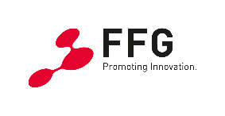

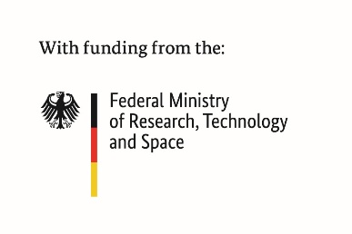
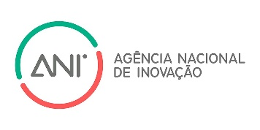
This project received funding from:

Note for editors, not for publication

For interview requests, questions and additional information about GenerIoT and ITEA, please contact:
GenerIoT Contact person ITEA Contact person
Wolfgang Ecker (Project leader Infineon Technologies) Régis Cazenave (ITEA Vice-chairman)
wolfgang.ecker@infineon.com regis.cazenave@itea4.org
GenerIoT Project partners
https://itea4.org/project/generiot.html

About ITEA
ITEA is the Eureka Cluster on software innovation, enabling a large international community to collaborate in funded projects that turn innovative ideas into new businesses, jobs, economic growth and benefits for society. https://itea4.org

