ITEA Press release
FAMILIAR boosts industrial efficiency and road safety through federated AI and XR
15 September 2026, Istanbul (Türkiye) - The ITEA project FAMILIAR has received the ITEA Award of Excellence 2026 in the category Impact. The award recognises the project’s success in helping companies use artificial intelligence (AI) collaboratively without compromising the privacy of sensitive data. It also acknowledges the translation of these capabilities into practical applications for manufacturing, mobility and extended reality, resulting in faster development, less waste and safer roads.

AI collaboration without sharing sensitive data
AI increasingly relies on large volumes of data, yet in many industries valuable datasets cannot easily be shared because they contain commercially sensitive information. Federated machine learning (FedML) offers a way for organisations to train AI models collaboratively without exchanging raw data, but its adoption has been constrained by privacy concerns, limited accessibility and a continued reliance on centralised coordination. At the same time, extended reality (XR) technologies have become increasingly relevant to industrial applications yet remain largely disconnected from federated AI approaches.

FAMILIAR was established to bridge these gaps. Bringing together partners from Austria, Germany and Türkiye, the project developed privacy-preserving FedML solutions that integrate XR technologies and head-mounted devices. By enabling organisations to collaborate on AI development while retaining control of their data, the project aimed to make federated AI more accessible, improve productivity in simulation-based workflows and support more sustainable industrial processes through a reduced need for physical prototypes.

Much faster development, less waste and safer roads
The project demonstrated its technology in four industrial use cases.
- In the automotive sector, FAMILIAR developed AI-supported XR solutions that dramatically reduce the time needed to prepare vehicle simulations. Processes that previously took days or even weeks can now be completed in minutes, accelerating product development and testing.
- For industrial 3D-printing applications, the project created XR-assisted setup tools that enable less experienced operators to configure complex machinery more efficiently. This reduces training requirements and helps manufacturers address skills shortages on the shop floor.
- In parts production, FAMILIAR combined AI, digital twins and XR technologies to improve quality control. The resulting solution reduced scrap rates by 10%, helping manufacturers lower material waste, reduce costs and improve sustainability.
- The project’s fourth use case focused on road safety. By combining vehicle-to-everything (V2X) communication with XR, FAMILIAR developed a system that helps drivers detect pedestrians and cyclists who may be hidden from view. Tests showed that vulnerable road users could be identified significantly earlier, potentially reducing collision risk through reaction times up to four times faster.

Delivering measurable business and societal impact
Several project results are already being commercialised. NXRT, one of the project partners, used FAMILIAR’s AI-driven XR technologies to develop an improved mixed-reality vehicle visualisation platform. The solution has already attracted more than 100 customers, with around 160 systems deployed and revenues of approximately EUR 1 million.
The project has also generated new industrial opportunities for consortium partners and produced reusable tools that allow organisations to build XR and AI applications more efficiently across different sectors.
Finally, the societal impact extends well beyond individual products. By reducing the need for physical prototypes and lowering production waste, widespread adoption of the project’s industrial solutions could save an estimated 5,000 tonnes of CO₂ emissions annually.
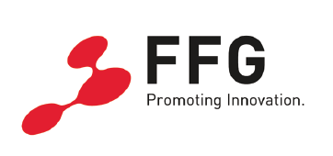
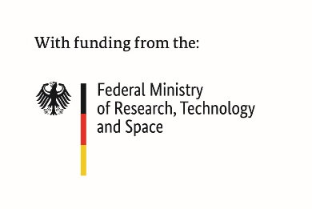

This project received funding from:

Note for editors, not for publication

For interview requests, questions and additional information about FAMILIAR and ITEA, please contact:
FAMILIAR Contact person ITEA Contact person
Tobias Koch (Project leader consider it GmbH) Régis Cazenave (ITEA Vice-chairman)
koch@consider-it.de regis.cazenave@itea4.org



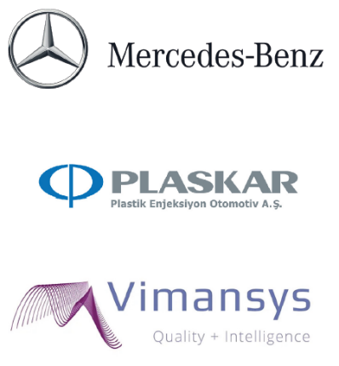
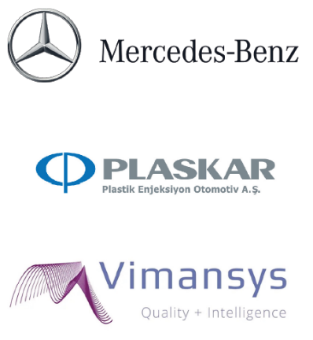
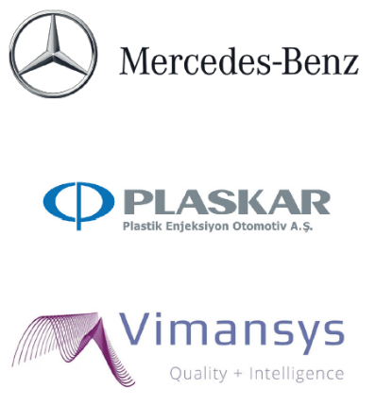

FAMILIAR Project partners
https://itea4.org/project/familiar.html

https://familiar-project.eu/

About ITEA
ITEA is the Eureka Cluster on software innovation, enabling a large international community to collaborate in funded projects that turn innovative ideas into new businesses, jobs, economic growth and benefits for society. https://itea4.org

