ITEA Press release
EMPHYSIS – the missing link between digital simulation and embedded software

15 September 2021 - The ITEA research project EMPHYSIS led by Bosch has delivered the new “eFMI standard” for model exchange to accelerate the model-based development of embedded software. Today, this international collaborative project gathering 25 industrial and academic partners from different fields like automotive and information technologies situated in Belgium, Canada, France, Germany and Sweden received the ITEA Award of Excellence for this unique achievement.

Better code with less effort through “ ” - the new model-exchange standard for embedded devices
When developing a new function, many engineers learn the hard way that their outstanding knowledge about the physics of their products is not enough by far to develop a function for an embedded target, due to the demanding requirements of safety-critical software, weak CPU magnitude and less memory than expected. While this might result in a never-to-be-realised excellent initial idea of operating and controlling their product in a much smarter way, at the same time it reveals the need for a link between digital simulation of physical processes and embedded software.
The aim of the ITEA project EMPHYSIS (Embedded Systems with Physical Models in the Production Code Software), led by Bosch, was to jointly come up with a new open standard that lays the foundation to develop new innovative tools that allow model-based functions to be realised directly in embedded software with better code and less effort. For this purpose, the project carried forward the idea of the very successful Functional Mock-up Interface (FMI) model exchange standard for simulation to develop FMI for embedded systems - the new “eFMI standard”. This enables a wide variety of advanced model-based approaches for control and diagnosis, such as solving a set of differential equations to compute a signal instead of measuring it via a sensor, thereby allowing a hardware sensor to be replaced with a piece of software, significantly reducing the total cost.
The EMPHYSIS project has achieved several outstanding results such as the automatic generation of efficient code for embedded devices. It shows the power of collaborative research projects to drive the adoption of a new standard and to generate significant productivity gains for the industry.
– Jean-François Lavignon, ITEA Vice-chairman
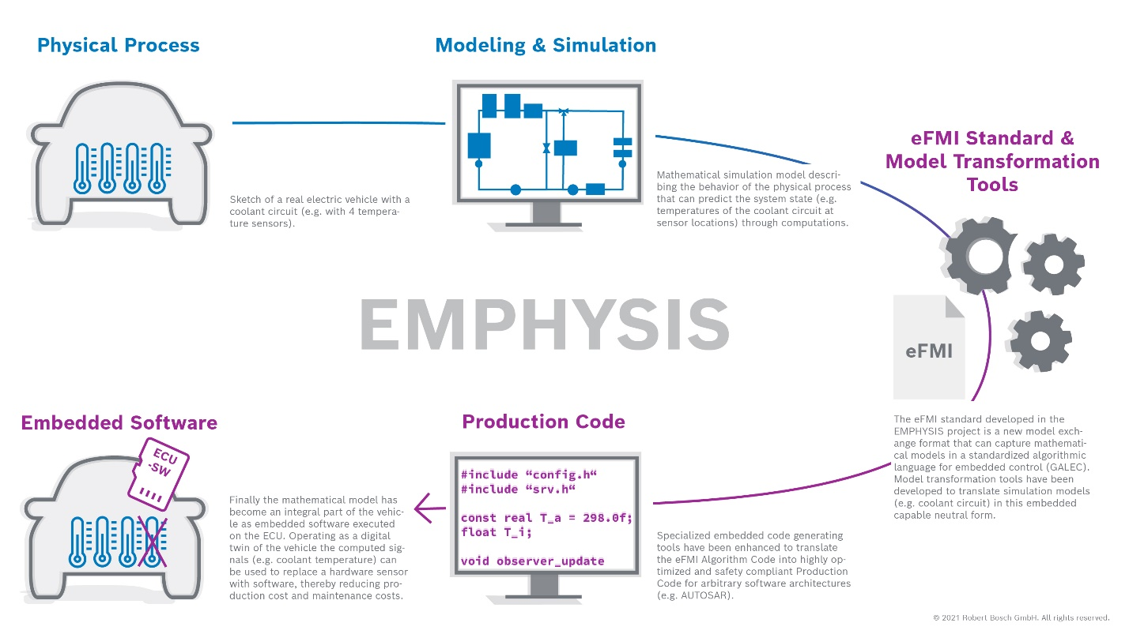
Figure 1: The mathematical model of a physical process becomes part of the software to replace a real sensor with a virtual sensor

The technical deep dive and benefits
Technically speaking, eFMI is innovative in that it provides a target-independent intermediate format defined by an entirely new language, the Guarded Algorithmic Language for Embedded Control: GALEC. This new programming language is able to guarantee that an algorithm described in this language can be translated into code that has:
- static worst-case execution time;
- static a-priori known memory demand; and
- a statically proven absence of illegal memory access.
In other words: code that satisfies the hard requirements of automotive safety-critical embedded software, which also makes it applicable to many more, less restricted domains like robotics, industrial applications and consumer goods.
With eFMI and GALEC it is now possible to capture the computational essence of a model in a target-independent form that is a solid foundation for any code generator to produce highly optimised code for arbitrary runtime environments and software architectures. All this is cast into a traceable, extendable and verifiable container architecture that goes far beyond a simple exchange format.
The eFMI workflow allows developers to model a system on a higher level of abstraction, starting with a reusable, high-level, component-oriented and physically structured model. The tooling kit then automatically transforms this into a solution which can be better integrated into software.
The main benefits of this solution and the associated eFMI workflow are:
- accelerating development time;
- better use of domain experts by separating the concerns of physical modelling and embedded implementation;
- overcoming vendor lock-in through eFMI being published as an open standard on GitHub; and
- enabling new ways of OEM supplier collaborations.

Continuous success
An OEM Advisory Board has been established to gather additional requirements, input and use-cases and further disseminate the project’s results, helping to secure uptake and future innovations in new domains.
On 22 March 2021, right after the project’s end, the non-profit Modelica Association officially approved a new project under its umbrella to further develop, standardise and promote eFMI. With Robert Bosch GmbH, Dassault Systèmes, DLR Institute of System Dynamics and Control, dSPACE, ESI Group, ETAS GmbH and Modelon AB as initial members of the steering committee and Mercedes-Benz AG having joined recently, the first official release of eFMI 1.0 is targeted within 2021. Having developed 14 tools within EMPHYSIS, eFMI already has a broad foundation even before its official release.
“What makes us proud as a team is the fact that this success has been recognised not only by our business partners and the OEM Advisory Board representing the voice of the customer, but also by the ITEA organisation.”
– Oliver Lenord, Research Engineer at the Model-based Systems Engineering
department at Robert Bosch
For society as a whole, EMPHYSIS’ better software translates into safer and more efficient vehicles which are able to keep pace with customer demands and help tackle climate issues in the longer term. For the time being, however, the project’s message is clear: by taking full advantage of an equation-based, component-oriented modelling language with a good library, 90% gains can be made in productivity of model-based function development.

Note for editors, not for publication
For interview requests, questions and additional information about ITEA and EMPHYSIS, please contact:
EMPHYSIS Contact person ITEA Contact person
Oliver Lenord, Robert Bosch GmbH – Project leader Linda van den Borne-Toupet
Oliver.Lenord@de.bosch.com linda.van.den.borne@itea4.org

EMPHYSIS project partners
Belgium
- Dana Belgium
- Siemens Industry Software NV
- University of Antwerp NEXOR
Canada
- Maplesoft
France
- CEA
- Dassault Systemes SE
- FH Electronics
- Institut Polytechnique de Grenoble
- OSE Engineering
- Renault SAS
- Siemens Industry Software SAS
- SOBEN
Germany
- AbsInt Angewandte Informatik GmbH
- Deutsches Zentrum für Luft- und Raumfahrt (DLR) System Dynamics and Control
- dSPACE GmbH
- Elektronische Fahrwerksysteme GmbH
- ESI ITI GmbH
- ETAS GmbH
- PIKETEC
- Robert Bosch GmbH
Sweden
- Dassault Systèmes AB
- Linköping University
- Modelon AB
- RISE - Research institutes of Sweden SICS East
- Volvo Personvagnar AB

About ITEA
ITEA is the Eureka Cluster for software innovation, enabling a large international community to collaborate in funded projects that turn innovative ideas into new businesses, jobs, economic growth and benefits for society. https://itea4.org

