ITEA Press release
AI FORSchung turns fibre-optic data into faster, smarter decisions in healthcare and infrastructure
15 September 2026, Istanbul (Türkiye) - The ITEA project AI FORSchung has received the ITEA Award of Excellence 2026 in the category Innovation, recognising its development of artificial intelligence (AI)-driven methods for compressing and analysing fibre-optic sensing data in healthcare, utilities and civil infrastructure.

Data compression and anomaly detection
Fibre-optic sensing is increasingly being used to monitor minute changes with exceptional sensitivity in real time, supporting applications ranging from medical device guidance to the monitoring of pipelines, bridges and tunnels. However, these systems generate enormous amounts of data, making storage, transmission and analysis increasingly challenging.
To address this challenge, AI FORSchung developed AI-based methods that can significantly reduce data volumes while improving the speed and accuracy of anomaly detection. The project brought together partners from Austria, Belgium and the Netherlands, combining expertise in healthcare technology, infrastructure monitoring, utilities and AI.
Compression rates of five to twenty times and beyond
One of AI FORSchung's key achievements was demonstrating that fibre-optic sensing data can be compressed substantially without compromising reliability. In pipeline and infrastructure monitoring applications, the project achieved compression factors of five to ten times, reducing 100 terabytes of data to as little as 12.5 terabytes. In healthcare use cases, compression rates exceeded 20 times*.
These reductions make it possible to retain data for longer periods, accelerate analysis and significantly reduce storage and infrastructure costs. They also help remove a major barrier to the wider deployment of fibre-optic sensing systems, where data volumes can quickly become difficult to manage.
Beyond data compression, the project advanced anomaly detection capabilities for critical applications. Pipeline operators can identify potential leaks and intrusions more quickly and accurately, while owners of bridges, tunnels and other infrastructure benefit from automated tools for condition monitoring. In bridge monitoring, AI FORSchung combined video analysis with fibre-optic sensing data to partially automate the generation of reference datasets, significantly reducing the manual effort required.

Improving the safety and reliability of critical assets
By lowering storage requirements and enabling more automated analysis, the project helps operators of critical assets improve safety, reliability and operational efficiency. Earlier detection of leaks, intrusions and structural degradation can help prevent service disruptions, environmental damage and costly repairs.
Commercial adoption of the project's results is already underway. Several consortium partners are integrating the developed technologies into their products and services while exploring additional applications.
In healthcare, the project also supports the development of thinner and longer fibre-optic devices, potentially expanding the use of minimally invasive procedures. By enabling earlier detection of leaks and structural damage, supporting advanced medical procedures and dramatically reducing data volumes, AI FORSchung delivers impact where it matters most: in the systems that support everyday life.
This project received funding from:
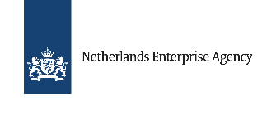

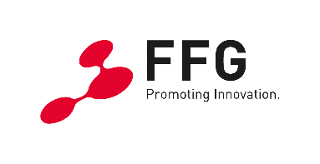

Note for editors, not for publication

For interview requests, questions and additional information about AI FORSchung and ITEA, please contact:
AI FORSchung Contact person ITEA Contact person
Ahmet Ekin (Project leader Philips) Régis Cazenave (ITEA Vice-chairman)
ahmet.ekin@philips.com regis.cazenave@itea4.org
*AI FORSchung Project partners and documents
https://itea4.org/project/ai-forschung.html








About ITEA
ITEA is the Eureka Cluster on software innovation, enabling a large international community to collaborate in funded projects that turn innovative ideas into new businesses, jobs, economic growth and benefits for society. https://itea4.org

