  - ITEA press release
  - Bittium strengthens connection and becomes ITEA Board member
Eindhoven, 30 November 2023 - Since the beginning of ITEA 25 years ago, Finland has been a very strong and stable supporting country with nearly 120 ITEA projects and over 250 participating partners. To underline this position of Finland and to strengthen the ITEA Programme, the ITEA Board has unanimously welcomed Bittium as a new member.
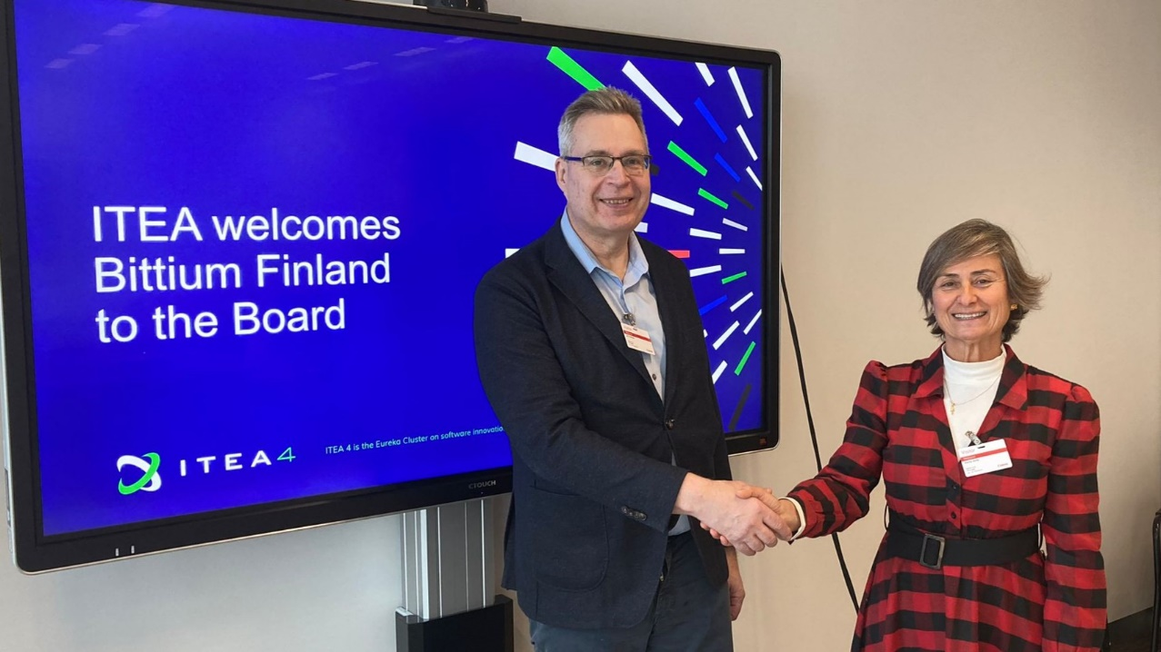
Jari Partanen, Director of Quality and Research at Bittium, officially signed the Deed of Accession with Zeynep Sarılar, Chairwoman of the ITEA Board.
Bittium’s slogan, ‘Connectivity to be trusted’, is a perfect fit for ITEA, which fosters software innovation by establishing valuable connections between partners from organisations worldwide in a trusted collaborative environment. Bittium has already been involved in ITEA for more than 15 years through participation in several ITEA projects over various ITEA Calls. Their first ITEA project was Flexi, which started in April 2007 and aimed for flexible global product development. In the ACCELERATE project, Bittium deployed an innovation management information system tool for collecting all innovation ideas and covering the innovation process from idea harvesting to business validation.
Last year, the CyberFactory#1 project, in which Bittium participated, received the 2022 ITEA Award of Excellence for Business Impact. CyberFactory#1 created a solid foundation for cyber security and cyber-resilience capabilities in the context of Factory of the Future and Industry 4.0. In order to be prepared for the reality of cyber-incidents, Bittium and Airbus Cybersecurity modelled SaaS digital twins and performed true simulations and testing with hundreds of test scenarios using available cyber-frameworks like MITRE Att&ck and OWASP. The outcome was that the cybersecure architecture for the use-case could be taken into use practically and can be adopted in alternative use-cases in the future.
R&D is high on Bittium's agenda; the company has been significantly investing in R&D for their own products and solutions over recent years. The ITEA Board membership will enable Bittium to play an important role in the industry-driven RD&I landscape of software innovation, which can also contribute to Bittium's international growth and a better go-to-market strategy in particular.
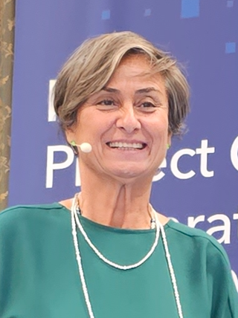
“The ITEA Board membership is a commitment to global collaboration on software innovation. Bittium has been an impactful partner in ITEA projects and is now taking a step forward into the leadership of ITEA as a Board member. Bittium not only represents its own innovation capacity but is also bringing the innovation culture of Finland to the ITEA Board. We warmly welcome them and I am very enthusiastic for the future that will be developed by an ITEA Community enriched not only by Bittium but also its networks.”
- Zeynep Sarılar
ITEA Chairwoman
New ITEA Board member representative Jari Partanen states: “I’m pleased to represent Bittium in the honourable ITEA Board, which represents the leading international software innovation forum. We hope to bring new insights to the forthcoming challenges for software-driven innovations from a mid-size company perspective!”
- Jari Partanen
Director of Quality and Research at Bittium
--------------------------------------------------------------------------------------------------------------------------------------

Note for editors, not for publication
For interview requests, questions and additional information, please contact:
Bittium contact person
Malmi Karoliina – Vice President, Corporate Communications and Marketing Bittium
karoliina.malmi@bittium.com
ITEA contact person
Linda van den Borne-Toupet
linda.van.den.borne@itea4.org

About Bittium
Bittium is specialised in the development of reliable, secure communications and connectivity solutions leveraging its over 35-year legacy of expertise in advanced radio communication technologies. Bittium provides innovative products and services, customised solutions based on its product platforms and R&D services. Complementing its communications and connectivity solutions, Bittium offers proven information security solutions for mobile devices and portable computers. Bittium also provides healthcare technology products and services for bio-signal measuring in the areas of cardiology and neurology.
Source: Bittium

About ITEA
ITEA is the Eureka Cluster for software innovation, enabling a large international community to collaborate in funded projects that turn innovative ideas into new businesses, jobs, economic growth and benefits for society.
https://itea4.org

