Gränges use case - Problem Description

Version | V1.1
Date | 24 March 2024
Confidentiality | Public
Type of Deliverable | Problem Description
Description | Report
Deliverables in the Project | One deliverable – D4.1

- Abstract

The project "VMAP analytics – Smart analytics for multi-scale material and manufacturing modeling" focuses on using technology to analyze materials and manufacturing processes. In today's competitive world, having smart digital copies of real things is crucial for staying ahead. These digital twins are powerful tools that help businesses stay competitive. This report describes the problem proposed in the project VMAP analytics. Gränges wishes to meet the unflatness of the aluminum alloy strip as per customer needs. The strip crown in hot rolling depends on various process parameters and rolling mill parameters and they are discussed in detail in this report. The methodology followed to meet the objectives are outlined.

- Change Log

- Contributors:
Name | Organization
Sivaprasad Palla | Swerim AB
Krister Ekström | Swerim AB
Pontus Darth | Swerim AB
Chunhui Luo | Swerim AB
Robbin Kantarp | Gränges AB

Table of Contents
Gränges use case - Problem Description 1
1. Abstract 2
2. Introduction 4
2.1. Business Objectives 4
2.2. Overview of production process 4
2.2.1. Profile related defects 5
2.3. Literature Review 6
2.3.1. Rolling Process 6
2.3.2. Modelling Rolling Process 7
2.3.3. Strip Profile Models 8
2.4. Methodology 9
3. Conclusions 10

- Introduction

The digitalization in materials and manufacturing industry is of high importance for any company that wants to keep and advance its position in the market. Many companies - majorly within logistics domain - have already introduced digital twins. However, if producers of advanced materials and complex parts need a more detailed look into the ongoing manufacturing processes and changing material properties, they will not find suitable solutions today. Gränges employs hot and cold rolling processes to deform aluminum so that the desired quality is achieved through as few reductions as possible. It may be easier said than done because there are many parameters that work together and that must be considered to do this in a controlled way.

This report describes the business objectives, market analysis, situation assessment, development of necessary digital twins and data analytics.

  - Business Objectives

Gränges is an aluminium technology company who drives the development of lighter, smarter and more sustainable aluminium products and solutions. The company offers advanced materials that enhance efficiency in the customers’ manufacturing process and the performance of the final products. Gränges have a leading global position in rolled aluminium materials for thermal management systems, speciality packaging and selected niche applications. It is important to adopt leading edge technologies to maintain the leading position and also expand the customer base. The company possess about 2700 skilled employees at various levels. It has net sales of about 24 billion SEK and has 20% global market share in rolled products for brazed aluminium heat exchangers. Gränges has a diversified product portfolio serving four key end-customer markets (Figure 1Key end-customer portfolio).

Figure 1Key end-customer portfolio
  - Overview of production process
Gränges rolls down direct chill (DC) cast slabs by reversible rolling from 600 mm – 15/20 mm and by subsequent tandem rolling down to a final thickness of 3-7 mm as given in Figure 22.

In the reversible rolling, the final thickness is reached by 20-30 roll passes depending on the composition of the package. Below 50 mm, the profile of the substance is taken into account for planning the last reductions in the knitting schedule.

The influence parameters for controlling profile and flatness in Gränges' reversible rolling mill are rolling force (reduction), rolling bombing (grinding) and thermal work roll cumber by cooling. After completing reversible rolling, the transitional unit goes via roller coaster to the tandem plant, which consists of two sequential rolling stands. After the tandem work, the sheet is coiled before further processing.
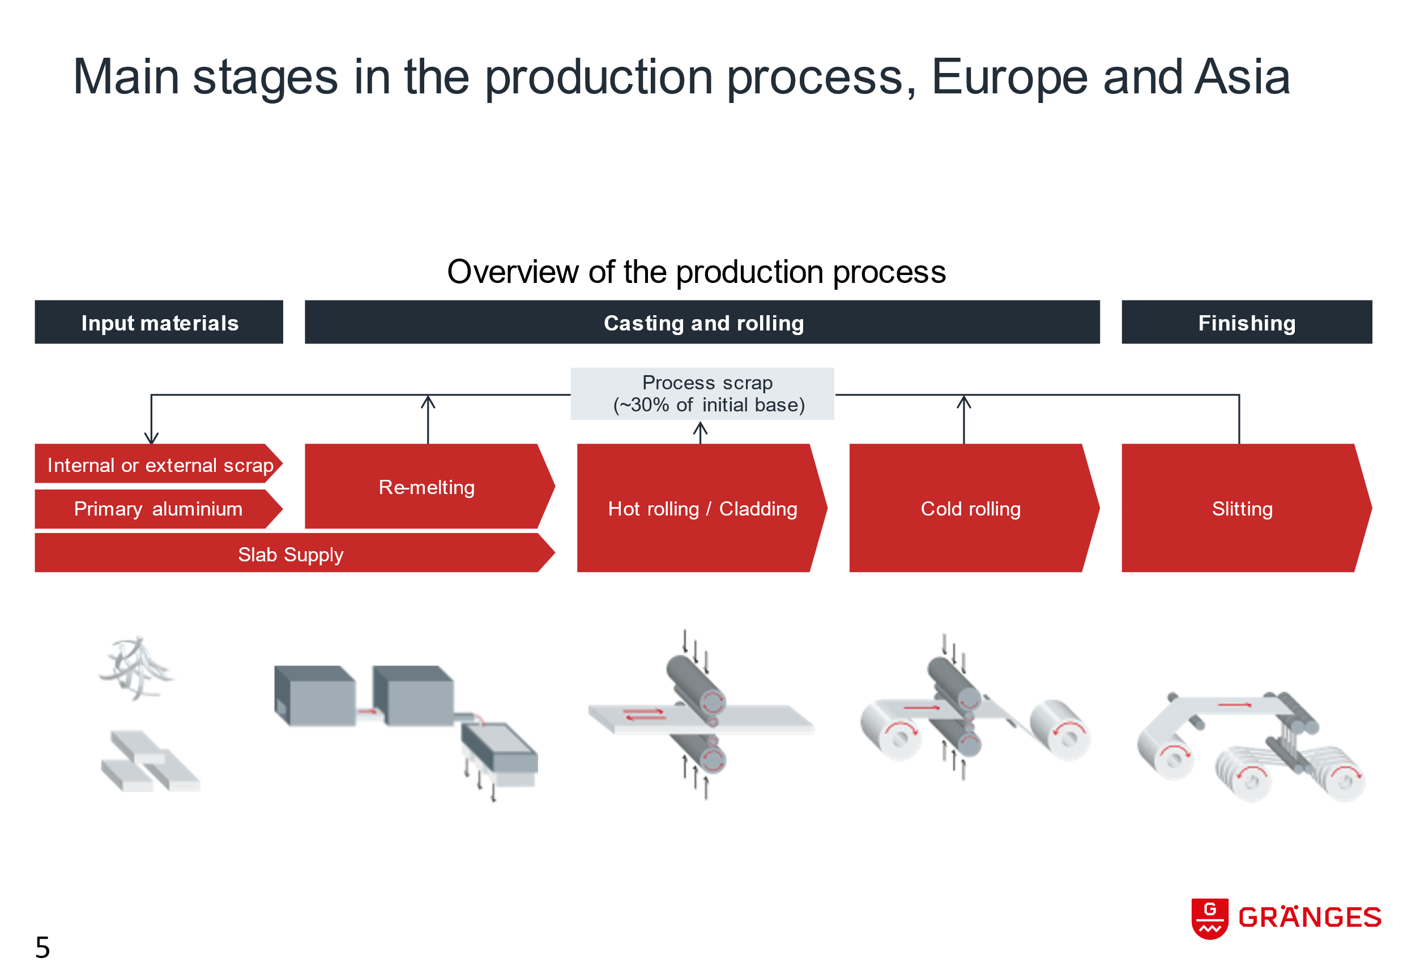
Figure 2 Production process at Gränges (Courtesy Gränges AB)

    - Profile related defects

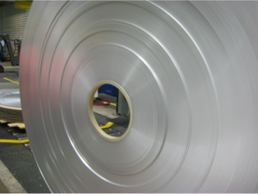
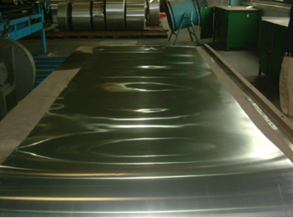
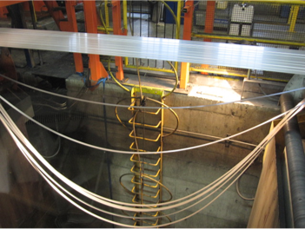
The thickness uniformity of the final sheet depends on various process parameters and it is quite complex to analyse. Large variation in sheet profile thickness can results in the defects shown in Figure 33.

Figure 3 The defects arising out of excess variation in profile thickness

These defects will lead to reduction in yield and unsatisfied customers. Therefore, it is important to understand the effect of various process parameters on profile variation.

In the hot rolling process of Gränges Finspång some important process parameters like accurate rolling force measurements isn´t available. This decreases the possibility to detect daily variations, for example material or lubrication related properties, work roll wear. This makes it difficult for the operator to aim for the target profile with low deviation.

The purpose of this project is thus to improve the understanding of the process better so that this can be controlled and optimized. The objective of the project is

- Get increased control of the profile and flatness
- Optimizing rolling process in a better way
- Optimize pass schedule
- Minimize variations in the end properties of the substance

  - Literature Review
Though rolling steel into flat sheets is an established manufacturing process, the steel industry is perpetually looking for ways to improve the quality of its products. The simplest way to improve quality is through better understanding and control of the rolling processes. All flat rolled products experience some flatness error due to the manufacturing process. This flatness error can range from small thickness variations to waves in the product itself. These variations force customers to request thicker material than necessary to ensure that they receive product of a certain thickness. For this reason, models of the rolling process have been developed throughout history to predict how aspects of the final product, such as thickness and flatness, may be affected based on the configuration of the mill.

    - Rolling Process
The process of creating a finished flat rolled product from the original slab consists of several stages. These stages in a typical hot rolling mill are strip preparation, roughing, finishing, measuring, and coiling. In general, rolling mill stands are composed of the set of rolls between which the strip passes and the structure that supports those rolls. Figure 44 shows a typical rolling stand and a graphical representation of all its parts.
Figure 4 A schematic representation of rolling process for a 4 Hi rolling mill

Ideally, a final product coming out of a mill would be perfectly flat across its width and length. Crown represents flatness error across the width of the strip, but error can also occur along the length of a strip. If the change in thickness at a stand is not nearly uniform, then it causes the strip to lengthen unevenly across its width. This change in length can cause either edge wave or center buckle. Edge wave occurs when the strip crown increases too much within a stand and center buckle occurs when the strip crown decreases too much within a stand. This rule says that the strip crown can only be changed so much within a stand before creating additional flatness error besides profile flatness error. Flatness error along the width and length of the strip must be controlled to create a usable product.
The only way to control the flatness error is to precisely control the strip crown. The strip crown is affected by the geometry of the rolls, the gap between the rolls, roll stiffness, roll bending, stand stiffness, and the strip material properties. While rolling the strip it is only possible to control a few of these parameters. The essence of controlling strip crown lies in determining which stand parameters have the greatest effect on crown and how they can be controlled.
Recent advances in finite element analysis and computing have made it possible to simulate the complex rolling process in great detail. The development of highly accurate models of the rolling process will lead to the more efficient production and use of steel.
    - Modelling Rolling Process
Metal working problems are studied using various kinds of approaches viz., analytical models, physical simulations, and high-performance computations. There are pros and cons for each type of simulations. A more popular approach to solving metal working problems in general and the hot rolling process is the Finite Element Method (FEM). A brief introduction to this method is given in introduction chapter. In the following sub-sections FEM and analytical methods are described.

Finite Element Modelling of Rolling Process:

FEM was used to simulate the structural deformation and dynamics of the roll-stack system. The purpose of the finite element method is to solve partial differential and integral equations over irregularly shaped domains. FEA breaks down the body into regular domains called elements through a process known as meshing. The characteristics of each element depend on the element’s size, shape, and material properties. The elements are then assembled to represent the entire body of the original system. Initial conditions such as velocities or accelerations are also applied. With the system fully described, it is possible to solve for element displacements and deformations. In addition, stresses, strains, velocities, accelerations, contact pressure, reaction forces, internal energy, and kinetic energy can be found. From these results, predictions about how a system behaves can be gathered and analyzed.

Since 1950s the development of FEM methods in rolling started. The improvements are then made with more and more computational power. Further, more and more complex models could be created. The general applications of FEM are discussed in detail by Reddy. During rolling, the extension in width direction of strip is not significant, plain strain conditions can be assumed. This simplifies the simulation to 2D FEM model. Several 2-D finite element models of the rolling process have been created and shown to offer more accurate approximations of rolling load. The model developed by Mori³² demonstrated the strip deformation during rolling. However, 3D models are more advanced models in predicting strip crown more accurately. Finite element models for predicting strip profile fall into two categories: static and dynamic. Static finite element model considers only applied loads and elastic forces. Dynamic models include inertial and damping forces in addition to applied loads and elastic forces.

The simulation of metal forming for a control system is a step on the way to realizing digital twins. The simulations take a long time to compute, so the requirement of a short computation time of 0.1 s, in on-line control systems prevent the application of FE simulations. A longer computation time would be a serious issue in the direct use of FE simulation in DT. To overcome this issue, FE simulated data and results must be stored instead of computing every time, or a rapid computing method based on phenomenological model must be used for the control system.

    - Strip Profile Models
Strip profile models attempt to represent deformation across the width of the rolls due to bending and contact. The interaction between the strip and the rolls is modeled in greater detail than is possible with rolling load models. Most strip profile models are based on beam or finite element theory.

Beam models are analytical models, based on beam theory and can be classified as simple beam models or slit beam models. The simple beam model represents the entire roll or rolls as a single beam and integrates the beam equation over the width of the roll using a distributed rolling load to determine deflection. Whereas the slit beam model represents the roll as a series of beam segments by subdividing the rolls. Hence the variation in the loads along the width of the strip can be better represented through equivalent nodal loads.

To summarize, the slit beam model does not completely model the roll-strip contact, which is approximation with discreet spring elements representing an elastic foundation. The 3-D rolling finite element model better represents the roll geometry and deformation along with the contact and nonlinear strip properties.

2D FEM models can predict rolling loads accurately. However, they do not consider lateral flow of sheet for predicting crown. Since lateral flow can significantly affect crown development, it cannot be neglected. Dynamic 3D finite element (FE) models provide the most precise depiction of roll and strip deformation, accounting for appropriate boundary conditions. These models replicate genuine roll rotation and strip translation, requiring contact conditions and pressure distributions to mirror the actual rolling process, assuming accurate material and geometry models. Nevertheless, these dynamic models must also address achieving stable conditions and handling substantial computational time. Slaughter developed a 3D dynamic finite element model for strip crown prediction. It could predict the rolling load, exit thickness, and strip crown within 5% of the test data measurements. There are attempts at combining FEM with analytical models for improving accuracy as well as computational efficiency. Several algorithms have been developed to improve the simulation of strip crown. FEA has been widely used for the flatness prediction, roll contour design, investigating the flatness control ability of rolling mills and buckling analysis of strips.
  - Methodology

The following methodology is proposed to meet the above-mentioned objective.

As described in Figure 55 the modelling is planned to be carried out using FEM, phenomenological and data-based models.

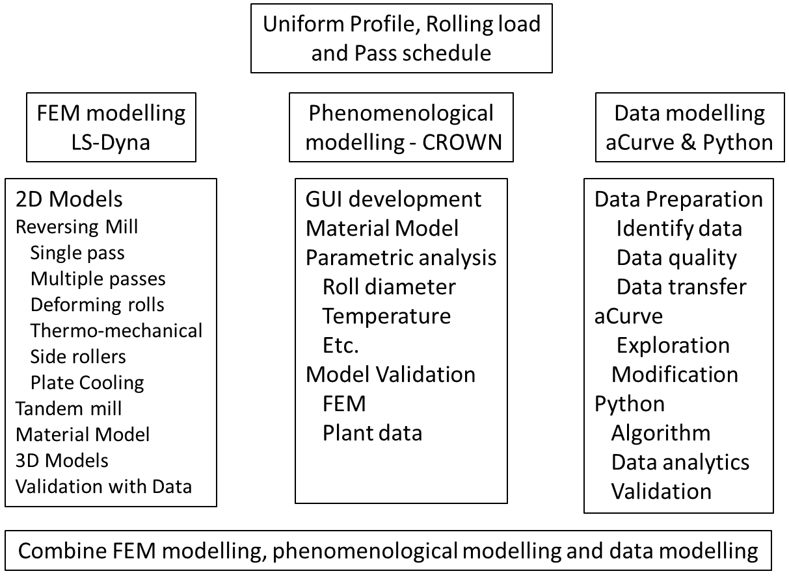
Figure 5 The methodology of application of various modelling tools to meet the objective

With the methodology proposed and once the models are validated with the plant data, the results will provide deeper understanding of the manufacturing processes.

The following deliverables are expected from this use case:

- Digital twin that mimics the rolling process closely
- DT with data analytics to provide deeper understanding
- Better product quality, increased yield.
- More efficient use of controlling actuators in hot rolling

With the above deliverables, one will be able to:
- Plan and optimize process parameters in a better way
- Maximize rolling power and torque without exceeding the performance of the work
- Get increased control of the profile and flatness of the substance during rolling
- Minimize variations in the end properties of the substance

- Conclusions

The problem description, business impact, development of digital twins, the methodology and the deliverables from the project are described in this report.

J. N. Reddy. An Introduction to the Finite Element Method. McGraw-Hill, New York, NY, 3rd edition, 2006..
K. Mori, K. Osakada, and T. Oda. Simulation of plane-strain rolling by the rigid-plastic finite element method. International Journal of Mechanical Sciences, 24(9):519 – 527, 1982.
Ohara K, Tsugeno M, Imanari H, Sekiyama Y, Kitagoh K, Yanagomoto J, Process optimization for manufacturing of sheets with estimated balance between product quality and energy consumption, CIRP Annals manufacturing technology 63(1) (2014) 257-260
Arif S. Malik and Ramana V. Grandhi. A computational method to predict strip profile in rolling mills. Journal of Materials Processing Technology, 206(1-3):263 – 274, 2008.
Vladimir B. Ginzburg. High-Quality Steel Rolling: Theory and Practice. Marcel Dekker, Inc., 1993.
G P Bernsmann, Later material flow during cold rolling of strip, Iron Steel Eng., 49(3) (1972) 67-71.
Derek E Slaughter, MS Thesis, Strip crown prediction: Developing a refined dynamic roll-stack model for the hot rolling process, 2009 Virginia Polytechnic institute and state university.
Z Y Ziang, A.K. Tieu, Elastic plastic FEM simulation of thin strip with tension in cold rolling, J. Mater. Proc. Technol. 130-131 (2002) 511-515.

