VMAP Standardization and Dissemination Activities

Version | V1.0
Date | 18 Mar 2024
Confidentiality | Public
Type of Deliverable | Dissemination Activities
Description | Report
Deliverables in the Project

Contributors:
Name | Organization
Klaus Wolf | SCAI Fraunhofer
Priyanka Gulati | SCAI Fraunhofer
Victor Lueddemann | SCAI Fraunhofer

Table of Contents
VMAP Standard Dissemination Activities 1
1. VMAP Standardization Activities 4
1.1. VMAP SC e.V. Establishment 4
1.2. VMAP Standard – Collaborations with Projects 6
1.3. VMAP Standard – Dissemination Activities 8
1.4. VMAP User Meeting 2024 10

- VMAP Standardization Activities
VMAP Standard is being actively used in many of the running projects and the further development of the standard in various domains is ongoing.
  - VMAP SC e.V. Establishment
The VMAP Standards Community eingetragener Verein (VMAP SC e.V.) was established as a not-for-profit association in Germany on the 20 December 2022. The preamble of the association summarizes the purpose of the association very clearly
“The association is a scientific research institution and promotes science and research. It is concerned with the scientific investigation of the application possibilities as well as further development and maintenance of an open software standard that can be used for industrial and academic applications in a generally and free accessible manner. "VMAP SC" is the "VMAP Standards Community", open to all interested parties who wish to use or contribute to the standardization efforts of the association. The association wishes to carry the VMAP standardization efforts into the future and for this purpose plans to found the "VMAP Standards Community e.V.”
Some of the goals of the association are:
- Storage of complete simulation models and consideration of further simulation disciplines and discretization methods,
- Connection to product management and design data,
- Linking of virtual simulation data with real measurement and sensor data,
- Semantic and cross-disciplinary organization of data via ontologies,
- Support for AI-based analysis and prediction methods.

In order to organize the work within the community, we have three separate groups which are working on various domains from the industry. These groups were organized based on the demands from the partners and other clients.
VMAP Working Groups
- Full Model Storage: The aim of this group is to develop a standardized storage structure and methods to store the complete simulation model within the VMAP Standard. The reason to store a full model is based largely on the use case, however, here are some points which are common to many of the industrial domains:
  - All geometrical information of the model can be found at one place
  - History of the material data can be easily stored
  - Useful for post processing of data to validate KPIs.
  - Possibility for a completely solver independent post processing analysis
  - Possibility of interoperable and reusable data
  - Storage of data like boundary conditions and loading over time steps will allow for development of complex workflow independent of commercial tools.
  - Provides the possibility to redo simulation independent of the platform to store the solution information

- Sensor Data Storage: The aim of this working is to integrate the measurement data into the VMAP Standard. This will finally enable the development of a seamless digital twin. Some of the reasons to add measurement data to the VMAP Standard are:
  - Experimental data plays an important role in the development of engineering designs
  - Confident validation of CAE data using real world testing data
  - Possibility to store additional metadata as part of the experiment in one place
  - Simulation and measurement data in one format can form a basis for a digital twin development
- Visualization of VMAP Data Sets: Since, VMAP data is stored in HDF5 format, it is not possible to view the models in a 3D format. Paraview, which is an open-source multiple-platform application for interactive, scientific visualization, has been used to view the VMAP data. The implementation of the IO library is part of this working group. The benefits of having a viewer are clear,
  - easy and handy method to look at the simulation and measurement results
  - open-source tool can also be employed by universities and students
  - a free result visualization tool will significantly increase the acceptance of VMAP​ Standard

  - VMAP Standard – Collaborations with Projects
VMAP Standards has been recognised by many industry experts as one stop shop for storing the CAE and measurement data. In this regard, VMAP Standard extensions are being employed in various horizon Europe Projects:
- Pioneer - Open innovation platform for optimising production systems by combining product development, virtual engineering workflows and production data. It’s important to ensure and optimise the manufacturing of new products or variants in low-volume production systems. With this in mind, the EU-funded PIONEER project will develop an open innovation platform and interoperable digital pipeline for addressing a design-by-simulation optimisation framework. The project has two use cases one from the automotive industry and the other one from additive manufacturing domain, VMAP Standard will be used to store & transfer the data among simulations and inspection testing.
Project Timeline: Jan 2023 - Dec 2025
- Restore - Sustainable Remanufacturing solution with increased automation and recycled content in laser and plasma-based process. Remanufacturing is critical for Circular Economies, extending product life, creating jobs and revenue streams, and reducing waste, energy consumption, and greenhouse gas emissions. The main challenges that need to be addressed for successful remanufacturing in an industrial value chain or, more appropriately, value cycle is related to process, design, and business models. To meet these challenges, RESTORE will offer sustainable design remanufacturing process and materials along with supporting tools for digitalization of remanufacturing ecosystem or value chain. For capturing the simulation data and analyse the use of experimental data, standards data formats will be pivotal, hence VMAP Standard will support the project and expand in domains, like railway axle simulation, ship propellers failure analysis, caster rollers & laser powder DED processing for Automotive components​.
Project Timeline: Jan 2024 – Dec 2027
- Alabama - Adaptive Laser Beam for additive manufacturing. The ALABAMA project aims to develop and mature adaptive laser technologies for AM. The objective is to lower decrease the porosity and to tailor the microstructure of the deposited material by shaping the laser beam, both temporally and spatially, during the AM process. The key innovations in the project are to develop multiscale physics-based models to enable optimization of the AM process. The matured technology will be tested on three use-cases: aviation, maritime and automotive. VMAP Standard will be used within this project to carry out the numerical analysis in AM processes and efficiently store the corresponding data.
Project Timeline: Jan 2024 – Dec 2027
- HyPerStripes - Hybrid integrated high performance electronic stripes​. In a number of today’s miniaturised electronics applications, conventional cable wiring is both costly and wasteful of materials. It also restricts scope to innovate and increase product performance. The HyPerStripes project is addressing these limitations by developing technologies and production techniques for long, smart, flexible electronic systems (‘hyperstripes’) that can replace traditional cables and printed circuit boards. It will focus on two key applications: medical instruments used in minimally invasive procedures (e.g. catheters and endoscopes) and eco-friendly LED lighting surfaces. VMAP Standard is being employed within this project to store the simulation data.

  - VMAP Standard – Dissemination Activities
Events
- 13th European LS-DYNA Conference 2021 (5-7 October 2021 | Ulm)
  - “VMAP enabling interoperability in integrated CAE simulation workflows”, Wolf K., Fraunhofer SCAI
- NAFEMS World Congress 2021 (25-29 October 2021 | Online)
  - “Bridging the gap between product & simulation data management. An analysis of the needs and possibilities in industrial engineering”, Spelten P., Fraunhofer SCAI
  - “An integrative optimization concept for extrusions blow moulded parts”, Bruch O., Dr. Reinold Hagen Stiftung
  - “VMAP Standard and the VMAP Standards Community e.V.”, Wolf K., Fraunhofer SCAI
  - “VMAP Enabling Interoperability in Integrated CAE Simulation Workflows”, Gulati P., Fraunhofer SCAI
- Webinar: VMAP Standards Community News (27 April 2022 | Online
- Hannover Messe (May 2022 | Hannover)
- NAFEMS DACH 2022 (4-6 October 2022 | Bamberg)
  - “VMAP-Analytics – A Smart Manufacturing Platform”, Palla S., Swerim
- NAFEMS World Congress 2023 (15-18 May 2023 | Florida)
  - “Development of a Hierarchical Data Format for Modeling, Simulation and Postprocessing in Structural Mechanics and its Ecosystem”, Rädel. M, Lefèvre. J, Schuster. A, German Aerospace Center (DLR)
  - “Breaking Down the Interoperability Barrier Among Different FEA Software”, Fassas. T, Mokios. G, BETA CAE Systems SA
  - “A Methodology for Integrating Hierarchical VMAP-data Structures into an Ontology to Enable Semantically Represented Analyses”, Wolf. K, Meyer. M-C, Fraunhofer SCAI, Wagner. A, PROSTEP AG, Reith. D, Institute of Technology, Resource and Energy-Efficient Engineering

Awards & Recognitions
- VMAP received the ITEA Award of Excellence for Standardisation (15 September 2021)

Technical Publications
- “A Methodology for Integrating Hierarchical VMAP-Data Structures into an Ontology Using Semantically Represented Analyses”, Spelten P (1,2), Meyer M (1), Wagner A (2), Wolf K (1), Reith D (1,3). 1 Fraunhofer-Institute for Algorithms and Scientific Computing SCAI, Schloss Birlinghoven, 53757 Sankt Augustin, Germany, 2 PROSTEP AG, Dolivostr. 11, 64293 Darmstadt, Germany, 3 Institute of Technology, Resource and Energy-Efficient Engineering (TREE), Bonn-Rhein-Sieg University of Applied Sciences, Grantham-Allee 20, 53757 Sankt Augustin, Germany (https://doi.org/10.3390/info15010021)

  - VMAP User Meeting 2024
The 1st VMAP User Meeting 2024 was hosted from 14-15 February 2024 at the Fraunhofer SCAI Institute, Schloss Birlinghoven in Sankt Augustin, Germany.
The event was attended by more than 35 people professionals coming from various industrial domains, like standardization, software vendors and OEMs. With more than 20 presentations delivered by industry experts on sensor data storage, standardization activities in the simulation domain, digital passport for parts and products, FAIR data it was a successful and a wholesome discussion.
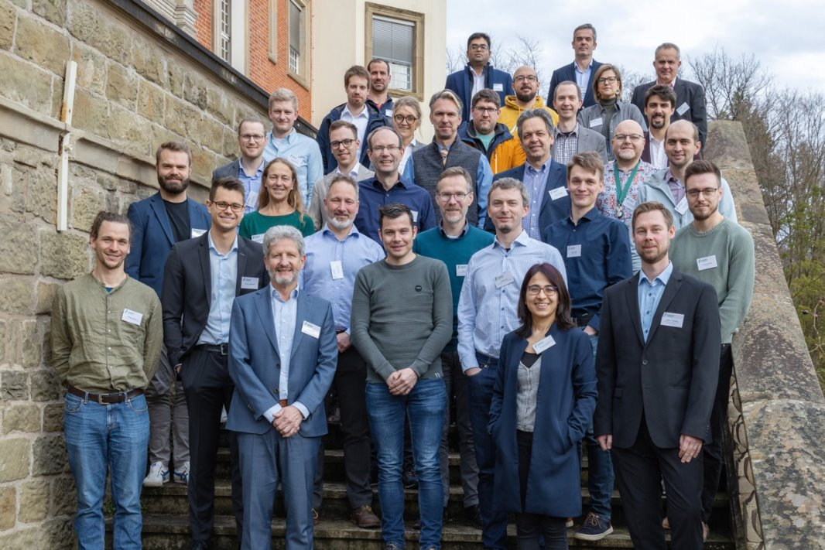
The event was opened by the VMAP SC Chairperson, Mr. Klaus Wolf, who welcomed the attendees and gave an overview about the goals and strategies for the VMAP SC e.V. One of the main discussion points in the event was the extension of the VMAP Standard. In this regard, there were presentations delivered about the VMAP Working groups, Sensor Data Storage, Full Model Storage & Visualization of VMAP Data Sets. These presentations mostly focussed on the overall demands from the industry and technical development of the standard.
Following this, we saw presentations from the application domains like blow moulding, furnace modelling, data validation for composite production. The presentation delivered by Olaf Bruch from Hagen Stiftung, showed a clear application from the blow moulding domain, where the stereography and thermography data need to be incorporated into the validation process along with the simulation data. This use case showcases the need for a standard format to store both test and simulation data, to carry-out such a validation process without any loss of information.
Another presentation on handling of sensor data using knowledge graphs, was presented by Morten Meyer from SICK AG. Such varied use cases, with a similar demand for data storage shows the need for a standard. These use cases form the basis for the work being carried out within the VMAP SC Sensor Data Storage Working Group.
One of the application-based presentation for the Full Model working group was delivered by Oliver Kunc from DLR, where we saw the requirements for storing numerical data, like boundary conditions, in the VMAP Standard. The jet engine design requires coupling of various tool, standardized data exchange and support for multi-fidelity data. Integration of all such data components into the VMAP Standard will provide, such complex uses cases, a comprehensive data exchange format.
The second day of the event saw presentations from various projects which are working and ex-tending the VMAP Standard. These include projects PIONEER, RESTORE, ALABAMA & METAFAC-TURING from the Horizon 2.4 – Digital, Industry and Space programme, and project HyPerStripes from Penta Call 6. It was interesting to see, how these projects are trying to use and extend VMAP in different domains where simulation and testing data is of utmost importance.
Last but not the least, the User Meeting also discussed complimentary standards which are being used in the industry. The presentation on the FAIR data principles within the Material Digital Platform was delivered by Markus Schilling from Bundesanstalt für Materialforschung und -prüfung (BAM). Furthermore, the handling of STEP and CAD data within the product data management framework was delivered by Jochen Boy from PROSTEP AG.
The presentations depict the demands for standardized data in the engineering domain and provides a good whole view of the current developments which are taking place in the industry, for the industry. This was a great opportunity to see the demands and needs from the industry and work towards the further development and expansion of the VMAP Standard.

