Blow moulding – Problem Description

Version | V1.0
Date | 21 Sep 2023
Confidentiality | Public
Type of Deliverable | Problem Description
Description | Report
Deliverables in the Project | One deliverable

- Abstract

The document describes the problem description of the Blow moulding use case.

- Change Log

- Contributors:
Name | Organization
Morten-Christian Meyer | SCAI Fraunhofer
Klaus Wolf | SCAI Fraunhofer
Priyanka Gulati | SCAI Fraunhofer
Victor Lueddemann | SCAI Fraunhofer

Table of Contents
Blow moulding – Problem Description 1
1. Abstract 2
2. Use case 4 (Blow moulding) 4
2.1. Problem description and goal 4
2.2. CAE-based Digital Twin 4
3. VMAP Extensions for Use Case 4 6
3.1. Experimental Data Integration 6
3.2. VMAP Storage Structure Extension 7

- Use case 4 (Blow moulding)
  - Problem description and goal
Industry demand: Use case 4, contributes to a digital twin development for optimization tasks in extrusion blow moulding, a widely used manufacturing process with 0.452 million tons of plastic currently processed in Germany. It operates by extrusion and inflation of a tubular melt strand into a mould and is adequate for thin-walled shell bodies at high production rates. It stands in the critique of high resource demand; yet the potential for savings is large along this intensive value chain. Blow moulding is extremely sensitive to material property fluctuations (polypropylene/polyethylene) with inadequate control measures to assure product quality for higher rates for recyclates. This will be possible, once optimization of the process is enabled at scale through a digital twin system, requiring significantly less energy than new material. Also, the wall thicknesses can be decreased and an AI-supported component design could also guide engineers towards more efficient geometries, again saving up to 10% of material. One requirement is a data infrastructure for dynamic exchange of data between machines and predictive tools coupled with the various model types for the process and components.
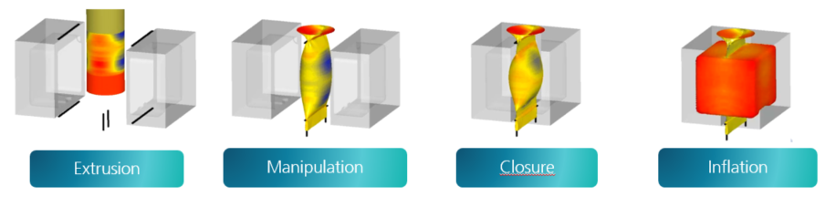
Figure 1: – Extrusion blow moulding process [adopted from Dr. Reinold Hagen Stiftung]

Goals: VMAPanalytics mainly aims at the goal to bridge the gap in data interoperability between measurement and simulation. Most of the formalization of the processes and interface development is out of the scope of this use case and left for funded work. In this project, we focus on the software-infrastructure – a necessity before the actual optimization tasks – and derive a proposition for the use of VMAP in a digital twin scenario. Concretely, this means two main outcomes: a) a VMAP ontology with recommendations for querying data, and b) a VMAP extension for experimental data with recommendations to parse and use CAE-experimental correspondences.
  - CAE-based Digital Twin
Digital twin technology is mostly driven by the “smart factory” system perspective. However, joining digital twins with simulations to understand and control the physics of a system requires a perspective that is not yet established in industrial digital twin standards. Dr. Reinold Hagen Stiftung has developed a unique simulation workflow in the first ITEA VMAP project that uses VMAP as exchange format between high-resolution simulations.
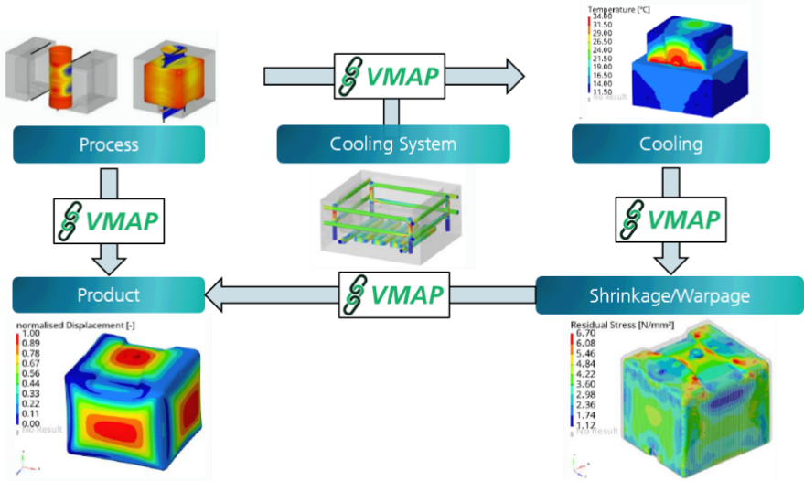
CAE-workflows: We start from a well-defined framework of rule-based simulations and transfer based on VMAP between CAE codes. Each individual simulation as well as intermediate mapping are validated and automated. However, the overall workflow is not fully formalised and disconnected from measurements and production machines. Interfacing to such data is required for automation of calibrations, comparisons or uncertainty quantification, global optimizations and use of analytics tasks with data based (ML) models. Still, there are no common principles for the interfacing of other data sources and model types into a CAE chain and joint management of such assets is not generally solved yet. For example, simulation data management (SDM) systems are commonly used to track and handle different simulation tracks with varying material assumptions, boundary conditions and numerical parameters - with large overlap with product design data (SPDM), i.e. CAD data and parameters, bills of material etc. On the data structure level, STEP AP209 is a standard that addresses both design and simulation data, but comes short in effectively storing large structured data on the CAE side (as opposed to VMAP). Moreover, SDM systems lack the capacity to merge with tracks of other types of data, i.e. they cannot be used when interfacing heterogeneous data sources.
Figure 2: Holistic CAE workflow for moulding assessment [adopted from Dr. Reinold Hagen Stiftung]
Overall target: Since SDM software does not offer these features, we propose to formalize the CAE workflow semantically and embed it in a meta-framework that allows interoperability with measurement / process data. This effectively results in a semantic digital twin system, which, from a CAE-perspective, could benefit greatly from a simpler way to pull measurement data into the simulation environment. The full formalization of the workflow will not be part of VMAPanalytics.
Project target: One option is to identify the relevant data from its semantic meaning and then store a required except of it directly alongside the corresponding simulation (that it should be compared/processed with). We propose the extension of the VMAP specifications towards the ability to store experimental data along with the CAE data. This should by no means replace a type-optimal management of measurement data, but allow for the joint propagation of corresponding measurement and simulation data through such workflows.

- VMAP Extensions for Use Case 4
  - Experimental Data Integration
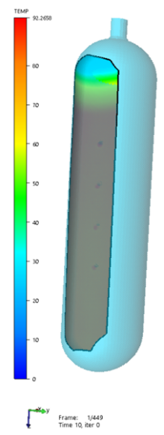
The influence of numerous work steps on the shape and strength of the final product poses a high demand on the entire simulation workflow of the Dr. Reinold Hagen Stiftung. Blow moulded parts undergo significant shrinkage during their solidification process, resulting in residual stresses and deformations. The ability of simulations to reliably reflect the real-world behaviour often remains unclear. To make a well-founded evaluation of the results, a comparison with measurements from real components is required. Therefore, the validation of the simulation workflow through measurement data plays an important role in validation and optimization.
Figure 3: Visualizing results from simulation and measurement using VMAP files.
In order to test how measurement data can be integrated in the VMAP standard an experiment is being conducted to measure the cooling behaviour of a blow moulded part. The measurement object is a plastic pipe made from high-density polyethylene (HDPE), that is heated up to 100°C. After the temperature is reached, the heating chamber is removed, and the component cools back down to room temperature. During this process, the pipe is measured by an optical measuring system, that uses digital image correlation to create a three-dimensional representation of the body. The measurement results are the transient temperature and deformation of the pipe surface. The values are available as a point cloud meshed with triangle elements.
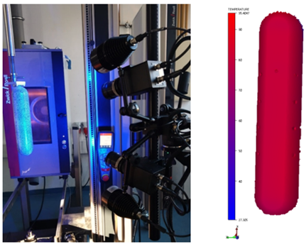
The real data from the optical measurement is supplemented by a fictitious measuring system. This involves two resistive temperature sensors that are located inside the pipe and measure the internal air during the cooling process. Thus, the measurement data set of the blow moulding use case includes measurement data on the surface and on the inside of the plastic pipe.
Figure 4: Setup of the optical measurement.
There is also metadata that needs to be stored due to the influence on the measurement process and to help interpret the results. Metadata is assigned to one of five groups and can therefore describe ambient conditions, the components and the setup of the measuring system, the measured object and post-processing of the measurement result in more detail.
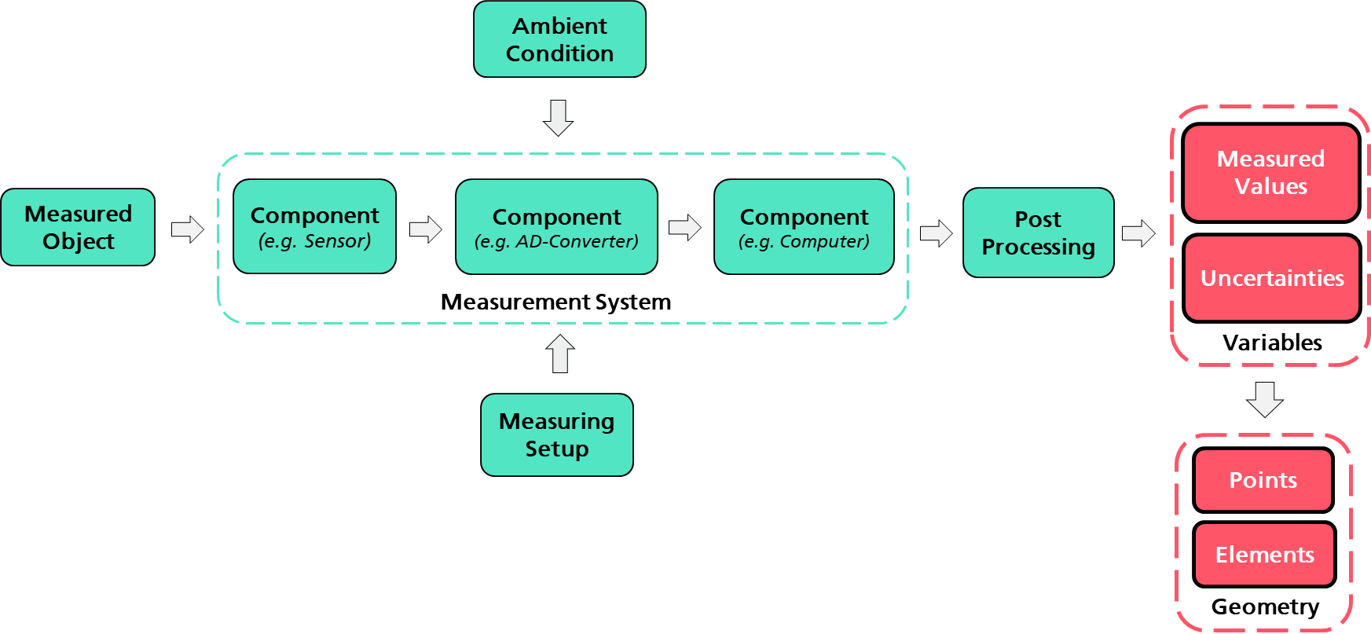
Ambient parameters from the blow moulding use case are the room temperature and the humidity at the begin of the measurement. Components from the optical measuring system include two cameras required for the stereoscopic measurement and a thermal imaging camera. The measuring setup refers to the calibration of the optical measuring system and thus to the distances and angles of the stereoscopic cameras. The measured object is the plastic pipe. For the optical measurement, the temperature results are subsequently corrected with the emissivity of the pipe. This information is assigned to post-processing as it describes an activity that has been carried out to adjust the signal after it has exited the previously described optical measuring system.
Figure 5: General measuring process with metadata (green) and results (red).
  - VMAP Storage Structure Extension
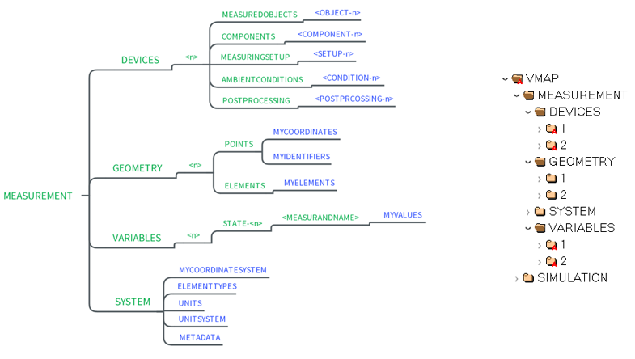
All the above data needs to be transferred to the VMAP structure, in which measurement data is saved according to the associated measuring system. Each measuring system gets a reference index <n>. For the blow moulding use case, index 1 refers to the thermocouple measurement system and index 2 to the optical measuring system.
Figure 6: General VMAP measurement structure and structure of the blow moulding use case.

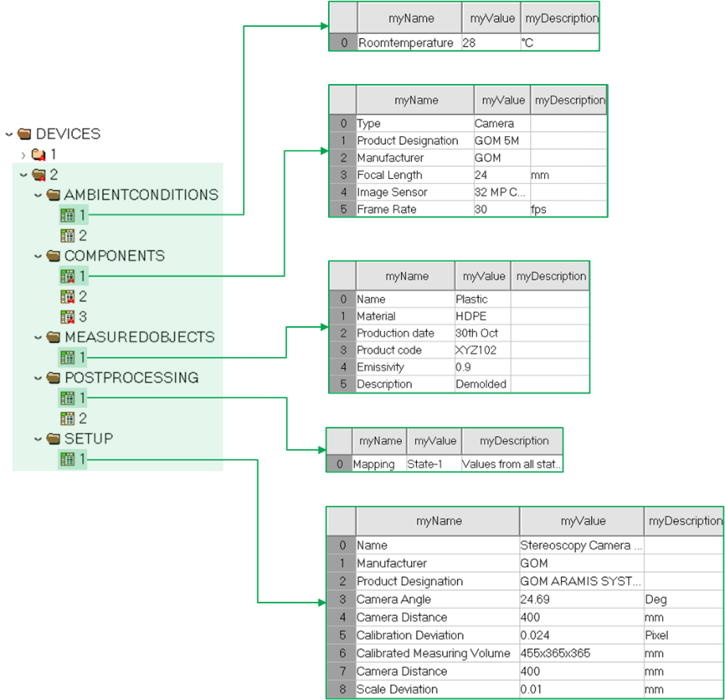
Figure 7 illustrates how metadata from the optical measurement is stored within the DEVICE group. For each subgroup a representative dataset is shown, that consist of several entries with a name, a value and a description.
Figure 7: Example of how metadata from the optical measuring system is stored in VMAP.
Since the measurement results comes in two different types, which is a measurement curve for the thermocouple system and a three-dimensional measurement with an associated mesh for the camera system they are stored differently in VMAP. However, both results consist of measuring points that are stored inside the GEOMETRY group and measured values stored inside the VARIABLES group.
Group 1 contains the variables from the thermocouple measuring system. The values are assigned to two measuring points, that refer to the sensor positions. An example data set can be seen, which contains the displacement at both measuring points. It is zero in all directions, since no movement of the sensors is assumed. A respective data set exists for both variables, temperature and displacement. It can be seen that the data sets are aligned in a table format and contain the measured values next to the time steps.
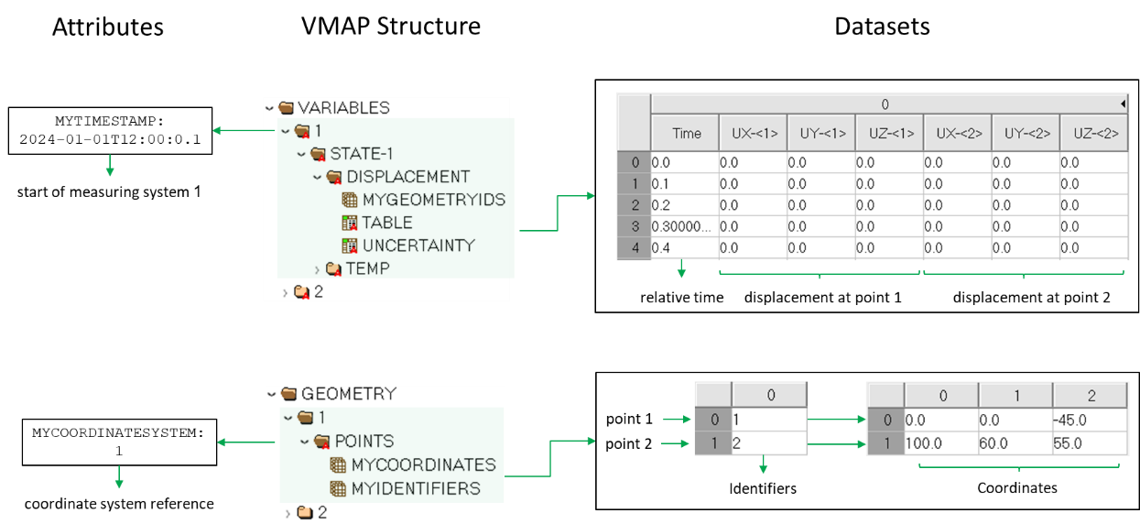
Figure 8: VMAP structure of the thermocouple system
Group 2 contains variables of the surface of the pipe. In this case, the displayed data set refers to the displacement of all points from the mesh at a single measuring time. Therefore, multiple datasets are needed to store the whole data, which is transient. For both measurement systems the time is referred to the absolute timestamp set in their respective group.
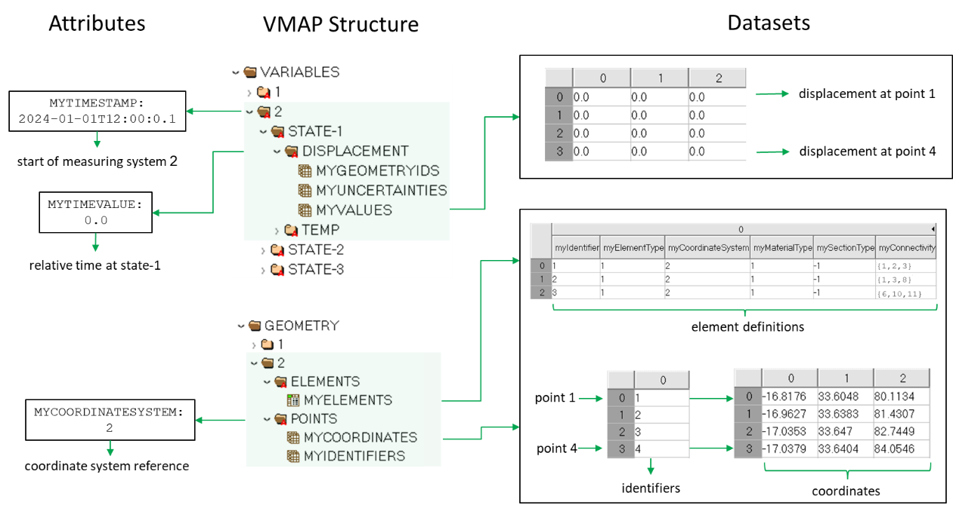
Figure 9: VMAP structure of optical measuring system.

Use case 4 is a (self-funded) use case lead by Fraunhofer SCAI based on a long-term collaboration with Dr. Reinold Hagen Stiftung.
https://kunststoffverpackungen.de/marktdaten, Access: 21.10.2022
D. Spancken; Zwischenbericht Promotion: Der Einsatz von Rezyklaten zur nachhaltigen Ausle-gung zyklisch belasteter Struktur-bauteile aus Polypropylen, Vom Promotionszentrum für Nachhaltigkeitswissenschaften an der Graduiertenschule Darmstadt, 2022.
Letellier, P., Modelling & Simulation, ITEA Magazine (35) 2020, available at https://itea4.org/project/vmap.html
Norris, M., How to - Get Started With Simulation Data Management. NAFEMS, 2020.
ISO 10303-209:2014. Industrial automation systems and integration - Product data representation and exchange - Multidisciplinary analysis and design. Standard, 2014.

