

This document will be treated as strictly confidential. It will only be public to those who have signed the ITEA Declaration of Non-Disclosure.

SMART Mobility

DELIVERABLE

D5.0 – State-Of-The-Art

•••••••••••••••••••••••••••••••••••••••••

Project number: ITEA 18036

Document version no.: V1.2

Edited: 02-06-2021

Owner: Egor Bondarev (TU/e)

**HISTORY**

|  |  |  |
| --- | --- | --- |
| Document version # | Date | Remarks |
| V0.1 | 02-02-2021 | Draft version, contributions by partners |
| V0.2 | 12-03-2021 | Esri Canada input added |
| V1.0 | 19-03-2021 | Integrating the storyline |
| V1.1 | 22-03-2021 | Integrating review remarks |
| V1.2 | 02-06-2021 | Sensitive chapters are removed for public access |
|  |  |  |
|  |  |  |
|  |  |  |

Contents

1 Introduction 4

2 State of the Art Analysis 5

2.1 SOTA in Traffic Management Systems 5

2.1.1 Traffic measurements 5

2.1.2 Traffic management 8

2.2 SOTA in GIS Transportation (GIS-T) Systems 11

2.2.1 Introduction to GIS-T 11

2.2.2 GIS overview 11

2.2.3 From GIS to GIS-T 12

2.2.4 GIS-T technologies explored for SMART 12

2.2.5 Advantages of Transportation GeoXchange (TGX) for SMART initiative 13

2.2.6 Stakeholder KPIs 14

2.2.7 System KPIs 14

2.3 SOTA in Advanced Traffic Analysis 15

2.3.1 Vehicle Re-Identification 15

2.3.2 Vehicle Detection and Classification 17

2.3.3 Anomaly Detection 18

3 Markets and Competitor Analysis 20

4 Alternative Business Models based on Open Data 21

Figures

Figure 1. Induction loops 6

Figure 2. Piezoelectric road sensor 6

Figure 3. Ultrasonic road sensors 8

Figure 4. Talking Traffic architecture (simplified) 9

Figure 5. Roadmap of SMART traffic-control system development over time. 10

# Introduction

The purpose of this document is to present the analysis of the following important aspects that define the project context and steer management decisions during the project execution: (a) State of the Art of industrial and research applications in the domain of SMART, (b) Analysis of competitors working or planning to work in the SMART R&D directions, (c) Analysis of current and future possible business models based on open data paradigm.

The structure of the document reflects these three important aspects. Chapter 2 presents the current SotA in the three complementary domains of the SMART project: Traffic Management Systems, GIS Transportation Systems and Advanced Traffic Analysis. Chapter 3 provides the analysis of the competitors in the domains targeted by the project. Chapter 4 shows our insights on the possible open-data business models.

# State of the Art Analysis

This chapter provide SotA analysis on the three complementary domains of the SMART project Traffic Management Systems, GIS Transportation Systems and Advanced Traffic Analysis (each domain analysis in a separate section). The former two domains are considered from an industrial perspective, since their technologies are quite mature and the levels (TRL) are in the range of 6-9. The latter domain is considered from a research perspective, since the domain technologies are in the prototyping phases with TRL range of 3-6.

## SOTA in Traffic Management Systems

Within the Traffic Management Systems (TMS) market we can distinguish several technologies that collect data through different methods. Each traffic measurement system has its own limitations and individual capabilities. Their successful application largely depends on the selection of the proper device for each situation; type of data required, data accuracy, ease of installation, cost, reliability, *etc*.

### Traffic measurements

* **Road sensors (intrusive)**. Data are obtained by means of sensors located on top of or in the road. It requires road intervention and provides only positional information. Different available technologies are:

1. **Inductive loops** (Figure 1) are squares of insulated wire embedded in the pavement. They work as a metal detector, measuring the change in the field when vehicles pass over them. They are very accurate counting cars and bicycles, although no pedestrians, and very expensive. Other disadvantages are related to maintenance as they can easily be damaged by road maintenance activities or penetration of water. Finally, they are not suitable for mounting on metallic surroundings (bridges, decks, *etc*.).
2. **Air-impulse tube detectors** send a burst of air pressure when a vehicle tire pass. The pulse of air pressure closes an air switch, producing an electrical signal that is transmitted to a counter or analysis software. They are a cheap solution commonly used for short-term traffic counting, vehicle classification by axle count and spacing. However, tube installations are not durable (lifetime < one month), unable to detect pedestrians and have difficulty detecting individual vehicles in large groups of traffic following each other very closely.
3. **Piezoelectric sensors** (Figure 2)collect data by converting mechanical energy into electrical energy, being very efficient to detect and count vehicles, but also high-priced. Typically, they are mounted in a groove cut into road's surface. When a car drives over the piezoelectric sensor, it squeezes it and causes an electric potential. Data may be collected locally via an Ethernet or RS232 connection or may be transmitted by modem. These sensors must be replaced at least once every 3 year, and in case the road is covered for example with snow, it does not work.
4. **Traffic Light cross-over buttons:** counting and monitoring traffic participants through traffic light signals. They can gather information about pedestrians and bicycles, but only when the cross-over button has been pressed. Likewise, no positional information on the crossroads or amount of traffic is provided.

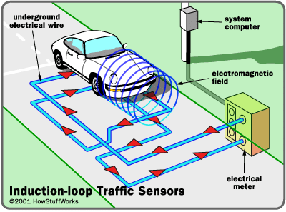

Figure 1. Induction loops

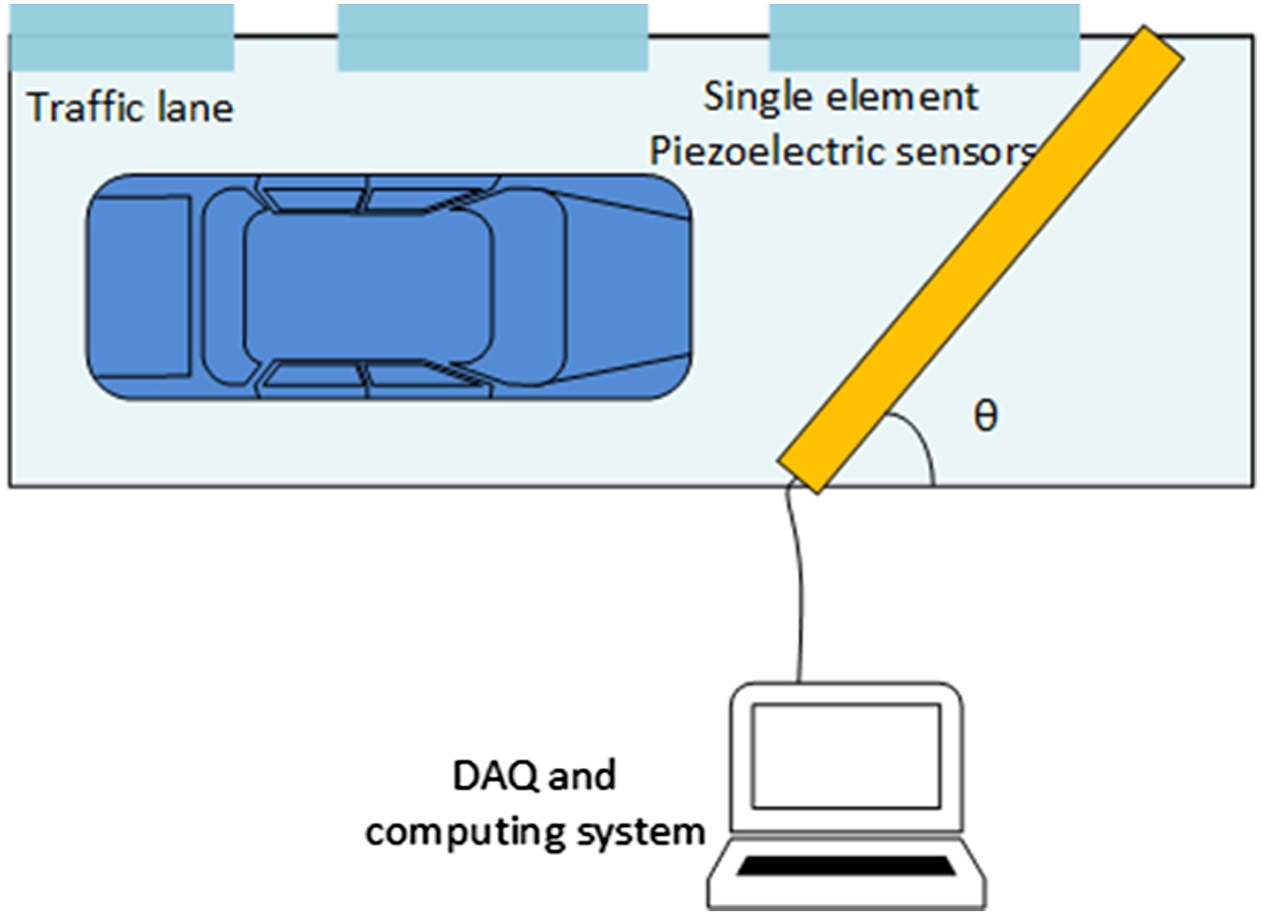

Figure 2. Piezoelectric road sensor

* **Non-intrusive sensors.** Data is obtained by the sensors that do not require integration into the road or existing poles infrastructure. These sensors can be positioned in any location near the road and use non-intrusive electro/optical/acoustic signals to detect vehicles and their positions.
  1. **Bluetooth-Wi-Fi-counters.** They count vehicles, pedestrians and bicycles based on BT/Wi-Fi signals. They offer a modest accuracy due to inevitable interferences and whether traffic participants send out signals. Equally, the recognition of objects is rather inaccurate and positional accuracy is limited by the sensor density.
  2. **Radars** are expensive but accurate systems, capable of detecting distant objects and determining their position and velocity. They direct high frequency radio waves at the roadway to determine the time delay of the return signal, thereby calculating the distance to the detected vehicle. They only detect (without accurate classification) motorised traffic and bicycles (not pedestrians).If the objects density is high the radar cannot distinguish each individual participant.
  3. **Ultrasonic sensors** (Figure 3)are installed on the side or on top of a road, and detect vehicles/pedestrians by receiving back the emitted ultrasonic waves (40 to 70 kHz). The time shift between the emitter and receiver provides the distance to an obstacle. Such sensors are able to work at night and in bad weather conditions. The disadvantage of this sensor type is that it only provides an abstract information (obstacle passed in the distance of X meters) and is not able to give data on vehicle type, speed and orientation. Another limitation is their low distance range (up to 20 meters).
  4. **Infrared sensors** are similar to ultrasonic, but emit and receive infrared light pulses (range from 300 GHz to 400 THz) and, by this, measure the distance to the obstacle. They also have similar pros and cons to the ultrasonic sensors.
  5. **LIDARs** are stillexpensive nowadays, therefore they are not widely used in vehicle detection (only at the road gates). The definitive advantages of LIDARs are their accuracy and long range up to 300 meters. These sensors can be classified in two types: single-beam and multiple-beam (including the nutation) lidars. The single beam lidars are cheap but do not provide any data on vehicle type, speed and orientation. The multiple beam lidars provide comprehensive 3D data on vehicles, their shape, orientation and speed. However, these are expensive not only from the hardware, but also from the algorithmic point of view.
  6. **In-car devices**

It is also possible to detect vehicles by obtaining signals directly from the devices located inside the cars. The options are the mobile localization messages (the principle that Google uses for the traffic jam visualization on its Google Maps service) or special 4G/5G devices integrated into the car management system. This data is currently coarse and does not allow accurate localization and detection of vehicle speed and orientation.

* 1. **CCTV Cameras.** They provide the most detailed and realistic data, since they offer real-time information from all traffic participants. Camera solutions are cost-effective, being able to count in many directions at once (only one camera may cover several lanes or exits). Their parameters (even recording areas) are easy to modify from a remote PC. However, they only **provide raw information** which **must be properly processed** to achieve useful data and statistics. This latter step is strongly reliant on the used method.

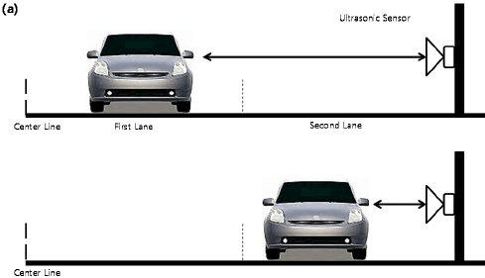

Figure 3. Ultrasonic road sensors

### Traffic management

The collected data from the abovementioned sensor alternatives provides valuable source for optimal traffic management.

At present, European Union defines and promotes the major traffic management program Cooperative Intelligent Transportation Systems (C-ITS). The Day-1 use cases of the program are: traffic light optimization, traffic signal priority and Green Light Optimal Speed Advice (GLOSA). Within this program, a Dutch innovative partnership ‘Talking Traffic’ (Figure 4) was introduced (the SMART project partners are also part of this partnership).

These C-ITS use cases define the new value chains for traffic light control.

* Service providers of in-vehicle applications are now able to inform their customers about the actual and predicted signal states (time-to-green, time-to-red) and translate this into a Green Light Optimized Speed Advisory (GLOSA), creating extra value for their services;
* Logistic companies, public transportation and other modalities are able to get a higher priority at signalized intersections, reducing delays and fuel consumption;
* Better optimized traffic lights for traffic flows have a positive impact on the liveability in urban areas. The traffic throughput can be increased, while at the same time emissions (CO2, NOx, etc) are reduced.

The developed ecosystem of Talking Traffic consists of multiple layers: Traffic Light Controller (TLC) Facilities, ITS Applications, Cloud Services and Information Services. This ecosystems makes use of the latest international ETSI standards (CAM, SRM, SSM, SPaT, MAP, TLC-FI and RIS-FI) for sharing information between the different systems and services. These ETSI standards are globally recognized, making cross-border cooperation between systems and vehicles possible (very relevant for international transport!). The way in which these standards are incorporated in the Talking Traffic architecture, the Dutch Profile, is adopted by C-Roads. C-Roads is an international organization of road authorities representing the most European countries, both also Israel and Australia. This means that the developed architecture, products and services can be implemented with minimal effort in these countries.

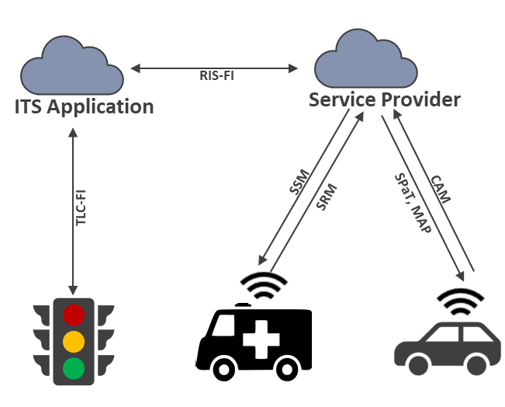

Figure 4. Talking Traffic architecture (simplified)

In the developed ecosystem of Talking Traffic, the ITS Application is the service responsible for scheduling green phases for the controlled intersection. Both traditional data (loop detectors) and information from connected vehicles are used as input to schedule green phases in advance, allowing them to be broadcasted to arriving vehicles for the GLOSA use case. The penetration rate of connected vehicles receiving the scheduled green phases (Signal Phase and Timing), called SPaT-message is currently between 5 and 10% in the Netherlands.

**Analysis of the GLOSA SotA quality**

There is a trade-off between the quality of the offered services for the three use cases (traffic light optimization, traffic signal priority and GLOSA) and the required amount of data. The higher the penetration rate of connected vehicles is, the better the three use cases can be executed.

Currently the quality of the GLOSA service is low. For maintaining an acceptable level of traffic control, in the Netherland the ITS Applications make last second changes to the scheduled green phases based on the occupancy of loop detectors. These last second changes result in (heavily) fluctuating green phase timings broadcasted to arriving vehicles (through SPaT message), making it impossible to calculate an optimal speed for arriving vehicles. As long as the reliability of the SPaT is low, the amount of service providers (or their customers) entering the eco-system remains low. This results in a ‘chicken-egg’ problem, where an increase in the number of connected vehicles results in a more reliable SPaT while, at the same time, no more vehicles become connected when the reliability of the SPaT is low.

Besides the Talking Traffic eco-system, within Europe there is a lot of data from connected cars collected. The in-car systems can be divided into connected systems provided by the OEM manufacturers (primarily provided by HERE and TomTom) and data collected from smartphone (navigation) apps (most popular are Waze, Google Maps, TomTom). A concern with this data is the privacy sensitivity. Due to the fact that trips are collected from origin to destination this creates privacy risks. The way these organizations deal with this risk is by aggregating raw data (GPS points) into stretch speeds and travel times. This means that highly valuable data is aggregated in such a way that the use-case to optimize traffic lights becomes impossible. Another issue with this data is the latency. In order to reduce the cost of data consumption as well as the battery drain of a consumer’s smartphone there is no real-time connection between the car and the datacenter. Data is transmitted every 10 to 120 seconds, making the data useless for real-time predictive systems for traffic light optimization.

The penetrations of these connected vehicles via in-car or smartphone systems is between 20% and 50%. The penetration differs per road category, the penetration is higher on highways and much lower in inner-city roads. This makes sense as not many people use navigation and traffic information to drive a short route to e.g. the grocery store. Please note that this only applies to vehicles, for pedestrians and cyclists there is limited to no data available.

Within the SMART project, we are planning to solve the low quality/density of GLOSA vehicle/pedestrian models by integrating it with an advanced vehicle/pedestrian detection and tracking system. This system receives data from cameras mounted on key road point and intersections, detects and tracks the traffic actor with high accuracy and provides the full vehicle/pedestrian density model for the traffic light management system at each intersection.

**ITS Roadmap**

The roadmap of Figure 5 depicts the development of traffic-control systems, where the outcomes of the SMART project become visible in the year 2022. At present, the induction-loop based measurements are the majority, which hardly allow intelligent traffic control. Some novel control systems like Talking Traffic of project partner Sweco appear this year, after which the SMART project results will take over in the market. The future vision after 2025 promises full situational awareness with networked, surroundings-aware vehicles, delivering very low or none CO2 exhaustion.

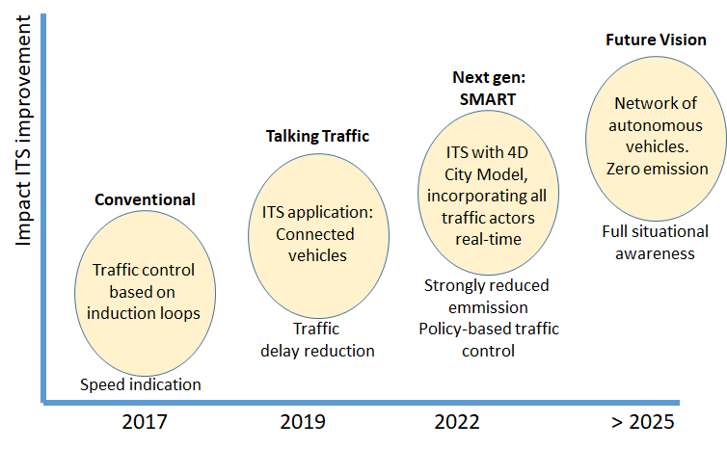

Figure 5. Roadmap of SMART traffic-control system development over time.

## SOTA in GIS Transportation (GIS-T) Systems

### Introduction to GIS-T

Since the early 1990s, GIS-T technologies have been related to the implementation of an intelligent vehicle and highway system (IVHS, which is now expanded into ITS). The Federal Highway Administration (FHWA), and then IVHS America (now ITS America), identified five functional areas for IVHS: advanced traffic management systems (ATMS), advanced traveler information systems (ATIS), commercial vehicle operations (CVO), advanced vehicle control systems (AVCS), and advanced public transportation systems (APTS).

Primarily, GIS-T supports ITS by proving necessary spatial/aspatial database management functions. Since ITS cannot be established without accurate geographic referencing subsystems provided by GIS, GIS-T technologies will be an essential part of ITS implementation. In addition, GIS-T will be used as the system integrator for the various technologies required for implementation, such as GNSS technology and graphic displays. As ITS continuously evolves, future GIS-T should be amenable to accommodate new developments in ITS.

### GIS overview

At present, we can highlight 5 top GIS systems that have a high potential to integrate transportation domain in their profile.

1. Esri ArcGIS

ArcGIS is a GIS mapping software that provides mapping and analytics platform for geographic data. ArcGIS extends some of the unique potentiality along with pliable licensing for applying location-based analytics to any business practices including high-security applications. It provides an insight to visualize and analyze the data and share the data in the form of maps, dashboards, reports, etc. ArcGIS technology provides both broad access to public basemaps, but also enables organizations to utilize their own, custom and private datasets without risking public exposure. Both public and private datasets can be used collaboratively for any use case. ArcGIS can be used as an enterprise or standalone application and combined with other as well to support location mapping. It’s helpful in working with a set of analytical data and spatial algorithms. ArcGIS software is useful in location monitoring of any type of sensor or device and integrating the resulting data into a collaborative environment.

2. Mapbox

Mapbox GIS mapping software provides the map designing tools and mapping libraries needed to make dynamic, performant, and customized maps that suit the requirements. Maps generated by Mapbox tools are comprehensive and available all over the globe. The Maps APIs support more than 5 billion requests per day. MapBox makes use of OpenGL technologies for on-device rendering, resulting in highly performant maps with maximum flexibility, allowing dynamic styling and optimize the map based on your custom data.

3. Maptitude

Maptitude is one of the GIS mapping software which provides the tools, maps, and demographic data which are useful to visualize data by unearthing geographic patterns from the available data, and presenting the data in a more in an elementary way. The benefits of desktop mapping and spatial analysis with a single, easy-to-use package can be availed in Maptitude. Maptitude is one of the best mapping software available in the market with the richest feature set and highest performance to its credit. Some of it’s best and enhanced features include creating and editing maps, adding data to the maps, analyzing graphics data.

4. QGIS

QGIS is an open-source geographic information system software, which is free and user-friendly that facilitates professionals to create, edit, visualize, analyze and publish geospatial information on any OS such as Windows, Mac, Linux systems and supports vector, raster, and database formats and functionalities. QGIS is a product of the Open Source Geospatial Foundation (OSGeo). Publishing QGIS projects on the web are made easy with the benefit from the powerful symbology, labeling and blending features for a better understanding of maps.

5. TerraSync Software

TerraSync software is a GIS software designed for collection and maintenance of efficient field GIS data. TerraSync is a powerful system that facilitates the collection of high-quality features and position data for GIS updates and maintenance. Along with the above feature, it provides simple and efficient workflows to capture high-quality data quickly and easily, which includes intelligent features such as map-centric operation, graphical status display, and the ability to record a position offset very quickly and easily.

### From GIS to GIS-T

Our analysis revealed that, at present, the integration of ITS systems with GIS systems is extremely fragmented. Many GIS systems include only local ITS-related tasks in their portfolio. To our best knowledge, nowadays, there is no comprehensive GIS-T system available on the market.

The major attempt to bring GIS and ITS systems together is currently performed by Esri Canada by integrating their ArcGIS system with required transportation management components. These efforts are being performed within our SMART mobility project.

ArcGIS Online (cloud) and industry solution offerings, is already considered a State-of-the-Art geospatial provider, currently ranked as the number one industry leader by Forrester in 2020 (The Forrester Wave: Location Intelligence Platforms Q2, 2020). Well recognized for their popular ArcGIS Online offerings, support of geospatial research, global partner and support networks and educational initiatives, Esri Inc, and Esri Canada as Esri’s largest global distributor and services provider, represents the latest in enterprise-grade geospatial technology, solutions and development tools available today.

### GIS-T technologies explored for SMART

The objective of the ITEA SMART project is to develop a new foundational transportation data model, with 4D operational capabilities including spatial data storage, input and output connectors for static and streaming spatial sources, spatial data processing, visualization, analysis, and reporting. This overall system from Esri Canada will form the “Transportation GeoXchange” or “TGX”.

This system utilizes the following technologies and areas of interest:

* Cloud-native Geospatial capabilities for real-time data feeds, spatially enabled “big-data” temporal data storage, advanced geospatial analytics.
* Ingestion of IoT and “Smart” devices to integrate real-time data, monitor critical assets, and enable geospatial analysis, workflows and alerting capabilities.
* Integration with IoT platforms, message brokers and third-party APIs, as a vendor-agnostic approach to enabling various static (fixed) and dynamic (moving) sensors and data sources to accommodate existing and emerging device, transportation, Smart City and IoT capabilities.
* Aggregation of disparate datasets through location referencing.
* Geo-spatial methodologies, data, and feature-sets, not reliant on fixed or proprietary data models, promoting near-limitless opportunities for evolving spatial data models and analysis insights previously non-existent or underutilized.
* Real-time or near-real-time location analytics with “binning” and classification of data elements based on geographical location and features. This reduces the sheer volume of data points consumers must work with by focusing analyses within targeted geographical contexts.
* Exploring new emerging edge-computing and AI/ML opportunities with traditional and non-intrusive sensor and imagery tools and technologies.
* Encourage data ontology, data governance, and research opportunities to further critical discussions of data standards, policies, and protections.
* Enable research opportunities, related to new areas of transportation data and geospatial insight.

Esri envisions a highly scalable geospatial environment to aggregate, analyse and act on information from a broad range of edge-devices and transportation infrastructure data providers, at increasing volumes and frequency.

### Advantages of Transportation GeoXchange (TGX) for SMART initiative

Existing tools that attempt to do this on the market are often closed, proprietary “walled gardens”, inaccessible by data providers external to the organization that owns or manages the environment. They are often individual point solutions, with minimal integration with other solutions, and that address a very narrow band of the smart technology spectrum or lack the ability to offer authoritative data from an open platform.

Many solutions must be custom built with individual components and proprietary technologies not openly documented or part of or compliant with open standards and common practices. Esri, as the world’s leading Geospatial provider, with wide adoption, standards-compliance, award winning and industry-leading tools, techniques, training, services, and documentation, ensures municipalities are at the forefront of geospatial technology and analysis and are future-ready.

The ability to build on a mature, industry-leading platform with a vast and knowledgeable user-base, lowers the barrier to adoption, enhances acceptance of municipalities and their partners.

Esri Canada also supports customers in protecting their data assets and providing control over data governance, confidentiality, retention, and acceptable use.

**Esri Canada’s TGX Advantages include:**

* Capacity to establish new data opportunities and data discoveries, forming a new baseline of municipal transportation that is measured, recorded, and not collected or integrated before.
* Creation of an advanced temporal dataset for trending, analysis, providing new data insights not previously available to municipal transportation organizations.
* Ability to integrate and analyze across other geospatial and open datasets, such as mobility data in conjunction with weather, construction, planning, noise, air quality, transit usage, congestion fees, and other KPIs and future data insights that become normalized.
* Municipalities empowered, through advanced geospatially-contextualized data analysis, the ability to assess new efficiencies and business opportunities such as: traffic density, urban density impact on transit, urban cellular coverage areas and 5G rollout impact on transit and infrastructure, vehicle type classifications and lane usage, emergency service prioritization and response planning, cost of living and demographical insights, time/distance to essential goods, electric car range and charging station locations, fleet vehicles insights, road condition and roadway maintenance needs, etc.

### Stakeholder KPIs

ArcGIS Online, as a central element of the TGX platform, enables the ability to use the Operations and Performance Management solution that can be deployed to configure, manage and track KPIs (including some which are pre-configured) for assessing performance and trending outcomes over-time. The solution provides a set of capabilities including a series of dashboards to visualize performance for defined geographies with the ability to share information with the public through a community site.

As such, the TGX solution accommodates KPI tabulation, monitoring, assessment, and outcomes that are configurable, flexible and in-line with any Municipality’s goals to help guide and improve their current and future transportation goals and analysis outcomes.

### System KPIs

The TGX system will include performance standards and limitations as outlined by service SLAs and system specifications according to the following typical deployment limitations and are flexible, best-in-class solutions, supporting the most demanding use-cases, including exceptional examples such as the [Johns Hopkins COVID-19 Dashboard](https://gisanddata.maps.arcgis.com/apps/opsdashboard/index.html#/bda7594740fd40299423467b48e9ecf6), which has handled loads in excess of 4B requests per day.

By default, organizations use a **Standard Feature Data Store**, which meets the needs of most organizations performing common workflows. Advanced organizations can specify **Premium Feature Data** Store options to provide dedicated resources, such as memory, CPU, and input/output (I/O):

* **Standard Feature Data Stores** have a limit of **150 GB** using credits for storage
* **Premium Feature Data Stores** are available in several performance tiers: **M1** (improved), **M2** (high), **M3** (higher) with a limit of **1 TB** of storage, and **M4** (highest) with a limit of **4 TB**.

For the Infrastructure device and IoT solution, the environment will be expected to accommodate the following available tiers of performance:

* **Standard**: Up-to **5** items (feeds and analytics) at any time, Ingest and process real-time data at **25 KB/s**, up to **100GB** data storage.
* **Advanced**: Up-to **10** data feeds at any time, Ingest and process real-time data at **250 KB/s,** up to **1TB** data storage**.**
* **Dedicated**; **20** or more feeds, Ingest and process data at **2,500 KB/s** and up with up to **3TB** storage; more with optional add-ons.

As the system will be architected to be capable to be tailored based on need, and the use of user role management and data storage credits, this provides a state-of-the-art and industry leading solution, built on a best-in-class geospatial, IoT, and location analytics platform.

## SOTA in Advanced Traffic Analysis

Currently, there are three hot topics in the advanced video-based traffic analysis domain: traffic anomaly detection, tracking of critical vehicles and re-identification of vehicles over their moving trajectories. All three topics are considered as missing cornerstones for the full-fledged traffic monitoring and management systems. At present, these topics are in the research phase with TRL range of 3-6. Once the anomaly detection, critical vehicles tracking and re-identification of vehicles becomes mature, video-based ITSs will be able to address most of the common use-cases and requirements that are nowadays required by the end-users. The following sections describe the research-level state of the art on these three technologies. Two best performing techniques are selected and presented for each topic.

### Vehicle Re-Identification

In industry, the only and main approach for the vehicle re-identification is based on the license plate recognition (LPR/ALPR) techniques. LPR cameras are located in several spots on a road (in a city) and they are constantly capturing and detecting the license plate numbers of cars passing by. The LP data is accumulated in a single database, from which the trajectory of a specific vehicle can be obtained.

Unfortunately, the ALPR cameras are very expensive (>10 times more than normal CCTV cameras), therefore the usage is limited, since they cannot be installed on every intersection. Therefore, it is not practical to use ALPR cameras for most of the ITS use-cases and scenrarios. Another drawback of ANPR is that it is not GDPR-proof and foreign license plates cannot be used for classification, but only for Re-ID and detection.

In literature, person Re-ID and vehicle Re-ID topics are very similar. Unlike person Re-ID, vehicle Re-ID requires more discriminative trained recognition ability. Re-ID plays an important role in intelligent transportation systems and public safety. Nowadays, deep learning techniques like CNN have become a mainstream in computer vision area for challenging vehicle Re-ID problems.

**In [1],** two branch Partition and Reunion Network (PRN) is proposed for the vehicle Re-ID task.

In PRN method, ResNet-50 is used as a backbone network and convolutional layers are duplicated to 2 branches, which are called as Height-Channel Branch and Width-Channel Branch, in order to increase independence of learned special features. 2 feature maps are generated from these branches and they are fed into the global max pooling and fully connected layers. The main reason for applying heigh-wise and width-wise partitions in the model for vehicle-ID is that car body could be divided into wind-shield, header panel a, wheels on the vertical axis and hood, doors, trunk etc. on the horizontal axis. In addition to softmax loss function, triplet loss function is used as a loss function to increase the performance.

In this research, mean Average Precision (mAP) and Top-1 and Top-5 accuracy of cumulative match curve (CMC) are mainly used for performance evaluation. PRN model results are compared on the 4 datasets, i.e., Veri-776, VehicleID, VRIC and CityFlow-ReID and the results are impressive.

**In the research [2],** another new method is proposed to improve the Multi-task learning (MTL), which is a machine learning strategy learning several related tasks. In this idea, the potential of MTL in combining multiple diversities (e.g. scale and color) of the vehicle image and being supervised by multiple kinds of manual labels(e.g. ID and orientation). Each of these tasks are associated with an individual branch of a single model and at the end consensus learning is conducted through feature fusion.

In detail, the branches of the model are as follows:

1) Identity classification, which is the root branch of the model

2) Identity classification from a scaled image to exploit multi-scale analysis

3) Identity from grayscale image to encourage the model to focus on details of the vehicles to separate similar identity classes without color information

4) Identity plus the vehicles’ orientations to simultaneously predict the identity class and the orientation class

These individual branches then form a consensus learning on the identity of the training examples via feature fusion of the final convolutional feature maps. ResNet-50 is used as a backbone network architecture in this model.

In this research, mAP and Rank-1 and Rank -5 accuracy of CMC are used for performance evaluation. This model results are compared on the 2 datasets, i.e., Veri-776 and CityFlow-ReID.

References:

*[1] Hao Chen, Benoit Lagadec, Francois Bremond. Partition and Reunion: A Two-Branch Neural Network for Vehicle Re-identification. CVPR Workshops 2019, Jun 2019, Long Beach, United States.*

*[2] Ayta Kanaci, Minxian Li, Shaogang Gong, and Georgia Rajamanoharan. Multi-task mutual learning for vehicle reidentification. In CVPR Workshops, 2019.*

### Vehicle Detection and Classification

One of the traditional method for vehicle detection and classification problem is mixture of Gaussian (MoG) + support vector machine(SVM) model. However, recently deep learning has become popular and outperforms the traditional methods.

**In the work [1],** MoG+SVM is compared to the one of the popular deep learning technique Faster Region Convolutional Neural Network (RCNN). This research shows Faster RCNN outperforms MoG in detection of vehicles especially which are static, overlapping or in night time conditions. It also outperforms SVM for classification of vehicle types.

2 different datasets of traffic videos are used in this research experiments, which are The Indonesian Toll Road dataset and MIT traffic dataset.

The Faster RCNN model works on the frames of the videos, and detects the bounding boxes and classes of any vehicles that may be present within said image frame. The Faster RCNN model can do both vehicle detection and classification of the vehicle types in one single model.

Five-fold cross validation accuracy is used as an evaluation technique compared in the classification accuracy results.

**In another research [2],** the convolutional neural network technique model based on You Look Only Once (YOLOv3) is used. Vehicle detection methods focusing on RCNN methods are popular trend now; however, the speed of detection algorithms has become critical especially in real time systems.

This work shows the YOLOV3 is one of the fastest computer detection algorithms for objects in an image with weighted probability. The real-time object is determined with YOLOv3 which uses DarkNet53 as a backbone model. The research has done on the vehicle classification and localization using real traffic surveillance MIOvision traffic dataset for the classification of 11 categories of vehicles such as bicycle, bus, car, motorcycle and so on.

Comparatively, accuracy of Fast RCNN is 71.6% and that of YOLO is 65.5% in the detection of objects in the frame. YOLOV3 processes streaming video in real-time with less than 25 milliseconds of latency.

It makes predictions with only one network compared to RCNN which needs thousands for only a single frame image. This evaluation makes it extremely faster comparatively i.e. 1000 times of RCNN as well as 100 times of Fast RCNN.

References:

*[1] A. Arinaldi, J.A. Pradana, A.A. Gurusinga, Detection and classification of vehicles for traffic video analytics. Procedia Comput. Sci. 144, 259–268 (2018).*

*[2] A. Shekade, R. Mahale, R. Shetage, A. Singh and P. Gadakh, "Vehicle Classification in Traffic Surveillance System using YOLOv3 Model," 2020 International Conference on Electronics and Sustainable Communication Systems (ICESC), Coimbatore, India, 2020, pp. 1015-1019, doi: 10.1109/ICESC48915.2020.9155702.*

### Anomaly Detection

Nowadays, the need for detecting anomalous vehicles in traffic surveillance videos is growing rapidly for intelligent transportation systems. The biggest challenge in this task is the lack of labelled datasets for training supervised models.

**Based on the research [1],** an unsupervised anomaly detection method for traffic surveillance is proposed based on the background modelling. It shows great potentials in handling heterogeneous scenes as well as extremely low resolution videos recordings without the dependence on labelled data.

Their traffic anomaly detection system includes three parts. The first module extracts the background images of every frame using mixture of gaussian (MOG2). The second module,which is the detection module, is made up of the Fast RCNN detector and the VGGNet classifier. The reason for applying VGGNet is to reduce the false positive detection rate coming with multi-scale detection. At the last step, detected boundary boxes are delivered to the decision module to make the final decision. To compare the similarity between detected vehicles, ResNet architecture is trained with triplet loss.

* UA-DETRAC dataset is used for detection and pretrained Fast RCNN model is fine tuned.
* ImageNet, UIUC Car Detection, GTI and Cars datasets are used for classification and VGGNet model is trained.
* ViRe dataset is used for finding the similarities between vehicles and ResNet50 is trained with triplet loss.

This method can detect most of the anomalies in the NVIDIA AI CITY CHALLENGE track-2 dataset with a 81.08% F1-score and 10.2369 RMSE.

**In the work [2],** fast unsupervised anomaly detection system is proposed. It includes three modules: pre-processing module, candidate selection module and backtracking anomaly detection module.

The pre-processing module outputs stationary objects detected in a video. Preprocessing step is composed of background modelling, road segmentation and object detection. For object detection purpose You Only Look Once (YOLO) is used and it is capable of processing faster while providing the similar accuracy as compared to the other state-of-the-art models such as SSD and ResNet. Having considered the speed of anomaly detection in traffic videos is a critical factor, they preferred YOLOv3 in their implementation.

Then, the candidate selection module removes the misclassified stationary objects using a nearest neighbour approach and then uses K-means clustering to identify potential anomalous regions.

Finally, the backtracking anomaly detection algorithm computes a similarity statistic and decides on the onset time of the anomaly.

Experimental results on the Track 4 test set of the NVIDIA AI CITY 2020 challenge shows the proposed framework achieve 59.26% F1-score and 8.2386 RMSE.

References:

*[1] J. Wei, J. Zhao, Y. Zhao and Z. Zhao, "Unsupervised Anomaly Detection for Traffic Surveillance Based on Background Modeling," 2018 IEEE/CVF Conference on Computer Vision and Pattern Recognition Workshops (CVPRW), Salt Lake City, UT, USA, 2018, pp. 129-1297, doi: 10.1109/CVPRW.2018.00025.*

*[2]K. Doshi and Y. Yilmaz, "Fast Unsupervised Anomaly Detection in Traffic Videos," 2020 IEEE/CVF Conference on Computer Vision and Pattern Recognition Workshops (CVPRW), Seattle, WA, USA, 2020, pp. 2658-2664, doi: 10.1109/CVPRW50498.2020.00320.*

# Markets and Competitor Analysis

This section is not available for public access

# Alternative Business Models based on Open Data

This section is not available for public access