
POLDER PROJECT
Deliverable 4.1
DATA SOURCE AND INPUT FORMAT SPECIFICATIONS

Project Identifier | Polder
Project Title | POLicy Data Exploitation & Re-use
Document Version | 1.0
Planned Delivery Date | M18
Actual Delivery Date | M19
Document Title | d4.1 Data Source and Input Format Specifications
Work Package | WP4
Document Type | Word
Abstract | This document shows the format and sources of the data that is going to be used in the POLDER project. Including original extracted data and external.
Keywords | City monitoring, high-precision regional population prediction, Crowd and evacuation modelling, data acquisition, data fusion, data storage, data processing, web-based monitoring user interfaces and dashboards, big data analytics, machine-learning

Function | Name | Entity
Author | Ivan Romero & David Rodríguez | Starflow
Editors | Ivan Romero | Starflow
Editors | David Rodríguez | Starflow
Editors | René Serral | UPC
Editors | Serdar Sultanoğlu | Fortearge
Contributors | Ali Kafali | ACD
Contributors | Alejo Vázquez | Accuro
Contributors | Güven Köse | Mantis
Contributors | Cristina Balaceanu | BEIA
Contributors | Bilge Başdemir Yalçin | ARD GROUP
Contributors | Ülkü Esra Okuyan | ARD GROUP

Contents
Document Objectives 6
Document Structure 6
Executive Summary 6
Data Sources for Use Cases 7
Network Data Monitoring Use Case 7
Network Traffic Data Source (Starflow – Not Shareable) 7
Smart Cities Tourism Destinations Use Case 8
Input Data Sources 9
Nommon 9
Mobile Phone Traffic Data (Not Shareable) 9
Institutional tourism statistics 9
Other Tourism Data 9
Census Data 10
Land Use Data 10
Data Generated & Shared by 10
Nommon 10
Zones characterization 11
Visitors presence information 11
Visits information 12
Starflow 12
Tourism Network Traffic Data 12
Decision Support and Simulation System for Urban Plans Use Case 13
Sub-case 1: City Monitoring 13
Image processing module data source 14
Sub-case 2: Urban population prediction and effect analysis 16
Population / density by municipal areas. (For different years) 16
Urban Plans 16
OGC WFS Service from Antalya Konyaaltı Municipality 18
Sub-case 3: Waste management system modelling 20
Waste Containers 20
Waste Trucks 20
Navigation data of Waste Trucks 20
Waste Treatment Facility 21
Streets 21
Sub-case 4: Crowd and evacuation modelling 22
Waste Water Use Case 23
Social Media Monitoring Use Case 25
Air Quality Monitoring 28
BEIA 28
ACD 30
Energy Monitoring 34
Traffic Use Case 37
References 38
Conclusions 39

List of Tables
Table 1: Data input format for network traffic 9
Table 2: Data format waste water use case 25
Table 3: Parameters waste water use case 25
Table 4: Description phases waste water use case 26
Table 5: Data format air quality monitoring use case 30
Table 6: Device configuration and monitored parameters 31
Table 7: The degree of exposure from UE-28 32
Table 8: Sensor variables information 34
Table 9: Energy use case sensor variabales and information 37

List of Figures
Figure 1: Starflow's data management architecture. 7
Figure 2: Starflow’s data extraction and management schema 8
Figure 3: Nommon's data generation and sharing schema 10
Figure 4: Puerta del sol image 14
Figure 5: Proposed architecture for the recognition and interpretation of situations through image recognition 15
Figure 6: UML Overview of the Planned Land Use application schema 17
Figure 7: Sample view from an Urban Plan 18
Figure 8: OGC WFS Data for Plan Functions 19
Figure 9: Konyaaltı Plan Function Data Thematic Map in QGIS 20
Figure 10: Sample UML of Wastewater 25
Figure 11: Sample UML of Air Pollution 33
Figure 12: Sample UML of Energy 36

List of Abbreviations

Abbreviation | Full Name
AI | Artificial Intelligence
API | Application Programming Interface
BTS | Base Transceiver Station
CDR | Call Detail Record
CSV | Comma Separed Values
ETL | Extract, Transform and Load
HTML | HyperText Markup Language
INE | Instituto Nacional de Estadística
IoT | Internet of Things
IP | Internet Protocol
KML | Keyhole Markup Lenguage
KPI | Key Performance Indicator
ML | Machine Learning
MNO | Mobile Network Operator
NDA | Non Disclosure Agreement
OGC | Open Geospatial Consortium
PoP | Point of Presence
SHP | Shapefile
SQL | Structured Query Language
WFS | Web Feature Service
WHO | World Health Organization
W3C | World Wide Web Consortium

Executive Summary
The goal of “WP4 Citizen and Data Inputs” led by STARFLOW - Spain is the selection,
specification and provisioning of the different data channels as input of the other Work Packages
to enable the overall project goal of data-driven policy making.

This deliverable reflects the activities performed up to June 2020 and is expected to be updated
on December 2020. Nonetheless as POLDER is still closing an agreement with the Smart Cities
which is key to guarantee WP4 information is validated in field trials with potential final users.
WP4 works in parallel with “WP3 Uses Cases” and “WP5 Modelling”.

“WP3 Uses Cases” provides the scenarios or use cases where the POLDER solution will be
tested. The scenarios and use cases will define the preliminary models and detailed definition of
the use cases scenarios, as well as the data and requirements to perform the project tasks. This
information will be updated once we have an agreement with a Smart City base on the data
available and requirements accepted by the Smart City allowing POLDER to be able to gather
from the Smart Cities and how and where we can process the collected data.

“WP5 Modelling” works on the combination of the data provided by WP4 based on the
requirements on WP3 to explore how the different data sources available for the project can be
combined to feed both descriptive and predictive data models to be deployed in “WP6 Platform”

Deliverable D.4.1 Data Source and Input Format Specifications include the results of “Task 4.1
Data Acquisition” led by ACD-Turkey and the following subtasks:

“Task T4.1.1 Data Acquisition” where the task adapters are being designed in order to get the
sensors and control systems data feeding the tasks shown in “WP5 Modelling”, that will, eventually, feed the platform.

“Task T4.1.3 Adapters for Data Fusion” where raw data is transform into useable information
feeding “D4.5 Data Fusion Specifications”.

Document Objectives
This document aims to show the data sources that are going to be used for the development of the project, either from data collection or by re-using external data sources. Furthermore, is going to specify the format followed by the data that is going to be shared with the rest of the partners.

Document Structure
The document starts with “Network Data Monitoring” use case, followed by “Smart Cities Tourism” use case. This last bullet differenciates between which is the information (input data source) that is going to be used from external sources and which information is coming from an internal data processing module that takes profit of this input data sources.
After this, it shows the “Decision Support and Simulation System for Urban Plans” use case, which is divided in 4 sub-cases: “City Monitoring”, “Urban Population Predition and Effect Analysis”, “Waste Management System Modelling” and “Crowd and Evacuation Modelling”.
Finally, there are three more 5 more use cases exposed: “Waste Water”, “Socual Media Monitoring”, “Air Quality Modelling”, “Energy Monitoring” and “Traffic”.

Data Sources for Use Cases

Network Data Monitoring Use Case
Starflow, inside POLDER project, aims to analyze the network traffic data (collected by data collectors located inside spanish populations) using AI techniques such as ML. Finding behaviour patterns using the user’s traffic data is the main objective. Aspects such as determining whether the available network infrastructure satisfies the traffic demand, coming from users and other IoT devices.

Network Traffic Data Source (Starflow – Not Shareable)
The proposed data source for extracting data information generated by the users of the smart city network comes from the data collectors.
That data will be stored in a dataset where processes of data analysis and enrichment will take place. After that, through the use of an API, the data will go into the POLDER platform.
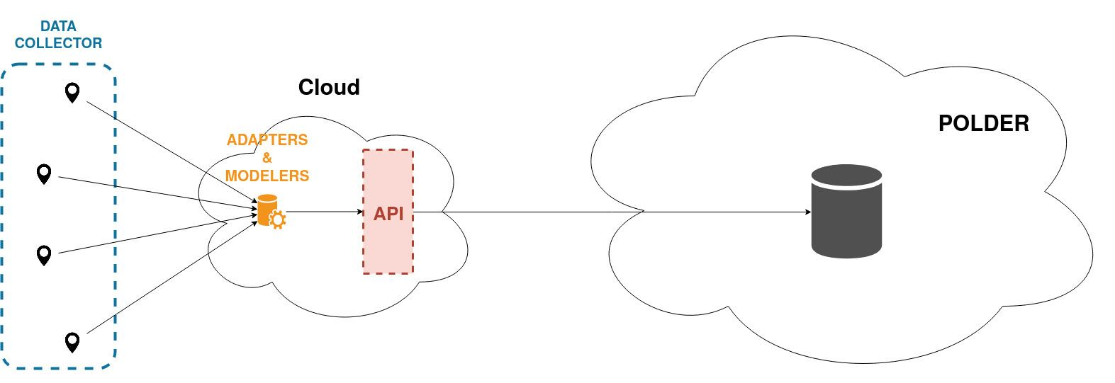Figure 1: Starflow's data management architecture.
Next, you may find a deeper approach of how the data aims to be extracted and sent to the POLDER platform, representing the tight integration schema proposed in deliverable d.4.2..
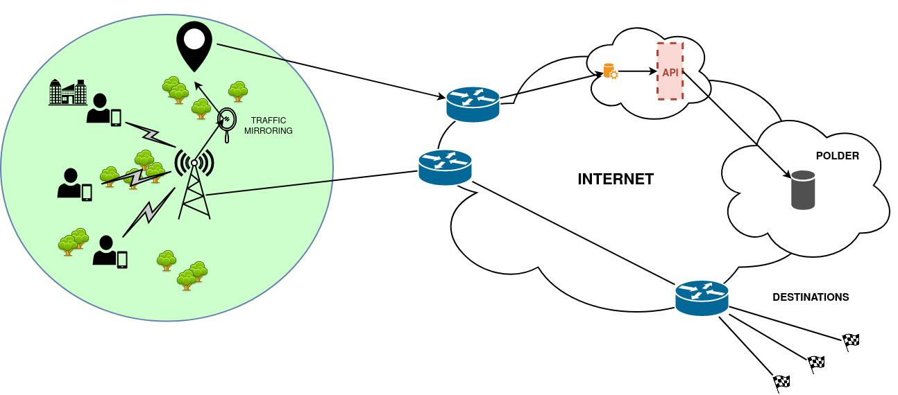Figure 2: Starflow’s data extraction and management schema

Data Format
When dealing with data collection, Starflow site receives traffic mirrored from a PoP. Such data is obtained from the traffic from users in a given zone (see the green scope zone in figure 2). Data is sent to the cloud where it is going to be processed by the adapters & modellers. Table 1 shows some of the raw data obtained from traffic that can be obtained from users traffic mirrored.
Field name | Description | Info size
timestamp | moment where the frame is sent or received in the PoP | 64-bit
IP source | Internet Protocol address of the sender | 32-bit/128-bit
IP destination | Internet Protocol address of the destination | 32-bit/128-bit
source port | Port number end-point in source | 16-bit
destination port | Port number end-point in destination | 16-bit
protocol | Internet Protocol number | 8-bits
seq.num | Sequence number | 32-bit
Table 1: Data input format for network traffic

Smart Cities Tourism Destinations Use Case
This use case intends to use “Information and Communication technologies” to contribute in terms of generating value-added experiences for tourists, the use case seeks to fill the research gap by identifying opportunities and challenges as well as conceptualising a framework

Input Data Sources

Nommon

Mobile Phone Traffic Data (Not Shareable)
Anonymised mobile phone records (call detail records, CDRs) provide location information about millions of users with high temporal and spatial resolution. CDRs are registers that are stored by the Mobile Network Operator (MNO) for invoicing purposes, and are generated when a mobile phone connects to the network, makes or receives a phone call or an SMS, or connects to the Internet. Although the format of CDRs may vary for each MNO, it includes at least the timestamp at which the connection occurs and the information regarding the base transceiver station (BTS) tower to which the user was connected, providing an indication of the geographical position of the user. Mobile phone records provide higher temporal resolution than other sources, as well as bigger and presumably less biased samples, allowing the obtention of a more accurate tourist characterization.
This information is stored following this structure:
agent id | timestamp | cell_id

Institutional tourism statistics
National entities such as INE in Spain offer statistics data related with tourism (i.e. FRONTUR), in which general information about tourists is extracted through surveys at entry and exit points, and expanded to the total visitor entries and exits. Additionally, some other institutions perform these analyses and publish them with a more regional approach.
This information is stored following this structure:
nationality | days of star | main visited reggion | other segmentations | number of visitors
Some examples of other segmentations are the point of entry or more sociodemographic information of the visitors.

Other Tourism Data
Other institutions or companies publish or may provide access to datasets that offer quantitative information about tourists.
Some examples of these data might be hotels location and occupancy, online lodging apps information, cruise ships information, airport arrival data, etc.
Information of how many cruisers visit a specific city can be provided by port authorities, and often has at least the following information structure:
cruise ship | arrival time | departure time | number of visitors

Census Data
Census data shows how much population is registered in each administrative area, many times segmented by demographic variables such as age and gender. Normally, registered population is a relatively accurate proxy of the actual population living in the area.
This information is stored following this structure:
administrative area | demographic segmentation | population

Land Use Data
Land use data classifies areas according to the kind of activities or uses that are associated with the equipment and buildings in the aforementioned area. This information can be useful to classify zones or Points of Interest, as well as to refine spatial precision of mobile phone data.
Some examples of land use data are public land use spatial files (SIOSE, Corine), points of interest files, restaurants, commerce, sport facilities, workplaces, etc. An example of a land use file could have the following structure:
land use area ID | types of land uses | percentage dedcated to each land use

Data Generated & Shared by

Nommon
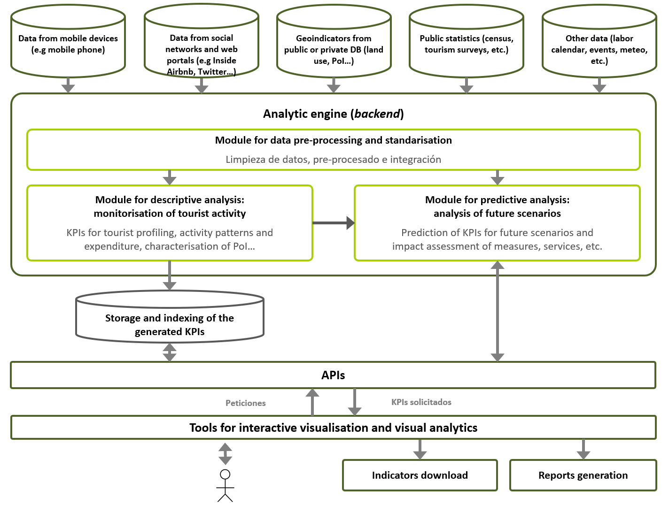Figure 3: Nommon's data generation and sharing schema
The generated KPIs will be included in the following types of files:
- Zones characterisation files: static information of each zone.
- Visitors presence information files: information about mobile phone users that are present in the zone.
- Visits information files: information about the visits to the zone.

Zones characterization
Provides with static tourism-related information for several zones, such as land-use distribution, population, points of interests, commerce, restaurants, etc.
- Format: JSON (to be defined)
- Example of structure (this is an on-going development so the structure might go through modifications):
{
"zone_id": "1",
"censed_population": 285,
"average_income": 2154.35,
"points_of_interest": {
"museum_ABC": {
"type": "museum"
}
},
"lodging": {
"hotels": {
"1": 840,
"2": 166
},
"shared": {
"A": 3,
"B": 7,
"C": 4,
"D": 3,
}
}
}

Visitors presence information
Provides information of the visitors that are present in a specific zone during a specific date and time period.
- Format: txt, delimited by ‘|’ (to be defined).
- Structure:
  - zone: identifier of the zone.
  - type_of_visitor: tourist / excursionist / cruiser
  - residence: ID of the residence province (only available for national tourists)
  - nationality: ID of country
  - income_group: i.e. 0-5000, 5000-10000, 10000-20000, 20000-30000, 30000-50000, > 50000 (only available for national tourists)
  - age_group: i.e. 10-20, 20-35, 35-55, 55-70, >70 (only available for national tourists)
  - gender: male / female (only available for national tourists)
  - time_period: i.e. 12:00-14:59
  - date: i.e. 2020/01/15
  - type_of_activity: lodging / pass_by / others
  - unique_visitors: unique visitors with presence in the study zone during the specified time_period of the specified date, that match all the provided segmentations.

Visits information
Provides information of the visits (stays in the study zone) to a specific zone during a specific date.
- Format: txt, delimited by ‘|’ (to be defined).
- Structure:
  - zone: identifier of the zone.
  - stay_duration: total hours of the visit (i.e. 56)
  - recurrence: number of visits in the month (i.e. 2)
  - type_of_visitor: tourist / excursionist / cruiser
  - arrival_mode: plane / ship / train / road
  - visit_purpose: leisure / business
  - unique_visits: unique visits in the study zone during the specified date, that match all the provided segmentations.

Starflow

Tourism Network Traffic Data
Starflow will provide information about the relevant traffic for the tourism sector by means of monitoring the traffic (Internet) in different geographically distributed points of presence, internet traffic patterns are going to be obtained in order to provide relevant information to the tourism sector. The sort of data used for obtaining these patterns is the same shown in the previous point “Network Traffic Data Source”.

Decision Support and Simulation System for Urban Plans Use Case

Sub-case 1: City Monitoring
This subcase will provide data monitoring capabilities and visualisation tools for the data in POLDER. Data may come from various sources as analysis results or real time sensors and may be related to any use case like environmental data monitoring, waste management or emergency management. The tools developed here will be use case agnostic and will work on specific types of standard data formats.
GeoJSON
- GeoJSON is a format for encoding a variety of geographic data structures.
- GeoJSON supports the following geometry types: Point, LineString, Polygon, MultiPoint, MultiLineString, and MultiPolygon. Geometric objects with additional properties are Feature objects. Sets of features are contained by FeatureCollection objects.
GML
- The OpenGIS® Geography Markup Language Encoding Standard (GML) The Geography Markup Language (GML) is an XML grammar for expressing geographical features. GML serves as a modeling language for geographic systems as well as an open interchange format for geographic transactions on the Internet.
Tabular Data Models of W3C
Tabular data may be in a variety of formats, including variants on CSV, tab-delimited files, fixed field formats, spreadsheets, HTML tables, and SQL dumps. W3C outlines a data model, or infoset, for tabular data and metadata about that tabular data that can be used as a basis for validation, display, or creating other formats. It also contains some non-normative guidance for publishing tabular data as CSV and how that maps into the tabular data model. Tabular data models proposes annotations for holding metadata about the data types below:
• Table groups
• Tables
• Columns
• Rows
• Cells

Image processing module data source
Accuro will contribute to this use case by developing an image processing module that will analyze in real time the number of people and certain objects present in different locations. This module will generate tags that describe the situation at a given time and will be stored in tables that can be accessed by other members of POLDER.
The data used as inputs to the image processing module are real-time image sequences that are analyzed with the intention of knowing at any given time, the amount of recognizable objects that are present at that moment.
Due to Accuro's use case, our module is mainly fed by the public webcams located in Madrid, as the one ubicated in Madrid’s Puerta del Sol shown in figure 4. However, the module is capable of processing real-time images from any type of webcam hosted anywhere in the world.
In order to use Accuro's image recognition module, POLDER users will only have to define the URL that is broadcasting the images and fill in some fields to start generating labels that can be viewed and used later in a public or private way.
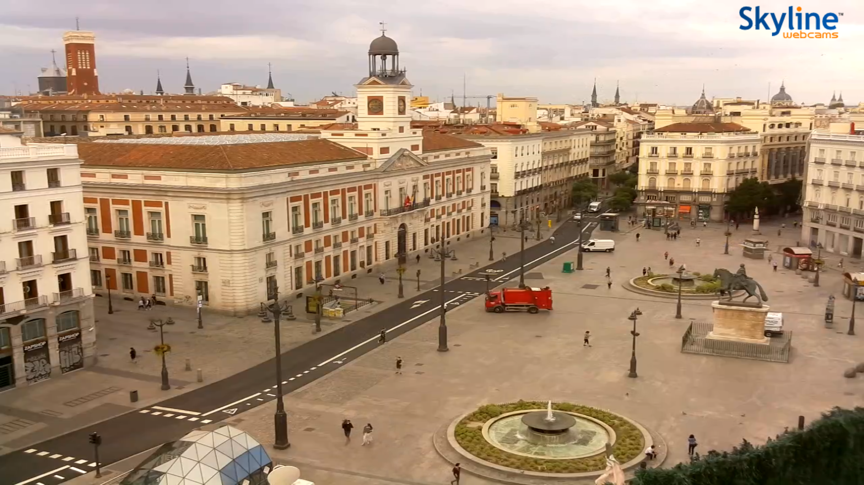Figure 4: Puerta del sol image
The inputs are not going to be stored in their raw form due to the inefficient consumption of resources that this would generate. As the images are processed, the module will generate tags that will be saved in the system for later use.
Data Schema
Figure 5 shows an architecture for identifying different characteristics of an image whose objective is to recognize the people circulating in the street, along with other outstanding objects that help to predict a desired situation, such as knowing the number of tourists that can circulate at the time the image is captured.
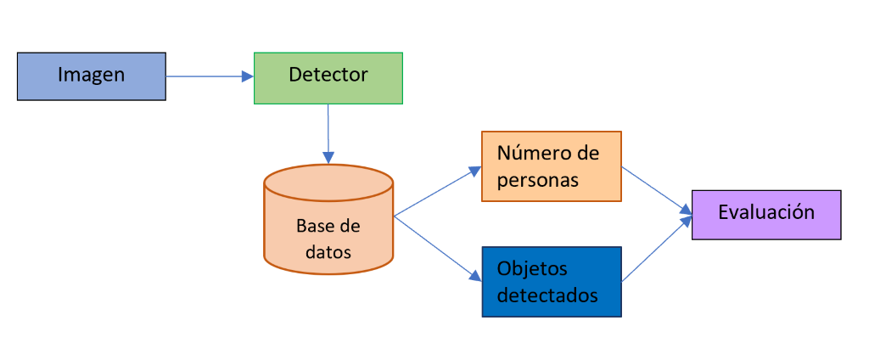Figure 5: Proposed architecture for the recognition and interpretation of situations through image recognition
As you can see in figure 5, the information will only be saved in the system after being processed by the image processing module, so there are no input specifications for our module because it is processed in streaming.

Sub-case 2: Urban population prediction and effect analysis
Two aspects of population estimation will be residential population and time based population.

Population / density by municipal areas. (For different years)
The "Density" attribute stores the value obtained for each area calculated as the number of inhabitants per hectare.
https://datos.gob.es/en/catalogo/l01290672-agenda-21-densidad-por-barrios-20131
Available Formats: SHP file for region based densities, tabular data for municipal densities

Urban Plans
Urban planning files for current and previous time periods will be used to develop an estimation model for population. The most important data for estimation of population is land use type.
Land Use is characterisation of territory according to its current and future planned functional dimension or socio-economic purpose (e.g. residential, industrial, commercial, agricultural, forestry, recreational).
INSPIRE data specification on Land Use document [5] will be accepted as a reference for expression and ontology of urban plans.
Primary Land Use Types given in INSPIRE directive is listed below:
• Residence or accommodation function
• General sales or services
• Manufacturing and wholesale trade
• Transportation, communication, information and utilities
• Arts, entertainment and recreation
• Education, public administration, health care and other institution
• Construction-related business
• Mining and extraction establishments
• Agriculture, forestry, fishing and hunting
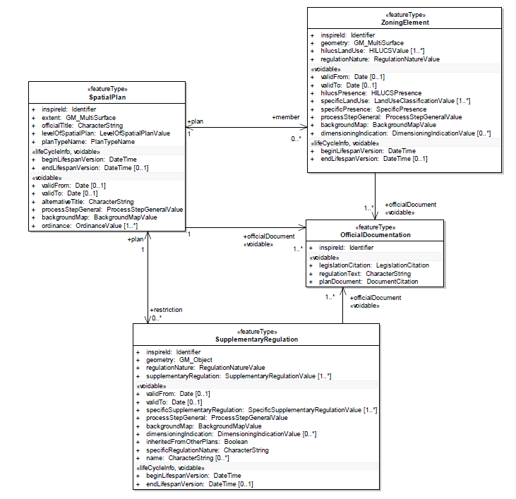Figure 6: UML Overview of the Planned Land Use application schema

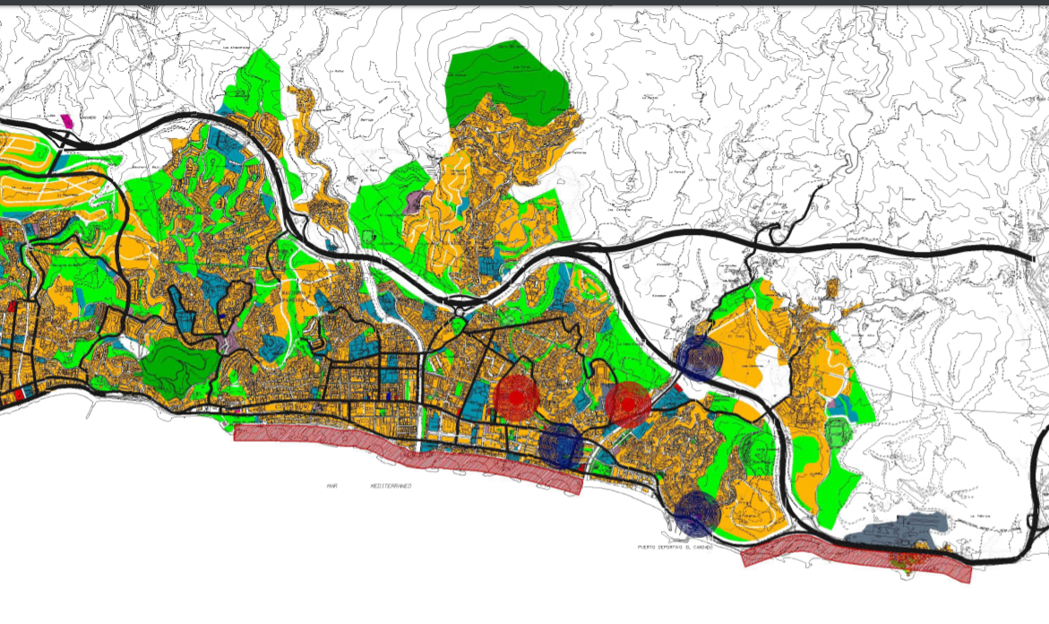Figure 7: Sample view from an Urban Plan
Available Formats: Spatial Datasets and OGC Service conformant to INSPIRE directive of EU Commission.
The datasets will be made available after NDA is signed with use case sites.
Below are some general links for further investigations:
- Urban plans: http://urbanismo.malaga.eu/
- Situation plans: http://cemi.malaga.eu/es/callejero-municipal/planos-de-situacin/index.html?codVial=230723#.XfiImmQzZPY
- 1-1000 Cartographic view: http://urbanismo.malaga.eu/es/plan-general-de-ordenacion/carto/#.XfiJ9GQzZPa

OGC WFS Service from Antalya Konyaaltı Municipality
https://harita.konyaalti.bel.tr/Netgis/wfs.ashx?request=getfeature&typename=belnet:geoplan_fonksiyon_1000
This kind of data which is not compliant to the POLDER ontology will be ingested with POLDER’s ETL capabilities.
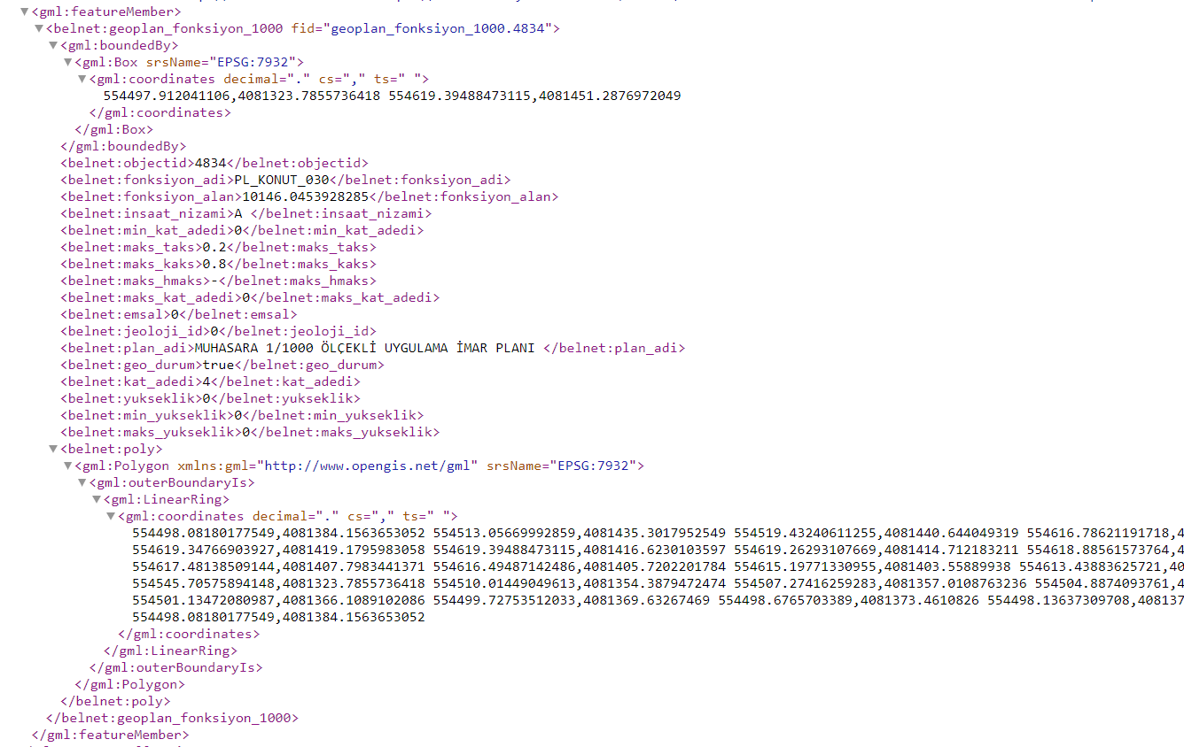Figure 8: OGC WFS Data for Plan Functions

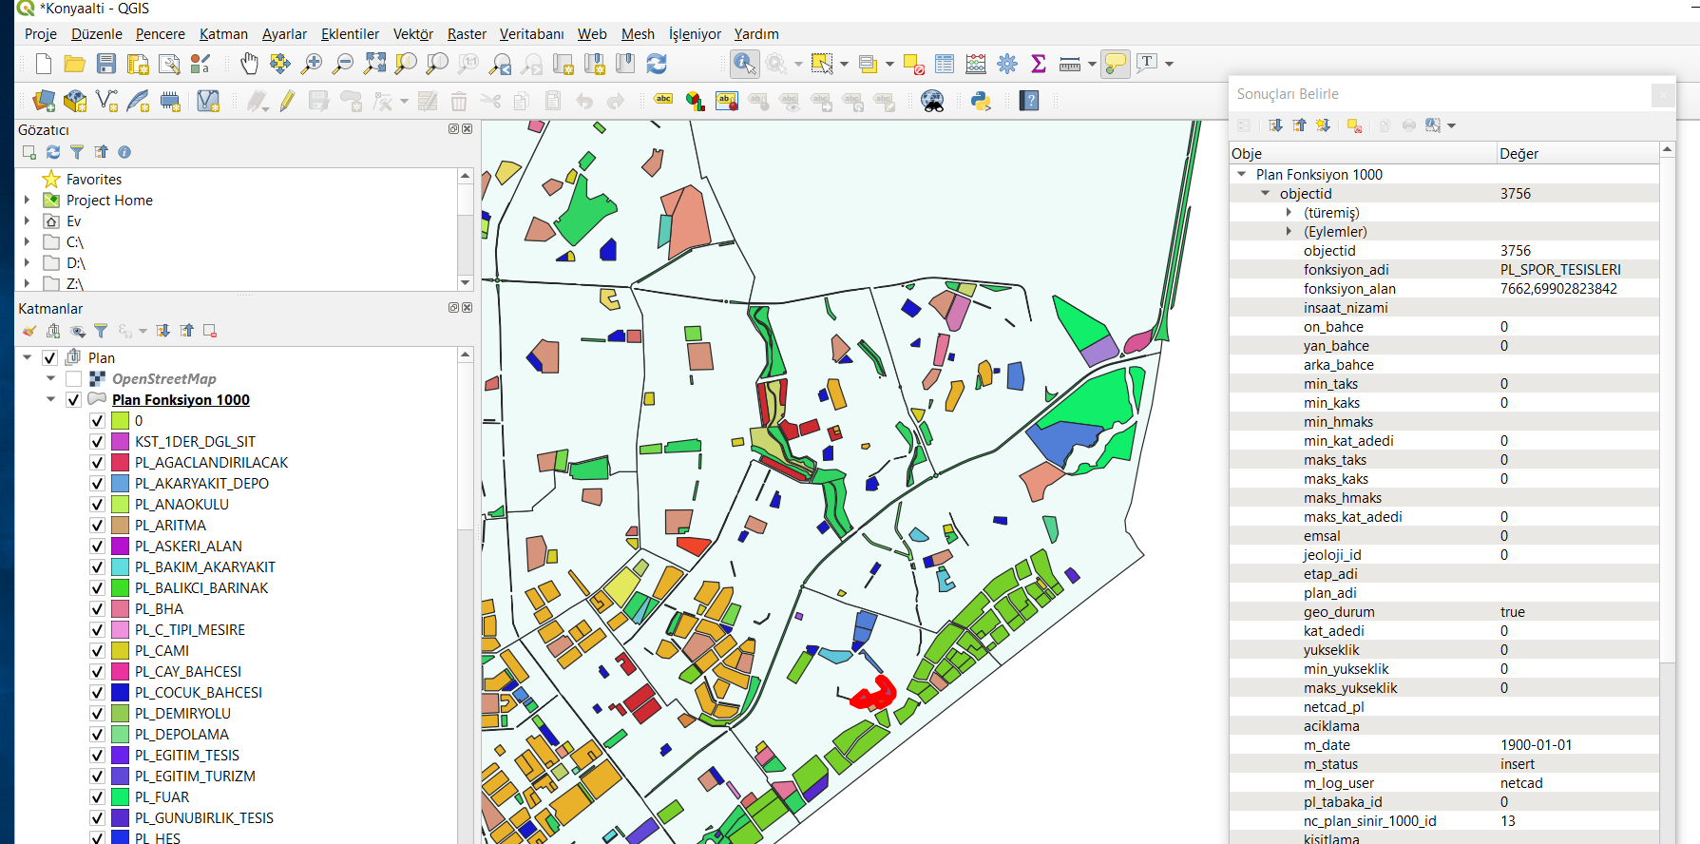Figure 9: Konyaaltı Plan Function Data Thematic Map in QGIS

Sub-case 3: Waste management system modelling
In this sub-case, a waste management system will be modelled for the part of the city or region, and waste management plan will be simulated based on the calculated waste load. Comparison between existing and predicted plans will be done.

Waste Containers
Capacities and locations of the waste containers will be the base data. Besides, sensor data about the load level of the containers will be used for cost and effectiveness analysis.
https://datosabiertos.malaga.eu/dataset/contenedores-para-residuos-solidos-urbanos
Available Formats: SHP, GeoJSON, KML, CSV

Waste Trucks
Waste Trucks, their capacities, size information, parking locations will be used in waste management analysis.
Available Formats: To be prepared as KML

Navigation data of Waste Trucks
Waste Trucks’ GPS data will be used to analyse the effectiveness of the routes for waste collection.
The simulations for the changes will be compared to current data.
Available Formats: To be prepared as KML

Waste Treatment Facility
There is one complex in Malaga, which is located in the Valsequillo area. This complex will be used for route based analyses for waste collection services.
Available Formats: To be prepared as CSV

Streets
Street will be used for localisation of waste containers and route based analyses for waste collection services.
https://datos.gob.es/en/catalogo/l01290672-sistema-de-informacion-cartografica-callejero1
Available Formats: SHP, GeoJSON, KML, CSV

Sub-case 4: Crowd and evacuation modelling
All data that is currently accessible on the web related the activities that cause periodic crowds e.g. during the tourism season such as concerts, events, fairs, congress, sports events etc will be collected by using “Web Scraping tools” as well as possible from the different websites including local government website, event websites, ticket sales or booking websites etc.
Also, another data channel will be the web services provided by the local government, local public administration or regionally serving organizations that are users of POLDER.

Waste Water Use Case
The aim of the use case is to monitor the waste water process and in case of rule events fired according to the rule system will provide alarms and warnings. Following data structure will be used to collect and store data generated by various sensors.
FIELD NAME | DESCRIPTION | VALUES
sensorID | Sensor identification number. | any integer value
eventType | Type of the current event. | input, error, warning, alarm, action
sensorName | Name of the current sensor. | temperature, ph, solid, etc.
frequency | Sample collection frequency for current sensor. | any integer value
value | Measured value for current sensor. | any float value
typeOfMeasure | Current state of the measurement. | input, output, state
timeStamp | Time stamp of the current measurement. | any time value
description | Short description of the measurement. | “Phase 1 waste Water level”, etc.
coordinates | Geographical location (lat,lng) of the current sensor. | “39.756731, 30.626215”
Table 2: Data format waste water use case
In this use case following parameters will be used to detect events.
PARAMETER | INPUT |  | OUTPUT |  | FREQUENCY
PARAMETER | MİN | MAX | MİN | MAX
Temperature | 8 | 20 | 6 | 20 |  | 3 per day
Ph | 6 | 9 | 6 | 9 |  | 3 per day
Solid | 700 | 800 | 50 | 100 |  | 3 per day
Oil | 400 | 500 | 5 | 10 |  | 3 per day
Con | 1000 | 1200 | 200 | 300 |  | 3 per day
Sulfate | 900 | 1000 | 1400 | 1500 |  | 3 per day
Total Nitrogen | 120 | 130 | 10 | 15 |  | 3 per day
Total Phosphorus | 15 | 20 | 1 | 3 |  | 3 per day
Total Cyanide | 10 | 15 | 1 | 2 |  | 3 per day
Total Plumbum | 3 | 5 | 1 | 2 |  | 3 per day
Total Chromium | 3 | 5 | 1 | 2 |  | 3 per day
Table 3: Parameters waste water use case
DESCRIPTION
Phase1Level | Level of the waste water level for Phase1 | 1 per minute
Phase3Level | Level of the waste water level for Phase3 | 1 per minute
Phase3O2 | Phase3 oxygen level | 1 per minute
Phase4FlowRate | Phase4 flowrate | 1 per minute
Phase5Ph | Phase5 ph level | 1 per minute
Phase6O2 | Phase6 oxygen level | 1 per minute
Phase7O2 | Phase7 oxygen level | 1 per minute
Table 4: Description phases waste water use case
Parameter : Name of the parameter used for the process of the waste water analysis.
Input : Valid input value range for parameter.
Output : Valid output value range for parameter.
Frequency : Sample frequency (per day).

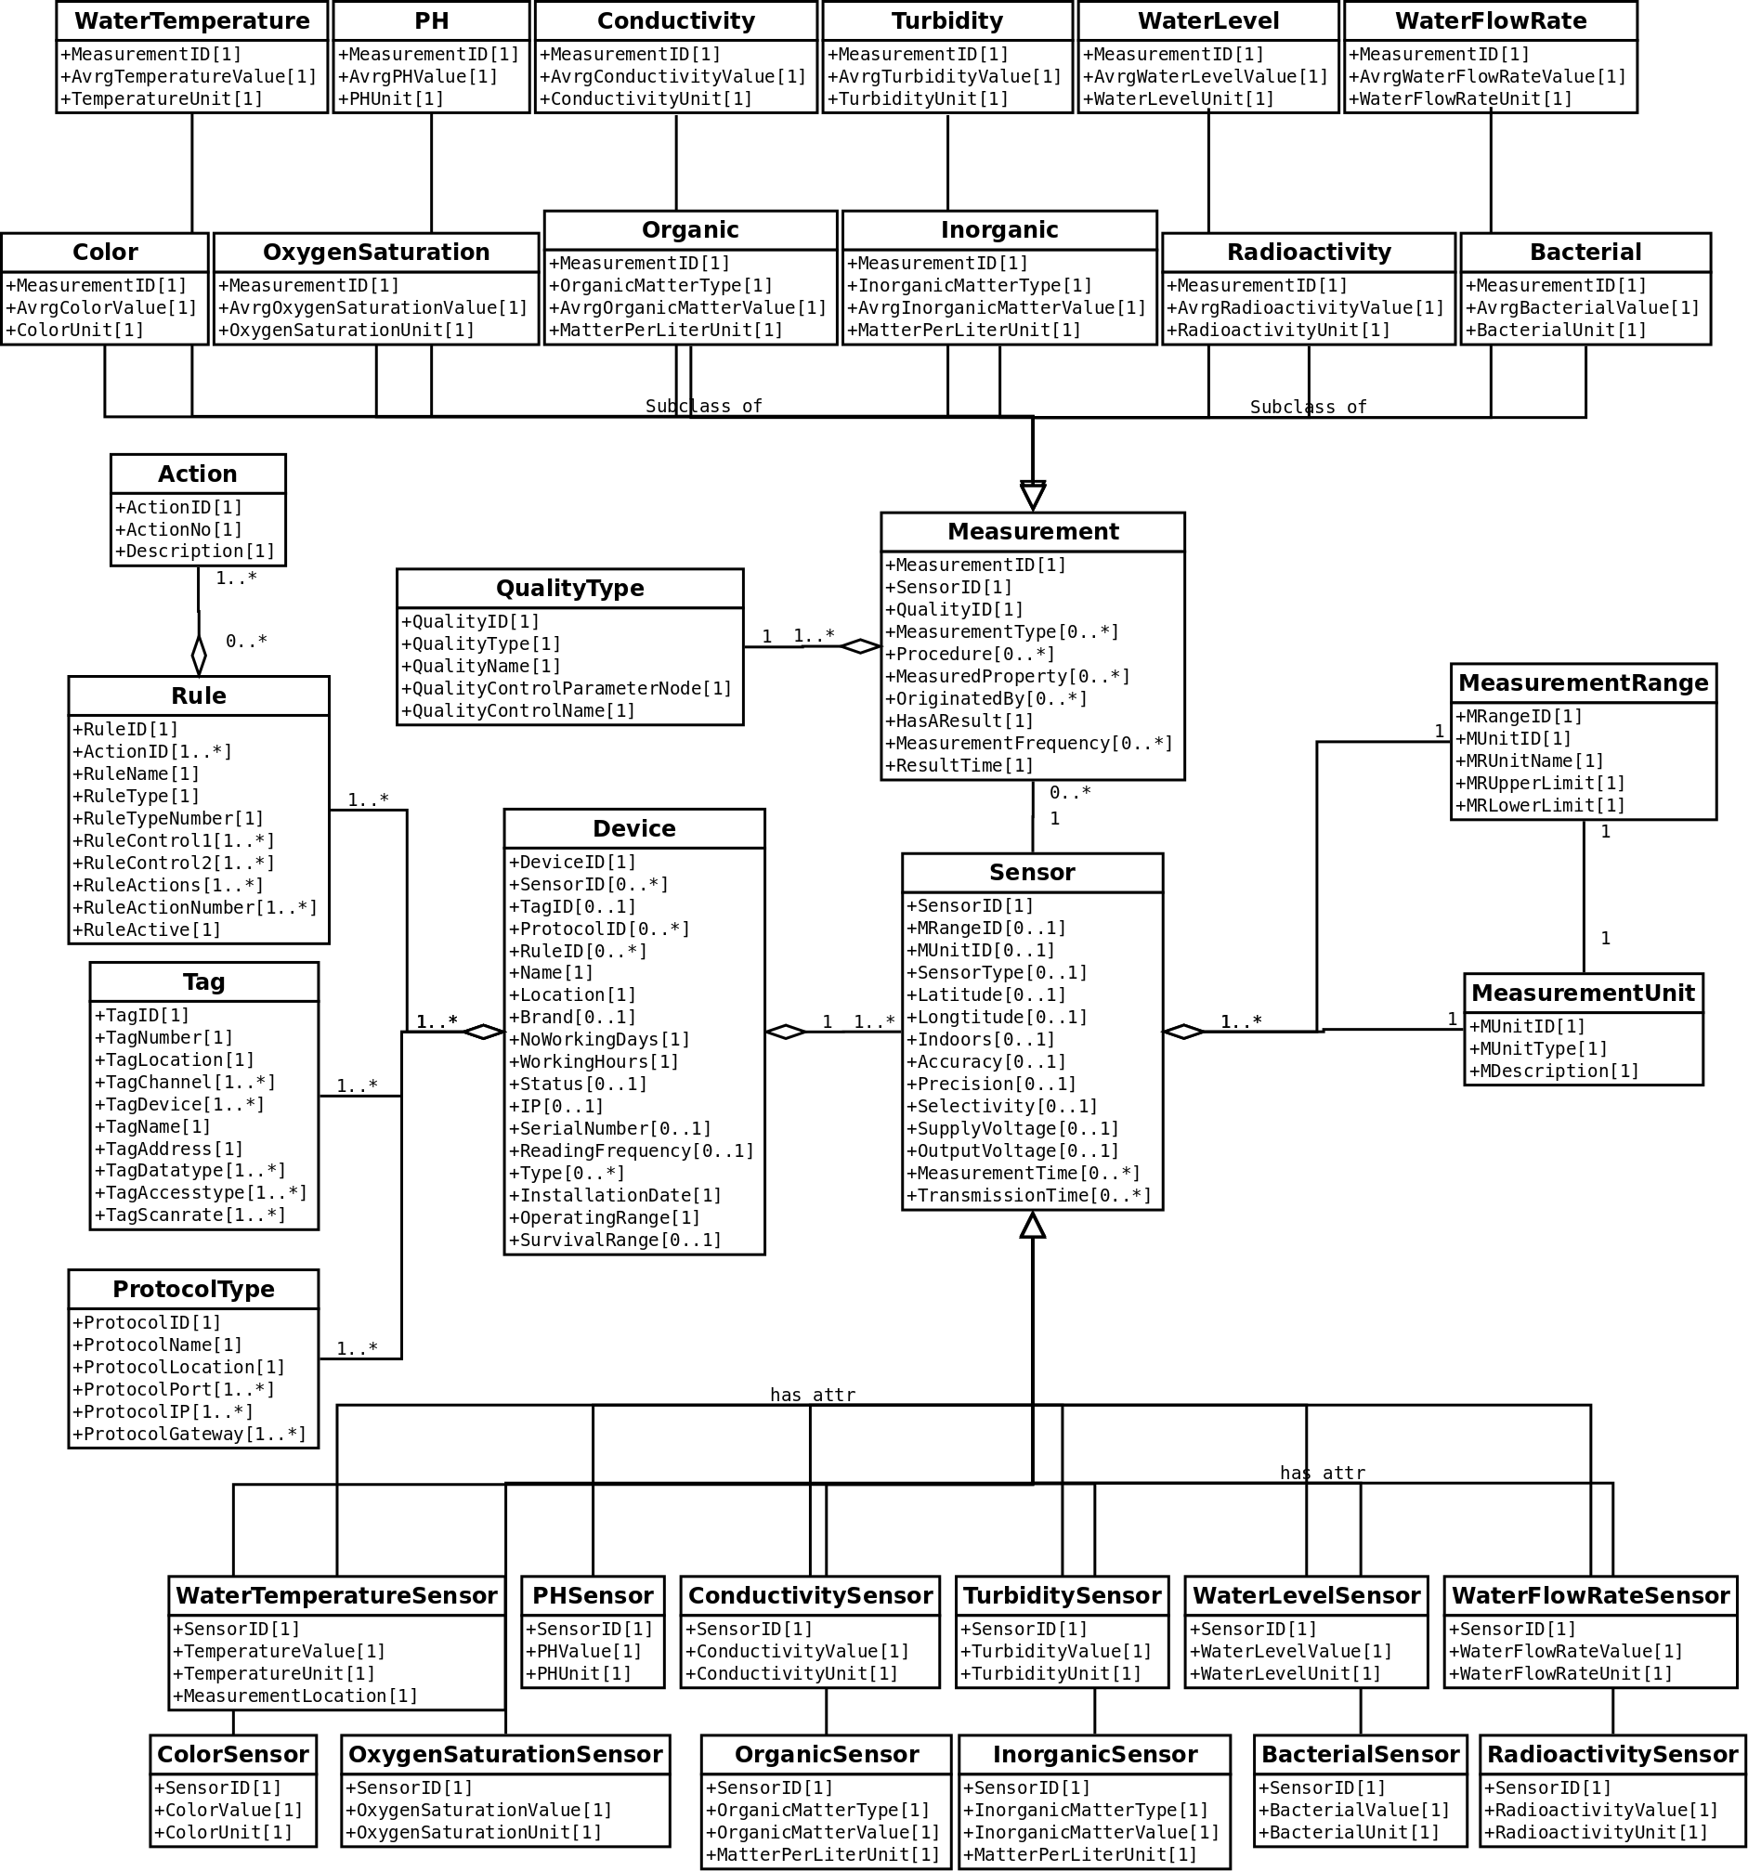Figure 10: Sample UML of Wastewater

Social Media Monitoring Use Case
The aim of the use case is to monitor social media sources and detect and analyze messages related to events about city monitoring events. Following data structure will be used to collect and store data generated by Twitter APIs.
{
"mappings": {
"doc": {
"properties": {
"@timestamp": { "type": "date" },
"tweet_coordinates": { "type": "geo_point" },
"tweet_favorite_count": { "type": "long" },
"tweet_hashtags": { "properties": { "indices": { "type": "long" },
"text": {
"type": "text",
"fields": {
"keyword": {
"type": "keyword",
}
}
}
}
},
"tweet_message": { "type": "text"},
"tweet_place_country": { "type": "text" },
"tweet_place_full_name": { "type": "text" },
"tweet_reply_count": { "type": "long" },
"tweet_retweet_count": { "type": "long" },
"tweet_retweeted_status": { "type": "text"},
"tweet_source": { "type": "text" },
"tweet_source_raw": { "type": "text" },
"tweet_user_description": { "type": "text" },
"tweet_user_followers_count": { "type": "long" },
"tweet_user_friends_count": { "type": "long" },
"tweet_user_lang": { "type": "text"},
"tweet_user_location": { "type": "text"},
"tweet_user_mentions": {
"properties": {
"id": {
"type": "long"
},
"id_str": {
"type": "text",
"fields": {
"keyword": {
"type": "keyword",
}
}
},
"indices": {
"type": "long"
},
"name": {
"type": "text",
"fields": {
"keyword": {
"type": "keyword",
}
}
},
"screen_name": {
"type": "text",
"fields": {
"keyword": {
"type": "keyword",
}
}
}
}
},
"tweet_user_name": { "type": "text"},
"tweet_user_screen_name": { "type": "text" }
}
}
}
}

Air Quality Monitoring
The aim of the use case is to monitor air quality and in case of rule events fired according to rule system will provide alarms and warnings. Following data structure will be used to collect and store data generated by various sensors.

BEIA
FIELD NAME | DESCRIPTION | VALUES
sensorID | Sensor identification number. | any integer value
eventType | Type of the current event. | input, error, warning, alarm, action
sensorName | Name of the current sensor. | temperature, pressure, humidity, wind and speed direction, SO2, NO2, CO, CO2, PM10, PM2.5, PM1
frequency | Sample collection frequency for current sensor. | any integer value
value | Measured value for current sensor. | any float value
typeOfMeasure | Current state of the measurement. | input, output, state
timeStamp | Time stamp of the current measurement. | any time value
description | Short description of the measurement. | “Phase 1 air pollution level”, etc.
Table 5: Data format air quality monitoring use case
In this use case following parameters will be used to detect events.
Station name | Monitored parameters | Sensor Name | Unit of measure | Minimum measured value | Maximum measured value | Communication module
 | Temperature | BME280 | °C | 0 | 65
 | Relative Humidity | BME280 | % RH | 0 | 100
 | Atmospheric pressure | BME280 | kPa | 30 | 110
Libelium Gas | CO | CO | ppm | 30 | 1000 | Wi-Fi Connect
Board |  |  |  |  |  | One
Board | NO₂ | NO₂ | ppm | 0,05 | 5 | One
 | CO₂ | CO₂ | ppm | 350 | 10000
 | O₂ | O2 | % | 0 | 30
 | VOC | VOC | ppm | 30 | 400
 | Temperature | BME280 | °C | 0 | 65
 | Atmospheric pressure | BME280 | kPa | 30 | 110
 | PM₁ | OPC-N2 | μg/m³ | 0 | 1
 | PM_{2.5} | OPC-N2 | μg/m³ | 0 | 2,5
 | PM₁₀ | OPC-N2 | μg/m³ | 0 | 10
Plug&Sense SCP |  |  |  |  |  | Wi-Fi Connect One
Plug&Sense SCP | NO₂ | NO₂-A43F | ppm | 0 | 20 | Wi-Fi Connect One
Plug&Sense SCP | LUX | Lux | lux | 0,1 | 40.000 | Wi-Fi Connect One
Plug&Sense SCP | Relative Humidity | BME280 | % | 0 | 100 | Wi-Fi Connect One
Plug&Sense SCP | CO | CO-A4 | ppm | 0 | 25 | Wi-Fi Connect One
Plug&Sense SCP | O₂ | 4-OL | % | 0 | 30% | Wi-Fi Connect One
 | PM_{2.5} | Winsen ZH03A | μg/m³ | 0 | 1000 | Wi-Fi ESP_D7AF40
 | PM₁₀ | Winsen ZH03A | μg/m³ | 0 | 1000 | Wi-Fi ESP_D7AF40
 | O₃ | Winsen ZE03-O₃ | ppm | 0 | 20 | Wi-Fi ESP_D7AF40
uRADMonitor City | SO₂ | Winsen ZE03-SO₂ | ppm | 0 | 20 | Wi-Fi ESP_D7AF40
 | NO₂ | Winsen ZE03-NO₂ | ppm | 0 | 20 | Wi-Fi ESP_D7AF40
 | CO | Winsen ZE03-CO | ppm | 0 | 1000 | Wi-Fi ESP_D7AF40
 | Device temperature | Integrated sensor | °C | -40 | 85 | Wi-Fi ESP_D7AF40
 | Altitude | Barometric altimeter | Pa | 10hPA | 200hPa | Wi-Fi ESP_D7AF40
Table 6: Device configuration and monitored parameters

Air pollution is a risk factor for human health, causing acute and chronic respiratory problems. Indoor air pollution can be quite high if homes are not well ventilated. Continuous exposure causes health problems including acute respiratory infections in children, as well as lung cancer in adults.

Outdoor air pollution comes mainly from the incomplete combustion of fuels used in transport, energy and industry, as well as other human activities. The urban population of the EU-28 is exposed to some extent to concentrations of pollutants in excess of the limit values set by EU legislation and those in World Health Organization (WHO) guidelines. The degree of exposure is shown in the following table.

Polutants | EU reference value (µg/m³) | Exposure percentage (%) | WHO reference value (µg/Nm³) | Exposure percentage (%)
PM_{2.5} | 25 µg/m³ - annual concentration | 7 - 8 | 10 µg/Nm³ - annual concentration | 82 - 85
PM₁₀ | 50 µg/m³ - daily concentration | 16 - 20 | 20 µg/Nm³ - annual concentration | 50 - 62
O₃ | 120 µg/m³ - average concentration at 8 hours | 7 - 30 | 100 µg/Nm³ -  average concentration at 8 hours | 95 - 98
NO₂ | 40 µg/m³ - annual concentration | 7 - 9 | 40 µg/Nm³ - annual concentration | 7 - 9
SO₂ | 125 µg/m³ - daily concentration | < 1 | 20 µg/Nm³ - daily concentration | 20 - 38
Table 7: The degree of exposure from UE-28

ACD
The complete list of classes:
- ProtocolType
- QualityType
- Tag
- Rule
- Action
- Device
  - Sensor
    - AirTemperatureSensor
    - HumiditySensor
    - WindSpeedSensor
    - WindDirectionSensor
    - AirPressureSensor
    - PM2.5Sensor
    - PM10Sensor
    - PollutantGasSensor
- Measurement
  - AirTemperature
  - Humidity
  - WindSpeed
  - WindDirection
  - AirPressure
  - PM2.5
  - PM10
  - PollutantGas
- MeasurementUnit
- MeasurementRange
  - MinValue
  - MaxValue
Variable | Information
Sensor::AirTemperatureSensor | Indicates the degree of heat present in the air. Measures air temperature. Measurement location indicates if the value is devices temperature or outside temperature.
Sensor::HumiditySensor | Indicates the amount of water vapor in the air. Measures air humidity
Sensor::WindSpeedSensor | Measures wind speed
Sensor::WindDirectionSensor | Measures wind direction
Sensor::AirPressureSensor | Measures air pressure
Sensor::PM2.5Sensor | Measures the particulate matter that are smaller than 2.5 micrometers present in diameter in the air.
Sensor::PM10Sensor | Measures the particulate matter that are smaller than 10 micrometers in diameter present in the air.
Sensor::PollutantGasSensor | Measures the amount of pollutant gasses in the air.
Table 8: Sensor variables information

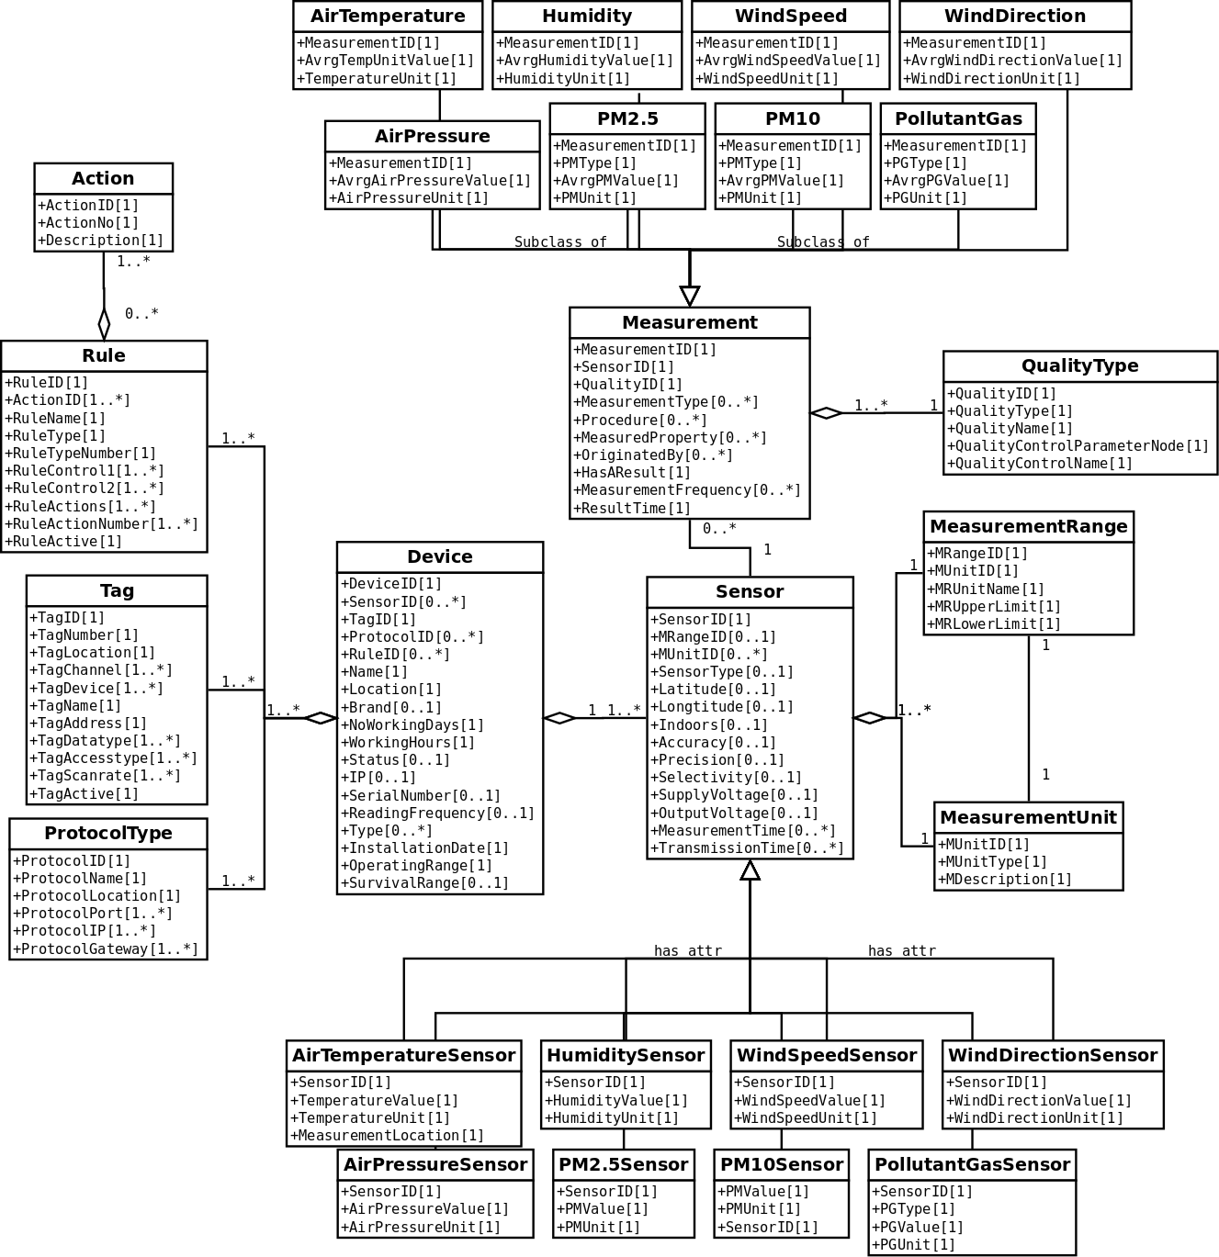Figure 11: Sample UML of Air Pollution

Energy Monitoring
The aim of the use case is to monitor energy monitoring and in case of rule events fired according to rule system will provide alarms and warnings. Following data structure will be used to collect and store data generated by various sensors.
The complete list of classes:
- ProtocolType
- Tag
- Rule
- Action
- Device
  - Sensor
    - TemperatureSensor
    - ElectricCurrentSensor
    - EnergySensor
    - PowerSensor
    - VoltageSensor
  - GeneralSensor
- Measurement
  - Temperature
  - ElectricCurrent
  - Energy
  - Power
  - VoltageSensor
- MeasurementUnit
- MeasurementRange
  - MinValue
  - MaxValue
Variable | Information
Device::Sensor | Technical devices that react qualitatively or quantitatively to certain physical or chemical properties of the environment. It can measure, record and transmit physical parameters that are transformed into a signal that can be read by an observer through a tool or a web platform. Models generic sensor.
Sensor::TemperatureSensor | Indicates the degree of heat present. Measures temperature. Measurement location indicates if the value is devices temperature or outside temperature.
Sensor::ElectricCurrentSensor | Indicates the electric current in terms of AC/DC.
Sensor::EnergySensor | Indicates the energy in terms of kWh.
Sensor::PowerSensor | Indicates the power in terms of Watt.
Sensor::VoltageSensor | Indicates the voltage in terms of V.
Measurement | The action of carrying out a measurement procedure to estimate a value for a property. Models a generic act of measuring.
Sensor::TemperatureSensor | Indicates the degree of heat present. Measures temperature. Measurement location indicates if the value is devices temperature or outside temperature.
Measurement::Temperature | Measuring degree of heat readings.
Measurement::ElectricCurrent | Measuring electric readings.
Measurement::Energy | Measuring energy readings.
Measurement::Power | Measuring power readings
Measurement::Voltage | Measuring voltage readings.
MeasurementUnit | Holding the unit type for sensors and measurements by recording unit type and measurement type ie.  kWh, energy;  W, power
MeasurementRange | Aim of this table to define upper and lower limits of a sensor.
Table 9: Energy use case sensor variabales and information
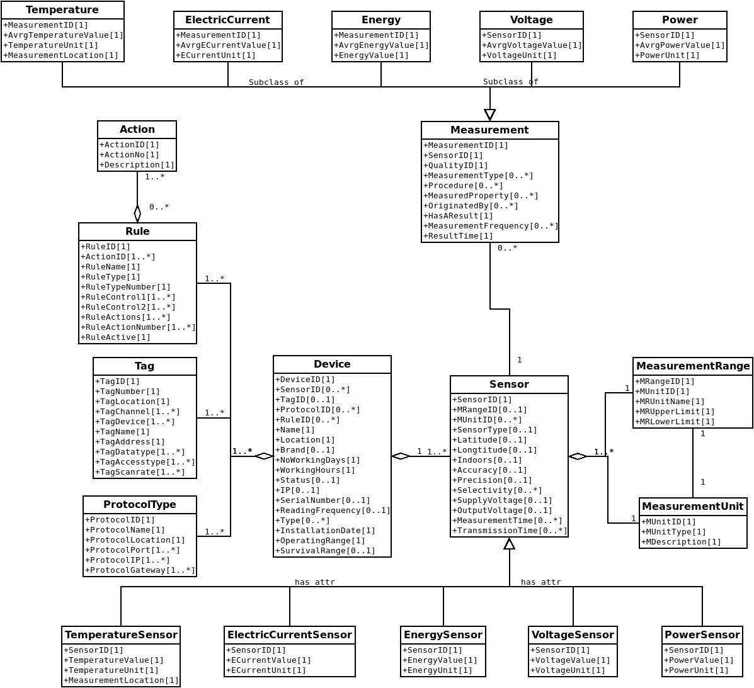
Figure 12: Sample UML of Energy

Traffic Use Case
Traffic data is increasing day by day so it is difficult to manage and control smart cities. To make decision making more responsive, predictive and automated, city officials need an end-to-end urban intelligence solution, leveraging innovative IoT-enabled analytics to deliver that support faster responses to traffic flow, passenger safety.
The anonymized data format to be recovered from the cameras will be similar to the table below. The information contained in the data format varies according to different sensors (different attribute and different time series).

References
- https://www.w3.org/TR/tabular-data-model/#model
- https://www.w3.org/TR/sdw-bp/#dfn-spatial-thing
- https://geojson.org/
- https://www.opengeospatial.org/standards/gml
- INSPIRE data specification on Land Use - Europa EU http://inspire.ec.europa.eu/documents/Data_Specifications/INSPIRE_DataSpecification_LU_v3.0rc2.pdf

https://www.skylinewebcams.com/es/webcam/espana/comunidad-de-madrid/madrid/puerta-del-sol.html
http://www.who.int/ceh/risks/cehair/en/
EEA, Report 2017, no. 12/2017, Air quality în Europe, 2017.

