|  |  |  |
| --- | --- | --- |
| ***Delivery Date*:**  M18 – 24/07/2018 | ***Project Number*:**  ITEA3 Call2 15011 | ***Responsible partner*:**  Taiger |





*Exploitation plan of the project*

Document Contributors

|  |  |  |
| --- | --- | --- |
| Name | Company | Email |
| George Suciu | Beia Consult International | [george@beia.ro](mailto:george@beia.ro) |
| Denisa Becheru | SIVECO Romania | Denisa.becheru@siveco.ro |
| Christian Álvarez | TAIGER SPAIN | Christian.alvarez@taiger.com |
| Raúl Santos de la Cámara | HI Iberia | rsantos@hi-iberia.es |
| Elena Muelas | Hi Iberia | emuelas@hi-iberia.es |
|  |  |  |

Document History

|  |  |  |  |
| --- | --- | --- | --- |
| Version | Date | Author | Description |
| 1.1 | 11.04 | SIVECO & Beia | Chapters 2, 3 and 4 |
| 1.3 | 15.06 | TAIGER SPAIN | Formatting, complete and merge information |
| 1.5 | 01.07 | Hi Iberia | KPI’s |
| 1.8 | 17.07 | Siveco | Review |
| 2.0 | 24.07 | TAIGER SPAIN | Final version |
|  |  |  |  |

# Table of contents

Document Contributors 3

Document History 3

Table of contents 4

1. Introduction 6

2. Market Analysis 7

2.1. Marketing Use Case 7

2.1.1. Market status 7

2.1.2. E-Commerce 8

2.1.3. Competitors Analysis 9

2.1.4. Gaps in the market 10

Recruiting 12

2.2. 12

Market status 12

2.2.1. 12

Competitors analysis 13

2.2.2. 13

2.2.3. Gaps in the market 18

Advances in technology create new opportunities, but they also open up new risks and problems []: 18

2.2.4. 18

3. Exploitation plan 18

3.1. Joint exploitation plan (consortium level) 20

3.2. Marketing solution exploitation plan 20

3.2.1. Subject of exploitation 20

3.2.2. Context of exploitation 21

3.2.3. Value proposition 21

3.2.4. Target audience / Market segments 21

3.2.5. Impact / revenue sources 22

3.2.6. Marketing 22

3.2.7. Business plan 23

Recruitment solution exploitation plan 25

3.3. 25

Subject of exploitation 25

3.3.1. 25

Context of exploitation 25

3.3.2. 25

Value proposition 26

3.3.3. 26

3.3.4. Target audience / Market segments 28

3.3.5. Impact / revenue sources 28

3.3.6. Increase the Product / Service Quality 28

3.3.7. Marketing 29

3.3.8. Business Plan 29

4. Dissemination 34

Online communication on social media 36

4.1. 36

Dissemination channel (Main Page of the project) 36

3.3.9. Dissemination channel (Company Webpages) 37

3.3.10. Dissemination channel (Social media) 39

3.3.11. Dissemination channel (Technological information platform) 40

4.2. Flyer & Leaflet 41

4.3. Publications & conferences 41

4.4. KPIs 42

5. Future use cases 43

5.1. Future use case 1 (Solomon – offline retailer) 43

5.2. Future use case 2 (Turkish consortium) 43

5.3. Potential use cases 43

6. Somedi standardization plan 44

6.1. Standards 44

• W3C (World Wide Web Consortium):  is the main international standards organization for the World Wide Web 44

• ISO (International Electrotechnical Commission): is an independent, non-governmental organization. It facilitates world trade by providing common standards between projects o partners who are in a common project. 44

o ISO IEC 29100 Information technology – Security techniques which specifies a common privacy terminology, defines the actors and their roles in processing personally indentifiable information, describes privacy safeguarding considerations and provides references to known privacy principles for information technology. 44

7. Conclusions and next steps 44

# Introduction

This deliverable summarizes the exploitation activities of the SoMeDi Project:

• Own dissemination materials generated by the project: project website, poster, conferences, etc

• Participation in events, industrial fairs, where activities and technologies are reported related to the SOMEDI project.

• Partners exploitation plan for the technology resulting from the SoMeDi Project.

In addition, this document updates the dissemination and exploitation activities of the project, especially in relation to participation in industrial events that have allowed creating focus around the new technologies developed in the project and those related to the plan of exploitation of the project and collaboration with third parties.

Dissemination has been carried out during the early phases of the project and has been maintained throughout of the project with dissemination activities of various kinds such as presence in web portals and demos. The dissemination activities have been synchronized and carried out in strict collaboration with the exploitation activities. This has included the constant monitoring of the market in order to prepare a successful exploitation of results.

In parallel, the activities for the definition of an effective plan of exploitation and use have been executed of the generated knowledge. As part of this analysis, the potential impact of the each of the results of the project that will be analyzed by SWOT analysis.

# Market Analysis

Gartner predicts that by 2020, 50 percent of analytical queries will be generated via search, (FIND BETTER WORD, IS THIS A GOOD USE? ) natural language processing (NLP), or voice. NLP will empower people to ask more nuanced questions of data and receive relevant answers that lead to better insights and decisions.

Simultaneously, developers and engineers will make greater strides in exploring how people use NLP by examining how people ask questions - from instant gratification to exploration. The biggest analytic gains will come from tackling this ambiguity and understanding the diverse workflows that NLP augments. The opportunity will arise not from placing NLP in every situation, but making it available in the right workflows so it becomes second nature to those using it.[1]



## Marketing Use Case

Marketing Use Case main objective is to improve the marketing performance of companies in two different sectors: e-commerce and restaurants with social media presence including promotions and marketing campaigns. The platform collects customer feedback on the company’s products and services in order to improve marketing performance. The idea is to use SoMeDi tools to measure brands’ social impact providing truthful information about how people feel towards the brand that will improve content quality and marketing plan performance by creating reports focused on client’s needs and their interaction (FAV/likes, etc.).

### Market status

The prominence of Social Media as a means of communication is part of today’s daily lives for citizens worldwide. Communities and personal relations of all sorts are now inextricable from the Internet tools that have appeared over the last decade. Impacts are felt everywhere: from news spreading through personal relationships and artistic movements; Social Media has grown to cover a majority of the spectrum of human activities. Thus, the use of social media has moved from experimentation phase to a more mission-critical activity, placing significant pressure on social programs to efficiently monitor, analyse and engage this variety of information.

The number and quality of Social Media Monitoring (SMM) tools available in the market has also changed considerably with the SMM technology maturing rapidly and delivering unique and more sophisticated analytical capabilities. New tools and services are emerging continuously, while already established SMM technologies are frequently improving their products by introducing new features and coverage to accommodate their clients’ needs or transforming their point solutions into a complete social suite to address multiple features within one single platform.

The way to make social media truly work for a business is by monitoring audience behaviour and seeing what they have to say about you, your products and services, and even your competitors. When a business has the proper data within its reach, it’s possible to analyse the information to make informed decisions about how the business promote on social media in order to achieve maximum engagement - which, in turn, can increase sales, and to reach business intelligence. Using all these insights serve to know your customers better and improve your marketing strategy.

It is important to bear in mind the following goals and plans that matter when a business intends to assess competitors on social networks:

* + **Deeper metrics**: Though comparing likes, mentions and retweets might make you think your business is winning (or losing) it is important to analyse other parameters: demographics are your framework, psychographics tell you what consumers are interested in, and sentiment provides context so you know where to focus your energy.
  + **Surprising challengers**: It is important to assume that competitors don’t look exactly like you and that at any moment, brands with a better grasp of your audience can bump you out of the limelight.
  + **Sentiment highs and lows**: To make the most of competitive data, apply sentiment analysis to identify the strongest reactions. These extremes point to the best opportunities to borrow great ideas or solve consumer problems in a way competitors aren’t.
  + **Content and channels**: To know where your competitors are, it is necessary to look beyond the channels your brand is on and see if you should be active elsewhere as well. Be sure to look at the content competitors share – and consumer response. Maybe you’re not sharing enough videos. Or maybe you need a different approach to the ones you do share. Pay attention to any trends emerging or being leveraged successfully.

With competitive data in hand you can move your brand forward on a number of fronts: marketing, engagement, customer service, product development, the customer experience, and more.

### E-Commerce

According to [[2]], the global e-commerce market will grow steadily and post an impressive CAGR of more than 19% by 2020. One of the major factors contributing to the growth of the e-commerce market is the diverse portfolio in several product segments such as electronic gadgets, apparels, books, and cosmetics. These categories in the e-commerce websites are regularly updated with latest offerings, which not only attract new customers but also retain customer loyalty. Also, these shopping websites allow customers to make multiple payment options through credit and debit cards, electronic wallets, net banking, cash on delivery (COD), and cryptocurrency. To withstand the growing competition in the market and maintain customer allegiance, several e-commerce companies are introducing incentives like free shipping to customers. They are also offering hassle-free exchange and return policies to increase their brand proposition. Social media advertising is one of the latest developments in the e-commerce market, which not only allows advertisers to use display banner ads but also sponsored content to attract customers.

Vendors in the market are switching from website platforms to app-only services owing to the increase in online shopping transactions through mobile apps. Shifting to app-only can be a risky situation for vendors as many developing countries, such as Africa, India, and South Korea face grave issues of internet connectivity, which restricts the customers from making an online purchase. The e-commerce vendors are coming up with a lighter version of the apps that work even with slow internet connectivity. They are focusing to develop lighter versions of their mobile sites that support browsing even at moderate internet connectivity like Google, Facebook, and LinkedIn.

The global e-commerce market is highly competitive because of the presence of many large established players. Intense competition prevails in this market where the vendors contend in terms of product portfolio, pricing, delivery and payment options, return policies, discounts and offers. To increase their profit margins and extend their geographic presence, vendors are making investments in planning, designing, and developing their services and acquiring new players. The strong positions of the established vendors and long break-even periods will restrict the entry of new players in the market over the predicted period.

Segmentation by application and analysis of the e-commerce market:

* Home appliances
* Clothing and footwear
* Books
* Cosmetics
* Baby goods
* Groceries

The home appliances segment is the largest revenue segment in the e-commerce market and accounted for more than 32% of the total market share in 2015. The segment includes consumer electronics, houseware, and other kitchen appliances. Much of the segment’s growth can be attributed to the increasing credibility of the brands online and the frequent tendency of consumers to upgrade their homes. Moreover, the growing trend towards recycling and the use of smart energy in consumer electronics will be a major factor augmenting the growth prospects for this segment in the coming years.

Geographical segmentation and analysis of the e-commerce market:

* Americas
* APAC
* EMEA

Among all geographies, APAC will be the fastest growing region in the e-commerce market during the forecast period due to the increasing internet penetration and high purchasing power of the middle class population. The local vendors dominate the region’s market and restrict the influence of foreign players, thereby maintaining the revenue growth. With the growing adoption of smart devices and latest digital technologies, the region is anticipated to grow at a tremendous CAGR of more than 25% over the next four years.

### Competitors Analysis

There is no debating that social media has taken many industries by storm, and the restaurant industry is certainly no exception. Patrons are Instagramming photos of food, following their favourite spots on Twitter or liking restaurants on Facebook, so they can share them with their friends.

To facilitate the Social Media Monitoring for enterprises, there are a number of available tools and service providers currently in the market. Some of them:

* *BoomSoonar* provides an integrated social media business platform, which empowers organizations to monitor, measure, manage, analyze and respond across social media channels and Web. The platform offers a real time web and social media monitoring, analytics and engagement platform with content categorization and social CRM modules that helps organizations gain a complete understanding of the online conversations about their company, products, topics or competitors, gather data for social CRM and engage directly from within the BoomSonar’s platform.
* *Brand24* is a technology company that offers social CRM and social monitoring platform, which empowers brands to get real time customer insights and actionable intelligence relevant to their products, brands, competitors, person, or topic of interest across multiple social media platforms including: Facebook, Twitter, YouTube, blogs, message boards and news sites.
* *BrandsEye* provides an online and social monitoring, listening and analytics tool that helps business and organizations track and evaluate their online presence and extract valuable insights out of the data to better inform their strategic business decisions.
* *Cision* is leading global media intelligence company that offers the industry most comprehensive public relations and social software, rich analytics and global insight team to enable communication, social media and content marketing professionals to plan, execute and measure influencer-oriented campaigns in one integrated platform to improve their marketing and make more data driven decisions.
* *Simply Measured* is a tool for social analytics that intends to help marketers to generate actionable insights from social-data for improving their job better and faster. It provides the company daily social engagement with a unified cross-channel view and filtering by channel, media type, text and hashtags. Also it is able to compare your business entire social footprint against competitors to bring context to your own performance as well as analyse the engagement on a specific campaign.
* *Echobot* provides a tool that helps public relationships and marketing professionals to find out how people talk about their brand and how effective certain marketing campaigns have been
* *Infegy* is a social media intelligence tool that takes the hard work out of making sense of social data, giving brands and agencies the ability to uncover unique insights and create impactful strategies through accurate, automated analysis of online dialogue

**E-Commerce**

Leading vendors in the market are:

* Alibaba
* Amazon.com
* Apple
* eBay
* Google
* PayPal

Other prominent vendors in the e-commerce market include ASOS.com, Barnes & Noble, Best Buy, Costco, GameStop, Groupon, J. C. Penney, Kohl's, Liberty Interactive, LL Bean, Lowe’s, Macy's, Newegg, MasterCard, Sears Holdings, Softcard, Staples, Target, The Home Depot, Visa, and Walmart.

### Gaps in the market

After introducing a product overview of the main competitors of SoMeDi related to media monitoring, a matrix has been generated where the features of these competitors are compared with the features of SoMeDi. This can be shown in the below figure:



As it can be shown, most of these tools provide very similar features:

* Extensive media coverage (Twitter, Facebook, Instagram, etc.)
* Real time search and monitoring
* In-depth semantic analysis
* Profiling analysis
* Sentiment analysis
* Trend analysis
* Geo-location, to do precise searches on certain locations
* Filtering of results by media type topic/keyword, time period, demographics, sentiment, custom tags or geography (geo-location based on the combination of self-reported location information and mapping of geo-enabled smartphones).
* Results visualization, extensive range of graphs and charts for interpreting appropriately the results.
* Natural Language Processing available in several languages.
* Data alerts with standard and fully customizable alerts.

However, other features more specialized for marketing engagement are difficult to be found in current tools available in the market. In consequence, SOMEDI intends to cover apart of the current functionalities’ available in the market, a more detailed analysis specialized mainly on social analysis providing details as the engagement on a specific campaign, recommendation about when is the best moment to publish information in the brand profile or suggestions about possible campaigns starting from the data analysis carried out considering the footprint of the profile.

Thus, SoMeDi thanks to its general and extensible architecture presents a set of features that will make it different to other competitors that currently exist in the market of social media monitoring. This also makes it easily customizable to future clients’ needs and requirements.

## Recruiting

### Market status

According to [[3]], the global market for Recruitment Software is projected to reach US$2.7 billion by 2022, driven by the need for effective candidate sourcing and proficient applicant tracking tools especially against the backdrop of changing labour demand and supply with respect to skills and the resulting increased risk of skills mismatch. Dwindling quality of skilled labour and growing role of intellectual capital competencies in knowledge intensive business sectors are together throwing the focus on aggressive talent acquisition. The scenario creates a fertile environment for the growth of recruitment software as a multi-faceted platform that fully acknowledges the myriad needs of talent acquisition for filling organizational roles. Recruitment software enables HR teams to save data, customize workflows, screen applications, apply filters to run searches with pre-designed set of keywords, automatically list out best suitable candidates for the job, schedule interviews, and on-board new hires in a seamless and effortless manner. Europe represents the largest market worldwide. Asia-Pacific ranks as the fastest growing market with a CAGR of 12.2% over the analysis period, led by stable economic growth, growing population and increase in employable workforce and mushrooming of new enterprises in diverse industries. The global recruitment process outsourcing market is forecast to grow at a compound annual growth rate (CAGR) of 17.66% from 2017 to 2021, according to a recent report by Technavio, a market research firm. This report is based on in-depth market analysis and insights from industry experts.

**The evolution of online recruitment [[4]]**

Digital recruitment is rapidly changing alongside technology. Online recruitment has moved beyond internet job boards to include innovative capabilities related to social media, mobile technology, big data, and artificial intelligence.

* **Social media sites** are a powerful tool for accessing information on potential candidates. Social media also enables recruiters to tap into a bigger talent pool by engaging passive job seekers. Approximately 87% of recruiters use LinkedIn to evaluate candidates, 43% use Facebook, and 22% use Twitter, according to a 2016 Jobvite survey that polled 1,600 recruiting and HR professionals across several industries in the U.S [[5]].
* **Mobile technology** is a huge opportunity to reach job seekers while they’re on the go, but 55% of recruiters still don’t have mobile ready career websites, the Jobvite survey finds. Candidates use mobile devices to browse job opportunities, get email alerts, and research potential employers. Mobile apps and web designs also influence employer branding. Tech-savvy candidates may lose interest in a company whose website takes more than a few seconds to load onto their mobile device.
* **Big data** can be used to sort through vast streams of data to find qualified candidates more quickly, predict hiring needs, and increase employee retention. Recruiters even use big data and predictive analytics to determine the willingness of employees to change jobs, by assessing their online behaviour (and visits to LinkedIn and other job sites).
* **Artificial intelligence** is another major recruiting trend. Artificial intelligence can be used to streamline the recruiting process, helping to identify the best candidates through the use of algorithms and advanced search technology. The AI company Connectifier, for example, crawls millions of websites to gather disparate information about people and create comprehensive profiles of potential job candidates. So far, its search index contains profiles for 400 million candidates.

### Competitors analysis

Recruitment platforms help internal recruiting teams attract and source job candidates to convert into applicants. Recruitment marketing platforms offer a variety of features to facilitate recruiting marketing efforts including social recruiting tools, job distribution features, and candidate relationship management (CRM) capabilities. Many of these features are similar to those that support inbound marketing efforts within marketing departments. Organizations use recruitment marketing platforms to market job openings, engage with candidates, nurture their interest, and encourage the submission of applications. Many of these platforms also offer tools for identifying candidates at events such as campus recruiting events. Recruitment marketing platforms are traditionally implemented in HR departments and used by internal recruiters to build talent pipelines. These platforms enable users to treat candidates as “leads”, qualifying them in a similar manner as leads in sales operations. Organizations can use recruitment marketing platforms to increase the volume and quality of applicants. Recruitment marketing platforms can be implemented either as a standalone solution or as part of an integrated [HR management suite](https://www.g2crowd.com/categories/hr-management-suites). These platforms can also be integrated with [applicant tracking systems (ATS)](https://www.g2crowd.com/categories/applicant-tracking-system-ats) and [on boarding](https://www.g2crowd.com/categories/onboarding) software to form a talent acquisition suite. Many features present in recruitment marketing platforms are similar to those found in [email marketing](https://www.g2crowd.com/categories/email-marketing), [customer relationship management (CRM)](https://www.g2crowd.com/categories/crm), and [organic search marketing](https://www.g2crowd.com/categories/organic-search-marketing) products [[6]].

According to the same source, to qualify for inclusion in the Recruitment Marketing category, a product must:

* Provide tools that help optimize employer branding on career sites, job portals, and employee testimonial pages
* Streamline the distribution and marketing of job openings
* Offer a candidate relationship management (CRM) system to track and organize candidates
* Facilitate employee referrals and social recruiting efforts
* Offer a built-in applicant tracking system or integrate with third-party ATSs

According to the study, the best Recruitment Marketing Platforms products are determined by customer satisfaction (based on user reviews) and scale (based on market share, vendor size, and social impact) and placed into four categories on the Grid®:

* Products in the Leader quadrant are rated highly by G2 Crowd users and have substantial Market Presence scores. Leaders include: [LinkedIn Talent](https://www.g2crowd.com/products/linkedin-talent/reviews), [Jobvite](https://www.g2crowd.com/products/jobvite/reviews), [SmartRecruiters](https://www.g2crowd.com/products/smartrecruiters/reviews), [CareerBuilder Applicant Tracking](https://www.g2crowd.com/products/careerbuilder-applicant-tracking/reviews), and [Zoho Recruit](https://www.g2crowd.com/products/zoho-recruit/reviews)
* High Performers are highly rated by their users, but have not yet achieved the market share and scale of the Leaders. High Performers include: [RecruitBPM](https://www.g2crowd.com/products/recruitbpm/reviews), [Avature](https://www.g2crowd.com/products/avature/reviews), [Lever](https://www.g2crowd.com/products/lever/reviews), [Recruitee](https://www.g2crowd.com/products/recruitee/reviews), [Beamery](https://www.g2crowd.com/products/beamery/reviews), [Entelo Search](https://www.g2crowd.com/products/entelo-search/reviews), [COMPAS ATS CRM](https://www.g2crowd.com/products/compas-ats-crm/reviews), [BreezyHR](https://www.g2crowd.com/products/breezyhr/reviews), [Newton ATS](https://www.g2crowd.com/products/newton-ats/reviews), [CareerArc](https://www.g2crowd.com/products/careerarc/reviews), and [Teamable](https://www.g2crowd.com/products/teamable/reviews)
* Contenders have significant Market Presence and resources, but have received below average user Satisfaction ratings or have not yet received a sufficient number of reviews to validate the solution. Contenders include: [SuccessFactors](https://www.g2crowd.com/products/successfactors/reviews)
* Niche solutions do not have the Market Presence of the Leaders. They may have been rated positively on customer Satisfaction, but have not yet received enough reviews to validate them. Niche products include: [Jobscience](https://www.g2crowd.com/products/jobscience/reviews), [SmashFly](https://www.g2crowd.com/products/smashfly/reviews), and [Workable](https://www.g2crowd.com/products/workable/reviews).

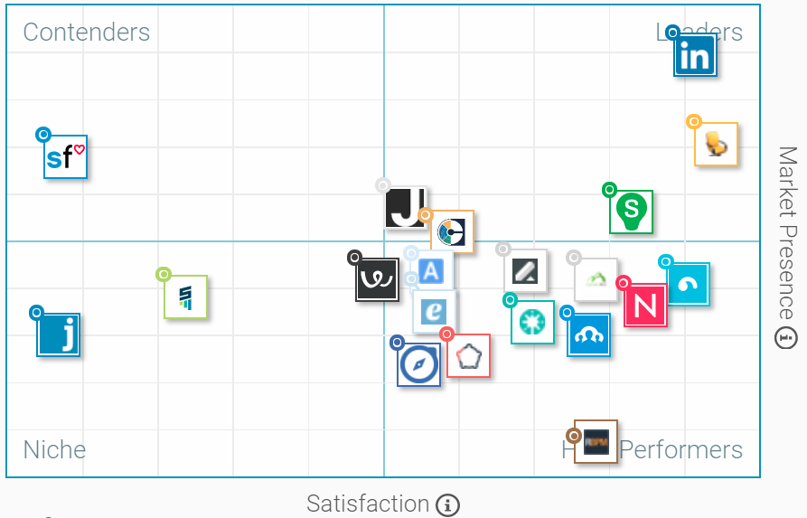

Figure 1. Market presence - Satisfaction status

Industry needs for internship and/or apprenticeship programs in Romania and Europe have resulted in several initiatives, as:

* Get in & GROWSTART: <http://www.startinternship.ro/despre>
* Go2intership:

<https://go2internship.com/?gclid=CMXF28nP-NICFWgW0wodRvIBjg>

* Hipo.ro: <http://www.hipo.ro/Interships>
* Internshipul.ro: <http://internshipul.ro/>
* Intership.gov.ro: <http://internship.gov.ro/>
* Practica-ta.ro: <http://www.practica-ta.ro/>
* Student in Romania: <http://www.studentinromania.ro/stagii-de-practica/>
* AIESEC: <http://www.aiesecbucharest.ro/>

Programedeintership.ro and inPractica.ro are other platforms for internship and apprenticeship: <http://programedeinternship.ro/> & <http://www.inpractica.ro/>

Competitors in the area of social media monitoring are depicted in the table below (TABLE 1).

|  |  |
| --- | --- |
| **Competitor​** | **Features​** |
| Hootsuite​ | * covers multiple social networks, including Twitter,Facebook, LinkedIn,WordPress, Foursquare and Google+​ * has social media management functions.​ * provide weekly reports​ * has excellent team management facility (delegating tasks, sending private messages) ​ |
| TweetReach​ | * measures the actual impact and implications of social media discussions​ finding out who are your most influential followers​ |
| Klout ​ | * measures influence through engagement on Twitter​ |
| Buzzsumo ​ | * tool for content research​ * analyze and monitorFacebook pages​ * will tell you what day is the best to post, how long your posts should be, what types of content works best, and monthly stats over time​ |
| Twazzup ​ | * Twitter monitoring tool​ * most active top influencers, most retweetedphotos and links, and the top 10 keywords related to your search​ |
| Boardreader ​ | * search for specific terms on a range of different forums​ * generate charts to look for trends​ * great way to find conversations about your brand​ |
| HowSociable ​ | * measuring your and your competitors’ social media presence​ * track 12 (free) / 24 (pro) social sites, including Tumblr and WordPress​ * breaks down scores for different social media platforms​ |
| Likealyzer​ | * analyze your Facebook page​ * get info on engagement, likes over time, and your ranking against similar pages​ |
| TweetDeck ​ | * tool for scheduling tweets and monitoring your interactions and messages, as well as tracking hashtags and managing multiple accounts​ |
| Mention ​ | * monitors million of sources in 42 languages​ * keep track of your team’s actions, share alerts and assign tasks. Generating reports and exporting mentions over a selected period of time​ |
| Twitonomy ​ | * offers a range of metrics about your account. You can add your competitor’s Twitter handles to gain insights about their activity too​ * shows you details of your Twitter lists, followers and followings, your most popular Tweets, engagement statistics and much more.​ * track conversations on Twitter based on hashtags, users, or lists. The details are displayed in graphs and easily digestible stats.​ |
| Followerwonk ​ | * find, analyze and optimize your online presence for social growth.​ * planning outreach campaigns by allowing to search Twitter bios, connect with influencers or fans and break them out by location, authority, number of followers and more.​ * can compare your social graph to competitors, friends or industry leaders and measure how well you are doing.​ |
| SumAll ​ | * a cross-platform social media monitoring tool that will help you understand the correlation between your social channels​ |
| Simply Measured​ | * analyze paid, owned and earned activity​ * used to create free individual reports for Facebook and Instagram.​ * the Instagram tool will analyze an account to see where its strengths and weaknesses are.​ |
| Google Alerts​ | * monitor the web for interesting new content, mentions of your brand or even yourself, your competitors, industry leaders and so on​ |

Table 1. Competitors in the area of social media monitoring

Competitors in the field of self-serve analytics and business intelligence for enterprises are depicted in the table below (TABLE 2).

|  |  |
| --- | --- |
| **Competitor​** | **Features​** |
| Teradata Analytics Platform​ | * gives access to the best analytical function and mentions​ * gives preferred tools and languages across data types and storage forms that are diverse in nature​ * removes the need to store data across multiple engines by pipelining the analytics directly into the platform.​ |
| Tableau ​ | * self-service analytics platform fordata visualisations​ |
| Qlik​ | * data visualisation, BI and analytics tool​ |
| SAS​ | * a self-serve solution called Visual Analytics​ * Has various add-ons available through their large portfolio of analytics products​ |
| Domo ​ | * BI and data visualisation​ * allowing any data source to be plugged into the platform and prepare data for analysis without knowing how to code in SQL. automate regular reports and easily share them across the organisation to collaborate on​ |
| Splunk Analytics for Hadoop​ | * explore, analyse and visualise data in Hadoop environments​ * Users can create and share charts, graphs and dashboards and interactively query raw data by previewing results and refining searches​ |
| Trillium​ | * two products for data quality control: Refine and Prepare. Both aid data preparation by connecting up disparate data sources and pooling them into a single repository, namely a Hadoop environment​ |
| Logi Analytics ​ | * self-serve analytics and data visualisation platform.​ |
| Crimson Hexagon​ | * self-serve social media analytics for large enterprise customers​ |
| Alteryx​ | * analytics platform for business analysts​ * combines data preparation, blending and analytics from across a variety of data sources, including spatial data​ * opens up R-based predictive analytics to analysts with no coding skills via a drag and drop tool​ * a simple tool for report generation and these can be exported to a variety of formats ​ |
| Spotfire ​ | * pulls together data from across the business and is able to present historical and real-time data on one unified platform.​ * data can then be broken down and analysed in a whole range of ways: interactive visualisation, diagnostic analytics, data augmentation, predictive analytics and location based insights​ |
| SRK ​ | * pull data from various data source into a dashboard​ |

**Table 2.** Competitors in the field of self-serve analytics and business intelligence for enterprises

The economic growth, which has led to the development of companies and the creation of new jobs, feels increasingly strong in the labour market for some time and implicitly in the financial results of the recruitment industry organizations. Thus, the biggest recruitment sites in Romania reported last year record highs, according to data from the Ministry of Finance[7], which shows that this year the leader has changed, eJobs[8] rising to the top position.

Last year, Ejobs Group and BestJobs Recrutare SA, which operates the ejobs.ro and bestjobs.ro recruitment sites, reported for last year record financial increases, with cumulative revenues reaching 11.3 million euros, according to the published data from the Ministry of Finance official website.

The ranking is led by eJobs Group SRL, the company that manages the online recruitment platform with the same name, which last year recorded business worth 26.6 million lei (5.9 million euros), up 59%, and a profit of 15.9 million lei, 58% higher than in 2015. By comparison, in 2015, the company had a turnover of 3.76 million euros and posted a net profit of 1.91 million euros.

For the current year, Andrei Frunza, eJobs CEO, estimates a 30% increase in turnover of ejobs.ro, amid growing demand for recruitment from companies.

Bestjobs.ro portal, developed by the Neogen group whose majority shareholder is Romanian entrepreneur Calin Fusu, generated last year 5.4 million euros, 39% more than in 2015. Net profit registered by Bestjobs.ro in 2016 was 1.75 million euros, the advance being 36% compared to 2015.

And Hipo.ro, a site developed by Catalyst Solutions, grew slightly in the past year when it recorded business growth of 5% and 6.1 million lei (1.35 million euros) respectively. The company recorded a 9.5% drop in net profit, down from 1.14 million lei.[9]

### Gaps in the market

Advances in technology create new opportunities, but they also open up new risks and problems [[10]]:

* Data security and privacy are key concerns going forward. Recruitment companies store huge quantities of sensitive data, including contact information, work history, and salary details. Security breaches could be devastating for recruiters and candidates.
* High attrition rates are another market challenge, according to TechNavio’s report. “Work pressure, monotonous work, other career opportunities, and organizational culture are the top reasons behind the increased attrition rates,” the report explains. High turnover creates additional costs and eat away at overall ROI.

### Advances in technology create new opportunities, but they also open up new risks and problems [[11]]:

* Data security and privacy are key concerns going forward. Recruitment companies store huge quantities of sensitive data, including contact information, work history, and salary details. Security breaches could be devastating for recruiters and candidates.
* High attrition rates are another market challenge, according to TechNavio’s report. “Work pressure, monotonous work, other career opportunities, and organizational culture are the top reasons behind the increased attrition rates,” the report explains. High turnover creates additional costs and eat away at overall ROI.

# Exploitation plan

The SoMeDi project will only succeed if the results of the project are converted into successful products in the market. This can only be achieved with an accurate market analysis, a realistic exploitation plan preparation, and the appropriate exploitation activities during the project (such as those indicated above).

The goal of SoMeDi is to unlock the hidden value in digital content and the trace left by human actions through the application of advanced artificial intelligence and machine learning techniques. In order to achieve this goal, SoMeDi wants:

1. develop new machine intelligence methods and tools that efficiently serve to analyse digital interaction data including social networks. These methods will produce improvements in the analysis of feelings and opinion mining that will increase the perception of user attitudes, methods to analyse user activities and online phenomena, how to detect communities and dissemination of messages on social networks, and methods to offer help in making decisions based on data analysis for different purposes of use.

2. connect the value extracted through these methods with production and business processes, to improve offers and customize services and content configurations.

3. explore how to use social networks actively and promote the growth of piracy and marketing in both B2C and B2B markets, develop a methodology to enter and act efficiently in social networks for the growth of piracy, help the client and offer marketing to company users and customers.

4. Produce a guide presenting a practical digital interaction and an intelligence methodology in social networks illustrated in the cases of use of the project.

As part of the exploitation plan, the potential impact of the SoMeDi project result has been analysed through a SWOT analysis - methodology of study of the situation of a product, analysing its internal characteristics (Weaknesses and Strengths) and its external situation (Threats and Opportunities ) in a square matrix. Next, the resulting SWOT analysis can be seen:

|  |  |  |
| --- | --- | --- |
|  | Positive aspects | Negative aspects |
| Internal origin | **Strengths**   * Technological superiority on the part of the partners * Projects of smaller scope that coer part of the needs described in this Project. * Access to the related market by the partners individually * Previous experience | **Weakness**   * **Partners develop their economic activity in other areas, which can cause them to lose focus** * **The nature of the different companies can make it difficult to create a common exploitation model and agenda** |
| External origin | Opportunities   * The SoMeDi market is incipient and studies point to the increase of users using social media at the same time or in relation to what happens on the screen * Innovative idea in the market and product without real competition * Booming social networks | Threats   * Very changing market * Appearance of new competitors very focused in particular areas * Regulatory changes in legislation on data protection |

The following table 3 explains the exploitation activities of the companies and research partners.

|  |  |
| --- | --- |
| Beia (SME,RO) | Use Case Recruiting applies Sentiment Analysis techniques to selected candidates for interview. The goal is to identify the candidates' opinion regarding several aspects: company activity, required aptitudes, and knowledge.  Thus, BEIA will attract new users in SoMeDi platform by promoting the following services:   * Data Mining type Clustering and Text Analytics methods to find the following information / pattern:   1. the general opinions of the candidates about the company where they are applying,   2. the candidates’ opinions about the fields of activity; why some fields are attractive and others are not,   3. the level of training of the candidates in the analyzed fields of activity,   4. the information level of the candidates regarding the company activity,   5. tendencies and expectations of internship programmes candidates. |
| Hi-Iberia (SME,ES) |  |
| Experis (SME,ES) |  |
| SIVECO (IND,RO) | Siveco, one of the leaders in the Romanian software market, is planning to use the results of the SoMeDi project in extending it’s technological portfolio and in the same time enter the specific market of recruiting thru social media. The know how acquired and shared in the SoMeDi project is also a pillar in for entering the Sentiment Analysis sector thru the use of specific demonstrators researched and built under the project. |
| Taiger SPAIN (SME,ES) | The TAI participation in the project aims to bring a certain number of benefits to the company: First, assets in the form of new technologies which will bring new opportunities to our current and future customers. Second, those technologies in current markets and also in new ones. Both cases are included in our exploitation plan. |



## Joint exploitation plan (consortium level)

The SoMeDi platform will include:​

* a marketing demonstrator, the platform will collect customer feedback on the company's products / services in order to improve marketing performance. ​
* the second demonstrator will provide a valuable service to recruiting companies, aspiring to increase the absorption rate of graduates and students on the labour market.​

## Marketing solution exploitation plan

### Subject of exploitation

The **goal** is to improve the marketing performance of companies in two different sectors based on their social media profiles and considering the feedback on the company’s products and services. The company will improve its marketing proposition by receiving personalized recommendation based on social impact information helping the business to modify their marketing campaign to align it with clients needs, understand their brand impact and performance and in a whole help them to increase their impact and incomes.

In consequence, this use case will be based on four main axes that could be exploited:

1. Competitor Analysis based on Social Media.
2. Brand monitoring (analyse the reputation of the brand).
3. Event detection with sentiment detection.
4. Marketing campaigns track and recommendations.

**KPIs:**

The current defined KPIs for the Marketing use case are as follow:

|  |  |  |  |
| --- | --- | --- | --- |
| KPI name | Initial  value | Targeted value | Current  value |
| **1. Real Customers Involved in the evaluation** | 0 | 2 | 1 |
| The only customer that is involved as of the writing of this document is the LATERAL restaurant chain. | | | |
| **2. % of users engaged increase (followers)** | 0 % | 30% | 0% |
| The number of followers (e.g., Twitter or Tumblr followers, Facebook friends) and their trend (increasing/stagnant/decreasing) is a good first-order indicator on the interest that an account generates. For any given customer campaign on a social media outlet we will track their followers for that and others social media sites and check for improvement. It is expected that moderate amounts of extra interest will be spurred by the use of SoMeDi campaigns.  This is yet not measured as official evaluation sessions have not started for SoMeDi. | | | |
| **3. Improved % in Monthly Active Users on Social Media by customers of SoMeDi over baseline** | 0 % | 30 % (*) | 0 % |
| Monthly Active Users (MAU) is a metric of how users interact with a social media offering of the customers (e.g., their Twitter profile). We expect that the increases capabilities offered by SoMeDi will result in a significant (~+30%) increase of this figure over the baseline.  This is yet not measured as official evaluation sessions have not started for SoMeDi. | | | |
| **4. Improved Stickiness of User Activity over baseline** | 0% | 50% | 0% |
| Stickiness of user activity is a measure of the daily returning rate of users to a business offering (e.g., Daily Active Users / Monthly Active Users). For example, stickiness of 50% would mean that half of the users interacting each month with the offering do so at least for 15 days. SoMeDi expects that the usage of their tools will improve this metric by at least 50% over the baseline that the customer achieves without our tools.  This is yet not measured as official evaluation sessions have not started for SoMeDi. | | | |
| **5. Improved M1 User Retention over baseline** | 0% | 50% | 0% |
| User retention is a measurement of the number of first time users that return over a given period of time to the business offering. In SoMeDi we will focus on month 1 (M1) returns to measure this and try to achieve over 50% improvement over the baseline.  This is yet not measured as official evaluation sessions have not started for SoMeDi. | | | |

The **solution** needs to support information from social media related to companies (restaurants and e-commerce) and provide the analysis details to them in an understandable and useful format.

The **solution** needs to support information from social media related to companies (restaurants and e-commerce) and provide the analysis details to them in an understandable and useful format.

### Context of exploitation

On January 2017, more than 200 million posts were tagged as *#food* and 23 million as *#drinks*, and food and beverage photos are easily some of the most popular types of content on Social Networks. It’s very likely that your customers are posting with or without your interaction. Besides, considering that 88%of people are influenced by reviews and online comments, having a social media strategy for your company is important[12].

In consequence, it’s clear that businesses — e-commerce— need to have a strong social media presence in order to drive more sales. However, listening in on the discussions surrounding your brand and products will help you better understand your buyer’s behaviours and how they use social media to search for and share their experience with your product or services. This will allow the enterprise to focus its social media strategy where it matters most.

As solution SoMeDi, intends to support enterprises to improve their presence in social media by providing feedback extracted from social media data from clients.

### Value proposition

SoMeDi platform tries to solve the challenge of efficiently generating and utilising social media and digital interaction data enabled intelligence. The results of the project will give the companies competitive advantage through quicker and more automatic processes that benefit from and utilise the data about users’ intentions and preferences in various digital environments, and by being able to reach out to consumer and business users through current and emerging social media channels.

The SoMeDi project explores how interaction data generated by users on digital systems, such as social networks and SaaS, as well as content created and shared in social media services, can be turned into Digital Interaction Intelligence (DII). DII can be used to provide insights for market and product development, improve the efficiency of business processes and personalise interactions and services. This way there will be added value both for companies and their clients.

Particularly for the Marketing use case, the added value provided by SoMeDi is the provision of a tool able to monitor the activity of the enterprise profile in the social media. Starting from the analysis of the evolution of mentions; the evolution of public sentiment; the impact of different topics; co-mentions; evolution of campaigns and promotions posts, the tools will recommend the enterprise with some practises to enhance the marketing performance of companies.

### Target audience / Market segments

The main targeted stakeholders are:

* Restaurants
* Companies with e-commerce
* Marketing enterprises managing the restaurants and companies social media

### Impact / revenue sources

**Improved customer support**

According to a recent study, over 60% of customers use social media every day. More than half prefer social media to reach out to brands rather than call a contact centre. These customers expect a response within the hour for general enquiries and over 70% expect a response to complaints within the hour. One fifth of customers spend 20% to 40% more with brands that provide good social customer service and 83% of consumers do not complete an intended purchase because of a poor social customer service. In short, customers are rapidly becoming increasingly social, vocal, mobile and brand engaged and pose increasingly high demands on the overall customer experience.

SoMeDi will allow companies and organizations to pick up on this trend and improve the overall customer experience by enabling them to interact faster and in a more targeted and personalized fashion.

**Increase the Product / Service Quality**

Since Turkey use case targets the understanding the complaint of the companies’ product / services, it is intended create a chance to represent those complaints to product / service owner as a potential that they can invest more to strengthen them. And if it’s a part of a product / service tree, then it will be also another benefit to warn the company not only a specific product / service buts it’s all connected product / service tree will benefit from the improvement. So SoMeDi will help to increase the Customer Experience that is created in the social media for future success of the companies.

### Marketing

Over the past five years, companies are increasingly investing into social media programs and employing Social Media Monitoring (SMM) technologies and services to monitor and solicit public opinions about their brand and products, shape their online presence and develop strategies to engage and harness the social paradigm in order to build long term and profitable relationships with their customers. At a time when the number of Social Media technologies grows at an unprecedented pace and as the lines between sales, service and marketing continue to blur, and increasing number of companies are demanding more than a point solution, but rather integrated social media monitoring tools.

Social media marketing has become an enterprise-wide endeavour. In 2014, enterprises with more than 100,000 employees reported an average of 49 full-time employees supporting social media, compared to just 20 in 2010 (2). This has driven to the fact that currently exist hundreds of Social Media Monitoring tools for companies and enterprises.

However, most of these tools are focused on providing their services to large enterprises with unaffordable prices. Being aware of the difficulty to compete with them, SoMeDi will focus on providing its Social Media Monitoring functionalities to small business enterprises interested in adopting this kind of tools and particularly to restaurants which are interested on improving their social media interactions without wasting high amounts of money. This, together with the general architecture of SOMeDi, will allow us to enter in this market, establish close contact with customers and provide personalized services adapted to clients’ specific needs. SoMeDi is designed to cover all the current challenges in social media monitoring in order to get reliable information from this vast amount of data, opening the path to anticipate to customers’ wishes and complaints.

In consequence, SoMeDi has been conceived under the Software as a Service (SaaS) approach, in which through a contract, clients are able to enjoy the services provided by the tool. It has been designed as a web application that via a web browser allows users extensive media coverage access. The web based architecture and mobile ready approach enables access to SoMeDi through mobile devices such as tablets or mobile phones. In addition, there is the possibility of integrating SoMeDi with third party applications currently used by restaurants or e-commerce as POS, warehouse management or CRM tools.

### Business plan

SoMeDi is envisaged as Software as a Service (SaaS) which means that it is a software licensing and delivery model in which software is licensed on a subscription basis and is centrally deployed and hosted by the provider and accessed on demand by the customer. As an example deployment using SaaS, SoMeDi will be installed on HI-Iberia servers. In consequence, for SoMeDi, a business model consisting on a contract for exploiting the services provided by it has been tentatively decided and, in this section, detailed for the case study of HI Iberia. The results are expected to be transferrable to the other comparable companies in the consortium such as Taiger or Experis IT.

Through the SaaS contract, clients are required to pay a monthly fee that allows them to enjoy the functionalities of SoMeDi. This will be offered as a bundle option with already offered SaaS systems by HI Iberia such as the HIPPOS[13] point of sale system.

Considering the project results expected for SoMeDi project two different types of clients are envisaged:

* Digital Marketing Companies which are in charge of managing and monitoring the enterprises social media
* Individual companies which internally manage their social networks. In this case, and based on HI-Iberia business and experience we envisaged also two types of clients:
  + Companies, shops, businesses which are connected to HI-Iberia through other company products could be interested in social media monitoring through SoMeDi.
  + Restaurants which already are using our Management Software, particularly POS, Warehouse management, CRM and so, SoMeDi is envisaged as an extra functionality in the set of services with an extra cost.

There will be different types of subscriptions depending on customers providing different support depending mainly on:

* Volume of messages posted daily via the Social Media
* Number of competitors
* Number of key words

In consequence, for SoMeDi we have envisaged different types of subscriptions:

* **Basic subscription** offers:
* Information about popular users, trending topics, percentage of positive/negative comments
* Personalized and configurable visualization layer for the info presentation.
* Multilingual platform for the analysis of data inputs in Spanish and English.
* Total number of analysed messages less than 1000 per month
* **Premium subscription** offers apart from the set of Basic subscription functionalities**:**
* Multimedia data as input to be analyzed and treat them as an extra source. This multimedia analysis will be mainly focused on images published by users in social networks.
* Proactive analysis results which provide suggestion about possible future measures to improve the business of the company (for example: product campaigns suggestions based on the social media users behavior).
* Any basic subscription that generates analyses in excess of 1000 per month
* **Business subscription** will be negotiated directly with the marketing company and therefore this modality won’t be considered for the revenue estimations.

Also the volume of messages to be analysed will be considered depending on the customer as the amount of information analysed by a marketing company will presumable be bigger than the data analysed by a single business.

Prior to the subscription, a user can access the services free of charge for a month as a test, starting from this period the user will have to pay according to the types of subscriptions already defined.

The Basic modality will cost 20 €/ month, while the Premium functionality will cost 35 €/month. Changes between modalities are allowed. In case SoMeDi tool is sent as an extra functionality to the services already hired, the extra cost will be 5€/month in case of basic subscription and 7€/month in case of premium subscription.

Considering this fees, the business plan envisaged for SoMeDi is provided in the following table. It is important to take into account the following details:

* Year 0 is considered as the starting point which includes the initial investment for the project execution.
* Once the project ends, the business plan is built for the following 5 years
* HI-Iberia needs an initial investment of 132k€ for obtaining the desired product, considering the current state of the art of the technology. This amount is distributed in the following manner:
  + 97 k€ for the project execution (currently on going)
  + 35 k€ for reaching the product level starting from project results.
* The number of users envisaged for the business forecast will be sequentially growing, considering both new and possible casualties over the year as well as the change between different modalities.



As it can be observed in the table, the payback period will last 3 years, which means that once the breakeven point will be achieved (3rd year), the application will start making money and the costs will disappear for the consortium. Following with the business analysis, it is necessary to calculate VAN, TIR and ROI rates to predict the results of the investment and profitability of the project:

|  |  |  |  |  |
| --- | --- | --- | --- | --- |
| **Concept** | **Discount Rate** | **VAN** | **TIR** | **ROI** |
| **Value** | **9%** | 30.679,70€ | 15,17% | 72,30% |

For the VAN and TIR calculus, a rate of 10% is considered to the first years of life of SoMeDi services. Analyzing these results:

* The VAN is greater than zero. It means that the investment is profitable and it adds value to the companies implicated.
* The TIR is much greater than the discount rate so this emphasizes the idea of the VAN value.
* The ROI rate is calculated considering the net retained earnings during the first 5 years of SoMeDi tool. This value means that the company is earning 72,30% on top of the investment at the closure of the simulation.

It is necessary to analyse this preliminary business plan with a series of caveats that apply for the envisaged product:

* Ever since the growth of social media in the last years has been steady and even exponential in some regards and timeframes, it is extremely difficult to anticipate the changes in the field and the impacts of any disruptive elements that appear in the global domain and which would require fundamental redesigns of SoMeDi rather than the incremental growth in features that is envisaged. However, the basics of analysis tools for SoMeDi are related not to particular details of the social media artefacts but on very substantial elements such as text and language that will be analysable through our NLP stack as well as image processing mechanisms that will also remain usable. So we perceive that the risk of truly disruptive change (e.g., one that renders SoMeDi as truly useless in the social media arena) is low for the following five years.
* Cost structure analysis is for now pretty simplistic. Only the basic needs for a medium set of analysis volumes are considered. The total aggregated costs of hosting and other operative expenses is around 40k€ which seems reasonable as of today and includes estimates on the aggregated cost of hardware, licenses, utility costs (electricity) and a number of others. This should be studied further and will be better refined in D5.3 in which we’ll present the final status of this business plan.
* Finally, this analysis only considers the two simpler methods in which the product is offered to the customers (as an extra on top of an existing product and as a simple standalone tool) and only considers low volume customers. For larger ones, the pricing could not be maintained and would require individual contracts to be produced and signed between the parties. The associated running costs would also change wildly. Then, by nature, it goes beyond what we can anticipate in this interim analysis. We expect that by the time D5.3 is released we will be able to anticipate at least partly the requirements and costs of these new customers, and hence provide an estimation of the associated business.

## Recruitment solution exploitation plan

### Subject of exploitation

Goal: to guide and support young adults in the transition from university/high schools and during their first experience on the labour market ​

* receive personal recommendations in the form of internship and apprenticeship programs ​
* professional micro networks with related events, geographical distribution and linkage with companies and organizations will be modelled

**KPIs:**

* Increase students’ access to internship and apprenticeship programs
* Better collaboration between universities and companies regarding internship and apprenticeship programs
* Increase employment rate
* In depth knowledge of the students regarding possible career paths according to their education level and profile

The solution needs to support:

* Students by identifying the major sectors in need of workforce;
* Recruiting companies by efficiently search through the candidates profiles and gather information from various sources to understand both the candidates' expectations and training, past education.

The current defined KPIs for the Recruiting use case are as follow:

|  |  |  |  |
| --- | --- | --- | --- |
| KPI name | Initial  value | Targeted value | Current  value |
| **1. Students accessing internship and apprenticeship programs** | 0 | 200 | 20 |
| This KPI represents the estimated number of students attracted into the SoMeDi platform, from an average number of 27000 students currently studying at University Politehnica of Bucharest[14]. | | | |
| **2. Better collaboration between universities and companies regarding internship and apprenticeship programs** | 0 % | 12,5% | 0% |
| This KPI represents the ratio between the number of universities that join the platform and the number of companies willing to recruit students for internship and apprenticeship programs. | | | |
| **3. Increase employment rate** | 0 % | 30 % (*) | 0 % |
| This KPI represents the ratio between the number of students that are accepted for internship and the total number of students that apply for an internship program. | | | |
| 1. **The students’ knowledge regarding possible career paths according to their education level and profile** | 0% | 70% | 0% |

This KPI represents the ratio between the students that are accepted for an internship program within their field of education and the total number of students accepted for internship programs.

### Context of exploitation

In Romania, according to this study [[15]] the percentage of students satisfied with the CCC (Career Counselling Centres) work was below 20%.

According to [[16]], the long-term unemployment incidence is above 40%.​ The main reasons behind these statistics concern the poor infrastructure – NGOs, Career Centres, etc.

The table below (Table 3) presents the main indicators of labour market, by gender and area.

|  |  |  |  |  |  |  |  |
| --- | --- | --- | --- | --- | --- | --- | --- |
| **Indicators for labour market** | **Total​** | **Gender** | | | | **Urban/rural area** | |
| **Men** | **Women** | | | **Urban** | **Rural** |
| ​Employment rate of population aged 20-64 ears | 66.0 | 74.7 | 57.2 | | | 65.4 | 66.9 |
| ​Unemployment rate | 6.8 | 7.5 | | | 5.8 | 7.0 | 6.6 |
| ​Long-term unemployment rate | 3.0 | 3.3 | | 2.6 | | 3.0 | 2.9 |
| ​Long-term unemployment rate for young people | 13.1 | 12.6 | | 14.0 | | 15.8 | 11.5 |
| Long-term unemployment incidence | 43.9 | 43.8 | | 44.1 | | 43.3 | 44.6 |
| Long-term unemployment incidence for young people | 60.6 | 61.2 | | 59.9 | | 58.6 | 62.4 |

Table 3. Main indicators of labour market by gender and rural/urban area

### Value proposition

**How SoMeDi platform – recruiting module is differentiating from other solutions.**

According to one of the majors HR portals [17], the decision to develop and implement a Facebook company page in order to run recruiting campaigns has proven more than inspired and fortunate, for the following reasons:

1. access to demographic information about the audience interested in the company and its job offers (from where can be obtained a clear understanding and model of motivation and preferences);
2. having a view over how the applicant uses such a platform (the conclusion being that the rate of application to jobs made public through Facebook and Twitter is twice as high as through the already established means);
3. the interview / employment rate was found to be 2:1;
4. the ROI in social networking for recruitment is very fast, although it does not necessarily generate a huge volume of new hired employees at the moment;
5. other arguments in favour for using Facebook to hold conversations with potential candidates.

The conclusion seems to be obvious: social networks will become more than just a fashion in recruitment, they will be a necessity. They not only change the focus from unilateral communication (publishing the ad in traditional environments, not allowing real feedback from the audience, rather than indirectly through the applications received) to a real conversation, but exponentially increase the level of understanding of the candidates' market and their expectations.

Other market studies [18] present the following statistics, more than relevant when planning to brand the SoMeDi platform products and services:

• 78.41% of the candidates say it's hard to find a job as expected;

• 85.49% of companies find it difficult to find the right candidates;

• 68.47% of companies have a career webpage section, and the application process takes about 5 minutes in nearly 63% of cases;

• 71.59% of candidates use a smart phone or other mobile device when looking for a job, but only 54.5% apply on such a device;

• 55.8% of companies have a clearly established recruitment budget, and in the case of 62.9% the budget is a maximum of 1,300 Euros;

• Finding the right candidates is the main problem for recruiters and the quality of applications is in the top of the challenges for the next 5 years.

On the other hand, an insight into the candidates’ opinions revealed the following aspects:

* Based on a market survey, the respondents stated that, if, in the current labour market, they find it hard to find a job adapted to the professional experience gathered. Almost 79% of the respondents answered affirmatively to the question above.

The main reasons which generated these statistics are:

* the candidate loss of interest due to lack of feedback from companies (50.16%),
* inappropriate and irrelevant jobs received from online recruitment platforms (48.03%),
* and a number insufficient of jobs adapted to the candidates' experience (45.57%).

Also, the study covered the main criteria important for a candidate when applying for a job:

* 59.38% of those who answered this question chose the simple and short application process as the first option,
* The following options are the ability to communicate directly with the recruiter (50.9%),
* an interesting job promotion (41.26%),
* and the ability to apply from mobile devices (16.9%).

**What is the biggest challenge for recruiters right now?**

Well, 69.09% of respondents say the biggest challenge is finding the right employees for their company vacancies. The next option that is found in the answers given by HR specialists is finding the necessary number of employees. Other challenges include building a stronger employer brand, recruiting costs, and technological developments in the field.

As for the challenges that recruiters will encounter over the next 2-5 years, the quality of applications seems to be the most important issue in the medium and distant future. This is followed by the number of applications, the technological solutions to ease work and relocation of employees.

The survey was conducted in March 2017 on a representative sample of 111 companies and 788 CEE candidates. The margin of error is plus or minus 3% across the entire sample.

### Target audience / Market segments

The main targeted stakeholders are:

* HR departments from various companies involved in recruiting processes;
* Recruitment companies;
* Students or fresh graduates.

### Impact / revenue sources

Impact on the current recruiting market:

* Employment rate by enabling recruiters to find quality hires by targeting talent, engaging candidates;
* Employment rate by giving personalized recommendation;
* Collaboration between universities and companies that offer internship or apprenticeship programs;
* Social presence for the companies that offer internship or apprenticeship programs.

According to a recent study, over 60% of customers use social media every day. More than half prefer social media to reach out to brands rather than call a contact centre. These customers expect a response within the hour for general enquiries and over 70% expect a response to complaints within the hour. One fifth of customers spend 20% to 40% more with brands that provide good social customer service and 83% of consumers do not complete an intended purchase because of a poor social customer service. In short, customers are rapidly becoming increasingly social, vocal, mobile and brand engaged and pose increasingly high demands on the overall customer experience.

SoMeDi will allow companies and organizations to pick up on this trend and improve the overall customer experience by enabling them to interact faster and in a more targeted and personalized fashion.

### Increase the Product / Service Quality

Since Turkey use case targets the understanding the complaint of the companies’ product / services, it is intended create a chance to represent those complaints to product / service owner as a potential that they can invest more to strengthen them. And if it’s a part of a product / service tree, then it will be also another benefit to warn the company not only a specific product / service buts it’s all connected product / service tree will benefit from the improvement. So SoMeDi will help to increase the Customer Experience that is created in the social media for future success of the companies.

### Marketing

The SoMeDi project recruiting use case will provide an enhanced solution for recruiters in order to reach a better fit when it comes to internship programmes and candidates skills.

Compared to direct competitors, SoMeDi platform will set a novel approach by using the latest technologies such as Machine Learning, Natural Language Processing and Sentiment Analysis backend services deployed within a reliable cloud infrastructure easily scalable, according to the number of subscriptions.

Pricing strategy is based on cost and competition, thus ensuring an optimal level of cost and revenue streams, while pursuing the prices set by direct competitors due to market growth in this area. Demand is also important in setting the price strategy, but the current market is not a decisive factor. The benefits of the services offered and the advantages to competitors can stimulate a higher price than the one demanded by demand as long as the market (and prices set by competitors) allows this.

To promote the online platform, the online promotion strategies will be used, such as:

* Search engine promotion: Using Google Adwords to show ads on the Google search engine.
* Promoting social networks: Using the advertising services offered by these platforms (Facebook, Twitter, LinkedIn, Youtube).
* Natural coverage: based on product content and publicly displayed on the platform or distributed on social networks where visitors arrive directly without clicking on a complaint.

Direct marketing will also be a strategic strategy for promoting the project and a platform that results from it.

In this sense, resources will be allocated for promotion in events of interest such as fairs, conferences, communication sessions and forums. For these are going to be compiled:

* info brochures in order to be distributed to prospective customers,
* posters that will be displayed on stands and,
* personalized with pens and sticks, where appropriate.

### Business Plan

The monthly subscription fee for companies varies based on specific desired criteria such as the competition analysis, reputation analysis and events prediction. The monthly subscription fee for students varies based on the complexity of recommendations, access to information and visibility to the company.

The platforms are provided by the means of four bundles:

* 1st tier – accessing the platform in order to search for candidates using several search filters;
* 2nd tier – matchmaking;
* 3rd tier – sentiment analysis over candidates CV;
* 4th tier – sentiment analysis over internship program feedback.

**Estimated prices** (TABLE4)

|  |  |
| --- | --- |
| **Customer​** | **Monthly fee (Euros)** |
| **Companies** | |
| Basic bundle | ​30 |
| Intermediate bundle | 60 |
| Advanced bundle | 100 |
| **Students** | |
| Basic bundle | 5 |
| Intermediate bundle | 10 |
| Advanced bundle | 15 |

**Table 4.** estimated prices

The monthly subscription fee for companies varies based on specific desired criteria such as the competition analysis, reputation analysis and events prediction.

The monthly subscription fee for students varies based on the complexity of recommendations, access to information and visibility to the company.

In the Tables shown in the following pages are presented:

* the estimated number of customers, companies and students (Table 5);
* the expected income during the exploitation period (Table 6);
* the expected profit during the exploitation period (Table 7).

**Estimated number of customers**

|  |  |  |  |  |  |  |  |  |
| --- | --- | --- | --- | --- | --- | --- | --- | --- |
| **Customer​** | **Year 1** | **Year 2** | **Year 3** | **Year 4** | **Year 5** | **Year 6** | **Year 7** | **Year 8** |
| Companies | 24 | 37 | 50 | 63 | 76 | 89 | 102 | 115 |
| Basic bundle | 10 | 15 | 20 | 25 | 30 | 35 | 40 | 45 |
| Intermediate bundle | 8 | 12 | 16 | 20 | 24 | 28 | 32 | 36 |
| Advanced bundle | 6 | 10 | 14 | 18 | 22 | 26 | 30 | 34 |
| Students | 210 | 420 | 630 | 840 | 1050 | 1260 | 1470 | 1680 |
| Basic bundle | 80 | 170 | 260 | 350 | 440 | 530 | 620 | 710 |
| Intermediate bundle | 70 | 140 | 210 | 280 | 350 | 420 | 490 | 560 |
| Advanced bundle | 60 | 110 | 160 | 210 | 260 | 310 | 360 | 410 |

**Table 5.** estimated number of customers

**Expected income during the exploitation period**

|  |  |  |  |  |  |  |  |  |
| --- | --- | --- | --- | --- | --- | --- | --- | --- |
| **Customer​** | **Year 1** | **Year 2** | **Year 3** | **Year 4** | **Year 5** | **Year 6** | **Year 7** | **Year 8** |
| **Companies** | 16.560 | 26.040 | 35.520 | 45.000 | 54.480 | 63.960 | 73.440 | 82.920 |
| Basic bundle | 3.600 | 5.400 | 7.200 | 9.000 | 10.800 | 12.600 | 14.400 | 16.200 |
| Intermediate bundle | 5.760 | 8.640 | 11.520 | 14.400 | 17.280 | 20.160 | 23.040 | 25.920 |
| Advanced bundle | 7.200 | 12.000 | 16.800 | 21.600 | 26.400 | 31.200 | 36.000 | 40.800 |
| **Students** | 24.000 | 46.800 | 69.600 | 92.400 | 115.200 | 138.000 | 160.800 | 183.600 |
| Basic bundle | 4.800 | 10.200 | 15.600 | 21.000 | 26.400 | 31.800 | 37.200 | 42.600 |
| Intermediate bundle | 8.400 | 16.800 | 25.200 | 33.600 | 42.000 | 50.400 | 58.800 | 67.200 |
| Advanced bundle | 10.800 | 19.800 | 28.800 | 37.800 | 46.800 | 55.800 | 64.800 | 73.800 |
| **TOTAL** | **40.560** | **72.840** | **105.120** | **137.400** | **169.680** | **201.960** | **234.240** | **266.520** |

**Table 6.** estimated income during exploitation period

**Expected profit during the exploitation period**

|  |  |  |  |  |  |  |  |  |
| --- | --- | --- | --- | --- | --- | --- | --- | --- |
| **Customer​** | **Year 1** | **Year 2** | **Year 3** | **Year 4** | **Year 5** | **Year 6** | **Year 7** | **Year 8** |
| **Companies** | 11.592 | 18.228 | 24.864 | 31.500 | 38.136 | 44.772 | 51.408 | 58.044 |
| Basic bundle | 2.520 | 3.780 | 5.040 | 6.300 | 7.560 | 8.820 | 10.080 | 11.340 |
| Intermediate bundle | 4.032 | 6.048 | 8.064 | 10.080 | 12.096 | 14.1112 | 16.128 | 18.144 |
| Advanced bundle | 5.040 | 8.400 | 11.760 | 15.120 | 18.480 | 24.840 | 25.200 | 28.560 |
| **Students** | 16.800 | 32.760 | 48.720 | 64.680 | 80.640 | 96.600 | 112.560 | 128.520 |
| Basic bundle | 3.360 | 7.140 | 10.920 | 14.700 | 18.480 | 22.260 | 26.040 | 29.820 |
| Intermediate bundle | 5.880 | 11.760 | 17.640 | 23.520 | 29.400 | 35.280 | 41.160 | 47.040 |
| Advanced bundle | 7.560 | 13.860 | 20.160 | 26.460 | 32.760 | 39.060 | 45.360 | 51.660 |
| **TOTAL** | **28.392** | **50.988** | **73.584** | **96.180** | **118.776** | **141.372** | **163.968** | **51.660** |

**Table 7.** estimated profit during exploitation period

# Dissemination

To reach the targets proposed in dissemination, various channels will be used efficiently. The main channel is the blog that can be adapted to the different levels of communication (general information and technical documentation) and the different types of content (text and presentations).

Other means that complement the composite of channels that serve for the communication of the SoMeDi project are:

Online communication/Social media:

* Creating a Twitter user to create community and encourage interaction with target audiences.
* Creation of Facebook page to create community and encourage interaction with target audiences.
* Instagram user creation
* Publications in the Linkedin profile of the partners for interaction with interest groups.
* Detection of influential people in each social network to act as ambassadors and prescribers of the product and communicate it.
* Identification of relevant spaces of third parties in the network with which links can be established as one more channel for transmitting project messages.
* Capturing emails from users to perform E-Mail Marketing

Online communication/Social media:

* A presentation PPT, that transmits in an agile and clear the solutions of SoMeDi to the needs of the market.
* Design of a technical sheet of the technological solution to place on the web, and
* Descriptive diptych of SoMeDi for events.
* Video?
* Infographics to distribute in online formats that explain graphically and easily the product and the process of using it.

Events:

* Broadcast in the press
* Presentation of the project to awards from the technology and marketing sector
* The dissemination in mass media, both specialized in the sector and generalist, is carried out thanks to the sending and follow-up of press releases.

The partners of the company will be able to offer a certain variety and channels depending on the type of company, use case and role in the Project. Table 8 includes a more detailed description of the approaches that the company's partners have chosen to access the markets with the results of the project.

To summarize the exploration approaches, we can see the results of the project in the following ways:

1. New features in current products / services

2. New products / services

3. New capabilities in business processes that can be used to offer products or services offering an improvement in the customer experience

As an example of new features added to current products we can mention the inclusion of data collection from social networks to support collaborative innovation.

Examples of new services to be marketed could be competitive intelligences and other types of customer and user analysis services, or a collective knowledge platform.

Examples of new capabilities in business processes are the planning, targeting and personalization of media since the current programming of the content of these media is largely following the typical transmission paradigm, as well as the marketing to users of businesses through current and emerging social networks.

The consortium has two research partners. This means that the results will be disseminated in scientific publications and conferences. In addition, the IPR generated in the project will be used in several ways, either through open source publication or through other licenses.

|  |  |
| --- | --- |
| Beia (SME,RO) |  |
| HI-Iberia (SME,ES) |  |
| SIVECO (IND,RO) | Siveco, one of the leaders in the Romanian software market, is planning to use the results of the SoMeDi project in extending it’s technological portfolio and in the same time enter the specific market of recruiting thru social media. The know how acquired and shared in the SoMeDi project is also a pillar in for entering the Sentiment Analysis sector thru the use of specific demonstrators researched and built under the project. |
| TAIGER SPAIN (SME,ES) | The project will contribute to overcome the previous limitations of the TAI portfolio, extending the technology and incorporating a fundamental set of characteristics identified in our business plan with respect to the processing and analysis of social networks. Therefore, it will provide an advantage over our competitors. While the European market of social networks is growing with new customers, there is an extensive opportunity in the Asian region where new market opportunities for the company have been sought. For this reason, TAI will build a headquarters in Singapore based on our experience in the fields of natural language processing, semantics and information retrieval. |

Table 8 Market opportunity and how partners want to benefit from it

Webpages will be the main channel of communication, that can be adapted to different levels of communication (general and technical documentation).

* Main webpage of the project (Figure 2):
  + News posted every month about the status of the project:
    - Increase visibility by (Google stats in Figure 3):
      * a tweet and a post on Facebook, of the post, to give more visibility;
      * mail to internal mailing list for the need of retweeting/sharing;
      * retweet or share by partners in order to increase visibility.

All partners reference the project on their webpage (Figures 4, 5, 6, and 7).

Webpages will be the main channel of communication, that can be adapted to different levels of communication (general and technical documentation).

* Main webpage of the project (Figure 2):
  + News posted every month about the status of the project:
    - Increase visibility by (Google stats in Figure 3):
      * a tweet and a post on Facebook, of the post, to give more visibility;
      * mail to internal mailing list for the need of retweeting/sharing;
      * retweet or share by partners in order to increase visibility.
* All partners reference the project on their webpage (Figures 4, 5, 6, and 7).

## Online communication on social media

* Creating a Twitter user account (Figure 9):
  + Create community and encourage interaction with target audiences. (future)
* Creation of Facebook page (Figure 8):
  + Create community and encourage interaction with target audiences. (future)
* Instagram user creation. (future)
* Publications in the Linkedin profile (future):
  + of the partners for interaction with interest groups.
* Detection of influential people in each social network (future):
  + to act as ambassadors and prescribers of the product and communicate it.
* Identification of relevant spaces of third parties in the network (future):
  + with which links can be established as one more channel for transmitting project messages.
* Capturing emails from users to perform E-Mail Marketing (future).

### Dissemination channel (Main Page of the project)

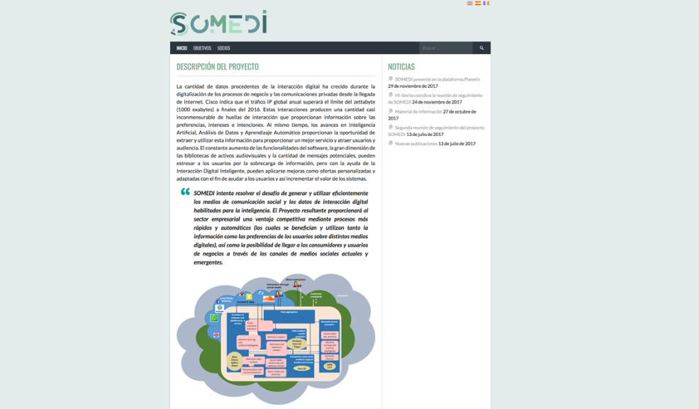

Figure 2. Somedi main page of the project

Based on Google Analytics information there are the audience numbers of the 3 last months:

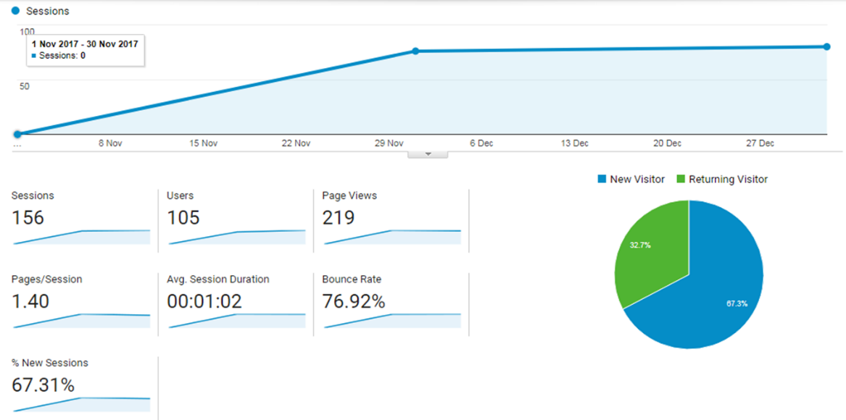

Figure 3. google analytics audience statistics

### Dissemination channel (Company Webpages)

Siveco’s Project Webpage

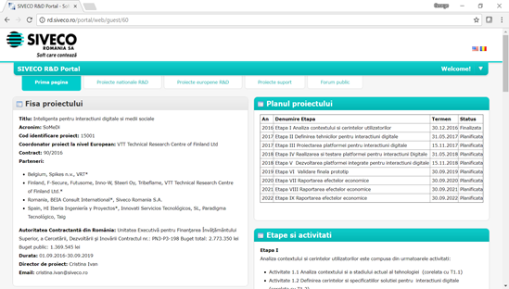

Figure 4. project webpage [siveco <http://rd.siveco.ro/portal/web/guest/60>]

Beia’s Project Webpage

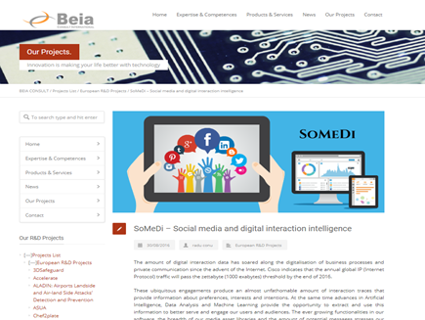

**Figure 5**. BEIA’s project webpage [BEIA webpage <http://www.beiaro.eu/somedi/>]

Taiger’s project webpage

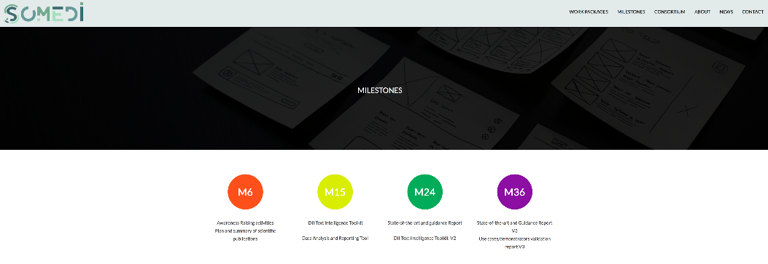

**Figure 6**. taiger project webpage

HI Iberia’s project webpage

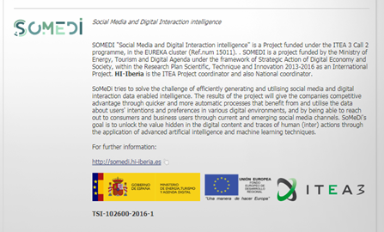

**Figure 7**. HI Iberia project webpage

### Dissemination channel (Social media)

Facebook

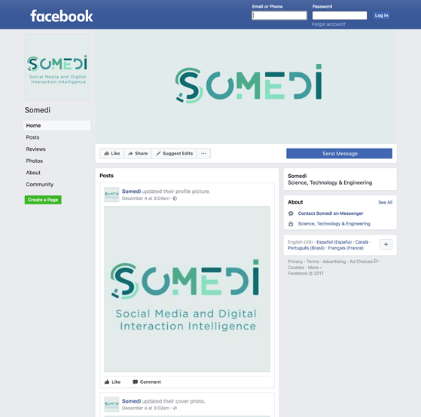

**Figure 8**. somedi facebook webpage <https://www.facebook.com/Somedi-146060299492427/>

Twitter

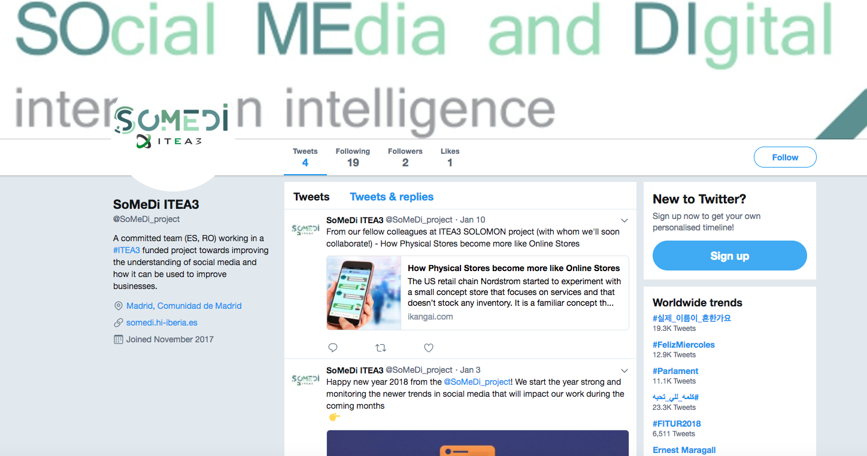

**Figure 9**. somedi twitter webpage <https://twitter.com/SoMeDi_project>

### Dissemination channel (Technological information platform)

The launch of SOMEDI project was reflected in the web page of the Technological platform PLANETIC, Figure 10, (Spanish technological platform for the adoption and dissemination of electronic, information and communication technologies) moreover it was also included in the newsletter of the platform, SOMEDI project will appear periodically when news should be disseminated.

* Currently there are 255-member organizations in Planetic.
* http://www.planetic.es.

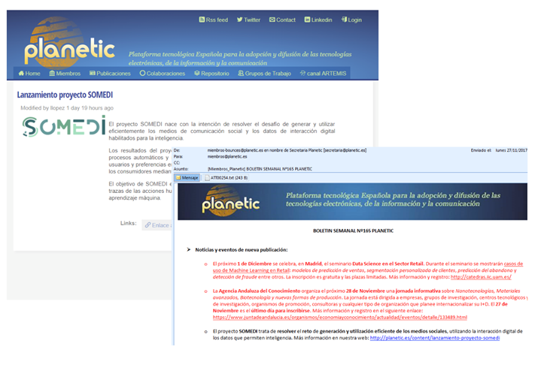

**Figure 10**. somedi dissemination channel – planetic spanish tech platform

## 4.2. Flyer & Leaflet

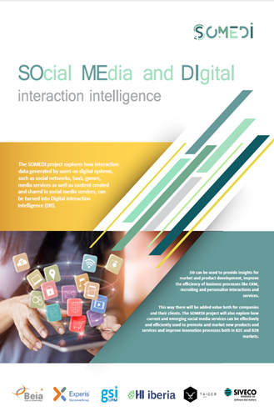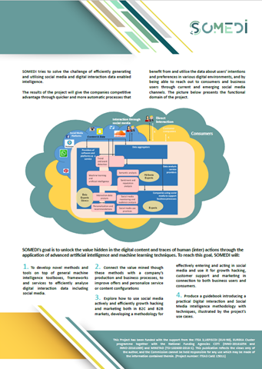

**Figure 11**. somedi flyer

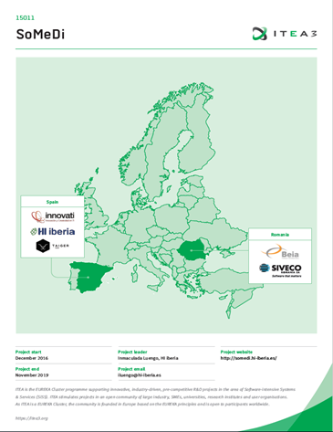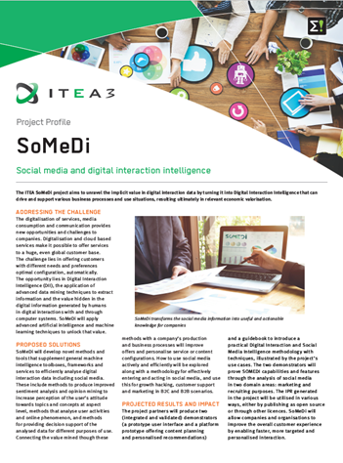

**Figure 12**. somedi leaflet

## 4.3. Publications & conferences

BEIA published in scientific journals and presented at conferences:

* G. Suciu, M. Anwar, R. Conu, “Social Media and Digital Interactions using Cloud Services for orienting Young People in their Careers” [19], In The International Scientific Conference eLearning and Software for Education (ELSE), “Carol I” National Defence University, Vol. 2, pp. 419-427, 2017, paper published and presented;
* G. Suciu, A. Pasat, T. Usurelu, “Social Media Cloud Contact Center using ChatBots”, Fabulous 2017; paper presented and accepted for publishing;
* G. Suciu, C. Boscher, L. Prioux, A. Pasat, C. Dobre, “Insights into Collaborative Platforms for Social Media Use Cases”[20], Studies in Informatics and Control Journal (SIC); paper published.

## 4.4. KPIs

Measures of success of the dissemination activities:

* Publication of at least 5 papers in technical and academic journals and conferences:
  + 1 published, 2 accepted;
  + 2 papers are being prepared (ongoing).
* Production of a guidebook:
  + Digital Interaction and Social Media Intelligence methodology and  
     techniques: Illustrated by the project’s use cases.
* Participation to minimum of 5 events (e.g. presentations, demonstrations or workshops):
  + 2 events attended: Big data driving business summit, Open Innovation 2.0 conference;
  + 3 events will be attended (ongoing).

# Future use cases

## 5.1. Future use case 2 (Turkish consortium)

INTRODUCTION

Turkish consortium use case aims at providing Next Best Offer (or Next Best Action) platform and corresponding services for telecommunications operator companies. Targeted platform will help telco companies and service providers with huge amount of consumers to provide the best personalized solution by predicting their next movement. Our use case will focus on collecting history data and real-time data from various channels such as mobile applications, services, as well as social media data.

Next Best Action solutions are regarded as a part of predictive analysis systems. Therefore proposed use case will study machine learning techniques extensively.

MARKET ANALYSIS

Acquiring and retaining customers is the main goal and one of the key challenges for any telecommunication service provider company. As the number, variety and complexity of products and services increase, providing a unique and personalized customer experience becomes the key selling point.

Better understanding of each individual customer and providing personal solutions have been a priority for organizations and marketing community for years. While the segmentation become one of the earliest solutions to address these problems, it has been evolved to persona based approach in time. While persona based approach increased the precision of targeted customers, none of the existing solutions were capable enough to get an accurate individual model.

Today, customer centric marketing is becoming even more challenging since the data sources increase and become more sophisticated. Real-time decision making is one of the key elements in putting the customer in center. Next Best Action solution (or Next Best Offer solutions) aims at predicting the instant, real-time trends of individual customers through different interaction channels and present the most suitable offer for upsell and cross sell.

As an emerging area, there are several actors targeting NBA solutions. In the context of market analysis, it has been observed that next best action product and real-time data processing products are difficult to communicate with each other on competitor platforms (IBM, ORACLE, Tibco etc.) and real incremental learning models are not used.

In addition, the platform to be integrated differs from other examples on the market in that it can work on the following skills:

• Use high-volume (~ 400gb) real-time cache and optimize services to run on.

• Execution of data analysis and preclustering and clustering algorithms on real-time data, ensuring that the best action is automatically selected after success comparison of clustering algorithms prepared for the same purpose.

• Providing an environment in which event management can analyze relationships and transitions between all events of a product to be fed.

EXPLOITATON POTENTIAL

Next best offer solution that is targeted to be developed in the project has a huge potential of exploitation. Main target customers will be telecom operators. Services that are provided will also be provided as corporate services for customers in several different markets such as, accommodation, retail, insurance, restaurants.

## 5.3. Potential use cases

Expansion plan:

* Future use case:
  + Turkish consortium, Solomon (Real-world shop retail analysis);
  + Potential areas of expansion: e.g. sales, politics, etc;
  + Will attend EUREKA Innovation May, 2018 to meet potential customers.

**Exploitation plan?**

Restaurant Lateral is currently a customer of HI-Iberia.

* HI-Iberia is providing Management Software for the restaurant (POS, Warehouse management, CRM).

SoMeDi is envisaged as an extra functionality in the set of services with an extra cost.

* The costs envisaged for SOMEDI functionalities will depend on:
  + Volume of messages posted daily via the Social Media;
  + Number of competitors;
  + Number of key words.

Preliminary business model depending on the type of users

* HR departments from various companies involved in recruiting processes:
  + Billed per number of profiles viewed.
* Students or fresh graduates:
  + Freemium (additional features will be charged).

# Somedi standardization plan

Standardization is the process of implementing and developing [technical standards](https://en.wikipedia.org/wiki/Technical_standard) based on the consensus of different parties that include firms, users, interest groups, standards organizations and governments Standardization can help to maximize [compatibility](https://en.wiktionary.org/wiki/compatibility), [interoperability](https://en.wikipedia.org/wiki/Interoperability), [safety](https://en.wikipedia.org/wiki/Safety), [repeatability](https://en.wikipedia.org/wiki/Repeatability), or [quality](https://en.wikipedia.org/wiki/Quality_(business)). It can also facilitate [commoditization](https://en.wikipedia.org/wiki/Commoditization) of formerly custom processes. In SOMEDI project, the idea of standardization helps to the solution for a [coordination problem](https://en.wikipedia.org/wiki/Coordination_problem), a situation in which all partnert can realize mutual gains, but only by making mutually consistent decisions.

## 6.1. Standards

* + W3C (World Wide Web Consortium):  is the main international [standards organization](https://en.wikipedia.org/wiki/Standards_organization) for the [World Wide Web](https://en.wikipedia.org/wiki/World_Wide_Web)
  + ISO (International Electrotechnical Commission): is an independent, non-governmental organization. It facilitates world trade by providing common standards between projects o partners who are in a common project.
    - ISO IEC 29100 Information technology – Security techniques which specifies a common privacy terminology, defines the actors and their roles in processing personally indentifiable information, describes privacy safeguarding considerations and provides references to known privacy principles for information technology.

# Conclusions and next steps

The overall outcome of the project can be evaluated as highly potential and beneficial for all the involved parties.

Throughout the project SoMeDi was able to receive fundamental market research outcomes, potential customers, marketing strategies, financial projections, human resources planning, and professional assistance. SoMeDi has a state of the art technology that allows it to position itself as first movers in the European Market as well as to attract necessary venture capital investment.

In the development of this business plan, six students of the International Master in Management were involved. They challenged themselves every day to think out of the box, search for information, act as consultants, put in practice skills learned and develop new ones in order to give VisualAD a new perspective and insights about their service.

The competitive advantage of SoMeDi can be maintained through a continuous investment in technology and an evolvement over years in order to be always one step ahead of its competitors. Two possibilities have been identified. The first option is to sell the technology to one of the big research companies. These companies could benefit from this technology in several ways. On the one hand, they could offer the same service as SoMeDi to their clients or produce production reports. On the other hand, they could support the research tools already present in the market.

1. <https://www.itproportal.com/features/top-10-business-intelligence-trends-for-2018/>
2. <https://www.technavio.com/report/global-media-and-entertainment-services-global-e-commerce-market-2016-2020>
3. <http://www.strategyr.com/MarketResearch/Recruitment_Software_Market_Trends.asp>
4. <https://blog.marketresearch.com/global-recruitment-industry-outlook-for-2017>
5. <http://www.jobvite.com/press-releases/2016/americans-uncertain-future-work-2016-jobvite-job-seeker-nation-shows/>
6. <https://www.g2crowd.com/categories/recruitment-marketing>
7. <http://www.mfinante.ro/pagina.html?pagina=acasa>
8. <https://www.ejobs.ro>
9. <https://www.wall-street.ro/articol/Careers/211593/joburi-joburi-joburi-ce-afaceri-au-rulat-cele-mai-mari-site-uri-de-recrutare.html>
10. <https://blog.marketresearch.com/global-recruitment-industry-outlook-for-2017>
11. <https://blog.marketresearch.com/global-recruitment-industry-outlook-for-2017>
12. <https://sproutsocial.com/insights/bars-restaurants-social-media-guide/>
13. <https://hippos.io/> -- HI Iberia Point of Sale product HIPPOS
14. <https://rei.gov.ro/index.php?&c=27&ddpN=1603056339&we=064a0196806f1159ce5df19dc5369c58&wf=dGFCall&wtok=69b9a4af975e07bf08e2a70ffbc56a01263608f4&wtkps=FYxBCoAgEAD/snfBbTVt/UN/CBWSgog1O0R/z24Dw8zCxI+wZbjrtguEwp6s1i5INyAlQSeDDLQad1rrIpadaFzblPEak6sK03Yk8Qo1mhbjHwz9lyHM4f0A&wchk=0d62cbee489f02638aca37215ffb869ce15b0d58>
15. <http://www.anosr.ro/wp-content/uploads/2014/04/Serviciile-de-consiliere-si-orientare-in-cariera-Perspectiva-studentilor.pdf>
16. ”LABOUR FORCE IN ROMANIA EMPLOYMENT AND UNEMPLOYMENT” , National Institute of Statistics, Information was obtained from “Household Labour Force Survey” (AMIGO), carried out in 2015
17. <http://www.portalhr.ro/studiu-de-caz-recrutare-prin-social-media/>
18. <https://smartdreamers.ro/blog/recrutare-afla-cum-se-recruteaza-in-2017/>
19. <http://proceedings.elseconference.eu/index.php?r=site/index&year=2017&index=papers&vol=25&paper=292d4776dfa7c7fbfa1bbff3820972dc>
20. <https://sic.ici.ro/insights-into-collaborative-platforms-for-social-media-use-cases/>