ITEA 3 PARTNER Project
Start date October 1st 2017
End date September the 30th 2020

Deliverable number and title:
D7.1 Internal and external web portals for the project
Lead beneficiary: | Benficiary Short Name
WP. no, title  and activity type | WP7: Project Management
Contributing Task (s) | Task 7.1: Coordination and management  Task 7.2: Communication and reporting
Dissemination  level | Type of dissemination level (PU - Public, CO-confidential,…)
Delivery date
Status | Working Draft
File name and  size | “File Name”, FileSize Kb

Authors List
Leading Author (Editor)
Name / Surname | Beneficiary Name (Short Name) | Contact email
Danny Deroo |  | danny.deroo@barco.com
Co- Authors
Name / Surname | Beneficiary Name (Short Name) | Contact email

Executive Summary

Table of contents
Executive Summary 3
Table of contents 4
1. Internal and external web portals for the project 8

List of figures
Figure 1: Example Figure 10
List of Tables
Table 1: Example of a table 11

List of abbreviations and acronyms
TAVI | Transcatheter Aortic Valve Implantation
AMC | Amsterdam Medical Center (Dutch Hospital)
GP | General Practitioner (Doctor)

- Internal and external web portals for the project

Internal project management:
Every member of every partner is registered on the online Basecamp tool, a great project management tool where all progress, contributions and documents are shared:
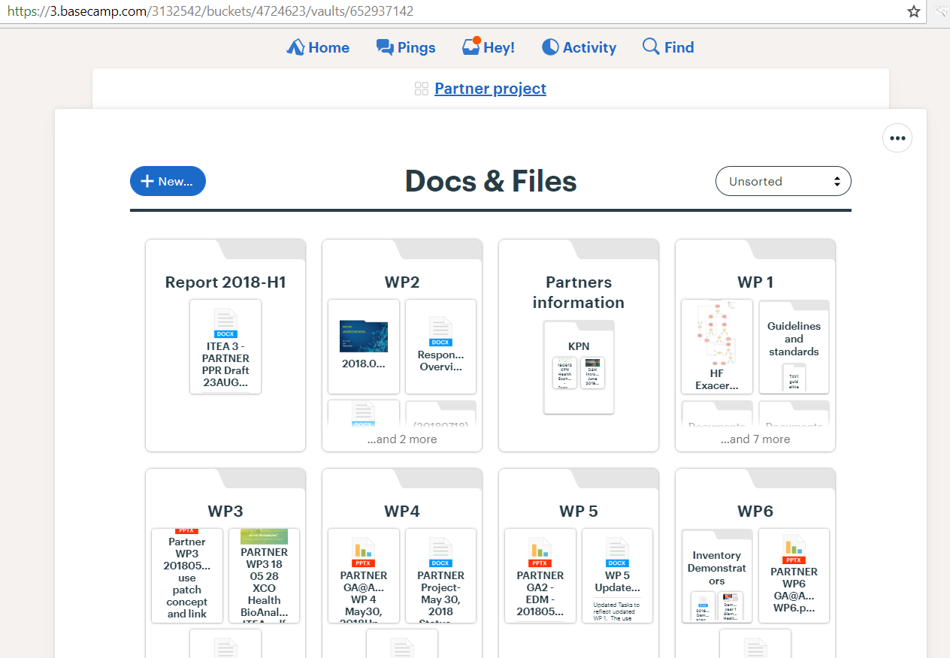

All reporting and progress of conference calls is also documented in Basecamp:
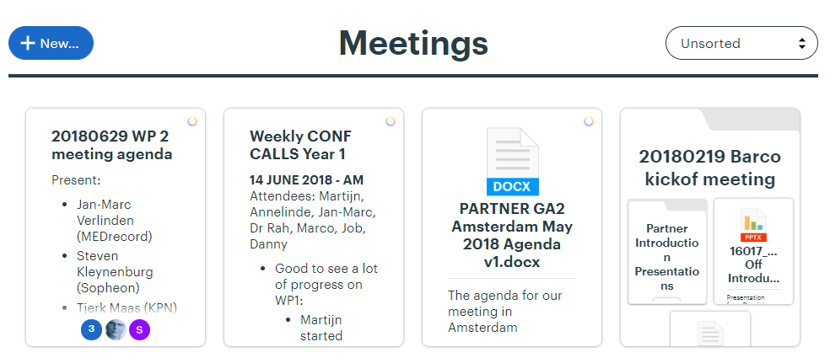

External web portal:
The partner Dapasoft has created a public website portal for our project on this URL:
http://dev.dapasoft.com/Barco
The current preview looks like this:
