Task 4.3 Advanced Visualization of Water Data

(Task leader: Keypro)

The purpose of this work task in Water-M project is to study, propose and pilot advanced visualization methods for smart water data. The special emphasis of this task is visualization of measurement data in the context of geospatial water network data.

In this task Water-M is using KeyAqua, a cloud based network and GIS solution to integrate measurement data and consequently visualizing the integrated measurement data on geographical network and background maps. Also, SAMI, the measurement data gathering and interfacing repository developed in the Water-M project is an important part of the overall architecture, which is depicted below:

SAMI
solution
Background
maps
Measurement
system 1

Water network
maps
Measurement
system 2
KeyAqua
solution
Network element information
Measurement
system N
Measurements relative to absolute location
Measurements relative to network topology
Geospatial analysis with other data sources

Also, here is screen capture from a real-world pilot that Water-M project runs with the water supply company in the City of Kuopio, Finland (case Vehmersalmi area).
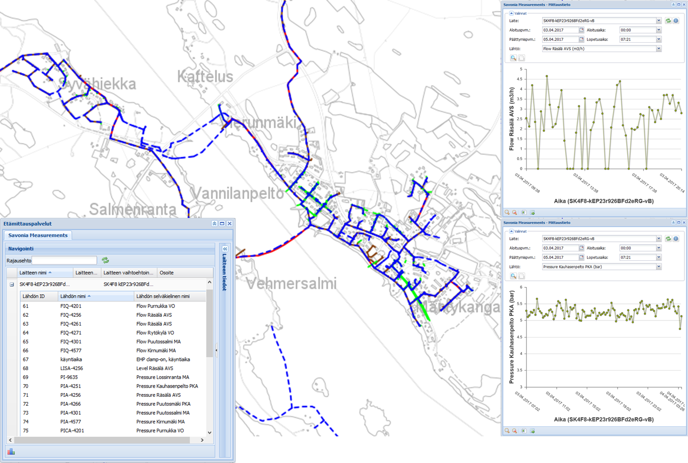

Visual user interface has several features, the main properties from end user point of view are:
- Geographic and property data:
KeyAqua allows you to exactly document the geographic and comprehensive property information of water, wastewater and mixed water networks and their related elements.
- Customer data:
Consumer points with their customer and contact information make it possible to e.g. notify the customers with SMS’s about possible interruptions in the service and hazardous events.
- SMS service:
With the SMS service, you’ll notify the customers and officials quickly and easily about upcoming interruptions in water supplying and maintenance operations. You can check the geographic area affected by the operation using a network tracer tool, and the SMS can be sent out to the customers inside this area.
- Advanced importing of surveying data:
KeyAqua supports importing of surveying data from almost any surveying instrument. Additionally, surveying data produced with an Android based GPS surveying device (e.g. Leica Zeno 20), surveying data can be entered from the field directly into the KeyAqua network information system, allowing the immediate utilizing of the surveyed data.
- Interfaces:
It is possible to connect KeyAqua to various customer management and invoicing systems. Interfaces e.g. to the Labkotec, Lining, RemoteMX ja EHP-Tekniikka systems area readily available, but it is also possible to implement other WFS and WMS interface solutions for importing and exporting data.
- Searching and reporting:
With KeyAqua’s extremely versatile searching and reporting capabilities, you get quickly the information you need about the system to support e.g. renovations, servicing, planning and investments.
- Distribution of information to the stakeholders:
You can freely create own usernames for all stakeholders without extra cost, and grant access to only the data needed. This way, you’ll maintain and distribute the information about your network easily with all parties.
- Versatile printing:
KeyAqua allows you to produce print-outs in different sizes and serial print-outs from the desired location in paper as well as in electronic PDF format.
- Cloud service:
KeyAqua operates fully in the net, so you need only an Internet browser to operate the network information system. A constant monthly fee. You can create as many extra user accounts as you need without additional cost.
- Mobile:
KeyAqua operates in a tablet as well as smartphone, using a mobile user interface. For this purpose, all you need is a mobile device with Internet connection and browser.
- Avoid damages in digging:
A direct interface to the safe-to-dig cable lookup service – be aware before you dig

