Water -M Project

D5.2 Dissemination, Standardization and exploitation Plan
D5.3 Dissemination, Standardization and exploitation Report

History
Date | Version & Status | Author | Modifications
28/11/2017 | V1.0 | Antoine Garnier | First version

- Table of Content
1Introduction 4
2 Dissemination 5
2.3Scientific contributions 5
2.3.1Université Jean Monet 5
2.3.1Kajaani University of Applied Sciences 5
2.3.2BEIA 6
2.4Workshops and International conferences 7
2.4.1From WATER-M consortium 7
2.4.2From French partners 9
2.4.3From Finnish partners 10
2.3.3From Romanian partners 12
3Standardization 13
3.2Enrichment proposal of the SEAS ontologies 14
3.2.1SEAS Ontologies description 14
3.2.2Water meters 15
3.3Status of SEAS ontologies on normalization 15
3.4Others interesting framework of standardisation 16
4Exploitation Plan 17

Introduction

This document describes the activities of the consortium concerning “Dissemination, Standardization and exploitation Plan and Report”. D5.2 has merged with D5.3 due to similarities and the continuity of the content (especially exploitation plan and report). This report is divided into three parts concerning dissemination, standardization and exploitation. The first one presents the dissemination activities of the consortium (events, dissemination material, scientific publications…). The standardization part goes back to water ontologies produced by the project. This work is complementary to SEAS (ITEA 2) ontologies on energy. It offers a possibility to enrich SEAS ontologies with a “water profile”. The report eventually presents a strategy of exploitation of the various outcomes of Water M project.

Concerning dissemination and since several universities are represented in the consortium, the consortium intends to publish various contributions such as scientific articles. the intention of the project was to publish results in prominent international journals, special issues of journals and chapters of edited books, international and national workshops and conferences and in magazines. The first chapter of this deliverables gathers all references of scientific articles made throughout the project. Seminars, workshops and conferences were planned too. This report presents all the events where the project has been showcased.

A substantial effort has been made regarding standardization during this project thanks to the work of University Jean Monnet on Data Model for water management purposes. Some part of this work regarding water meters could be reused for SEAS ontologies that are currently presented before standardization bodies (W3C, ETSI and IRTF).

For the exploitation plan please refer to the dedicated task and deliverable “T5.3 Market Monitoring and Exploitation”. The direct aim of this work package was to plan and carry out exploitation activities of the project and assist the industrial members of the consortium to take decisions on strategy and tactics for a successful exploitation of the project results.

Dissemination

This section presents scientific articles produced within WATER-M project in a first time. In a second time, it presents the various workshops that had been organized during the project time.

Scientific contributions

Université Jean Monet

- Abderrahmen Kammoun et. al: All that Incremental is not Efficient: Towards Recomputation Based Complex Event Processing for Expensive Queries. accepted in EDBT 2018

- Julien Subercaze, Christophe Gravier, Syed Gillani, Abderrahmen Kammoun, Frédérique Laforest: Upsortable: Programming TopK Queries Over Data Streams. PVLDB 10(12): 1873-1876 (2017)

- Abderrahmen Kammoun, Syed Gillani, Christophe Gravier, Julien Subercaze: High performance top-k processing of non-linear windows over data streams. DEBS 2016: 293-300

- François-Élie Calvier, Abderrahmen Kammoun, Antoine Zimmermann, Kamal Singh, Jacques Fayolle: Ontology Driven Complex Event Pattern Definition (Short Paper). COOPIS 2016: 522-530

Kajaani University of Applied Sciences
A very comprehensive article has been published by Finnish partners about WATER-M in a magazine called Pointer. The article originally in Finish is currently being translated.

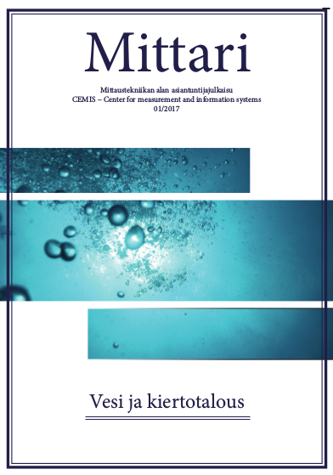

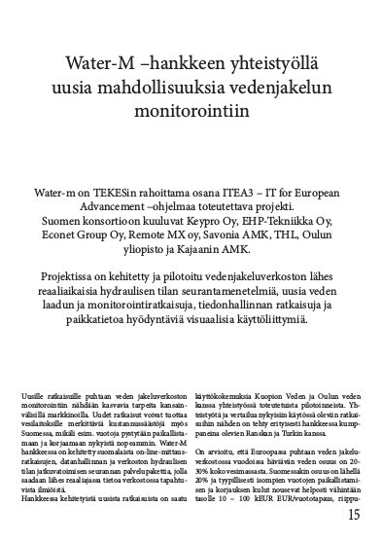
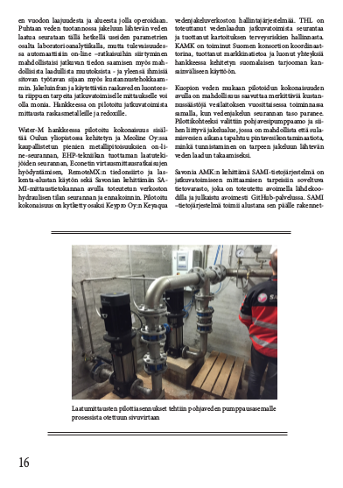
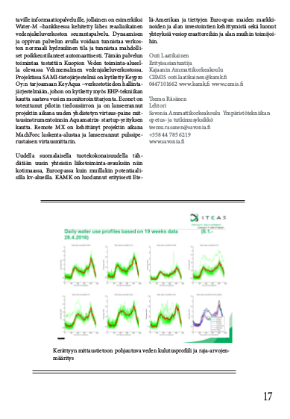

Extract of the article from Pointer Magazine, 2017

BEIA
Romanian partners have also participated in several scientific conferences to present WATER-M contributions:
CSCC 2014: 18th International Conference on Circuits, Systems, Communications and Computers” held in Santorini Island, Greece on 17-11 July 2014
- G. R. Tecu, G. Suciu, A. Ochian, S. Halunga, “Cloud-based Tele-Monitoring System for Water and Underwater Environments”
7th edition of the International Conference "Advanced Topics in Optoelectronics, Microelectronics and Nanotechnologies“ held in Constanta, Romania on 21-24 August 2014:
- G. Suciu, G. R. Tecu, O. Fratu, A. Ochian, V. Suciu, “Tele-monitoring system for water environments”.
SIITME - IEEE 21st International Symposium for Design and Technology in Electronic Packaging” held in Brasov, Romania on 22 - 25 October 2015
- G. Suciu, A. Vintea, S. C. Arseni, C. Butca, V. Suciu, “Challenges and solutions for advanced sensing of water infrastructures in urban environments”
CSCS The 20th International Conference on Control Systems and Computer Science” held in Bucharest, Romania on 27 – 29 May 2015
- G. Suciu, V. Suciu, C. Dobre, C. Chilipirea, “Tele-monitoring system for water and underwater environments using cloud and big data systems”
2nd and 3rd International Conference - Water resources and wetlands” held in Tulcea on 8-13 September 2014 and 2016, events organized by The Romanian Limnogeographical Association in collaboration with the German Limnological Society, Polish Limnological Society, Danube Delta National Institute Tulcea and the Danube Delta Biosphere Reserve Authority
- A. Vasilescu, V. Suciu, G. Suciu, “Monitoring the Danube with equipment from Adcon Telemetry, an OTT Hydromet business unit distributed by Beia Condult Bucharest”, 2014
- A. Vasilescu, G. Suciu, V. Suciu, “Monitoring the Danube with Adcon Telemetry equipment – A Case study for OTT Hydromet and Rowter Company”, 2016

Workshops and International conferences

From WATER-M consortium
The project was presented in Stockholm in 2016 during the ITEA Event 2016/ Innovation Week. The partners of WATER-M have had the chance to present their contributions on the project before a qualited audience of professionnals and ITEA personnalities.
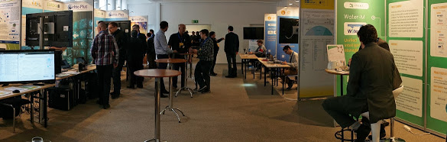

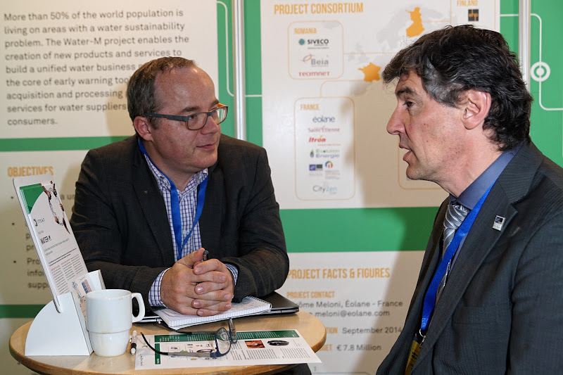

The WATER-M project was also presented at the Digital Innovation Forum in Amsterdam on 10 and 11 May 2017.
This presentation was an opportunity to formalize the work accomplished after three years. It allowed the project to be presented to the European authorities (ITEA) and several groups of international visitors.
This event was also an opportunity to connect with potential customers interested in water management systems.

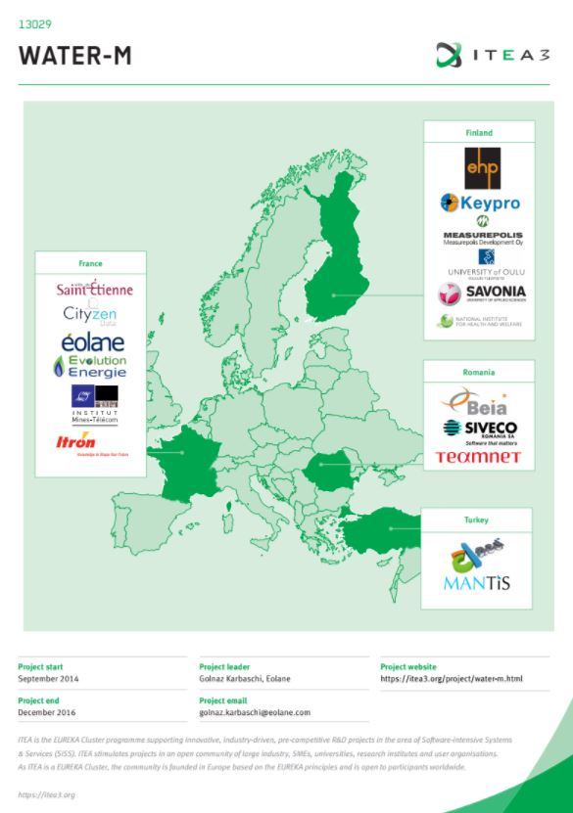
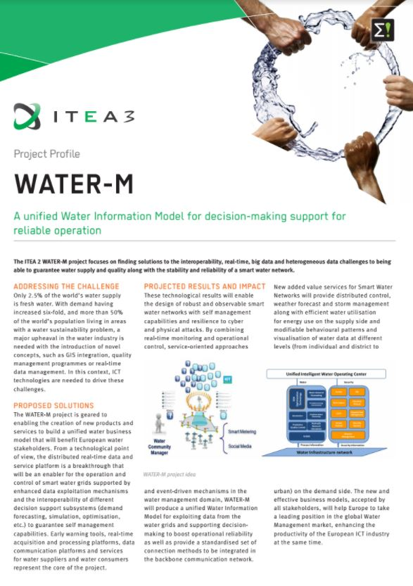

Poster of the WATER-M project, DIF 2017

From French partners
Telecom Evolution participated in one international event:

- 17th IEEE International Conference on Environment and Electrical Engineering, 6-9 June 2017, Milan, Italy where they presented some of their contributions on the project.

Télécom Saint-Etienne participated in several conferences and workshops to present WATER-M outcomes :

- All that Incremental is not Efficient: Towards Recomputation Based Complex Event Processing for Expensive Queries : Accepted paper in EDBT 2018, PFA
- Pi-CEP: Predictive Complex Event Processing using Range Queries over Historical Pattern Space, ICDM2017
- Upsortable: Programming Top-K Queries Over Data Streams, VLDB 2017
- High performance top-k processing of non-linear windows over data streams, DEBS 2016
- Ontology Driven Complex Event Pattern Definition, International Conference on Cooperative Information Systems (CoopIS) 2016

From Finnish partners
Finnish partners organized an international conference dedicated to water management in 2016. International specialists and Water management managers from various cities were invited to talk about their water policies and solutions about water management. The Kuopio International Water Seminar lasted 2 days (14.-15.6.2016). It was held in Kuopio, in Measurepolis facilities.

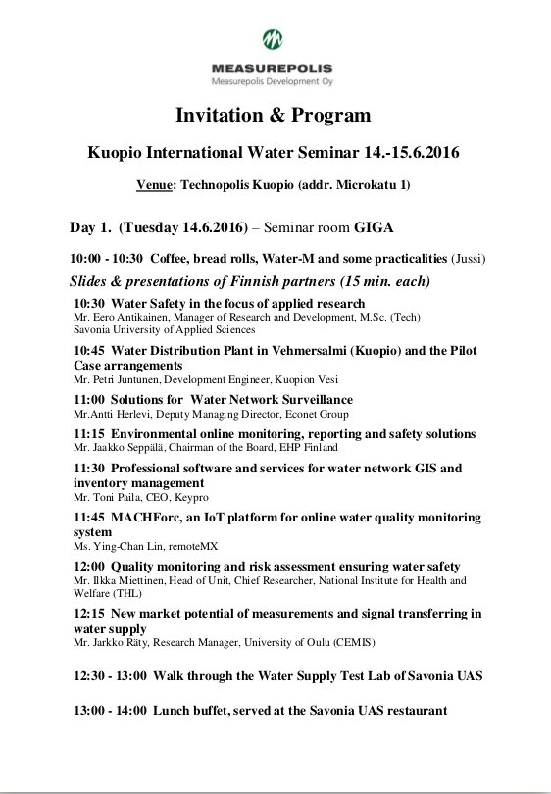
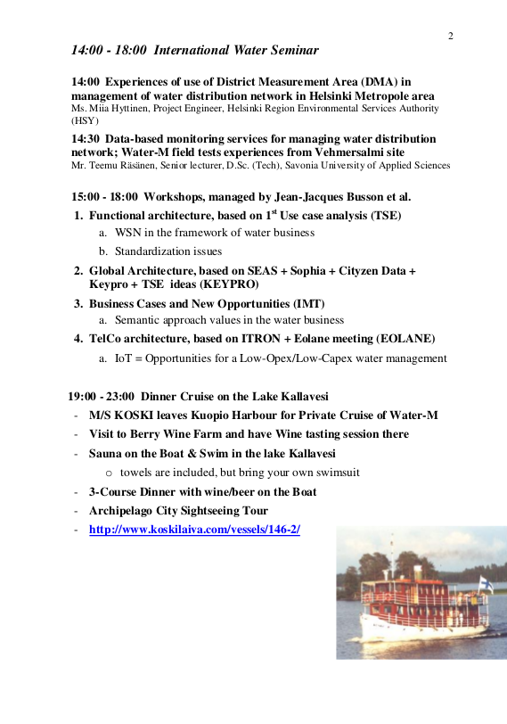

Extract form the Kuopio International Conference on Water Management

From Romanian partners

Networking & disseminating at International Technical Fair (TIB), co-located with Romenvirotec, Inventika, ExpoEnergie and participated at the Smart City and Mobility workshop 11-14th of October 2017, Bucharest, Romania https://twitter.com/GeorgeSuciuG/status/919917000671006721
Participating at Smart City Industry Awards second edition, an event organized by the Romanian Association for Smart City and Mobility, held at CCIR Business Center on October 19th. Smart City Industry Awards aimed to recognize and award the best projects, people, and companies involved in the Smart City Industry in Romania
Presenting at “Weather, climate, and society” event, organized by the Research Institute of the University of Bucharest, National Weather Agency, and Romanian Association of Applied Meteorology and Education 26th of October 2017, Bucharest, Romania
Exhibiting at IMWorld2017, the largest B2B Expo-Conference for IT&Digital Solutions in the SEE, took place October 4-5th at Romexpo, Bucharest’s main exhibition venue
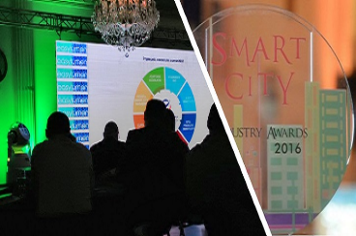
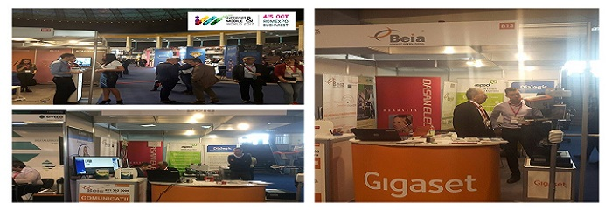

Standardization
A first draft of the desciption of the water ontolgy has been provided by Télécom Saint-Etienne/Université Jean Monet. It completes the work on SEAS project which has produced ontologies for energies. Our work on WATER-M provides enrichments regarding water meters especially. In the future, these new elements could enrich SEAS ontologies corpus as normalization is ongoing for SEAS.
  - Description of the new ontology from Water M
The WATER-M ontology describes the data model for the project WATER-M. The goal of the data model is to define the local data and general data, which communicates with other levels of the WATER-M platform.
Infrastructure of Water-M platform is a complex system thus we need local and general definition of the data models to comply with Water-M requirements (D1.5). This model is used by the plateform as a solution for central collection of the relevant data such as pressure,control parameters,raw data for CEP engine,alarms,events, etc. As requested by D2.1 ”Functional and Technical Architecture”.
The Data Model Document (D4.1) provides two databases structures (local, global). The local structure will be used in order to store local entites related to a place (i.e. a plant) to define and communication with the global structure. Instead the global one will be used for ensuring a unique structure with the communication API that sends data to the enterprise level.
On a local level, we consider local data provided by a unique place (i.e. plant) and specific actions (paramters) designed to monitor a specific use case (i.e. waste water monitoring). Tables store local entity of the plant to define and communicate with global structure.

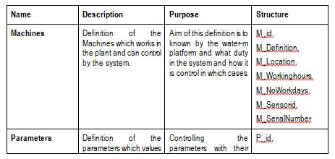
Local Database structure: objects and actions

On Global level (entreprise levele), data are agregated and stored together. Database structure can be changed into one structure according to their requirements but must be one structure with communicating API in order to send data to Enterprise level.This structure will be message base in order to send data other relevant system like Enterprise Bus service and CEP engine.

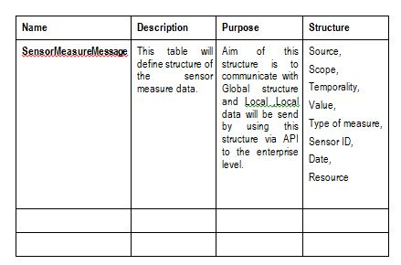

Global Database structure: Entreprise level

Enrichment proposal of the SEAS ontologies

SEAS Ontologies description

SEAS ontology modules are organized on top of a core of three main modules:
- FeatureOfInterestOntology describes feature of interests and their properties;
- EvaluationOntology describes evaluations of these properties;
- SystemOntology describes virtually isolated systems that share connections with other systems;
Unlike in the 2005 SSN ontology, any feature of interest property may itself be a feature of interest (an new object in WATER-M case). In fact, the SSN ontology was originally based on the DUL ontology, which imposed that properties could not be feature of interest themselves. Yet we identified in some use cases where properties should have properties.
These features of interest own properties linked to them :

Water meters
Our water meters are described closely like it is in WATER-M with objects and properties easly translatable in SEAS model.
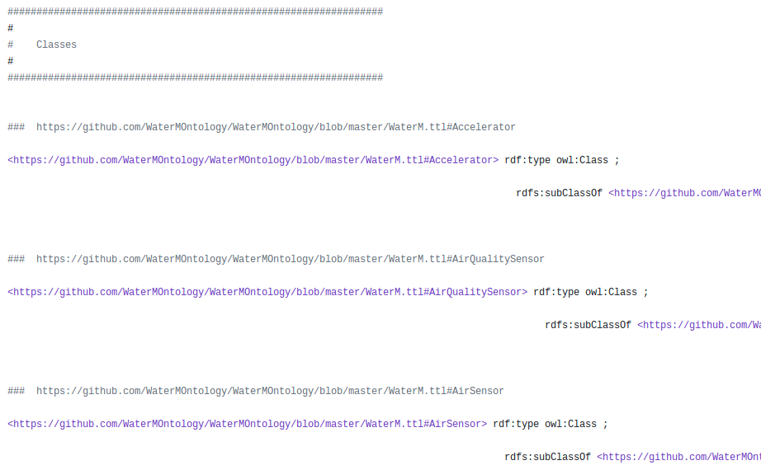

Status of SEAS ontologies on normalization
SEAS ontologies are currently being standardiezd. Here are the status of the ontologies into different standardization bodies.
SEAS, or rather the way it is designed, is accepted for standardization at ETSI by mid-2019.
Two Action Item were accepted, and we are working on the submission of a "STF" (application for funding) to draft these standards. From a content point of view, SEAS will merge with the existing ETSI SAREF standard.
It is mainly Fayol Institute and Télécom Sud-Paris who are involved.
SEAS has also given rise to participation in the W3C with standard Semantic Sensor Network published in Oct 2017 https://www.w3.org/TR/vocab-ssn/
SEAS is also currently reviewed by IRTF.

Others interesting framework of standardisation

Project Haystack is an open source initiative to streamline working with data from the Internet of Things. The standardization concerns semantic data models and web services. It aims to unlock value from the vast quantity of data being generated by the smart devices that permeate our homes, buildings, factories, and cities. Applications include automation, control, energy, HVAC, lighting, and other environmental systems.
The framework is supported by major companies such Airmaster (Australia), Enerliance/Yardi, Intel, Legrand, Siemens or SkyFoundry.
Each object is tagged following a model developed by Haystack. Haystack provides a global marup laguage to enable large quantites of sensors to communicate toghether.

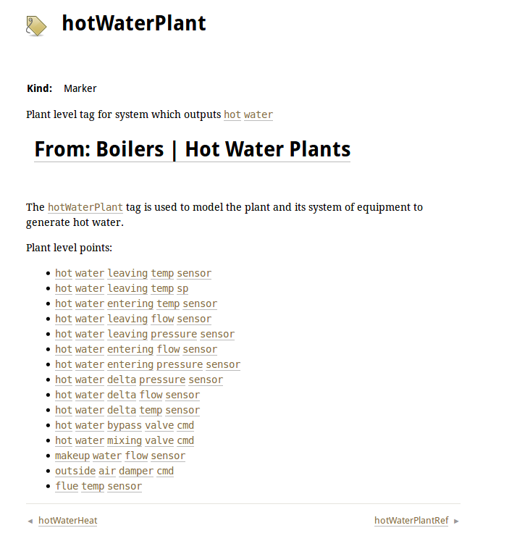

Exploitation Plan
Please refer to the deliverable D5.5 ”Business opportunities & Exploitation Plan”.

