APPS ONTOLOGY

ADVANCING PLUG & PLAY SMART SURVEILLANCE (APPS) PROJECT

ITEA Contract Number
13035

 | Due Date:
 | Actual Submission Date:
 | Project Dates: |  | Project Start Date : January 01, 2015  Project End Date : December 31, 2017  Project Duration : 36 months
 | Leading Contractor Organization: |  | ITEA2
Project funded by the ITEA2
(2015-2017)
Dissemination Level
PU |  | Public
PP |  | Restricted to other programme participants (including the Commission Services)
RE |  | Restricted to a group specified by the consortium (including the Commission Services)
CO |  | Confidential, only for members of the consortium (including the Commission Services)

Document management
Document history
Version | Status | Date | Responsible | Reason for change
V1.0 | First Issue | 28.11.2017 | SRDC | Ontology has been made public

Change authorization
Name | Company

TABLE OF CONTENTS
1 OVERVIEW 4
2 APPS Ontology 5

OVERVIEW
This document includes APPS Ontology.

  - APPS Project
At present, surveillance systems in the maritime domain consist of radar and visual sensors. Whereas radar is used to detect and track vessels, the visual sensors are used for securing borders in and around large infrastructures as e.g. along a coast or in a harbour. These sensors are never used in conjunction in full capacity and have severe limitations. Radar is only capable of detecting large vessels without getting details about the type and identity, whereas visual sensors are too static and hamper 3D capabilities. Therefore, future surveillance systems will differ significantly from today’s systems in several important dimensions by exploiting the benefits of different sensor modality. They will integrate high-quality (HD and 3D video), multi-sensory data inputs taken from multiple viewpoints and exchange multi-streamed data between subsystems and take actions in a plug-and-play fashion, where that multidimensional data is analysed in real-time. This will place unprecedented demands on networks for high capacity, low-latency, and low-loss communications paths. The APPS project will contribute to this transition by advancing the state-of-the-art in surveillance systems in two key areas: (1) it will enable the development of plug & play solutions; and (2) it will enhance the sensor processing and intelligent decision making capabilities of such systems to achieve smart surveillance in large spaces such as coastal areas and harbours with critical infrastructures.

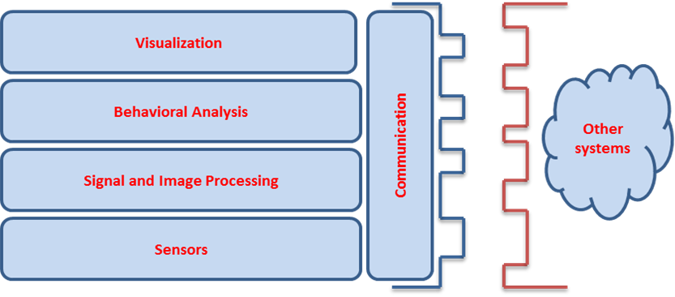

The above objectives and contributions are difficult to realize because many different systems are used. For the surveillance in maritime environments, interoperability among systems and also with the legacy of already deployed systems is a major concern. The APPS project will specify and implement a profiling-based architecture addressing technical, semantic and organizational levels of the interoperability stack, to enable the development of plug and play solutions. At the device level, the sensors will work plug and play into a surveillance system. The system will automatically detect when a new sensor is attached or an existing sensor is removed. As a result, all the layers of the system will reconfigure themselves and continue operating without interruption. At the other end of the stack, the surveillance systems will work as a system of systems and will be able to exchange and fuse information and share situational awareness.
To benefit from the advanced and flexible plug and play systems approach, the APPS project also aims to enable smart surveillance based on simultaneous observations of events made by multi-sensor systems (radar, visual, thermal, acoustic and physicochemical), by recognizing abnormalities and behaviour in a sequence of events observed over longer time intervals. Existing surveillance systems based on radar only are not always able to recognize new sorts of emerging threats or issues, such as small, non-cooperative vessels, unloading narcotics at sea or carrying illegal immigrants. In order to tackle such circumstances, the project will implement a novel approach with sensor fusion by exploiting the benefits of directional acoustic information, multi-view video and other sensors.
The project results will be integrated and demonstrated for maritime surveillance, in particular cases based on detecting illegal activities at sea and protection of critical infrastructure at sea and in harbours. This corresponds to wide-area and mobile surveillance applications exploiting various sensor, where data communication networks are scarce. The technologies developed as part of this project will however be applicable to other surveillance applications as well. The chosen application domain corresponds to a growing market segment and present significant business potential for the industrial partners in the APPS consortium.

APPS Ontology
The ontology has been developed by using Web Ontology Language (OWL). The standards included in the ontology are as follows:
- OGC Sensor Web Enablement (SWE) Observation and Measurement (O&M)
- OGC Sensor Web Enablement (SWE) Sensor Markup Language (SensorML)
- OASIS Emergency Data Markup Language (EDXL)
- OASIS Common Alerting Protocol (CAP)
- AIS (Automatic Identification System)

http://srdc.com.tr/generaldocuments/APPS_Harmonized_Ontology.owl

