**ITEA 3 Call 7**

**OMD**

**Optimal Management on Demand**

Project Number : ITEA-2021-20003

Project Start Date : 01.01.2022

Project Duration : 36 Months

**List of Publications and Dissemination Activities**

**References :**

Work Package : WP6 Dissemination&Exploitation

Task : T6.1 Communication & Dissemination

Deliverable Document : D6.1 - List of publications and dissemination activities

Version : V1.0

Dissemination Level : Public

**Authors :** in alphabetical order

| **Company** | **Name Surname** | **E-mail** |
| --- | --- | --- |
| ARD Group | Bilge Başdemir | bilge.basdemir@ardgrup.com.tr |
| BEIA Gmbh | George Suciu | george@beia.eu |
| Caretronic d.o.o. | Simona Brezar | simona@caretronic.com |
| Dogus Technology | Setenay Gemici | setenay.gemici@d-teknoloji.com.tr |
| Experteam | Demet Seyhan | [demet.seyhan@experteam.com.tr](mailto:demet.seyhan@experteam.com.tr) |
| FrontEndART Software | Tibor Bakota | tibor.bakota@frontendart.com |
| FTP - LDA | Germano Fernando Santos Pinto | germano.pinto@ftpporto.com |
| Hiperlink | Hilmi Oğuz | hilmi@hiperlink.com.tr |
| ISEP | Goreti Marreiros | [mgt@isep.ipp.pt](mailto:mgt@isep.ipp.pt) |
| Strategy Big data | Igor Casado Moreno | icasadom@grupokonecta.com |
| University of Szeged | László Vidács | lac@inf.u-szeged.hu |

Table of Contents

**1** **Introduction** 3

**2** **The list of Publications and Dissemination Activities** 3

2.1 ARD Group 3

2.2 BEIA Gmbh 3

2.3 Caretronic d.o.o. 3

2.4 Dogus Technology 3

2.5 Experteam 3

2.6 FrontEndART Software 3

2.7 FTP - LDA 3

2.8 Hiperlink 3

2.9 ISEP 3

2.10 Strategy Big data 3

2.11 University of Szeged 3

Summary :

# Introduction

# The list of Publications and Dissemination Activities

Each partner has dissemination and publication activities which is listed below.

## ARD Group

A conference summary paper entitled ‘Named Entity Recognition for Lawyer Assignment in Justice Cases’ has been prepared.

This paper evaluates the effectiveness of Legal Entity Recognition (LER) systems that enable the recognition and categorisation of specific entities in legal texts.

Using Transformer-based models, it examines improvements in the automation and analysis of legal documents.

This study aims to increase efficiency by reducing manual labour in legal research processes.

With this abstract, we contribute to the dissemination activities of the OMD project, which aim to make the innovative approaches and results of the OMD project available to a wider audience.

## BEIA Gmbh

The project has been presented at the following events:

* Cluj Innovation Days 2023 on 24-26 May in Cluj Napoca, Romania
* IDENTICOM4 – Metal Technologies and Industrial Equipment – Connecting Global Competence on 24-26 May 2023.
* Manufacturing Performance Days 2023 happening on June 5-7, in Tampere, Finland
* Forum Produktion 2023, on 09 - 10 May, in Steyr, Austria
* AUSTRIAN WORLD SUMMIT 2023 on 11 May
* Industry 4.0 International Business Meetings 2023, from the 8th to the 14th of March 2023 at Chassieu in France.
* Research and Innovation Week in Belgium in March 2024
* European Innovation Council Summit in Belgium in March 2024
* Polifest in Romania in April 2024
* Green Energy Expo & Romenvirotec in Romania in April 2024
* Hannover Messe in Germany in April 2024
* Bucharest Tech Week in Romania in June 2024
* InnoPro in Romania in October 2024
* GoTech World in Romania in November 2024

Also, the following paper was presented and published: Pant, Piyush, Anand Singh Rajawat, S. B. Goyal, Pradeep Bedi, Chaman Verma, Maria Simona Raboaca, and Florentina Magda Enescu. "Authentication and authorization in modern web apps for data security using Nodejs and role of dark web." Procedia Computer Science 215 (2022): 781-790.

## Caretronic d.o.o.

The **OMD project** and the **Healthcare Use Case (Speech2Service)** developed by Caretronic have been actively showcased at leading global healthcare and technology events to expand visibility, attract partnerships, and introduce the solution to a diverse international audience. The solution has been featured at the prestigious **Medica Trade Fair** in Düsseldorf, Germany, consecutively in November 2023, and 2024, where it reached a wide network of healthcare professionals, suppliers, and innovators in medical technology. This event allowed Caretronic to demonstrate Speech2Service’s capabilities to key stakeholders, providing a direct platform for feedback and collaboration within the European healthcare community.





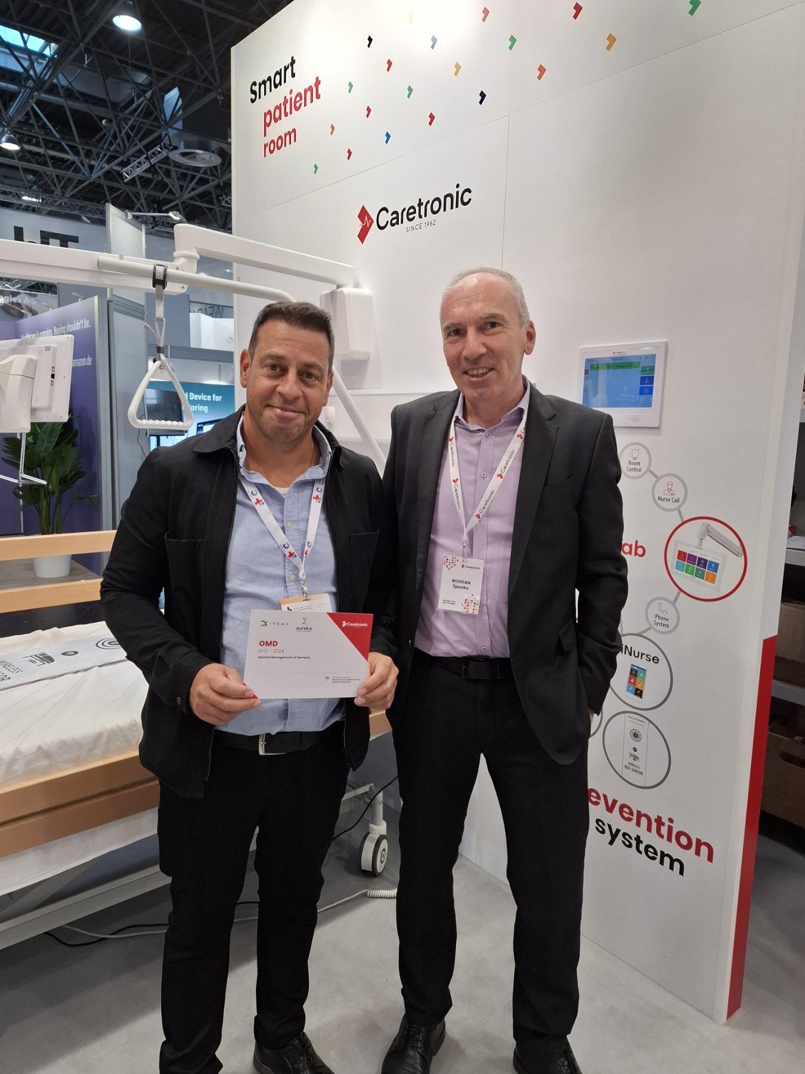

In addition, Caretronic presented at **Arab Health** in Dubai in January 2024, the largest healthcare event in the Middle East. This venue expanded Caretronic's reach to Middle Eastern and North African markets, where the need for healthcare automation and efficiency is increasingly recognized. Similarly, at **HIMSS (Healthcare Information and Management Systems Society)** Health Tech Conference in the USA in April 2023, the solution was introduced to North American leaders in digital health, IT, and health technology innovation. This exposure positioned Speech2Service as a forward-looking solution that addresses critical challenges in documentation accuracy and efficiency for US-based health providers and tech-forward health systems.





In April 2023, **AltenPflege**, the leading event for elderly care in Germany, served as an essential platform to introduce Speech2Service to senior care providers and nursing home administrators. Here, Caretronic highlighted how Speech2Service can significantly improve care documentation and patient-centered care in long-term care settings, aligning closely with the needs of senior care facilities.



With a **strong international network of distributors** spanning over 40 countries, Caretronic leverages its partnerships to promote Speech2Service globally. This network facilitates market entry into care organizations and collaboration with telecom companies, who are increasingly investing in digital health solutions. Through these industry events and partnerships, Caretronic is establishing a strong presence in the global market, demonstrating Speech2Service’s value and adaptability across healthcare systems, languages, and regulatory environments worldwide.

## Dogus Technology

At the ICENSS 2024 conference held on 24 - 25 May, the abstract ‘Utilising Turkish Language Processing and RAG in Chatbot Systems: Approaches Based on ChatGPT and Generative AI’ was presented at the ICENSS 2024 conference.

The abstract text of the paper titled ‘Developing and Comparing Classification Models Using Generative AI and Advanced Language Models Like BERT’ was shared to the ICAIAME 2024 conference, which will take place on 26 - 28 September, and a return was received in July 2024 that the paper was accepted. The full text of the paper is in the writing stage.

The abstract ‘Exploring Prompt Engineering Techniques for Multilabel Classification Using LLMs: Approaches, Challenges, And Scoring’ and the abstract text of the paper was shared and the acceptance of the paper was received in July 2024. The full text of the paper is in the writing stage.

"Developing a Chat Software for Turkish Consumer Electronics: Learning Problem and Solution Methods from Crawled Web Pages and Responding With RAG’ and the abstract text of the paper was shared and a return was received in July 2024 that the paper was accepted. The full text of the paper is in the writing stage.

## Experteam

Publications and Dissemination Activities and descriptions are below.

Our academic publications on the classification of customer tickets and prediction of completion times in the ITSM-Help Desk sector are as follows;

**1- IT Support Ticket Completion Time Prediction**

Conference Paper

Conference: 2022 7th International Conference on Computer Science and Engineering (UBMK)

September 2022

DOI: 10.1109/UBMK55850.2022.9919591

**2- The Efficiency of Regularization Method on Model Success in Issue Type Prediction Problem**

Article

Acta Infologica (WoS Index)

December 2023

DOI: 10.26650/acin.1394019

During this period, we participated in two international conferences with our presentations. The conference in Istanbul was about digitalization and the second conference in Gaziantep was about sustainability.

We published an article in which we examined the effect of the regularization method on Issue Type prediction success, which is one of the important stages of our project. It was published in ActaInfologica, an ESCI journal (WoS) within Istanbul University.

Finally, we will participate in the IV International Congress on Artificial Intelligence in Health with a paper that we will present in December and refer to our OMD project .

OMD project was mentioned in conference and journal publications.

## FrontEndART Software

FrontEndART did not plan and had no separate dissemination activities. In the Hungarian consortium this was a task of the University of Szeged.

## Portuguese Consortium

## FTP & ISEP

During this project some activities were carried out in order to publicize and raise awareness of our developments.

Scientific paper “Chatbot Architecture for a Footwear E-commerce Scenario” released and accepted by the International Conference DCAi was presented on 12-14 of July.

Scientific paper “E-commerce platform with a chatbot for the footwear industry” is being developed so that it can be accepted and presented in 2024.

on February 16 2023, a conference was held at ISEP where we presented our use case to the academic community.

On March 02 2023, we had our first physical meeting with international consortium In Istanbul, so we presented our use case to the international community.

On June 23, 2023, was the first review by ITEA. Since our contribution ended in June, we made the project final presentation.

On July 27,2023, a conference was held at ISEP a conference for the final presentation of our project. The results obtained were presented, as well as a real demonstration.

Master's Thesis” Recommendation Services and Applications Using Machine Learning” expected to be completed in 2023.

Publication and dissemination of our demo and use case, on ITEA channels during October 2023.

We share our developments on social media:

Website project: https://omd.ftpporto.com/

https://www.instagram.com/ftpporto/?img_index=1

https://www.instagram.com/ftpporto/?img_index=1

## Hiperlink

We made the presentation of our project in Antwerb, Belgium within the scope of ITEA PO Days.

## Strategy Big data

No dissemination in this use-case.

## University of Szeged

Project webpage @ USZ:

* https://u-szeged.hu/pmi/2020-1-2-3-eureka-2021/2020-1-2-3-eureka-2021

Press releases (in Hungarian):

2024

* https://u-szeged.hu/sztehirek/2024-januar/optimalizalt
* Scientific publication: We have prepared a manuscript for a scientific publication, which is about the implemented AI solutions and their evaluation along with the lessons learned during the development phase. The manuscript had been submitted to two relevant conference proceedings, and although the received reviews were not bad, the overall review was weak reject in both cases. We have made the necessary modification according to the reviews, and we will submit the manuscript to another publication platform.

2023

* https://u-szeged.hu/sztehirek/2023-januar/gepi-tanulasi-modellek
* https://szegedma.hu/2023/01/szoftverhibak-javitasat-segito-megoldason-dolgoznak-szegedi-kutatok
* https://www.szegedon.hu/szeged-hirek/jovo-technologiai-projektek-szegeden
* https://www.delmagyar.hu/helyi-kozelet/2023/01/mesterseges-intelligencian-alapulo-rendszer-fejleszteseben-vesz-reszt-az-szte
* https://itcafe.hu/hir/szte_szoftverhibak_projekt.html

OMD project has been presented to business partners at various events.