WP1 Use-cases, Requirements and Architecture
Deliverable 1.1 & Deliverable 1.2
State of The Art (D1.1) & Gap Analysis (D1.2) Report
Project Name: 24017 STRUCTURE
Status: Draft (v1.0)
Contributors
Names | Date | Contribution
SpectX | April 2026 | Ground Penetrating Radar (GPR), Backscatter X-Ray sensing, UAV-based subsurface inspection, Airborne NDT technologies, High-payload UAV platforms, Autonomous inspection architectures
XenomatiX | May 2026 | LiDAR / Distance Sensing, Mobile Mapping LiDAR, Pavement Inspection, Road Surface Metrology, LiDAR-based SLAM, Orthomosaic Mapping, High-precision localization and navigation
KoçSistem, TAV | September 2026 | AI Analytics & Defect Intelligence, Edge Computing & Onboard Processing, Multi-Modal Data Fusion, Predictive Defect Intelligence, Digital Twin Layer, Predictive Maintenance Models, Decision Support & Operational Intelligence, Airport Use Case SOTA
Avular | June 2026 | Autonomous Carrier Platform Layer (UAV/Robotics), Flight Control and Navigation, Autonomous Mission Planning, Obstacle Avoidance, Edge AI-enabled Robotics, UAV Platform Integration
Evolve Dynamics | June 2026 | Heavy-Payload UAV Systems, Autonomous Carrier Platforms, Stabilized Sensor Mounting, BVLOS-ready UAV Architectures, Complex Environment Deployment
Sorama | May 2026 | Acoustic Sensing Technologies, Acoustic Imaging, Beamforming, Acoustic Holography, Acoustic Inspection of Bridges and Infrastructure
FIB Belgium / Infrastructure | July 2026 | Infrastructure / Asset Layer, Bridges & Viaducts Infrastructure, Tunnel Assets, Structural Health Monitoring requirements, Maintenance and operational requirements
Railway Infrastructure Partners | August 2026 | Railway / Transport Infrastructure (BO3), Railway Inspection Requirements, Railway SHM, Track and Corridor Monitoring
Airport Infrastructure Partners | August 2026 | Airport Runways & Terminals (BO2), Airport Infrastructure, AGL Systems, CNS Systems, Airport Maintenance Operations, Airport Digital Twin requirements
All Technical Partners (cros |  | Data Fusion & Integration Layer, Service Delivery Layer, System Integration, DTaaS, End-to-End Architecture, Problem-Innovation-Business Outcome Mapping
KoçSistem | September 2026 | Consolidaiton, links to references, integrity check

Document Glossary 3
Introduction 5
Problem Space & Use Case Context 6
Use Case-Centric SoTA Analysis 7
Road Inspection 7
Airport Runways & Terminals 8
Railway / Transport Infrastructure 10
SoTA Landscape (Technology Domains) 11
Infrastructure / Asset Layer 11
Airport Infrastructure 11
Bridges, Viaducts and Tunnels Infrastructure 14
Railway and Port Infrastructure 15
Sensing & Data Acquisition Layer 16
Acoustic Sensing Technologies for Bridge and Infrastructure Inspection 16
LiDAR / Distance Sensing 22
Ground Penetrating Radar (GPR) 26
Backscatter X-Ray Inspection Technologies 29
Optical and Thermal Imaging Technologies 31
Autonomous Carrier Platform Layer (UAV / Robotics) 35
Localization, Mapping & Navigation Layer 43
Edge Computing & Onboard Processing Layer 50
AI Analytics & Defect Intelligence Layer 58
AI Based Processing 58
MultiModal Data Fusion Models 60
Multi-Modal Defect Intelligence Technologies 62
Predictive Defect Intelligence 63
Integration Layer 65
Multi-Source Data Integration Technologies 65
Sensor Fusion Technologies (TI6) 67
Standardized Data Pipeline Technologies 68
Current Technology Limitations and Open Research Challenges 70
Digital Twin Layer 70
Decision Support & Operational Intelligence Layer 75
The Cognitive Engine for Airport Maintenance 75
Railway Infrastructure 80
Roads, Bridges, and Viaducts 81
Service Delivery Layer 83
End-to-End System Integration 83
Data-as-a-Service (DTaaS) 84
LiDAR system Integration & Service Delivery Layer 86
Problem - Innovation - Business Outcome Mapping 92
Emerging Research & Technology Gaps 93
Extreme Environments 94
Standardization and Interoperability 95
Regulatory Readiness and Trustworthy AI 96
Scalability Toward National Infrastructure Ecosystems 97
Overall Perspective 98
Future Directions 98
Conclusion 99

Document Glossary

Acronym | Definition
AE | Acoustic Emission
AI | Artificial Intelligence
AODB | Airport Operational Database
AOCC | Airport Operations Control Centre
AR | Augmented Reality
ARFF | Aircraft Rescue and Firefighting
BIM | Building Information Modelling
BO | Business Outcome
BVLOS | Beyond Visual Line of Sight
CityGML | City Geography Markup Language
CMMS | Computerised Maintenance Management System
CNN | Convolutional Neural Network
CNS | Communication, Navigation and Surveillance
CPP | Coverage Path Planning
DaaS | Data as a Service
DME | Distance Measuring Equipment
DTaaS | Digital Twin as a Service
EAM | Enterprise Asset Management
EASA | European Union Aviation Safety Agency
FFT | Fast Fourier Transform
FMCW | Frequency-Modulated Continuous Wave
FOD | Foreign Object Debris
FoV | Field of View
GIS | Geographic Information System
GNSS | Global Navigation Satellite System
GPR | Ground Penetrating Radar
HVAC | Heating, Ventilation and Air Conditioning
ICAO | International Civil Aviation Organization
IFC | Industry Foundation Classes
ILS | Instrument Landing System
IMU | Inertial Measurement Unit
INS | Inertial Navigation System
IoT | Internet of Things
IRI | International Roughness Index
LAZ | Compressed LAS Point-Cloud Format
LiDAR | Light Detection and Ranging
LOAM | LiDAR Odometry and Mapping
LIO-SAM | LiDAR Inertial Odometry via Smoothing and Mapping
MPD | Mean Profile Depth
NAH | Near-Field Acoustic Holography
NDT | Non-Destructive Testing
P1–P12 | STRUCTURE Problem Statements 1–12
PAT | Pavement Assessment Technology
PCI | Pavement Condition Index
PPK | Post-Processed Kinematic
RGB | Red, Green and Blue Imaging
RGB-T | Red, Green and Blue–Thermal Imaging
ROI | Region of Interest
RTK | Real-Time Kinematic
RUL | Remaining Useful Life
SCADA | Supervisory Control and Data Acquisition
SfM | Structure from Motion
SHM | Structural Health Monitoring
SLA | Service-Level Agreement
SLAM | Simultaneous Localisation and Mapping
SoTA | State of the Art
SORA | Specific Operations Risk Assessment
SPL | Sound Pressure Level
TEV | Transient Earth Voltage
TI | Technological Innovation
TPU | Tensor Processing Unit
UAV | Unmanned Aerial Vehicle
UGV | Unmanned Ground Vehicle
UHF | Ultra-High Frequency
UUV | Unmanned Underwater Vehicle
VIO | Visual-Inertial Odometry
ViT | Vision Transformer
VOR | VHF Omnidirectional Range
VTOL | Vertical Take-Off and Landing

Introduction
This document presents the State-of-the-Art (SoTA) and Gap Analysis for the STRUCTURE project, aiming to systematically assess the current technological, industrial, and research landscape related to autonomous inspection and predictive maintenance of transportation infrastructure. It analyses existing solutions against the identified problem space and highlights the key technological limitations that motivate the STRUCTURE project. In this context, the report establishes a clear baseline from which the project’s technological innovations (TI1–TI7) position themselves as targeted advancements addressing these gaps.
The primary purpose of this document is to:

- provide a structured overview of the current SoTA across sensing, UAV-based inspection, AI analytics, and digital twin technologies,
- identify and consolidate gaps aligned with the project’s defined problem statements (P1–P12), and
- justify the necessity, novelty, and expected impact of STRUCTURE’s innovation framework in relation to these gaps.

This report serves as a foundational reference for subsequent project activities and deliverables. It directly supports:
- use-case and requirements definition (WP1) by grounding functional and non-functional requirements in identified gaps,
- architecture and system design by informing technology selection and integration strategies,
- AI model development and data fusion activities (WP3) by highlighting limitations in current detection and learning approaches, and
- pilot implementations and validation activities (WP4) by defining measurable improvement targets over the state of the art.

The intended audience of this document includes:
- project partners and technical work package leaders,
- research and innovation stakeholders involved in UAV inspection, AI analytics, and digital twins,
- industrial asset owners and system integrators, and
- external reviewers, funding authorities, and the broader ITEA community.

This document is conceived as a living deliverable. Given the rapid evolution of enabling technologies (e.g., edge AI, autonomous systems, multi-modal sensing) and the dynamic nature of the transportation infrastructure inspection market, the SoTA and gap analysis will be continuously updated throughout the project lifecycle. Updates will reflect emerging scientific and technological advancements, changes in regulatory and standardization frameworks, and evolving business and market needs.

Problem Space & Use Case Context
The STRUCTURE project addresses a complex and fragmented problem space in the inspection and maintenance of transportation infrastructure, where current practices remain largely manual, costly, and technologically limited. The problem space is defined through a set of interrelated challenges (P1–P12), including high operational costs, safety risks during inspections, limited accessibility to critical areas, low detection capabilities—especially for subsurface defects—and the absence of integrated predictive maintenance and decision-support systems.

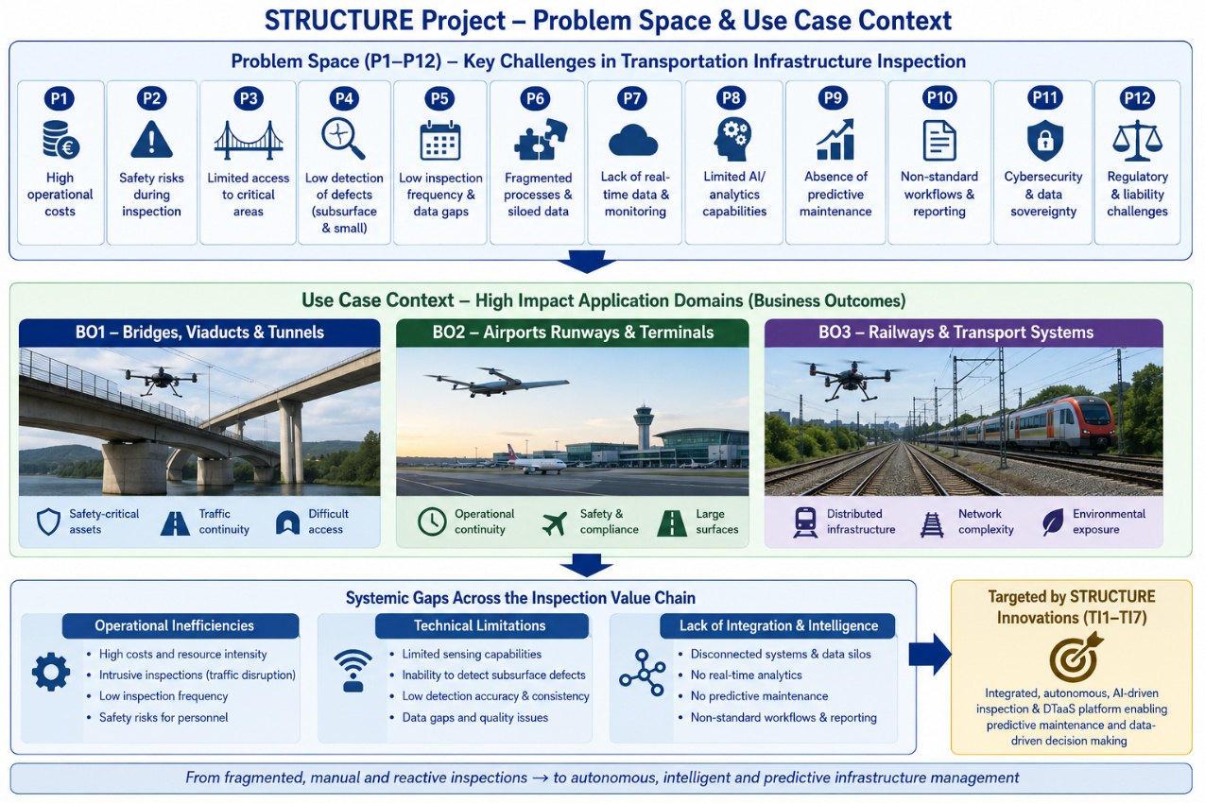
Figure 1Structure Project Problem Space and Use Case Context

From a SoTA and Gap Analysis perspective, these problems can be interpreted as systemic gaps across the entire inspection value chain:
- Operational inefficiencies and intrusiveness (e.g., traffic disruption, low inspection frequency),
- Technical limitations in sensing and detection (e.g., inability to detect subsurface defects or low detection accuracy), and
- Lack of integration and intelligence (e.g., disconnected systems, absence of real-time analytics and predictive maintenance).

The use case context of STRUCTURE translates this problem space into three primary application domains (Business Outcomes), each representing a high-impact operational environment where these gaps are critical:
- Autonomous inspection of bridges, viaducts, and tunnels,
- Airborne health monitoring of airport runways and terminals, and
- Inspection of railway and transport infrastructure systems.

These use cases share common characteristics—large-scale assets, safety-critical operations, and limited accessibility—while also imposing distinct constraints such as operational continuity (e.g., airports), environmental complexity (e.g., tunnels), and distributed infrastructure (e.g., railways).
Within the scope of the SoTA and Gap Analysis report, the problem space and use case context serve to:
- anchor the analysis in real operational needs, ensuring that identified gaps are not purely technological but also practical and industrial,
- enable structured comparison of existing solutions across different infrastructure domains, and
- provide a clear mapping between problems (P1–P12), use cases (BO1–BO3), and the targeted technological innovations (TI1–TI7) as defined in the proposal.

Use Case-Centric SoTA Analysis

Road Inspection
Road inspection is a critical activity for ensuring road safety, maintaining infrastructure quality, and optimizing maintenance budgets. Traditionally, road condition assessments were carried out through manual visual inspections, which are time-consuming, prone to subjective interpretation, and challenging to implement consistently across extensive road networks. To overcome these limitations, the industry has increasingly adopted automated and data-driven inspection approaches. Advances in sensing technologies, positioning systems, artificial intelligence, and geospatial analytics have enabled the development of solutions that provide accurate, consistent, and scalable assessments of road conditions.
The current state of the art in road inspection combines advanced sensing technologies, precise localization, automated defect detection, and digital asset management workflows to deliver accurate and scalable road condition assessments. Modern inspection systems are capable of collecting high-quality road data at normal traffic speeds, reducing inspection time and operational costs while identifying defects such as cracks, potholes, rutting, and surface deterioration. Beyond detection, these systems can quantify defect severity, accurately geolocate assets, and monitor pavement deterioration over time, enabling a shift from reactive maintenance to predictive and condition-based asset management.
The increasing adoption of multi-sensor platforms integrating LiDAR, imaging sensors, Global Navigation Satellite System (GNSS), and inertial positioning systems has significantly improved inspection accuracy and enabled the generation of detailed digital representations of road infrastructure. At the same time, advances in artificial intelligence and machine learning have automated data processing and defect assessment, providing faster and more consistent analysis. Inspection results are increasingly integrated into GIS, asset management systems, and digital twin platforms, supporting infrastructure monitoring, maintenance optimization, and evidence-based decision-making. Overall, the road inspection sector is moving towards highly automated, scalable, and data-driven solutions that improve road safety, infrastructure lifecycle management, and maintenance efficiency. Within this evolving landscape, XenomatiX aligns with industry trends through its focus on high-accuracy sensing, automated pavement assessment, infrastructure digitization, and data-driven road asset management.

Airport Runways & Terminals
This State-of-the-Art (SoTA) analysis examines how automated maintenance operations are transforming airport infrastructure from a largely inspection-driven, reactive discipline into an integrated, data-driven, and predictive operational capability. Within the airport context, maintenance is not a back-office technical function; it directly determines runway availability, aircraft turnaround reliability, terminal throughput, passenger safety, regulatory compliance, and the resilience of mission-critical systems. The analysis therefore evaluates automated maintenance across three interdependent infrastructure domains: airside assets, terminal and building assets, and power and energy infrastructure.
Across airside operations, the SoTA is characterized by the migration from manual, periodic inspections toward autonomous sensing, UAV-assisted assessment, edge analytics, and CMMS-connected maintenance workflows. Runway and taxiway pavement monitoring is evolving beyond visual Airport Pavement Condition Index assessments toward automated defect detection, multi-modal sensing, and analytics capable of identifying both visible surface distress and early indicators of structural degradation. Aeronautical Ground Lighting maintenance is similarly moving from infrequent vehicle-based photometric testing to UAV-enabled measurement of luminous intensity, beam alignment, and chromaticity against ICAO-compliance thresholds. In CNS/ATM infrastructure, UAV-based calibration of ILS, VOR, and DME systems reduces the cost, disruption, and emissions associated with manned flight inspection. For FOD detection and ARFF response, fixed radar/optical installations combined with automated drone patrols enable faster detection, verification, and removal of hazardous objects, minimizing runway closure times and operational risk.
Within terminal and building infrastructure, the analysis shows that automation is increasingly centered on IIoT sensorization, predictive diagnostics, digital twins, and cyber-physical monitoring. Passenger boarding bridges, baggage handling systems, HVAC assets, elevators, escalators, moving walkways, CCTV networks, access control, public address systems, fire detection, and fiber-optic communication backbones are no longer treated as isolated equipment groups. Instead, next-generation maintenance architectures continuously ingest vibration, temperature, torque, flow, visual, and network-performance data to identify degradation patterns before they become service failures. Digital Twin as a Service further enhances this approach by linking live telemetry with BIM-based spatial models, enabling maintenance teams to localize faults, simulate deterioration, optimize energy consumption, and plan interventions during low-impact operational windows.
For power, energy, fuel, and water infrastructure, the SoTA emphasizes continuous risk detection in systems where failure can have immediate safety, environmental, and operational consequences. Online partial discharge monitoring, TEV/UHF/acoustic/HFCT sensing, AI-based noise filtering, acoustic leak detection, pump vibration diagnostics, and fuel-system integrity monitoring collectively reduce dependence on scheduled shutdowns and manual inspections. These capabilities are particularly important in airports because electrical failures, fuel leaks, drainage problems, and water-system breakdowns can cascade rapidly across runway operations, terminal services, air traffic systems, security systems, and passenger processing flows.
The overall conclusion is that the airport maintenance landscape is entering a maturity stage in which individual automation technologies are available, but their full value depends on integration. The most advanced model is not simply the use of drones, sensors, AI models, or digital twins in isolation; it is the creation of a unified maintenance intelligence layer that connects field sensing, edge analytics, operational systems, asset management platforms, and decision-support workflows. In this model, maintenance evolves from “inspect and repair” to “sense, predict, prioritize, and act,” supporting higher asset availability, reduced unplanned downtime, better safety assurance, more efficient use of maintenance windows, and improved sustainability. The remaining gaps are mainly related to data interoperability, regulatory acceptance of autonomous inspection, explainable AI, cybersecurity, operational integration with CMMS/BMS/AOCC environments, and the need to scale pilots into standardized airport-wide maintenance practices.

Railway / Transport Infrastructure
Railway infrastructure represents one of the most extensive and safety-critical transportation networks, requiring continuous monitoring to ensure operational reliability, passenger safety, and asset longevity. Current maintenance practices are increasingly moving from periodic manual inspections toward data-driven condition monitoring and predictive maintenance. The state of the art is characterized by the deployment of accelerometers, vibration sensors, track geometry measurement systems, onboard monitoring equipment, and AI-based analytics that continuously assess the condition of both rolling stock and railway assets during regular operations. Modern railway operators increasingly leverage sensor-equipped trains as mobile inspection platforms, enabling infrastructure condition assessment without disrupting normal traffic operations. These approaches support the detection of track irregularities, rail defects, sleeper degradation, ballast deterioration, wheel defects, and vehicle-related anomalies while significantly reducing the dependency on manual inspections. The emergence of AI-driven predictive maintenance platforms further allows operators to identify degradation trends, estimate asset remaining useful life, and optimize maintenance schedules before failures occur. Railway digitalization initiatives increasingly integrate these inspection results into centralized asset management systems and digital twin environments, supporting risk-based maintenance planning and operational decision support. This evolution is gradually transforming railway maintenance from reactive and calendar-based practices into continuous and condition-based asset management.
Despite these advances, significant gaps remain. Existing railway inspection solutions primarily focus on detecting defects that manifest through vibration signatures, visual observations, or track geometry deviations, while subsurface defects within the track structure, ballast layers, foundations, and supporting infrastructure often remain difficult to detect until they affect operational performance. Inspection frequency also remains constrained by operational schedules, sensor deployment costs, and fragmented monitoring systems, resulting in incomplete temporal coverage across large rail networks. Current approaches frequently rely on isolated data sources and lack comprehensive integration between onboard sensing, infrastructure monitoring, historical maintenance records, environmental conditions, and predictive analytics. As a result, maintenance decisions are often based on partial information, limiting the accuracy of deterioration forecasting and long-term asset planning. Furthermore, many existing systems struggle to correlate vehicle-borne measurements with precise defect localization and severity assessment, reducing their effectiveness for proactive maintenance. These limitations create a need for more integrated railway inspection ecosystems capable of combining continuous sensing, AI-driven multi-modal analysis, digital twin technologies, and predictive maintenance intelligence to deliver earlier defect detection, improved situational awareness, and more reliable maintenance planning across distributed railway networks.

SoTA Landscape (Technology Domains)

Infrastructure / Asset Layer
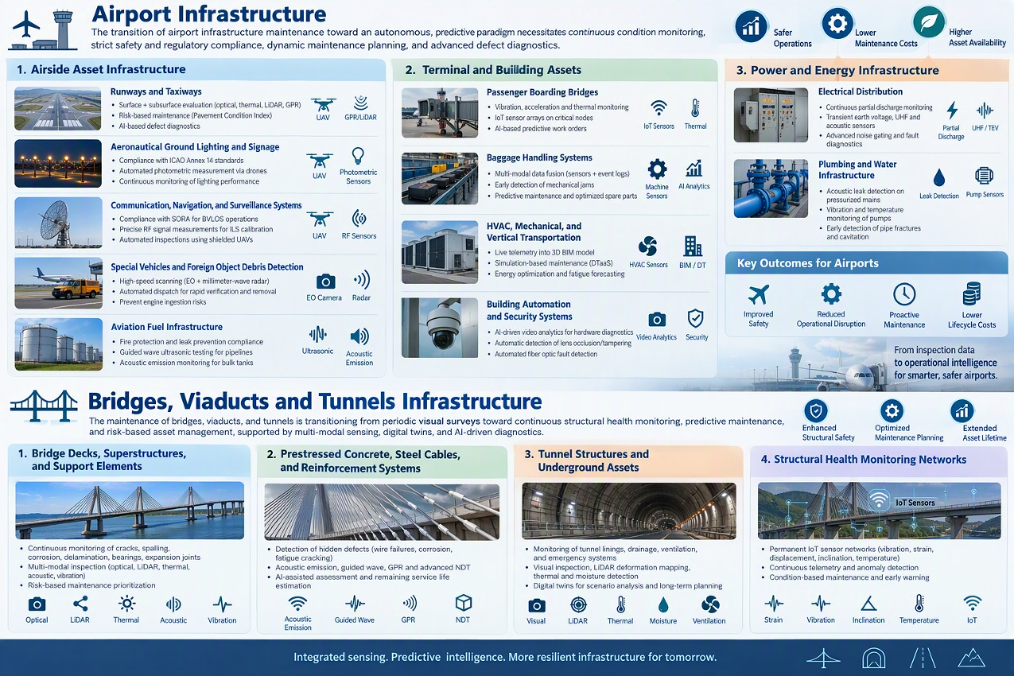

Airport Infrastructure
The transition of airport infrastructure maintenance toward an autonomous, predictive paradigm necessitates a complete overhaul of traditional inspection requirements. Driven by advanced sensor fusion, digital twins, and artificial intelligence, the inspection mandates for various asset classes now heavily emphasize continuous condition monitoring, strict safety and regulatory compliance, dynamic maintenance planning, and advanced defect diagnostics. The following summary outlines these specific inspection requirements organized hierarchically by asset category.
1 Airside Asset Infrastructure
Runways and Taxiways
Condition monitoring requires simultaneous surface and subsurface evaluations, utilizing high-resolution optical cameras, thermal sensors, and LiDAR for surface defects, alongside Ground Penetrating Radar for hidden voids and rebar corrosion. Maintenance planning demands a shift to risk-prioritized strategies, utilizing the Airport Pavement Integrated Risk Management model to allocate resources based on the specific operational safety risk of the pavement sector. Defect diagnostics mandate advanced artificial intelligence capable of suppressing false positives to ensure accurate Pavement Condition Index calculations.
Aeronautical Ground Lighting and Signage
Safety compliance necessitates strict adherence to ICAO Annex 14 photometric standards, which rigidly govern luminous intensity, beam elevation, and chromaticity. Condition monitoring requires high-speed, automated drone payloads to continuously capture these photometric curves across hundreds of fixtures, effectively replacing slow and disruptive manual ground vehicle testing.
Communication, Navigation, and Surveillance Systems
Safety compliance involves navigating stringent regulatory frameworks, such as the Specific Operations Risk Assessment, to legally authorize Beyond Visual Line of Sight drone flights in active control zones. Condition monitoring requires highly precise spatial measurements of radio frequency signal strength and modulation depth to calibrate Instrument Landing Systems using specialized, shielded unmanned aerial vehicles.
Special Vehicles and Foreign Object Debris Detection
Hazard diagnostics mandate the continuous, high-speed scanning of runway perimeters using fixed electro-optical and millimeter-wave radar to detect minute debris. Operational response and maintenance planning require the automated dispatch of multi-rotor drones or firefighting vehicles to exact coordinates for rapid verification and removal, preventing catastrophic engine ingestion.
Aviation Fuel Infrastructure
Safety compliance is governed by rigid regulations for fire protection and leak prevention across highly volatile distribution networks. Condition monitoring requires advanced Non-Destructive Testing, deploying Guided Wave Ultrasonic Testing for volumetric pipeline coverage and Acoustic Emission sensors on bulk tanks to track micro-crack propagation continuously without introducing sparking hazards.
2 Terminal and Building Assets
Passenger Boarding Bridges
Condition monitoring entails the continuous tracking of vibration velocity, multidimensional acceleration, and thermal profiles on critical mechanical nodes via Industrial Internet of Things sensor arrays. Maintenance planning leverages edge-computing artificial intelligence to detect anomalous degradation signatures, automatically generating predictive work orders so repairs occur during scheduled low-traffic overnight windows.
Baggage Handling Systems
Defect diagnostics require highly sophisticated multi-modal data fusion, aligning high-frequency continuous sensor readings with discrete machine event logs to uncover latent degradation. Maintenance planning applies dimensionality reduction to these massive datasets to forecast mechanical jams weeks in advance, optimizing replacement part consumption and preventing operational downtime.
HVAC, Mechanical, and Vertical Transportation
Condition monitoring involves streaming live telemetry, such as compressor vibration and elevator motor torque, directly into a 3D Building Information Model. Maintenance planning utilizes Digital Twin as a Service to execute continuous simulations against historical deterioration curves, empowering teams to forecast mechanical fatigue and proactively optimize energy consumption.
Building Automation and Security Systems
Condition monitoring requires artificial intelligence-driven video analytics to run hardware diagnostic checks concurrently with security surveillance, automatically identifying lens occlusions or tampering. Defect diagnostics involve automated fault detection across the fiber optic backbone to instantly isolate micro-bends or signal attenuation that could compromise critical data transmission.
3 Power and Energy Infrastructure
Electrical Distribution
Condition monitoring replaces scheduled power outages with continuous, online Partial Discharge tracking within medium voltage switchgear using Transient Earth Voltage, Ultra-High Frequency, and Acoustic Emission sensors. Defect diagnostics rely on advanced hardware and software noise gating to strip away severe background radio frequency noise, successfully isolating faint discharge signals to pinpoint insulation degradation.
Plumbing and Water Infrastructure
Condition monitoring utilizes acoustic leak detection algorithms on pressurized water mains to precisely localize subterranean pipe fractures before structural flooding occurs. Maintenance planning applies continuous vibration and temperature monitoring to heavy-duty water booster pumps to predict cavitation and impeller wear, mirroring the proactive strategies applied to airside mechanical assets.

Bridges, Viaducts and Tunnels Infrastructure

The maintenance of bridges, viaducts, and tunnels is transitioning from periodic visual surveys toward continuous structural health monitoring, predictive maintenance, and risk-based asset management. Modern inspection requirements increasingly combine multi-modal sensing, digital twins, and AI-driven diagnostics to support early defect detection, lifecycle management, and safety assurance. The following asset categories represent key infrastructure domains requiring advanced monitoring capabilities.

1 Bridge Decks, Superstructures, and Support Elements
Condition monitoring requires continuous assessment of cracks, spalling, corrosion, delamination, cable degradation, bearing faults, expansion-joint deterioration, and structural deformation. Inspection increasingly combines high-resolution optical imaging, LiDAR, thermal sensing, acoustic monitoring, and vibration analysis to track both localized defects and global structural behaviour. Maintenance planning is evolving toward risk-based prioritization using deterioration models, traffic loads, and structural criticality indicators to optimize intervention timing.

2 Prestressed Concrete, Steel Cables, and Reinforcement Systems
Structural integrity assessment requires the detection of hidden deterioration mechanisms such as prestressing-wire failures, reinforcement corrosion, fatigue cracking, and loss of tension capacity. Acoustic Emission monitoring, guided-wave inspection, Ground Penetrating Radar, and advanced NDT methods are increasingly deployed to identify early-stage degradation before visible symptoms appear. Predictive maintenance relies on AI-assisted assessment of defect progression and remaining service life estimation.

3 Tunnel Structures and Underground Assets
Safety compliance requires continuous monitoring of tunnel linings, concrete segments, drainage systems, ventilation infrastructure, and emergency systems. Condition monitoring combines visual inspection, LiDAR-based deformation mapping, thermal diagnostics, moisture detection, and structural sensing to identify cracks, water ingress, settlement, and lining deterioration. Digital twins increasingly support scenario analysis and long-term rehabilitation planning for ageing tunnel assets.

4 Structural Health Monitoring Networks
Modern infrastructure management increasingly deploys permanent IoT-based monitoring systems measuring vibration, strain, displacement, inclination, temperature, and acoustic signatures. Maintenance planning utilizes continuous telemetry and anomaly detection algorithms to identify deviations from normal structural behavior, enabling condition-based maintenance rather than periodic manual inspections.

Railway and Port Infrastructure
Railway and port infrastructure are characterized by large-scale distributed assets operating under continuous traffic loads and harsh environmental conditions. The state of the art increasingly focuses on condition-based maintenance, continuous sensing, autonomous inspection, and AI-supported operational decision-making.
1 Railway Track, Sleepers, Ballast, and Switches
Condition monitoring requires continuous assessment of rail wear, corrugation, cracks, ballast degradation, sleeper defects, and turnout failures. Modern systems increasingly utilize onboard accelerometers, vibration sensing, track geometry measurements, machine vision, and AI analytics to detect degradation during normal train operations. Maintenance planning relies on predictive models capable of forecasting deterioration and prioritizing interventions before service disruptions occur.

2 Railway Electrification and Signalling Infrastructure
Safety and operational reliability require continuous monitoring of overhead contact lines, power distribution assets, signalling systems, and communication networks. Inspection technologies increasingly employ drones, machine vision, thermal imaging, and automated diagnostics to detect alignment issues, overheating, component wear, and network faults while minimizing traffic interruptions.
3 Port Quays, Piers, and Waterfront Structures
Condition monitoring requires assessment of concrete deterioration, corrosion of steel elements, joint failures, settlement, scour effects, and structural deformation caused by marine exposure. Multi-modal inspection approaches increasingly combine visual imaging, LiDAR, acoustic sensing, conductivity-based measurements, and underwater inspections. Predictive maintenance strategies incorporate environmental exposure, loading patterns, and historical degradation trends.
4 Cargo Handling and Intermodal Infrastructure
Operational continuity depends on continuous monitoring of cranes, rail-mounted gantries, container handling equipment, and associated mechanical systems. Maintenance planning utilizes vibration diagnostics, thermal monitoring, and predictive analytics to identify early signs of wear, mechanical imbalance, and component fatigue, enabling proactive maintenance scheduling and reduced operational downtime.

Sensing & Data Acquisition Layer
- Acoustic Sensing Technologies
- LiDAR / Distance Sensing
- Ground Penetrating Radar (GPR)
- Backscatter X-Ray
- Optical and Thermal Imaging

Acoustic Sensing Technologies for Bridge and Infrastructure Inspection
Acoustic sensing has become an increasingly important technology within Structural Health Monitoring (SHM) and Non-Destructive Testing (NDT) of civil infrastructure. By capturing sound waves and vibration-induced acoustic phenomena generated by structural components during operation or inspection, acoustic methods provide a non-invasive means of assessing structural integrity and identifying potential defects. Compared with conventional visual inspections, acoustic sensing can reveal information related to active damage mechanisms, material degradation, frictional processes, crack propagation, and other dynamic structural behaviours that may not yet be visible at the surface. As a result, acoustic technologies are increasingly being investigated for bridge monitoring, infrastructure inspection, and predictive maintenance applications.
Modern acoustic monitoring systems combine advanced sensor technologies with signal processing and artificial intelligence techniques to transform raw acoustic measurements into actionable information. Foundational analysis approaches such as Sound Pressure Level (SPL), frequency spectrum analysis using Fast Fourier Transform (FFT), time-frequency spectrograms, beamforming, and acoustic holography provide complementary insights into the spatial, spectral, and temporal characteristics of acoustic signals. These techniques support tasks ranging from anomaly detection and condition assessment to source localization and structural diagnostics. Increasingly, they are integrated with machine learning and multi-modal sensing frameworks to enable automated inspection and decision-support systems for critical infrastructure assets.
Core Acoustic Analysis Techniques
Sound Level (SPL): Sound Pressure Level (SPL) quantifies acoustic intensity in decibels (dB), often A-weighted (dBA) to account for human auditory perception. Within bridge and infrastructure monitoring, SPL measurements provide an overall indication of acoustic activity associated with traffic loads, mechanical components, expansion joints, bearings, movable bridge mechanisms, and structural interactions. Long-term SPL monitoring enables the establishment of operational baselines and may reveal abnormal increases linked to deterioration, excessive friction, looseness, fatigue damage, or changes in structural behaviour. SPL measurements therefore provide a simple but effective initial indicator of infrastructure condition and operational anomalies.
Frequency Spectrum Analysis (FFT): Frequency spectrum analysis, typically performed using the Fast Fourier Transform (FFT), decomposes acoustic signals into their constituent frequency components. The resulting spectrum provides insight into the distribution of acoustic energy across frequency bands and enables the identification of characteristic resonances, tonal components, and abnormal frequency signatures. In bridge monitoring applications, FFT analysis can support the detection of changes in structural dynamics, bearing defects, mechanical degradation of movable bridge components, cable vibration behaviour, and defect-related resonances. Changes in dominant frequencies or harmonic content may indicate evolving structural deterioration long before visual symptoms become apparent.
Spectrogram (Time-Frequency Analysis): A spectrogram visualizes the evolution of frequency content over time, providing simultaneous information in both the temporal and frequency domains. Persistent horizontal signatures often correspond to continuous structural or mechanical processes, while transient vertical features may indicate impulsive events such as crack growth, impact loading, wire failures, or friction-induced damage mechanisms. Spectrograms are widely employed within modern condition-monitoring systems because they allow degradation processes to be tracked over time and provide suitable inputs for machine-learning-based anomaly detection and fault-classification algorithms.
Far-Field Beamforming (Acoustic Imaging): Beamforming utilizes microphone arrays and signal-processing algorithms, such as Delay-and-Sum or adaptive beamforming techniques, to generate spatially resolved acoustic maps that localize sound sources. For infrastructure inspection, beamforming enables non-contact identification of sound-generating mechanisms associated with structural or mechanical anomalies. Potential applications include localization of defective bridge bearings, expansion joints, cable anchorage systems, and movable bridge drive mechanisms. Furthermore, beamforming can support UAV-based inspection workflows by allowing acoustic sources to be identified from safe stand-off distances without requiring physical access to the asset. These capabilities make acoustic imaging an attractive complement to visual and thermal inspection technologies.
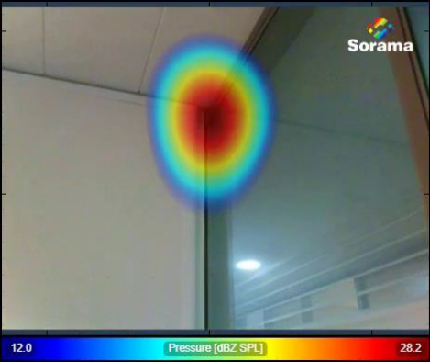
Figure _: Example of Beamformed acoustic overlay.
Near-Field Acoustic Holography: Near-Field Acoustic Holography (NAH) reconstructs the acoustic pressure field in the vicinity of a sound source by solving an inverse propagation problem based on microphone-array measurements. Compared with conventional beamforming, holography provides significantly higher spatial resolution and enables detailed visualization of distributed sound radiation patterns. In infrastructure applications, acoustic holography can support the investigation of localized structural vibrations, dynamic interactions, and defect-related acoustic phenomena occurring on bridge components and mechanical subsystems. Such detailed spatial information is valuable for validating structural models, understanding defect mechanisms, and supporting high-fidelity diagnostic assessments.
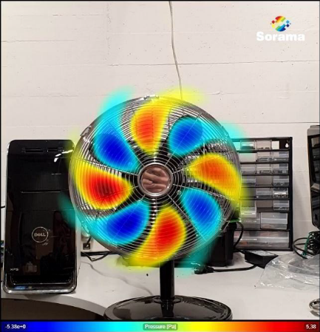
Figure _: Example of a near-field acoustic holography reconstruction generated using the Sorama Portal.
3._ Acoustic Structural Health Monitoring of Bridges
The increasing age of bridge infrastructure and the growing demand for reliable condition assessment have driven significant research into advanced Structural Health Monitoring (SHM) technologies. Traditional bridge inspections remain predominantly based on periodic visual surveys, which are often labor-intensive, subjective, and limited in their ability to identify early-stage or hidden deterioration. As a result, considerable attention has been directed towards sensing technologies capable of continuously monitoring structural condition and detecting damage before it becomes observable through conventional inspection methods.
Within this context, acoustic sensing has emerged as a promising approach for bridge health monitoring because it provides direct access to damage-related phenomena occurring within structural components. Unlike purely geometric or image-based inspection techniques, acoustic methods can capture stress-wave activity associated with crack initiation, crack propagation, wire breakage, frictional slip, material degradation, and other degradation mechanisms. This capability enables the identification of active damage processes and provides information regarding structural integrity that complements traditional inspection methodologies.
Among the available acoustic methods, Acoustic Emission (AE) monitoring is the most extensively investigated technique for bridge applications. AE is based on the detection of transient elastic waves released when stored strain energy is liberated during damage events. Numerous studies have demonstrated its capability to detect crack initiation, crack propagation, reinforcement deterioration, prestressing-wire failures, and fatigue-related damage before visible manifestations appear at the surface. Tonelli et al. validated AE technology on a full-scale prestressed concrete bridge subjected to progressive loading until failure and concluded that parameters such as hit count, signal strength, amplitude, and peak frequency can provide direct information regarding damage progression and structural degradation mechanisms.
Particularly significant advances have been achieved in the monitoring of cable-supported bridges. Suspension bridges, cable-stayed bridges, and tied-arch bridges contain critical steel cable components whose deterioration often remains hidden from conventional visual inspections. Recent studies have shown that acoustic emission monitoring can identify individual wire-breakage events and monitor the progression of corrosion-induced failures within cable systems. The increasing maturity of these techniques is evidenced by their incorporation into modern bridge monitoring guidelines, where acoustic emission monitoring is recognized as a suitable methodology for detecting cable-wire failures and assessing deterioration of tension members .
Beyond passive acoustic emission monitoring, active acoustic inspection methods have also attracted increasing attention. Approaches such as impact echo, acoustic sounding, and automated acoustic scanning exploit externally generated acoustic responses to identify defects including delamination, voids, honeycombing, debonding, and reinforcement deterioration in reinforced concrete bridge decks. Recent developments combine automated excitation systems, microphone arrays, positioning systems, and machine-learning-based classification algorithms to improve inspection repeatability and coverage compared with traditional hammer-sounding procedures. These developments demonstrate a gradual transition from specialist diagnostic tools towards scalable and automated infrastructure assessment solutions.
The broader bridge SHM community increasingly recognizes that future monitoring systems require the integration of dynamic sensing modalities capable of observing both localized damage mechanisms and global structural behaviour. Recent reviews on bridge sensing technologies identify acoustic sensing as a valuable complementary modality capable of providing information unavailable from vision-based, LiDAR-based, or strain-based monitoring systems alone. Consequently, acoustic technologies are becoming a key component of next-generation infrastructure monitoring frameworks.
3._ Acoustic Inspection Within Multi-Modal Non-Destructive Testing Frameworks
Contemporary infrastructure assessment increasingly relies on the integration of multiple sensing modalities rather than individual inspection technologies. A growing body of literature acknowledges that no single Non-Destructive Testing (NDT) method is capable of comprehensively characterizing the diverse deterioration encountered in aging bridge assets. Surface cracks, subsurface voids, corrosion processes, prestressing failures, moisture ingress, geometric deformations, and fatigue damage exhibit fundamentally different physical manifestations and therefore cannot be fully captured using a single sensing technology .
Visual inspection and computer vision systems provide efficient detection of surface-level defects such as cracks, spalling, corrosion, and deformation. Thermal imaging extends this capability through the identification of moisture ingress, delamination, and thermal anomalies associated with subsurface deterioration. Ground Penetrating Radar (GPR) provides information regarding reinforcement positioning, concrete condition, and hidden internal defects. Acoustic sensing contributes an additional dimension by capturing active damage processes and dynamic mechanical phenomena occurring within the structure.
Consequently, a major research trend within bridge SHM is the development of sensor-fusion frameworks capable of exploiting the complementary strengths of multiple sensing modalities. Several studies have demonstrated that acoustic information can substantially improve diagnostic confidence when combined with conventional NDT techniques. In particular, the combination of acoustic scanning and GPR has shown strong potential for bridge deck assessment because both technologies provide complementary perspectives on deterioration. Acoustic methods are especially sensitive to delamination and void formation, whereas GPR is highly effective for reinforcement corrosion assessment and material degradation characterization.
Recent advances in Artificial Intelligence have further accelerated the adoption of multi-modal inspection systems. Deep learning architectures, attention-based fusion networks, and hybrid feature learning approaches allow heterogeneous datasets originating from acoustic sensors, thermal cameras, vision systems, radar platforms, and LiDAR scanners to be analysed jointly. Such approaches have demonstrated improved robustness and defect classification performance when compared with single-modality solutions. The state-of-the-art increasingly views bridge inspection as an integrated information-fusion problem requiring the combination of complementary physical measurements into unified representations of structural condition.
Despite these developments, acoustic sensing remains underrepresented in operational inspection workflows. Most current inspection systems continue to rely predominantly on visual, thermal, and LiDAR data, while acoustic information is often treated as a specialist dataset rather than a fully integrated component of comprehensive infrastructure assessment frameworks.
3.X Limitations of Current State-of-the-Art Acoustic Technologies
Despite considerable progress during the past decade, several scientific and technological barriers continue to limit the widespread adoption of acoustic inspection technologies for bridge monitoring.
A fundamental challenge arises from the complex propagation of acoustic and elastic waves within civil infrastructure materials. Reinforced concrete, prestressed concrete, steel-reinforced structures, asphalt overlays, and composite bridge components exhibit highly heterogeneous material properties. Acoustic wave attenuation, scattering, reflection, and mode conversion become increasingly significant as structures grow in size and complexity. Consequently, acoustic signals often experience substantial distortion before reaching sensing systems, complicating defect localization and characterization.
Environmental conditions constitute an additional challenge. Traffic-induced vibrations, vehicle noise, wind loading, precipitation events, and ambient acoustic disturbances may overlap with defect-related signatures. In operational bridge environments, signal-to-noise ratios are therefore significantly lower than those obtained in laboratory conditions. Distinguishing genuine damage events from environmental noise remains an active field of research.
Scalability represents another important limitation. Most acoustic SHM implementations rely on permanently installed piezoelectric sensors or acoustic emission transducers physically attached to the structure. Although such systems provide highly sensitive measurements, deployment, calibration, maintenance, and long-term operation become increasingly expensive when large bridge inventories are considered. Consequently, widespread portfolio-level adoption remains limited.
Most existing studies also focus on relatively controlled experimental environments. Publicly available bridge-specific acoustic datasets remain scarce, particularly for deterioration mechanisms such as prestressing-wire failures, advanced delamination, and internal cracking. This scarcity limits the development, validation, and generalization of machine-learning-based diagnostic systems.
From an airborne inspection perspective, additional challenges arise through the introduction of UAV platforms. Rotor-induced noise, airframe vibrations, aerodynamic turbulence, position uncertainty, and changing source-to-sensor geometries significantly affect acoustic measurements. While UAV-based visual inspection has become well established, relatively little research has investigated microphone-array-based acoustic imaging for bridge inspection under realistic field conditions. Consequently, the robustness of beamforming, acoustic source localization, and anomaly detection during UAV operation remains insufficiently understood .
Finally, acoustic monitoring systems frequently operate as standalone technologies. Integration with digital twins, predictive maintenance systems, and multi-modal decision-support platforms remains relatively immature. As a result, acoustic information often remains disconnected from broader asset-management workflows, reducing its potential value to infrastructure owners and operators.

LiDAR / Distance Sensing
1. Introduction
LiDAR and other distance-sensing technologies have become important tools for automated measurement and inspection of road infrastructure. Unlike conventional camera-based inspection, LiDAR directly measures three-dimensional geometry, making it particularly suitable for applications where surface elevation, deformation and depth are important. Recent research shows increasing use of mobile LiDAR for pavement inspection, including road-surface geometry, distress detection and road asset inventory. Mobile systems are particularly attractive because they combine high measurement capability with the ability to survey roads at normal traffic speeds.
For road inspection, however, the requirements are different from those of conventional automotive or mapping applications. Detecting an object at a distance is fundamentally different from accurately measuring millimetre- or centimetre-scale variations in a road surface. Therefore, the relevant State of the Art is not simply the highest-performance LiDAR available, but the combination of sensing technology, spatial resolution, accuracy, repeatability, vehicle speed, positioning and processing.
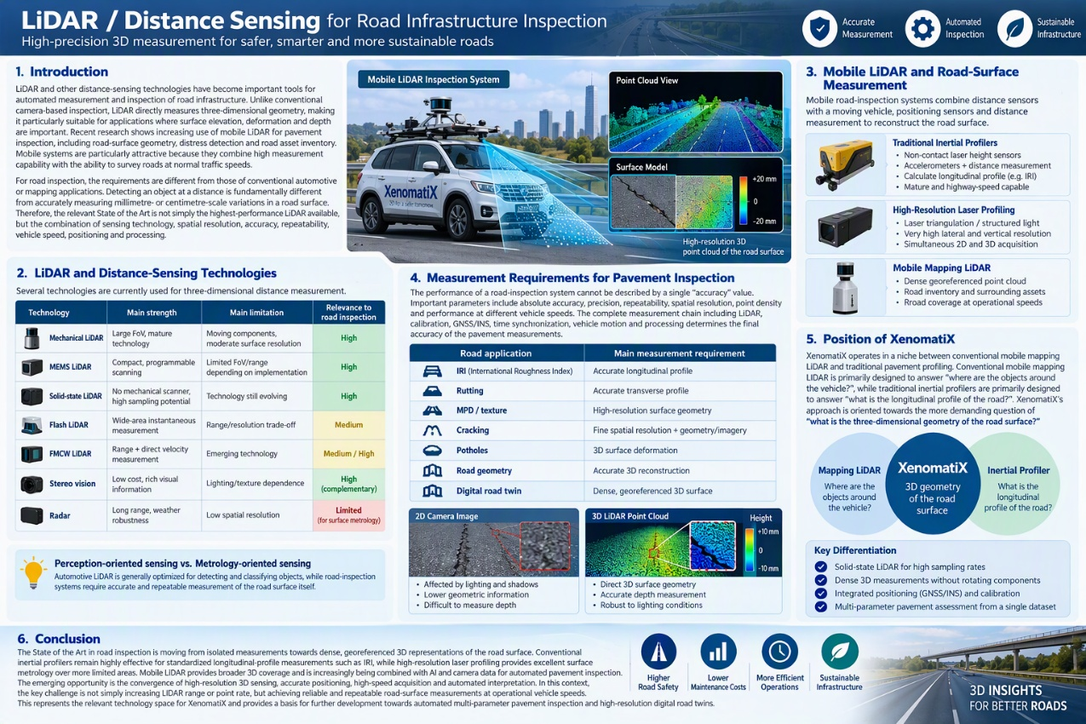
2. LiDAR and Distance-Sensing Technologies
Several technologies are currently used for three-dimensional distance measurement. Conventional mechanical LiDAR uses rotating components to scan the environment and is widely used for mobile mapping because of its large field of view and high point-generation rate. MEMS-based and solid-state LiDAR technologies replace or reduce mechanical scanning components, allowing smaller systems and more programmable scanning patterns. Flash LiDAR uses array-based time-of-flight measurements to capture a wider area simultaneously, while FMCW LiDAR uses frequency-modulated continuous-wave principles and can additionally provide direct velocity information. Laser triangulation and structured-light systems are another important category, particularly for high-resolution surface measurement at relatively short ranges. Stereo vision can also provide 3D information, although its accuracy is strongly dependent on camera geometry, texture and lighting conditions. Radar offers long range and strong environmental robustness but generally has significantly lower spatial resolution than optical sensing.
Technology | Main strength | Main limitation | Relevance to road inspection
Mechanical LiDAR | Large FoV, mature technology | Moving components, moderate surface resolution | High
MEMS LiDAR | Compact, programmable scanning | Limited FoV/range depending on implementation | High
Solid-state LiDAR | No mechanical scanner, high sampling potential | Technology still evolving | High
Flash LiDAR | Wide-area instantaneous measurement | Range/resolution trade-off | Medium
FMCW LiDAR | Range + direct velocity measurement | Emerging technology | Medium/High
Stereo vision | Low cost, rich visual information | Lighting/texture dependence | High as complementary technology
Radar | Long range, weather robustness | Low spatial resolution | Limited for surface metrology
The important distinction for road inspection is therefore between perception-oriented sensing and metrology-oriented sensing. Automotive LiDAR is generally optimized for detecting and classifying objects, while road-inspection systems require accurate and repeatable measurement of the road surface itself.
3. Mobile LiDAR and Road-Surface Measurement
Mobile road-inspection systems combine distance sensors with a moving vehicle, positioning sensors and distance measurement to reconstruct the road surface. Traditional high-speed inertial profilers use accelerometers, non-contact laser height sensors and a distance-measuring instrument to calculate the longitudinal pavement profile, which can subsequently be used to derive the International Roughness Index (IRI). These systems are mature and capable of highway-speed measurement, but their primary objective is profile measurement along specific measurement paths rather than full three-dimensional surface reconstruction.

Modern 3D laser imaging systems extend this concept by measuring the surface over a much wider area. Laser triangulation systems, for example, can project a laser pattern onto the pavement and reconstruct the surface from the observed deformation of that pattern. Such systems can provide very high lateral and vertical resolution and can simultaneously acquire 2D and 3D information.
Mobile mapping LiDAR provides a different approach, generating a dense georeferenced point cloud over the road and surrounding environment. It is particularly useful when the objective extends beyond pavement condition to include road inventory, road geometry and the surrounding infrastructure. Recent reviews identify mobile laser scanning as one of the most relevant LiDAR approaches for pavement inspection because it combines mobility, coverage and 3D measurement capability.
4. Measurement Requirements for Pavement Inspection
The performance of a road-inspection system cannot be described by a single "accuracy" value. Important parameters include absolute accuracy, precision, repeatability, spatial resolution, point density and performance at different vehicle speeds. The complete measurement chain including LiDAR, calibration, GNSS/INS, time synchronization, vehicle motion and processing determines the final accuracy of the pavement measurements.
Different pavement parameters require different levels of measurement capability. IRI primarily depends on the longitudinal road profile, while rutting requires accurate transverse geometry. Surface texture and MPD require substantially finer spatial measurements, while crack and pothole detection can benefit from both high-resolution 3D geometry and imagery. A full 3D road model can potentially support several of these measurements from the same underlying dataset.
Road application | Main measurement requirement
IRI | Accurate longitudinal profile
Rutting | Accurate transverse profile
MPD / texture | High-resolution surface geometry
Cracking | Fine spatial resolution + geometry/imagery
Potholes | 3D surface deformation
Road geometry | Accurate 3D reconstruction
Digital road twin | Dense, georeferenced 3D surface
The advantage of 3D sensing over conventional 2D imaging is particularly relevant for pavement distress. Camera-based methods can be affected by lighting, shadows, stains and low contrast, whereas 3D systems directly capture surface geometry.
At the same time, LiDAR does not eliminate the need for imaging. Cameras provide colour and texture information that can complement geometric measurements, making LiDAR + camera + GNSS/INS an increasingly relevant architecture for automated road inspection.
5. Position of XenomatiX
XenomatiX operates in a niche between conventional mobile mapping LiDAR and traditional pavement profiling. Conventional mobile mapping LiDAR is primarily designed to answer "where are the objects around the vehicle?", while traditional inertial profilers are primarily designed to answer "what is the longitudinal profile of the road?". XenomatiX's approach is oriented towards the more demanding question of "what is the three-dimensional geometry of the road surface?"
The use of solid-state LiDAR for road inspection provides the potential for high sampling rates, dense 3D measurements and the absence of mechanically rotating scanning components. Combined with accurate positioning, calibration and processing, this enables a single mobile platform to capture detailed road-surface geometry that can subsequently be used for multiple pavement-condition parameters. The XenoTrack/XenomatiX architecture therefore fits within the broader industry transition from dedicated single-parameter measurement systems towards dense 3D sensing and multi-parameter road inspection.
The main technological differentiation should consequently not be expressed only in terms of the LiDAR sensor itself. The relevant performance is the complete measurement chain: sensor characteristics, spatial sampling, calibration, GNSS/INS integration, synchronization, vehicle speed, processing and the ability to derive repeatable pavement metrics from the resulting 3D surface.
6. Conclusion
The State of the Art in road inspection is moving from isolated measurements towards dense, georeferenced 3D representations of the road surface. Conventional inertial profilers remain highly effective for standardized longitudinal-profile measurements such as IRI, while high-resolution laser profiling provides excellent surface metrology over more limited areas. Mobile LiDAR provides broader 3D coverage and is increasingly being combined with AI and camera data for automated pavement inspection.
The emerging opportunity is therefore the convergence of high-resolution 3D sensing, accurate positioning, high-speed acquisition and automated interpretation. In this context, the key challenge is not simply increasing LiDAR range or point rate, but achieving reliable and repeatable road-surface measurements at operational vehicle speeds. This represents the relevant technology space for XenomatiX and provides a basis for further development towards automated multi-parameter pavement inspection and high-resolution digital road twins.

Ground Penetrating Radar (GPR)
1. Introduction
Ground Penetrating Radar (GPR) has become one of the most important non-destructive testing (NDT) technologies for transportation infrastructure inspection. Unlike visual inspection methods, which are restricted to surface-visible defects, GPR can characterize subsurface conditions by transmitting electromagnetic waves into materials and analysing reflected responses. This allows detection of hidden defects such as voids, delamination, moisture ingress, reinforcement corrosion, ballast degradation, and internal cracking within bridges, pavements, railways, airport runways, tunnels, and port structures.
The increasing age of transportation infrastructure and the need for predictive maintenance have accelerated the adoption of GPR-based inspection systems. Modern deployments combine ground-coupled or air-coupled radar sensors with vehicle-mounted platforms, drones, autonomous robots, and AI-driven processing frameworks. As a result, GPR is evolving from a specialist diagnostic tool into an integral component of large-scale infrastructure monitoring ecosystems.
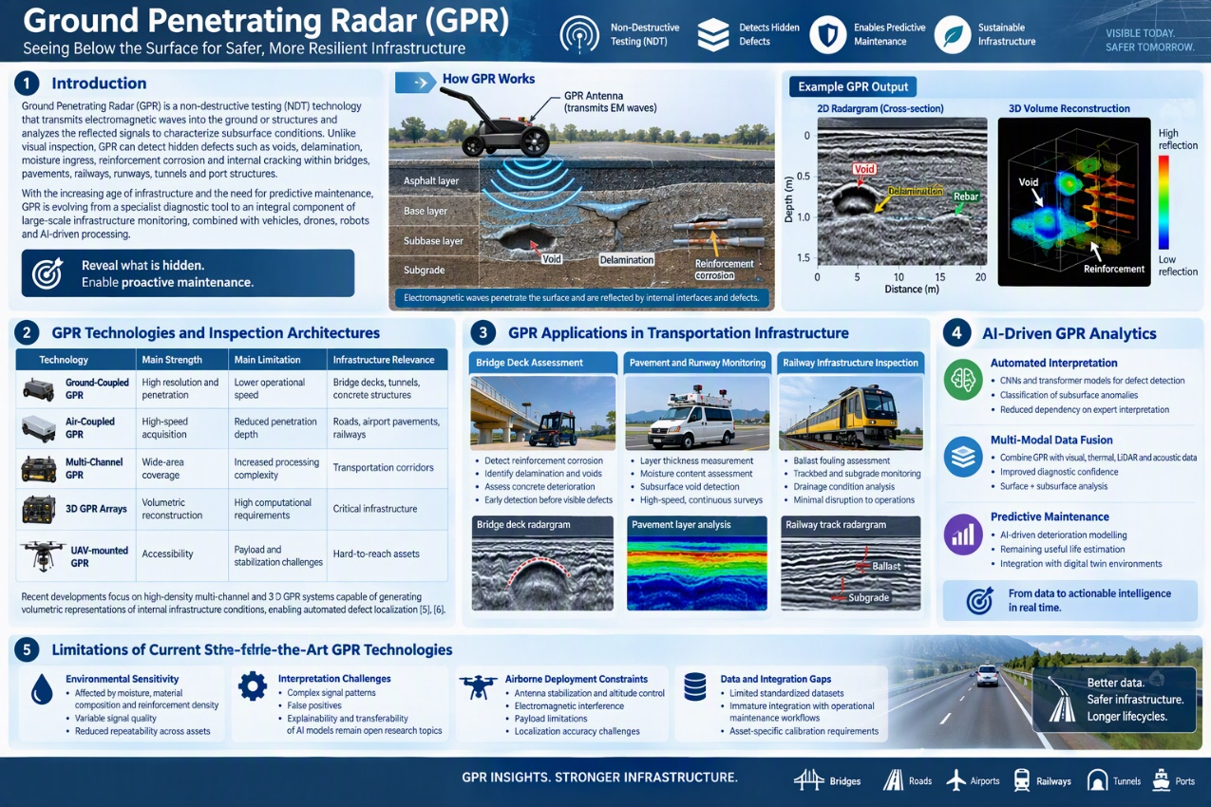
2. GPR Technologies and Inspection Architectures
Several GPR configurations are currently employed for infrastructure assessment.
Technology | Main Strength | Main Limitation | Infrastructure Relevance
Ground-Coupled GPR | High resolution and penetration | Lower operational speed | Bridge decks, tunnels, concrete structures
Air-Coupled GPR | High-speed acquisition | Reduced penetration depth | Roads, airport pavements, railways
Multi-Channel GPR | Wide-area coverage | Increased processing complexity | Transportation corridors
3D GPR Arrays | Volumetric reconstruction | High computational requirements | Critical infrastructure
UAV-mounted GPR | Accessibility | Payload and stabilization challenges | Hard-to-reach assets
Recent developments increasingly focus on high-density multi-channel and 3D GPR systems capable of generating volumetric representations of internal infrastructure conditions. These systems support automated defect localization and provide substantially richer information than traditional single-channel radar profiles.
3. GPR Applications in Transportation Infrastructure
Bridge Deck Assessment
Bridge inspection represents one of the most mature GPR application domains. GPR is extensively used to identify reinforcement corrosion, chloride penetration, concrete deterioration, void formation, and delamination. Numerous studies have demonstrated its effectiveness for detecting deterioration mechanisms long before visual manifestations appear on the structure surface.
Pavement and Runway Monitoring
For roads and airport runways, GPR enables continuous assessment of pavement layer thickness, moisture content, foundation stability, subsurface voids, and structural degradation. Modern vehicle-mounted systems can perform inspections at operational traffic speeds, making GPR particularly attractive for large-scale transportation asset management .
Railway Infrastructure Inspection
Railway applications increasingly employ GPR for ballast fouling assessment, subgrade characterization, drainage analysis, and trackbed monitoring. Combined with train-mounted deployment and AI-based signal interpretation, GPR enables condition monitoring of entire railway corridors with minimal disruption to operations .
4. AI-Driven GPR Analytics
Historically, GPR interpretation relied heavily on expert analysis of radargrams. Recent advances in artificial intelligence have transformed this process. Convolutional Neural Networks (CNNs), transformer architectures, and deep-learning-based anomaly detection systems are increasingly used to automatically identify hidden deterioration patterns and classify defect types directly from radar data .
Research increasingly focuses on fusing GPR information with visual imaging, thermal sensing, LiDAR, and acoustic inspection data. Such multi-modal approaches improve diagnostic confidence by simultaneously incorporating information from both surface and subsurface conditions.
5. Limitations of Current State-of-the-Art GPR Technologies
Despite significant progress, several limitations remain. Electromagnetic wave propagation is highly sensitive to moisture, material composition, reinforcement density, and environmental conditions, complicating interpretation and reducing repeatability across different assets.
Another major challenge involves automated interpretation. While AI models improve scalability, explainability and transferability between infrastructure types remain active research topics.
For airborne deployments, UAV-mounted GPR systems face additional constraints including antenna stabilization, altitude control, electromagnetic interference, payload limitations, and localization accuracy. Consequently, operational UAV-based GPR inspection remains less mature than ground-based implementations .

Backscatter X-Ray Inspection Technologies
Backscatter X-ray imaging represents an emerging non-destructive testing (NDT) technology capable of detecting hidden structural anomalies that are difficult or impossible to identify using conventional visual inspection methods. Unlike transmission X-ray systems, which require access to both sides of an object, backscatter X-ray systems measure radiation scattered back from the inspected material, allowing one-sided inspection and making them particularly attractive for large infrastructure assets such as bridges, pavements, airport runways, tunnels, and transport infrastructure components. Technology enables subsurface characterization of material discontinuities, voids, moisture accumulation, delamination, foreign inclusions, and internal deterioration mechanisms that remain invisible to optical inspection techniques. Recent advances in portable radiation sources, detector miniaturization, image reconstruction algorithms, and robotics integration have significantly expanded the applicability of backscatter imaging beyond laboratory and security applications into infrastructure assessment and maintenance domains.
2. Backscatter X-Ray Inspection Principles
Backscatter imaging operates by directing low-energy X-rays toward a target structure and measuring photons scattered backwards through Compton scattering interactions. Variations in material density, thickness, composition, and internal defects alter the scattering response, allowing hidden anomalies to be visualized without destructive intervention.
Compared with alternative subsurface inspection techniques:
Technology | Main Strength | Main Limitation | Infrastructure Relevance
Backscatter X-Ray | High sensitivity to shallow subsurface anomalies | Regulatory constraints | Concrete, pavements, airport assets
GPR | Large-area coverage | Material-dependent interpretation | Roads, railways, bridges
Ultrasound | High defect characterization accuracy | Contact inspection required | Concrete and metallic structures
Thermal Imaging | Fast deployment | Indirect subsurface assessment | Surface and moisture-related defects
Current research increasingly focuses on integrating backscatter imaging with autonomous platforms, enabling rapid inspection of large infrastructure surfaces while reducing human exposure and operational disruption.
3. Infrastructure Inspection Applications
Airport Runways and Pavements
Airport pavement maintenance increasingly requires detection of hidden defects before visible failures emerge. Backscatter imaging has demonstrated potential for identifying shallow voids, subsurface cracking, moisture ingress, foreign material inclusions, and early-stage delamination within rigid and flexible pavement structures. When combined with AI-based image interpretation, these systems can support predictive maintenance strategies and reduce the need for destructive coring operations.
Bridge Decks and Concrete Structures
Bridge inspections frequently face challenges in identifying internal deterioration of concrete elements. Backscatter X-ray techniques can reveal delamination, internal cracking, material degradation, reinforcement positioning anomalies, and localized voids near the surface. The ability to inspect from a single accessible side is particularly attractive for bridge decks, retaining structures, and tunnel linings where access is constrained.
Transport and Railway Infrastructure
Emerging research explores the use of backscatter imaging for railway asset assessment, including detection of ballast contamination, concrete sleeper degradation, hidden material defects, and localized structural damage. These capabilities complement traditional GPR-based assessments by providing higher-resolution characterization of near-surface deterioration mechanisms.
4. Autonomous and Airborne Backscatter Inspection
Recent advances in lightweight imaging hardware, robotic manipulation systems, and autonomous navigation are enabling the deployment of backscatter X-ray technologies on mobile and aerial platforms. Within the broader State of the Art, research increasingly investigates UAV-assisted and robotic inspection concepts capable of operating in difficult-to-access locations while maintaining precise sensor positioning and safety controls. The combination of autonomous carrier platforms, high-precision localization, edge computing, and AI-assisted interpretation creates new opportunities for scalable, non-intrusive subsurface infrastructure assessment.
5. Current State-of-the-Art Limitations
Despite significant potential, several challenges continue to limit widespread adoption. Regulatory requirements governing ionizing radiation remain one of the primary barriers to operational deployment. System weight, power consumption, shielding requirements, and safety certification constraints currently limit integration on smaller autonomous platforms. Furthermore, image interpretation remains dependent on advanced reconstruction algorithms and specialist expertise, while publicly available infrastructure datasets for AI training remain scarce. Consequently, current research increasingly focuses on combining backscatter X-ray data with Ground Penetrating Radar (GPR), optical inspection, thermal imaging, and multi-modal AI fusion systems to improve defect characterization accuracy and operational usability.
The State of the Art indicates that backscatter X-ray imaging uniquely addresses one of the most significant gaps in current infrastructure inspection: reliable detection and characterization of hidden subsurface defects without destructive intervention. Within STRUCTURE, this technology directly contributes to TI1 – Airborne Subsurface Defect Detection, complementing Ground Penetrating Radar by providing higher-resolution characterization of near-surface deterioration mechanisms and enabling more comprehensive assessment of critical transport infrastructure assets. Through integration with autonomous UAV platforms, edge intelligence, multi-modal sensing, and Digital Twin environments, backscatter X-ray technologies represent a promising pathway toward non-intrusive, predictive infrastructure maintenance.

Optical and Thermal Imaging Technologies
1. Introduction
Optical and thermal imaging technologies represent the dominant sensing modalities for modern infrastructure inspection. Their widespread adoption is driven by their ability to provide rapid, non-contact, high-resolution observations over large geographical areas. Deployed on UAVs, vehicles, robots, and fixed monitoring systems, these sensors enable automated assessment of bridges, tunnels, roads, railways, airport facilities, and port infrastructure .
While RGB imaging primarily captures geometric appearance, texture, and visible deterioration, thermal sensing extends inspection capabilities by visualizing temperature distributions that may indicate hidden defects, moisture ingress, delamination, insulation failures, or overheating components. Together, these technologies form the foundation of most contemporary automated inspection systems .
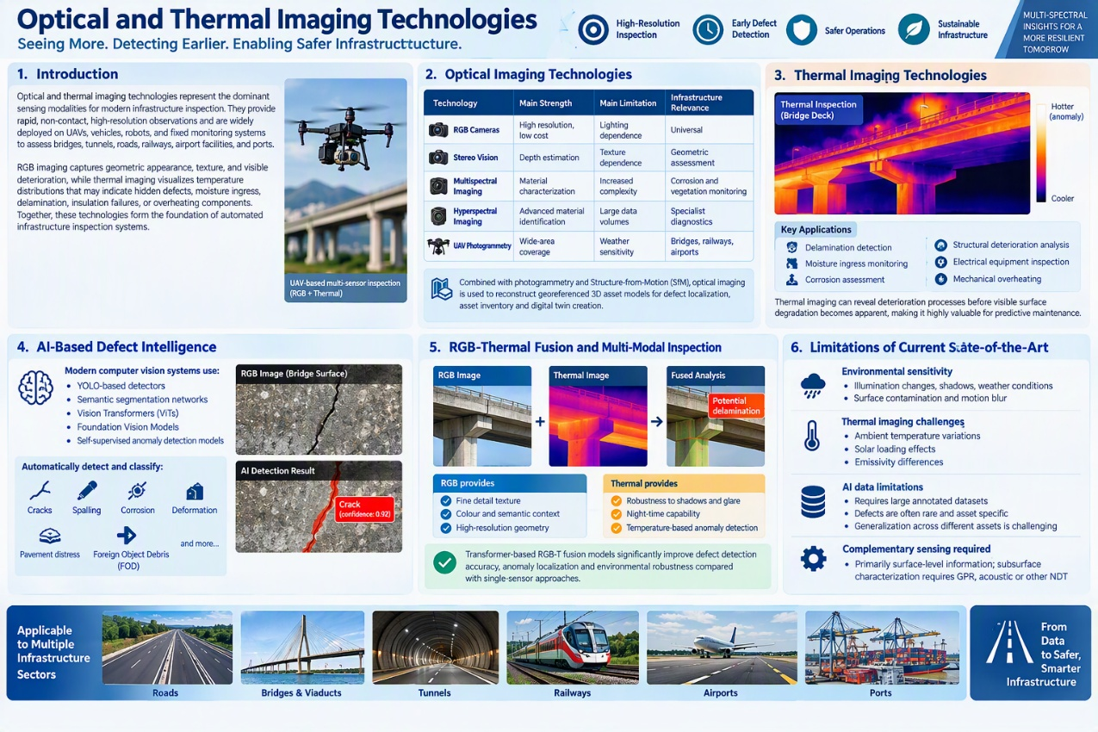
2. Optical Imaging Technologies
Several optical sensing approaches are currently employed in automated infrastructure inspection.
Technology | Main Strength | Main Limitation | Infrastructure Relevance
RGB Cameras | High resolution, low cost | Lighting dependence | Universal
Stereo Vision | Depth estimation | Texture dependence | Geometric assessment
Multispectral Imaging | Material characterization | Increased complexity | Corrosion and vegetation monitoring
Hyperspectral Imaging | Advanced material identification | Large data volumes | Specialist diagnostics
UAV Photogrammetry | Wide-area coverage | Weather sensitivity | Bridges, railways, airports
The current state-of-the-art increasingly combines high-resolution optical imagery with photogrammetry and Structure-from-Motion (SfM) techniques to reconstruct georeferenced 3D asset models. Such approaches support defect localization, asset inventory generation, and digital twin creation .
3. Thermal Imaging Technologies
Thermal sensing enables visualization of infrared radiation emitted by infrastructure components and therefore provides information unavailable to conventional visual inspection.
Major applications include:
- Delamination detection
- Moisture ingress monitoring
- Corrosion assessment
- Structural deterioration analysis
- Electrical equipment inspection
- Mechanical overheating detection
Recent studies show that thermal imaging can reveal deterioration processes before visible surface degradation becomes apparent, making it particularly valuable for predictive maintenance applications .
4. AI-Based Defect Intelligence
The greatest advancements in optical and thermal inspection have been driven by artificial intelligence. Modern computer vision systems increasingly utilize:
- YOLO-based detectors
- Semantic segmentation networks
- Vision Transformers (ViTs)
- Foundation Vision Models
- Self-supervised anomaly detection models
These systems can automatically detect and classify cracks, spalling, corrosion, deformation, pavement distress, Foreign Object Debris (FOD), and numerous other defect categories. Recent reviews suggest that AI-assisted visual inspection is becoming sufficiently robust for operational deployment across multiple infrastructure sectors .
5. RGB-Thermal Fusion and Multi-Modal Inspection
A major State-of-the-Art trend involves RGB-T fusion, where visual and thermal data are analysed jointly. Thermal information adds robustness against shadows, glare, night-time conditions, and surface reflections, while RGB data provides fine-detail texture and semantic context.
Recent transformer-based cross-modal architectures demonstrate significant improvements in defect detection accuracy, anomaly localization, and environmental robustness compared with single-sensor approaches. Consequently, RGB-T systems are increasingly viewed as a core component of future multi-modal inspection frameworks .
6. Limitations of Current State-of-the-Art Optical and Thermal Systems
Despite considerable progress, several challenges remain. Optical systems remain sensitive to illumination changes, shadows, weather conditions, surface contamination, and motion blur. Thermal imaging is similarly affected by ambient temperature variations, solar loading effects, emissivity differences, and seasonal environmental changes.
AI models additionally require large volumes of representative training data, while infrastructure defects are often rare, imbalanced, and asset specific. Consequently, model generalization across different infrastructure assets remains a significant challenge.
Finally, optical and thermal technologies primarily characterize surface manifestations of deterioration. Although thermal anomalies may indirectly indicate hidden defects, direct subsurface characterization still requires complementary sensing modalities such as GPR, acoustic sensing, or advanced NDT technologies. Current research therefore increasingly emphasizes multi-modal fusion as the path toward comprehensive infrastructure condition assessment.

Autonomous Carrier Platform Layer (UAV / Robotics)
1. Introduction
Autonomous carrier platforms have emerged as one of the most transformative technologies for transportation infrastructure inspection. Traditional inspection practices for bridges, tunnels, railways, airport facilities, and port assets rely heavily on manual access methods, including scaffolding, cranes, rope-access teams, inspection vehicles, and lane closures. These approaches are costly, disruptive, and inherently limited by accessibility constraints. Recent advances in Unmanned Aerial Vehicles (UAVs), autonomous robotics, onboard sensing, and artificial intelligence are enabling a paradigm shift toward autonomous, high-frequency, and non-intrusive inspections capable of reaching locations previously inaccessible to human operators.
From the perspective of the STRUCTURE project, autonomous carrier platforms directly address three major challenges identified in the problem space:
- P5 – Intrusiveness and traffic disruption, by reducing or eliminating lane closures and heavy equipment deployment.
- P6 – Low inspection frequency, by enabling rapid and cost-effective repeat inspections.
- P7 – No access in hard-to-reach areas, by providing close-proximity access to confined, elevated, or hazardous locations.
The State of the Art is increasingly characterized by the convergence of autonomous UAV platforms, high-payload carrier systems, advanced stabilization mechanisms, AI-driven navigation, and real-time mission adaptation. Modern inspection systems no longer view UAVs merely as flying cameras but as intelligent sensor carriers capable of executing complex inspection tasks autonomously while maintaining inspection quality comparable to or exceeding traditional methods.
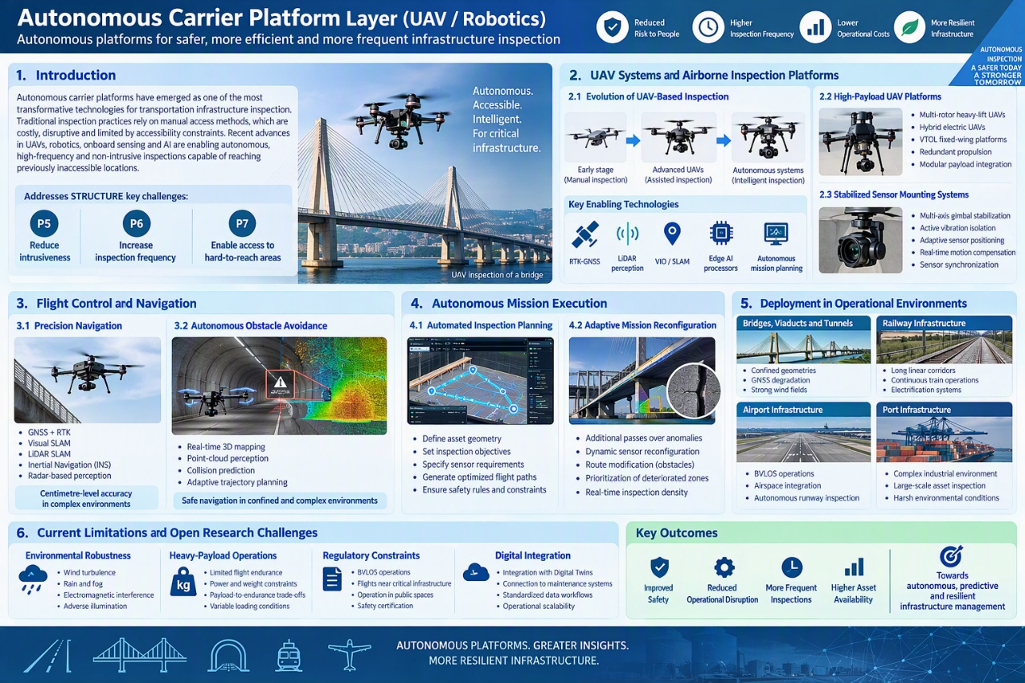
2. UAV Systems and Airborne Inspection Platforms
2.1 Evolution of UAV-Based Inspection
Infrastructure inspection was one of the earliest industrial applications of UAV technology. Initial deployments focused primarily on visual inspection using manually piloted drones equipped with RGB cameras. While these systems substantially improved operator safety and accessibility, they remained dependent on pilot expertise and generated largely unstructured image datasets requiring extensive post-processing .
Recent generations of UAV platforms integrate:
- RTK-GNSS positioning
- LiDAR-based perception
- Visual-Inertial Odometry (VIO)
- Simultaneous Localization and Mapping (SLAM)
- Edge AI processors
- Autonomous mission planning
These capabilities enable repeatable inspection missions, precise defect localization, and integration into digital asset management workflows .
As a result, UAV inspection is entering a new phase where autonomous operation rather than manual piloting becomes the primary value proposition.

2.2 High-Payload UAV Platforms
Many advanced NDT modalities proposed for transportation infrastructure inspection are significantly heavier than traditional visual sensors. Ground Penetrating Radar (GPR), backscatter X-ray sensors, acoustic arrays, advanced thermal cameras, and multi-modal sensing payloads frequently exceed the payload capacity of conventional commercial UAVs.
Consequently, substantial research efforts have focused on high-payload UAV architectures capable of transporting sensor suites weighing several kilograms while maintaining flight stability and operational endurance .
Current state-of-the-art approaches include:
- Multi-rotor heavy-lift UAVs
- Hybrid electric UAVs
- VTOL fixed-wing platforms
- Redundant propulsion architectures
- Modular payload integration systems
The primary challenge is balancing payload capacity against flight time, maneuverability, energy consumption, and environmental robustness. Recent studies indicate that heavy-payload infrastructure inspection UAVs increasingly employ advanced flight-control algorithms and adaptive propulsion management to maintain stable operation under variable loading conditions.

2.3 Stabilized Sensor Mounting Systems
Inspection quality depends not only on sensor characteristics but also on sensor positioning stability during acquisition.
Modern UAV inspection systems increasingly employ:
- Multi-axis gimbal stabilization
- Active vibration isolation
- Adaptive sensor positioning
- Real-time motion compensation
- Sensor-to-platform synchronization
These technologies are particularly important when operating high-resolution optical systems, LiDAR scanners, thermal cameras, GPR antennas, or acoustic arrays. Even small platform oscillations can significantly reduce measurement quality and impair defect detection performance .
Recent UAV inspection research has focused on tightly coupled stabilization architectures where flight-control systems continuously compensate for turbulence-induced disturbances while simultaneously maintaining precise sensor orientation relative to the inspected asset .

3. Flight Control and Navigation
3.1 Precision Navigation
Transportation infrastructure inspection differs fundamentally from conventional aerial surveying.
Instead of operating at large stand-off distances, inspection UAVs frequently operate within:
- Narrow bridge structures
- Confined tunnel entrances
- Railway corridors
- Airport facilities
- Cable-supported bridge systems
These environments require centimetre-level positioning accuracy and precise trajectory control.
State-of-the-art localization architectures increasingly combine:
- RTK-GNSS
- Visual SLAM
- LiDAR SLAM
- Inertial Navigation Systems (INS)
- Radar-based perception
Multi-sensor localization significantly improves robustness in environments where GNSS signals are degraded by structural occlusions, reflections, or confined geometries .

3.2 Autonomous Obstacle Avoidance
Safe close-proximity inspection requires continuous awareness of the surrounding environment.
Modern systems increasingly employ:
- Real-time 3D mapping
- Point-cloud perception
- Collision prediction
- Adaptive trajectory planning
- Reinforcement-learning-based avoidance algorithms
These approaches allow UAVs to inspect complex structures while maintaining safe separation from cables, beams, walls, lighting infrastructure, and moving equipment.
Recent advances in onboard AI enable real-time obstacle avoidance without dependence on remote operators, allowing greater levels of autonomy and reducing operational complexity.

4. Autonomous Mission Execution
4.1 Automated Inspection Planning
The current State of the Art increasingly focuses on transforming inspection from a piloting problem into a mission-planning problem.
Modern inspection workflows allow operators to define:
- Asset geometry
- Inspection objectives
- Sensor requirements
- Coverage constraints
- Safety rules
The autonomous system subsequently generates optimized flight trajectories and inspection plans. Recent research demonstrates significant improvements in inspection repeatability and coverage optimization when autonomous mission planning replaces manual pilot navigation.

4.2 Adaptive Mission Reconfiguration
A growing research trend involves adaptive inspection missions capable of responding dynamically to observed conditions.
Examples include:
- Additional passes over detected anomalies
- Dynamic sensor reconfiguration
- Route modification due to environmental obstacles
- Prioritization of deteriorated asset zones
- Real-time inspection density management
Such capabilities significantly increase inspection efficiency by concentrating sensing resources where the highest information value exists.

5. Deployment in Complex Environments
5.1 Bridges, Viaducts and Tunnels
Bridge and tunnel inspection remains among the most demanding operational environments for UAV systems.
Challenges include:
- Strong local wind fields
- GNSS degradation
- Confined geometries
- Variable illumination
- Multipath reflections
Recent research increasingly investigates autonomous UAV operation within these environments through the integration of LiDAR navigation, SLAM, and AI-assisted flight control. These systems demonstrate substantial improvements in accessibility compared with conventional crane-based inspections .

5.2 Railway Infrastructure
Railway inspections introduce additional constraints including:
- Long linear corridors
- Continuous train operations
- Electrification systems
- Regulatory safety requirements
Emerging solutions involve autonomous UAV patrols combined with railway-mounted sensing platforms and predictive scheduling systems capable of monitoring extensive rail networks without service interruptions .

5.3 Airport Infrastructure
Airport environments represent one of the most regulated operational domains for autonomous UAV deployment.
Current research focuses on:
- BVLOS operation
- Airspace integration
- Collision avoidance
- Autonomous runway inspection
- Automated pavement assessment
Recent pilot deployments demonstrate increasing acceptance of autonomous UAV operations for airport infrastructure inspection, although regulatory integration remains an active challenge.

6. Current Limitations and Open Research Challenges
Despite substantial progress, several challenges continue to limit widespread deployment.
Environmental Robustness
Current autonomous systems remain sensitive to:
- Wind turbulence
- Rain and fog
- Electromagnetic interference
- Adverse illumination
Maintaining precision during close-proximity inspection under such conditions remains a major research challenge .
Heavy-Payload Operations
As sensor suites become larger and more sophisticated, flight endurance decreases significantly. Improving payload-to-endurance performance remains an active area of UAV research.
Regulatory Constraints
Autonomous infrastructure inspection frequently requires:
- BVLOS operations
- Flights near critical infrastructure
- Operation in public spaces
- Safety certification
Regulatory approval pathways continue to evolve and represent a significant barrier to large-scale adoption.
Digital Integration
Finally, many UAV inspection systems remain isolated from broader infrastructure management workflows. Full integration with AI-driven analytics, predictive maintenance systems, Digital Twins, and maintenance planning environments remains relatively immature despite increasing research activity in this direction .

Localization, Mapping & Navigation Layer
1. Introduction
Accurate localization and navigation are fundamental requirements for autonomous infrastructure inspection systems. While advances in sensing technologies have significantly improved defect detection capabilities, the value of inspection data ultimately depends on the ability to accurately determine where observations were collected and to repeatedly revisit the same locations over time. For transportation infrastructure such as bridges, viaducts, tunnels, airport facilities, railways, and ports, positioning errors of only a few centimeters may result in incorrect defect localization, unreliable deterioration tracking, or ineffective maintenance interventions.
The State of the Art is therefore moving beyond standalone GNSS navigation toward integrated localization, mapping, and navigation systems that combine satellite navigation, computer vision, LiDAR, inertial sensing, and artificial intelligence. These technologies collectively enable high-precision inspection, safe autonomous operations, and optimized coverage of complex infrastructure environments .
For the STRUCTURE project, this layer represents the technological foundation that transforms autonomous sensor carriers from remotely piloted drones into intelligent inspection platforms capable of navigating complex environments, generating repeatable spatial representations, and supporting predictive maintenance workflows through accurate geo-referenced data acquisition.

2. Multi-Sensor Localization Technologies
GNSS-Based Localization
Global Navigation Satellite Systems (GNSS), including GPS, Galileo, GLONASS, and BeiDou, remain the foundation of most outdoor autonomous navigation systems. Modern inspection platforms increasingly employ Real-Time Kinematic (RTK) and Post-Processed Kinematic (PPK) techniques capable of achieving centimeter-level positioning accuracy under favorable conditions .
In transportation infrastructure inspection, RTK-GNSS enables:
- Precise defect geolocation
- Repeatable survey trajectories
- Spatial alignment of multi-temporal inspections
- Accurate digital twin synchronization
However, infrastructure environments frequently challenge GNSS reliability. Bridges, tunnels, rail corridors, airport terminals, steel structures, and urban environments may introduce satellite masking, multipath effects, and signal degradation. Consequently, GNSS alone is typically insufficient for high-precision close-proximity inspection .

Vision-Based Positioning
Vision-based localization has emerged as a critical complement to satellite navigation. Unlike GNSS, visual localization derives positional information directly from environmental features captured by onboard cameras.
Current approaches include:
- Feature-based visual odometry
- Visual-Inertial Odometry (VIO)
- Deep-learning-based localization
- Structure-from-Motion (SfM)
- Dense visual mapping
Vision-based positioning is particularly valuable in environments where GNSS performance deteriorates, such as beneath bridge structures, inside tunnels, underneath viaducts, and around complex steel constructions .
Recent advances in deep learning and transformer architectures have substantially improved visual localization robustness under changing illumination, weather conditions, and viewpoint variations. As a result, visual positioning increasingly forms a core component of autonomous inspection systems .

GNSS + Vision Sensor Fusion
The current State of the Art increasingly relies on tightly coupled GNSS-vision architectures.
In these systems:
- GNSS provides global positioning references.
- Cameras provide local environmental awareness.
- IMUs provide high-frequency motion estimation.
- AI fusion algorithms combine information streams into a unified trajectory estimate.
Sensor fusion dramatically improves localization robustness because individual sensor weaknesses are compensated by complementary modalities. When GNSS becomes unreliable, visual and inertial systems maintain trajectory estimation. When visual tracking quality degrades, GNSS and IMU measurements stabilize navigation .
Recent infrastructure inspection studies demonstrate that fused GNSS–Vision–INS systems consistently outperform single-sensor solutions with respect to positioning accuracy, navigation robustness, and inspection repeatability .

3. SLAM and Infrastructure Mapping
Simultaneous Localization and Mapping (SLAM)
Simultaneous Localization and Mapping (SLAM) has become one of the most important technological developments for autonomous inspection.
SLAM allows an autonomous platform to:
- Estimate its own position
- Build a spatial representation of its environment
- Continuously update both simultaneously
Unlike GNSS-based navigation, SLAM does not require external positioning infrastructure. This makes it particularly valuable in:
- Tunnels
- Under-bridge environments
- Confined industrial assets
- Indoor airport facilities
- GNSS-denied inspection scenarios
Current State-of-the-Art approaches include:
- Visual SLAM
- LiDAR SLAM
- Visual-LiDAR SLAM
- Visual-Inertial SLAM
- Multi-modal SLAM
Recent benchmark studies consistently demonstrate that multi-modal SLAM architectures provide superior robustness compared with single-sensor solutions.

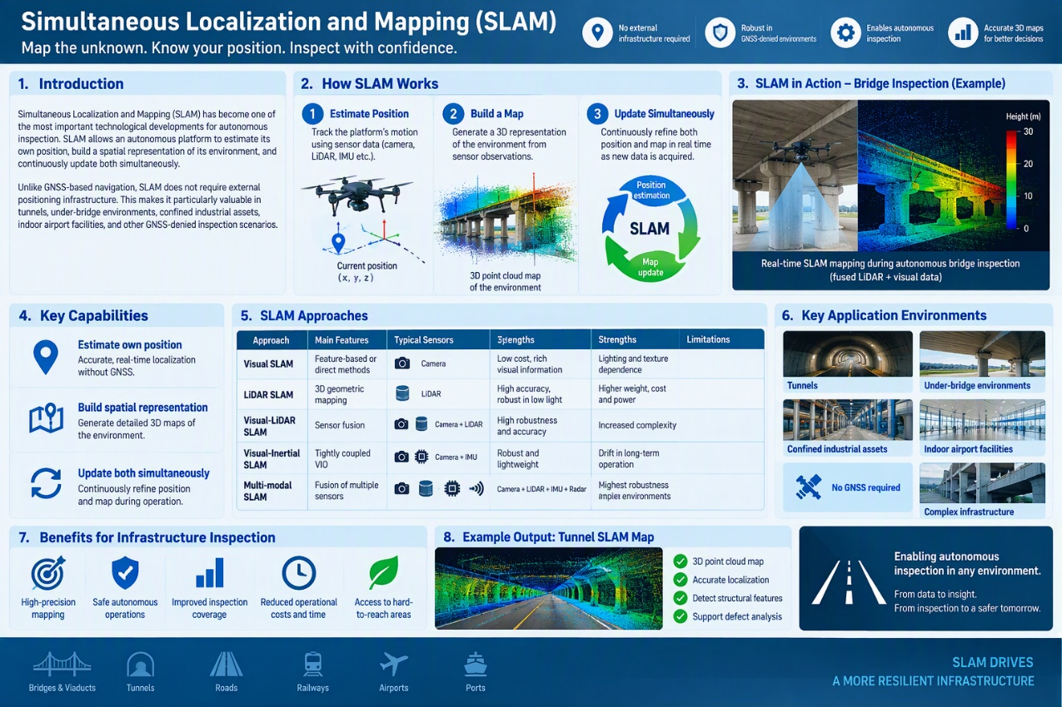
LiDAR-Based SLAM
LiDAR SLAM represents one of the most reliable localization technologies for infrastructure inspection.
By matching 3D geometric observations between consecutive measurements, LiDAR-based systems generate highly stable localization and mapping solutions even under:
- Variable illumination
- Night-time operation
- Texture-poor environments
- Adverse weather conditions
Recent developments such as LOAM, LIO-SAM, FAST-LIO2, and Graph-SLAM architectures have significantly improved real-time mapping performance and localization precision.
For transportation infrastructure inspection, LiDAR SLAM enables accurate mapping of complex bridge geometries, tunnel interiors, railway corridors, airport pavements, and port facilities while simultaneously supporting autonomous navigation.
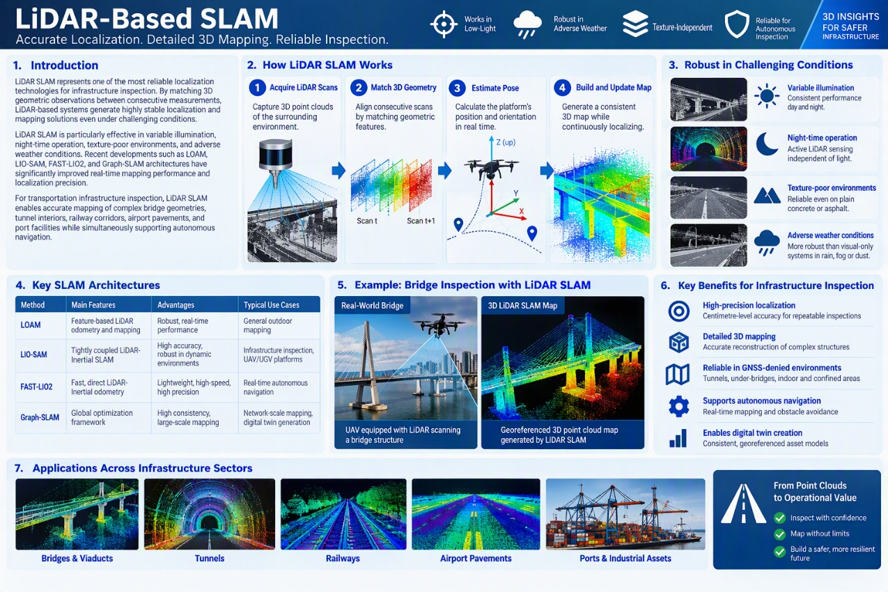

Orthomosaic Mapping
Orthomosaic reconstruction has become a standard technique for large-scale infrastructure inspection.
Orthomosaics are produced by:
- Capturing overlapping imagery.
- Estimating camera poses.
- Performing geometric corrections.
- Generating a seamless georeferenced image map.
These products provide:
- Continuous visual coverage
- Spatial consistency
- Historical change tracking
- GIS integration
Recent UAV inspection workflows increasingly integrate orthomosaic generation with defect detection and digital twin workflows. This enables asset managers to visualize deterioration patterns across large infrastructure assets with high spatial accuracy .

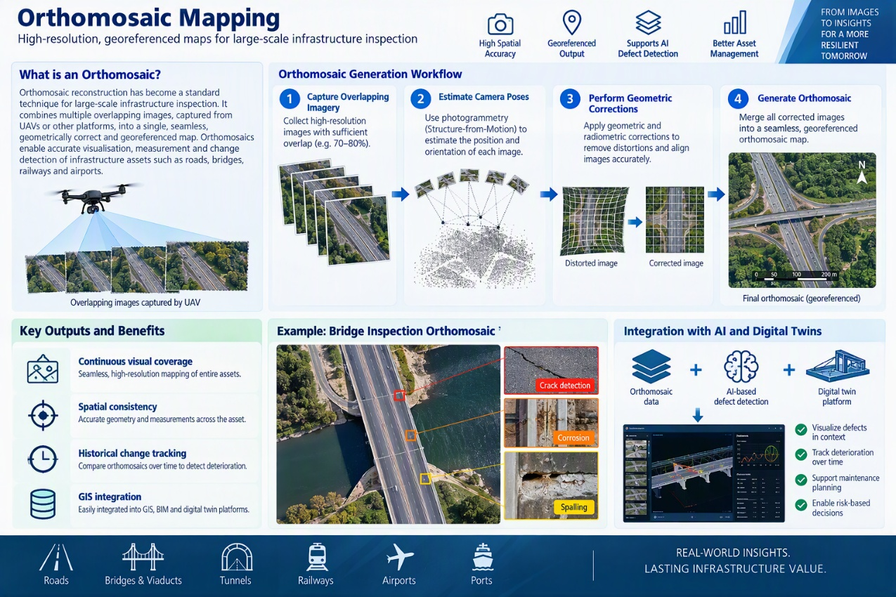
4. Path Planning and Adaptive Navigation
Autonomous Path Planning
Path planning determines how autonomous platforms navigate inspection environments to maximize coverage while minimizing operational costs.
Traditional inspections rely on manually defined trajectories. Modern State-of-the-Art systems increasingly employ:
- Coverage Path Planning (CPP)
- Graph-based navigation
- Optimization-driven routing
- AI-assisted mission planning
- Energy-aware trajectory generation
These systems automatically determine optimal inspection paths based on asset geometry, sensor constraints, battery capacity, accessibility requirements, and safety.

Adaptive Navigation
The next evolution involves adaptive navigation systems capable of modifying inspection trajectories in real time.
Emerging approaches integrate:
- Real-time obstacle detection
- Dynamic mission re-planning
- Sensor-driven task prioritization
- Autonomous anomaly revisit strategies
- AI-enhanced decision making
For example, when a potential defect is identified, the platform may autonomously reduce speed, alter its trajectory, collect additional observations, or trigger higher-resolution sensing operations.
Such adaptive capabilities improve data quality while simultaneously reducing inspection duration and operator workload.

Coverage Optimization
Coverage optimization is becoming a major research topic as transportation assets grow larger and more complex.
The objective is to achieve:
- Maximum inspection completeness
- Minimum mission duration
- Reduced energy consumption
- Reduced data redundancy
Modern systems increasingly employ:
- Coverage heat maps
- Sensor visibility analysis
- Viewpoint planning algorithms
- Digital asset models
- AI-based coverage assessment
By maintaining continuous awareness of already-inspected areas, autonomous systems can identify coverage gaps and dynamically generate additional trajectories, ensuring complete inspection of critical infrastructure assets .

5. Key Enabling Capabilities
High Precision Inspection
Accurate localization and mapping provide the foundation for repeatable defect identification, precise defect localization, and temporal deterioration tracking. Modern GNSS–Vision–LiDAR fusion architectures increasingly enable centimeter-level positioning accuracy required for predictive maintenance and digital twin integration.
Safe Autonomous Operations
SLAM-based perception, obstacle avoidance, adaptive path planning, and multi-sensor localization collectively enhance operational safety. These capabilities enable autonomous inspection of confined, elevated, and hazardous infrastructure environments with minimal human intervention.
Coverage Optimization
Advanced mapping and navigation systems continuously evaluate inspection completeness and dynamically optimize trajectories to maximize information gain while minimizing operational costs, significantly improving scalability across large infrastructure networks.

Edge Computing & Onboard Processing Layer
1. Introduction
The rapid growth of autonomous infrastructure inspection has led to an unprecedented increase in the volume, diversity, and speed of sensor data acquisition. Modern inspection platforms may simultaneously collect high-resolution RGB imagery, thermal video streams, LiDAR point clouds, Ground Penetrating Radar (GPR) measurements, acoustic signals, vibration data, and navigation information during a single mission. Transmitting all raw sensor data to cloud platforms for processing introduces significant communication overhead, increased latency, and dependence on stable network connectivity. Consequently, edge computing has emerged as a critical enabling technology for next-generation infrastructure inspection systems.
Within transportation infrastructure monitoring, edge computing refers to the deployment of computational resources directly on autonomous carrier platforms, including UAVs, robotic vehicles, and sensor gateways. Instead of relying exclusively on centralized cloud infrastructures, data can be processed, filtered, analyzed, and interpreted locally at the point of acquisition. This shift is particularly important for real-time defect detection, autonomous mission adaptation, predictive maintenance workflows, and large-scale infrastructure monitoring where immediate situational awareness is required .
From the perspective of the STRUCTURE project, the Edge Computing & Onboard Processing Layer directly contributes to:
- P10 – Low situational awareness and slow decision-making, by enabling real-time detection and analytics.
- Reducing communication overhead, by filtering and processing data locally before transmission.
- Supporting autonomous operation and adaptive mission execution through low-latency AI inference.

2. Edge AI Hardware Platforms
Evolution of Onboard Computing
Historically, infrastructure inspection UAVs functioned largely as data collection devices. Images, videos, and sensor outputs were stored onboard and transferred to centralized workstations for post-mission analysis. While suitable for visual documentation, this approach introduced substantial delays between data acquisition and actionable decision-making .
The emergence of embedded AI hardware has fundamentally changed this model. Modern autonomous inspection platforms increasingly incorporate:
- NVIDIA Jetson systems (Nano, Xavier, Orin)
- Intel Movidius and OpenVINO accelerators
- Google Coral TPUs
- ARM AI processors
- FPGA-based acceleration platforms
- Specialized neuromorphic processors
These systems enable execution of advanced AI models directly on mobile inspection platforms while maintaining strict power and weight constraints .
Recent benchmarking studies indicate that state-of-the-art edge processors can execute real-time object detection, semantic segmentation, anomaly detection, SLAM, and multi-sensor fusion algorithms with inference times below 100 milliseconds, making onboard decision-making increasingly feasible in operational environments .
Edge Processing Architectures
Current State-of-the-Art inspection platforms increasingly employ hierarchical processing architectures consisting of:
- Sensor Layer
- Edge Processing Layer
- Cloud Analytics Layer
The edge layer performs initial processing, filtering, and inference, while cloud platforms focus on long-term storage, large-scale analytics, predictive maintenance, and digital twin updates.
This distributed architecture significantly reduces network dependence while providing near-real-time operational intelligence.
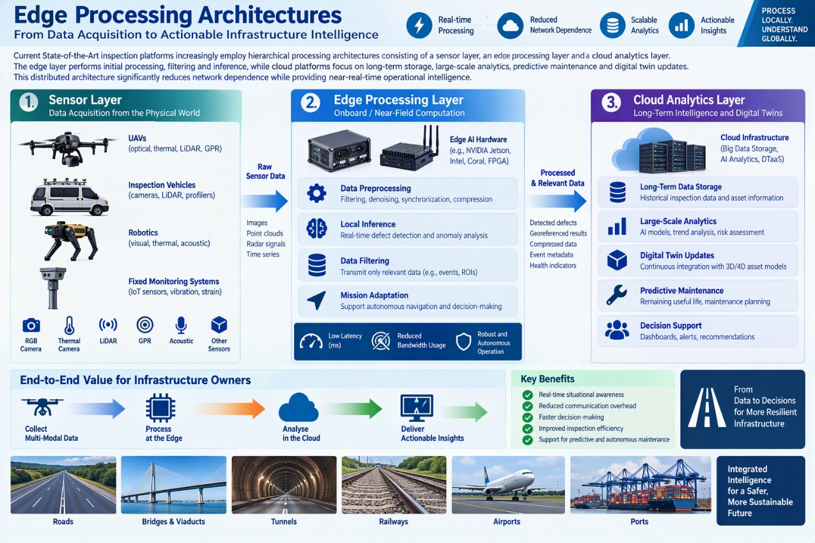
3. Real-Time Data Preprocessing
Sensor Data Conditioning
Raw infrastructure inspection data often contains substantial noise, distortions, and redundancies that can degrade subsequent AI analysis.
Consequently, modern onboard systems increasingly perform:
- Image denoising
- Motion correction
- Sensor calibration
- Geometric alignment
- Signal enhancement
- Data normalization
before AI processing occurs.
For example:
- Thermal imagery may require temperature calibration and emissivity correction.
- LiDAR scans require point-cloud filtering and registration.
- GPR signals require clutter removal and signal enhancement.
- Acoustic data requires background-noise suppression and frequency filtering.
These preprocessing stages improve defect-detection reliability and reduce computational requirements for downstream analytics.

Multi-Modal Data Synchronization
A major challenge in autonomous inspection involves synchronization of heterogeneous sensor modalities.
Different sensors operate at:
- Different frame rates
- Different sampling frequencies
- Different resolutions
- Different acquisition latencies
Recent research increasingly focuses on edge-based synchronization frameworks capable of temporally aligning LiDAR, RGB, thermal, acoustic, vibration, and GPR measurements before further analysis .
Accurate synchronization is essential for multi-modal defect analysis because it ensures all modalities describe the same physical asset condition.

4. Data Filtering and Intelligent Data Reduction
Edge-Based Data Filtering
High-resolution infrastructure inspections frequently generate terabytes of information during a single campaign.
Transmitting all collected data to cloud infrastructures is often impractical due to:
- Limited bandwidth
- Communication costs
- Storage overhead
- Latency constraints
Modern edge systems therefore increasingly perform intelligent data filtering before transmission.
Examples include:
- Discarding low-quality images
- Removing redundant frames
- Selecting high-information regions
- Compressing point clouds
- Event-triggered data storage
Only data judged operationally relevant is forwarded to downstream systems.

Region-of-Interest Processing
Recent State-of-the-Art inspection systems increasingly employ Region-of-Interest (ROI) extraction.
Rather than transmitting complete datasets, edge AI models identify:
- Cracks
- Corrosion
- Delamination
- Surface deterioration
- FOD
- Structural anomalies
and transmit only relevant image segments or defect metadata .
This approach can reduce data transmission volumes by more than an order of magnitude while preserving critical inspection information.

5. Local AI Inference
Real-Time Defect Detection
One of the most important applications of edge computing is local AI inference.
Modern edge platforms increasingly deploy:
- YOLO object detectors
- Semantic segmentation models
- Vision Transformers (ViTs)
- Anomaly detection networks
- Multi-modal fusion architectures
directly onboard UAVs and robotic platforms .
These systems can identify defects during data acquisition rather than after mission completion.
Examples include:
- Crack detection
- Pothole detection
- Corrosion identification
- Foreign Object Debris recognition
- Railway anomaly detection
- Airport pavement assessment
Real-time inference significantly accelerates inspection workflows and enables immediate operational responses when critical hazards are detected .
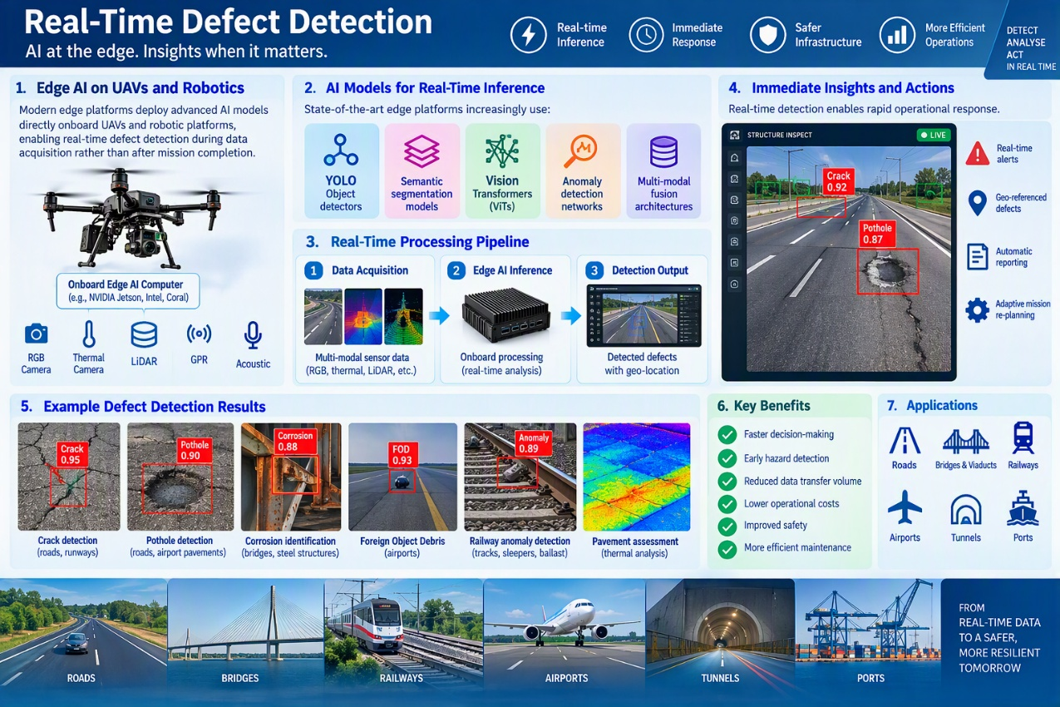
Edge AI for Autonomous Decision-Making
Recent research extends beyond defect detection toward autonomous mission adaptation.
Edge AI can support:
- Dynamic path planning
- Obstacle avoidance
- Sensor reconfiguration
- Additional inspection passes
- On-demand data acquisition
For example, if an onboard model detects a potential defect, the UAV may automatically modify its trajectory to collect higher-resolution observations before leaving the area .
Such adaptive inspection capabilities are becoming a major focus of autonomous infrastructure monitoring research.

6. Latency Reduction and Operational Responsiveness
Communication Latency Challenges
Traditional cloud-based processing introduces unavoidable delays caused by:
- Data transmission
- Network congestion
- Cloud scheduling
- Centralized analytics
For safety-critical infrastructure assessments, these delays can significantly impair decision-making .
Recent studies consistently demonstrate that edge computing architectures reduce end-to-end response times compared with cloud-only systems by performing analytics directly where data is generated.
Real-Time Situational Awareness
The combination of edge AI and onboard processing enables real-time situational awareness.
Operators can obtain:
- Immediate defect notifications
- Live asset condition updates
- Dynamic risk indicators
- Mission health information
without waiting for post-processing workflows.
This capability directly addresses the situational-awareness challenges identified in transportation infrastructure maintenance and supports the transition toward predictive and autonomous inspection operations .

7. Current State-of-the-Art Limitations
Despite substantial advances, several research challenges remain.
Computational Constraints
Edge platforms remain limited by:
- Power availability
- Thermal management
- Weight restrictions
- Processing capacity
Running large AI models onboard remains significantly more challenging than executing them in cloud environments.
Model Compression Trade-Offs
To enable deployment on embedded hardware, AI models frequently undergo:
- Quantization
- Pruning
- Knowledge distillation
These techniques reduce computational requirements but may also affect detection accuracy and robustness.
Multi-Modal Fusion Complexity
Synchronizing and processing multiple sensing modalities in real time remains computationally expensive. As a result, many operational systems continue to rely on simplified fusion approaches rather than fully integrated multi-modal analytics .
Digital Twin Integration
Although edge platforms increasingly support real-time analytics, direct integration with Digital Twin platforms and predictive maintenance ecosystems remains relatively immature. Future research is expected to focus on seamless edge-to-cloud orchestration where local analytics continuously update predictive digital infrastructure models .

AI Analytics & Defect Intelligence Layer

AI Based Processing
- Defect detection & classification
- Pattern recognition
- Learning from small datasets
Artificial intelligence (AI) is increasingly used to convert sensor-specific inspection data into defect and condition information. For RGB imagery, the state of the art has progressed from hand-crafted image processing towards deep-learning pipelines for classification, object detection and pixel-level segmentation. These approaches support the localization and quantification of cracks, spalling, corrosion, potholes and related surface defects, while vision-based monitoring can also estimate displacement, vibration and traffic-related parameters. Comparable learning pipelines are applied to thermal images, LiDAR point clouds and structural-health-monitoring time series, although the learned features and preprocessing requirements remain modality-specific,.
For visible defects, one-stage detectors such as the YOLO family are attractive where near-real-time inference is required, whereas segmentation networks are preferable when crack width, length, area or severity must be estimated. Recent lightweight road-defect models show that model size and computational complexity can be reduced while retaining competitive detection performance, which supports deployment on mobile or embedded inspection platforms. Point-cloud methods instead exploit geometry, intensity and neighborhood structure to identify deformation or surface irregularities, while models for vibration and other monitoring signals use temporal features to detect changes in structural behavior. Across modalities, repeat inspections add a further task, which is distinguishing genuine defect progression from changes in pose, scale, illumination or acquisition quality.
A persistent constraint is the limited availability of representative labelled defects. Infrastructure datasets are typically asset-specific, highly imbalanced and dominated by normal observations, while rare but safety-relevant defects may have few examples. Transfer learning and data augmentation are therefore common baselines; few-shot, semi-supervised and self-supervised methods aim to reduce annotation needs further. Self-supervised anomaly detection is particularly relevant because a model can learn normal structure or signal patterns and flag deviations without requiring exhaustive defect labels. However, anomaly scores do not automatically provide an engineering diagnosis, and their reliability depends strongly on whether the training data adequately represent normal variation.
Operational robustness is now a central research focus. Low illumination in tunnels, shadows, glare, adverse weather, motion blur, long stand-off distances, surface contamination and changing camera viewpoints can alter the data distribution and reduce detection performance. Quality-control and restoration methods can identify insufficient coverage, blur, exposure problems or inadequate resolution before downstream analysis; near-real-time image-quality assessment has already been demonstrated for UAV bridge inspection. Domain adaptation and test-time adaptation can improve transfer to unseen inspection scenarios, including pavement-distress detection, but adaptation must be monitored because erroneous pseudo-labels can reinforce model errors. Robust evaluation should therefore separate performance by asset, defect class and environmental condition rather than reporting only a single aggregate accuracy.
The emerging SOTA combines efficient model architectures with calibrated confidence, explainability and explicit human review. Edge inference can provide rapid screening, acquisition feedback and bandwidth reduction, while more computationally intensive quantification or change analysis can be performed off board. For safety-critical use, outputs should retain the source observation, spatial location, model version and confidence, and uncertainty should trigger reinspection or expert assessment rather than an automatic maintenance conclusion. Overall, strong task-specific results are available for individual sensors, but reliable transfer between assets and acquisition systems, calibrated uncertainty, repeatable severity assessment and robust edge operation under real inspection conditions remain open challenges,.

MultiModal Data Fusion Models
Multi-modal data fusion models are machine learning models which leverage a multitude of inputs from different sensors, combine the different but complementary resulting data and insights from these sensors to make a coherent decision. Distinct from data fusion task itself, multi-modal detection algorithms allow for a decision to be made from a faceted, nuanced view of a situation. Based on how humans leverage all our senses to understand the world around us, this is a very powerful method of learning that can give us more insights than would be available from each mode of data individually.
While these models can be quite powerful, they are subject to specific and unique challenges in both their model design and their extraction of information from data. For example, the synchronization of different data modes temporally due to different sampling rates must be addressed properly to prevent spatiotemporal blurring if there are different sampling rates between modes or if the different modes are not exactly synchronized in time, which is critical for tracking applications. Furthermore, spatial and angle-dependent reconciliation of view points due to slightly different viewing angles between different modalities is a key challenge which has some solutions via cross-modal alignment or multi-domain feature alignment.
Of particular salience to the STRUCTURE project, RGB-T models utilize the fusion of visual and infrared video information to perform multi-object tracking, drone-based vehicle detection, drone-based crowd counting, and pavement assessment. Other models have chosen to fuse image and point-cloud data to inspect tunnels for structural damage , while still others choose to fuse data from two different acoustic test methods to localize and characterize bridge defects. In terms of the state of the art within these fields for detection algorithms, SOTA models utilize various intermediate fusion for pavement health assessment,,, and 3D railway object detection. In terms of accuracy improvement and detection rate improvement, multimodal models regularly outperform the multimodal RGB-T pavement health model referenced in footnote 15 was able to achieve a 7.7% accuracy improvement over RGB-only training, while the 3D railway object detection model utilizing camera and LiDAR information in footnote 16 was able to achieve an 8.4% higher mAP than a previous baseline model.

Core value:
- Accuracy improvement
- Detection rate improvement (P12)
- Decision support readiness

Multi-Modal Defect Intelligence Technologies

1. Multi-Modal Defect Analytics
Single-sensor inspection systems are increasingly considered insufficient for critical infrastructure monitoring.
Current state-of-the-art systems integrate:
- RGB imagery
- Thermal imaging
- LiDAR point clouds
- Ground Penetrating Radar (GPR)
- Acoustic sensing
- Vibration measurements
- Environmental telemetry
This multi-modal approach improves robustness, defect characterization accuracy, and resilience against environmental disturbances such as shadows, glare, fog, rain, and night-time conditions.

2. Cross-Modal Attention Networks
Transformer-based architectures have emerged as the dominant framework for multi-modal defect intelligence.
Cross-attention mechanisms allow models to:
- Associate thermal anomalies with visible defects
- Correlate subsurface radar signatures with surface deterioration
- Combine geometric and visual evidence for defect severity estimation
- Improve robustness under adverse environmental conditions
Compared with traditional feature concatenation approaches, attention-based architectures provide substantially better interpretability and defect localization capabilities.

3. RGB–Thermal (RGB-T) Fusion
RGB-T fusion represents one of the most mature multi-modal AI approaches.
Thermal sensors contribute robustness against:
- Night-time operation
- Lighting variability
- Shadows
- Surface reflections
while RGB imagery provides:
- Texture information
- Colour context
- Fine structural details
Recent investigations demonstrate successful RGB-T applications in:
- Drone-based inspection
- Object detection
- Multi-object tracking
- Crowd monitoring
- Infrastructure risk assessment

Predictive Defect Intelligence

1. Predictive Maintenance Analytics
The latest generation of inspection systems extends beyond defect detection toward forecasting future infrastructure deterioration.
Machine learning approaches increasingly combine:
- Time-series modelling
- Spatio-temporal learning
- Reinforcement Learning
- Physics-informed neural networks
- Digital Twin integration
to estimate:
- Defect progression
- Remaining useful life
- Failure probability
- Maintenance scheduling priorities
This enables a transition from reactive inspection practices to predictive maintenance paradigms.

2. Risk-Aware Decision Intelligence
Modern AI analytics systems increasingly integrate engineering context into defect assessment.
Rather than reporting isolated observations, inspection systems now produce:
- Risk scores
- Severity levels
- Maintenance priorities
- Operational recommendations
- Confidence estimates
This shift transforms inspection outputs into actionable operational intelligence supporting maintenance and airport decision-making workflows.
CURRENT TECHNOLOGY LIMITATIONS AND OPEN RESEARCH CHALLENGES
Despite significant advances, multiple challenges remain unresolved within the current state of the art:
- Limited availability of representative labelled infrastructure defect datasets
- Reduced robustness under adverse environmental conditions such as fog, rain, snow, shadows, glare, and motion blur
- Difficulty detecting extremely small FOD objects and early-stage structural degradation.
- Limited explainability and engineering interpretability of anomaly detection models.
- Challenges in synchronising heterogeneous sensor modalities and ensuring reliable cross-modal reasoning.
- Trade-offs between detection accuracy and edge deployment constraints.
- Limited capability for calibrated uncertainty estimation in safety-critical decision-making.
- Insufficient integration between defect intelligence models, digital twins, predictive maintenance systems, and operational airport management platforms.

Integration Layer
The Data Fusion & Integration Layer represents the technological foundation that enables heterogeneous inspection data to be transformed into a coherent and operationally useful representation of infrastructure health. In airport runway and terminal monitoring environments, inspection systems increasingly rely on multiple sensing modalities including RGB cameras, thermal imagers, LiDAR, Ground Penetrating Radar (GPR), acoustic sensing, vibration measurements, environmental telemetry, and operational databases. While individual sensing technologies have reached a relatively high degree of maturity, the integration of these heterogeneous information streams remains one of the most active research topics in intelligent infrastructure monitoring. The primary objective of this layer is to overcome system fragmentation (P11) and lack of interoperability by providing a common information framework capable of combining diverse sensor observations, analytics outputs, and operational data sources into a unified decision-support ecosystem.

Multi-Source Data Integration Technologies

1. Heterogeneous Sensor Data Integration
Modern infrastructure inspection platforms increasingly operate as multi-sensor ecosystems rather than standalone sensing systems. A typical airport monitoring deployment may simultaneously collect:
- High-resolution RGB imagery
- Thermal images
- LiDAR point clouds
- Ground Penetrating Radar (GPR) scans
- Acoustic measurements
- Structural vibration signals
- Weather and environmental data
- Operational airport information
The current state of the art focuses on transforming these heterogeneous data streams into a common spatio-temporal representation that allows infrastructure conditions to be analysed holistically rather than from isolated observations. Recent digital infrastructure architectures increasingly employ cloud-native integration frameworks and data-lake approaches capable of storing, organizing, and synchronizing high-volume sensor data originating from multiple acquisition platforms.

2. Temporal Synchronization and Data Alignment
One of the key challenges in multi-source integration is temporal synchronization.
Different sensors typically operate with:
- Different sampling frequencies
- Different recording latencies
- Different acquisition schedules
- Different communication protocols
Even sensors with identical sampling frequencies may exhibit slight timestamp misalignments, introducing uncertainty into downstream analytics processes.
Current research therefore focuses on:
- Time-series alignment algorithms
- Cross-modal synchronization mechanisms
- Event-based correlation models
- Timestamp correction frameworks
that ensure observations from different modalities correspond to the same physical infrastructure state before fusion is performed.

3. Spatial Registration and Georeferencing
Reliable fusion requires all inspection information to be mapped into a common coordinate system.
Current state-of-the-art approaches increasingly combine:
- GNSS positioning
- RTK localization
- LiDAR-based mapping
- Visual SLAM
- Orthomosaic reconstruction
to generate georeferenced datasets where visual defects, thermal anomalies, subsurface radar signatures, and operational events can be associated with identical physical locations.
Accurate registration is particularly critical in airport environments, where centimetre-level localization errors may lead to incorrect maintenance actions or inaccurate digital twin representations.

Sensor Fusion Technologies (TI6)

1. Early Fusion Architectures
Early fusion approaches combine raw sensor measurements before feature extraction.
Examples include:
- RGB + thermal image fusion
- LiDAR + camera fusion
- Radar + visual sensing integration
The primary advantage of early fusion lies in its ability to learn correlations directly from sensor observations. However, these approaches are highly sensitive to synchronization errors, calibration drift, and varying sensor resolutions.
Consequently, early fusion remains challenging in real-world infrastructure inspection scenarios involving heterogeneous sensing technologies.

2. Feature-Level Fusion
Feature-level fusion represents the most common approach in current research.
Individual neural networks first extract representations from each sensor modality before those representations are combined into a shared latent space.
Typical examples include:
- RGB feature embeddings
- Thermal feature embeddings
- LiDAR geometric features
- Acoustic spectral features
- Environmental risk indicators
Feature fusion architectures based on transformers and attention mechanisms have shown significant improvements in defect characterization and anomaly detection performance compared with single-modality systems.

3. Cross-Attention and Transformer-Based Fusion
Transformer architectures have become the dominant paradigm for multimodal sensor fusion.
Cross-attention mechanisms allow models to:
- Associate surface cracks with thermal signatures
- Correlate LiDAR geometry with visual defects
- Combine environmental information with structural observations
- Relate subsurface radar signals to visible pavement deterioration
These architectures dynamically learn which modalities should contribute most strongly to a particular decision rather than applying fixed weighting strategies.
Recent studies indicate that transformer-based fusion provides superior robustness in noisy environments and significantly improves defect localization accuracy under adverse operational conditions.

4. Decision-Level Fusion
Decision-level fusion combines outputs from multiple independent AI models.
Instead of integrating raw data directly, separate models analyse individual modalities and subsequently merge:
- Defect predictions
- Confidence scores
- Anomaly indicators
- Severity estimations
This approach is increasingly adopted in safety-critical infrastructure environments because it provides greater interpretability and fault tolerance than tightly coupled fusion strategies.
Decision-level fusion is especially relevant when integrating legacy monitoring systems that cannot easily share raw sensor data.

Standardized Data Pipeline Technologies

1. End-to-End Data Pipelines
The current state of the art increasingly adopts field-to-decision architectures.
These pipelines transform observations according to:
Sensor Data → Calibrated Data → Georeferenced Data → Analytics → Defect Intelligence → Decision Support
The objective is to eliminate fragmented processing steps and establish continuous workflows from acquisition to operational action.

2. Common Geospatial Standards
Modern inspection systems increasingly rely on standardized formats to support interoperability.
Frequently adopted standards include:
- LAS / LAZ point-cloud formats
- GeoTIFF imagery
- Shapefiles
- CityGML
- IFC (Industry Foundation Classes)
- Open GIS standards
These standards facilitate integration with digital twins, GIS environments, and infrastructure management platforms.

3. API-Based Interoperability
A growing trend involves service-oriented integration architectures based on standardized APIs.
These solutions support:
- Sensor interoperability
- Digital twin connectivity
- Asset management integration
- Cloud-edge orchestration
- Cross-platform analytics deployment
Such architectures aim to eliminate vendor lock-in and improve scalability across distributed infrastructure environments.

4. Digital Twin Integration
The most advanced inspection platforms increasingly position digital twins as the central integration layer.
Digital twins provide:
- Unified infrastructure representation
- Common semantic context
- Temporal data management
- Historical traceability
- Predictive analytics integration
This approach enables otherwise disconnected inspection systems to contribute to a common operational model of infrastructure health.

Current Technology Limitations and Open Research Challenges
Despite significant progress, numerous limitations remain:
- Lack of universally accepted interoperability standards across sensing platforms and digital twins
- Persistent challenges in temporal synchronization and spatial registration of heterogeneous sensor data.
- Difficulty scaling multimodal fusion architectures to large infrastructure ecosystems.
- Limited explainability of transformer-based fusion models.
- High computational requirements of advanced fusion approaches.
- Incomplete integration between inspection platforms, enterprise systems, and operational airport workflows.
- Limited standardisation of defect ontologies and maintenance intelligence outputs.
- Lack of robust frameworks for cross-domain reasoning across infrastructure, environmental, and operational data sources.
These challenges directly motivate STRUCTURE's focus on TI6 Multi-Modal Data Fusion, where the objective extends beyond individual sensor analytics toward interoperable, multi-source, operationally integrated infrastructure intelligence capable of supporting airport-scale digital twins and predictive maintenance ecosystems.

Digital Twin Layer
The State-of-the-Art in Digital Twin technologies demonstrates a clear transition from static asset visualization toward continuously updated, data-driven infrastructure intelligence platforms. By integrating multi-modal inspection data, historical maintenance records, environmental conditions, and predictive analytics into a unified operational model, Digital Twins directly address the Predictive Gap (P9) identified in STRUCTURE. Rather than merely documenting existing defects, modern Digital Twin environments enable deterioration forecasting, remaining useful life estimation, risk assessment, and predictive maintenance planning, allowing interventions to be executed before failures occur. Simultaneously, Digital Twins address Low Situational Awareness (P10) by consolidating fragmented inspection information into a single, spatially aware decision-support environment where asset owners can monitor infrastructure health, visualize defect evolution, assess operational risks, and prioritize maintenance actions across entire infrastructure networks. Consequently, the Digital Twin Layer serves as the primary mechanism through which distributed inspection data is transformed into predictive maintenance intelligence and actionable situational awareness for infrastructure operators

Digital Twins for Automated Maintenance and Decision Support
The Digital Twin and Predictive Intelligence Layer serves as the cognitive epicenter of the infrastructure monitoring framework. It bridges the gap between raw, multi-modal sensor data acquired by autonomous platforms and the high-level strategic needs of asset owners. By transitioning from static, fragmented reporting to a dynamic, continuous digital reality, this layer systematically eradicates the predictive maintenance gap (P9) and transforms isolated data points into global situational awareness (P10). The following sections detail the architecture, capabilities, and expanded functionalities of this critical intelligence layer.
- Digital Twin as a Service (DTaaS) Architecture
The implementation of Digital Twin as a Service represents a paradigm shift from traditional, on-premises software to a highly scalable, cloud-native ecosystem. This service provides a continuous infrastructure representation by seamlessly mapping real-time inspection telemetry, ground penetrating radar scans, and thermal imaging onto high-fidelity 3D structural models. By operating as a continuous service rather than a static deliverable, the architecture ensures that all stakeholders, from frontline maintenance crews to financial planners, have decentralized, uninterrupted access to the exact current state of critical assets. This cloud-based approach allows for the ingestion of massive datasets without requiring airport operators to maintain restrictive on-site supercomputing hardware, thereby democratizing access to state-of-the-art infrastructure monitoring.
From a state-of-the-art perspective, the distinguishing feature of a digital twin is not simply its cloud deployment or three-dimensional interface, but the maintained connection between the physical asset, its digital representation, the data exchanged between them, and the analytical services operating on that information ,.
- Spatiotemporal Data Integration and 4D Evolution
A static 3D model is insufficient for tracking structural degradation. To accurately assess infrastructure health, the platform executes deep temporal data integration, transforming the digital twin into a 4D environment where time is a foundational axis. Every detected defect, whether a microscopic surface crack or a hidden subterranean void, is timestamped and geographically anchored to the millimeter. This allows algorithms to analyze the historical dynamics of fault propagation, comparing the structural integrity of a taxiway today against its exact state from previous months or years. By layering geological foundation maps, historical weather data, and cumulative traffic load profiles over these temporal records, the system identifies complex, non-linear deterioration patterns that isolated inspection sessions completely miss.
This progression from static visualization to traceable condition histories is also evident in transportation-infrastructure research, where successive observations are linked to the same asset components to support longitudinal analysis across planning, construction, maintenance and operation.
- Advanced Predictive Maintenance and Algorithmic Forecasting
Directly addressing the predictive gap (P9), the intelligence layer moves entirely beyond reactive defect detection. Traditional inspections flag a defect after it has become a hazard; this system utilizes advanced machine learning and physics-informed neural networks to forecast structural failures before they physically manifest. By synthesizing the spatiotemporal data with material fatigue models, the predictive maintenance algorithms calculate the remaining useful life of specific asset components. The system simulates how intertwined faults multiply each other's severity over time, such as how surface delamination accelerates hidden rebar corrosion under varying traffic loads. Consequently, maintenance can be scheduled during optimal logistical windows, minimizing operational disruption and maximizing asset longevity.
This proactive planning capability can be strengthened by continuously updating deterioration forecasts as new inspection evidence becomes available and by communicating the associated uncertainty to engineers. For example, bridge-maintenance research has begun to connect component-level digital twins, condition indicators and maintenance rules, demonstrating the potential for proactive maintenance planning.
- Holistic Situational Awareness and Decision Support Environments
To resolve the industry-wide challenge of low situational awareness (P10), the digital twin fundamentally reimagines the human-machine interface. The reliance on dense, localized Excel spreadsheets and fragmented photogrammetry is replaced by a highly intuitive, spatially aware decision support environment. Asset managers are presented with a macro-level, color-coded health dashboard of the entire airport infrastructure, allowing them to assess structural risks at a single glance. When a critical anomaly is predicted, operators can seamlessly zoom from a satellite view down to the exact sub-surface millimeter of the affected concrete slab. This immersive visualization is coupled with automated decision support algorithms that instantly calculate the financial and operational impact of various repair strategies, drastically accelerating the decision-making pipeline.
- Climate Resilience Testing and Scenario Simulation
Moving beyond standard maintenance, the predictive intelligence layer introduces powerful scenario simulation capabilities to safeguard assets against evolving macro-environmental threats. Utilizing the digital twin, engineers can execute localized stress tests, simulating the impact of extreme climate change events, such as unprecedented heatwaves on runway asphalt or severe flooding on underground electrical vaults. Furthermore, operators can run "what-if" simulations regarding future traffic increases, such as modeling the structural strain of introducing a heavier class of aircraft to an older terminal gate. This forward-looking simulation ensures that infrastructure resilience planning is based on empirical, data-driven forecasting rather than reactive guesswork.
To support reliable operational use, these predictive capabilities should be accompanied by human-supervised interpretation, with assumptions, uncertainty, data provenance and model validity remaining visible to engineers. Advanced implementations demonstrate the progression beyond static visualization, while recent reviews indicate that continuous updating, long-term prognostics and integration with operational maintenance workflows are still being validated across the wider built-environment sector,. The principal SOTA limitation is therefore the limited evidence that predictive twins remain accurate, explainable and operationally useful throughout an asset’s service life. Continued validation is needed to address this gap.
Predictive Maintenance Models
Predictive maintenance has evolved from simple threshold-based monitoring toward AI-driven forecasting systems capable of estimating degradation trends, remaining useful life (RUL), failure probability, and maintenance priorities. Current state-of-the-art approaches increasingly combine computer vision outputs, sensor telemetry, historical maintenance records, and digital twins to support proactive infrastructure management rather than reactive defect response (Jeon et al., 2024; Wang et al., 2024).

1. AI-Driven Degradation Modelling
Modern predictive maintenance models use machine learning and deep learning techniques to identify early indicators of infrastructure deterioration before visible failures occur. Time-series models, spatio-temporal learning architectures, and anomaly detection algorithms are increasingly applied to monitor defect evolution and detect abnormal degradation patterns across infrastructure assets (Jeon et al., 2024). f

2. Multi-Source Predictive Analytics
Current research focuses on combining multiple information sources including:
- Visual defect observations
- Thermal anomalies
- Structural health indicators
- Environmental conditions
- Historical maintenance records
This enables predictive models to estimate not only the current condition of an asset but also its expected future behaviour under operational and environmental stresses. Predictive accuracy improves significantly when multiple data streams are analysed jointly rather than in isolation.

3. Digital Twin-Enabled Forecasting
The latest predictive maintenance architectures increasingly use Digital Twins as the operational environment where AI models analyse defect progression over time. Historical inspections, current observations, and maintenance events are continuously integrated to build deterioration trajectories and forecast future infrastructure health. This allows maintenance actions to be scheduled before safety or operational thresholds are exceeded.
Predictive maintenance is primarily an AI analytics and decision-support problem rather than a digital-twin modelling problem. KoçSistem's contribution focuses on transforming defect detection outputs, anomaly indicators, and multi-modal inspection data into actionable maintenance intelligence through:
- AI-based degradation modelling
- Predictive risk assessment
- Remaining useful life estimation
- Early warning generation
- Maintenance prioritization recommendations
- Real-time decision-support analytics
Rather than merely identifying cracks, FOD, surface deterioration, or security anomalies, the objective is to predict which assets are likely to deteriorate, estimate their risk evolution, and provide maintenance decision support before operational disruption occurs. This directly addresses the Predictive Gap (P9) by enabling proactive maintenance planning and improves Situational Awareness (P10) through continuously updated risk and health assessments delivered to airport operators and digital twin platforms. KoçSistem's role therefore lies at the intersection of AI analytics, predictive intelligence, and operational decision support, converting inspection data into maintenance foresight and risk-informed actions.

Current Research Challenges
Despite significant progress, predictive maintenance models still face several limitations:
- Limited longitudinal infrastructure datasets.
- Uncertainty in long-term deterioration forecasting.
- Transferability between different airports and infrastructure types.
- Explainability of maintenance recommendations.
- Reliable integration of multi-modal inspection outputs into predictive models.
These challenges remain active research topics and present opportunities for innovation beyond current state-of-the-art predictive maintenance solutions.

Decision Support & Operational Intelligence Layer

The Cognitive Engine for Airport Maintenance
The ultimate value of deploying autonomous UAV fleets, multi-modal sensors, and advanced predictive AI models is not found in the sheer volume of data collected, but in how that data is translated into decisive, operational action. The Decision Support and Operational Intelligence Layer serves as the apex of the digital architecture. It acts as the sophisticated human-machine interface that filters the immense complexity of the underlying predictive models, presenting airport management with clear, context-aware intelligence.
By synthesizing vast, complex datasets into clear operational directives, this layer directly addresses the critical aviation industry challenges of slow, fragmented decision-making and blind operational risk. It provides a unified environment for holistic situational awareness, automated alerting, and strategic maintenance orchestration.

1. Advanced Monitoring Dashboards and Spatial Visualization
Traditional infrastructure monitoring relies heavily on decentralized Excel spreadsheets, static PDF engineering reports, and localized SCADA (Supervisory Control and Data Acquisition) screens. These legacy tools obscure the true macroscopic health of the airport. The intelligence layer entirely replaces these outdated methods with dynamic, spatially aware monitoring dashboards that leverage the 3D Digital Twin.
- Macro-to-Micro Volumetric Navigation: The primary interface is a high-fidelity, interactive 3D representation of the entire airport footprint. Asset managers do not look at lists of defects; they navigate a digital replica where the infrastructure is color-coded based on its real-time health score. When an anomaly is detected, operators can seamlessly zoom from a high-level satellite overview down to the exact millimeter-scale 3D point cloud of a specific pavement crack or a deformed lighting mast.
- Multi-Layer Subsurface Projection: For complex airside pavements (PAT), the dashboard allows engineers to virtually slice through the concrete. Operators can toggle specific visual layers to expose Ground Penetrating Radar (GPR) data and radiometric thermal gradients hidden beneath the tarmac. This provides immediate visual confirmation of subterranean voids, trapped moisture, or rebar corrosion without the need for disruptive physical core drilling.
- Role-Based Data Democratization: A major airport involves multiple stakeholders who require different cuts of the exact same data. The dashboard provides role-based, multi-layered views. A structural engineer can filter the dashboard to exclusively display material fatigue metrics and LiDAR depth charts. Conversely, an Airport Duty Manager views the same defect translated into a calculated metric of runway downtime, operational availability, and the immediate impact on gate assignments.
- Real-Time Sensor Telemetry Integration: The dashboard is a live operational environment, not a static 3D model. It ingests the real-time telemetry streaming from Edge AI processors mounted on active drones. As a drone conducts a runway sweep, verified anomalies—such as Foreign Object Debris (FOD)—populate on the 3D map instantaneously, providing operators with a continuous stream of situational awareness.
- 4D Temporal Playback and Simulation: The dashboard features a temporal slider, allowing users to interact with time. Operators can "rewind" the Digital Twin to view the exact state of a runway sector six months prior, visually animating how a specific structural crack has propagated. Furthermore, they can slide forward into the future, visualizing the AI's predicted deterioration of the asset under current aircraft load stresses.
- Augmented Reality (AR) Field Integration: The visualization layer extends beyond the control room directly to the engineers on the tarmac. Maintenance crews equipped with industrial AR smart glasses or ruggedized tablets can look at a stretch of asphalt and view the Digital Twin's hidden data superimposed over physical reality. They can physically "see" the exact coordinates of subsurface water pooling detected by a drone, ensuring they excavate or drill with absolute precision.
- Cross-System Contextual Harmonization: The dashboard acts as a "single pane of glass," integrating live feeds from external airport systems. It overlays the structural health map with live weather radar, active aircraft ground movements, and incoming flight schedules from the Airport Operational Database (AODB), providing total operational context for every maintenance decision.

2. Intelligent Alerting Systems and Cognitive Alarm Management
In a highly automated environment monitoring thousands of continuous sensors and daily drone sweeps, the greatest operational risk is "alert fatigue"—where human operators become overwhelmed by a constant barrage of minor notifications and begin ignoring critical warnings. The intelligent alerting system acts as a cognitive filter, employing advanced AI to contextualize and suppress noise.
- Contextual Risk Stratification and Prioritization: Alerts are not generated merely because a physical threshold is crossed (e.g., "Crack width exceeds 2mm"). Instead, the system cross-references the anomaly with the operational context to generate a dynamic risk score. A 2mm crack on an active, high-speed touchdown zone utilized by heavy-body A380s will trigger an immediate, high-priority alarm. The exact same 2mm crack on a remote, low-traffic apron used for overnight parking will be categorized as a low-priority observation, suppressing unnecessary alarm bells.
- Multi-Modal False Positive Suppression: Leveraging the Edge AI processing from the drone layer, the alerting engine cross-references data from multiple sensors to aggressively filter out environmental noise. If an optical camera flags a dark mark as a runway crack, but the LiDAR scan registers no depth change and the thermal camera registers no moisture gradient, the system intelligently classifies it as a harmless tire skid mark and suppresses the alarm, preventing the dispatch of a manual inspection team.
- Predictive Time-to-Failure Notifications: Moving beyond real-time alerts, the system generates future-oriented notifications based on the digital twin’s time-series forecasting. Operators receive alerts stating, "Based on current traffic loads and historical propagation rates, Taxiway Alpha Section 4 will exceed safe friction thresholds in precisely 42 days," allowing for proactive scheduling.
- Root-Cause Aggregation: When a complex failure occurs, legacy systems might fire off dozens of localized alarms, confusing the operator. The intelligent alerting system uses topological mapping to recognize that these multiple alarms are all symptoms of a single root cause (e.g., a localized power fluctuation affecting multiple terminal sensors). It suppresses the symptomatic noise and delivers one concise alert pinpointing the exact failure, drastically reducing troubleshooting time.
- Multi-Channel, Role-Specific Escalation: The alerting system ensures the right information reaches the right person instantly. A critical predictive failure in the terminal's baggage handling system triggers a direct mobile push notification to the on-duty mechanical engineering lead. Simultaneously, a severe subsurface void detected under a taxiway triggers a visual alarm on the Air Traffic Control (ATC) radar screen, allowing them to immediately reroute heavy aircraft.
- Automated Incident Playbooks: When a critical threshold is breached, the alerting system launches an automated playbook. If a drone confirms a hazardous chemical spill on the apron, the system immediately pulls up the relevant hazardous materials handling protocol, identifies the nearest spill response kits, and provides the incident commander with a digital checklist of required emergency actions directly within the alert notification.

3. Prescriptive Maintenance Recommendations and Strategic Planning
The ultimate goal of the intelligence layer is to move beyond simply telling the operator what is wrong or predicting when it will fail, and instead prescribe how to fix it optimally. It functions as an automated engineering consultant, actively participating in resolving the defect.
- Algorithmic Repair Strategies: When the AI models predict a structural failure, the system automatically generates a list of prescriptive recommendations based on historical repair data, fused sensor data (depth, volume, moisture content), and engineering best practices. For a detected runway crack, it will specify whether the defect requires simple epoxy sealing, deep mill-and-overlay, or complete concrete slab replacement.
- Dynamic Maintenance Scheduling via AODB Integration: The recommendation engine queries the live flight schedule and gating assignments from the Airport Operational Database (AODB) to prescribe the optimal time to execute the repair. It actively searches for the widest temporal window where taking a specific asset offline will cause the absolute minimum disruption to airline operations and passenger flow.
- Operational Impact Simulation and What-If Analysis: Before a maintenance manager approves a repair, they can utilize the dashboard's "What-If" simulation engine. The manager can simulate: "If we close Taxiway Alpha tonight for four hours to patch this concrete, how will it affect the arrival of the morning cargo fleet?" The system instantly calculates the resulting taxi-time delays, fuel burn increases, and potential gate conflicts, allowing data-driven operational trade-offs.
- Automated CMMS Integration and Resource Dispatching: Once a repair strategy and time window are approved, the intelligence layer completely automates the administrative workflow. It interfaces directly with the airport’s Computerized Maintenance Management System (CMMS). The system autonomously generates a work order, assigns the appropriate specialized engineering crew, and dispatches the digital work package with precise 3D GPS coordinates directly to the crew's mobile devices.
- Automated Contractor and Supply Chain Triggering: In advanced deployments, prescriptive intelligence extends to the supply chain. If the predictive models forecast that a specific asset component will fail within three months, the system autonomously queries the airport's warehouse inventory. If spare parts are insufficient, it initiates a proactive procurement request to external vendors, entirely preventing supply-chain-induced operational delays.
- Lifecycle Financial Modeling (CapEx Optimization): The recommendations extend beyond immediate repairs to long-term financial planning. By aggregating predictive maintenance data across all assets, the system advises the CFO on optimal capital allocation. It can mathematically demonstrate that spending $50,000 on early intervention epoxy sealing today will prevent a $2 million structural failure and runway closure two years in the future, transitioning maintenance into a tightly controlled capital investment strategy.

4. The Ultimate Outputs: Accelerating Decision-Making and Risk-Informed Operations
The cumulative effect of orchestrating spatial dashboards, context-aware alerting, and prescriptive recommendations results in a fundamental, measurable transformation in how an airport operates commercially and operationally.
- Drastic Reduction in Decision Latency (Faster Decision-Making): What traditionally required weeks of manual surveying, cross-departmental coordination, and subjective engineering debates is compressed into a matter of minutes. Because the data is already collected, fused, verified, and presented alongside an optimized, cost-calculated repair strategy, airport executives can authorize critical interventions almost instantaneously with absolute confidence.
- Transition to Quantifiable, Risk-Informed Operations: Airport operations shift from a reactive stance—where budgets are unexpectedly drained by emergency repairs—to a highly calculated, risk-informed posture. Decisions are no longer based on subjective visual inspections or rigid calendar schedules. Every maintenance action is backed by empirical sensor data and AI-driven risk scores, ensuring that capital and human resources are deployed exactly where the infrastructure needs them most.
- Eradication of the "Discovery-to-Action" Gap: By automating the fusion of aerial data, the classification of defects, and the generation of work orders, the time between discovering a hidden structural fault and dispatching a repair crew is virtually eliminated. This closes the "predictive gap," ensuring that maintenance occurs on the system's terms, not as a panicked response to an emergency.
- Maximized Asset Availability and Revenue Protection: The ultimate output is the protection of the airport's revenue streams. By dynamically scheduling maintenance during AI-identified micro-windows of low traffic, and by preventing unexpected critical failures, the airport maximizes the availability of its runways, gates, and terminals, ensuring continuous, uninterrupted commercial operations and protecting airline Service Level Agreements (SLAs).
- Enhanced Regulatory Defensibility and Safety: The continuous, objective, and multi-modal nature of the data collection removes human subjectivity from safety assessments. Airport operators can demonstrate to civil aviation authorities with absolute, data-backed certainty that their infrastructure maintenance decisions are strictly tied to objective safety thresholds, exponentially reducing the risk of catastrophic infrastructure failure and ensuring flawless regulatory compliance.
- Optimized Human Resource Allocation: Human capital is no longer wasted on blind, routine patrols searching for defects across thousands of acres. Maintenance teams and heavy machinery are deployed solely for verified, AI-prescribed repair operations, drastically reducing the operational expenditures (OpEx) associated with manual labor and unnecessary equipment wear.

Railway Infrastructure
Monitoring Dashboards
The State-of-the-Art in railway decision-support systems has evolved from isolated maintenance databases and signalling logs toward integrated operational dashboards capable of combining train-borne measurements, track infrastructure condition data, maintenance history, traffic schedules, and environmental information into a single operational view. Modern railway dashboards increasingly ingest data from track geometry systems, accelerometers mounted on rolling stock, vibration sensors, signalling assets, overhead electrification systems, and IoT monitoring networks. Advanced visualization environments allow infrastructure managers to view network-wide condition indicators, defect heatmaps, deterioration trends, and maintenance priorities in real time. Increasingly, digital twin technologies are used as the visualization layer, enabling operators to explore defects spatially while maintaining access to historical inspection records and predicted future asset states.
Alerting Systems
Modern railway alerting systems are moving beyond simple threshold-based alarms toward context-aware risk intelligence. Instead of triggering alerts solely when individual sensor values exceed predefined limits, state-of-the-art systems correlate multiple information sources including vehicle vibration signatures, track geometry degradation, weather conditions, traffic density, and previous maintenance activities. Machine-learning-based anomaly detection increasingly identifies abnormal infrastructure behaviour before operational disruptions occur. Advanced systems classify alerts according to operational risk, asset criticality, and expected time-to-failure, enabling maintenance teams to prioritize the most urgent interventions while reducing alarm fatigue caused by false positives and non-critical notifications.
Maintenance Recommendations
Current railway maintenance intelligence platforms increasingly integrate predictive analytics with asset management workflows. Rather than producing defect reports alone, modern systems generate risk-ranked maintenance recommendations, estimate remaining useful life of track components, forecast deterioration rates, and recommend intervention windows that minimize service disruption. Multi-source predictive models combine historical maintenance records, inspection findings, operational loads, environmental conditions, and traffic patterns to optimize maintenance strategies. The resulting recommendations support a transition from reactive maintenance toward condition-based and predictive maintenance, reducing operational costs while improving network reliability and asset availability.
Outputs: Faster Decision-Making and Risk-Informed Railway Operations
The integration of monitoring dashboards, intelligent alerts, and predictive maintenance recommendations significantly accelerates railway decision-making. Operators gain continuous visibility into infrastructure health, allowing maintenance actions to be planned proactively rather than in response to failures. The combination of real-time situational awareness and risk-based prioritization improves safety, optimizes maintenance budgets, reduces unplanned downtime, and supports more resilient railway operations.

Roads, Bridges, and Viaducts
Monitoring Dashboards
For road, bridge, and viaduct infrastructure, the State-of-the-Art increasingly relies on centralized operational intelligence platforms that aggregate information from UAV inspections, LiDAR surveys, visual monitoring systems, acoustic sensors, Ground Penetrating Radar, structural health monitoring networks, and traffic management systems. Modern dashboards provide infrastructure owners with continuous visibility into asset condition through interactive 3D and 4D representations, condition indices, deterioration histories, and network-level risk maps. Rather than reviewing isolated inspection reports, engineers can visualize infrastructure health across entire bridge portfolios, track defect evolution over time, and compare asset conditions across regions and infrastructure classes.
Alerting Systems
Current bridge and roadway monitoring solutions increasingly use AI-driven alerting mechanisms capable of identifying anomalies before they become safety-critical failures. Structural movement, unusual vibration patterns, progressive cracking, settlement, corrosion indicators, moisture ingress, and deformation trends can trigger context-sensitive alerts. Advanced alerting systems increasingly combine multiple sensing modalities to reduce false positives and improve confidence in detected anomalies. Alerts are commonly prioritized based on structural significance, defect severity, traffic exposure, and potential safety consequences, enabling infrastructure managers to focus resources on the highest-risk assets.
Maintenance Recommendations
The latest generation of infrastructure management platforms extends beyond defect detection toward prescriptive maintenance. By combining inspection observations, deterioration models, historical maintenance data, traffic loads, and environmental influences, these systems generate recommendations for repair prioritization, intervention timing, and resource allocation. Digital twin environments increasingly support simulation of various maintenance scenarios, enabling stakeholders to evaluate cost, risk, operational disruption, and expected asset life extension before selecting remediation strategies. Emerging approaches additionally incorporate remaining useful life estimation and risk forecasting to support long-term infrastructure investment planning.
Outputs: Faster Decision-Making and Risk-Informed Infrastructure Management
State-of-the-art decision support systems enable infrastructure owners to move from asset-by-asset inspections toward network-level infrastructure awareness. Interactive dashboards, intelligent alerting mechanisms, and predictive maintenance recommendations reduce the time required to assess infrastructure conditions and support rapid response to emerging risks. By linking inspection data directly to maintenance planning and operational impacts, these systems improve situational awareness, optimize maintenance investments, reduce lifecycle costs, and support risk-informed management of roads, bridges, and viaducts.

Service Delivery Layer
1. Introduction
The Service Delivery Layer represents the final stage in the infrastructure inspection value chain, where sensing technologies, autonomous carrier platforms, AI analytics, predictive maintenance models, and Digital Twin environments are transformed into operational services and business value for infrastructure owners. While significant research attention has historically focused on individual enabling technologies, recent industrial and academic developments increasingly emphasize end-to-end solutions capable of delivering actionable outcomes rather than isolated datasets. In the State of the Art, value creation is shifting from hardware-centric and inspection-centric offerings toward integrated service ecosystems combining sensing, analytics, decision support, and lifecycle asset management.
This evolution reflects a broader trend within infrastructure sectors such as roads, bridges, railways, ports, and airports, where owners increasingly seek operational intelligence, predictive maintenance capabilities, and service-level outcomes rather than standalone inspection equipment. Consequently, service delivery has become a critical differentiator in next-generation infrastructure monitoring platforms.

End-to-End System Integration
Hardware and Software Orchestration
Modern infrastructure monitoring systems increasingly operate as cyber-physical ecosystems integrating heterogeneous hardware and software components. The State of the Art is characterized by tightly coupled architectures that combine autonomous carrier platforms, multi-modal sensors, edge computing devices, cloud infrastructures, AI analytics, Digital Twins, GIS platforms, and asset management systems into a unified operational environment.
Rather than functioning as independent technology components, these elements are orchestrated through standardized data pipelines and service-oriented architectures. Data acquired by sensors can automatically flow through calibration, localization, AI analysis, digital twin updating, predictive maintenance algorithms, and decision-support layers before reaching end users. Increasingly, cloud-native architectures and microservice-based deployments are employed to improve scalability, interoperability, and maintainability of such systems.
The most advanced service frameworks additionally support integration with enterprise platforms such as Computerized Maintenance Management Systems (CMMS), Enterprise Asset Management (EAM) solutions, Building Information Modeling (BIM) environments, and operational control systems, enabling infrastructure inspections to directly influence maintenance planning and asset lifecycle management.
Deployment in Operational Environments
A major trend in recent infrastructure monitoring research concerns the transition from pilot deployments toward operational-scale implementations. While many sensing and AI technologies demonstrate promising laboratory performance, successful deployment within real transportation environments introduces additional requirements related to scalability, reliability, interoperability, cybersecurity, and regulatory compliance.
Current State-of-the-Art deployments increasingly rely on cloud-edge architectures that support distributed operation across geographically dispersed infrastructure networks. Autonomous inspection platforms must coexist with existing operational workflows, requiring robust integration mechanisms and minimal disruption to ongoing infrastructure operations.
Furthermore, the infrastructure sector increasingly adopts phased deployment models that allow technologies to operate initially in advisory or decision-support roles before progressing toward automated and autonomous operational modes. This staged approach facilitates user trust, regulatory acceptance, and gradual integration into existing maintenance processes.
3. Service Models
Infrastructure Inspection Services
Infrastructure inspection is increasingly delivered as a managed service rather than as a technology product. In this model, service providers offer complete inspection capabilities including sensor deployment, autonomous data acquisition, AI-driven analysis, defect reporting, digital twin generation, and maintenance recommendations.
The State of the Art increasingly emphasizes outcome-based services where customers purchase asset intelligence rather than sensor hardware or software licenses. Such models reduce technology adoption barriers for infrastructure owners while allowing service providers to continuously improve sensing and analytics technologies without requiring major customer-side investments.
Recent business reviews indicate growing adoption of Infrastructure Inspection as a Service models within transportation, energy, utilities, and industrial infrastructure sectors. The primary drivers include reduced operational costs, improved inspection frequency, increased safety, and access to advanced analytical capabilities that would otherwise require substantial in-house expertise.

Data-as-a-Service (DTaaS)
One of the fastest growing service concepts in infrastructure management is Data-as-a-Service (DaaS), where operational and inspection data are delivered through cloud-based subscription models rather than through individual inspection campaigns.
Digital Twin as a Service (DTaaS) extends this concept further by providing continuously updated virtual representations of physical assets alongside integrated analytics services. Modern DTaaS offerings increasingly combine:
- Multi-modal inspection data
- Historical maintenance information
- Environmental monitoring
- Predictive maintenance models
- Risk analytics
- Decision-support tools
into a single cloud-accessible environment.
Unlike traditional digital twins that primarily provide visualization capabilities, current DTaaS platforms increasingly function as operational intelligence environments capable of supporting maintenance planning, infrastructure resilience management, scenario simulation, and lifecycle optimization.
Recent industry analyses suggest that DTaaS adoption is accelerating because it allows infrastructure owners to access sophisticated digital-twin capabilities without maintaining extensive computational infrastructure or specialist modelling teams. This transition mirrors broader cloud-service trends observed within industrial digitalization and Industry 4.0 initiatives.
4. Final Value Delivery to Asset Owners
The ultimate objective of the Service Delivery Layer is to transform infrastructure monitoring technologies into measurable operational outcomes. The State of the Art increasingly focuses on delivering:
- Reduced inspection costs
- Increased inspection frequency
- Improved asset availability
- Enhanced infrastructure safety
- Faster maintenance decisions
- Reduced unplanned downtime
- Risk-informed maintenance planning
- Extended asset lifetime
Rather than requiring infrastructure owners to interpret large volumes of raw sensor data, modern service platforms provide actionable intelligence, predictive insights, and prioritized maintenance recommendations directly aligned with operational objectives.
Consequently, the service delivery layer represents the commercial and operational realization of the entire infrastructure intelligence stack, connecting autonomous sensing, artificial intelligence, digital twins, and predictive maintenance into a cohesive value proposition for transportation infrastructure operators.

LiDAR system Integration & Service Delivery Layer
1. Introduction
Modern mobile inspection systems are increasingly developed as integrated platforms rather than as individual sensing devices. A complete solution combines LiDAR, cameras, GNSS/INS, onboard computing, communications, software and data-processing pipelines into a single operational workflow. The State of the Art is therefore moving beyond sensor performance towards system-level integration, interoperability, field reliability and service delivery. Commercial mobile-mapping providers increasingly offer complete workflows covering sensor integration, data acquisition, processing, analytics and delivery to GIS or asset-management systems rather than delivering raw point clouds alone.
For road and infrastructure inspection, this integration layer is particularly important because the value of the system depends on its ability to operate reliably in real-world environments. A successful solution must coordinate heterogeneous sensors, synchronize and process large data streams, manage different vehicle configurations, validate the resulting measurements and convert raw data into customer-ready outputs.
2. Multi-Sensor System Integration
A modern inspection platform typically integrates several sensors with different data rates, coordinate systems and measurement characteristics. LiDAR provides 3D geometry, cameras provide visual information, GNSS provides absolute positioning and IMUs provide high-frequency motion and orientation measurements. The integration layer is responsible for time synchronization, coordinate transformations, calibration, data acquisition and communication between the different components. The quality of the final product depends on the combined performance of this complete chain rather than on the specifications of an individual sensor.
A key trend is the development of modular architectures in which sensors and processing components can be added or replaced without redesigning the entire system. Commercial mobile-mapping platforms increasingly use this approach, allowing different LiDARs, cameras, positioning systems and computing platforms to be configured for different applications. For XenomatiX, such modularity is particularly relevant because the same core LiDAR technology can be integrated into different vehicle platforms and application-specific configurations.
3. Data Interoperability and Processing Pipeline
A complete inspection system must transform heterogeneous sensor data into standardized and usable information. This requires well-defined interfaces between acquisition, localization, point-cloud generation, image processing, pavement analysis and reporting. Common geospatial formats such as LAS/LAZ , geotagged pictures, shapefiles and standard coordinate reference systems allow processed results to be integrated with GIS and asset-management systems.
The State of the Art is increasingly characterized by field-to-finish workflows, where data acquisition, processing, classification and delivery are treated as one continuous pipeline. Mobile mapping service providers already offer workflows that combine capture, processing, digitization and delivery into GIS-ready datasets. This reduces the need for customers to develop their own processing infrastructure and shifts the focus from raw sensor data towards actionable information.
For XenomatiX, this means that the integration layer should ultimately support a clear transformation:
Sensor data → calibrated/georeferenced data → pavement measurements → condition information → customer-ready output
The ability to maintain this chain reliably is as important to the delivered product as the underlying LiDAR technology.
4. System Validation and Quality Assurance
Field validation is a critical component of an integrated inspection system because laboratory or component-level performance does not necessarily translate directly into real-world performance. Validation must consider sensor calibration, GNSS availability, vehicle dynamics, environmental conditions, vehicle speed, synchronization and data-processing performance. Repeat surveys over known reference areas can be used to evaluate accuracy, repeatability and stability.
Modern mobile-mapping workflows increasingly combine automated quality-control procedures with field verification. Quality indicators can include trajectory quality, sensor status, point density, missing data, coverage, GNSS/INS solution quality and consistency between overlapping measurements. Detecting such problems during the survey can prevent incomplete or unusable datasets from reaching the customer.
For XenomatiX, pilot execution and validation in real environments are therefore an important part of the technology development cycle. Real-world pilots provide the link between laboratory performance and operational capability and allow the complete LiDAR, positioning, software and vehicle integration to be evaluated under realistic conditions.
5. Pilot Execution and Real-World Deployment
The transition from a prototype to an operational inspection system requires testing across different vehicles, road types, environmental conditions and operational scenarios. Pilot deployments provide an opportunity to evaluate not only measurement accuracy but also installation procedures, sensor calibration, operator workflows, data handling, system reliability and processing time.
The State of the Art in professional mobile mapping increasingly follows a turnkey or managed-service model, where the technology provider can support system configuration, field data capture, processing and final delivery. This approach reduces the technical burden on customers and provides a more consistent outcome. It also creates a feedback loop in which field experience can be used to improve hardware configuration, software, processing algorithms and operational procedures.
For XenomatiX, pilot execution is particularly important because road-inspection applications involve different vehicle platforms, sensor mounting configurations and customer requirements. A repeatable deployment methodology can therefore become an important part of the overall product offering.
6. Service Delivery and Customer Integration
The final stage of the system is the delivery of useful information to the customer. Depending on the application, this can include processed point clouds, pavement-condition parameters, GIS layers, reports, APIs, dashboards or data integrated directly into an existing asset-management platform. Modern mapping providers increasingly emphasize integration with customer GIS, asset-management and other enterprise systems rather than treating the point cloud as the final product.
This creates a shift from a traditional equipment-sale model towards a broader technology and service model. Customers increasingly expect the provider to support installation, configuration, training, processing, maintenance, software updates and troubleshooting throughout the operational lifetime of the system.
For XenomatiX, this service-delivery layer can connect the sensing technology directly to customer requirements. Instead of delivering only LiDAR data, the system can deliver standardized pavement metrics, georeferenced inspection results and other application-specific outputs, reducing the amount of specialist processing required by the customer.
7. Position of XenomatiX
XenomatiX contributes to this system-integration layer by combining LiDAR sensing, software, vehicle integration and application-specific processing into complete inspection solutions. Rather than treating the LiDAR as an isolated component, the objective is to integrate sensing, positioning, data acquisition, processing and reporting into an operational system that can be deployed in real-world environments.
A key contribution is therefore the integration of LiDAR sensing and software into full system solutions, together with pilot execution and validation in real environments. This provides the link between the underlying sensing technology and practical inspection operations. Through field deployment, the complete system can be evaluated and refined with respect to accuracy, reliability, usability, processing performance and customer requirements.
The resulting architecture can be viewed as:
Sensor integration → Data acquisition → Localization → Processing → Inspection analytics → Validation → Customer delivery
This end-to-end approach allows XenomatiX to capture value not only from the LiDAR hardware but also from the software, integration expertise, application knowledge and operational workflows surrounding it.
8. Conclusion
The State of the Art in mobile inspection is increasingly moving towards integrated, service-oriented platforms rather than standalone sensing systems. Successful solutions combine multiple sensors, onboard and offline processing, standardized data pipelines, automated quality control and customer-specific data delivery. Commercial mobile-mapping providers already demonstrate the value of combining sensor integration with field deployment, processing and ongoing technical support.
The System Integration & Service Delivery Layer provides the connection between the company's solid-state LiDAR technology and practical inspection applications. Integration of LiDAR, positioning, cameras, computing and application software, combined with pilot execution and real-world validation, enables the technology to be transformed into a reliable operational product.
This ultimately enables:
- Reliable end-to-end inspection systems through integrated sensing, processing and validation.
- Repeatable field deployment through standardized system configuration, calibration and operational workflows.
- Scalable service delivery through modular architectures, automated processing and customer-specific outputs.
- Continuous system improvement through field feedback, monitoring and real-world validation.
- Integration with existing customer workflows through standardized data formats, GIS interfaces and application-level outputs.
The objective is to move from delivering a LiDAR sensor or a dataset to delivering a complete, validated and operational inspection service.

Airport-Specific Service Delivery and Operational Integration
The System Integration and Service Delivery Layer serves as the digital central nervous system of the entire infrastructure monitoring project. It is the critical threshold where raw telemetry from autonomous drones, multi-modal sensors, and ground rovers is transformed into actionable intelligence, predictive foresight, and commercially viable service models. To fully capture the state-of-the-art landscape in airport environments, this layer must be analyzed not only through the lens of hardware and software orchestration, but also through advanced data architectures, human-machine interfaces, cybersecurity frameworks, and expansive service delivery paradigms.
- End-to-End System Integration and Architecture
Multitiered Computing and Edge-to-Cloud Orchestration
Achieving true end-to-end integration requires a sophisticated, multi-tiered computing architecture. At the extreme edge, autonomous sensor carriers such as drones and robotic crawlers are equipped with embedded artificial intelligence accelerators. These edge nodes perform localized data filtering, sensor fusion, and immediate anomaly detection, such as identifying a critical runway debris hazard without waiting for cloud processing. Intermediate fog computing nodes, located within terminal communication rooms, aggregate this high-bandwidth data, bridging the gap between legacy Supervisory Control and Data Acquisition networks and modern digital protocols. Finally, the centralized cloud infrastructure houses the massive computational power required to render the Digital Twin as a Service, train deep learning algorithms on historical degradation patterns, and execute complex structural simulations over decades of projected use.
Interoperability and Legacy System Harmonization
Airports are fundamentally brownfield environments, characterized by a patchwork of legacy systems installed over varying decades. State-of-the-art orchestration relies on highly adaptable middleware capable of translating proprietary, siloed data from older baggage handling systems or passenger boarding bridges into open, standardized formats such as Industry Foundation Classes for Building Information Modeling. This harmonization ensures that the continuous telemetry from newly deployed IoT arrays seamlessly overlays onto historical maintenance logs, creating a unified, single source of truth without requiring the immediate, financially unviable replacement of existing infrastructure.
- Deployment Dynamics in Mission-Critical Operations
Shadow Deployment and Continuous Model Calibration
Introducing autonomous inspection frameworks into a live, hyper-regulated aviation environment requires meticulous deployment strategies. Initial phases utilize a shadow mode operation, where the artificial intelligence and drone platforms conduct inspections concurrently with traditional manual engineering teams. This dual-track approach validates the algorithm's accuracy, mitigates false positive rates, and builds necessary trust among airport operators and civil aviation regulators. Furthermore, continuous integration and continuous deployment pipelines are established to ensure machine learning models do not experience drift. As seasonal weather changes or new aircraft types alter pavement stress profiles, the predictive models are autonomously retrained and pushed to the edge devices without interrupting ongoing monitoring services.
Zero-Trust Security and Data Governance
Deploying thousands of networked sensors and autonomous vehicles exponentially increases the digital attack surface of an airport. The integration layer mandates a zero-trust cybersecurity architecture, meaning every sensor pulse, drone transmission, and digital twin query must be authenticated and encrypted. Furthermore, strict data governance protocols are embedded directly into the deployment phase to handle privacy concerns, automatically blurring passenger faces or license plates captured inadvertently during terminal or landside structural inspections.
- Advanced Service Delivery Models
Comprehensive Infrastructure Audit Services
The audit service model provides airport authorities with high-fidelity, retrospective evaluations of asset health and regulatory compliance. By querying the digital twin, operators can instantly generate audit trails required by international aviation bodies, proving that runway friction testing, approach lighting photometry, and structural concrete integrity meet stringent safety thresholds. This service also visualizes long-term deterioration maps, allowing financial stakeholders to accurately audit capital expenditure requirements and assess the residual lifecycle value of major infrastructure investments before committing to massive reconstruction projects.
Dynamic Infrastructure Inspection Services
Moving beyond static reports, the inspection service model delivers real-time, automated condition monitoring. When the multi-modal sensor suite detects a subsurface void beneath a taxiway or anomalous vibration in a terminal chiller unit, the integration layer automatically cross-references the severity of the defect with the current flight schedule. It then dynamically generates a prioritized work order within the airport’s Computerized Maintenance Management System, dispatching human technicians with exact 3D spatial coordinates and required tooling. This service effectively eliminates routine, blind manual inspections, focusing human capital strictly on verified repair operations.
Predictive Maintenance as a Service
Expanding the service scope, state-of-the-art platforms are pioneering Predictive Maintenance as a Service. Under this model, the technology consortium does not merely provide software; they guarantee infrastructure uptime. By running continuous Monte Carlo simulations within the digital twin, the system forecasts the precise week a baggage handling bearing will fail or the optimal overnight temperature window to inject epoxy into a runway crack. This paradigm shifts maintenance from a reactive operational expense into a tightly controlled, predictable logistical operation, entirely averting catastrophic operational downtime.
Augmented Reality and Stakeholder Collaboration Services
The final frontier of service delivery is the Human-Machine Interface utilized by ground personnel. The digital twin extends out of the control room and into the field via augmented reality services. A maintenance engineer standing on the tarmac can wear industrial smart glasses to literally see through the concrete, viewing the subsurface ground penetrating radar data overlaid onto the physical runway. Additionally, multi-tenant collaboration portals allow airlines, ground handling companies, and air traffic control to access role-specific layers of the digital twin, ensuring that all stakeholders have real-time, synchronized awareness of infrastructure health, ongoing maintenance closures, and operational capacity limits.

Problem - Innovation - Business Outcome Mapping
The State-of-the-Art analysis demonstrates that current transportation infrastructure inspection solutions remain fragmented across sensing, data processing, and maintenance decision-making workflows. Across roads, bridges, tunnels, railways, and airports, existing approaches continue to suffer from high operational costs (P1), limited accessibility (P7), low inspection frequency (P6), poor subsurface defect visibility (P8), insufficient predictive maintenance capabilities (P9), fragmented information environments (P10–P11), and limited defect detection accuracy under real operational conditions (P12). The reviewed SoTA reveals that while advanced technologies such as UAV-based inspection, multi-modal sensing, AI-driven defect analytics, Digital Twins, and predictive maintenance platforms have individually reached significant maturity, their integration into a unified operational framework remains limited.

The STRUCTURE innovation framework directly addresses these identified gaps through seven complementary technological innovations (TI1–TI7). TI1 (Airborne Subsurface Defect Detection) responds to the documented limitations of visual-only inspection and the inability to detect hidden deterioration (P8) through the integration of airborne GPR and backscatter X-ray sensing. TI2 (Edge AI and Real-Time Defect Detection) addresses delayed analytics and low situational awareness (P10) by enabling onboard processing and real-time infrastructure intelligence. TI3 (High-Precision Localization, Mapping and Autonomous Navigation) targets accessibility, intrusiveness, and inspection frequency challenges (P5–P7) by supporting safe, repeatable, and autonomous inspections in complex environments. TI4 (Digital Twin as a Service) directly addresses the predictive maintenance and situational-awareness gaps (P9–P10) by transforming fragmented inspection results into continuously updated infrastructure intelligence. TI5 (AI Learning from Small Datasets) mitigates the scarcity of defect datasets that currently limits inspection accuracy and reliability (P12). TI6 (Multi-Modal Data Fusion) addresses system fragmentation and interoperability limitations (P11) by providing integrated analysis across heterogeneous sensing technologies. TI7 (High-Payload Autonomous UAV Platforms) overcomes operational constraints related to accessibility, safety, and deployment of advanced sensing payloads (P4–P7).

These innovations collectively enable the three targeted Business Outcomes. BO1 (Autonomous Inspection of Bridges, Viaducts and Tunnels) benefits from advanced multi-modal sensing, autonomous UAV inspection, subsurface defect detection, Digital Twin-based monitoring, and predictive maintenance support. BO2 (Airborne Health Monitoring of Airport Runways and Terminals) leverages autonomous sensing, edge analytics, defect intelligence, DTaaS, and operational decision support to improve airport maintenance efficiency, safety, and asset availability. BO3 (Railway and Transport Infrastructure Inspection) combines continuous condition monitoring, onboard sensing, predictive analytics, and digital infrastructure intelligence to support proactive management of distributed railway assets. Consequently, the SoTA findings validate the necessity of the STRUCTURE technology stack and demonstrate how the proposed innovations collectively bridge the gap between current inspection practices and the envisioned autonomous, predictive, and intelligence-driven maintenance ecosystems represented by the three Business Outcomes.

Emerging Research & Technology Gaps
While STRUCTURE substantially advances the state of the art by integrating autonomous multi-modal sensing, AI-enabled defect analytics and Digital Twin as a Service (DTaaS), several important scientific and technological challenges remain beyond the project's scope. These challenges are not unique to transportation infrastructure but represent broader research directions currently being addressed by the international research community. They are expected to shape the next generation of intelligent infrastructure inspection systems during the coming decade.
Rather than focusing solely on technological maturity, future developments will increasingly require convergence between sensing technologies, trustworthy AI, resilient autonomous robotics, interoperable digital twins, and regulatory ecosystems. Recent scientific reviews consistently identify four major research directions that will dominate infrastructure inspection over the next years:
- operation in extreme environments;
- large-scale interoperability and standardization;
- regulatory readiness and trustworthy AI;
- scalability toward national digital infrastructure ecosystems.

Extreme Environments
STRUCTURE addresses challenging transportation scenarios including bridges, tunnels, airports and railways. Nevertheless, truly autonomous inspection under extreme environmental conditions remains an open research problem. Future infrastructure inspection systems are expected to operate under:
- severe wind turbulence around large bridges,
- heavy rain, snow and fog,
- maritime and coastal corrosion environments,
- underground or GPS-denied spaces,
- high electromagnetic interference,
- disaster-affected infrastructure immediately after earthquakes, floods or landslides.
Although robust navigation algorithms and multi-modal sensing improve operational reliability, current autonomous systems still experience degraded localization accuracy, sensor interference and reduced AI confidence under such conditions. In addition, different sensing modalities (thermal, LiDAR, GPR, acoustic, X-ray) exhibit different failure modes depending on weather, material properties and environmental noise.
Future research therefore requires:
- adaptive sensor selection,
- uncertainty-aware AI,
- self-calibrating multi-modal fusion,
- resilient edge autonomy,
- physics-informed digital twins capable of reasoning under incomplete observations.

Outlook (1–3 years)
- Improved AI robustness against adverse environmental conditions
- Better multimodal sensor calibration
- Edge AI for resilient autonomous inspections
- Increased use of synthetic data for rare inspection scenarios

Outlook (3+ years)
- Fully autonomous inspection in disaster environments
- Self-adaptive sensor payloads
- Physics-informed autonomous digital twins
- Cooperative UAV/UGV/UUV inspection teams operating with minimal human supervision

Standardization and Interoperability
Transportation infrastructure remains highly fragmented across countries, operators, inspection methodologies and asset management platforms. While Digital Twin technologies are rapidly evolving, there is still no universally adopted framework governing interoperability among sensing systems, AI services, asset models and maintenance workflows.
Current challenges include:
- heterogeneous infrastructure information models,
- incompatible inspection data formats,
- vendor-specific Digital Twin implementations,
- inconsistent metadata for defects and maintenance history,
- limited interoperability between BIM, GIS, asset management systems and operational technologies.
The emergence of Digital Twin as a Service (DTaaS) further increases the need for standardized APIs, semantic information models and lifecycle data exchange mechanisms.
Future research should therefore investigate:
- semantic interoperability,
- common defect ontologies,
- standardized AI outputs,
- open Digital Twin architectures,
- cross-border infrastructure data sharing.
Although STRUCTURE establishes an integrated platform architecture, developing internationally accepted interoperability standards requires collaboration among standards organizations, infrastructure owners, software vendors and regulatory bodies, extending well beyond the project duration.

Outlook (1–3 years)
- Growing adoption of open Digital Twin APIs
- Harmonization between BIM, GIS and asset management systems
- Standardized metadata for inspection datasets

Outlook (3+ years)
- Cross-European infrastructure Digital Twin interoperability
- International inspection data standards
- Vendor-neutral AI service ecosystems
- Digital infrastructure marketplaces supporting reusable inspection services

Regulatory Readiness and Trustworthy AI
Technical capability alone is insufficient for widespread deployment of autonomous inspection systems in safety-critical infrastructure. Regulatory readiness is becoming one of the major barriers to industrial adoption.
Future autonomous inspection platforms must satisfy requirements concerning:
- AI transparency,
- explainability,
- human oversight,
- cybersecurity,
- data governance,
- operational safety,
- privacy,
- liability allocation.
This challenge becomes even more significant when autonomous UAVs operate near airports, railway corridors, highways or critical public infrastructure.
The rapid evolution of AI regulation—including the European AI Act—places increasing emphasis on risk management, traceability, human supervision and continuous monitoring of high-risk AI systems. Consequently, future Digital Twin ecosystems will need to incorporate governance mechanisms alongside technical functionality.
Research opportunities include:
- explainable defect detection,
- uncertainty estimation,
- certification methodologies,
- AI auditing,
- secure Digital Twin governance,
- continuous compliance monitoring.

Outlook (1–3 years)
- Integration of explainable AI into inspection workflows
- Increased adoption of AI governance frameworks
- Cybersecurity-by-design for Digital Twins

Outlook (3+ years)
- Certified autonomous infrastructure inspection
- Regulatory acceptance of AI-assisted maintenance decisions
- Continuous AI assurance embedded into Digital Twin platforms

Scalability Toward National Infrastructure Ecosystems
STRUCTURE demonstrates integrated inspection across multiple transportation domains. However, scaling these capabilities from individual assets toward national infrastructure ecosystems introduces significant scientific and engineering challenges.
Large-scale deployment requires Digital Twins capable of synchronizing:
- thousands of infrastructure assets,
- continuous multi-modal sensor streams,
- historical maintenance records,
- traffic information,
- climate models,
- predictive deterioration models.
Such large-scale systems introduce challenges regarding:
- computational efficiency,
- cloud-edge orchestration,
- distributed AI,
- lifecycle data management,
- federated learning,
- long-term model maintenance,
- cybersecurity across interconnected infrastructure.
Recent reviews emphasize that future Digital Twins will evolve from isolated asset representations toward interconnected infrastructure ecosystems supporting network-level optimization, resilience assessment and autonomous maintenance planning. This transition requires scalable AI architectures, cloud-native DTaaS platforms and interoperable cyber-physical ecosystems that extend considerably beyond the objectives of STRUCTURE.

Outlook (1–3 years)
- Cloud-native Digital Twin platforms
- Federated learning across infrastructure owners
- Edge-cloud collaborative AI processing
- Multi-asset predictive maintenance

Outlook (3+ years)
- National-scale infrastructure Digital Twins
- Self-evolving AI maintenance ecosystems
- Cross-sector transportation resilience platforms
- Autonomous infrastructure management supported by foundation AI models and agent-based Digital Twins

Overall Perspective
STRUCTURE addresses several of today's most pressing technological gaps by integrating autonomous sensing, multimodal AI, Digital Twin technologies and predictive maintenance into a unified inspection framework. Nevertheless, the broader research landscape indicates that future intelligent infrastructure systems will increasingly emphasize resilience under extreme conditions, standardized digital ecosystems, trustworthy and regulated AI, and scalable Digital Twin infrastructures operating across interconnected transportation networks. These emerging directions represent the natural evolution beyond STRUCTURE and define an important research agenda for the next decade.

Future Directions
The STRUCTURE project establishes an important technological foundation for the digital transformation of transportation infrastructure inspection by integrating autonomous multi-modal sensing, AI-driven defect analytics, and Digital Twin as a Service (DTaaS) into a unified inspection framework. Beyond the project lifetime, continued advances in artificial intelligence, autonomous robotics, edge-cloud computing, and digital engineering are expected to significantly extend these capabilities from asset-level inspection toward intelligent infrastructure ecosystems.
In the near term (1–3 years), research is expected to focus on improving the robustness, interoperability, and operational readiness of autonomous inspection platforms. Advances in foundation AI models for vision and multi-modal sensing, explainable AI, adaptive sensor fusion, and edge-cloud collaborative processing will enable more reliable operation under diverse environmental conditions while increasing user confidence in AI-assisted maintenance decisions. At the same time, emerging Digital Twin standards and cloud-native DTaaS platforms are expected to facilitate interoperability between inspection systems, asset management platforms, BIM/GIS models, and maintenance planning tools, supporting more seamless integration into existing infrastructure management workflows.
Looking beyond the project horizon (3+ years), infrastructure management is expected to evolve from periodic asset inspection toward continuously connected, self-updating digital infrastructure ecosystems. Future Digital Twins will increasingly integrate inspection data with structural simulation, traffic information, climate projections, and historical maintenance records to support network-level resilience assessment and autonomous maintenance planning. Distributed AI, federated learning, and large-scale cloud-edge architectures will enable collaborative learning across multiple infrastructure owners while preserving data sovereignty and cybersecurity requirements. These developments will progressively transform Digital Twins from visualization and decision-support tools into intelligent operational platforms capable of continuously assessing asset health, predicting deterioration, optimizing maintenance strategies, and supporting resilient transportation networks at regional and national scales.
In parallel, increasing regulatory attention toward trustworthy AI, autonomous systems, and critical infrastructure protection will require future inspection platforms to incorporate explainability, cybersecurity, lifecycle governance, and compliance-by-design principles. Although these developments extend beyond the scope of STRUCTURE, the project's modular architecture, multi-modal AI framework, and DTaaS concept provide a scalable technological foundation upon which future generations of intelligent, trustworthy, and interoperable infrastructure management systems can be built. Collectively, these advances are expected to accelerate the transition from reactive inspection practices toward predictive, autonomous, and ultimately self-evolving maintenance ecosystems that enhance the safety, resilience, and sustainability of transportation infrastructure.

Conclusion

This report has presented a comprehensive State-of-the-Art (SoTA) and Gap Analysis for the STRUCTURE project, examining current advances in autonomous inspection, multi-modal sensing, AI-driven defect detection, Digital Twin technologies, and predictive maintenance for transportation infrastructure. The analysis demonstrates that although significant progress has been achieved in individual technology domains, existing solutions remain fragmented and lack the integration required for fully autonomous, intelligent, and scalable infrastructure inspection.

The identified technological gaps directly justify the innovation framework proposed by STRUCTURE, which combines autonomous multi-modal sensing, AI-enabled analytics, and Digital Twin as a Service (DTaaS) into a unified platform addressing the project's defined problem space (P1–P12). While emerging challenges such as extreme-environment operation, regulatory readiness, interoperability, and large-scale infrastructure ecosystems remain beyond the project's scope, STRUCTURE establishes a robust technological foundation for future intelligent, trustworthy, and resilient infrastructure management systems. Its outcomes are expected to contribute significantly to safer, more efficient, and more sustainable maintenance of critical transportation infrastructure.

Recognizing the rapid evolution of enabling technologies, regulatory frameworks, and industrial practices, this document is intended to be a living deliverable. The State-of-the-Art and Gap Analysis will be reviewed and updated at least once during each project reporting period to reflect relevant scientific advances, technological developments, market trends, and changes in the regulatory landscape, ensuring that the project remains aligned with the latest state of knowledge throughout its lifetime.

D. Tonelli, M. Luchetta, F. Rossi, P. Migliorino, and D. Zonta, “Structural Health Monitoring Based on Acoustic Emissions: Validation on a Prestressed Concrete Bridge Tested to Failure,” Sensors, vol. 20, no. 24, p. 7272, 2020.
E. M. Abdelkader, T. Zayed, and N. Faris, “Synthesized Evaluation of Reinforced Concrete Bridge Defects, Their Non-Destructive Inspection and Analysis Methods: A Systematic Review and Bibliometric Analysis of the Past Three Decades,” Buildings, vol. 13, no. 3, p. 800, 2023.
X. Kang, B. Zhu, Y. Cai, Y. Xiao, N. Liu, Z. Guo, Q.-A. Wang, and Y. Luo, “A Concise Review of State-of-the-Art Sensing Technologies for Bridge Structural Health Monitoring,” Sensors, vol. 25, no. 17, p. 5460, 2025.
Y. Tang, S. Wan, Q. Yang, Z. Chen, and Y. Xu, “A Review: Research Progress in Bridge Structural Health Monitoring From the Perspective of AI Development,” Structural Control and Health Monitoring, 2025.
IEC 61672-1, Electroacoustics - Sound Level Meters - Part 1: Specifications, International Electrotechnical Commission, Geneva, Switzerland.
SO 1996-1, Acoustics - Description, Measurement and Assessment of Environmental Noise - Part 1: Basic Quantities and Assessment Procedures, International Organization for Standardization, Geneva, Switzerland.
S. Zhao, G. Li, C. Wang, et al., “Bridge Cable Damage Identification Based on Acoustic Emission Technology: A Comprehensive Review,” Measurement, vol. 237, 2024.
D. Kumar and A. K. Agrawal, “Smart Acoustic Sounding for Automated Delamination Detection in Concrete Bridge Decks,” International Journal of Bridge Engineering, Management and Research, vol. 2, no. 4, 2025.
H. Sun, S. Pashoutani, and J. Zhu, “Nondestructive Evaluation of Concrete Bridge Decks with Automated Acoustic Scanning System and Ground Penetrating Radar,” Sensors, vol. 18, no. 6, p. 1955, 2018.
“Acoustic Emission-Based Assessment of Damage Evolution in Bridge Structures,” Journal of Nondestructive Evaluation, 2026.
S. Zhao, G. Li, C. Wang, et al., “Bridge Cable Damage Identification Based on Acoustic Emission Technology: A Comprehensive Review,” Measurement, vol. 237, 2024.
D. Tonelli, M. Luchetta, F. Rossi, P. Migliorino, and D. Zonta, “Structural Health Monitoring Based on Acoustic Emissions: Validation on a Prestressed Concrete Bridge Tested to Failure,” Sensors, vol. 20, no. 24, p. 7272, 2020.
L. Zhang, S. Liu, S. Wang, and J. Xiehui, “Application and Improvement of Bridge Cable Broken Wire Acoustic Emission Monitoring System,” 2024.
D. Kumar and A. K. Agrawal, “Smart Acoustic Sounding for Automated Delamination Detection in Concrete Bridge Decks,” International Journal of Bridge Engineering, Management and Research, vol. 2, no. 4, 2025.
X. Kang, B. Zhu, Y. Cai, Y. Xiao, N. Liu, Z. Guo, Q.-A. Wang, and Y. Luo, “A Concise Review of State-of-the-Art Sensing Technologies for Bridge Structural Health Monitoring,” Sensors, vol. 25, no. 17, p. 5460, 2025
Y. Tang, S. Wan, Q. Yang, Z. Chen, and Y. Xu, “A Review: Research Progress in Bridge Structural Health Monitoring From the Perspective of AI Development,” Structural Control and Health Monitoring, 2025.
E. M. Abdelkader, T. Zayed, and N. Faris, “Synthesized Evaluation of Reinforced Concrete Bridge Defects, Their Non-Destructive Inspection and Analysis Methods: A Systematic Review and Bibliometric Analysis of the Past Three Decades,” Buildings, vol. 13, no. 3, p. 800, 2023.
F. Wang, Y. Zou, E. del Rey Castillo, and J. B. P. Lim, “Enhancing UAV Efficiency in Bridge Inspection Through BIM-Based Flight Planning and Image Quality Assurance,” Proceedings of the 41st ISARC, 2024.
V. Vasilopoulos et al., “Combining UAV-LiDAR and UAV-Photogrammetry for Bridge Inspection and Structural Assessment,” Arabian Journal of Geosciences, 2024.
Rasol, M. et al. GPR Monitoring for Road Transport Infrastructure: A Systematic Review and Machine Learning Insights. Construction and Building Materials, 2022.
Abdelkader, E.M., Zayed, T., Faris, N. Synthesized Evaluation of Reinforced Concrete Bridge Defects, Their Non-Destructive Inspection and Analysis Methods. Buildings, 2023.
Sun, H., Pashoutani, S., Zhu, J. Nondestructive Evaluation of Concrete Bridge Decks with Automated Acoustic Scanning System and Ground Penetrating Radar. Sensors, 2018.
Li, N. et al. MV-GPRNet: Multi-View Subsurface Defect Detection Network for Airport Runway Inspection Based on GPR. Remote Sensing, 2022.
Alani, A.M. et al. Applications of Ground Penetrating Radar in Bridge Deck Monitoring. NDT&E International.
Maser, K. Pavement Evaluation Using Ground Penetrating Radar. Transportation Research Record.
Kumar, A., Harsha, S.P. Machine Vision and Advanced Sensing for Railway Inspection. IJTST, 2024
Liu, K. et al. Subsurface Defect Detection in GPR Data Integrating Temporal and Spatial Features. IEEE JSTARS, 2024.
Blasch, E. et al. Machine Learning/Artificial Intelligence for Sensor Data Fusion. IEEE A&E Systems Magazine, 2021.
Recent UAV-GPR Infrastructure Inspection Surveys, 2024–2026.
Zhang, Y., Li, G., Shen, R. Computer Vision for Infrastructure Defect Detection: Methods and Trends. Automation in Construction, 2026.
Jin Lim, H. et al. Steel Bridge Corrosion Inspection with Combined Vision and Thermographic Images. Structural Health Monitoring, 2021.
Wang, F. et al. Rapid In-Flight Image Quality Check for UAV-Enabled Bridge Inspection. ISPRS Journal of Photogrammetry and Remote Sensing, 2024.
Hiasa, S. et al. Infrared Thermography for Civil Infrastructure Evaluation: A Review.
Hojjati, H. et al. Self-Supervised Anomaly Detection in Computer Vision and Beyond. Neural Networks, 2024.
Zhu, X. et al. RGB-T Multi-Object Tracking: A Survey. 2024.
Li, Z. et al. Translating Multimodal AI into Real-World Inspection: TEMAI Evaluation Framework and Pathways for Implementation. 2025.
Ahmed, H., La, H.M., Gucunski, N. Review of Non-Destructive Civil Infrastructure Evaluation for Bridges: Robotic Platforms, Sensors and Algorithms. Sensors, 2020.
Dorafshan, S., Maguire, M. Bridge Inspection: Human Performance, Unmanned Aerial Systems and Automation. Journal of Civil Structural Health Monitoring, 2018.
Wang, F. et al. Enhancing UAV Efficiency in Bridge Inspection Through BIM-Based Flight Planning and Image Quality Assurance. ISARC, 2024.
SpectX Consortium Contributions on Autonomous Aerial NDT Systems, STRUCTURE FPP.
Vasilopoulos, V. et al. Combining UAV-LiDAR and UAV Photogrammetry for Bridge Inspection and Structural Assessment. Arabian Journal of Geosciences, 2024.
Wang, F. et al. Rapid In-Flight Image Quality Check for UAV-Enabled Bridge Inspection. ISPRS Journal of Photogrammetry and Remote Sensing, 2024.
Jantos, T. et al. AIVIO: Closed-Loop Object-Relative Navigation of UAVs With AI-Aided Visual Inertial Odometry. IEEE RA-L, 2024.
Wu, J., Ye, Y., Du, J. Multi-Objective Reinforcement Learning for Autonomous Drone Navigation in Urban Areas with Wind Zones. Automation in Construction, 2024.
Wu, J. et al. Adaptive UAV Mission Execution for Infrastructure Monitoring. Automation in Construction, 2024.
Wang, Y. et al. Digital Twin Applications for Highway Infrastructure. Journal of Traffic and Transportation Engineering, 2024.
Qian, Y. Intelligent Railroad Inspection and Monitoring. Frontiers in Built Environment, 2024.
Minařík, K. et al. Digitalization and Automation of Runway Inspection Using Unmanned Aerial Vehicles. Sensors, 2026
Zhang, Y., Carballo, A., Yang, H., Takeda, K. Perception and Sensing for Autonomous Vehicles Under Adverse Weather Conditions: A Survey. ISPRS Journal of Photogrammetry and Remote Sensing, 2023.
AlBalkhy, W. et al. Digital Twins in the Built Environment: Definition, Applications and Challenges. Automation in Construction, 2024.
Wang, Y., Wang, H., Wang, W., Song, S., Fu, X. Architecture, Application and Prospect of Digital Twin for Highway Infrastructure. Journal of Traffic and Transportation Engineering, 2024.
Khurshid, M., Shahzad, M., Khattak, H.A., Malik, M.I., Fraz, M.M. Vision-Based 3-D Localization of UAV Using Deep Image Matching. IEEE JSTARS, 2024.
Reder, M., Yürüşen, N., Melero, J. Data-Driven Learning Framework for Associating Weather Conditions and Infrastructure Monitoring Systems. Reliability Engineering & System Safety.
Jantos, T., Scheiber, M., Brommer, C., Weiss, S., Steinbrener, J. AIVIO: Closed-Loop Object-Relative Navigation of UAVs With AI-Aided Visual Inertial Odometry. IEEE Robotics and Automation Letters, 2024.
Luo, K. et al. Computer Vision-Based Bridge Inspection and Monitoring: A Review. Sensors, 2023.
Zhang, Y., Carballo, A., Yang, H., Takeda, K. Perception and Sensing for Autonomous Vehicles Under Adverse Weather Conditions: A Survey. ISPRS Journal of Photogrammetry and Remote Sensing, 2023.
Wang, F., Zou, Y., Del Rey Castillo, E., Lim, J.B.P. Enhancing UAV Efficiency in Bridge Inspection Through BIM-Based Flight Planning and Image Quality Assurance. ISARC, 2024
Cadena, C., Carlone, L., Carrillo, H., et al. Past, Present, and Future of Simultaneous Localization and Mapping: Toward the Robust-Perception Age. IEEE Transactions on Robotics.
Vasilopoulos, V. et al. Combining UAV-LiDAR and UAV Photogrammetry for Bridge Inspection and Structural Assessment. Arabian Journal of Geosciences, 2024.
Wu, J., Ye, Y., Du, J. Multi-Objective Reinforcement Learning for Autonomous Drone Navigation in Urban Areas with Wind Zones. Automation in Construction, 2024.
Outay, F., Mengash, H., Adnan, M. Applications of UAVs in Road Safety, Traffic and Highway Infrastructure Management. Transportation Research Part A, 2020.
Minařík, K. et al. Digitalization and Automation of Runway Inspection Using Unmanned Aerial Vehicles. Sensors, 2026.
Suganya, B., Gopi, R., Kumar, A.R. et al. Dynamic Task Offloading Edge-Aware Optimization Framework for Enhanced UAV Operations on Edge Computing Platforms. Scientific Reports, 2024.
Chou, J.S., Liu, C.Y. Optimized Lightweight Edge Computing Platform for UAV-Assisted Detection of Concrete Deterioration Beneath Bridge Decks. Journal of Computing in Civil Engineering, 2024.
Ahmed, H., La, H.M., Gucunski, N. Review of Non-Destructive Civil Infrastructure Evaluation for Bridges: Robotic Platforms, Sensors and Algorithms. Sensors, 2020.
Google Coral Edge TPU Platform Documentation.
Lee, H., Ryu, J., Won, D. Secure and Anonymous Authentication Scheme for Mobile Edge Computing Environments. IEEE IoT Journal, 2024.
Wang, F. et al. Rapid In-Flight Image Quality Check for UAV-Enabled Bridge Inspection. ISPRS Journal of Photogrammetry and Remote Sensing, 2024.
Li, Z. et al. Translating Multimodal AI into Real-World Inspection: TEMAI Evaluation Framework and Pathways for Implementation. 2025.
Wang, J. et al. Road Defect Detection Based on Improved YOLOv8s Model. Scientific Reports, 2024.
Zhang, Y., Li, G., Shen, R. Computer Vision for Infrastructure Defect Detection: Methods and Trends. Automation in Construction, 2026.
Hojjati, H., Ho, T.K.K., Armanfard, N. Self-Supervised Anomaly Detection in Computer Vision and Beyond. Neural Networks, 2024.
Wu, J., Ye, Y., Du, J. Multi-Objective Reinforcement Learning for Autonomous Drone Navigation in Urban Areas with Wind Zones. Automation in Construction, 2024.
McEnroe, P., Wang, S., Liyanage, M. Edge AI for Autonomous UAV Operations. IEEE IoT Journal, 2022.
Minařík, K. et al. Digitalization and Automation of Runway Inspection Using Unmanned Aerial Vehicles. Sensors, 2026.
Blasch, E. et al. Machine Learning/Artificial Intelligence for Sensor Data Fusion: Opportunities and Challenges. IEEE Aerospace and Electronic Systems Magazine, 2021.
AlBalkhy, W. et al. Digital Twins in the Built Environment: Definition, Applications and Challenges. Automation in Construction, 2024.
Luo, K., Kong, X., Zhang, J., Hu, J., Li, J., & Tang, H. (2023). Computer vision-based bridge inspection and monitoring: A review. Sensors, 23(18), 7863. https://doi.org/10.3390/s23187863
Zhang, Y., Li, G., & Shen, R. (2026). Computer vision for infrastructure defect detection: Methods and trends. Automation in Construction, 183, 106795. https://doi.org/10.1016/j.autcon.2026.106795
Wang, J., Meng, R., Huang, Y., Zhou, L., Huo, L., Qiao, Z., & Niu, C. (2024). Road defect detection based on improved YOLOv8s model. Scientific Reports, 14, 16758. https://doi.org/10.1038/s41598-024-67953-3
Hojjati, H., Ho, T. K. K., & Armanfard, N. (2024). Self-supervised anomaly detection in computer vision and beyond: A survey and outlook. Neural Networks, 172, 106106. https://doi.org/10.1016/j.neunet.2024.106106
Wang, F., Zou, Y., Chen, X., Zhang, C., Hou, L., Del Rey Castillo, E., & Lim, J. B. P. (2024). Rapid in-flight image quality check for UAV-enabled bridge inspection. ISPRS Journal of Photogrammetry and Remote Sensing, 212, 230–250. https://doi.org/10.1016/j.isprsjprs.2024.05.008
Hou, Y., Li, Y., Du, M., Li, L., Wu, D., & Yu, J. (2024). Bridging data distribution gaps: Test-time adaptation for enhancing cross-scenario pavement distress detection. Applied Sciences, 14(24), 11974. https://doi.org/10.3390/app142411974
Wang, J., Meng, R., Huang, Y., Zhou, L., Huo, L., Qiao, Z., & Niu, C. (2024). Road defect detection based on improved YOLOv8s model. Scientific Reports, 14, 16758. https://doi.org/10.1038/s41598-024-67953-3
Zhang, Y., Li, G., & Shen, R. (2026). Computer vision for infrastructure defect detection: Methods and trends. Automation in Construction, 183, 106795. https://doi.org/10.1016/j.autcon.2026.106795
X. Liu, M. Lv, D. Zhou, L. Si, R. Zhang, and H. Xu, “Breaking the alignment barrier: A spatiotemporal alignment-free RGBT tracking approach,” Neurocomputing, vol. 656, p. 131382, Dec. 2025, doi: 10.1016/j.neucom.2025.131382.
M. Yuan, Y. Wang, and X. Wei, “Translation, Scale and Rotation: Cross-Modal Alignment Meets RGB-Infrared Vehicle Detection,” Sep. 28, 2022, arXiv: arXiv:2209.13801. doi: 10.48550/arXiv.2209.13801.
X. Zhang, Y. Li, Z. Qi, Y. Sun, and Y. Zhang, “Learning multi-domain feature relation for visible and Long-wave Infrared image patch matching,” Aug. 09, 2023, arXiv: arXiv:2308.04880. doi: 10.48550/arXiv.2308.04880.
Y. Zhu, Q. Wang, C. Li, J. Tang, and Z. Huang, “Visible-Thermal Multiple Object Tracking: Large-scale Video Dataset and Progressive Fusion Approach,” Aug. 02, 2024, arXiv: arXiv:2408.00969. doi: 10.48550/arXiv.2408.00969.
Y. Sun, B. Cao, P. Zhu, and Q. Hu, “Drone-based RGB-Infrared Cross-Modality Vehicle Detection via Uncertainty-Aware Learning,” Oct. 14, 2021, arXiv: arXiv:2003.02437. doi: 10.48550/arXiv.2003.02437.
T. Peng, Q. Li, and P. Zhu, “RGB-T Crowd Counting from Drone: A Benchmark and MMCCN Network,” in Computer Vision – ACCV 2020: 15th Asian Conference on Computer Vision, Kyoto, Japan, November 30 – December 4, 2020, Revised Selected Papers, Part VI, Berlin, Heidelberg: Springer-Verlag, Nov. 2020, pp. 497–513. doi: 10.1007/978-3-030-69544-6_30.
C. Xu, L. Shu, A. Dao, and Y. Cui, “Multimodal generative AI for automated pavement condition assessment: Benchmarking model performance,” PLOS ONE, vol. 21, no. 2, p. e0340380, Feb. 2026, doi: 10.1371/journal.pone.0340380.
H. Huang, S. Liu, M. Zhou, H. Shao, Q. Li, and P. Thansirichaisree, “Automated 3D defect inspection in shield tunnel linings through integration of image and point cloud data,” AI Civ. Eng., vol. 4, no. 1, p. 12, May 2025, doi: 10.1007/s43503-025-00054-w.
R. D. Rachuri, D. Liao, S. Sarikonda, and D. V. Kondur, “A Multimodal Fusion Framework for Bridge Defect Detection with Cross-Verification,” in 2024 IEEE International Conference on Big Data (BigData), Dec. 2024, pp. 3292–3300. doi: 10.1109/BigData62323.2024.10825867.
R. Xiao and X. Chen, “IRFusionFormer: Enhancing Pavement Crack Segmentation with RGB-T Fusion and Topological-Based Loss,” Dec. 29, 2024, arXiv: arXiv:2409.20474. doi: 10.48550/arXiv.2409.20474.
M. Rashidi, S. Ghazimoghadam, V. Mousavi, S. Dorafshan, and B. Bozorg, “A New Multi-Modal Data Fusion Framework for Delamination Detection in Concrete Bridge Decks,” Sensors, vol. 26, no. 12, p. 3926, Jan. 2026, doi: 10.3390/s26123926
Y. T. Huang, M. R. Jahanshahi, F. Shen, and T. G. Mondal, “Deep Learning-Based Autonomous Road Condition Assessment Leveraging Inexpensive RGB and Depth Sensors and Heterogeneous Data Fusion: Pothole Detection and Quantification,” J. Transp. Eng. Part B Pavements, vol. 149, no. 2, Jun. 2023, doi: 10.1061/JPEODX.PVENG-1194.
W. Liu, Y. Wang, G. Yu, Z. Wang, and P. Chen, “RailFusion: A Lidar-Camera Data Interaction Network for 3-D Railway Object Detection,” IEEE Trans. Intell. Transp. Syst., vol. 26, no. 8, pp. 12761–12773, 2025, doi: 10.1109/TITS.2025.3555414.
Naderi, H., & Shojaei, A. (2023). Digital twinning of civil infrastructures: Current state of model architectures, interoperability solutions, and future prospects. Automation in Construction, 149, 104785. https://doi.org/10.1016/j.autcon.2023.104785
AlBalkhy, W., Karmaoui, D., Ducoulombier, L., Lafhaj, Z., & Linner, T. (2024). Digital twins in the built environment: Definition, applications, and challenges. Automation in Construction, 162, 105368. https://doi.org/10.1016/j.autcon.2024.105368
Wang, Y., Wang, H., Wang, W., Song, S., & Fu, X. (2024). Architecture, application, and prospect of digital twin for highway infrastructure. Journal of Traffic and Transportation Engineering (English Edition), 11(5), 835–852. https://doi.org/10.1016/j.jtte.2024.03.003
Jeon, C.-H., Shim, C.-S., Lee, Y.-H., & Schooling, J. (2024). Prescriptive maintenance of prestressed concrete bridges considering digital twin and key performance indicator. Engineering Structures, 302, 117383. https://doi.org/10.1016/j.engstruct.2023.117383
AlBalkhy, W., Karmaoui, D., Ducoulombier, L., Lafhaj, Z., & Linner, T. (2024). Digital twins in the built environment: Definition, applications, and challenges. Automation in Construction, 162, 105368. https://doi.org/10.1016/j.autcon.2024.105368
Mousavi, Y., Gharineiat, Z., Karimi, A. A., McDougall, K., Rossi, A., & Gonizzi Barsanti, S. (2024). Digital twin technology in built environment: A review of applications, capabilities and challenges. Smart Cities, 7(5), 2594–2615. https://doi.org/10.3390/smartcities7050101
https://www.mdpi.com/2076-3417/15/24/13135

