VISION VIRTUAL INTEGRATED SUPPLY-CHAIN IMPROVEMENT WITH OPTIMISED NETWORKING

D1.6 Security framework Design

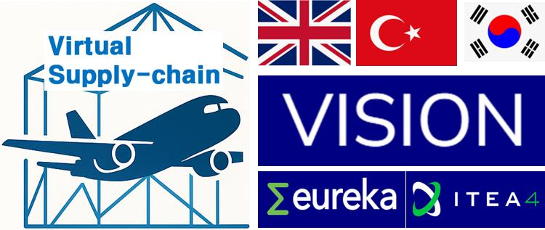

Project Identifier | Vision
Project Title | Virtual Integrated Supply-Chain Improvement with Optimised Networking
Document Version | V0.0
Planned Delivery Date
Document Title | Security framework Design
Work Package | WP1

Table of Contents

D1.6 Security framework Design 0
1. Introduction 2
1.1 Purpose 2
1.2 Scope 2
1.3 Status 2
2. Security Objectives 2
3. Design Principles 2
4. Trust Model and Boundaries 3
5. Security Areas Addressed at Design Level 3
5.1 Identity and access management 3
5.2 Protection of data in transit and at rest 3
5.3 Data provenance and traceability 4
5.4 Logging and monitoring 4
5.5 Segregation of environments 4
5.6 Edge and device-level considerations 4
6. Data Classification 4
7. Privacy and Regulatory Considerations 4
8. Roles and Responsibilities 5
9. Relation to Other Deliverables 5
10. Next Steps 5

1. Introduction

1.1 Purpose
D1.6 defines the security framework for the VISION platform at design level. It establishes the security objectives, the principles to be applied by all components, and the areas in which each partner is expected to implement measures. It complements the overall solution design (D1.4) and the data model design (D1.5) by describing how the platform protects the data it exchanges.

1.2 Scope
The document addresses the security of the VISION platform and of the data exchanged between its components. It covers design-level requirements and principles. Product-level security of the partners' own commercial systems, and the internal security policies of the partner organisations, are outside its scope.

1.3 Status
This is a design document issued before the components are implemented. Concrete mechanisms, algorithms, configurations and credentials are chosen by the component owners during implementation, in line with the principles set out here. Where implementation experience requires a change of approach, this document is updated.

2. Security Objectives
- Confidentiality — supply chain data, which is commercially sensitive, is disclosed only to the parties entitled to it.
- Integrity — data is not altered without authorisation between its source and its consumers.
- Availability — the platform's services remain available at a level appropriate to the use case.
- Traceability and provenance — the origin of data and the identity of the party that supplied it can be established.
- Accountability — relevant actions on the platform are attributable and recorded.

3. Design Principles
- Defence in depth — security is applied at several layers rather than relying on a single control.
- Least privilege — each component, service and user is granted only the access required for its function.
- Secure by default — the default configuration of a component is its more restrictive one.
- Explicit trust boundaries — every point at which data crosses an organisational or network boundary is identified and protected.
- Documented, not implicit — security-relevant assumptions of a component are documented rather than assumed by its counterparts.
- Privacy by design — personal data is avoided where the functionality can be achieved without it.

4. Trust Model and Boundaries
The VISION platform operates across several partner organisations and, in the use cases, across end-user sites. The following boundaries are identified as requiring protection:
Boundary | Description
End-user system to platform | Data extracted from operational and enterprise systems of the use case owners
Field and sensing layer to platform | Data originating from sensing, positioning and edge devices
Between partner components | Data exchanged over the interfaces defined during integration
Platform to user-facing layer | Data presented through visualisation portals and AR interfaces
Platform to external services | Any exchange with services outside the consortium
Each boundary has an identified owner responsible for the protection applied at it.

5. Security Areas Addressed at Design Level

5.1 Identity and access management
Components authenticate before exchanging data. Access is granted on the basis of the role of the requesting party, and access rules are defined per interface rather than platform-wide.

5.2 Protection of data in transit and at rest
Data exchanged between components is transmitted over protected channels. Data stored by a component is protected in accordance with its sensitivity, as classified in Section 6.

5.3 Data provenance and traceability
Data flows carry sufficient information to identify their source, so that the origin of a value used in an optimisation or reporting result can be established.

5.4 Logging and monitoring
Security-relevant events are logged by the component that handles them. Logging is designed so that it does not itself become a source of unintended disclosure.

5.5 Segregation of environments
Development, integration, use case and demonstration environments are kept separate. Production or operational data is used in non-operational environments only with the agreement of its owner.

5.6 Edge and device-level considerations
Components deployed outside a controlled data centre — including edge nodes and field devices — are treated as operating in a less trusted environment, and the data they transmit is protected accordingly.

6. Data Classification
A simple classification is applied so that partners can decide the level of protection required without a case-by-case negotiation:
Class | Description | Handling
Public | Information intended for dissemination | No restriction
Internal | Project working material | Shared within the consortium
Confidential | Commercially sensitive operational data of a partner or end user | Shared only with the parties that need it, under the consortium agreement
Personal | Data relating to identified or identifiable persons | Avoided; where unavoidable, processed under the applicable data protection requirements

7. Privacy and Regulatory Considerations
The platform is designed to operate without personal data wherever the functionality permits. Where positioning or workforce-related data could identify individuals, anonymisation or aggregation is applied at the earliest possible point. Applicable data protection requirements, and the relevant provisions of WP8 on legal compliance and ethics, apply to all use cases.

8. Roles and Responsibilities
Role | Responsibility
WP1 leader (Alpata) | Maintain the security framework; ensure consistency between D1.4, D1.5 and D1.6
Component owners | Implement the principles in their components; document security-relevant assumptions and interface requirements
Use case owners | Classify the data they make available; define access conditions for their environments
WP6 leader | Verify during integration that the agreed security arrangements are in place at each interface
WP8 | Legal compliance, ethics and project-level risk

9. Relation to Other Deliverables
D1.6 builds on the architecture in D1.4 and the data model in D1.5. Its principles are applied during integration under WP6 and are reflected in the implementation guidelines of D6.1. Any security-relevant constraint identified in the technical work packages is reported back to WP1 for inclusion in a later version.

10. Next Steps
- Confirmation of the trust boundaries and data classification with the use case owners.
- Collection of security-relevant requirements from the component owners.
- Definition of the security expectations per interface, in coordination with WP6.
- Update of this document once implementation choices are known.

