3D FE model of Gränges Hot Strip Mills

Version | V1.0
Date
Confidentiality | Public
Type of Deliverable | FE model and report
Description | Report
Deliverables in the Project | Deliverable D4.2a

- Abstract

The project "VMAP analytics – Smart analytics for multi-scale material and manufacturing modeling" deals with digitalization, encapsulating the concept's essence. Various digital twins for various manufacturing processes are developed in this project. This report deals with the development of a 3D Finite Element model for Gränges hot strip mills. The report discusses the development of a material model for the aluminium alloy that was used in the present investigation. The 3D FEM model developed in the project considers 25 passes of reverse rolling and two passes of tandem mill. The 3D FE model for about 27 rolling passes has not been reported in the open literature. The FEM results are validated with the experimentally measured values and found to be in good agreement.

- Change Log

- Contributors:
Name | Organization
Pontus Darth | Swerim AB

Table of Contents
3D FE model of Gränges Hot Strip Mills 1
1. Abstract 2
2. Introduction 4
2.1. Business objective 4
2.2. Hot rolling process 4
2.3. Finite Element Modelling 7
3. Work plan 7
3.1. Material modelling 8
3.1.1. Johnson-cook model 8
3.1.2. Thermodynamics 11
3.2. Reversing mill 12
3.3. Tandem mill 14
4. Results 17
4.1. Reversing mill 17
4.1.1. Torque 19
4.1.2. Load 20
4.1.3. Temperature 20
4.1.4. Profiles 21
4.2. Tandem mill. 24
5. Conclusions 26
6. Suggested continued work. 26
7. Acknowledgments 27

- Introduction
  - Business objective
Gränges employs reversible rolling to reduce direct chill (DC) cast slabs from 600 mm down to 15/20 mm, followed by tandem rolling to achieve a final thickness of 3-7 mm (Figure 1). During this manufacturing process, all flat-rolled products inevitably encounter flatness errors, ranging from minor thickness variations to waves within the product itself. These thickness variations can lead to unflatness defects and reduced yield. Gränges faces increasingly stringent demands from its customers regarding thickness consistency. Therefore, ensuring controlled crown profiles during production is of paramount importance for Gränges. Analyzing and controlling the thickness uniformity of the final sheet involves various complex process parameters. The key parameters influencing profile control and flatness in Gränges' reversible rolling mill include rolling force (reduction), grinding (rolling bombing), and the thermal workload camber by cooling the work rolls.
Following tandem rolling, the sheet undergoes slitting and coiling before undergoing further processing.

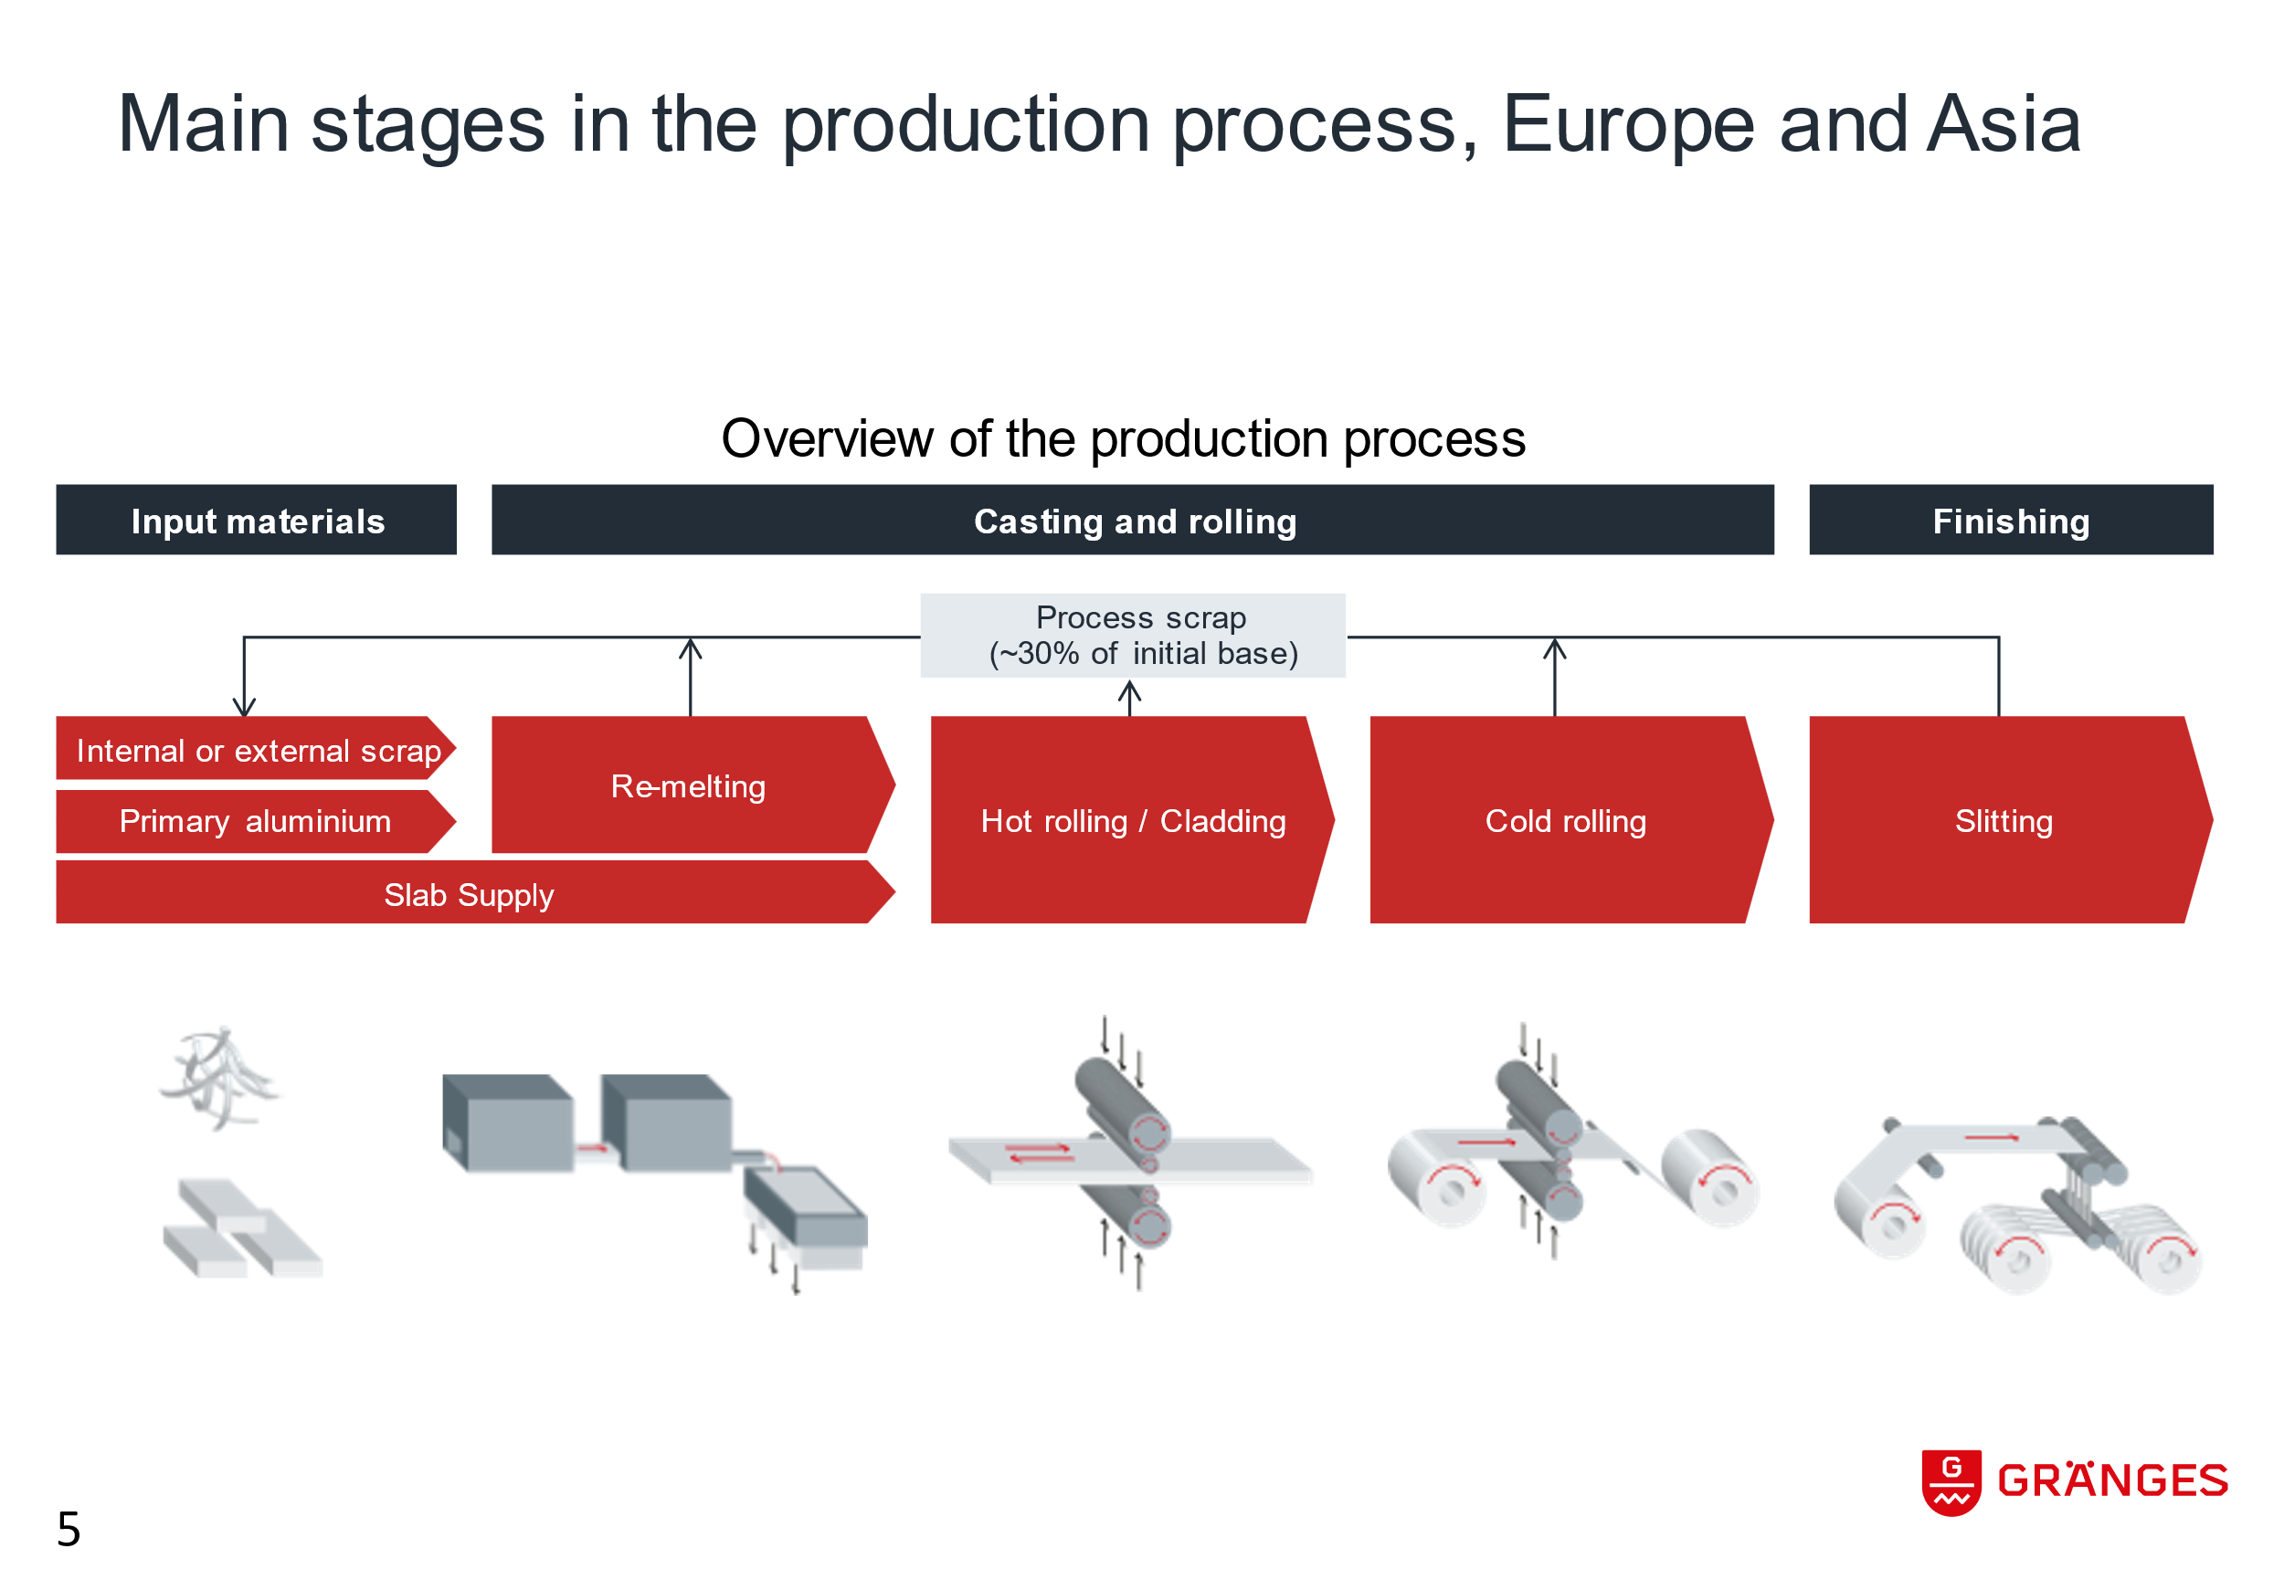
Figure 1 - Production process at Gränges (Courtesy Gränges AB)

The purpose of this project is thus to improve the understanding of the hot rolling process so that process parameters can be optimized in controlling thickness variation that adds customer value.
  - Hot rolling process
As mentioned above, the hot rolling consists of a two-stage process where the workpiece or billet is passed through a reversing mill and reduced from about 600 mm thick to 18 mm thick in 25 passes. The roll pass schedule is given in Table 1 and is shown schematically in Figure 2. The slab is then passed through a tandem mill where the thickness is reduced to about 3.7 mm in two steps (18 mm to 9 mm and 9 mm to 3.7 mm). The hot rolling process is schematically shown in Figure 3. It may be noted that both reversing mill and tandem mill are 4Hi rolling process that consists of two backup rolls and two work rolls. The main objective of the project is deeper understanding of the hot rolling processes by employing a physics based model which can predict the sheet crown according to a set of boundary conditions.

Table 1 - Roll pass schedule for the reversing mill [mm].
Pass | Roll gap | Pass | Roll gap | Pass | Roll gap | Pass | Roll gap | Pass | Roll gap
1 | 575 | 6 | 475 | 11 | 350 | 16 | 225 | 21 | 100
2 | 555 | 7 | 450 | 12 | 325 | 17 | 200 | 22 | 75
3 | 525 | 8 | 425 | 13 | 300 | 18 | 175 | 23 | 50
4 | 515 | 9 | 400 | 14 | 275 | 19 | 150 | 24 | 28
5 | 495 | 10 | 375 | 15 | 250 | 20 | 125 | 25 | 18

Figure 2 - Roll gap (upper image) and thickness change (lower image).

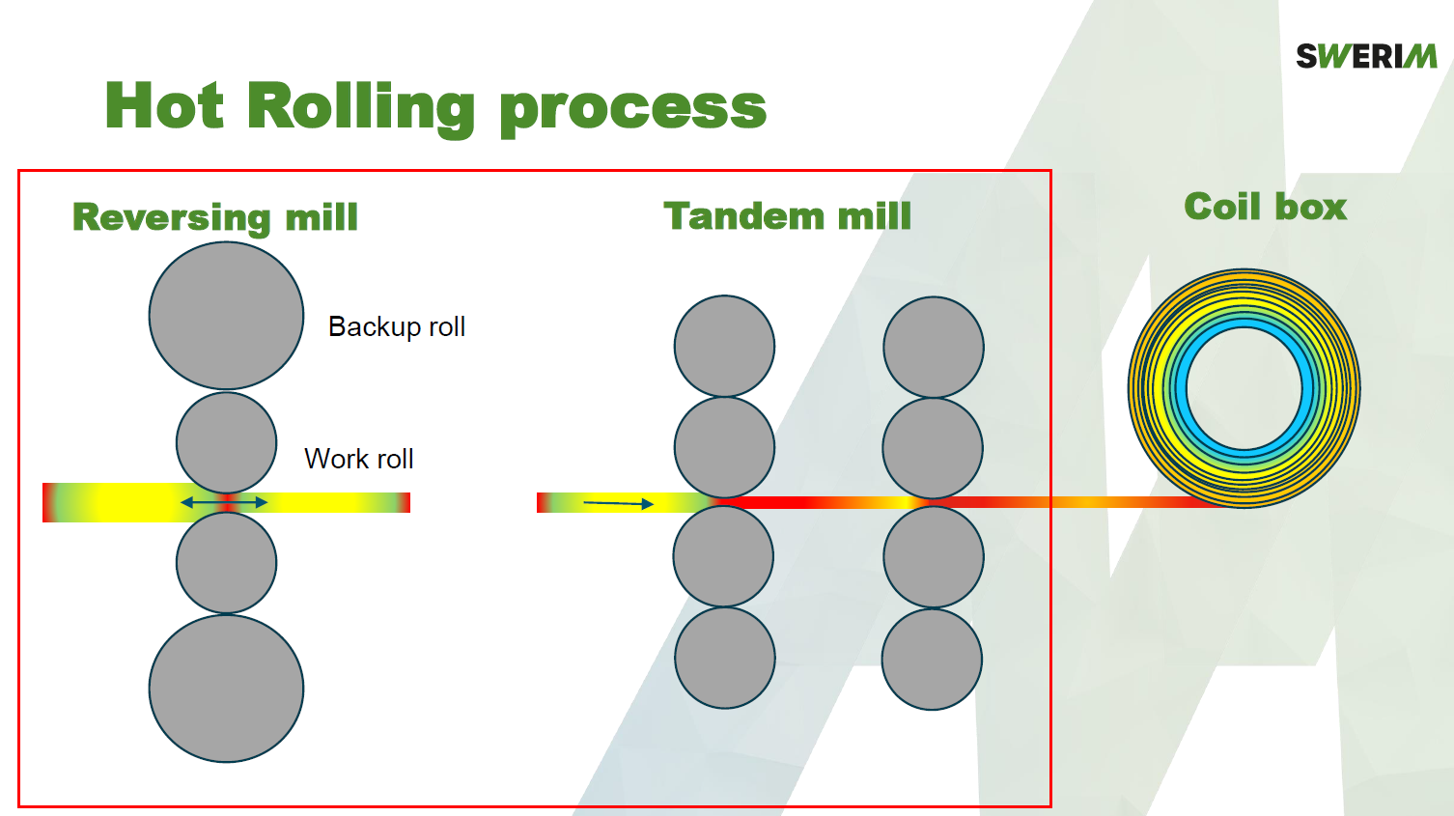
Figure 3 - Hot rolling process, the red square between the work rolls is the modelling domain.

The tandem mill is directly connected to the reversing mill at the entrance and a coil box at the other end. Since the material is reduced by about 50% (roll pass reductions of 18 mm to 9 mm and 9 mm to 3.7 mm) in each roll pair, the speed increases by two in each of them which is why the roll speed is more than twice the speed of roll pair 1 in roll pair 2 (Figure 4). The coil box is also applying tension in the aluminium strip to steer the material and make create homogeneous rolling conditions in the roll pairs.
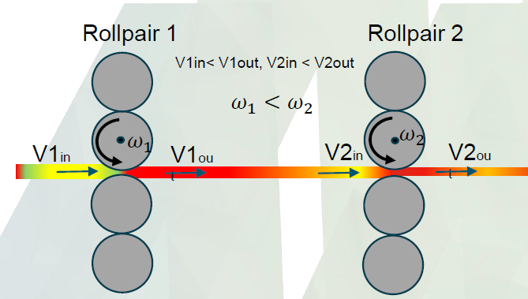
Figure 4 - Tandem mill illustration.
At the first roll pair, the gap is 9 mm and in the second roll pair is 3.7 mm.

Based on the mill data and process data, a 3D finite element has been developed and described in the following section. In the literature, simulation of more than a few passes are rare, whereas this project considers simulating 25 rolling passes in the reversing mill and two passes in tandem mill.

  - Finite Element Modelling
A digital twin (DT) is a digital representation/replica/ prototype to mirror the physical entity or process in a real-time manner. DT is immensely helpful in optimizing decisions-making and controlling, monitoring health condition, and forecasting and preventing the upcoming problems. As per a study in web of science, it is reported that the application of DTs in manufacturing is going through an exponential rise from 2020. The finite element method (FEM) has been proven to be a versatile and powerful tool as a DT for solving complex manufacturing problems.
FE modelling of rolling have been done since the 1950’s, these were rough plastic flow models in 2D. Since then, improvements have made with more and more computational power, leading to the more complex models that exists today. The general applications of FEM are discussed in detail by Reddy. During rolling, the extension in width direction of strip is not significant, plain strain conditions can be assumed. This simplifies the simulation to 2D FEM model. Several 2-D finite element models of the rolling process have been created and shown to offer more accurate approximations of rolling load. The model developed by Mori⁴ demonstrated the strip deformation during rolling. 3D models are more advanced models in predicting strip crown more accurately. However, 3D models are computationally very expensive.

Though the FEM model is an advanced computational method, the development of current model is associated with a lot of challenges that are described below:

- No temperature measurements in the reversing mill.
- No crown measurements in the reversing mill.
- Large span of temperature.
- Large span of strain rate.
- Large timespan.
- Many passes and extremely large plastic flow.
- Complex lubrication and cooling properties.
- Siderollers.
- Roll lubricant and cooling.

These challenges require creative solutions and simplifications which makes manual measurement for validation of the model extra important.

- Work plan
The modelling started with a need analysis where the goals and wanted results were defined. The problem was at first modelled in 2D to test material models and strategies on how to achieve a reversible mill. The best practices were then implemented in a 3D symmetry model where also the thermal boundary conditions were added. Additional programming was added to the script for file management. The 3D model was then redesigned iteratively to find the configurations best suited for the problem.

The hot rolling mill simulation was separated into two parts, one for the reversing mill and one for the tandem mill. As described in the following section the reversing mill was separated further with one simulation per pass with cooling simulations in between. Both the tandem and reversing mills were simulated with LS-Dyna R13 with mesh and model developed with Siemens NX and LS-Prepost. A material model using Johnson-Cook equation is developed to use in the FEM simulation which is described in the following section.
  - Material modelling
    - Johnson-cook model
To accommodate for the large temperature span and the range of strain rate the Johnson-Cook material model was selected. The JC model computes the plastic stress according to equation 1,2, and 3.

$$σ=\left(A+Bε^{n}\right)\left(1+C{\dot{ε}}^{*}\right)\left(1-T^{*m}\right)$$
1
Where
$$T^{*}= \frac{T-T_{ref}}{T_{m}-T_{ref}}$$
2
And
$${\dot{ε}}^{*}=\frac{\acute{ε}}{{\acute{ε}}_{ref}}$$
3

Descriptions of the coefficients follows in Table 2.
Table 2 - Johnson-Cook coefficient or variable description.
Coefficient | Variable | Description
A |  | Flow stress
B |  | Hardening
n |  | Strain hardening
C |  | Strain rate hardening
m |  | Temperature influence
 | T | Temperature
$$T_{ref}$$ |  | Reference temperature (Lowest gleeble temp)
$$T_{m}$$ |  | Melting temperature
 | $$ε$$ | Plastic strain
 | $$\acute{ε}$$ | Strain rate
$${\acute{ε}}_{ref}$$ |  | Reference strain rate (Lowest strain rate)

The evaluation of Johnson-Cook parameters needs flow stress data of aluminium in various temperatures and strain rates domains. Towards this end, cylindrical samples provided by Gränges were tested in Gleeble 3800 system at 0.2, 2, and 20 strain/s and temperatures at 350, 400, 450, and 500ºC.
The variation of flow stress as a function of strain, strain rate and temperature ware evaluated to obtain the coefficients in a Matlab algorithm. This algorithm was further modified to include an optimizer routine to get a suggestion of suitable JC coefficients.
Figure 5 shows manually calibrated values which were used as initial values for the optimization routine.
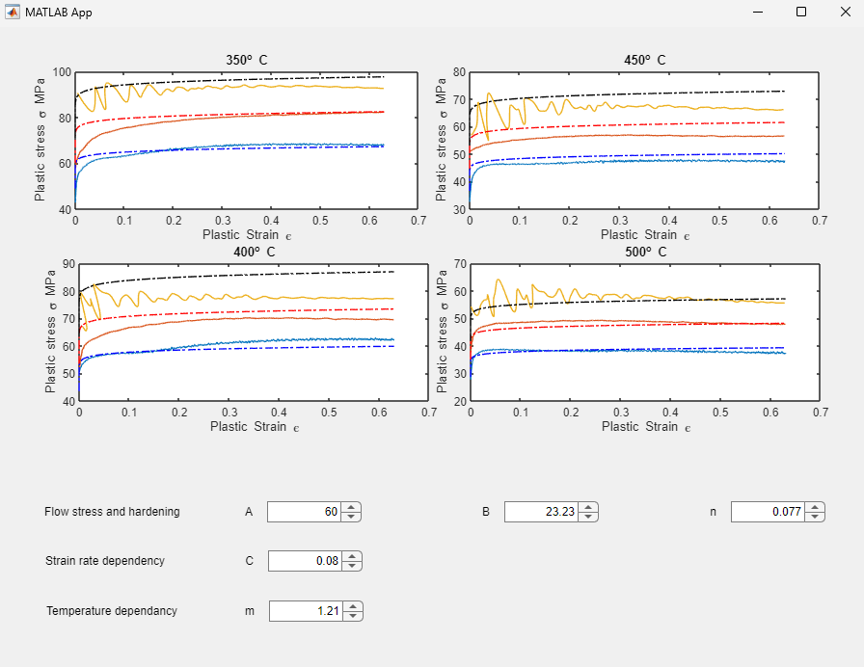
Figure 5 - Johnson-Cook calibration software before optimization

The final values are shown in Table 3 which yields the results described in Figure 6.

Table 3 - JC coefficients ALU 3003.
Coefficient | Value
A | 30.85 MPa
B | 54.27 MPa
n | 0.0901
C | 0.0711
m | 1.188599

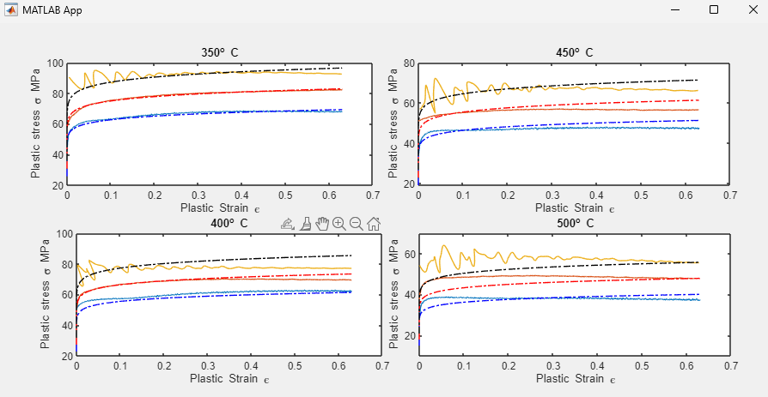
Figure 6 - Johnson-Cook parameters after optimization vs Gleeble data.
    - Thermodynamics
The thermodynamics of a rolling mill is very complicated. Other than the natural time dependant from convection and radiation, the workpiece is heated through the deformation whilst being cooled from lubrication and roll contact. The thermal properties of metals are often dependent of temperature which is why they can be implemented as curves in LS dyna. However, this data is difficult to get as they must be measured with specialized equipment. For this material the thermal properties were implemented as the constants presented in Table 4 and Table 5 below. This assumption was made because it was estimated that the thermal properties temperature dependency is not significant and that there are many other inaccuracies in the thermal boundary conditions that implementing exact functions would not affect the result.
Table 4 - Thermal properties of Aluminium 3003.
Cofficient | Value | Unit | Description
Hc | 893 | J/kgK | Specific Heat
Tc | 157 | W/mK | Thermal conductivity
h | 293 | W/m² | Convective heat transfer coefficient
f_{rad} | 5.103e-09 | W/m²K⁴ | Radiation energy
Table 5 - Thermal properties of generic steel as roll material.
Cofficient | Value | Unit | Description
Hc | 420 | J/kgK | Specific Heat
Tc | 45 | W/mK | Thermal conductivity
The values from Table 4 were average values computed with Thermocalc and the values in Table 5 are generic values for steel. Instead of computing the temperatures in the rolls, the temperatures are controlled which means that radiation and convection coefficients are not needed.
Other than the natural convection and radiation between the workpiece and its environment heat is lost due to lubrication and the contact between the workpiece and the roll. The splashing of fluid and the cooling patterns are not possible to accurately simulate in the FE-environment which is why it was implemented as a heat loss contribution in the contact. This is done with a parameter that is called HTC parameter which stands for “heat transfer contact” and has the unit W/m². Attempts were made to compute what it should be by estimating how much of the cooling fluids are lost to steam but at the end the HTC parameter were set to 10 000 W/m² for the reversing mill.

  - Reversing mill
As it is difficult to simulate multipass rolling, the easiest case was selected. This case is the rolling of a Gränges AL 3003 which is a non-sandwiched material that is rolled in 25 passes. The starting dimensions are 595x1420x5000 mm (height, width and length respectively), heated to 500º C and then transported from a furnace to the mill. The workpiece is then rolled to 18 mm according to the pass schedule presented in Table 16. The mill also uses side rollers to create a keep specific width during the rolling but for simplicity, the width is kept to 1420 mm at all times in the simulation. As the objective was to predict the sheet profile over 25 passes a thermomechanical 3D model was needed.

The roll gap is visualized as a function of pass and change in roll gap per pass in Figure 2.

As the sheet crown was of interest it was decided that instead of using cylinder shells as the roller body the rolls were to be modelled using flexible solid elements. This is because the rolls are bending, causing the workpiece to get thicker at the middle than at the edge. As the simulation is already time-consuming quarter symmetry using global constraint planes was used. This meant that a quarter of the workpiece and half of the upper roll pair was simulated as pictured in Figure 7. This reduces the element count to a quarter thus reducing the amount of computations per time increment a lot.
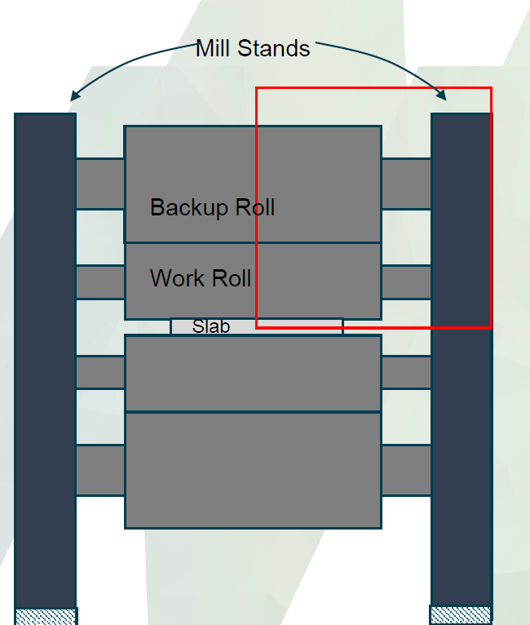
Figure 7 - Quarter symmetry conditions.
The FE model was created exclusively with 8 node hexaede elements. To model the rolls in a way that saves computations and gives an accurate description of the deformation, the rolls were modelled so that they have small elements at the surface and big elements towards the middle. Mesh and boundary conditions is described in Figure 8.
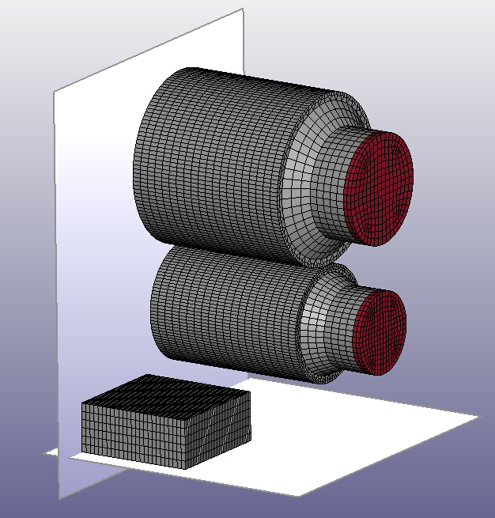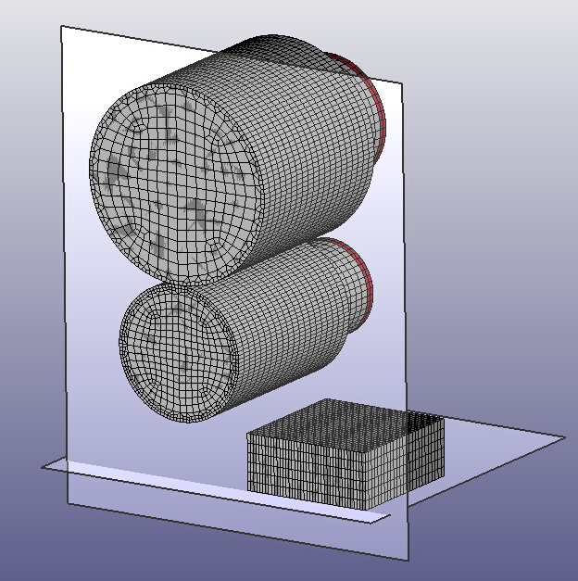
Figure 8 - Mesh with boundary conditions. Nodes touching the planes are only allowed movement on the plane. The red discs are "rigid bearings" where the position (upper) and rotational velocity (lower) is controlled.
Radiation and convection is added to the upper and outer segments of the workpiece with and ambient temperature of 20ºC. To get a thermal crown contribution, a node set on the work roll where the contact between workpiece and work roll occurs were defined and programmed to be 100º C at all times while the rest of the roll is 20º C. This had to be done as the HTC parameter was scaled to add a cooling contribution from the lubrication which means that it is larger than in reality. This affects how much energy is transferred to the roll, and if the temperature and thermal crown is computed from that value, the thermal crown would overestimated. The boundary conditions are visualized in Figure 9.
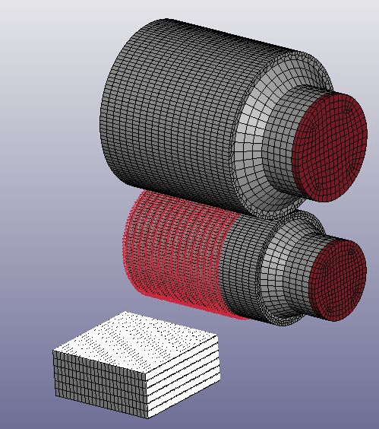
Figure 9 - Thermal boundary conditions. White is radiation and convection, red marked nodes on the work roll body are controlled temperatures.

Different options to solve the reversibility of the mill were explored. The most reliable option was to utilize LS-Dyna’s parameter functions and use the Linux terminal to launch simulations. Therefore, the model is defined so that it has an initial velocity on the slab and rotational velocity on the work roll. These velocities are also connected to a scale factor which is defined by a parameter Vdir which is 1 if the pass number is even and -1 if the pass number is odd.
The roll gap is also controlled by the Python script. It writes a definition for a curve that controls the position of the backup rolls bearing. It also controls the cooling simulations between the passes by controlling the length of the cooling simulations with a parameter. The cooling times are the time it takes for the sheet to return to the rolling mill.
Additionally, the script creates a file structure where the results are stored which means that the full 3d plot files are accessible for post-processing.
  - Tandem mill
The tandem mill was modelled in two steps. The first step was with elastic rollers so that the contact shape with bending and roll flattening could be measured. Then the contact shape was used to create geometric contact surfaces to simulate the rolls. This had to be done to reduce the computational times as the sheet required many and small elements as well as a solid roll also needed to have small surface elements to get a stable contact. The roll bend and flattening model is shown in Figure 10 and the geometrical contact model is shown in Figure 11.

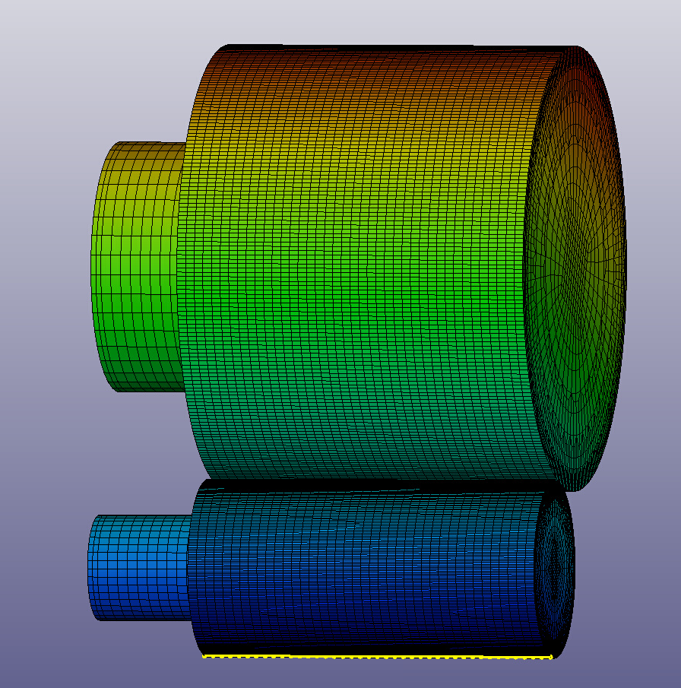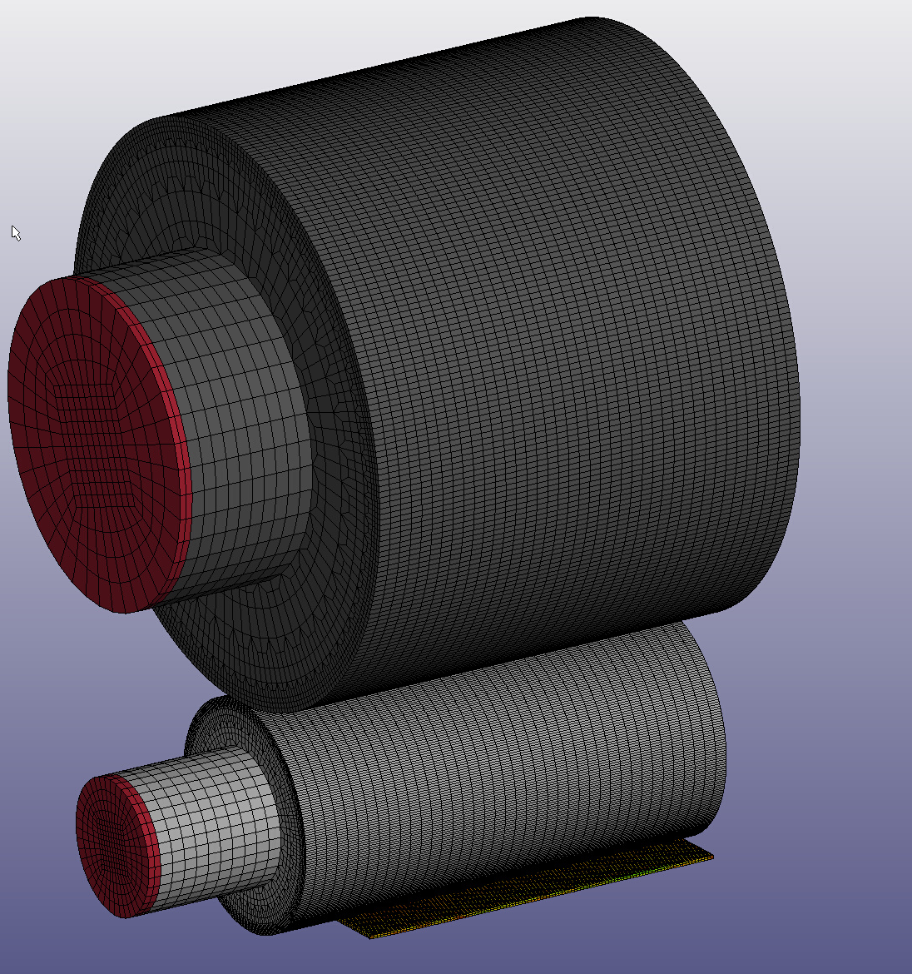
Figure 10 - Roll bend and nodal position readout.

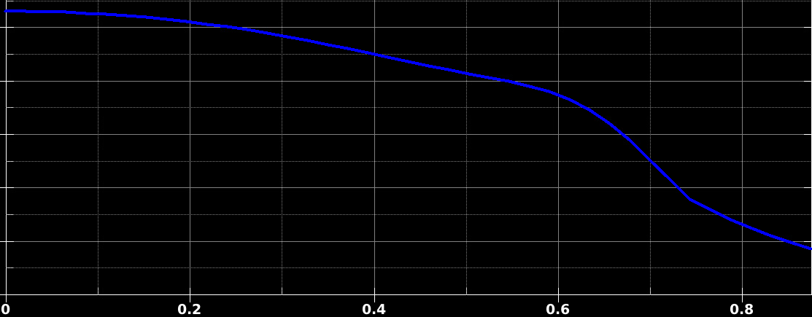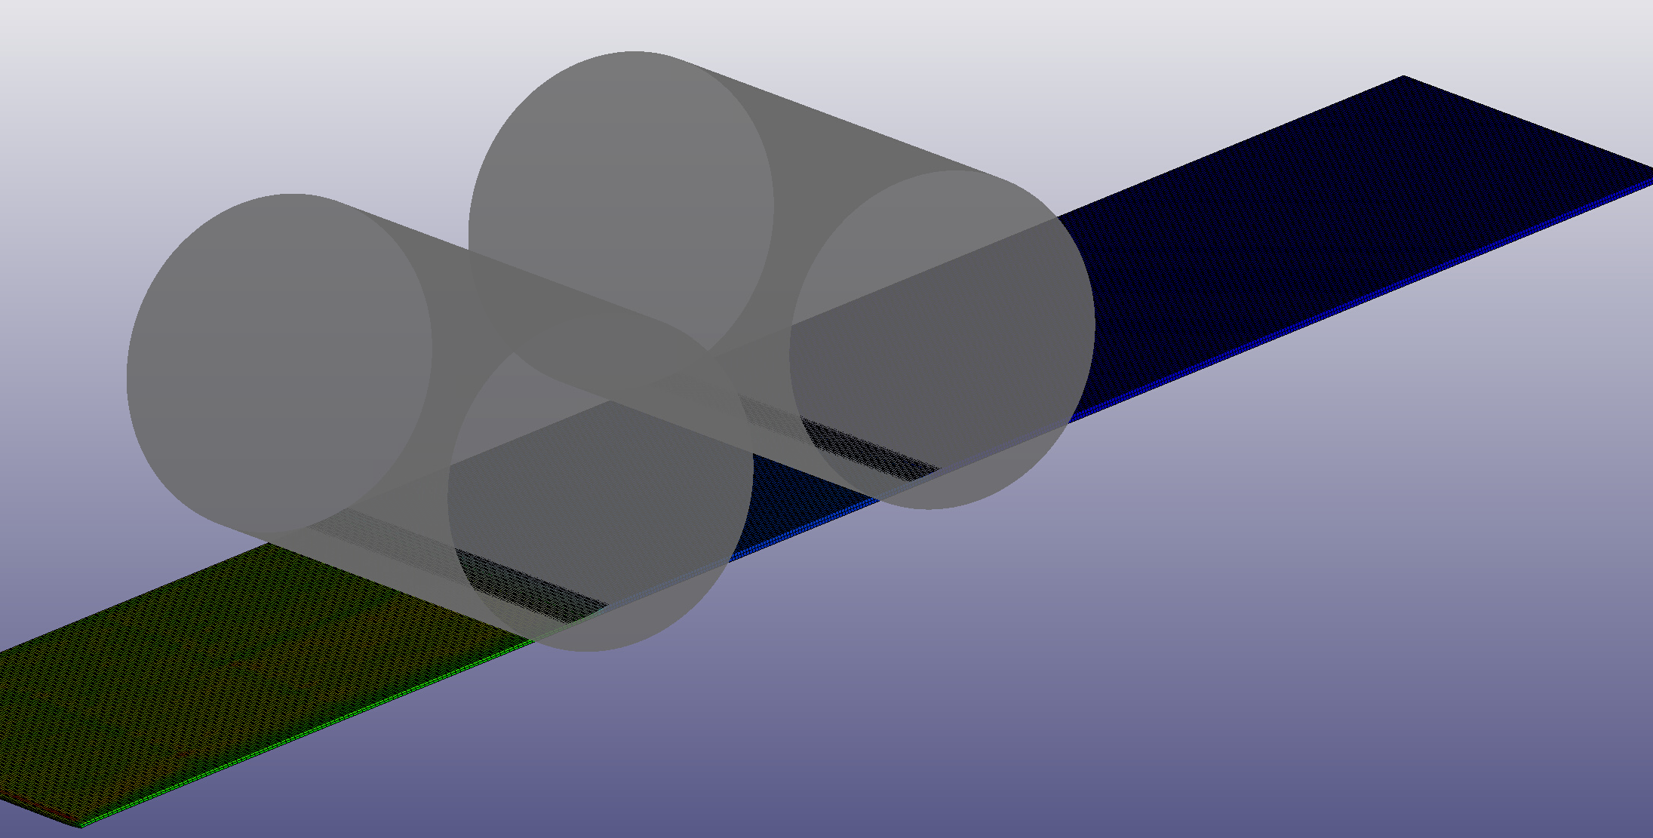
Figure 11 - Geometrical contact model
As seen In Figure 6 the gray contact surfaces are the blue function revolved about an axis which defines cylindrical surfaces centre and direction. The blue function is extracted from the yellow marked nodes in Figure 10.
These geometrical contact can not conduct any heat so to remove heat and simulate the thermal contact LS-Dyna’s user defined features were used to create convective heat transfer zones around the roll to workpiece interface. These UDF’s are defined as a negative heat flux with the unit W/m².
The rollers have been moved closer together in the simulation to save computational time. Having them the actual distance between them would mean that a much longer workpiece would have been needed in the to achieve steady state and the correct inter stand tension in the sheet. This ment that the heat transfer values and material parameters had to be scaled so that the heat transfer is a lot faster than in reality.
- Results
  - Reversing mill
The reversing mill model was successfully used to simulate all 25 passes of the case problem. The simulation was completed in about 80 hrs of computational time, running on 15 cores on Swerim’s computing cluster. The simulation required mesh splitting after passes 8, 12, and 16. Completely new meshes were generated after passes 18, 23 and 24. Using the result files it is now possible to get a comprehensive understanding of behaviors in the rolling mill that can’t otherwise be seen. Figures 12 – 17 show the plastic strain and temperature development from pass 1,12, and 25.
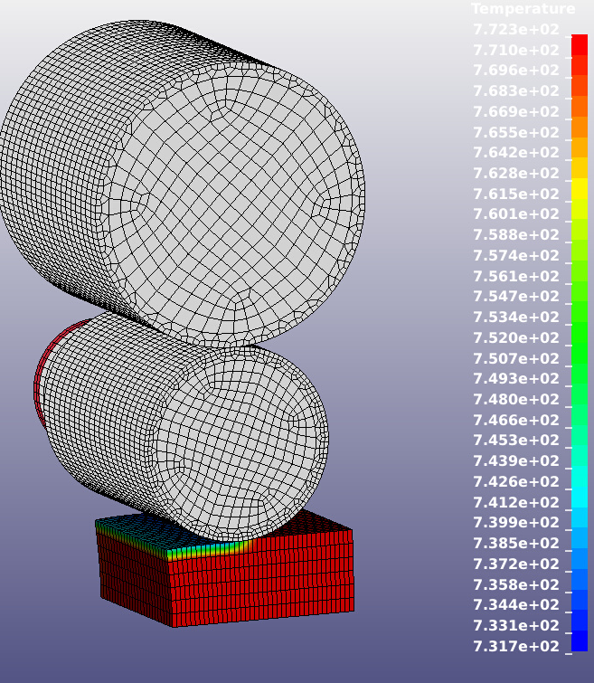  Figure 12 - Temperature developement Pass 1. | 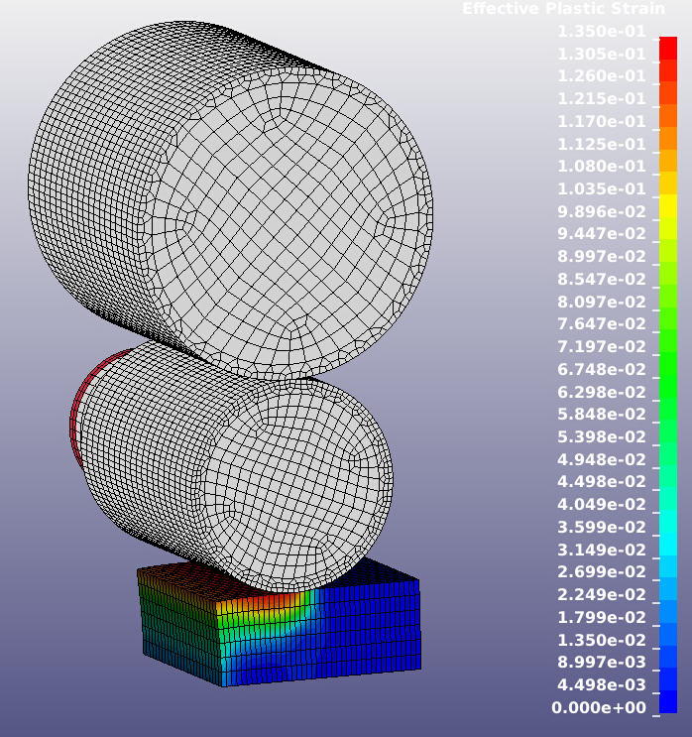  Figure 13 - Plastic strain developement Pass 1
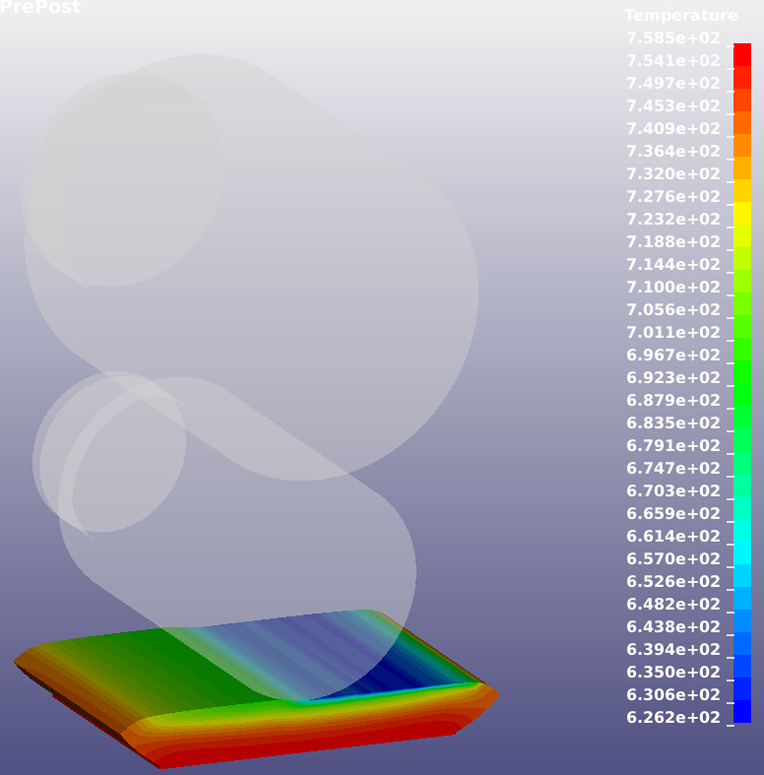  Figure 14 – Temperature development under pass 12. | 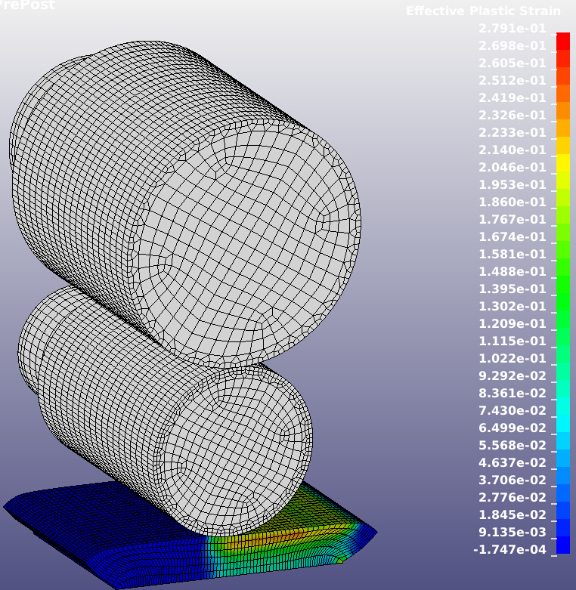  Figure 15 – Plastic strain developement in workpiece under pass 12.
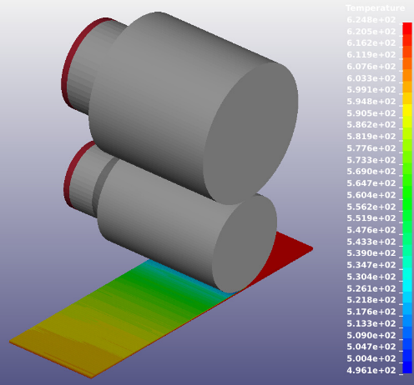  Figure 16 - Temperature developement Pass 25. | 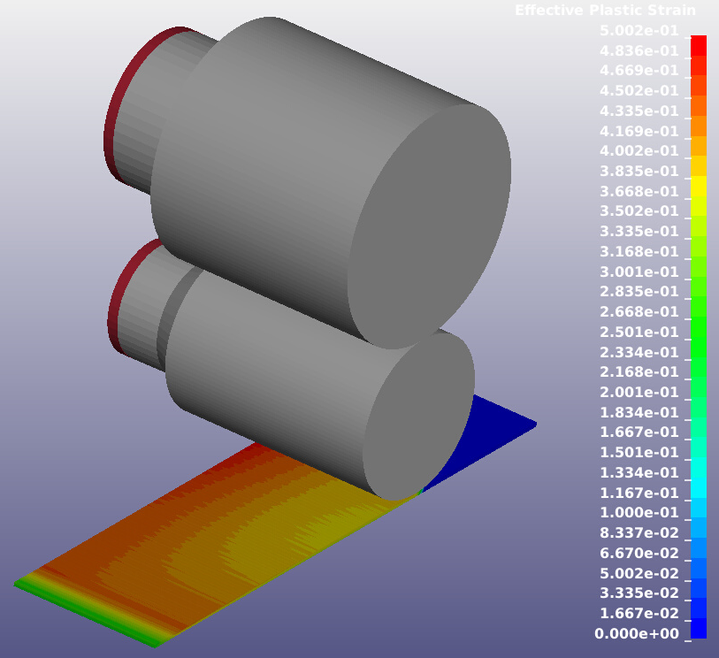  Figure 17 – Plastic strain development Pass 25
From the results it can be seen that the rolls cool the surface of the workpiece whilst the plastic strains behave differently at the beginning, middle and at the end of the process. At the beginning the largest strains are at the surface of the workpiece whilst the largest strains are just below the surface in the middle of the process. At the later stages of the process, the largest strains are at the outer edge of the workpiece and homogenously in the thickness, As the material is very thin.
    - Torque
In the reversing mill, the torque information is outputted in 2 signals ACT A1 and ACT B1 which would represent the upper and lower torque, This data is also average values from 70 coils (a campaign). Shown in Figure 18 are the values between ACT A1 and ACT B1 compared to each other and the FE-Data seems to follow ACT B1. Also, it seems that the torque is very dependent on the rolling direction as the data shows a zigzag pattern.

Figure 18 - Comparison of torque data between FE model and Mill Data.
The FE model seems to be in the correct range of torque, there is a difference between the results that most likely depend on force but also complex friction conditions which are hard to replicate in the FE-Model.

    - Load
Average load data from 70 coils is compared with the FE-model loads Figure 19. The results show that the loads follow quite closely with the mill data ntill pass 10 where the FE-model starts to show higher forces than the mill data.

Figure 19 – Comparison of force data between FE model and mill.
The FE-loads seem to follow the mill data but diverts from the data at the later stage of the process. This correlates well with the temperature as the temperature error influences the material model and thus the FE- Loads and torques. Also note that the core temperature of the workpiece remains constant until pass 16-17 where the core temperature starts to drop as the heat generation is not enough for the core temperature to be maintained. The rolling load starts to increase in the FE model and starts to diverge from the measurements as soon as this happens. This naturally indicates that the thermodynamic model needs improvement. But also confirms that the mechanical material model behaves correctly.
    - Temperature
As no temperature guage exist in the reversing mill the temperature was manually contact measured on a material with a similar pass schedule as there were no pending campaign of ALU 3003 at the time of measurement. In Figure 20, the temperature evolution of the FE-results is compared with the measured results of a similar alloy.

Figure 20 - Temperature evolution and comparison with measurements.
The surface temperature of the FE model drops faster than in the measurement, The core temperature does not start to diverge from the measured temperature until after pass 16. The difference in temperature between the mill and the model might seem big but over 25 passes that is only an error of about 3°C per pass or a difference in 18.3%.
The temperature error per pass is acceptable but as the error increases for each pass the divergence from reality is significant. Attempts were made to compute an exact heat flux by examining how much water is lost to steam each day and then computing an energy loss per slab and pass. This however increased the error more which meant that the thermal boundary conditions had to be approximated with educated guesses and time-consuming trial and error.
    - Profiles
From the result files it is possible to read the surface profile from the nodal coordinate values and subtracting the edge value from all of the data points. This must be done as otherwise the profile would not be noticeable as the sheet crown differs in the scale of micrometers. Presented in Figures 21 – 23 are the sheet profiles exported from the FE mesh after each pass. Figure 24 shows the profile after stand 1 and 2 in the tandem mill.

Figure 21 - Profiles for pass 2-10.

Figure 22 - Profiles for Pass 11-20.

Figure 23 - Profiles for pass 21-25
The mesh distortion was too severe at the later stages of the process which meant that the crown shape is not predicted as accurately as in the earlier stages. This is because it proved to be difficult to transfer the crown from a previous pass to a new mesh in the cases where a completely new mesh was needed. This had to be done after passes 17, 23, and 24 and most likely produces a flatter profile than in reality, as the contribution from the previous passes is lost. There is also a waviness towards the edge, this comes from that the sheet is not allowed any widening to mimic the side rollers.

  - Tandem mill.
16 cores solved the FE model of the tandem mill in 57 hrs. Unfortunately, it was not possible to extract the rolling loads and torques from the contact entities.

In the tandem mill, Temperature is measured between the stands. Figure 24, shows data from 70 sheets. The temperatures seem to be about 400۠°C with the nose of the sheet being colder than the tail.
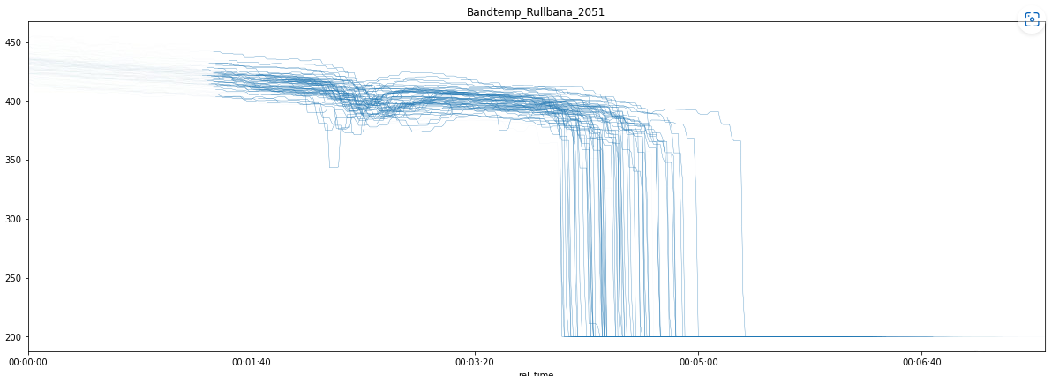
Figure 24 - Tandem mill data temperature between mill stands.
From the reversing mill the temperature has been measured to about 400° C which was also the input temperature in the simulation. Figure 25 shows the temperature evolution of 6 nodes in the sheet, the locations are shown with a complete 3D plot of the temperature after rolling in Figure 26.
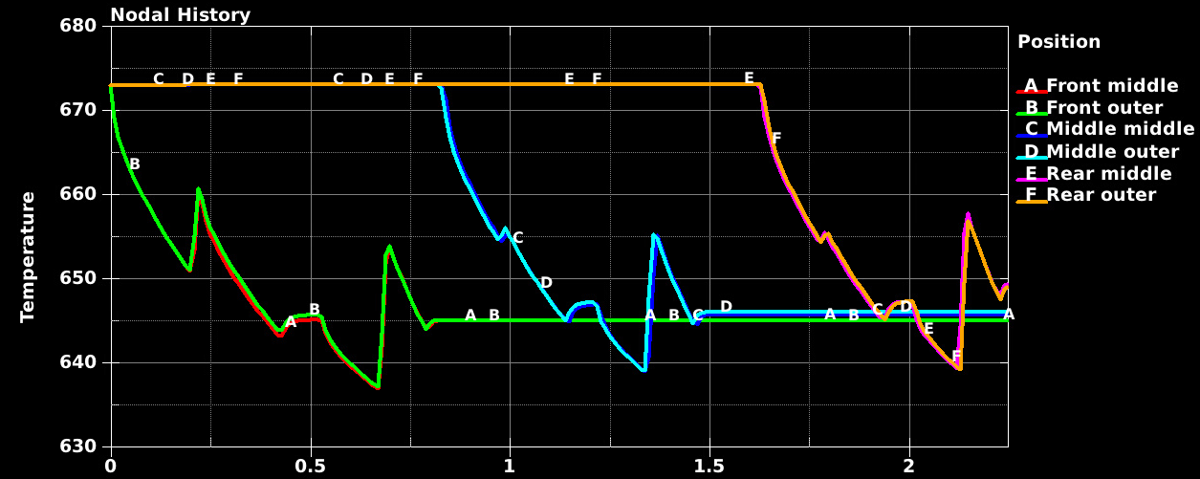
Figure 25 - Temperature evolution of 6 nodes in the sheet. Positions described in Figure26, outer nodes are placed closest to the colour index.
The contact force logging did not work in the tandem mill simulation. LS dyna was programmed to log them the same way as in the other simulations but somehow this contact formulation is not compatible with the database binout data logging. The mill does not have force logging in the tandem mill which makes it extra frustrating that it was not possible to extract the rolling loads.

From Figure 25 the FE-temperatures settle at about 645º K which is 372° C.
Figure 26 shows the FE computed profile of the same set of nodes after stands 1 and 2. The crown does not seem to change a lot between the stands. Suggesting that the roll deflection is very similar in stands 1 and 2.

Figure 26 - Profile after stand 1 and 2 in the tandem mill.

- Conclusions
Overall, the FE models produced a lot of data and information. The work done in this project shows that it is possible to simulate Gränges hot rolling process with results that are similar to reality. As seen in the results, there is a diversion in the results from the measurements. For instance, the temperature also influences the rolling load and torque.

As there was some noise in the signal from the higher strain rate for the Gleeble tests it was very difficult to adapt the JC model to that data. However, the optimization routine in combination with the Matlab app was a very effective method to find suitable JC coefficients even to it was difficult to find a set of coefficients that perfectly matched the higher strain rates.

For Swerim it is an achievement and technological advancement to have created a FE model that can simulate a reversible mill with 25 passes. Some practical issues need solving for the future to use this model.
- The models produced were computation-wise heavy which means that it takes a long time to get an answer from the model. It is not usable online and should only be used to study phenomena that need a detailed description. A suggestion is to use it in cooperation with the crown or the data-driven models to get more detailed information on interesting cases that the crown generates.

- For a finite element model of this scale to be successful, further development of boundary condition control and adaptive meshing or mesh-free methods needs to be made.

- This was a very difficult project that required a lot of development, research, and support from LS-Dynas support service. It also required innovative solutions which meant that modelling skill was increased by this project.

For steel rolling this approach could be valuable and functional as the steel industry doesn’t use as thick starting dimensions in their slabs and use about 10 passes in the breakdown mills. Naturally, the thermal properties need thorough investigation before applying this method to steel.
- Suggested continued work.
The work and experiences gained in this project opens new questions.
- The thermodynamic conditions were especially difficult to replicate, thereby research and development of thermal boundary conditions in rolling would be interesting to investigate. Possible by using detailed CFD simulations and mapped convective heat transfer.

- Friction is a factor that affects the torque, the zig-zag pattern produced by the measurements indicates that there is a directional behaviour. It would be interesting to find out why.

- Adaptive meshing and mesh refinement were not used as it made it impossible to simulate convection and radiation as the node numbering changes every iteration. This caused mesh deformation so severe that a completely new mesh had to be generated. This mesh lacked the crown that was computed previously which in turn influenced the result. It would be beneficial for future work in multipass thermomechanical hot rolling to utilize UDF boundary conditions. By inventing a new way to simulate convection and radiation without assigning node sets, so that adaptive meshing could be used.
- Acknowledgments

The author acknowledges the support received in various forms from Gränges.

Fei Peng, Li Zheng, Xianghui Meng, Digital Twin for rolling bearings: A review of current simulation and PHM techniques, Measurement 201 (2022) 111728
Zienkiewicz OC, Huan GC, Lie YC, Adaptive FEM computation of forming processes – Application to porous and non-porous materials. Int. J Numerical Methods in Engng 30 (1990) 1527–1553.
J. N. Reddy. An Introduction to the Finite Element Method. McGraw-Hill, New York, NY, 3rd edition, 2006..
K. Mori, K. Osakada, and T. Oda. Simulation of plane-strain rolling by the rigid-plastic finite element method. International Journal of Mechanical Sciences, 24(9):519 – 527, 1982.

