Blow moulding – Problem Description

Version | V1.0
Date | 21 Sep 2023
Confidentiality | Public
Type of Deliverable | Problem Description
Description | Report
Deliverables in the Project | One deliverable – D5.1

- Abstract

The project "VMAP analytics – Smart analytics for multi-scale material and manufacturing modeling" focuses on using technology to analyze materials and manufacturing processes. In today's competitive world, having smart digital copies of real things is crucial for staying ahead. The document describes the problem description of the Blow moulding use case.

- Change Log

- Contributors:
Name | Organization
Morten-Christian Meyer | SCAI Fraunhofer
Klaus Wolf | SCAI Fraunhofer

Table of Contents
Blow moulding – Problem Description 1
1. Abstract 2
2. Use case 4 (Blow moulding) 4
2.1. Problem description and goal 4
2.2. CAE-based Digital Twin 5
3. Project target: 6

- Use case 4 (Blow moulding)
  - Problem description and goal
Industry demand: Use case 4, a contributes to a digital twin development for optimization tasks in extrusion blow moulding, a widely used manufacturing process with 0.452 million tons of plastic currently processed in Germany. It operates by extrusion and inflation of a tubular melt strand into a mould and is adequate for thin-walled shell bodies at high production rates. It stands in the critique of high resource demand; yet, the potential for savings is large along this intensive value chain. Blow moulding is extremely sensitive to material property fluctuations (polypropylene/polyethylene) with inadequate control measures to assure product quality for higher rates for recyclates. This will be possible, once optimization of the process is enabled at scale through a digital twin system, requiring significantly less energy than new material. Also, the wall thicknesses can be decreased and an AI-supported component design could also guide engineers towards more efficient geometries, again saving up to 10% of material. One requirement is a data infrastructure for dynamic exchange of data between machines and predictive tools coupled with the various model types for the process and components.

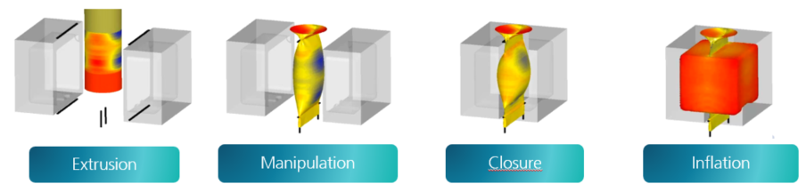
Figure 1 – Extrusion blow moulding process [adopted from Dr. Reinold Hagen Stiftung]

Goals: VMAPanalytics mainly aims at the goal to bridge the gap in data interoperability between measurement and simulation. Most of the formalization of the processes and interface development is out of the scope of this use case and left for funded work. In this project, we focus on the software-infrastructure – a necessity before the actual optimization tasks – and derive a proposition for the use of VMAP in a digital twin scenario. Concretely, this means two main outcomes: a) a VMAP ontology with recommendations for querying data, and b) a VMAP extension for experimental data with recommendations to parse and use CAE-experimental correspondences.
  - CAE-based Digital Twin
Digital twin technology is mostly driven by the “smart factory” system perspective. However, joining digital twins with simulations to understand and control of the physics of a system requires a perspective that is not yet established in industrial digital twin standards. Dr. Reinold Hagen Stiftung has developed a unique simulation workflow in the first ITEA VMAP project that uses VMAP as exchange format between high-resolution simulations.

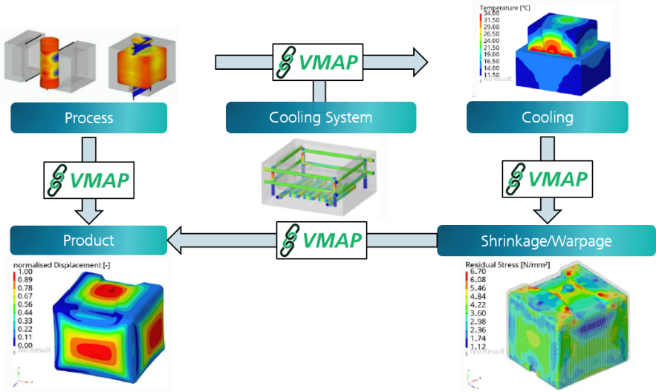
Figure 2 - Holistic CAE workflow for moulding assessment [adopted from Dr. Reinold Hagen Stiftung]

CAE-workflows: We start from a well-defined framework of rule-based simulations and transfer based on VMAP between CAE codes. Each individual simulation as well as intermediate mapping are validated and automated. However, the overall workflow is not fully formalised and disconnected from measurements and production machines. Interfacing to such data is required for automation of calibrations, comparisons or uncertainty quantification, global optimizations and use of analytics tasks with data based (ML) models. Still, there are no common principles for the interfacing of other data sources and model types into a CAE chain and joint management of such assets is not generally solved yet. For example, simulation data management (SDM) systems are commonly used to track and handle different simulation tracks with varying material assumptions, boundary conditions and numerical parameters - with large overlap with product design data (SPDM), i.e. CAD data and parameters, bills of material etc. On the data structure level, STEP AP209 is a standard that addresses both design and simulation data, but comes short in effectively storing large structured data on the CAE side (as opposed to VMAP). Moreover, SDM systems lack the capacity to merge with tracks of other types of data, i.e. they cannot be used when interfacing heterogeneous data sources.
Overall target: Since SDM software does not offer these features, we propose to formalize the CAE workflow semantically and embed it in a meta-framework that allows interoperability with measurement / process data. This effectively results in a semantic digital twin system, which, from a CAE-perspective, could benefit greatly from a simpler way to pull measurement data into the simulation environment. The full formalization of the workflow will not be part of VMAPanalytics.
- Project target:
One option is to identify the relevant data from its semantic meaning and then store a required except it directly alongside the corresponding simulation (that it should be compared/processed with). We propose the extension of the VMAP specifications towards the ability to store experimental data along with the CAE data. This should by no means replace a type-optimal management of measurement data, but allow for the joint propagation of corresponding measurement and simulation data through such workflows.

Use case 4 is a (self-funded) use case lead by Fraunhofer SCAI based on a long-term collaboration with Dr. Reinold Hagen Stiftung.
https://kunststoffverpackungen.de/marktdaten, Access: 21.10.2022
D. Spancken; Zwischenbericht Promotion: Der Einsatz von Rezyklaten zur nachhaltigen Ausle-gung zyklisch belasteter Struktur-bauteile aus Polypropylen, Vom Promotionszentrum für Nachhaltigkeitswissenschaften an der Graduiertenschule Darmstadt, 2022.
Letellier, P., Modelling & Simulation, ITEA Magazine (35) 2020, available at https://itea4.org/project/vmap.html
Norris, M., How to - Get Started With Simulation Data Management. NAFEMS, 2020.
ISO 10303-209:2014. Industrial automation systems and integration - Product data representation and exchange - Multidisciplinary analysis and design. Standard, 2014.

