# Prevas use case - Problem Description

|  |  |
| --- | --- |
| Version | V1.1 |
| Date | 24 March 2024 |
| Confidentiality | Public |
| Type of Deliverable | Problem Description |
| Description | Report |
| Deliverables in the Project | One deliverable D3.1 |

1. Abstract

The project "VMAP analytics – Smart analytics for multi-scale material and manufacturing modeling" focuses on using technology to analyze materials and manufacturing processes. In today's competitive world, having smart digital copies of real things is crucial for staying ahead. This report discusses the use case of Prevas industry partner where a 3D model of walking beam furnace is developed to understand the evolution of skid marks. This model thus helps in optimizing FOCS system for further savings in energy consumption.

1. Change Log

|  |  |  |  |
| --- | --- | --- | --- |
|  |  |  |  |
|  |  |  |  |
|  |  |  |  |

1. Contributors:

|  |  |
| --- | --- |
| Name | Organization |
| Sivaprasad Palla | Swerim AB |
| Krister Ekström | Swerim AB |
| Johan Lindwall | Swerim AB |
| Per Åhman | Prevas AB |
| Jorma Pataalo | Outokumpu AB |

Table of Contents

Prevas use case - Problem Description 1

1. Abstract 2

2. Introduction 4

2.1. Business Objectives 4

2.2. About Prevas 4

2.2.1. FOCS system – description 4

2.3. Problem Description 5

2.3.1. Furnace description 6

2.4. Literature review 7

2.5. Methodology 8

3. Conclusions 9

1. Introduction

This use case deals with improving control in reheating and heat treatment furnace operations. Prevas supply an unique solution: FOCS – Furnace Optimization Control System, to optimize furnace parameters. The business objectives and problem description are discussed in the following sections.

* 1. Business Objectives

Metal and mineral producers face major challenges in terms of competition and profitability. Prevas offer customers to improve their products, services to be more efficient, user-friendly, and profitable. With high technical expertise and deep business understanding, Prevas helps customers from a wide variety of industries to benefit through continuous technological innovation.

The basic requirement of industry is growing steadily. Sustainability is a driving force and the increased degree of automation, digitalization, increased technology content in all things, increased degree of connectivity contributes to increased demand for advanced expertise. With this there is also an increased demand for half packaged capital structure that can be used to increase the flexibility, speed and efficiency in development of solutions. The requirement for advanced expertise and need for capital structure are two trends that both indicate a strong future for Prevas. The ambition is to help customers to benefit from this and to offer employees exciting work tasks that can also contribute to a better world in different ways.

* 1. About Prevas

Prevas was founded in 1985 and currently employs about 800 people in Sweden, Norway and Denmark. The company provides advanced solutions and consultancy services within product development and production development with a yearly revenue of about 800 MSEK. Prevas is quite an innovative company, and some examples includes the first collaborative robot in serial production, the world's safest bicycle helmet, and a global cloud service to meet the latest demands on traceability and labelling. Prevas also supply an unique solution: FOCS – Furnace Optimization Control System, to optimize furnace parameters. Today 90% of all steel produced in Scandinavia is heated in a furnace controlled by FOCS. However, it needs continual improvement to stay ahead in the competition.

* + 1. FOCS system – description

The primary goal of the FOCS is to minimize fuel consumption while simultaneously enhancing productivity and the quality of products in a range of furnace applications[1]. These applications encompass pit furnaces, normalizing furnaces, annealing furnaces, and reheating furnaces. The FOCS achieves its objectives by performing real-time calculations of slab temperatures, coupled with diverse levels of control intricacy tailored to the specific requirements of each furnace type. The temperature computation is executed through a 2D model known as STEELTEMP, which has been co-developed by MEFOS. This model considers both workpiece details and furnace-specific data to yield precise results[2].

FOCS – RF (reheating furnace) is a system for fuel optimization of furnaces where slabs are heated for hot rolling. The furnace is normally divided into several zones consisting of preheating, heating and soaking. In FOCS – RF, each furnace control zone is divided into several calculating zones depending on burner positions and thermocouples configuration. Figure 1 shows FOCS interface with the live temperatures in various zones and the control parameters. The interface provides information on deviation from the ideal heating curve, slab location, speed, discharge interval etc. Each slab, billet or bloom is given its own target heating profile depending on dimension, material type and quality aspects. Depending on the production situation in surrounding processes FOCS adopts pacing and heating to deliver material with the correct temperature at the correct time for further processing. The purpose of furnace pacing is to increase the productivity, save fuel and achieve accurate target temperatures.

The control strategy of FOCS adopts both feedforward as well as feedback part. Feedforward adopts to new steel quality, new dimensions, and requirements whereas feedback is used to keep the slabs on their ideal heating curve. Typical energy savings is in the range 5-20%. On top of reduced energy consumption, the system increases production capacity by intelligent pacing control of the furnace and surrounding processes. Productivity increases with up to 28% have been realized.

Figure 1 FOCS interface to monitor temperatures in various zones1

* 1. Problem Description

A reheat furnace is generally employed to bring slabs or metal workpieces to the proper temperature for hot rolling. Such furnaces normally include multiple zones and the heat is usually supplied , from burners located above and below the slab, which is pushed through the furnace. The slabs are supported on skids which are cooled with water to prevent too rapid deterioration and to maintain the strength of the skids. This results in thermal gradients in the slab and continue to exist at the time of rolling, result in differences in the deformation resistance of the material and increase the difficulty of rolling consistent gage metal. Figure 2 shows slabs and skid marks after reheating1.

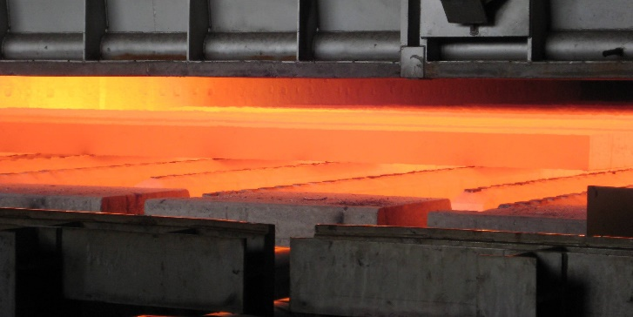

* + 1. (b)

Figure 2 a) Slabs placed on water cooled skids and b) Evolution of skid marks in the furnace1

These skid marks create inhomogeneous deformation and result in non-uniform thickness which are not desirable. Further, they affect the roll pass schedule.

The main objectives of the project are

* Create a new 3D heating model to be able to account for the skid marks.
* Use process data to correlate temperature difference in the skid marks to increase in rolling load.
* Ally 3D model for finetuning FOCS system.

The expected results from the project are:

* Possibility to analyse the problem of skid marks in production. The new improved inhouse model will create opportunities to reach new market segments for the FOCS system.
* Develop a 3D furnace model. This model could be used for verification of inhouse model or for simulate different strategies to minimize the skid marks.

This project proposal includes the development of necessary process models.

The purpose of this project is thus to improve the FOCS system to avoid or reduce skid marks problem. This needs development of a 3D furnace model and a protocol for how to use process data to build a higher level model based on real time signal data.

* + 1. Furnace description

Two walking beam furnaces are in use at the Outokumpu Hot rolling mill in Tornio, Finland. Slabs from melting shop are heated in a furnace before rolling. Weight of the slabs is approx. 23 tons. Carbon monoxide and natural gas are used as fuels in the furnaces and combustion air is heated in recuperators. Figure 3 shows Walking beam furnace 2 (WBF2). The effective length is 35.5 m. Charging takes place with the help of a long charger. The slabs can be placed in the furnace without large gaps if the arrival of the slabs is delayed.

The walking beams are electromechanically movable, the forward movement is 580 mm in WBF2. There are 7 fixed beams and 6 moving beams. The furnace has three zones, and the burners are located on the side of the furnace and there is a total of 72 of them. The discharging temperature varies between 1100 °C and 1250 °C. Skid marks are first noticed after heating as peaks in the rolling forces. Because the skid marks are colder areas, the material becomes more resistant to deformations, hence, they increase the rolling forces.

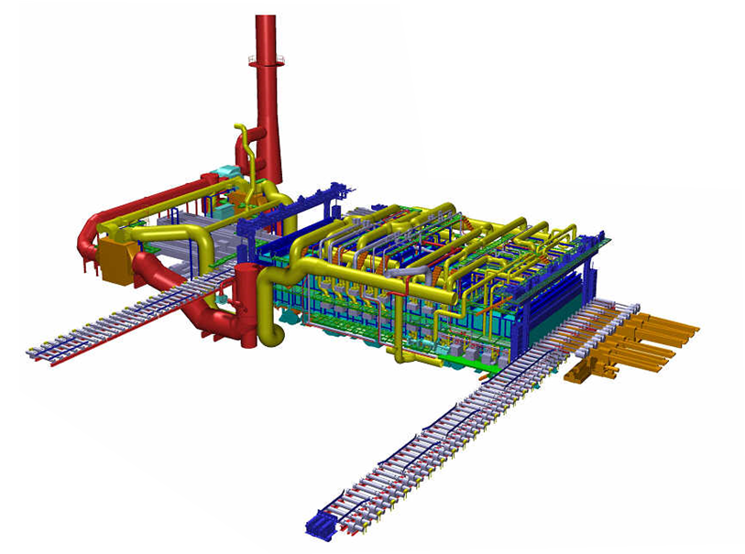

Figure 3 Schematic of the waling beam furnace 2 at Tornio (courtesy Outokumpu AB, Tornio)

* 1. Literature review

The performance of reheating furnaces greatly depends on oxide layer and skid marks produced on the slab during heating which will significantly affect the surface quality, dimensional accuracy, and product properties. The reported literature is scarce on controlling the skid marks and oxide layer through 3D furnace models[3]. A suitable 3D numerical model helps in the prediction of the slab’s temperature field[4]. By employing 3D simulations Hsieh et al.[5] have shown that the skid marks are mainly caused by radiation shielding and worsened by cooling system. Various researchers have employed CFD for 3D simulation of the reheating furnaces to study the skid marks and oxide layers. Thus, establishing a 3D furnace model that considers skid marks is of prime importance for fine tuning the furnace control systems.

* 1. Methodology

The methodology to meet the above mentioned objective is given in Figure 4.

Figure 4 Methodology for furnace control

The model thus developed will be able to:

* Understand the temperature distribution in the slab at any position in furnace
* Applicable to various boundary conditions
* Applicable to various geometries
* Provide increased control to FOCS

However, the process models will be developed and implemented in such a way that they can be used off-line, whereas "on-line" design is a possible future continuation. Since the process models are developed and validated, they are implemented in a GUI-based application format so that it can be easily absorbed in a process environment.

The 3D FEM furnace model is developed in Matlab and includes a full description of the heat conduction equation in a transient approach. The temperature evolution in the slab is computed in a series of short time increments and is thereby set up to develop over time, equivalent to the slab position along the furnace. The FE-modelling domain can be discretised upon choice, and this gives to possibility to resolve the contact area between the slab and beams, on the expense of computational time. Contrary, the resolution can be chosen as less refined which results in considerable computation speedup, one critical landmark for “on-line” simulations. Further development may allow combinations in form of sub-modelling to extract the best trade of with computational speed and accuracy.

One major functionality in the developed model as compared to similar simulation tools, including Steeltemp, is a complete representation of the furnace configuration with respect the radiative heating. Radiative heating by the furnace walls is of the dominant mechanisms for heat transfer from the heat source (burning fuel in this case) to the slab surface. Therefore, the heat input at any position is calculated by integration of all furnace walls. Figure 5 illustrates all possible heat exchange pathways at three different slab positions in a fictive furnace. Whenever a walking beam is present, it will black out the radiative heating at that position, providing a contribution to the skid marks. This functionality, together with an active heat loss by conduction in the contact interface provides a complete representation of the source of skid marks.

Figure 5. Radiative heating illustrated in two dimensions at three different positions in a fictive furnace. Red lines represents the heat echange pathways and the discretisation of the furnace walls. Note that vertical walls are blocking the view at some instances.

The data analytics involve application of XGBoost algorithm on process data. The details of the analysis are provided in Figure 4. The results from FEM model and data model would be used for deeper understanding of formation of skid marks.

1. Conclusions

The main objective of the use case – Prevas is to develop a digital twin for a walking beam furnace and understand the evolution of skid marks. The methodology applied includes a FEM based DT and a data based model for deeper understanding of the process.

1. M Evestedt and P-O Norberg, Precise temperature control in high quality steel reheating and annealing furnaces, 13th Sumposium on automation in mining, mineral and metal processing, Cape Town, South Africa, August 2-4, 2010.
2. B Leden, Mathematical reheating furnace models in Steeltemp, in SCANHEATING, 2:1-2:28.
3. Zhang Z, Luo X, Qiao J, Optimal investigation of the reheating furnace based on a 3D numerical model with the formation of both oxide scale layer and skid marks, Compters in mathematics and applications 128 (2022) 12-20.
4. Dubey S K,Zh Srinivasan P, Steel billet reheat simulation with growth of oxide layer and investigation on zone temperature sensitivity, J Mech. Sci and Technol., 28(3) (2014) 1113-1124.
5. Hsieh C T, Huang M J, Lee S T, Wang C H, A numerical study of skid marks on the slabs in a walking beam type slab reheating furnace, Numer. Heat Trans., Part A, Appl. 57(1) (2010) 1-17.