Ovako use case - Problem Description

Version | V1.0
Date | 21 Sep 2023
Confidentiality | Public
Type of Deliverable | Problem Description
Description | Report
Deliverables in the Project | One deliverable

- Abstract

The project "VMAP analytics – Smart analytics for multi-scale material and manufacturing modeling" deals with digitalization, encapsulating the concept's essence. In an era of fierce competition, the paramount importance of intelligent digital twins is underscored, as they serve as powerful tools for staying ahead. This report discusses the use case of the Ovako industry partner. Two use cases are considered for Ovako. The first one is the optimization of the degassing process, and the second one is the development of an automated guide control system for rod rolling. The degassing process is an important process that controls the chemistry and cleanliness of the ingot and is energy intensive. This report describes the process in detail and the objectives and deliverables of this project. In the second part of this use case, guide control system is explained.

- Change Log

- Contributors:
Name | Organization
Sivaprasad Palla | Swerim AB
Krister Ekström | Swerim AB
Marcus Svadling | Ovako AB
Eric Svensson | Danieli AB

Table of Contents
Ovako use case - Problem Description 1
1. Abstract 2
2. Introduction 4
2.1. Production process: 4
2.2. Problem description - Degassing 5
2.3. Temperature before degassing 5
2.4. Problem Description - Automatic guide control 6
3. Conclusions 7

- Introduction

Ovako is a European manufacturer of engineering steel for customers in the bearing, transportation and manufacturing industries. With geographical presence in Europe, North America and Asia, and a steel product line that includes niche products and customized solutions, Ovako is contributing to create value for its customers and their customers all over the world.
Ovako manufactures clean, strong and sustainable steel. Their steel is sustainable because the production process is based on steel scrap and a Nordic low-carbon electricity mix. As a result, the carbon footprint of Ovako’s steel products is a full 80 percent lower than the global average. It is also clean and strong because Ovako minimizes impurities in the steel during the production process. This gives the steel high-quality properties that enable customers to create lighter, stronger and more durable end products. Ovako have around 2 900 employees in more than 30 countries, including production facilities in nine locations.
  - Production process:
Steel making process at Hofors is schematically given in Figure 1. The process includes the following steps:
1. Scrap is loaded at the scrap yard
2. The scrap is melted in an electric arc furnace (EAF)
3. The steel is dropped into a ladle and excess slag is removed
4. New slag and the desired alloys are added to the ladle furnace
5. In the degassing, the steel is cleaned
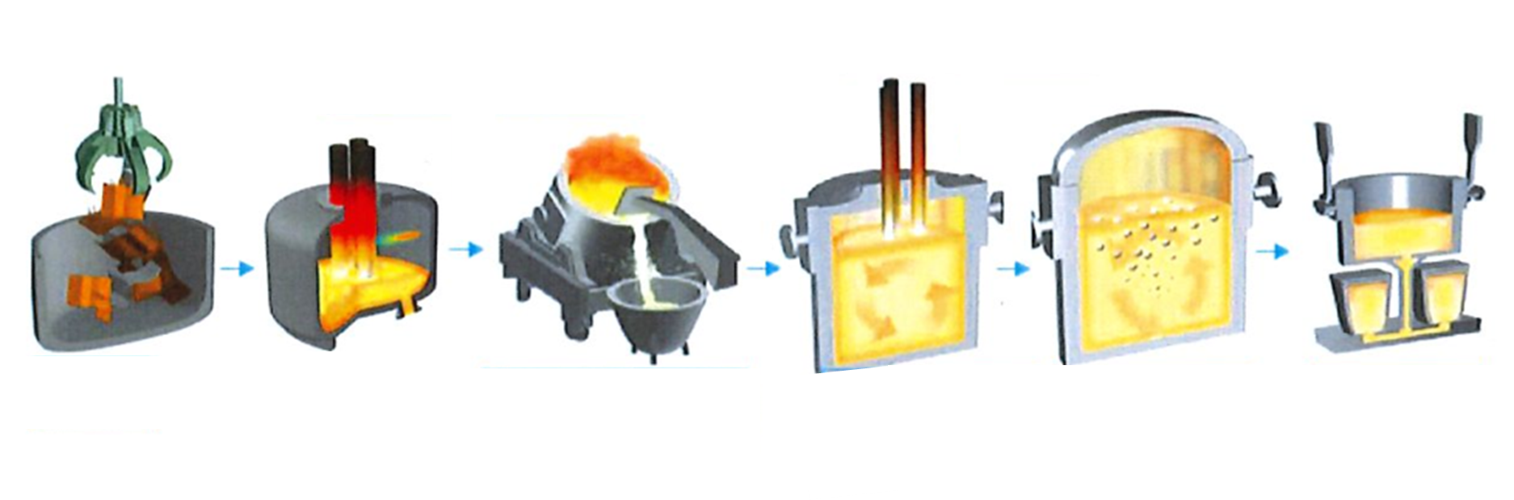
6. Steel with the desired analysis is cast in molds
Scrap
EAF
Deslagging
Ladle furnace
Degassing
Teeming
Figure 1 Steel making process at Ovako (courtesy Ovako AB)
  - Problem description - Degassing
As mentioned earlier, the quality of steel is very clean and with controlled chemistry. Degassing is an important process that controls chemistry of important elements such as hydrogen and nitrogen to allowable limits.
The efficiency of the degassing depends to a large extent on:
1. Slag composition and quantity
2. The analysis of the steel
3. The temperature
4. Porous plugs
This varies with detailed analysis and temperature from the arc furnace.
Three important decisions are needed for the operator before degassing process:
1. Mixture and amount of new slag
2. Amount of alloy
  - Temperature before degassing
If the degassing does not work as intended, it would be difficult for the operator to determine how long the degassing needs to be caried out for the steel to acquire the desired properties. The probability that the steel needs to be corrected, which takes time, is then high. If the degassing conditions are not good enough, new slag and new alloys need to be added and the degassing might need to run again. This is both uneconomical and time consuming.
Therefore, this project aims for deeper understanding of the process to support the operator to determine:
1. Mixture and amount of new slag
2. Amount of alloy additions
3. Temperature before degassing
Would make the process and thus energy consumption and cost significantly lower.
• Flux splashing and operator adjustments
• Effect of process parameters on degassing
The proposed methodology to meet the objectives is to employ the process data to correlate to chemistry control and degassing time. CRISP DM process would be employed to understand data, prepare data and perform analytics. The selected algorithm for analytics is XGBoost.
  - Problem Description - Automatic guide control
MH sign stands for reliability and innovation in Guiding Technology. Since 1944 when Mr Erik Norlindh patented the first roller guide in MH Sweden, Morgårdshammar has been the front-runner in this field.
Danieli Morgårdshammar have been developing the RX guide since 2015 and have successfully released smaller versions of the guide. Together with Ovako we have developed a larger version with higher torques and also started implementing feedback for the mill control, in order to set the gap from the previous stand correctly. Figure 2 shows the location of smart guide and a smart guide.
The main product features; The vision is clear, single click setting. We want to make roller guides part of Industry 4.0.
- First of all the guide should be safe and to achieve that human intervention in the mill during rolling must be eliminated. Today, normally operators go into the mill and adjust the guides with hot material rolling in the line. If the roller holders are force-controlled, there is no need to go into the mill and adjust the guide – it adjusts itself.
- The guide itself should be flexible in order to be able to handle variations in the stocks dimension. If the head or tail of the stock is a little out of dimension, the guide should be able to handle that.
- The guide should also save time in the mill by quick dimension setup change, especially for mills that have several setups per shift, in order to improve the mill’s utilization.
- Helpful tool for the operators at the mill. The guides give feedback on the gap setting or wear in the previous stand.
- The guide should be consistent, i.e. operator-independent. All settings are stored in a database and called up on request.
Three trials have been made at Ovako Smedjebacken in order to collect data foremost for mechanical properties of the guide, to make sure that it is strong enough and there are no issues with interference. Datalogging and analysis has also been set up in order to give feedback to the operator on the stock size of the bar. This to ensure that the correct size is coming out from the previous stand.
The project aims at preparation of necessary data and analytics to enable the mill controller to react to the data from the guide and adapt the rolling product in order to align the rolling setting.

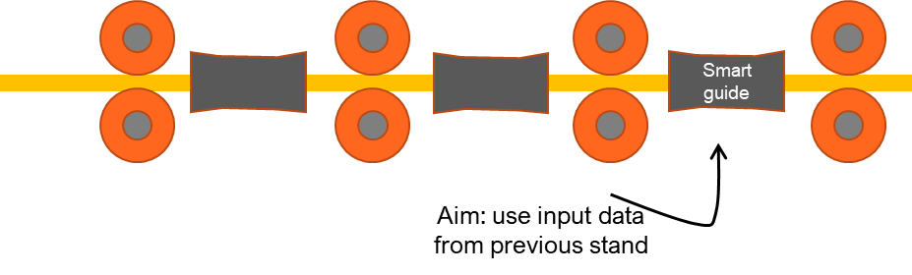

Figure 2 a) The location of smart guide in rod rolling and b) a smart guide

The objective of the project is:
- Optimization of degassing parameters
- Chemistry control
- Automatic guide control for rod rolling
The deliverables from the project are
- Data based digital twin for degassing process
- Operator support for degassing process
- Smooth rolling process for rod rolling mill with automated guides

- Conclusions
The report describes the two sub use cases within Ovako use case. The first sub use discusses the importance of degassing in steel making process and the objective of optimizing the degassing process with a data-based model development. The second sub-use case describes implementation of sensor technology to automate the rod rolling process that is safer and faster.

