Automatic Guide Control

Version | V1.0
Date
Confidentiality | Public
Type of Deliverable | Prototype
Description | Report
Deliverables in the Project | Deliverable D2.2b

- Abstract

The project "VMAP analytics – Smart analytics for multi-scale material and manufacturing modeling" deals with digitalization, encapsulating the concept's essence. Various digital twins for various manufacturing processes are developed in this project. This report deals with the development of a prototype automatic guide system for rod rolling.

- Change Log

- Contributors:
Name | Organization
Eric Svensson | Morgårdshammar AB

Table of Contents
Automatic Guide Control 1
1. Abstract 2
2. Introduction 4
2.1. Automatic guide control 4
2.2. Development and testing of prototype 6
3. Summary and Future scope 7

- Introduction

The digitalization in materials and manufacturing industry is of high importance for any company that wants to keep and advance its position in the market. Automation in manufacturing is transforming the way products are made by increasing efficiency, flexibility, and quality while reducing costs and lead times. As technology continues to advance, the adoption of automation is expected to further accelerate, driving innovation and competitiveness in manufacturing industries worldwide. This report discusses the development of an automated guide roll system for rod rolling.

  - Automatic guide control
Automated rod rolling processes can significantly improve efficiency, consistency, and safety in manufacturing operations. The various stages involved in designing an automated rod rolling involve:

- Determine the specifications and quality requirements for the rolled rods, including diameter, length, surface finish, and tolerances.
- Establish objectives for the automatic guide system, such as improving process stability, reducing downtime, and enhancing product quality.
- Choose appropriate rolling mill equipment capable of accommodating an automatic guide system. This may include rod rolling mills equipped with sensors, actuators, and control systems.
- Select sensors for measuring parameters such as rod diameter, temperature, and position, as well as actuators for adjusting guide positions.
- Develop a design for the automatic guide system based on the specific requirements of the rolling process and equipment.
- Determine the number and placement of guide rollers along the rolling mill to ensure uniform rod dimensions and minimize deviations.
- Install sensors at critical points along the rolling mill to monitor rod dimensions, temperature, and other relevant parameters.
- Connect actuators to the guide rollers to enable automatic adjustment of guide positions based on sensor feedback.
- Develop or configure a control system to coordinate the operation of sensors, actuators, and other components of the automatic guide system.
- Program the control system to analyze sensor data, calculate required guide adjustments, and send commands to the actuators.
- Calibrate sensors and actuators to ensure accurate measurement and control of rod rolling parameters.
- Conduct thorough testing of the automatic guide system under simulated and actual operating conditions to verify performance and identify any issues.
- Optimize the control system settings and parameters to achieve desired rod dimensions, surface finish, and production rates.
- Fine-tune the automatic guide system based on feedback from testing and production operations to address any deficiencies or areas for improvement.

By following these steps, one can establish an effective automatic guide system for rod rolling that enhances process control, consistency, and efficiency, ultimately leading to improved product quality and manufacturing performance.

Morgårdshammar AB (MH) sign stands for reliability and innovation in Guiding Technology. Since 1944 when Mr Erik Norlindh patented the first roller guide in MH Sweden, Morgårdshammar has been the front-runner in this field.
Danieli Morgårdshammar have been developing the RX guide since 2015 and have successfully released smaller versions of the guide. Together with Ovako we have developed a larger version with higher torques and also started implementing feedback for the mill control, in order to set the gap from the previous stand correctly. Figure 1 shows the location of smart guide and a smart guide.
The main product features: The vision is clear, single click setting. We want to make roller guides part of Industry 4.0.
- First of all the guide should be safe and to achieve that human intervention in the mill during rolling must be eliminated. Today, normally operators go into the mill and adjust the guides with hot material rolling in the line. If the roller holders are force-controlled, there is no need to go into the mill and adjust the guide – it adjusts itself.
- The guide itself should be flexible in order to be able to handle variations in the stocks dimension. If the head or tail of the stock is a little out of dimension, the guide should be able to handle that.
- The guide should also save time in the mill by quick dimension setup change, especially for mills that have several setups per shift, in order to improve the mill’s utilization.
- Helpful tool for the operators at the mill. The guides give feedback on the gap setting or wear in the previous stand.
- The guide should be consistent, i.e. operator-independent. All settings are stored in a database and called up on request.
Three trials have been made at Ovako Smedjebacken to collect data foremost for mechanical properties of the guide, to make sure that it is strong enough and there are no issues with interference. Datalogging and analysis have also been set up to give feedback to the operator on the stock size of the bar. This to ensure that the correct size is coming out from the previous stand.
The project aims at preparation of necessary data and analytics to enable the mill controller to react to the data from the guide and adapt the rolling product to align the rolling setting.

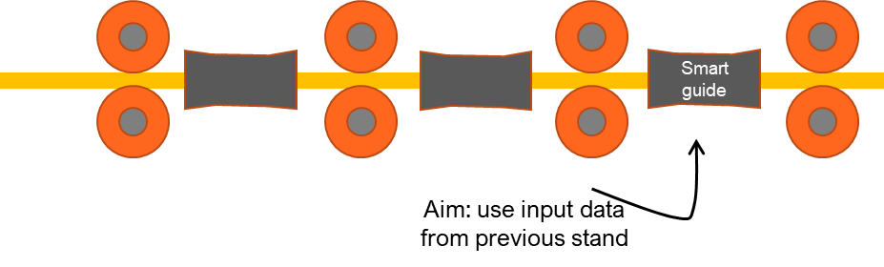

Figure 1 a) The location of smart guide in rod rolling and b) a smart guide
  - Development and testing of prototype
Late 2021 we started prototype design and testing, achieving a good result by the summer 2022 when running flats at Ovako Smedjebacken.
By this time the guide control system was not connected to the mill as the test was just to see if the prototype was successful or not.
This was done in autumn in -22 with an additional test with rounds, which was unsuccessful because the motor in the guide had issues with overspeeding.
New design and change of drive allowed us to test yet again early -23 with the possibility of achieving higher speeds, but this was not enough. We opted to go from using a 230V servo motor to a 400V servo motor for higher speeds and torque which allowed us to decrease the gear ratio. This also meant that the mechanics of the guide had to be redesigned and machined, errors in manufacturing have halted the progress of the testing.
To summarize the use case, automated guide control demands good cooperation between the designer and the user. Owing to the complexities involved in the rod rolling process concerning high temperatures and forces, it is not surprising that a relook into the design was necessary.
The modified automatic guide system is expected to be ready by April 2024 and the testing will restart after summer.

- Summary and Future scope
The prototype tests was a great learning for us in helping us develop the product and see what kind of issues might occur within the mill. We had water ingress, cable faults and motor issues. All those issues have been addressed and applied to our smaller products. The idea of tying the analytical data from the guide back to the mill has been tested further by our other customers with great success. Some will use the data from the guide as a gauge, adjusting the gap of the mill stand in accordance with the guide. Whereas others will use the inputs to react with the mill controller.

