Platform Development - Strategy

Version | V1.0
Date | 21 Sep 2023
Confidentiality | Public
Type of Deliverable | Platform Development Document
Description | Report
Deliverables in the Project | One deliverable

- Abstract

The document discusses the strategy of developing a platform for the visualization of results and an operator support system for the Gränges use case.

- Change Log

- Contributors:
Name | Organization
Sivaprasad Palla | Swerim AB
Jonas Bäckman | Gemit Solutions AB
Gustav Skoog | Gemit Solutions AB

Table of Contents
Platform Development - Strategy 1
1. Abstract 2
2. Platform development and deployment 4

- Platform development and deployment
As mentioned in the previous sections, the various use cases in this project employ digital twins for deeper understanding of manufacturing processes. Depending on the type of numerical tools employed, the results are quite complex for a non-modelling specialist. Simulation tools create visual results, but often these graphics are densely technical and require refinement to make their information accessible to a wider audience. It is important to visualize the results from DTs in a good way so that non-modelling specialists such as operators get a good support system. Keeping this in view a platform is being developed for each use in this project.

Platform is a graphical representation of the results obtained from various kinds of DTs (physics based, phenomenological and data based) and also representation of current data. Development of such a kind of platform needs iterative discussions with plant operators as well as engineers to design the GUI. The following strategy is being adopted in the present case as shown in Figure 1. This is a schematic picture and giving a general representation that can be adopted to any use case in manufacturing.

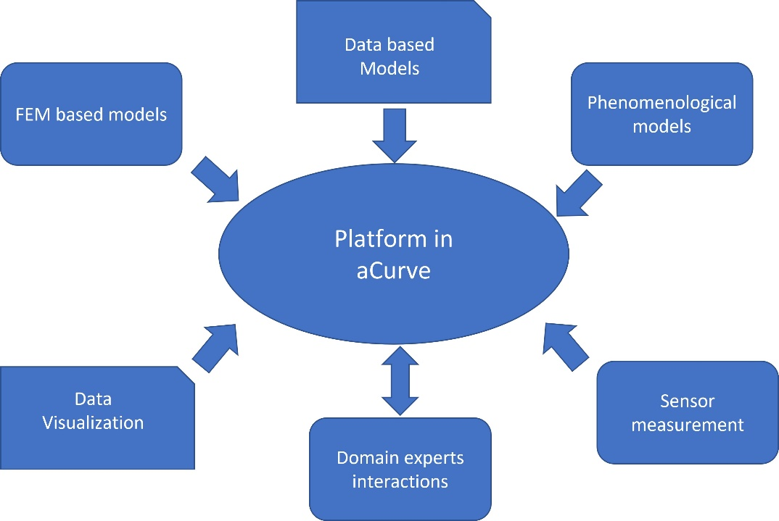
Figure 1 Concept of Platform

As given in Figure 27 the platform receives results from various DTs and present them in a form suitable for the operators as well as process engineers. This needs close interactions between modelers, platform developers and domain experts.

The various phases of platform deployment are given in Figure 2. The literature is scarce for developing platforms to visualize the modelling results in manufacturing processes. This project proposes to present the simulation results in aCurve platform. The GUI that is planned to be developed helps in visualizing various results from various software packages. One such example is given in the Fig. ?? where the results from CROWN software can be seen and the plant engineer/operator can modify the input data to see the predicted crown. This is an offline platform where the results from this project can be visualized.
Figure 2 GUI in aCurve showing the model results.

As given in the Figure 2, the various controls are provided. The GUI is similar to the one reported for Polymer Electrolyte Membrane Electrolyzer (PEMEL) . Through the GUI user takes control over all aspects of the models: setting the parameters, running the models, displaying results, saving data etc. The input variable window allows the engineer to modify the input parameters that prepares the input file for the software. Model control facilitates to run the model, prepare data for plots etc. The GUI control helps in plotting specific data, menu options, save data and plots. Model internal parameters are those important parameters which the user can see always. In the present case the use can see roll diameters, roll speed, roll gap etc.

It is planned in this project to develop such platforms for other use cases as well where the user can vary the input parameters and visualize the results. The on-line visualization of data, predictions and control forms future scope and extension of current project. This platform is planned to be developed in aCurve.

aCurve is a Self-Service Data Analytics platform designed for high user-friendliness. The system offers pre-built connectors to a wide range of industrial SCADA systems, utilizing various technologies like APIs, OPC, and database queries. Additionally, aCurve addresses data wrangling challenges, standardizing different sampling frequencies and storage formats within the system. The platform also provides an array of tools for data visualization and analysis.

Within the platform, users can develop and deploy different AI models. Additionally, models created outside of aCurve, for instance in Python, can be uploaded to the platform and seamlessly deployed with real-time data. Building dashboards is swift and uncomplicated. Everything operates dynamically, meaning a dashboard doesn't require a separate publishing step and is immediately ready for use. Furthermore, any data accessed by aCurve can be utilized by third-party software through a standardized REST API. This enables seamless integration with external applications and systems.

Francisco Javier Folgado, Isaias Gonzalez, Antonio Jose Galderon,, Simulation platform for the assessment of PEM electrolyzer moderls oriented to implement digital replicas. Energy Convesion and Management 267, 2022 115917

