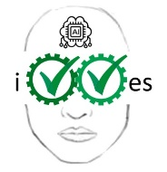
IVVES
Industrial-grade Verification and Validation of Evolving Systems
Labelled in ITEA3, a EUREKA cluster, Call 5
ITEA3 Project Number 18022
D5.6 – Report on training and course material
Due date of deliverable: December 31, 2022
Actual date of submission: December 31, 2022
Start date of project: 1 October 2019 |  |  | Duration: 39 months
Organisation name of lead contractor for this deliverable: OU
Author(s): | Pekka Aho, Tanja Vos, Juan Leandro, Mark van Helvoort
Status: | Final
Version number: | 1.0
Submission Date: | 31-12-2022
Doc reference: | IVVES_Deliverable_D5.6_V1.0.docx
Work Pack./ Task: | WP5
Description:  (max 5 lines) | References to the online training and course material.
Nature: | R=Report
Dissemination Level: | PU | Public |  | X
 | PP | Restricted to other programme participants
 | RE | Restricted to a group specified by the consortium
 | CO | Confidential, only for members of the consortium

DOCUMENT HISTORY
Release | Date | Reason of change | Status | Distribution
V1.0 | 31/12/2022 | Final version | Final | Public

Table of Contents
Glossary 4
1. Executive Summary 5

Glossary
Abbreviation / acronym | Description
IVVES artifact | An outcome of IVVES project. Types of artifacts we will have are: tools, data, courses, tutorials, tool chains, use cases and success stories.

Executive Summary
The IVVES framework has been described in IVVES Deliverable 5.5 and is an online platform that acts as a front-end for the public IVVES artifacts to the people outside of the consortium. The aim of the framework is that all the public IVVES outcomes come with a well-defined and clear package of training and possibilities to try them out (experiment with them).

Training materials and links to YouTube tutorials can be found via the IVVES homepage: https://ivves.eu (under Tools). The online platform can be found here: https://learn.ivves.eu. See Figure 1 for a snapshot.

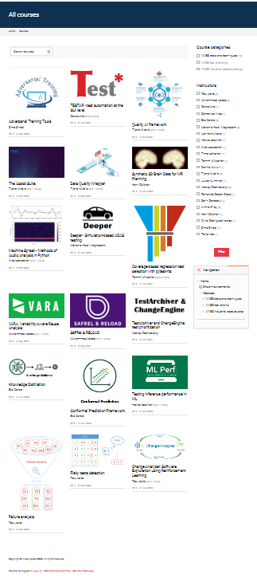

Figure 1 Snapshot of online framework

