Artificial Intelligence supported Tool Chain in Manufacturing Engineering

ITEA 3 – 19027
Work package 5
Systematic layout planning and multi-objective optimization

Deliverable 5.1
Formalizing industrial requirements
Document type  Document version  Document Preparation Date  Classification  Contract Start Date  Contract End Date | : Deliverable  : 0.1  : 2022-01-10  : public  : 2021-01-01  : 2024-02-28

Final approval | Name | Partner
Review Task Level | Mario Thron | IFAK
Review WP Level | Raad Salman | FCC
Review Board Level | Sabino Roselli | Chalmers

Executive Summary
This document defines requirements for the layout of production systems in the automotive and manufacturing industries. Industrial partners have been requested to describe their layout planning processes and to define requirements towards better processes and tools. The results have been summarized and a set of requirements has been identified. This list will guide further work in the AIToC project, especially in WP5.

Content
Executive Summary 3
1 Introduction 5
2 Layout processes in car, truck and other manufacturing industries 5
2.1 Volvo AB – manufacturer of trucks and drive line parts 5
2.1.1 Layout Process 1: Truck component manufacturing facility 1 6
2.1.2 Layout Process 2: Truck component manufacturing facility 2 7
2.1.3 Layout Process 3: Truck component manufacturing facility 3 7
2.1.4 Layout Process 4: Final assembly facility 8
2.2 Ford Otosan – automobile manufacturer 9
2.2.1 Layout Process 1: New line construction in Eskişehir 9
2.2.2 Layout Process 2: Layout updates in dyeworks 9
2.2.3 Layout Process 3: New assembly line planning in Yeniköy 9
2.3 Tofaş – automobile manufacturer 10
2.4 EKS InTec – virtual commissioning in manufacturing industry 11
2.5 TactoTek – Injection molded structural electronics (IMSE) manufacturing line planning and optimization 14
3 Summary of common practices and requirements during layout planning 15
3.1 Common practices 15
3.2 Common requirements 16
4 Possibilities for improvement to the layout planning process 17

Introduction
In order to better understand the needs and requirements of the manufacturing industry during the layout planning process a questionnaire was formulated and sent out to five partners within the AIToC project:
- Volvo AB – manufacturer of trucks and drive line parts
- Ford Otosan – automobile manufacturer
- Tofaş – automobile manufacturer
- EKS InTec – supplier of virtual commissioning in manufacturing industry
- TactoTek – designer of injection molded structural electronics
The questionnaire asked the partners to detail the layout planning process at their company and instructed them to separate different types of planning if the requirements and workflow differed significantly between them. The use of pictures and diagrams was encouraged. Furthermore, the questionnaire asked for a description of tools used today and how the layout planning process could be improved. This document attempts to assemble and detail the common practices and requirements that the industrial partners described in their answers.
Some partners have given an account of the layout planning work from the point of view of several different facilities, applications and/or individual perspectives while others have tried to give an overview of their general workflow and procedure. In general, the answers gave a similar picture, where the differences were mainly due to organizational differences or the level of automation in the production system.

Layout processes in car, truck, and other manufacturing industries

Volvo AB – manufacturer of trucks and drive line parts
Volvo AB is a world-leading manufacturer of trucks and transmissions, committed to drive progress and shape the future landscape of sustainable transports. They provide total transport solutions in the medium to heavy-duty segment and offer support to customers in more than 130 countries.
Figure 1 depicts a summary of the different layout planning activities at Volvo AB. It reaches from strategic decisions about product plans and introduction of new technologies over planning of specific product projects up to the concrete plans about the production execution. It is complemented by a continuous improvement process.
The concrete layout planning process at Volvo AB may differ between facilities, depending on the manufactured product(s) and process requirements at hand. People with different perspectives at four different facilities have answered questions regarding their role and work in relation to layout planning, three component manufacturing facilities and one facility for final assembly. Their engagement in the layout planning process may span across several of the activities depicted in Figure 1 or can be limited to only one specific area.

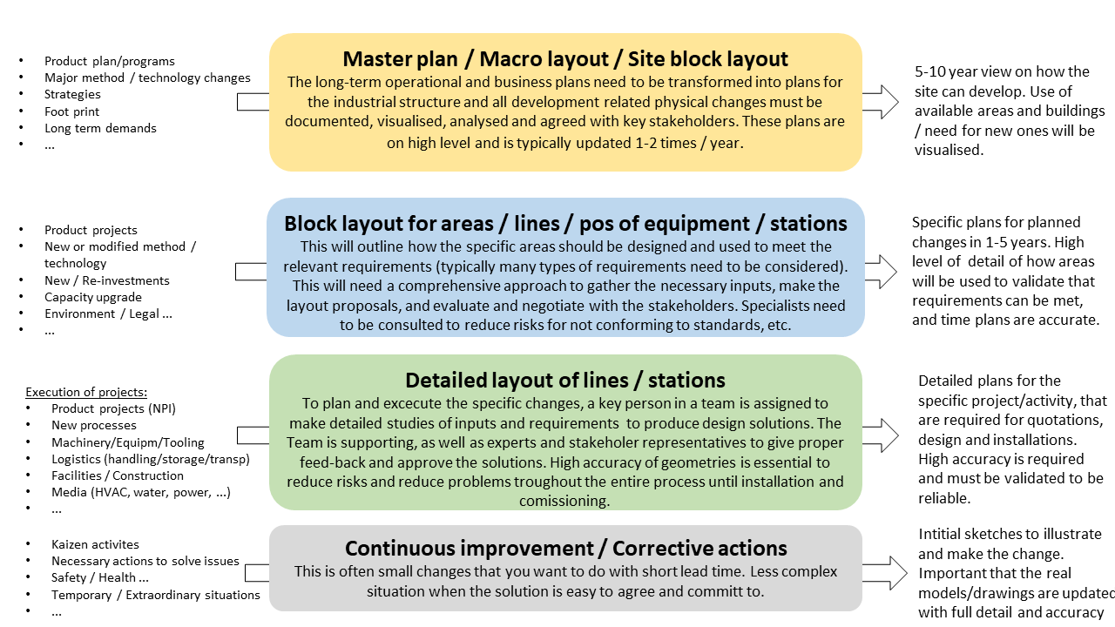
Figure 1: General layout process at Volvo AB

Layout Process 1: Truck component manufacturing facility 1
There is no defined work process for the layout planning at this facility. It is up to the engineer to rely on know-how and company and/or facility standards to draw up the layout in collaboration with managers of other specific values such as work environment, safety, logistics, maintenance etc.
The tools used can range from pen-and-paper drawings and SketchUp to more advanced virtual engineering tools such as Technomatix FactoryCAD and AutoDesk Factory Design. In the latter tools point cloud data and 3D models of the actual facility equipment and environment may be used. Most often 2D layouts are drawn in AutoCAD based on 2D or 3D models.
The process often starts with knowing the geometry of the product being manufactured, an estimation of the time for the assembly steps, and a production volume. The production volume and assembly time estimation together provide an estimation for the number of stations needed to meet the production requirements. These stations are then fitted in a facility standard sized line, usually on an I- or U-shaped surface. When the block layout is set one can do more detailed planning of individual stations where material, tools, and equipment is placed so that everything fits, and the assembly can be performed.
Then the logistics in the manufacturing line is planned. The size of walkways and driving paths for trucks and AGVs are determined. The most important criteria are safety, accessibility, and efficient traffic flow. Important parameters to consider are estimated material use at each station and the size of the manufactured product which gives an idea of the flow of material and available space along the assembly line. Lastly, one would plan the material consumption, kitting process and secure the assembly process for the different product variants in more detail.
Requirements for better tools and processes
The most difficult and time-consuming problem is planning and analyzing the logistics of the layout. An optimization of traffic flows is required. One must chart how and where material is being consumed in the layout and secure the appropriate amount of material at each station or process step while also considering the possibility of differing product variants. Different solutions can be employed depending on space and the material flow.
A 2D block layout could be automatically generated based on standard shapes and station configurations, and certain parameters such as production volume and cycle time estimations.

Layout Process 2: Truck component manufacturing facility 2
There is no formally defined process for the layout planning at this facility. Organizationally, the process starts at the product design phase where simple block layouts are designed in 2D using available and convenient virtual tools (AutoCAD, Microstation). In the next stage the logistics for the parts and material is planned and the block layout is refined based on flow simulations. This block layout forms the basis for the detailed planning of the manufacturing. The engineer will now consider constraints in the facility, different modes of manufacturing for the product, plan the needed equipment, and simulate the process at a detailed level.
When planning the detailed layout, parts of the engineering team has started to use the PLM system Dassault 3DEXPERIENCE due to convenience and its simulation capabilities. Engineers can easily identify and import virtual models of equipment, parts and material and swap between different virtual tools in the platform. There are possibilities to share layout candidates among colleagues to comment and discuss them and branch out from existing layout candidates to try out modifications and changes. Simulation of equipment in a layout candidate can be done directly in the software platform.
Requirements for better tools and processes
There may be issues with the block layout which is designed at an earlier phase of production planning that need to be addressed before continuing with the more detailed planning. This is mostly due to inexperience with layout planning work among the engineers working at the earlier planning stages but also due to some discrepancy of information between the engineers working at the later stages. A simpler virtual tool which could incorporate some of these “unknown” constraints and guide an engineer working with the earlier stages of planning through the layout planning process would be convenient.
Another issue is sometimes moving from 2D designed layouts to 3D and finding large differences between them that need to be addressed.
The exchange of data with subcontractors and line builders is often challenging and time consuming. Both in terms of providing and receiving the data in the desired formats and in terms of ensuring the quality of the data.

Layout Process 3: Truck component manufacturing facility 3
At this facility the layout planning work is more formalized and is divided into four levels: site, macro, midi and mini. The site level shows how buildings are located at the factory site. At the macro level the placement of the different departments of the factory is planned, i.e. assembly, processing, maintenance etc. The macro level planning is not necessarily concerned with the detailed function of the different blocks but is more concerned with a block layout planning of the lines and cells at the different departments. At the midi level the different lines and stations within each macro block are planned and finally at the mini level the placement of equipment within each line and station is planned.
Each macro block has a head of department which is responsible for any layout changes together with the facility layout manager. If there is a larger change in layout which involves several blocks or if there is a change within a block which encroaches on the surface of another block, then a meeting is called with all the department heads and the facility layout manager to discuss how the blocks can be redrawn and/or how space can be freed to accommodate the change in layout. The change of surface distribution between blocks is then documented centrally and the layout plans may be updated.
When the surface for the layout change is available, some candidates for the layout are presented in a meeting together with the heads of the department and the logistics manager. The layout alternatives are analyzed using a checklist with facility and company requirements to ensure that material flow, maintenance, work safety and environment, and the logistics surrounding the layout change itself are properly accommodated.
For the planning and drawing the detailed plans of the layout, different parts of the AutoDesk software suite are used. Ranging from AutoCAD for 2D layouts to Inventor and Navisworks for 3D layout planning. For the facility environment scanned point clouds may be used while equipment, machines and material are usually modeled using 3D models provided by the supplier.
Requirements for better tools and processes
From an organizational point of view, it’s very difficult to coordinate and plan the layout change together with all the stakeholders and responsible individuals that are involved. Minimizing the need for iterating the layout and ensuring that as many requirements as possible are fulfilled from an early stage would be beneficial.

Layout Process 4: Final assembly facility
There are technicians who are responsible for the layout planning at their respective departments. When a layout change takes place, it is sent to the facility layout manager so it can be documented centrally. What drives the changes in layout are typically changes in production processes and the introduction of new products while changes in logistics operations are usually too small to prompt a layout planning process. Currently, the introduction of electric vehicles is the biggest driver for changes in layout and production processes.
Layout plans are mostly drawn as 2D in AutoCAD. For ceiling installations, one usually draws up a plan from a scanned point cloud using AutoDesk Inventor. The 3D environment gives better precision and a better idea of how the facility looks but due to supplier and subcontractor limitations, 2D layouts are still commonly used for much of the equipment and material placement.
Requirements for better tools and processes
For now, the layout planning process needs to develop further. Above all, the jump from 2D layout planning to 3D layout planning needs to be made. Other than the need for digitizing models of equipment, materials and environment, there is a need for tools where everything can be visualized together, and distances and objects can be easily measured. This would give a better view of the facility and the possibility to easily check that requirements are fulfilled in the layout plans.

Ford Otosan – automobile manufacturer
Ford Otomotiv Sanayi A.Ş. (Ford Automotive Industry, or Ford Otosan) is an automotive manufacturing company based in Turkey that is equally owned by Ford Motor Company and Koç Holding. It was established in its current form in 1977, with original relations dating back to 1928. Ford Otosan employs almost 11,000 people. It is one of the top 3 exporting companies of Turkey since 2004. Ford Otosan has the biggest and most capable R&D organisation of the Turkish automotive industry in Turkey with its R&D engineer staff of 1,389 people.
At Ford Otosan, there are two main types of Layout processes:
- new line construction
- update of production lines
They are described in the following by use of three examples.

Layout Process 1: New line construction in Eskişehir
When the new lines are constructed in the Eskişehir plant of Ford Otosan, the line is simulated from material supply of line to end of line. The process is finalized with experience of production engineers.
Requirements for better tools and processes
When a new line is constructured AutoCad software is used to design. Placements and physical constraints are evaluated according to AutoCad outcome. The CAD programming may be supported with AR/ VR to visualize the construction process and demo production process. It would be helpful to monitor work ergonomics.

Layout Process 2: Layout updates in dyeworks
One of the important steps in the vehicle production is the dyeing process because color and its quality provide the first impression with customers. There is also a wide range of specifications from customers such as different color for ceil, doors and different color requirements, etc. When the production planning continues, the dyeworks team may require some updates. The planning step is conducted manually by technicians and responsible engineers.
Requirements for better tools and processes
Manual monitoring of the process may cause hitches. The supply chain mechanism can be automated for an efficient production line. This is critical to obtain sustainable manufacturing process.

Layout Process 3: New assembly line planning in Yeniköy
One of the middle commercial vehicle models is Ford Custom which is produced in the Yeniköy Plant. When a new assembly or body line is constructed, over 100 iterations that include land evaluation, performance of staff, technological sufficiency and cost are evaluated during sprint reviews. Iterations are designed by AutoCad and Process Simulate that is a simulation tool to observe production parameters and even working ergonomics. Some plans are visualized in a VR room before real application. 3D render of the plant is helpful to implement AR/VR environment. In parallel, the experience of the teams and product backlogs are highly significant in the final decision step.

Requirements for better tools and processes
Iterations may be conducted by AI algorithms because there are many parameters from different domain from ergonomics to product quality.

Tofaş – automobile manufacturer
TOFAŞ was established in 1968 by the late Vehbi Koç, founder of the Koç Group, and jointly owned by Koç Holding and FIAT Chrysler Automobiles. In 2021, Stellantis was founded by the merger of FCA and PSA groups. TOFAŞ is today one of the strategic production hubs of Stellantis with an annual production capacity of 450,000 units.
The general layout process of Tofaş is depicted in Figure 2.
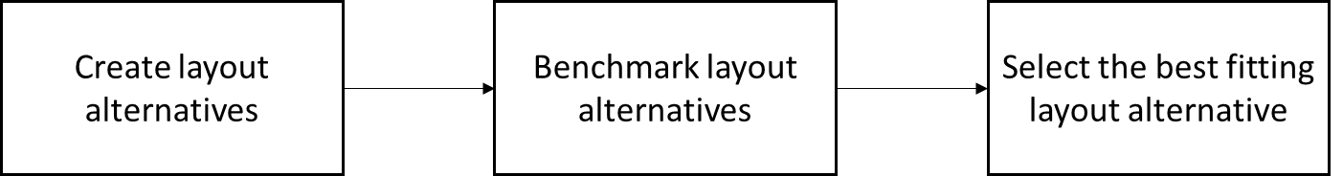
Create layout alternatives
Benchmark layout alternatives
Select the best fitting layout alternative
Figure 2: General layout process at Tofaş
Before deciding on the optimum layout, at least 2 or 3 different alternative layouts are prepared. For each alternative, 2 and 3 dimensional technical drawings are prepared. These different layout alternatives can then be characterized by attributes like:
- Number of operations in the production line
- Number of robots in the production line
- Location of the robots
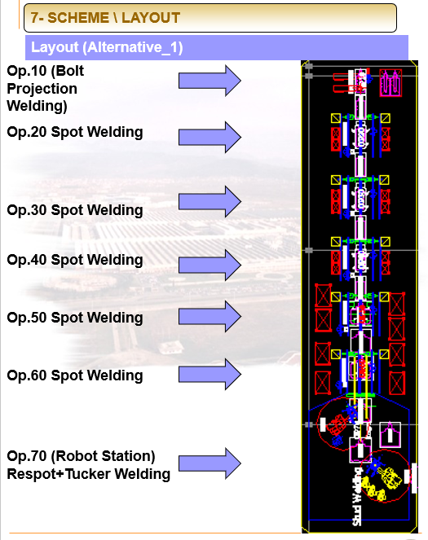
Figure 3: Process layout alternative at Tofaş
Figure 3 illustrates a process layout alternative at Tofaş. It is created by use of several engineering tools like AutoCAD or UniGraphics (UG-11 Process Simulate).
Layout preparation activities are done by a dedicated group that contains experts from different disciplines such as production, logistic, power supply, etc. They work together at the same file but at different layers of the designing program. For example, robots, transportation equipment, power supply lines can be seen in the same file but at a different layer.
Basic information of the vehicle planned to be produced, is shared with the layout preparation group.
- Annual production number (production line capacity),
- The number and type of models to be produced on the same production line (Commercial, Passenger, Sedan, Hatchback, Station Wagon, SUV)
- The target automation level (percentage of the production line equipment/fixture to be manual/automated)
- Cycle time of the production line (derived from annual production number and shift number),
- Target budget (in some projects),
- Production area (in some projects),
Some of the information may be updated later in the project but this causes iterations in all areas which are dependent on this data.
While preparing the layout, the order of processes and their locations are determined. For example, from the Bodyshop layout, the number and application station can be seen for all
- Spot/arc weldings,
- Sealing operations,
- Nut/bolt welding etc.
The created process layout alternatives are finally benchmarked with each other according to budget, commissioning time, flexible production ability, logistic activities, etc. In the end, the best alternative layout is chosen.
Requirements for better tools and processes:
An ideal tool should support the work of the planning engineers. It should provide the right information at the right time. If the initial requirements of the layout are changed, the planning engineers should see this new information in real time. This would minimize the planning time and effort of the layout preparing experts. Presenting the information to the planning experts graphically would be preferred.

EKS InTec – virtual commissioning in manufacturing industry
EKS InTec GmbH is a partner for development, design and software, as well as virtual commissioning of simple to complex production plants and special machines for the automotive industry and its system partners. The range of services begins with process planning, through the design of stations and complete production systems for body in white manufacturing to simulation and optimization of production processes. EKS InTec GmbH represents the complete digital development process, including virtual commissioning of complete production plants, innovative planning, analysis and predictive maintenance of real plants.
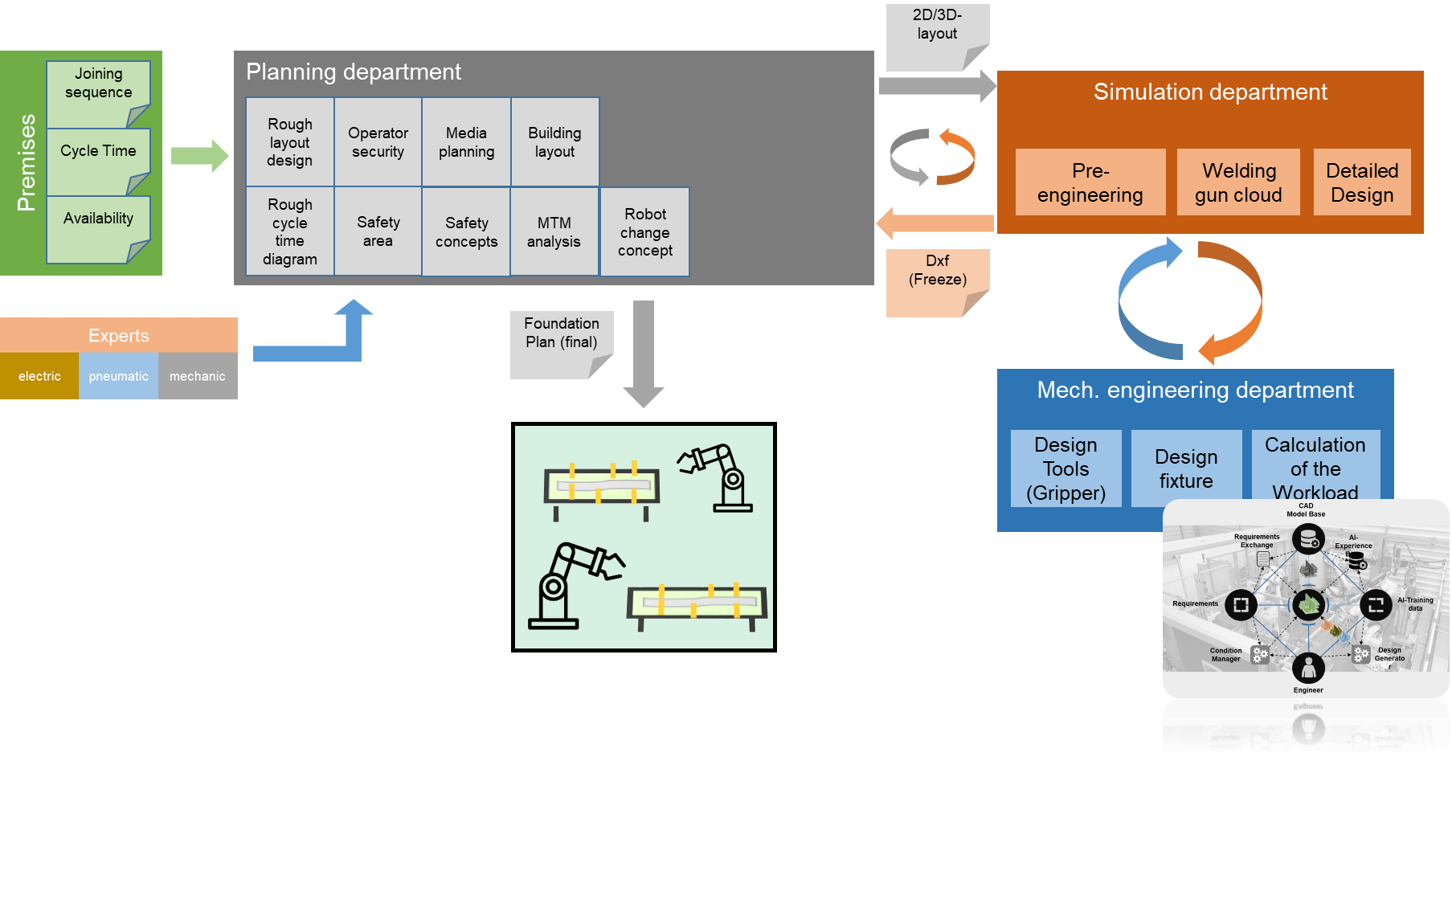
Figure 4: Layout planning at EKS InTec
The layouts are developed for the customers based on several premises, which are handed over to the planning department. This department creates an initial 2D/3D layout based on prior experiences and supported by several experts. It then initiates virtualization and simulation by collaboration with the simulation department, which itself collaborates with the mechanical engineering department. The final layout is the result of several iterations of planning (including planning of pneumatic, electric and hydraulic systems), simulation and verification of mechanical constraints.
At the beginning of the layout planning phase, the customer makes requirements and provides data on the product.
- Joining sequence (sequence in which the individual parts are assembled into the final product including hints on the joining technology)
- Cycle time
- Availability of components
The planning department uses the requirements and the information from the product to create a first draft of the layout.
The following steps are taken by the planning department:
- Rough design
- Rough cycle time diagram
- Definition of safety areas
- Media planning (e.g. cable trays)
- Safety concepts
- MTM analysis (Methods-Time Measurement)
- Robot change concept
The planning department has the following interfaces:
- Base documents, from the customer
- 2D-Cut of the current state, from the simulation department
- Freeze of finale state, from the simulation department
- Rough layout, to the simulation department
- Foundation plan, to commissioning
To describe a layout and to extend it, tools are used which generate a 2D or 3D layout as output. EKS uses the common software for the automotive industry in Germany. In addition, office tools are also used to update information and pass it on to third parties.
The simulation department and the department of mechanical engineering use a first draft of the layout to complete the following processes:
- Detailed design of the layout
- Pre-engineering, use of reference-resources (fixtures)
- Specification of components like robot variants and tools like welding guns, gluing stations etc.
- Set-Up of documentation
- Generate welding gun clouds
- Definition and verification of the reachability of the joining points
The simulation department is in constant exchange (loops) with the engineering and layout department in the execution of tasks. Thus, the simulation department has the following interfaces:
- 2D/3D layout, input from the planning department
- Dxf-file (2D-Cut of the current state), output -> layout
- Freeze of the finale state of the layout, output -> layout
- iterations to the mechanical engineering department
- Detailed Fixture/ Gripper, input
- Requirements for robots, input
- Welding gun cloud, output
- Robot specs, output

The simulation department uses 3D environments to simulate realistic component behavior and create offline robot programs.
Office software is used for storing information. Here, for example, adjustments of joining points are updated and joining sequences are mapped.
Requirements for better tools and processes:
General requirements and feature wishes
- Partially automated first draft layout derived from base documents
- Interface between cycle time diagram and planning tools for faster updates
- Assistance in the preparation of the foundation plans
  - Prevent failures of manual work
- AutomationML for exchange of data and description of workflows
Requirements for a specific tool: Design Generator (focus of EKS in the project)
- Support the simulation department in pre-engineering phases
- Calculation of the initial robot position
- Support the planning department in rough design
- Optimization of the design process
  - Reduce time effort
- Decision/recommendation systems
  - Reduce know-how effort

TactoTek – Injection molded structural electronics (IMSE) manufacturing line planning and optimization
TactoTek is developing and commercializing IMSE technology that transforms the way electronics are designed and built. Manufacturing IMSE parts uses clean additive processes, less plastics and reduces greenhouse gas emissions. TactoTek supports IMSE licensees that globally design, and mass produce reliable, and economical smart molded structures.
The use case of TactoTek for the production line planning is focusing on the optimization of cost and production rate. The production line works with producing IMSE parts starting from printing of graphic inks, conductive inks and possibly dielectrics on top of flexible, thermoformable substrate. After that electronic SMD components are assembled with conductive adhesive and mechanically supported by structural adhesive. In the third process phase, the substrate having the printed circuitry and components is formed from 2D to 3D format and finally injection molding that in plastic body to get the final seamless 3D part (see Figure 5). There are several automated quality checks that can be incorporated in between individual production steps.
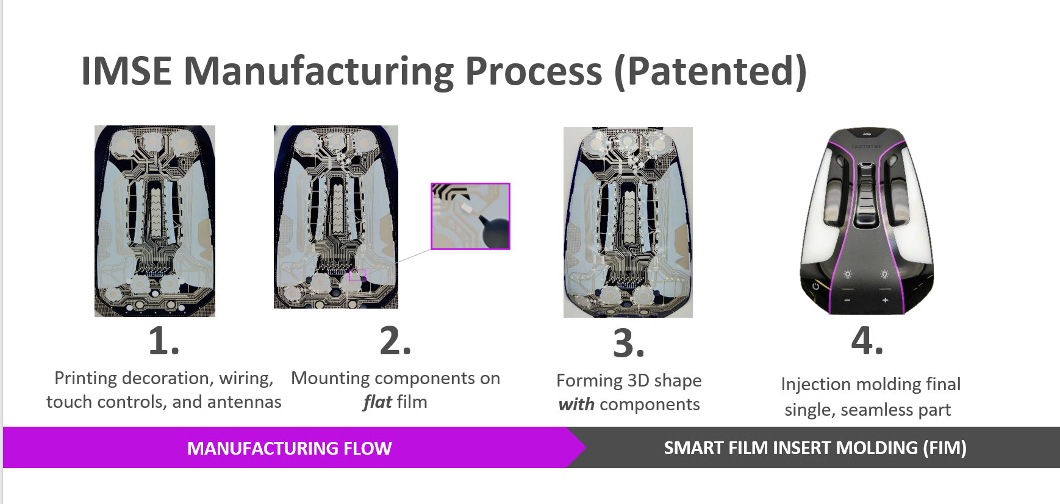
Figure 5: Factory layout and manufacturing process template from TactoTek
Models of the production equipment utilized in the production line are available but would need to be implemented in component standard utilized by AIToC project. Additional models could come from WP4 efforts. Each production line building block can be parametrized depending on the operations required for specific product. At first stage simulation of the process and optimization of cost and machine use, including line balancing should be built. Secondly, higher level of details, including actual layout, intermediate storage, and transport systems should be considered to refine the actual design. This can also utilize floor plan and restrictions on space usage to optimize the production line layout.
Requirements for better tools and processes:
A simulation model that is capable of computing line cost, individual product production cost based on assumed production volume, actual product design and process steps defined format proposed in WP3. In addition to fully automated optimization routine generating feasible layouts, it should allow to manually manipulate process flow and layout and simulate output of the changes. The line balancing problem and machine selection for individual step is based on the input parameters of the production requirements. Production volume, longer or shorter product series, flexibility of the production line vs production speed, are some of the key parameters that affect the selection of individual machines (and specific process used for realizing those process steps) and final cost. Additionally, electricity costs, material costs, component costs and manual labor costs are parameters, that might not only affect the product cost and maintenance costs, but also the layout to some extent (choice of robots vs people in certain operations).
Inputs to the optimization routine could be:
- predefined process plan,
- number of electronic components and printed layers
- models of the production equipment from a standardized library,
- machine parameters that should be fixed and those that are free to be modified by the optimization routine,
- production requirements (volume, operation time of the line per day, etc.),
- production space model showing available space, reserved areas, zones for machines, walking paths, etc. (preferably 3D, but 2D layout would be minimum requirement)
- information whether the whole production is realized as a single production line or is it distributed over several locations, thus requiring independent layouts for individual locations.
- yield rate per production process phase
Expected optimization outputs:
- Unit process cost estimate of single product
- Units per hour
- List of equipment required for balanced production line implementation with their cost and production capabilities
- 2D layout proposals that can be evaluated or modified to create the final layout.
Web interface for the simulation and optimization tool would be beneficial but it is not a strong requirement.

Summary of common practices and requirements during layout planning
The detailed descriptions of the layout processes of the project partners are abstracted and summarized in the following sections.

Common practices
Layout planning is often done collaboratively and iteratively with different stakeholders
A very common feature of layout planning in manufacturing facilities is that requirements and constraints in many different areas such as safety, work environment, maintenance, media, logistics, equipment and of course the manufacturing process itself need to be fulfilled. Often the responsibility for these areas is divided between different individuals so that the layout planning needs to be a coordinated effort between these experts.
This is done by either having a project team consisting of people from the different disciplines working on the facility layout together or by having one or several people who are responsible for the layout planning itself who can then consult the appropriate experts when it comes to specific requirements. The work is often iterative, and many layout candidates are considered before accepting one that fulfills the appropriate requirements. This can sometimes pose an organizational bottleneck as several meetings need to be held before the layout can be agreed upon. In some cases, several experts could collaborate on the layout in the same virtual tool where the appropriate information could be visualized in layers which simplified the planning process.
Early phase layout planning using 2D CAD drawings
The use of 2D CAD drawings of equipment and the facility during layout planning is widely spread among the industrial partners, especially during early stages where dynamic models and simulation are not considered to any large extent. The use of 2D CAD is convenient since many suppliers and manufacturers still do not provide 3D models for many of their products.
This also skews the use of tools towards programs which can handle these types of file formats (*.dxf, *.dwg, *.dgn) such as the AutoDesk software suite and Bentley Microstation. In at least two facilities from one company, it was expressed that the spatial understanding of a 2D layout is usually more difficult for the engineer than when considering a 3D environment, and that for ceiling or wall installations a 3D environment is crucial. A virtual 3D environment also enables the use of VR and AR which can further enhance the visualization of the layout.
Planning production lines based on production volume or required cycle times
A commonly used parameter for starting the layout planning is a target production volume or a target cycle time. After dividing the production process into process steps based on the complexity of the product design one can start to plan the mode of manufacturing (e.g., manual processes or automated solutions), and the time for each process step. This gives the engineer an idea of the number of stations, robots and/or human operators that are needed to fulfill the production plan.
In some cases, a standard line shape is used as a starting point which is then filled with the appropriate number of stations in some standard configuration. This layout plan is then refined further as process steps are distributed among the stations and more requirements are considered.

Common requirements
Availability of media
The availability of media such as electricity, water, pneumatics, and ventilation are usually fixed features of the facility and associated with a high cost to change. Planning the layout around the availability of these features is a common point among the industrial partners.
Safety
Safety standards can be enforced in different ways. In the case of high automation, the planning can consist of adequate fencing around machines or robots, operator gates, laser curtain sensors, and the use of PLCs to stop operations if a dangerous situation arises. In more manual processes, the layout may be planned such that there are separate designated areas for the movement of workers and logistic operations such as trucks and AGVs, and the possibility for the worker to keep an appropriate distance from dangerous machinery.

Logistics and material flow
The logistic operations around the layout are also a crucial point. Material availability for a high number of product variants must be ensured at each station. Paths for AGVs and trucks that transport material and products are planned so that the traffic flow is efficient and safe.
Ergonomics and work environment
In cases where the layout is planned for human workers and operators the ergonomics and work environment are also considered. Machine operators should have a clear view of safety lights from their work position. In some cases, work environment requirements are established together with local union representatives. An MTM-analysis can be performed to ensure that all process steps can realistically be performed within the required time.

Possibilities for improvement to the layout planning process
The suggestions for the improvement of the layout processes in each of the project partners are summarized below.
- Optimization of traffic flow (see: 2.1.2, 2.2.3)
This can e.g. involve the placing of material stores, definition of transportation type (floor-bound, roof-construction, …) and computation of transportation routes.

- Automated generation of a basic (often 2D) block layout (see 2.1.2, 2.4)
Customers usually define a kind of basic specification of the production system, which could be evaluated in combination with a block library to generate a first block layout, which is roughly parameterized too.

- Automated verification of layouts (see 2.1.3)
Layout planning is an iterative process. Different planning layers (e.g. electrical, mechanical, hydraulic, pneumatic engineering) have strong dependencies, but are in the hands of different planning teams. Changes in one layer should transfer the right change information into the dependent engineering layers and lead to change notifications in combination with design warnings.

- AI based adaptation of layouts triggered by change events (see 2.2.4)
Input of information during the planning process can trigger further generation or adaptation of layout blocks.

- Automated transfer of 2D layouts to 3D layouts and finding of differences (see 2.1.3)
Planning in early stages is often done as 2D layout. Later, the designs are transferred into 3D models. Discrepancies between the 3D layout and 2D layout can often remain undetected but this could be supported by the planning tools.

- Minimize the need for iterations (see 2.1.4)
This is a motivation requirement for “automated generation of layouts” and “automated verification of layouts”. If these are fulfilled, then the need of iterations is at least reduced.

- There should be one planning tool for all engineering levels (see 2.1.5, 2.3)
This is an implementation variant to ensure “automated verification of layouts” on all engineering levels. It assumes there is a super model of engineering data, which can be used by verification algorithms. An alternative would be that different engineering tools are able to subscribe to design changes in other engineering layers (which is probably more difficult). Both principles would ensure, that the right information is available for further design steps at the right time.

- CAD systems should support AR/VR (see 2.2.2, 2.3)
This would facilitate a layout verification by engineers. This is necessary for those verifications which cannot be automated.

- Information exchange between tools (see 2.4).
When the requirement “there should be on planning tool for all engineering levels” cannot be met, there should at least be the possibility to exchange information between tools. Such information exchange can be done via APIs of the tools or via file exchange. In the last case, AutomationML could serve as a basic data format, but there are alternatives too (e.g. plain XML or JSON).

