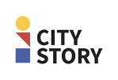

D6.1 Dissemination & Exploitation Related Achievements and related materials

(PUBLIC document)

Edited by: Elke Matthyssen (BUUR), Miechel De Paep (BUUR)
Contributions from: Dries De Roeck (StudioDott), Sofie Dieltjes (Studio Dott) Andries De Reyghere (Bits of Love), Chaja Libot (VRT), Karim Dahdah (VRT), Paul Biedermann (KULeuven), Henk Lannoo (NXP),

Version: M24
Date of the 2st year review meeting: September 28th , 2021

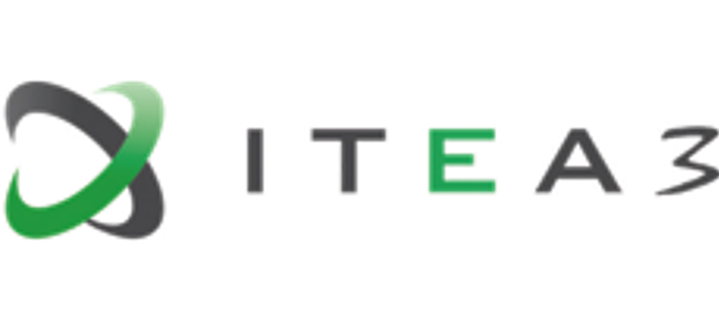

CityStory is an ITEA 3 project from call 4 (reference 17006)

Project Key Data

Acronym and full-length title

Reference: 17006
Full-length title: Citizen Storytelling
Roadmap Challenge: Urbanisation

Project description

The project CityStory wants to innovate through a creative, intelligent, safe, and social storytelling development environment. Do-it-yourself and do-it-with-others, around media and make it accessible for everyone. The project aims to stimulate collaboration with a co-creation and design platform to share ideas and get opinions heard. Through new modes of interactive storytelling, city touchpoints, interactive screens, innovative media recognition, and data analysis, tools that assist while filming and intelligent, and deep learning tools, the project will enable ideas to be turned into a story and valuable media output.

Project duration & size

Size: Effort: 40.68 PY
Costs: 2 933 930 €
Time frame: Start: 01-09-2019
End: 31-08-2022 (36 months)

Coordinator

VRT (Belgium)
Type: Public Company
Contact person: Karim Dahdah
E-mail address: karim.dahdah@vrt.be

Consortium

Belgium Bits Of Love
BUUR bureau voor urbanisme
Katholieke Universiteit Leuven
NXP SemiConductors Belgium NV
Studio Dott
VRT
Denmark Legind Technologies

Inhoud

Brand and public relations 5
Member in user groups 5
Presentations 5
Publications 5

As a result of covid19 , the organisation of global use cases and live events to make CityStory widely known has not been possible since the start of the project. However, this does not mean that there has been no publicity for CityStory and the various tracks. Below we give an overview of the publications and other dissemination initiatives.

Brand and public relations
- Brand style designed
- Several press releases sent out and published in relevant digital and written media
- Press releases with regard to the Poster Talk track:
  - http://www.buurtcomiteskessello.be/debatboom/de-debatboom-discussieer-mee-over-de-toekomst-van-kessel-lo
  - https://www.hln.be/in-de-buurt/overleg-buurtcomites-kessel-lo-obk-lanceert-dialoogplatform-volledig-in-handen-van-burgers~a768e453/
  - https://www.robtv.be/nieuws/debatboom-duikt-op-aan-hal-5-om-inwoners-te-laten-nadenken-over-toekomst-kessel-lo-121831

Member in user groups
Partners of the project are active in following user groups:
- VRT Smart Cities Chair
- MediaSpecs: https://www.mediaspecs.be/
- Media Marketing: https://www.mm.be/
- PUB: https://pub.be/

Presentations
- ITEA Smart City Day 2020; Citizen Engagement

Intern Dissemination moments
- Wild Radio Days Europe; October 2021
- Dissemination about Audio Stories track at VRT Intranet
- Share & improve @ BUUR_pos

Publications
- Jorgos Coenen, Paul Biedermann, Sandy Claes, and Andrew Vande Moere. 2021. The Stakeholder Perspective on Using Public Polling Displays for Civic Engagement. In Proceedings of Communities & Technologies 21 (C&T ’21). ACM, 61-74. https:// doi.org/10.1145/3461564.3461585
- Paul Biedermann and Andrew Vande Moere. 2021. A Critical Review of how Public Display Interfaces Facilitate Placemaking. In Proceedings of Media Architecture Biennale 20 (MAB20). ACM, accepted for publication. https://doi.org/ 10.1145/3469410.3469427
- Dries De Roeck, Sofie Dieltjes, Paul Biedermann, Andrew Vande Moere, Miechel De Paep.2021. Hybrid Urban Interventions: Towards Story-driven Citizen Engagement. In Proceedings of Media Architecture Biennale 20 (MAB20). ACM, accepted for publication.

