REFLEXION
React to Effects Fast by Learning, Evaluation, and eXtracted InformatiON

Exploitation plan
D5.6

© REFLEXION consortium
Axini – Barco – Océ Technologies – Philips – Siemens ISW – Synerscope – TNO – Yazzoom

Version, Date : v1.0, 14/02/2019
Confidentiality : public

Abstract
This document describes the exploitation plan comprising the short term commercial plans, and longer-term exploitation perspectives for new business opportunities, of all Reflexion partners. It presents what will be communicated publicly as relevant project results and what will be exploited for commercial benefits. Furthermore, where applicable, it will describe what relevant project results will be integrated in the internal processes and knowledge base, and whether collaboration with other Reflexion partners will be continued and / or commercialized after the project ends.
Only the partners’ public view on the exploitation prospects is presented, anything business confidential is left out of this document.

Change log
Version, Date | Description
V1.0, 14/02/2019 | all partner contributions included

Table of Contents
Abstract 2
Change log 2
1. Axini 4
2. Barco 4
2.1. Nexxis Vision 5
2.2. Nexxis Care Plan architecture 5
2.3. Nexxis Care Plan functionalities 6
2.4. Nexxis Care Plan, go to market 6
2.5. Nexxis Care Plan, exploitation summary 6
3. Océ 6
4. Philips 7
5. Siemens ISW 8
6. SynerScope 9
7. TNO 9
8. Yazzoom 12

- Axini
The main results of Reflexion for Axini is a newly developed test-derivation strategy that takes real world usages of the system to be tested into account. This is also known as Usage Profile Model Based Testing. We have developed several prototypes that we will implement in our flagship products.
Product-wise we developed several proto-types in the project that we implemented in our commercial version of our Axini Test Manager toolset. This gives us a more competitive product with which we are better suited to model the designs of our clients, including a new visualization. Our test-derivation strategies have improved and based on the models we can generate higher coverage test-sets.
We have open-sourced two results: plugin adapters and a safe sandbox. Plugin adapters provide a standardized way to connect test-tooling to systems under test. The Safe Sandbox allows safe execution of code or models with potential harmful side-effects.
We are proud of several results from the Reflexion project.
- We developed a new model-visualization prototype that we incorporated in our main product.
- We developed a prototype to generate applications from models. We incorporated this in our main product.
- We worked together with Philips to develop a test-derivation strategy that takes real world usages of the system to be tested into account. This is also known as Customer Profile Model Based Testing. We have developed several prototypes that we will implement in our flagship products.
- We have open-sourced two results: plugin adapters and a safe sandbox. Plugin adapters provide a standardized way to connect test-tooling to systems under test. The Safe Sandbox allows safe execution of code or models with potential harmful side-effects.
- We have developed a prototype for smart coverage tracking. Though a good improvement to the functionality that we had before, this is not yet to our satisfaction. We will continue to work on it.
We estimate that the improvements in model-based working will have an estimated revenue impact in the coming 5 years of EUR 10M, and the improvements for model-based testing of complex interfaces and protocols for the coming 5 years is EUR 10M.
- Barco
The results of Reflexion are productized and marketed in the context of Nexxis Care Plan for Nexxis™, Barco’s video-over-IP platform for the integrated digital operating room. Nexxis™ offers the precision needed in an operating room with high resolution, uncompressed medical images in pixel-perfect precision and shared more efficiently with raw, uncompressed images, eliminating artefacts, and near-zero latency for perfect hand-eye coordination and 4K end-to-end.
A Nexxis system consists of the following software services and devices.
- NMS, ‘network monitoring suite’, is a software services that manages all devices in an operating room.
- MNA-120, MNA-240, MNA-440, ‘medical network adapters’, are streaming devices that encode SDI, DP, HDMI inputs into a network video stream (rfc 4175, RTP Payload Format for Uncompressed Video) or decode a video network stream in DP or HDMI. These devices are often integrated in the customers’ endoscope (encoder) or in the surgical imaging monitor (decoder).
- PCIe card which is a network card for sending and receiving uncompressed video (rfc 4175, RTP Payload Format for Uncompressed Video). The PCIe card is bundled with a windows device drivers and software for integration with NMS.
- MNC-180, ‘medical network compositor’, is an x86 based appliance that hosts a PCIe card and an NVIDIA graphics card. The appliance receives up to 8 streams from the network, uploads these to the graphics board and makes a composition on the graphics board. The result is streamed on the network through the PCIe card.
- Network switch.
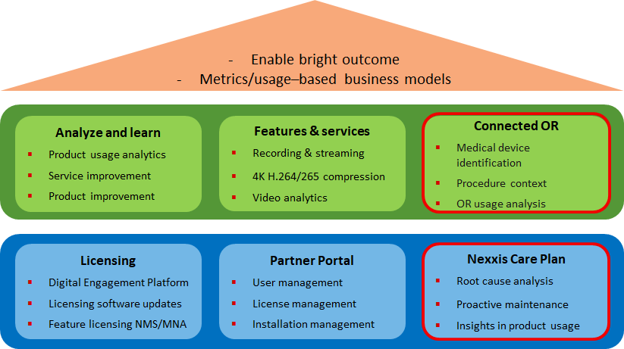
  - Nexxis Vision
The results of Reflexion play a vital role in implementing Nexxis™ vision in ‘Nexxis Care Plan’ by increasing the uptime of an operating room with (i) support for the service organization in root cause analysis and reduction of the response time to incidents (ii) proactive maintenance by notifying the service organization in case of malfunctioning of a device and degradation of a device (e.g. fiber, power adapter, FPGA, …) and (iii) getting insights into product usage.
Figure 1, Nexxis Vision
Furthermore, the Reflexion results pave the way in a second phase towards the ‘Connected Operating Room’ in providing the first insights in operating room workflows, enabling Barco’s partners and end-users to deliver services that increase Operating Room utilization.
  - Nexxis Care Plan architecture
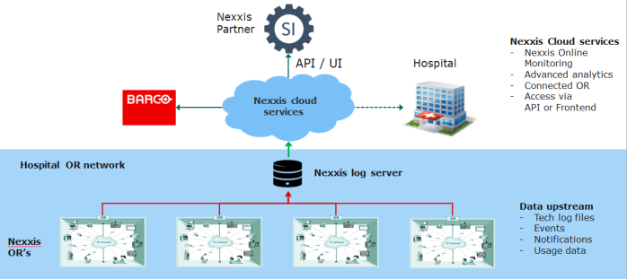
For collecting data, the Nexxis system is extended with an extra component: NLS-110, ‘Nexxis Log Server’.
Figure 2, Nexxis Care Plan, architecture
Nexxis Care Plan is integrated into Barco’s customer portal, Barco’s licensing system and internal IT systems such as SAP and Salesforce.

  - Nexxis Care Plan functionalities
Nexxis Care Plan provides
- Predictive maintenance: Anomaly is preventively detected and integrator is informed prior to outage
- Troubleshooting by service organization: Problem occurs in the hospital and integrator is called for support
- Usage monitoring: Get field data on the usage of the OR in order to improve the offering
    - Input from the field on system deployment
    - Is the OR used a lot? Almost never?
    - Which medical devices are typically used? Which are never used?
    - Which layouts, presets are mostly used?
    - Which features are mostly used? Which never?
  - Nexxis Care Plan, go to market

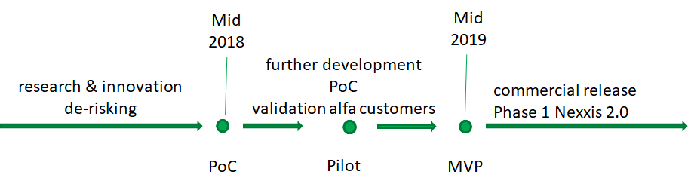
Nexxis Care Plan is planned to go to market mid 2019.

Figure 3, Nexxis Care Plan, go to market timeline
  - Nexxis Care Plan, exploitation summary
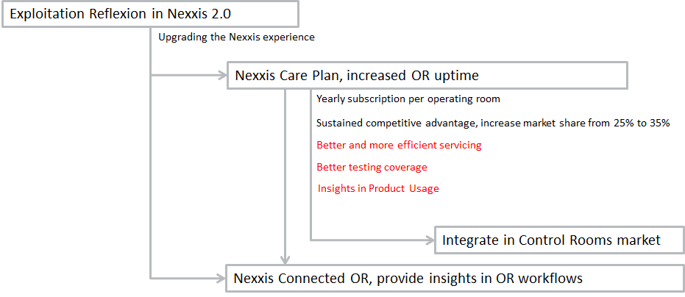
The results of the research carried out in the context of Reflexion are exploited in Nexxis Care Plan. Integrators pay a yearly subscription per operating room. Furthermore, Nexxis Care Plan offers sustained competitive advantage, is expected to increase the market share from 25% to 35%, enables better and more efficient servicing, better testing coverage and insights in product usage.
Figure 4, Nexxis Care Plan Exploitation Summary
In a next step, Nexxis Care Plan is a first step towards the Connected OR, providing insights in OR workflows.
- Océ
The main result of Reflexion for Océ is the diagnostic analysis system ODAS and its accompanying course. ODAS makes it possible for a printer domain expert at Océ R&D to develop notebook analysis code to quickly solve a typical data science question related to printer diagnosis and share the information with other experts.
The basis for the data is formed by structured functional machine logging. ODAS supports multiple machine analysis and pattern-searching and it is based on an open source technology framework: HDF5 with tables in a hierarchical tree, Python Notebooks, pre-processing with Pandas, interactive visualization with Bokeh, and processing with Scipy & Scikit-learn.
Anomalies in machine performance can be traced with functional logging and ODAS, which is paramount to quickly discover problems in design, construction, build, as well as installation. Moreover, every connected machine is a valuable source of data that helps to verify working latitudes and performance.
Several thousands of notebooks are currently available, and their number is rapidly growing. There is already a considerable amount of ODAS users. Furthermore, every new Océ root project will use ODAS.
- Philips
Royal Philips is a diversified health and well-being company and a global top 3 player in diagnostic imaging and image guided therapy with a complete portfolio of modalities. In 2017 overall sales amounted to Euro 17.8 billion with a double digit adjusted EBITA margin. The market for diagnostic imaging is growing from Euro 23 billion in 2016 to an estimated Euro 41 billion in 2023, the market for image guided therapy will increase from Euro 2.7 billion in 2017 to a forecasted Euro 4.4 billion by 2025.
The innovations delivered by REFLEXION are compliant with a common cloud-based platform which has been established in Philips globally. Via dissemination to sales/marketing and services departments this leads to a large exploitation potential. Based on the validation in two different modalities the expected business results of REFLEXION can be quantified for the following categories:
- Improved development efficiency
- Test coverage
- Design for reliability
- Customer centric solutions
REFLEXION results improve the efficiency of development by providing easy accessible fact-based field data for supporting design and business decisions. Over 50 engineers are already utilizing the data for analysis. Up to three months reduction in time-to-market can be achieved. In addition to system software Philips provides specific protocols to their customers, which need to be maintained as part of every new software release. Focusing attention to only the protocols which are in active use by customers should lead to 20% reduction in maintenance effort. This will be explored further in 2019 as internal follow-up on REFLEXION.
REFLEXION results improve the coverage of system test during development and verification by generating clinical relevant test scripts based on field data. This leads to 15% reduction in manual testing effort (initial REFLEXION target was 20%), while the reliability of verification and early fault detection will improve by focusing on customer operation profiles.
REFLEXION results support the Philips Design for Reliability program by proving the data infrastructure to support analysing complaints. On average this speeds up the analysis by at least a factor five (which is much better than the initial target of 1.5!). This in turn will reduce the number of escalations. Like other software companies Philips needs to provide service packs on a regular base. Since these are not deployed to all customers at once, automatic detection of issues during first-of-a-kind monitoring prevents mass-deployment in case of bugs. This saves up to Euro 1 million per service pack. Further REFLEXION innovation supports internal reliability programs to reduce replacement rates of components installed in the field by utilizing easy understandable dashboards.
REFLEXION results provide new solutions for a customer centric approach and give the opportunity to explore new markets via a customer facing utilization dashboard and proactive service alerting capabilities. These dashboards will also be used as preparation for each R&D visit to customers thereby improving service and consultancy value for the customer.
All measures together will improve overall customer satisfaction. We expect that the initial REFLEXION target to improve the net promotor score by a 5 to 10% will be achieved. In addition, research activities in REFLEXION indicate that the potential value of analysing field data is even larger than already obtained with the innovations delivered by REFLEXION. Philips will continue to cooperate with several partners from REFLEXION to allow more extensive mining. Several public-private partnership projects are in preparation.
- Siemens ISW
Siemens Industry Software (SISW) is a unique tool provider combining simulation, test and services solutions into one single Simcenter portfolio. SISW has become worldwide leader in performance engineering for the automotive and aerospace industries.
Through the REFLEXION project, SISW seeks to enter new markets outside of its traditional activity scope. The machine condition monitoring market is envisioned as a growth market with high potential: according to a new market research report, the machine condition monitoring market is estimated to grow from USD 2.38 Billion in 2018 to USD 3.50 Billion by 2024, at a CAGR of 6.7% between 2018 and 2024. Factors such as the development of a secure cloud computing platform, the increased use of wireless communication technology for condition monitoring of equipment, and the inclination of end users toward predictive maintenance are driving the growth of the machine condition monitoring market at present.
In the REFLEXION project, SISW researched 2 key innovations which offer unique selling points in the condition monitoring market: i/ For use cases where large fleets of machines (e.g. wind farms) are being monitored, novel unsupervised fleet-based clustering and anomaly detection techniques were developed. ii/ An often-recurring problem is that historical datasets are incomplete or unbalanced (in particular, there is a scarcity of “fault data”, whereby the machine is operated in faulty conditions). The key idea of the SISW research is to leverage simulation models (as provided in the Simcenter portfolio), in order to generate this missing data such that more accurate machine learning classifiers can be trained, an approach denoted as “simulation-driven machine learning”.
The research results have been disseminated in various public domain papers, in order to have reference cases to attract pilot customers. In terms of further commercialization, it is expected that the first related revenue will be generated through selling of engineering services projects. For example, a recent success was booked in the wind energy sector where SISW sold a services project to Winergy (global key provider for wind energy).
Finally, the REFLEXION R&D activities also fit into a broader SISW initiative on “AI-driven design”, a highly innovative design approach. A new prototype software tool for AI-driven design, which will be integrated into the Simcenter portfolio, is currently under development at the SISW Leuven headquarters. Machine learning constitutes a key component of this new tool, so that the REFLEXION project has enabled an important step forward in this development.
- SynerScope
SynerScope is a technology company that is helping leading insurance companies transform their business into data-driven organizations with first results within weeks. The technology built by SynerScope contains unique pattern matching and analysis algorithms that help to quickly pin-point the right data for the right job. By combining structured and unstructured data, it provides a unique insight into complex problems.
Through REFLEXION, SynerScope has evaluated its technology against new use-cases, has identified white-gaps and has implemented solutions to fill these gaps. The activities performed included testing on data available within the consortium, and that has given unique insights into the bottlenecks commonly associated with a data-driven way of working.
We have learned from those bottlenecks and have applied our technology to alleviate them, so that users can more quickly make decisions based on their data. This highly innovative approach has been successfully applied to customers in other market segments and has had demonstrable benefits.
- TNO
Easy access and utilization of data throughout industrial processes are fundamental elements of Industry 4.0. System connectivity, autonomy and continuous evolution have become key drivers for the next generation of industrial systems. High-tech systems companies pursue opportunities for both improving their system life cycle and defining new business cases by transforming themselves into service providing companies. However, they need to deal with a number of significant challenges such as the increase in system complexity, customization requests and continuous evolution.
Key challenges in today's system engineering
Current trends in high-tech industry show an increasing demand for high-quality and customized products, while keeping development time and costs at minimum. Traditional system engineering approaches, heavily based on human experience mixed with assumptions, become limited in satisfying these demands (Figure 5). The increasing system complexity and diversity of operational environment become key challenges in the system development and operational life-time. This raises the need for enhancing the capabilities of system engineers by bringing in a new “expertise” – operational data.

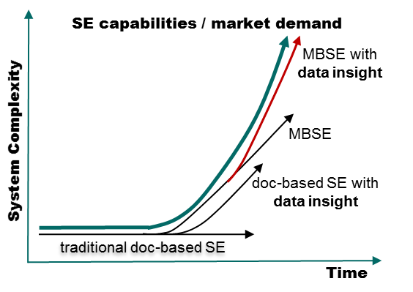
Figure 5, forecast of the need for various model-driven system engineering capabilities to cope with the expected increase of system complexity over time
Towards the next level of system engineering
TNO has developed methodologies that start with – iteratively – understanding and translating business goals into data-driven application areas and requirements. For instance, product customizations may lead to a need for better system usage insights and dedicated testing, which subsequently could lead to a better definition of product customization and the identification of new customization strategies.
The vision is to support system engineers with methodologies that integrate knowledge and data into a system-level reasoning framework (Figure 6). In traditional knowledge engineering, we systematically model domain knowledge, often scattered across documents, or in the heads of experts. This supports the effective analysis of operational data, by applying, for example, feature selection or constraints in learning algorithms. Exploitation of profiling, process and data mining techniques allow the generation of context-specific operational models that can support, among others, automated testing or customization of system operations. The integration of knowledge-driven and data-driven approaches enable continuous system evolution and operational support, thereby reusing and strengthening the company’s knowledge. In Reflexion a major step to achieve this vision was realized.

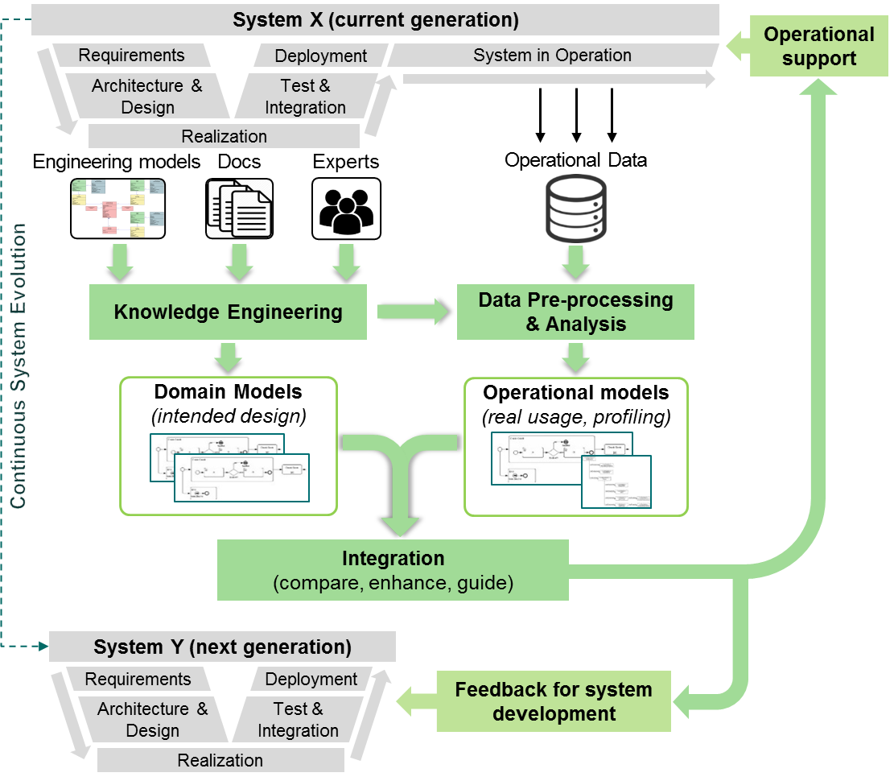
Figure 6, extension of traditional knowledge engineering-based way of working with operational data-driven models strengthening the system development life-cycle
Exploitation prospects
TNO targets to become a catalyst in the high-tech systems eco-system on the valorisation and exploitation of (operational) system data, empowering system engineering with data insights and thereby driving the innovation of high-tech product and service development:
- Establish a system data expertise group on applying data insight methods in the high-tech industry which has already been achieved during the Reflexion project.
- Development of generic approach(es) on usage profiling for industrial (operational) system data, which has been explored during the Reflexion project and will be continued in follow-up projects.
- Study how to exploit integration of domain expert models and data sciences methods for system data services, now included in the TNO knowledge roadmap.
To achieve this ambition, TNO will systematically support successful deployment and anchoring of the Reflexion results by improving companies’ processes and competencies. This leads to the following exploitation prospects:
- An established system data expertise team for high-tech systems industry to be exploited for innovation / consultancy services, valued to be 1,2 M€ by 2020.
- Dissemination of system data insights methods in dedicated knowledge valorization B2B programs in the ESI (TNO) industry partner network, valued to be 5 M€ by 2020.
- Yazzoom
Yazzoom’s participation in Reflexion has enabled the accelerated development and validation of its two core products, namely Yasense Excel (a tool for creating, deploying and managing soft sensor models written in Microsoft Excel) and Yanomaly – a big data platform for unsupervised AI-based anomaly detection on machine-generated data.
Yanomaly is capable of ingesting and learning the normal properties of two types of data: numeric data (typically generated by sensors) and text data (typically coming from logs). The participation in and collaboration during Reflexion has allowed Yazzoom to make significant progress in the algorithms and supporting infrastructure code to train and apply these anomaly detection models to live data. In particular, Yanomaly is unique in its capacity of doing unsupervised anomaly detection on multivariate data, and to yield not only anomaly scores and events but also corresponding root causes indicating the main contributors to the anomaly scores. The unsupervised nature of the algorithms (which means no labelled data of known incidents is necessary to train the models) together with the variety of tools available to select subsets of data for training drastically lowers the threshold for applying Yanomaly to data from known and new assets.
Yanomaly has been actively marketed from the middle of the execution of Reflexion and has been generating additional revenue since. The go to market strategy is a three-stage approach:
- A Proof of Concept stage whereby Yazzoom’s data scientists use the technology in Yanomaly for assessing and showing the added value of the application of the algorithms to a historic dataset. The results (sometimes presented as a blind test without known labelled incidents or anomalies) are then presented to and discussed with the customer.
- A pilot stage during which Yazzoom helps the customer in integrating Yanomaly with the existing data sources and sinks and does the knowledge transfer to the customer about the configuration of the models and the interpretation of the results
- A rollout stage during which the customer (with limited support from Yazzoom) does the rollout to other assets of a similar type or retrains and manages the model on existing assets.
Yazzoom plans over the exploitation period of the results of Reflexion (the five years after project end + 2 years) to further expand and improve the functionality offered by Yanomaly, through the additionally generated revenue and partially also through funded follow-up research projects.

Philips Annual Report 2017, February 2018
https://www.marketsandmarkets.com/Market-Reports/diagnostic-imaging-market-411.html
https://www.researchandmarkets.com/research/vfrhgg/global_diagnostic?w=5
https://www.grandviewresearch.com/industry-analysis/image-guided-therapy-systems-market
https://www.grandviewresearch.com/press-release/global-image-guided-therapy-systems-market
https://www.marketsandmarkets.com/Market-Reports/machine-health-monitoring-market-29627363.html
For example, “Simulation-driven machine learning” in high-impact journal paper MSSP: https://www.sciencedirect.com/science/article/pii/S0888327017303357
More info is available on: https://community.plm.automation.siemens.com/t5/Simcenter-Blog/Neural-networks-amp-digital-twins-change-the-O-amp-M-in-the-wind/ba-p/544642

