WoO - Web of Objects Project
D6.1 Description of the five demonstrations planned and requirements

••••••••••••••••••••••••••••••••••••••••••••••••••••••

Contract Number: |  | ITEA-2 10028
Starting date: | 01/01/2012 | Ending date: | 31/12/2012

Title of the main deliverable: | Description of the five demonstrations planned and requirements
Title of the main deliverable: | WoO-WP6-D61
Work Package deliverable: | D6.1
Task related to the deliverable: | T6.1, T6.2, T4.3, T4.4
Type (Internal / Restricted / Public): | Public

LEADER | CONTRIBUTORS:
Lead Participant:
Telespazio Iberica / HUFS
Lead author: Marc Caballé
E-mail: mcaballe@telespazio.es
REVIEWERS
Marc Caballé (Telespazio Iberica)

HISTORY

NB: a status is associated to each step of the document lifecycle:
- Draft: this version is under development by one or several partner(s);
- Under review: this version has been sent for review;
- Issued: this version of the document has been submitted to EC.

Version | Status | Date | Author | Main Changes
0.1 | Draft | 21/02/2013 | Marc Caballé | Table of contents and first version of the textual description for the demonstrator for the Spanish demonstrator.

TABLE OF CONTENTS

1. Introduction 5
2. T6.1 Smart Greener Village Demonstrator (Egypt) 6
2.1. Description: 6
2.2. Technical contributions: 8
3. T6.2 Open Smart Neighborhood Demonstrator (Spain) 9
3.1. Description: 9
3.2. Technical contributions: 10
4. T6.3 Smart Devices Network Demonstrator. Cooperative Objects for Secured & Smart Buildings (France) 11
4.1. Description: 11
4.2. Technical contributions: 13
5. T6.4 Smart building Emergencies Demonstrator (Korea) 14
5.1. Description: 14
5.2. Technical contributions: 15

Introduction
The aim of this deliverable is to describe the scenario of each demonstrator that is intended to be submitted in the ITEA’s reviews.

T6.1 Smart Greener Village Demonstrator (Egypt)

Description:

This is a comprehensive use case that will take the form of a pilot project titled “Autonomous Energy Efficient Climate Control Solution for SMART Buildings.”
The idea is to offer a solution that provides a climate control with an optimized energy usage based on smart sensing, autonomous actuation and localized decision making. Moreover, adding the feature of facilitating the SMART Village manager/officer with the ability to monitor the climate of the village facilities at his fingertips using a web portal or through his smart mobile phone.
The pilot project will be carried out under the slogan “Let’s make Smart Village Greener”. The Egyptian partners will participate in the development of various web-of-objects technologies that supports this pilot and will call it "ClimaCon". The solution augments centralized or individual HVAC systems to provide in-building climate control solution using Wireless sensor Networks. It will be designed for the highest energy efficiency as well as the utmost comfort in terms of (temperature, humidity, air quality, etc.). Moreover, it has been intended to be easy to deploy, maintain and integrate with legacy systems.

The following are the key factors that differentiate ClimaCon from other existing solutions:
- Saving energy
Implementing comprehensive algorithms for In-building optimization of HVAC energy efficiency will result in reducing energy consumption (heating, cooling) according to the pre-set control rules such as: - Only use energy when it is really required, Only use the amount of energy actually required, and Apply the energy that is used with the highest possible efficiency.
- Efficient climate control
The developed algorithms will mainly focus on three objectives: Maintaining the delicate mix of climate parameters (temperature, humidity, oxygen level … etc) according to cultural and industrial/business requirements, Reducing CO2 foot print within buildings, and Paving the road for new industries or improving current industries that are heavily dependent on the climate mix.
- Easy and Cost Effective Deployment
By adopting wireless technologies as the backbone of communication between the various sensors and actuators within the developed solution (ClimaCon), the effort needed as well as the cost for installation, servicing and maintenance will be greatly reduced through eliminating most of the wiring (50% - 90% of retrofitting costs is due to wiring), connectors ... etc. Also, the ease of system reconfiguration is achieved as often wired sensor/actuator locations cannot adapt to building reconfiguration.
- Smart Monitoring and Diagnostics
Providing smart remote monitoring and diagnostics for HVACs; HVACs used on commercial buildings are often poorly maintained and operated. Remote monitoring of this equipment would increase the awareness by building owners and maintenance service providers of the condition and quality of performance of these units, enabling conditioned-based maintenance rather than the reactive and schedule-based preventive maintenance approaches commonly used today. Improved maintenance would help achieve persistent peak operating efficiencies, reducing energy consumption by an estimated 10%.

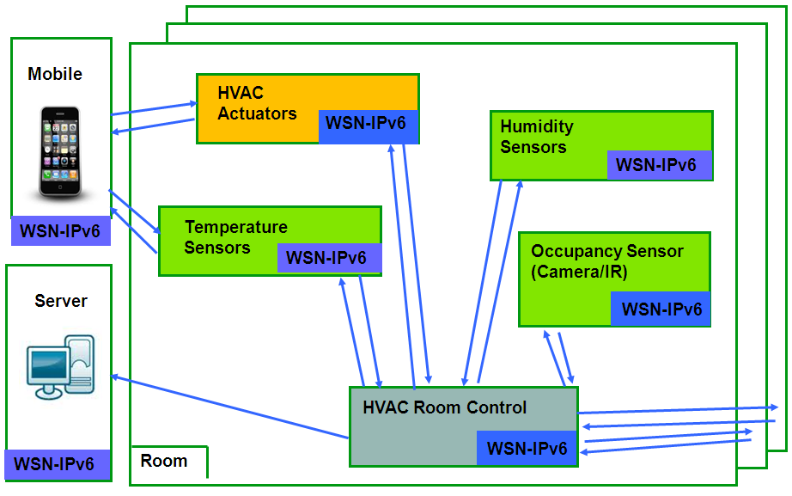

Technically, ClimaCon has the following main features:
- The solution is mainly consists of a set of Sensors (temperature, humidity, pressure, air-quality, occupancy … etc) and Actuators (solenoids, motors, levers … etc) that work together in harmony to control modern HVAC systems to achieve multiple goals like energy efficiency, effective climate control, smart mentoring and diagnostics, conditioned-based maintenance … etc
- Adopting Wireless Sensor Networks (WSN) as the core for communication between the various sensors and actuators within the solution; and focusing on low power wireless technologies.
- An extended network infrastructure based on IPv6, encompassing WSN and legacy field buses (through gateways):- Supporting IPv6-based self-configuration and self-healing, Including appropriate application protocols, algorithms (e.g. routing, power management) and a networking components architecture for optimizing WSN … etc
- A homogeneous distributed service infrastructure: - Deployable on each node (smart object) of the Web of Objects, Adapted to the specific requirements (memory footprint, performances) of WSN, Supporting a variety of message exchanges patterns (synchronous and asynchronous request/response, event-driven, streaming, Supporting policy-based interoperability and QoS, Supporting metadata, policy and semantics-based autonomic behaviour: discovery, localization, self-configuration, self-adaptation and self-healing
- In each node, a semantic and adaptive service composition layer featuring: - Semantic modelling and ontology definition mechanisms, Service component modelling, Service composition and orchestration mechanisms, Semantic reasoning mechanisms: event filtering, correlation and aggregation, situation assessment using object semantics, rule-based and temporal reasoning.

In order to facilitate the feature of easy and efficient deployment for ClimaCon, a Mote Placement Optimization Tool (MPOT) will be developed to ensure quality of resource sharing and allocation in the final deployment through modelling and measurements. Moreover, the tool calculates the optimum deployment schemes for network through environment-aware mechanisms. Therefore, MPOT will be designed to be aware of surrounding structure, furniture, and devices. It will also include optimization objectives that vary from least cost, best coverage to least power consumption ... etc.

Technical contributions:

NMATec: The ClimaCon core development including Hardware and Software Services such as: Smart configuration of the system's sensors and actuators, Data collection of system information, Smart control of the climate-mix parameters (temperature, humidity, pressure …), Smart monitoring and optimization of consumed energy, and Fault detection and diagnostics.

Smartec: Mote Placement Optimization Tool (MPOT) including resource sharing and allocation, modelling and optimization.
Cairo University: Smart Phone User Interface that will be used for configuration, monitoring and diagnostics of ClimaCon.

T6.2 Open Smart Neighborhood Demonstrator (Spain)

Description:
One evening from home to the mall: A family at home decides to go to the mall to see a film and eventually having dinner. Thanks to various smart objects, like their smartphones, public user profiles, sensors (NFC and WSAN based), monitoring agents, etc., interaction with other smart objects and innovative services are available.
Exiting the house, one of the person holds his smartphone near the door and by matching the mobile phone with an NFC-based lock, the doors recognizes its owner and gets closed. The house detects that no one else is at home, and enters an energy-efficient standby mode. On leaving the house and entering in standby mode a monitoring system, based on different sensors and actuators in a WSAN at home, is automatically activated which alerts the house owner of any anomalies (abnormal energy use fluctuations) while he is not at home. The user smartphone makes available access to other mobile sensors as the user is leaving a private context.
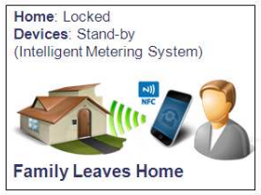

Entering in the car, the environmental conditions and the music are set fulfilling the requirements and preferences of all through NFC sensors by holding a smartphone near the onboard computer.
At the mall parking, the family which benefits from the mall loyalty program can easily access to the reserved parking spaces surveyed with a smart vehicle verification system.
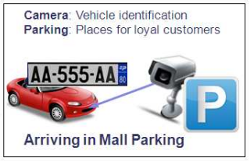
Once in the mall, the cameras located in shops allow to keep track of the customers to facilitate the store management and to inform the family about the occupation of their favorite stores.
Being inside the elevator, the users can see all the information about the services of the mall, movies, food, shops, ... on the elevator screen. They can buy movie tickets, book a table in a restaurant, provide feedback about the mall services , etc. directly from the ads.
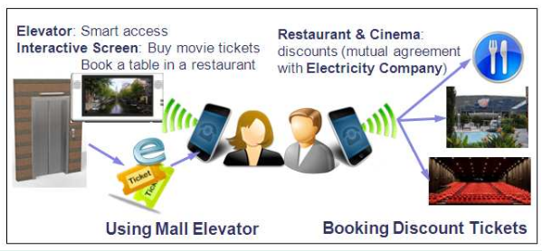
When using services of companies that have commercial agreements with the energy provider of the user, discount tickets will be automatically uploaded into the terminal of the user.
On returning home, the terminal will interact with the household energy system to activate the necessary household appliances (heating, illumination, etc.) and the accumulated discount tickets will be downloaded from the terminal into the intelligent metering platform for their processing.

Technical contributions:
DEIMOS: Sensor access platform and user question/answer mobile interface
PRODEVELOP: Social data and geolocated sensor processing
TELESPAZIO IBERICA: Remote & intelligent metering
ETIC: Intelligent interaction
UPC: Security
UPM: SOA based WSAN with annotated services that will leverage interoperability and making decisions.
UPV/PROS: Sensor access and smart home platforms
VISUAL TOOLS: Algorithms based on full-body image vectors for identifying and tracing people, vehicle identification system

T6.3 Smart Devices Network Demonstrator.
Cooperative Objects for Secured & Smart Buildings (France)

Description:
The French demonstrator is focused on a scenario enabling the device sharing between different stakeholders that share the same space, enabling business specific workflows to be executed while devices have autonomy and reactivity features. The considered real-life emergency management scenario will be detailed further, after presenting its context and collateral problems.
In public interest buildings such as metro/train stations, airports or shopping malls a lot of video surveillance cameras and display monitors are installed, alongside with large range of sensors (e.g. for detecting fire, humidity, vibration, noise etc) and actuators (for blocking doors, delivering water or ventilating). In addition, significant number of Smartphones and other mobile devices are used to assure the well functioning of the activities. Having different ownerships and being based on different technologies, these devices should be shared in regulated conditions by all the stakeholders that operate in the building: Control Center, Surveillance Company, Train/air Company, Area Administration, Shops, First Responders. Each of them should take advantage of the various devices in the context of the workflows specific to their business interest.
We consider as example the following alternative workflows to be executed in particular conditions:
- Maintenance workflow [M], handled by the Control Center: devices (objects) are first installed, dynamically configured and replaced in case of dysfunction. For each new device, it involves the assignment of an IP address and its registration in the network. When a repairman comes in place, he will receive all the technical and localization details about the damaged device;
- Public security workflow [S]: suspect person is tracked further to a malicious action (e.g. intrusion);
- Emergency management workflow [E] – in case of an incident (e.g. fire) affecting the infrastructure, an operational procedure involving first responders is executed;
- Commercial workflow [C]: the commercial administrative staff visualizes real-time videos taken with various cameras, and set up different publicity messages (e.g. discounts) to be advertised on the display monitors in the building and captured by the visitors Smartphones. In a more complex situation, a music band or VIP is visiting the building and his trajectory is tracked with video-surveillance cameras, while the display monitors pre-announce his passing.
Each workflow includes an application logic, which could be fixed and exteriorly controlled through a Web application. In order to avoid this limitative situation, we consider further a scenario where multiple of above-mentioned workflows overlap dynamically. Thus, a centralized control solution will not be possible, and the devices autonomy will be a requirement but also a challenging issue.
Figure 1 An emergency management scenario illustrating the data transmission between different devices
As illustrated as well in Figure 1, we detail further the steps of the chosen scenario by indicating as prefix the code of the workflow to which each step belongs:
- [M] All the devices are set up and registered in the building network;
- [S] A Burglar enters into a restricted area and is detected by the Door and by the PTZ camera;
- [S+E] The burglar damages electrical equipment (EE), which raises an alarm; PTZ turns to the scene.
- [E] A fire is caused, and is detected by the Fire detector, Smoke detector, Temperature meter;
- [S+E] Further to received alarms, the Control Center (CC) calls the Fire agency and sends a broadcast alarm to security agents in the station area, calling two of them in the damaged restricted area;
- [E] The fire agent and the security agent confirm the mission;
- [S] CC initiates the video tracking process, having priority over other stakeholders using the cameras;
- [S] The security agent catch the suspect and immobilize him, while notifying the CC;
- [E]Arriving in the building, the fire agent is notified by the closest Water plug about its position;
- [E] During the water distribution, the Water plug notifies about its action the CC and the fire agent;
- [S+E] After alarm validation, the Display monitors will replace publicity with security messages;
- [M]Arriving in the building, the repairman is notified about the EE location and technical details.

As could be noticed, this scenario takes various incidental events as basis for automatic triggering of actions belonging to different workflows. Thus, the devices are reactive to events through specific actions that could be capitalized, in function of the global context, in these different workflows. The Control Center has only a supervision role, and the human intervention (such as alarm validation or mission acceptance) is included in the loop for illustrating how a minimal human control could avoid false alarms or devices exclusivity in taking important decisions.

Technical contributions:
The technical contributions were distributed in the consortium according each partner expertise and business interests, while keeping the main goal of building together a solution for addressing the above mentioned challenges:
- Thales Services : Real-time video-tracking, Semantics: exploiting data from other sensors inside a video-surveillance system; making cameras to collaborate with other devices; associate semantics to services and exploit it for reasoning;
- Thales Communications: Devices registry & configuration, REST services: devices cartography, Control of connected objects, Communications mechanisms, Service workflow management capabilities;
- CEA List: Real-time video-tracking: transfer the current vision based processing technologies inside integrated systems, as video-surveillance camera services;
- Odonata: Embedded and distributed service infrastructure: contribute to the device set-up and management improving the current open source DPWS toolkit and developing additional pluggable components required by the concrete French scenario;
- Sogeti High Tech: Bridges between technologies, Security, Semantic administration of devices: solutions on interoperability aspects to break in-silos and legacy device protocols and provide unified and secured device management also exploiting semantic technologies.
- Univ. Paris East: Devices control and cooperation, Semantic modeling: developing a choreography-based approach for device collaboration, where bricks of the application are deployed on different objects together with their reactivity to collaboration
- Inst. Telecom SudParis: Building topology modeling, devices cartography, mediator enabling devices to communicate with different Web applications;
- Univ. Concordia University: 4G EPC Based Video Surveillance services enabling the remote control through role-based access policies.

T6.4 Smart building Emergencies Demonstrator (Korea)

Description:
Part 1: Emergency Service in Smart Home for Pet Care:
While Mr. Lee is watching TV in the living room, phone call is ringing. The motion sensor in TV set (KINECT) senses his motion receiving phone, and the volume of TV sound is automatically reduced during his talking. The dog is sitting at near beside sofa in the living room. The sensor on the neck of dog is sensed to set the dog’s location in the house. After a while Mr. Lee is exiting to go to his office. In the scenario, sensor and devices in the home will be getting in the mode of “smart home service”, and the home gateway starts their collaborations to provide “smart home care service”. And the smart phone of Mr. Lee is also set to the same service mode with sensing data at the door sensor.
All sensors, smart phones of family members, dog’s sensor and other devices in the home are on user-centered operation through semantic ontology relationship among them to provide intelligent smart home care service.
Mr. Lee is working at his office, and an emergency message with warning sound is arriving at his smart phone to indicate that the dog in the home is in some abnormal condition. When Mr. Lee touches the button on his smart phone to figure out its emergence situation of the dog, and all objects of sensors in the home, the dog’s status, devices (e.g., camera and other actuators, etc.), and other historical data are collaborated in terms of service features in the AS (Application Server) to figure out its proper emergency service for the dog. Its semantic ontology process in the AS will search the secure operation for the dog.
The AS will request the home gateway to perform the required actions to enhance room’s environment for the dog’s emergency treatment. A monitoring camera sends the dog’s scene to Mr. Lee’s smart phone with its simple treatment notes. If the dog’s condition is recognized getting worse, Mr. Lee will bring the dog to the animal hospital in the shopping mall.

Part 2: Emergency Service in Smart Shopping Mall:
Three customers (Mr. Lee (A), handicapped person (B), and Guard (C)) are arriving at shopping mall, and they are registered at the shopping mall gate through Wifi access pont. The Emergency service scenario is provided to evacuate from the fire in the shopping mall in 3 steps as follows.
- Users (A, B and C) Enter the Shopping Mall.
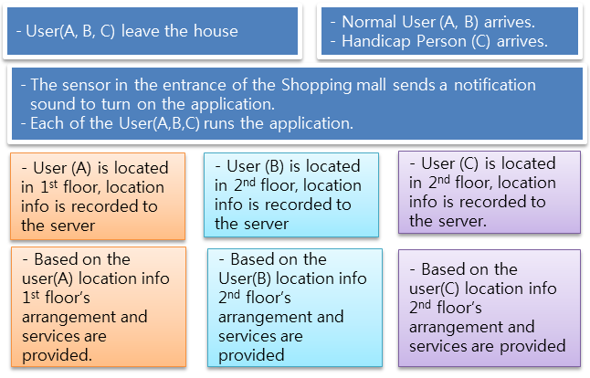
- Users (A, B and C) starts to shop.
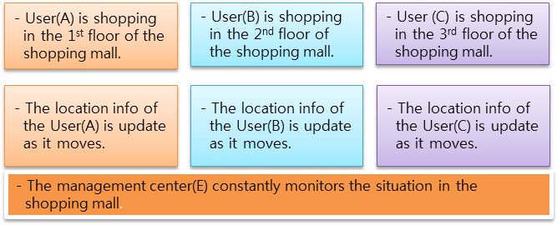

- Users(A, B and C) confront emergency situation of the fire in the 1st floor, but they evacuate from the emergency situation with safe,
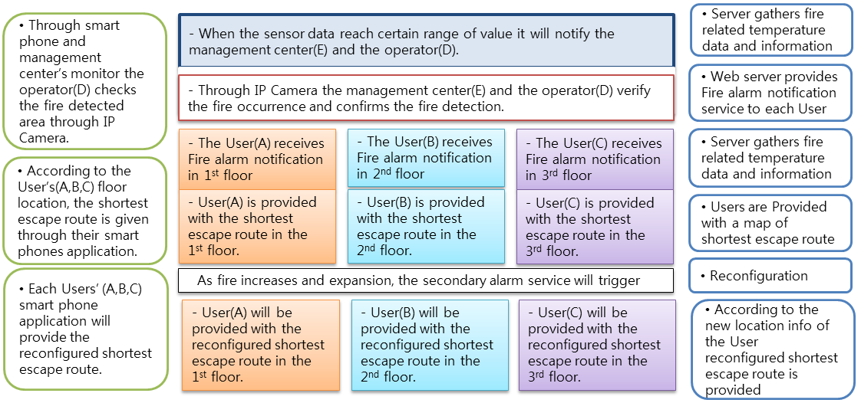

Technical contributions:
KT: Business service Model, user Interface for Emergency service
ETRI: Service delivery platform for web services, WoO gateway functions
HUFS: WoO based service architecture for smart shopping mall and home, semantic ontology for emergency service in smart shopping mall
KAIST: Device/sensor web service, WoO based objectification
Kwangwoon Univ.: Context aware smart streaming for emergency multimedia service
Mik System: Semantic ontology features for emergency service in smart home
EGC&C: Media multicast function including IPTV service features related smart emergency service

