# Project Progress Report Annex

Version 21, June 2023

Foreword

# 2023-H1 Project Progress report

OMD

OPTIMAL MANAGEMENT OF DEMAND

Edited by: Hatice Betül HERSEK, PMP

Date: 25.09.2023

## Project key data

### ACRONYM and full-length title

|  |  |
| --- | --- |
| 20003 | OMD |
| Program Call | ITEA 3 Call 7 |
| Full-length Title | Optimal Management of Demand |
| Roadmap Challenge | Smart industry |

### Project duration and size

|  |  |  |
| --- | --- | --- |
| Size | Effort: 72.07 PY | Costs: 2.4 M€ |
| Time frame | Start: 2022-01-01 | End: 2024-12-31 (36 months) |

### Coordinator

|  |  |
| --- | --- |
| Türkiye | Experteam |
| Type | Small and Medium sized Enterprise |
| Contact Person | Dr. Demet Seyhan |
| Email Address | demet.seyhan@experteam.com.tr |

### Project Status

|  |  |
| --- | --- |
| Latest FPP | Change Request (21-12-2022) |
| Latest PPR | 2022 Semester 2 |
| Latest Review | OMD #1 (a.m.) (23-06-2023) |
| Upcoming Review |  |
| PCA status | PCA Signed.pdf (Signed: 30-03-2023) |

### Consortium

|  |  |  |  |  |
| --- | --- | --- | --- | --- |
| Country | Funding Status | National Coordinator (Company) | Total Effort (PY) | List of Partners |
| Austria | Not funded (N) | George Suciu (BEIA GmbH) | 3 PY | BEIA GmbH |
| Hungary | Funded (Y) | Tibor Bakota (FrontEndART Software Ltd.) | 5 PY | FrontEndART Software Ltd., University of Szeged |
| Portugal | Funded (Y) | Goreti Marreiros (Instituto Superior de Engenharia do Porto (ISEP)) | 19 PY | FTP - Com. Equip. Inf. Lda, Instituto Superior de Engenharia do Porto (ISEP) |
| Slovenia | Funded (Y) | Simona Brezar (Caretronic d.o.o.) | 11 PY | Caretronic d.o.o. |
| Spain | Funded (Y) | Alberto Oliva (Strategy Big Data) | 13 PY | Strategy Big Data |
| Türkiye | Funded (Y) | Arda Ödemiş (ARD GROUP) | 20 PY | ARD GROUP, DOGUŞ BILGI ISLEM VE TEKNOLOJI HİZMETLERİ, Experteam, Hiperlink Eğitim İletişim Yayıncılık Gıda San. Paz. ve TIC. LTD. STI. |

## Project Acronyms

|  |  |
| --- | --- |
| OMD | Optimal Management of Demand |
| ML | Machine Learning |
| ITSM | Information Technology Service Management |
| NLP | Neuro-Linguistic Programming |
| GDPR | General Data Protection Regulation |
| KPI | Key Performance Index |
| DL | Deep Learning |
| AI | Artificial Intelligence |
| SDM | Service Demand Management |
| HLA | High Level Architecture |
| PCA | Project Cooperation Agreement |
| ARR | Automated Request Routing |
| SoTA | State of The Art |
| STG | ITEA Steering Group |
| min.s | minutes |
| PPR | Project Progress Report |

## Table of contents

Foreword 2

Project key data 4

Project Acronyms 5

Table of contents 6

1. Project one-page description 7

2. Project overall status 8

2.1. Top 4 overall targeted innovations 8

2.2. Top 4 overall targeted business impacts 9

2.3. Top 4 overall project KPIs 10

2.4. Top 4 overall risks 11

2.5. Change in the technology and market during the reporting period 14

3. Market access & Exploitation 15

3.1. Partners’ market access 15

3.2. Top 8 cumulative project achievements 15

3.3. Realised achievements 15

4. Project progress during the reporting period 17

4.1. Project progress and issues during the reporting period 17

4.2. Details of progress per Work Package 21

4.3. Per partner progress during the reporting period 21

5. Additional feedback to previous STG remarks (optional) 23

1. Project one-page description

OMD is a product that helps businesses to assign the correct agent to a specific service demand effectively, and remotely. In our speedy internet era, it meets the need of a fast processing of each call on the demand side, and the effective management of resources on the supply side of businesses. Increasing demands and time pressures accelerated by the pandemics make organizations ask for new automations to proactively manage their environments. SDM tools are important to do so, and existing products focus mainly on IT support: ITSM. The ITSM tool market can be considered mature as in the number of products, yet in AI capabilities they are in their infancy. Meanwhile, we need advanced approaches for optimizing demand management and a better utilization of resources in many domains. However, there is no general framework providing SDM in multiple sectors such as judicial, health, sales, marketing or manufacture. The OMD will address the high demand for online service support for numerous different sectors due to the pandemics and thus will create a significant business impact.
  
OMD embodies a number of technological innovations aimed at providing cross-domain enhanced tools, components and services for efficient service demand management and remote customer support. By applying novel approaches mainly from AI, ML/DL, and NLP, OMD will significantly impact the market, providing cross-domain breakthroughs that will be validated in nine domains: software support, justice, healthcare, consumer electronics, e-commerce, telemarketing, manufactury, logistics and software development.
  
   
Our innovation applies novel AI solutions to support a general SDM framework, considering many parameters related to request, service experts (agents), customer, and company from various domains. Bringing together technology providers and use case owners from different sectors, OMD goes far beyond the state of the art. OMD strengthens the concept of Cross-Domain Cognitive Service Management for enhanced customer satisfaction, user experience, and cost savings. OMD will analyse different approaches to create efficient workflows for dynamic priority management in customer support teams. The profiling of customers and agents based on data-driven social mood analysis, will help to process new dimensions of customers, designing a methodology that captures emotions that will increase the quality of the customer experience. OMD will perform research and development in key topics: category classification, emotion classification, semantic capabilities to easily extract information from unstructured data, topic detection, demand and service level classification, intent classification, entity recognition and linking, request summarization and standardization, agent classification, solution classification and dynamic “time to finish” prediction using state-of-the-art AI and ML/DL models. Furthermore, we plan to open source some core components of the project to facilitate its cross-domain sustainability.
  
   
The OMD framework produced in this project will rapidly contribute to many sectors effectively using AI models to improve service as a CSM approach. With the remote working model now more intensely in our lives, companies providing remote support will dramatically increase in number and so our product will be high in demand.

1. Project overall status
   1. Top 4 overall targeted innovations

|  |
| --- |
| **1. Framework for a multi-domain service management software** |

***Main contributors***: Doğuş, Hiperlink, Experteam and All

***Short description of innovation and the State-of-the-Art***:

Our innovation applies novel AI solutions to support a general SDM framework that can serve many different domains, considering many parameters related to request, service experts (agents), customers, and companies. This kind of framework does not exist to the best of our knowledge and thus this is the main innovation. Bringing together technology providers and use case owners from different sectors, OMD goes beyond the state of the art.

Currently, systems focus on specific domains; ITSM being is the leading domain in terms of maturity and utilisation of new technologies such as AI. However, even in this domain, the use of AI technologies is in their infancy. OMD aims for more effective and deep use of AI in ITSM domain as well as other domains by sharing and transferring AI models among domains as much as possible.

Within the concept of ITSM, we focus specifically on the development of SDM platforms. Three points stand out in our project; ticket prioritisation, ticket integration and automated ticket routing. Our successes will produce results that positively affect the entire system.

In addition, one power of OMD is that the partners work with many use case models. OMD will need a cross-domain service to realize the interoperability model and to use the OMD infrastructure for multiple use cases. In this, each use case owner needs some standardization under the umbrella of the OMD framework. The innovation here is to ensure that different domains with similar model structure can work together and to establish a cross domain service structure that provides project development flexibility for different domains.

|  |
| --- |
| **2. Optimization based on the dynamic workload of the agents and other constraints** |

***Main contributors***: Hiperlink and all

***Short description of innovation and the State-of-the-Art***:

Our first task is to understand the distribution of requests for a "call center" or "help desk". We search for such data to understand how the help desk requests (tickets) are opened/sent over in a time period. With this information we understand its distribution (as well as its statistical attributes: mean, standard deviation, skewness, quartiles ... .etc). This will be the first step.

Determining agent workload to ensure customer satisfaction and meeting their needs while minimizing service costs is a continuous challenge. OMD will enhance prediction-based approaches, by combining not only traditional demand-supply schemas, but also different dimensions and constraints of every company. Besides agent and department workload, the profiling of agents based on emotional fingerprint (what is the mood of an agent) and the analysis of external sources (like weather) will increase the efficiency and will allow us to provide more detailed SLA forecasts. These innovations will be based on NLP, ML and DL approaches that will be analysed and tested during the project.

Workforce scheduling and dynamic task assignment is an optimization problem which focuses on assigning the tasks to appropriate agents to minimize the "total" duration to complete "all / or many" tasks in a shorter time. There have been many studies on task optimization which focus on integer programming. We focus on a “mixed integer programming” approach as it fits our project; the method is often used to solve scheduling problems for multi-skilled agents.

Statistical metrics such that; task durations (how long a task normally takes in average and what is its standard deviation) as well as agents average resolving durations (how long does it take a ticket in category A to be resolved by an agent X, what is the average and what is the standard deviation), and finally, what is the std of the agents can be used as the inputs of optimization algorithm. Additionally deep learning methods such as LSTM can be used to forecast demands (number of tickets in a time frame: for example, hours) which can also be used as the inputs of optimization algorithms. With this approach we aim to assign the tasks not only with the information of incoming tickets at that moment, but also with the prediction of future incoming tickets.

|  |
| --- |
| **3. Use of NLP for topic classification** |

***Main contributors***: DT, XT, USZ, SBD

***Short description of innovation and the State-of-the-Art***:

The current state-of-the-art in probably most NLP applications is to utilise a large pre-trained language model and either fine-tune it in a domain-specific downstream task with several labelled examples, or use a meta-training strategy, e.g., few-shot learning without actual model weight updates. The latter requires much less labelled data than the proper fine-tuning, however, works only with relatively large and carefully pre-trained language models.

The global OMD project involves mainly classification tasks in various domains. In the Software Development use case, USZ together with the use case owner, FEA develop an NLP-based AI solution to assign source code bugs to developers. This task can be considered as a classification over the available developers considering a complex set of features describing, among others, the code, the bug, and the developers themselves. The main idea in this, and in other classification tasks is to develop AI-based solutions relying on pre-trained language models, namely one of many variants of the BERT or the GPT families of language models. The particular choice of model and fine-tuning strategy depends on the specific task at hand.

|  |
| --- |
| **4. Automated Request Routing (ARR)** |

***Main contributors***: All

***Short description of innovation and the State-of-the-Art***:

OMD will introduce innovations in several use cases by employing Artificial Intelligence (AI) and optimization techniques. These include category classification, emotion classification, semantic capabilities to easily extract information from unstructured data, topic detection, demand and service level classification, intent classification, entity recognition and linking, request summarization and standardisation, agent classification, solution classification and dynamic “time to finish” prediction using state-of-the-art NLP, ML and DL models. The project will newly introduce these advanced technologies to some of the domains or will advance the AI applications on some domains beyond the state of the art.

In customer support operations, ARR is focused on ticket routing. Ticket routing is the process of setting rules around how tickets are assigned to departments, agents, and functions. OMD embodies technology innovations related to enhanced, cross-domain ticket routing. OMD will perform research and development in key topics: category classification, emotion classification, topic detection/classification, intent classification, entity recognition and linking, request summarization and standardisation, agent classification, solution classification and dynamic “time to finish” prediction; generating services, components and tools that will be designed taking into account the requirements from the use cases. Intent classification is the automated association of text to a specific purpose or goal. Different classifiers categorise text into intents such as buy, change, generate complaint, etc. Emotion classification will rely on NLP-based techniques as sentiment analysis to build a model to predict the emotion of a text (or transcript) from a client. Specific attention will be given to aspects of multilingualism as the OMD platform addresses a broad market within the EU and beyond. Innovative ML approaches like e.g. Transformer models such as BERT may be considered because they enable the transfer of learned models across languages. This will help to solve challenges of under-resourced languages in the EU.

By combining well-established ticket classification techniques, with the most cutting-edge solutions for category classification and intent classification, OMD will add new layers/aspects for the enhanced analysis and processing of ARR pipelines. These new aspects will rely on latest advances in Speech Analysis, NLP, ML and DL, and will include computer-vision based services that will support the automation of tickets where paper-based / manual-based steps may be required. This will open OMD to more traditional, but widely consolidated processes currently available throughout logistics (i.e. public postal service) and judicial services.

ARR will be optimising the processes in all domains, increasing usability of the OMD Framework for the management of demand.

* 1. Top 4 overall targeted business impacts

|  |
| --- |
| **1. EqualityInJustice Business Impact** |

***Short description***: EqualityInJustice use case will enable enterprise licensing for Government Authorities including Ministry of Justice, General Directorate of Police and Union of Turkish Bar Associations. The EqualityInJustice Cloud Application is planned to be licensed for the 82 Bars and Union of Turkish Bar Associations and end user licensing model will be provided for the attorneys who will participate in assignments to counsel.

***Main contributors***: ARD

***Market / competitors***:

There are 174.533 attorneys registered to the union as of December 2022. End users (attorneys, law enforcement personnel and Ministry of Justice personnel) will be connecting the EqualityInJustice Cloud Application via the web application and mobile application, which will provide flexibility of usage. Furthermore, this business model will be targeted for other countries. There is no competition in the AI / NLP integrated demand management systems in the justice domain.

|  |
| --- |
| **2. Health care Business Impact** |

***Short description***: EU Market - existing network of distributors

Caretronic has a strong international network of distributors mostly in EUROPE and all around the world. Based on the Caretronic has developed the business model and road to market that includes market introduction to hospitals, nursing homes, care organisations, telecom companies, our international distributors’ network.

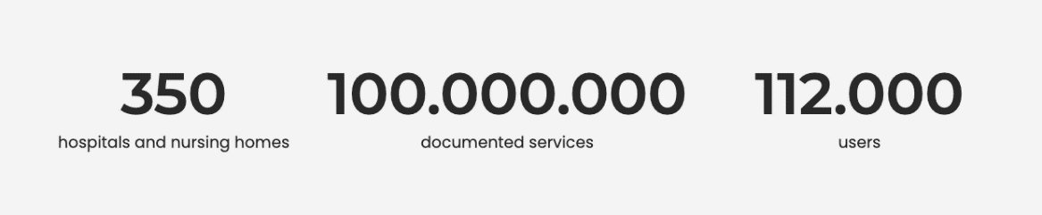

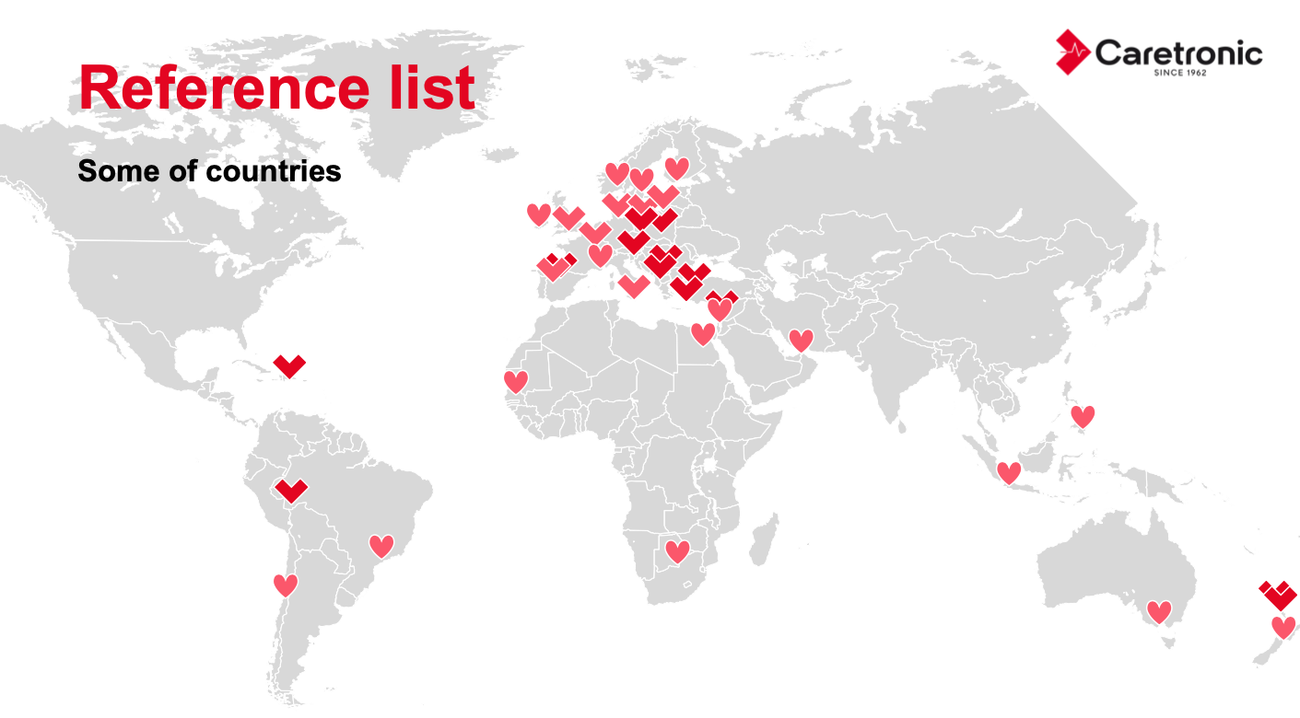

In the highly competitive healthcare industry, establishing a unique differentiator can significantly impact business success.

Caretronic's extensive network of distributors, combined with its advanced technology solutions, can offer the following business impacts that set it apart from competitors:

* Wider Market Reach: Caretronic's global distributor network provides unparalleled access to healthcare institutions, including hospitals, nursing homes, and care organisations. This wide reach allows the company to penetrate diverse healthcare markets more effectively than competitors.
* Streamlined Market Introduction: Caretronic's established network simplifies market introductions. New healthcare products and services can be efficiently introduced to a broad customer base, reducing time-to-market and enhancing revenue generation.
* Enhanced Product Adoption: The distributor network facilitates quicker adoption of Caretronic's innovative healthcare solutions. With distributors familiar with local healthcare needs and regulations, the company can tailor its products to meet specific market requirements, increasing adoption rates.
* Global Expertise: Caretronic's international distributors bring valuable local knowledge and expertise. This knowledge helps the company navigate complex healthcare landscapes, adapt to cultural nuances, and stay compliant with regional regulations.
* Competitive Advantage: Competitors may find it challenging to replicate Caretronic's vast and well-established distribution network. This network provides a competitive advantage, making it harder for rivals to enter or gain traction in certain healthcare markets.
* Improved Customer Service: With local distributor support, Caretronic can offer prompt and effective customer service. This enhances customer satisfaction and loyalty, critical factors in the healthcare sector.
* Market Expansion Opportunities: The distributor network not only serves as a sales channel but also as a valuable source of market intelligence. Caretronic can identify emerging healthcare trends and expansion opportunities more readily through its network.
* Risk Mitigation: Distributors can help Caretronic manage risk in various markets. They understand local regulations, manage logistics, and navigate potential challenges, reducing the company's exposure to risks.
* Scalability: The existing distributor network provides a scalable infrastructure for growth. As Caretronic expands its product offerings or enters new healthcare segments, it can leverage its network's established infrastructure.
* Brand Credibility: Collaborating with respected international distributors enhances Caretronic's brand credibility. This trust in the distribution channel can positively influence healthcare organizations' purchasing decisions.

In summary, Caretronic's extensive distributor network serves as a potent differentiator in the healthcare business. It not only expands market reach but also streamlines market entry, enhances product adoption, and provides a competitive edge. This unique business impact can be leveraged to achieve sustainable growth and success in the healthcare industry.

***Main contributors***: Caretronic

***Market / competitors***:

Rauland, Ackerman, Tunstall

|  |
| --- |
| **3. Contact services, Telemarketing and Big Data Business Impact** |

***Short description***: Both the initial business model proposal and the estimates will have to be updated during the execution of the project. SBD proposes a sales model for contact process optimization services. OMD's services are also applicable to corporate clients and users of contact and telemarketing solutions in general. The following table shows the estimated sales of corporate and individual licences for OMD services.

***Main contributors***: SBD

SBD will integrate OMD's results as part of its strategy to automate and optimize sales agent selection and sales agent prediction. sales agent selection and resource forecasting for Telemarketing and Contact centers based on customer characteristics (Speech-to-text, NLP, Entity Extraction, sentiment analysis) and product characteristics (Target, audience and trends).

SBD will improve with OMD the customer experience, by analyzing external sources to better identify the mood, culture and socio-economic profile of a new customer in order to better match the customer with the most suitable agent and product campaign. This new strategy will have a positive impact that will scale beyond the customer interaction processes of contact services, enhancing security, providing feedback based on cognitive parameters (what is expressed, how it is expressed, what is perceived and how it feels...) and on artificial intelligence, natural language processing and Deep Learning / Machine Learning.

The Konecta Group has:

- An R&D&I strategy based on the optimization of all aspects that accompany contact processes.

- Data, based on the daily relationship of more than 71,000 agents internationally with more than 2 million daily contacts.

- A specific BIG DATA and Modeling company with experts in Data Science as STRATEGY BIG DATA.

- A proprietary S2T model, developed according to the problems of a Contact Center and telematic models.

- A distribution of operation centers in Spain based in Castilla y León where the human capital is distributed.

- A distribution of operation centers in Spain where human capital is distributed.

- A process of attracting resources and a local and international training model.

- The need to systematize learning with new real KPIS.

Additionally, the current situation has allowed:

- Large corporate clients assume teleworking as a reality.

- Homeshoring model is a necessity.

- The user experience in the contact is a variable with as much weight as the efficiency of the process.>

- SBD, bases OMD's marketing strategy on:

- The sale of new Language optimization services based on artificial intelligence, natural language processing, Deep Learning / Machine Learning and all the aspects that accompany the contact processes.

- A huge database, based on more than 55 million conversations per year, in Spanish with different accents and dialects.

- Modeling with Data Science experts in voice processing.

Based on the business strategy described above, and taking into account the discussions held with the members of the consortium, a preliminary analysis of the exploitation of results has been carried out. Both the initial business model proposal and the estimates will have to be updated during project execution. SBD proposes a sales model for contact process optimization services. OMD's services are also applicable to corporate clients and users of contact and telemarketing solutions in general.

***Market / competitors***:

Strategy Big Data S.L. frames OMD's results in the field of contact services, Telemarketing and Big Data. It is increasingly difficult for companies to differentiate themselves. Therefore, they must offer remarkable experiences to customers, leaving a positive memory. In this sense, the Call Center can be a support for business success.

The key factor is to have the necessary technology to offer a unique customer experience, meet their needs and expectations to create a bond. Many companies invest in the Call Centers to maintain the relationship with the customer, launch campaigns, sell products, answer questions and conduct opinion surveys.

Technology companies

In general, the service used by the sector is based on the helpdesk style. It has, in general, the function of providing solutions to technical problems that the customer may have. It has different levels of service.

Financial Institutions

Banks, insurance companies and credit card companies also use call center services to maintain customer relationships. The call center also becomes an alternative, new sales channel for offering investment and financing products. It also ends up facilitating the fulfillment of the objectives of professionals, who do not need to move from their work environment to conduct a negotiation.

Product sales and convergence

In addition to traditional product sales (telemarketing), providers (i.e. cable TV, Internet and telephone channels...) use the Call Center to offer products to customers and increase their chances of sales. It is based on customer prospecting, satisfaction surveys and product sales.

The contact center sector is undergoing a major change in the way it operates.

Until now, the massive incorporation of resources, manual call validation processes and/or the implementation of automation (IVRS) that flattened the demand curve sought to bring quality and profitability to the service.

The increase in process capabilities and the emergence of Machine Learning techniques has enabled a change in this model where Big Data and Inference processes allow a proactive exploitation of the customer relationship.

|  |
| --- |
| **4. Consumer Electronics Targeted Business Impact** |

***Short description***: As consumers learning and working from home, consumer electronics sales grown faster. Türkiye is the Largest TV & white goods producer in the European Market: $40 bn (CAGR: 6.5%) Export: $21 bn. To grow revenue in the domain, business analytics need insights about consumers feedback and intent after sales. There is a gap between sales and after sales customer problems for data flow because of complexity of processes on after sales support platforms or contacting call centers. According to the Turkish Call Centers Association, call centers industry had a value of TRY 5.1 billion and employed 91,000 people in all the call centers throughout the country in 2017, up from the 2013 figures of TRY 2.9 billion and 70,200 employees. The call center sector has set an ambitious target of having a work force of 300,000 people by 2023. OMD framework aims to prioritise data governance and collecting accurate data to unlock deeper insights and more cohesive decision making. Also to tolerate the complexity and make activities smart, using artificial intelligence is a must adoption at work and in our private lives. OMD will deliver practical actions to produce immediate business impact powered by AI. Such as shortening problem identification and also solution generation will reduce number of tickets and requests to call centers. In addition, 60% of the records coming to the Call Center are simple problems. Solving these problems through the call center creates a huge time and cost loss. There is no alternative to OMD for making customer support smart in consumer electronics. So the targeted business impact of OMD brings a total change to current solutions for all companies in the domain.

***Main contributors***: DOGUS

***Market / competitors***:

Qudini, ServiceHub By HubSpot, Qless

* 1. Top 4 overall project KPIs

|  |  |  |  |
| --- | --- | --- | --- |
|  | Initial value | Targeted value | Current value |
| **1.** **Reduction of average maintenance costs for tasks assigned using the developed method** | 5 hrs per task | 4 hrs per task | 5 hrs per task |

The value is computed by analysing the internal issue management system. Times spent on fixing bugs and closing the issues are recorded by the developers. We compute a simple average to determine the actual value of this KPI.

|  |  |  |  |
| --- | --- | --- | --- |
| **2. Decrease in ticket assignment time to the most appropriate agent** | 4-5 minutes | %10 (<4 minutes) | 4-5 minutes |

Ticket assignment process will include classification and processing of open tickets for the most appropriate agent in various domains. Training of the AI models will enable efficiency mainly in the classification phase and the target will be to provide less than 4 minute overall classification and processing phase for the assignment of the most appropriate agent.

|  |  |  |  |
| --- | --- | --- | --- |
| **3. Increase of customer satisfaction** | Baseline (Pre-OMD  solutions) | %20 | Baseline (Pre-OMD  solutions) |

Baseline will be defined as non-OMD platforms and the average client satisfaction rates of the existing solutions and their existing processes. A customer/patient satisfaction survey will be conducted in different domains and the target is to compare the pre-OMD and post-OMD satisfaction by minimum 20%. Shortened process times and more efficient agent assignments will be the basis of this satisfaction.

|  |  |  |  |
| --- | --- | --- | --- |
| **4. Increase in average number of tickets processed by an agent per month (agent utilisation)** | Baseline (Pre-OMD  solutions) | %10 | Baseline (Pre-OMD  solutions) |

The KPIs above which result in decrease in ticket filling and ticket assignment time will enable the agent utilisation. Pre-OMD agent performance will be compared with post-OMD agent performances on daily, weekly and monthly basis for the exact month for best comparison and evaluation. Copy the above template if more result KPIs need to be indicated.

* 1. Top 4 overall risks

|  |  |  |  |
| --- | --- | --- | --- |
|  | Severity | Probability | Stage |
| **1.** Technological Breakthrough Not Achieved | High | Possible | Monitoring & Controlling |

***Avoidance action***:

Continuously monitoring of the project progress and allocating resources effectively to support research and development efforts. Regularly tracking the project's technological development and allocating resources appropriately will help ensure that the project stays on track. It allows for early identification of potential issues and provides the opportunity to make necessary adjustments to the research and development processes.

***Back-up / Mitigation plan***:

Developing contingency plans to adapt project goals and objectives if the technological breakthrough is not fully achieved. Despite careful monitoring and resource allocation, there may still be circumstances that prevent the project from achieving its intended technological breakthrough. In such cases, having predefined contingency plans in place allows the project team to pivot, adjust objectives, or explore alternative approaches to still meet project goals.

***A period in which the risk is relevant***

Throughout the project, with a critical review at the end to assess progress.

|  |  |  |  |
| --- | --- | --- | --- |
| **2.** Key Partner Withdrawal | High | Possible | Monitoring & Controlling |

***Avoidance action***:

Maintaining strong communication and collaboration with key partners throughout the project. Consistent and open communication is the foundation of a successful partnership. By fostering a collaborative environment and ensuring that all partners are well-informed and engaged, the risk of a key partner withdrawing can be reduced. Regular meetings, progress updates, and shared decision-making contribute to partner satisfaction and commitment to the project.

***Back-up / Mitigation plan***:

Developing contingency plans to address the departure of a key partner, including redistributing responsibilities or seeking alternative partners if necessary. Despite best efforts, unforeseen circumstances may lead to a key partner's withdrawal. To mitigate the critical impact of such a situation, the project OMD team proactively prepare contingency plans. These plans involve reassigning tasks and responsibilities originally handled by the departing partner to remaining collaborators. Additionally, we are considering identifying potential replacement partners in advance to minimize disruptions.

***A period in which the risk is relevant***

Throughout the project, with regular partner assessments. Partner relationships require ongoing management and attention. Monitoring partner engagement, satisfaction, and commitment should occur throughout the entire project duration. By regularly assessing partner dynamics and addressing issues promptly, the project team can proactively reduce the probability of a key partner withdrawal and be prepared to implement mitigation strategies if necessary.

|  |  |  |  |
| --- | --- | --- | --- |
| **3.** Funding Issues | Critical | Possible | Monitoring & Controlling |

***Avoidance action***:

BEIA is working self-funded as the administrative capacity is still under evaluation by the funding agency FFG for applying to Basis program, although BEIA has demonstrated its capacity already with projects funded in Austria, including by other FFG programs.

***Back-up / Mitigation plan***:

The contributions have been limited to BEIA's own use case. Other funding sources and business cases are being investigated by BEIA team.

Identifying alternative funding sources or strategies, such as seeking additional grants or investments, to address a potential funding shortfall.

***A period in which the risk is relevant***

Start of project - until now. Throughout the project, with ongoing financial monitoring and contingency planning.

|  |  |  |  |
| --- | --- | --- | --- |
| **4.** Cross-domain platform endangered - to integrate, in an efficient way, we consult techniques and proposals existing at the academic level to a particular field and use case. | Low | Rare | Monitoring & Controlling |

***Avoidance action***:

1. Avoided to some degree by organising the workshops for general architecture. The framework in the deliverable 3.1. submitted and the risk is reduced. Here we determined use-case specific structures of the HLA and tried to combine them into the HLA.

Microservices will make it easy for multi-domain OMD teams to work in parallel. We focus on use-cases for feature engineering, and they use a standardised way to share data (MQTT, etc.)

2. Within this scope, various technical workshops were organized with the consortium members, and we decided on three different models.

a- partially independent code with container structure in same server

b- Developed use case models that will be served on hosted inference API

c- Creating API Gateway between use case applications

The consortium aims to generate a set of flexible APIs - reference patterns - that allow easy connection and disconnection of services.

***Back-up / Mitigation plan***:

Every partner focuses on their particular use-case to get the feature engineering as a first step; In T4.4 consortium will begin integration plan.

***A period in which the risk is relevant***

Especially during the development of T4.1 and during the integration period in T.4.4, the WP leader and technical leaders on the use case side will work on standardising the common model.

* 1. Change in the technology and market during the reporting period

The BPM sector continues to develop improvements in CRM tools and Contact Center technology tools, for outbound, inbound and back office, whether they are their own or those of their clients. With respect to CRM tools, those of the clients not only weigh more (56%), but have increased by three percentage points, which have scratched those of their own (44%). Curiously, this balance was reversed last year when we talked about Contact Center technology tools, but this year it is the same as for CRM tools: 56% customers and 44% in-house.

The three most used technologies in companies are: Omnichannel Solutions with 94% and WorkForce and Artificial Intelligence with 83%.Next are: RPA with 78%, Conversational Analytics with 72% and Social Media and Machine Learning with 67%. Curiously, in last place and with 16% usage, we find Business Analytics / Advanced Reporting.

The trend continues to advance in the quality, quantity and efficiency of the services and processes of processing and management of the Administrations at all levels, through intelligent automation technologies (data analytics, artificial intelligence, Robotic Process Automation and Intelligent Business Process Modelling).

Public administrations demand a transversal infrastructure that facilitates the automation of administrative actions of different public bodies and promotes synergies, as well as the creation of a service to develop reusable automations with high impact.

1. Market access & Exploitation
   1. Partners’ market access

|  |  |  |  |
| --- | --- | --- | --- |
| Strategy Big Data | ind | ESP | 13 PY |

|  |
| --- |
| Big Strategy data is currently part of ROCKETHALL Group. ROCKETHALL Group has a vast network of customers in Spain and LATAM, with presence in several countries such Colombia, Mexico and Peru.    Strategy Big data will integrate the project results to advance its portfolio of highly innovative, added-value niche services on AI, ML and NLP techniques. Strategy Big Data estimates that the new emerging opportunities will impact in the company with an expected employment growth, as a result of the project, of 8%, and an impact on annual turnover of 9%. A positive ROI is estimated to be achieved within 18 months of commercial exploitation. |

|  |  |  |  |
| --- | --- | --- | --- |
| Caretronic d.o.o. | sme | SVN | 11 PY |

|  |
| --- |
| RT is planning to communicate OMD project results on several scales:  Internal dissemination acitivities: Inside the company ERT will communicate activites of the project regulary  through e-mails and on a monthly basis at general company meetings. ERT will hold also task-specific  meetings with project team working on OMD project on weekly basis or whenever required.  On home-market (Slovenia) ERT has many customers (nursing homes, health-care facilities, care  organisations with primary and secondary end-userse as well as market-players) where we will promote the  system directly with personal visits and e-mail newsletters. ERT also organises business events for  presentation of novelties to existing and potential new customers from Slovenia where also OMD solution  will be presented. ERT will also publish OMD solution on their company's website.  On international markets (EU and outside EU – Turkey, Israel, Middle East, New Zealand, Brasil, Latin  America ...) ERT will present solution on exh |

|  |  |  |  |
| --- | --- | --- | --- |
| FTP - Com. Equip. Inf. Lda | sme | PRT | 11 PY |

|  |
| --- |
| Over the past few years, e-commerce has become a key part of selling physical, digital, and service products. Thanks to the constant evolution of the Internet, its growth has been constant from year to year and the projections also point to the continuation of this increase. In 2021 it reached 5 billion dollars in sales and the estimate for 2026 is 8 billion dollars.  From the technological point of view, several tools and technologies have also evolved to make e-commerce more accessible. This accessibility applies not only to the consumer who makes his purchases but also to those who sell since several platforms and services facilitate operationalizing the entire process. However, many custom-developed systems still allow for complete customization, but at the cost of greater complexity during development.  E-commerce will be the target of constant investment and technological evolution, because of its growing adoption and practical use.  We focus on developing a recommended system t |

|  |  |  |  |
| --- | --- | --- | --- |
| Instituto Superior de Engenharia do Porto (ISEP) | uni | PRT | 9 PY |

|  |
| --- |
| As a research center that works closely to a diversity of companies and associations, ISEP-GECAD will develop, promote, install, and undertake the maintenance of the results of this project. More in detail, ISEP-GECAD expects to develop new recommendation and search services and applications to help customers search products in web stores. Also, we will contribute to the project dissemination actions such as marketing leaflets, press releases and results presentation in conferences, journals, seminars or other events as a writer or a co-writer, as organizer or a participant. |

|  |  |  |  |
| --- | --- | --- | --- |
| ARD GROUP | ind | TUR | 6 PY |

|  |
| --- |
| EqualityInJustice use case will enable enterprise licencing for Government Authorities including Ministry of Justice, General Directorate of Police and Union of Turkish Bar Associations. The EqualityInJustice Cloud Application is planned to be licenced for the Unuion of Turkish Bar Associations and end user licencing model will be provided for the attorneys who will participate in assignments to counsel. There are 160.651 attorneys registered to the union as of December 2021. End users (attorneys, law enforcement personnel and Ministry of Jusitce personnel) will be connecting the EqualityInJustice Cloud Application via the web application and mobile application which will provide flexibility of usage. Furthermore this business model will be targeted for other countries. |

|  |  |  |  |
| --- | --- | --- | --- |
| Experteam | sme | TUR | 6 PY |

|  |
| --- |
| The solution to be developed in this project is primarily for our own use to reduce costs internally. It will attract also the attention of of our contacts who switch to the remote working model due to pandemics and wish to reduce their operation costs. Similar to Experteam we can name some twenty to thirty companies whom we have in our immediate surrounding / network as our primary market for such product. Oracles partner database lists some 150 companies in Turkey providing various services. They will be filtered for finding those sharing this particular need with XT. 50 companies for now seems a realistic estimate for this first, local market covering both Oracle and SAP partners. Our market in Europe can be estimated to be 250 companies and the global market 500 companies. We can expect some 100 of these companies to be in those countries of our consortium partners.  It makes sense to run local competitor analyses. In Turkiye Asana or Atlassian could be the first competitors.  The |

|  |  |  |  |
| --- | --- | --- | --- |
| BEIA GmbH | sme | AUT | 4 PY |

|  |
| --- |
| BEIA already supplies big data and speech processing solutions to various customers in Romania (automotive, academia, car insurance, tourism, etc.) and will be able to sell the platform in a basic scenario as a nationwide SaaS service platform to public & private stakeholders in the profiling and analysis call-center business domain.  In an extended scenario, the commercialization of the services of the platform will be enlarged in the Balkan/Danube region through BEIA's sales and partners network. BEIA had several presentations of the solutions advanced within the project objectives, focusing on RPA for tenders.  We proposed to expand the targeted companies from other fields that have support operations and logistics, not only from the field of industrial production. |

|  |  |  |  |
| --- | --- | --- | --- |
| DOGUŞ BILGI ISLEM VE TEKNOLOJI HİZMETLERİ | ind | TUR | 4 PY |

|  |
| --- |
| With a dedicated team of researchers Dogus Technology is working on NLP and machine learning technologies to develop digital assistants to solve/meet customer problems/demands. Dogus Technology provide NLP services to Dogus Group companies and outside customers. With the result of this project, Dogus Technology targets its existing partner, Samsung. Our customers and group companies that we work with for customer support with our other products (agent panel, Chatbots of support, sales, service appointment) may be our first potential customers. In other sectors where product after-sales support is provided, for example, food, clothing, technology can be used. First of all, local customers will be targeted specifically in Turkish. Subsequently, international sales can be targeted for customers with their own data in different languages. |

|  |  |  |  |
| --- | --- | --- | --- |
| Hiperlink Eğitim İletişim Yayıncılık Gıda San. Paz. ve TIC. LTD. STI. | sme | TUR | 4 PY |

|  |
| --- |
| We will use the product that will come out as a result of the project as a priority in the products we have developed, to direct the errors we caught from the trace logs to the correct team and to show the correct error messages to the user. In addition, we will work effectively in projects such as licensing this product in departments such as universities, university libraries, and municipalities in terms of marketing and sales. We have studies on universities that provide American Turcology education abroad. Currently, 4 universities in America are using our products. We are planning marketing activities for our own products in the next year as the European Union countries and the UK. |

|  |  |  |  |
| --- | --- | --- | --- |
| FrontEndART Software Ltd. | sme | HUN | 3 PY |

|  |
| --- |
| By integrating the results of the project into FrontEndART's source code quality management system called QualityGate, all the users will benefit from the project's outcome. Furthermore, provided that QualityGate continuously analyzes a large number of open source software systems, the tool will be able to generate maintenance tasks for the community members automatically in an optimal way. All the functionalities (including the ones coming from the project) are free for open source communities. This will improve the productivity and reliability of open source software developments that take up a large amount of global market. |

|  |  |  |  |
| --- | --- | --- | --- |
| University of Szeged | uni | HUN | 2 PY |

|  |
| --- |
| USZ collaborates with many prominent industrial partners and research organizations worldwide, ensuring its leading position on the list of higher education institutions in Hungary according to the QS World University Rankings of 2022. As Healthcare and Health Sciences are essential parts of USZ, it will be possible to directly evaluate and use the relevant project output in a real working healthcare environment. The innovative solutions and knowledge output, on one hand, are great opportunities for USZ to strengthen its R&D activities, encouraging new collaborations and future projects. On the other hand, being a higher educational institute, USZ can also take part in various teaching activities, and help its students or the project output’s end users gain high quality, state-of-the art knowledge of a modern and innovative new technology. Furthermore, this knowledge introduced by developing new AI/ML and NLP methods during the project can be transferred to other projects and products |

* 1. Top 8 cumulative project achievements
  2. Realised achievements

|  |  |  |  |  |  |
| --- | --- | --- | --- | --- | --- |
| Dissemination | Exploitation | Standardisation | New company | Patent | Human capital |
| Total: 9 | Total: 17 | Total: 0 | Total: 0 | Total: 0 | Total: 0 |

1. Project progress during the reporting period
   1. Project progress and issues during the reporting period
      1. Top 4 technical achievements during the reporting period

|  |
| --- |
| **1. AI/ML models scaled effectively for improved performance and efficiency** |

The proposed approach involves the use of demand agents that consider user preferences and use reinforcement learning to assign tickets based on related goals in different use cases.

In ticketing cases, we have analysed the use of demand and success cases to learn about them and take action and make policies to improve the performance and efficiency of these services. So we have made an Artificial Intelligent Machine and AI models to make it possible.

|  |
| --- |
| **2. Alpha version of purchase propensity models** |

This application takes information about potential buyers from a database and tries to predict their propensity to make a purchase. The model is trained based on past behaviour of buyers and takes in account their past interactions. The model’s input comprises three data sources: - Client’s information: Address, Sex, etc. - Client’s past purchases - Past calls to the clients. we want to precit the product purchase probability.

So we take information about potential buyers to try to predict their propensity to make a purchase. The model is based on past past interactions to predict the behavior of buyers.

|  |
| --- |
| **3. Research of purchase prediction methodologies** |

State of the art studies and analysis of the different existing technologies associated to: - Techniques and methodologies associated to purchase probability prediction. - Techniques and methodologies associated with the generation of socio-cultural profile of potential customers. - Techniques and methodologies associated with the prediction of rapport and mood.

To make this propensity model, we have studied several technologies associated to purchase probability prediction, socio-cultural profile of potential customers, prediction of rapport.

|  |
| --- |
| **4. Architecture and Optimization** |

We made workshops for architecture and the optimization problem for the whole consortium to agree on one general scheme that involves all workshops for architecture and the optimization problem for the whole consortium to agree on one general scheme that involves all.

* + 1. Top 4 next technical targets

|  |
| --- |
| **1. AI Model Design** |

Designing an artificial intelligence (AI) model involves several key steps, from problem definition and data collection to model selection, training, and evaluation. In our project we will continue AI model design based on best practices which are described below.

● Problem Definition and Scope

● Data Collection and Preprocessing

● Feature Engineering

● Model Selection

● Model Training

● Model Evaluation

● Fine-tuning and Optimization

● Deployment and Monitoring

Image: Sample model framework from data sources to data pipeline

**Mitigation plan:** OMD project partners design unique AI modules for their Use Cases. Meetings with technical teams are planned to combine the original designs into a common architecture.

|  |
| --- |
| **2. Data pipeline and Database Connectivity Modules** |

Pipelines and database connectivity modules are essential components in the development and deployment of machine learning models. They help streamline the process of data preprocessing, model training, and deployment, as well as enable efficient data storage and retrieval.

Benefits of using pipelines;

● Code Organization

● Reproducibility

● Ease of Deployment

● Hyperparameter Tuning

● Reduced Data Leakage

In our project we will continue Data pipeline and Database Connectivity Modules implementation based on best practices which are described below.

● Pipelines in Machine Learning

● Database Connectivity Modules

Pipelines facilitate the structured and automated flow of data preprocessing and model training in machine learning workflows, while database connectivity modules enable seamless interaction between machine learning models and databases, supporting data retrieval, storage, and updates.

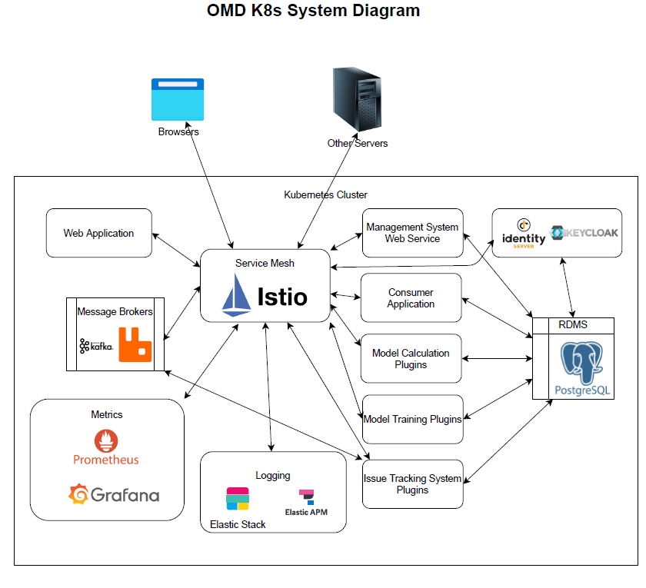

**Mitigation plan:** When looking for a new solution to problems, we will always consider whether there is a step that can be added to the pipeline. In the Pipeline steps, disaster plans should be made to continue where the problems are resolved or to continue where they left off. Performance monitoring and error tracking should be possible.

|  |
| --- |
| **3. Preprocessing Modules** |

Preprocessing modules play a crucial role in preparing and transforming raw data into a suitable format for training machine learning models. They encompass a range of techniques and operations that help improve the quality of the data and enhance the model's performance. In our project we will continue Preprocessing Modules design and implementation based on best practices which are described below.

● Data Cleaning

● Feature Scaling

● Feature Transformation

● Encoding Categorical Variables

● Text and Natural Language Processing (NLP) Preprocessing

● Feature Extraction and Dimensionality Reduction

● Handling Imbalanced Data

● Time Series Data Preprocessing

● Pipeline Integration

**Mitigation plan:** The datasets that OMD project partners use to train their models are real-life data specific to use cases. Meetings will be organized for partners to share their experiences and understand the impact of the datasets on the targeted model performance.

|  |
| --- |
| **4. AI Modules** |

AI models are composed of various modules that work together to perform specific tasks. These modules can include components related to data processing, feature extraction, learning algorithms, decision-making, and more.

● Data Collection and Preprocessing Modules

● Feature Extraction and Transformation Modules

● Learning and Training Modules

● Decision-Making and Inference Modules

● Optimization and Fine-Tuning Modules

● Evaluation and Performance Metrics Modules

● Deployment and Integration Modules

● Monitoring and Maintenance Modules

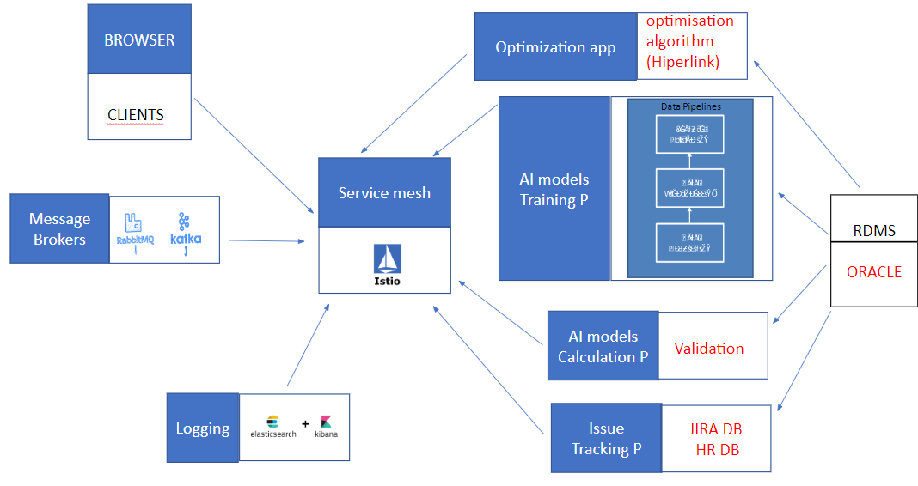

**Mitigation plan:** The OMD architecture has multiple sources and multiple target systems. Work is ongoing to create a common architecture body. The common architecture body provides a distributed data streaming, fault-tolerant, horizontally scalable and flexible architecture. The main challenge is to integrate, in an efficient way, different techniques and proposals existing at the academic level to a specific field and use case. The extensive experience of the development team in this field mitigates almost entirely this risk. Another potential risk is associated with the integration of results into the OMD framework at the international level. In this regard, the consortium aims to generate a set of flexible APIs - reference patterns - that allow easy connection and disconnection of services. The software architecture follows a microservices-based approach. Microservices are small, independent applications that can be developed and deployed individually by dedicated teams, making it easier for OMD's multidisciplinary teams to work on research activities in parallel.

* + 1. Top 4 issues

|  |
| --- |
| **1.** **1. Preprocessing Challenges** |

***Details***:

Teams encountered unforeseen complexities, like missing values, inconsistent data formats, and noisy data have been more prevalent than initially estimated. Many labels need to be organised in a meaningful manner.

***Impact***:

The teams have had to spend additional time identifying, understanding, and rectifying these data issues, which has resulted in delays. More resources have been directed towards preprocessing.

***Mitigation action***:

Organising training sessions for the team to understand and handle data inconsistencies and challenges better.

|  |
| --- |
| **2. Model Performance Issues** |

***Details***:

There are too few data points and the label distribution is heavily imbalanced that limits the model performance. Different feature sets may be needed in a single data source.

***Impact***:

The task specific fine tuning of LLMs and the performance of the resulting models are limited. Selecting the optimal multimodal feature set is a time-consuming task.

***Mitigation action***:

To boost performance, augment with multimodal features. Integrate structured/unstructured data. Predict top-3 or top-5 outputs for stability and accuracy. Apply rule-based corrections for output.

|  |
| --- |
| **3. Emergence of ChatGpt** |

***Details***:

The AI industry has seen a surge in the utilization of Large Language Models like ChatGPT. These models have set new benchmarks in various tasks.

***Impact***:

It's crucial for our project to establish unique selling points and functionalities that distinguish our product.

***Mitigation action***:

To obtain shortcuts by using LLMs. Identifying niche areas or specific applications where our AI project can offer added value or a unique solution compared to existing LLMs.

|  |
| --- |
| **4. Architecture Implementation Problem** |

***Details***:

Affinity of partners is Affinity of partners is widely variable. Especially, after having decided each to deploy their own servers, development focuses more and more on singular use-cases.

***Impact***:

Content management and documentation less aligned or change harder to manage in execution, with the missing information. Those shared tasks remain postponed and will require more coordination.

***Mitigation action***:

Technical response, prioritisation and teamwork to be strengthened. Project direction committee and the technical team need to be in close cooperation. We also defined a dissemination committee.

* + 1. Status of deliverables

|  |
| --- |
| **[Planned] What is the total number of deliverables in the project?** |

There are twenty-four deliverables defined in the overall project.

|  |
| --- |
| **[Planned] How many deliverables are supposed to be finalised (from the start of the project until the end of this reporting period)?** |

The following deliverables are supposed to be finalised below.

|  |  |
| --- | --- |
| D1.1 - Project Progress Report - PPR1 | Jun 2022 |
| D2.1 - State-of-the-art Analysis | Jun 2022 |
| D2.2 - Scenarios and Use cases | Jun 2022 |
| D2.3 - Legal, ethical and Acceptance analysis | Sep 2022 |
| D2.4 - Requirement analysis | Sep 2022 |
| D3.1 - General system architecture | Dec 2022 |
| D1.2 - Project Progress Report - PPR2 | Dec 2022 |
| D1.3 - Project Progress Report - PPR3 | Jun 2023 |

|  |
| --- |
| **[Actual] How many deliverables have already been finalised (from the start of the project until the end of this reporting period)?** |

We finalised the following eight deliverables.

|  |  |
| --- | --- |
| D1.1 - Project Progress Report - PPR1 | Jun 2022 |
| D2.1 - State-of-the-art Analysis | Jun 2022 |
| D2.2 - Scenarios and Use cases | Jun 2022 |
| D2.3 - Legal, ethical and Acceptance analysis | Sep 2022 |
| D2.4 - Requirement analysis | Sep 2022 |
| D3.1 - General system architecture | Dec 2022 |
| D1.2 - Project Progress Report - PPR2 | Dec 2022 |
| D1.3 - Project Progress Report - PPR3 | Jun 2023 |

|  |
| --- |
| **[Delayed] Are there any deliverables delayed more than 2 months in this reporting period? If so, please explain why.** |

There is no delayed deliverables.

* + 1. Statement on project progress during the reporting period

In both General Assemblies in this period (hosted by Experteam and Caretronic) we discussed the integration and revised the direction of the project. Technical progress and partners roles in terms of WP leadership revised. We have all deliverables opened by partners. Technical Progress of the third period involves POCs and machine learning model developments.

StG review and national evaluations (biannual) were successfully completed. Risk management played a key role in linking the project. We have determined the potential paths of integrating the product. The PCA was signed and submitted. FTP has left the consortium after presenting with the team in StG review. They have finalised and shared a demo before their exit.

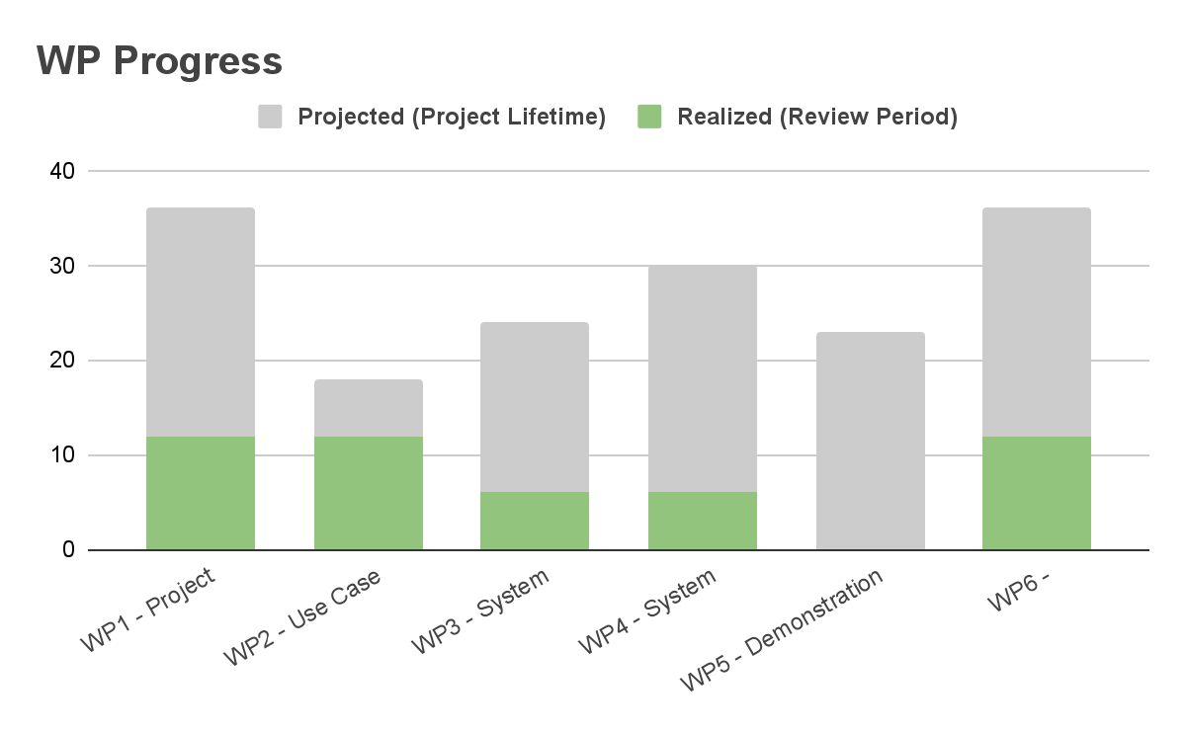

Three out of seven milestones are achieved. WP1 is 40% complete, with three reports on the national and international side. WP2 has reached 1st and 2nd Milestones; being ready technically 90% and with 80% WP progress, to be closed in the fourth period. WP3 has progressed 40%. WP4 is 5 to 10% completed, and WP5 showed only 5% progress. In WP6 we have 30% technical and 40% WP progress, with 9 dissemination activities and some exploitable results.

|  |  |  |
| --- | --- | --- |
| **ID** | **Description** | **Month of completion** |
| MS1 | Specification of use cases, State-of-the-art Analysis.  Deliverable D2.1, D2.2 are released. | M6 |
| MS2 | Definition of requirements.  Deliverable D2.3, D2.4 are released. | M9 |
| MS3 | Definition of general system architecture.  Deliverable D3.1 is released | M12 |
| MS4 | Specification of evaluation metrics.  Deliverable 5.1 is released. | M28 |
| MS5 | System Architecture Design and AI Models Development, System Development and Integration, Realization of Use Cases tasks outputs.  Deliverable D3.2, D3.3, D3.4, D4.1, D4.3, D5.2 are released. | M30 |
| MS6 | UI and Reporting Interfaces Development, Integration, Test, and Validation tasks outputs.  All use cases successfully installed with OMD.  Deliverable D4.2, D4.4, D5.3 is released. | M36 |
| MS7 | OMD Dissemination and exploitation tasks.  Deliverable D6.1, D6.2, D6.3 are released. | M36 |

* 1. Details of progress per Work Package

#### WP 1: Project Management

Coordinating the consortium, communications management (National, International, Internal), scope and time management, risk management, resource management, configuration management, reporting were amongst the management efforts realized by Experteam in this third reporting period.
  
Two international face to face meetings were held. The first one being GA Istanbul organized by Experteam. Technical progress and partners roles in terms of WP leadership revised. We have all deliverables opened by partners. The second one was in Slovenia. Here also the meeting was managed towards StG review, as a prep, roles were distributed to partners in terms WPs and use-case focused in accordance with ITEA format.
  
Risk management meeting was held on technical progress.
  
The PCA was signed and submitted.
  
Around 30 actions were solved.
  
Email and other groups were managed. We continue managing and leading the preparation of national and international reports as well as presentations.

#### WP 2: Use Case Requirements and Business Models

In WP2, the Deliverable 2.4 Requirement Analysis Document is uploaded in this reporting period. In this deliverable, all functional and non-functional requirements of OMD Framework are defined for covering all 9 domains with different use cases including software support, justice, healthcare, consumer electronics, e-commerce, telemarketing, manufacturing, logistics, and software development. Overall project-level key results and use case key results are also defined for different use cases. In the Business Models part, a market assessment has been made in order to recognize the market positioning of our project and our competitors and given in the StG review. Potential users and potential placeholder of market analysis are determined for each use case. Progress of WP2 is discussed in General Assembly meetings which take place on March 2023 in Istanbul and on June 2023 in Slovenia.

#### WP 3: System Architecture Design and AI Models Development

3.1 - General system architecture
  
The OMD framework that will be produced in this project will rapidly contribute to many industries by effectively using AI models to improve service as a CSM approach. The OMD Framework, which will carry the necessary features and configurations for use in the markets mentioned above, has been determined with a general system architecture that can be used by every market. While preparing this general system architecture, it was prepared based on the microservice architecture. Services and modules that form the backend of the system to be developed, and artificial intelligence models and services the general structure of the connections is indicated as an outline.
  
3.2 Data Pipelines and Preprocessing Design
  
This task includes design of models for data acquisition from data sources such as databases for structured and unstructured data, establishing data pipelines, and data preprocessing modules which is of critical importance for the quality and the performance of machine learning models. This includes Speech-to-Text development to transform speech into textual format so that we can apply NLP models.
  
External data is collected to help the model provide accurate predictions when the amount of information provided by the client is not rich enough. Even if the client provide a lot of useful variables it is always helpful to possess this external data that helps modeling the target population.
  
Data sources are obtained through a process of investigation which webs contain potentially useful information and the viability of obtaining this data.
  
If a web page is considered to contain needed information then a crawler must be built for this source. Each crawler is different and must be personalized for each web page. These crawlers scrap the webs retrieving all information recursively.
  
Web pages usually deny requests from the same source/ip if a big amount is received in a short period of time. This makes the process of scraping a web terribly slow, therefore a pool of proxies is used to be able to perform a big number of requests in a short span of time.
  
Once this data is collected it must be cleaned and transformed into a tabular format so that it can be stored in a SQL structured database. Once again this module is independent for each data source, since the way their data is structured is totally independent. This process can be quite elaborated as it will be seen later.
  
The different data sources are updated with different periodicities. Weather predictions must be refreshed every day while data published by the tax office is updated once a year. Therefore each pipeline has its own cron job which triggers its execution.
  
3.3 - AI Models Design For Structured DataThis task involves designing AI models and microservices to process structured data, which is acquired and preprocessed from structured data sources such as relational database management systems and data lakes. These data can include clustering/segmentation, classification, time-series analyses and numeric prediction models.
  
AI models combine information from very different sources in two models with different purposes.
  
These models are not generic and are trained independently for each client, since each client provides their own data about their customers.
  
AI module has different purposes but since they have a lot of common data loading, data preprocessing, model usage operations… they are all build in a single module which can be launched with different objectives depending on the params passed.
  
The models are trained using the external data obtained previously from public sources and the data provided by the client. This data can contain information about the customers, past purchases, phone interactions, complaints…
  
3.4 -Optimization Models Design
  
This task includes the design of overall optimization system and use case specific models based on the largest common intersection of all use case restrictions related to time, budget, and load of the overall system as well as individual agents.

#### WP 4: System Development and Integration

Regarding this WP, we open the deliverables in our shared drive.
  
We also insert the contributions.
  
D.4.1 Data Pipelines and Preprocessing Modules Description
  
D.4.2 AI Modules
  
D 4.3 Optimization Modules
  
D 4.4 User Interface & Modules Integration.
  
The main objective of WP4 is the iterative and incremental implementation of the overall system framework and the modules of the OMD system to meet the project requirements based on the design in WP3. It involves the process of implementing for the OMD best practices and developing a framework, that can serve the needs of different use cases with the common goal of an optimal assignment of the demands to the resources.
  
Following WP3, this work package covers the implementation of a comprehensive set of tools to build the overall OMD framework, which covers data connection pipelines and preprocessing, UI and reporting interfaces (T4.2), AI models including supervised and unsupervised ML models that work on structured and unstructured data, and optimization models (T4.3), as well as the development of the general system framework and the integration of different modules (T4.1).
  
We held online meetings to organize and coordinate this WP.
  
In our last physical meeting, in Slovenia, we handed over the leadership of this WP.

#### WP 5: Demonstration

Work Package 5, an integral component of our project, officially kicked off its activities in January 2024. This milestone marks the beginning of an exciting phase that promises significant advancements and breakthroughs. It's important to note that even before this official commencement, we have already demonstrated a successful use case from Portugal, setting the stage for the remarkable developments yet to come.
  
   
Amid the preparations and meticulous planning that have gone into this phase, we eagerly anticipate the highly anticipated WP5 demonstration. Scheduled for January 2024, this demonstration holds immense importance in our project timeline. It serves as a pivotal moment when we will unveil the concrete outcomes of our collective efforts and showcase the innovative solutions we've tirelessly developed.
  
   
Work Package 5 embodies a critical juncture in our project's evolution, and our commitment to delivering exceptional results is unwavering. Every step we take aligns with our project's overarching objectives and vision. We firmly believe that through collaboration, innovation, and our steadfast dedication, we will achieve remarkable milestones and, most importantly, make a meaningful and lasting impact.
  
   
As we draw closer to the WP5 demonstration in January 2024, we acknowledge that continued support and active participation from all stakeholders are invaluable. Together, we will work tirelessly to realize our project's goals and set the stage for an inspiring and unforgettable demonstration of our collective achievements.

#### WP 6: Dissemination&Exploitation

XT:
  
As the leader of the international consortium, Experteam (XT) coordinates the communication and dissemination. For this , the organization holds regular online meetings and on-site meetings. During this period, 2 general assemblies were organized in Istanbul and Slovenia. Istanbul general assembly was hosted by Experteam. In Slovenia, the general assembly was chaired, the total of dissemination activities were determined for the international consortium.
  
   
Creation of datasets, the analysis of data, the preparation of it for the model, and the evaluation of the results of the experimental first applications with ml algorithms in the sample dataset and the use scenario. With the sample data set, a model in which the completion times of the requests from the customer is estimated has been studied and experimental results have been obtained. Comparative algorithm bundles were determined by testing regression models for the sample scenario.
  
A paper presented at an international conference was produced from these model studies.
  
“Yıldız, M., Alsaç, A., Ulusinan, T., Gancope of the studies:iz, M. C., & Yenisey, M. M. (2022, September). IT Support Ticket Completion Time Prediction. In 2022 7th International Conference on Computer Science and Engineering (UBMK) (pp. 198-203). IEEE.”.
  
ITEA project brochure approved. Within the scope of dissemination studies, preparations for the second publication (Data Noise Reduction-Regularization) have started.
  
   
ALL: The project web page was created with the domain “http://https://omdproject.com/” and published and announced to all stakeholders. As a result of the feedback received, the domain name of the web page was determined and all entries created specifically for the project were added to the web page and published for viewing by all national and international partners.
  
The paper titled "A Survey: Tree-Structured Topic Modeling Methods in After Sales Customer Problems Domain", whose full-text writing was completed as a result of the review of the literature studies carried out in the 2nd work package in the project, was accepted by the ICONDATA 2022 conference and presented at the conference within the scope of dissemination activities.
  
Studies have been carried out on the standardization of common architecture and use cases.
  
   
Experteam; The paper titled “IT Support Ticket Completion Time Prediction” was accepted by the UBMK 2022 conference and presented at the conference as part of its dissemination activities.
  
   
Doğuş Technology; The paper titled "A Survey: Tree-Structured Topic Modeling Methods in After Sales Customer Problems Domain" was accepted by the ICONDATA 2022 conference and presented at the conference as part of its dissemination activities.
  
   
FTP/ISEP; The paper titled “Chatbot Architecture for a Footwear E-commerce Scenario” was accepted by International Conference DCAi 2022 and presented at the conference within the scope of dissemination activities. In addition, the website https://omd.ftpporto.com/ was established to promote the OMD project.
  
   
FEA/USZ; News was published in the Hungarian press for the promotion of the project. https://u-szeged.hu/sztehirek/2023-januar/gepi-tanulasi-modellek
  
   
https://szegedma.hu/2023/01/szoftverhibak-javitasat-segito-megoldason-dolgoznak-szegedi-kutatok
  
   
https://www.szegedon.hu/szeged-hirek/jovo-technologiai-projektek-szegeden
  
   
https://www.delmagyar.hu/helyi-kozelet/2023/01/mesterseges-intelligencian-alapulo-rendszer-fejleszteseben-vesz-reszt-az-szte
  
   
https://itcafe.hu/hir/szte_szoftverhibak_projekt.html
  
   
In addition, OMD was introduced on the website of the University of Szeged-Project Management Directorate.
  
   
Caretronic; The OMD project and HealthCare use case were presented at the following events:
  
Medica Dusseldorf in Germany in November 2022
  
Arab Health Dubai in January 2023
  
Health Technology at HIMMS USA, April 2023
  
AltenPflege Germany April 2023
  
   
BEIA; The OMD project and HealthCare use case were presented at the following events:
  
scewc 2022
  
GoTech 2022
  
Innoweit Weeks 2022
  
Hanover Messe 2023
  
Forum Production 2023
  
   
BACK; A website has been prepared to promote the OMD project.
  
https://omdproject.com/

* 1. Per partner progress during the reporting period
     1. Partners’ main contribution and effort

|  |  |  |  |
| --- | --- | --- | --- |
| Partner | Planned effort (Project start~ end of reporting period) | Actual effort (Project start ~ end of reporting period) | Contact |
| FTP - Com. Equip. Inf. Lda | 4.39 | 4.39 | Germano Fernando Santos Pinto |

|  |  |
| --- | --- |
|  | Main contributions during the reporting period: Our contributions have focused on completing the tasks thet we set out to do.  Our national funding ended on June 2023. We have developed the e-commerce recommended system in our use case provider.  As WP4 leaders we execute the system development and Integration based on the design in WP3.  We completed all the tasks allocated to WP4 and inserted the contributions into the deliverables.  We also handed over the leadership of WP4 to another partner, since our participation ended in June |

|  |  |  |  |
| --- | --- | --- | --- |
| DOGUŞ BILGI ISLEM VE TEKNOLOJI HİZMETLERİ | 1.73 | 1.74 | Setenay Gemici |

|  |  |
| --- | --- |
|  | Main contributions during the reporting period: The data set, consisting of customer complaints, solution reports, and brand-model matches, was enriched and finalized with synthetic data produced with the GPT-3.5 Turbo language model.  Two methods, BM25 and BERT, were tested for pre-processing. Due to the limited size of the dataset and the computational cost of training from scratch, it was decided to use a pre-trained transformer model.  Finally, the model will be fine-tuned on Samsung data and evaluated by classification metrics. |
|  | Discrepancy explanation: don't have discrepancy explanation |

|  |  |  |  |
| --- | --- | --- | --- |
| University of Szeged | 0.90 | 1.03 | László Vidács |

|  |  |
| --- | --- |
|  | Main contributions during the reporting period: USZ develops language model-based AI tools to automate the assignment of developers to issue tickets in the Software Development use case. Both structured and unstructured data sources are used for model training from the issue ticketing as well as version control systems. An early version of a knowledge graph built from the available data is also designed, which later will be used to obtain all necessary data for model training or update as well as the developer profiling information. |
|  | Discrepancy explanation: The slight increase of the actual effort is mainly due to the task complexity issues. In particular, more machine learning experiments were performed than planned in order to achieve state-of-the-art performance. |

|  |  |  |  |
| --- | --- | --- | --- |
| FrontEndART Software Ltd. | 0.79 | 1.06 | Tibor Bakota |

|  |  |
| --- | --- |
|  | Main contributions during the reporting period: The first contribution of FEA in this reporting period is an analysis (performed by a subcontractor) of the UK, German and Hungarian software development market for potential users of the OSMTA models. The business plan will be aligned with the findings. Second, FEA developed and continuously upgraded its data extractor modules to extract various data from its databases. USZ made use of the extracted data in its experiments to create the OSMTA model. |
|  | Discrepancy explanation: The discrepancy between the planned and actual effort is caused by the previous reporting period, where the replacement of the planned developer with a less experienced colleague and a deeper dive into architecture planning raised the actual effort well beyond the plans. In this period we could reduce the cumulative overspending due to the utilization of the work done in the previous period, yet, it is still above the plans. |

|  |  |  |  |
| --- | --- | --- | --- |
| Experteam | 2.46 | 2.46 | Demet Seyhan |

|  |  |
| --- | --- |
|  | Main contributions during the reporting period: Main contributions of Experteam in this third period were project management (national / international), dissemination and completion time prediction for resolving tickets, by using ML algorithms.  In the prediction of completion time we use the following algorithms / regression models: logistic regression, support vector regression, decision tree regression and random forest regression. To predict the completion time we use regularization.  We ran another market research this semester. |
|  | Discrepancy explanation: no discrepancy |

|  |  |  |  |
| --- | --- | --- | --- |
| Strategy Big Data | 5.34 | 5.33 | IGOR CASADO MORENO |

|  |  |
| --- | --- |
|  | Main contributions during the reporting period: AI/ML models scaled effectively for improved performance and efficiency>  This application takes information about potential buyers from a database and tries to predict their propensity to make a purchase. So we take information about potential buyers to try to predict their propensity to make a purchase.  Research of purchase prediction methodologies  To make this propensity model, we have studied several technologies associated to purchase probability prediction, socio-cultural profile. |
|  | Discrepancy explanation: There have been no significant discrepancies with respect to the initial planning. |

|  |  |  |  |
| --- | --- | --- | --- |
| ARD GROUP | 2.93 | 2.02 | Arda Ödemiş |

|  |  |
| --- | --- |
|  | Main contributions during the reporting period: As WP2 leader, ARD made contributions to the review meeting and carried out analysis studies for score programming on the data set of 30,000 rows. In WP4, data packages for a customized selection of texts to represent three different classes (law, medicine, and software) according to different domains were created. The training was held on a total of eight models consisting of machine learning and deep learning methods. The OMD web page has been revised, and publications and meetings added. |
|  | Discrepancy explanation: Our actual effort is given 2.02 PY for this reporting period as our national funding gives 6.25 PY to us for project totally. |

|  |  |  |  |
| --- | --- | --- | --- |
| BEIA GmbH | 1.68 | 0.55 | George Suciu |

|  |  |
| --- | --- |
|  | Main contributions during the reporting period: WP1: Beia participated in the planned online meetings.  WP2: Beia worked on state of the art analysis. Beia worked on the definition of the assigned use-case and on the test scenarios of the OMD platform for this use-case. Also, we started working on the business model for the targeted market.  WP3: BEIA worked on time-critical cloud architecture and models for timeseries from IoT/telemetry logs.  WP6: Beia continued to disseminate the OMD project at various events. |
|  | Discrepancy explanation: BEIA hasn't received funding for this project yet. We are looking for international and national R&D calls (2023/Q4 and 2024/Q1) with a subject similar to the OMD project for which we should receive funding. Until then, we are making minimal efforts within the project, but fulfilling the assigned tasks. |

|  |  |  |  |
| --- | --- | --- | --- |
| Hiperlink Eğitim İletişim Yayıncılık Gıda San. Paz. ve TIC. LTD. STI. | 1.60 | 1.60 | Hilmi Oğuz |

|  |  |
| --- | --- |
|  | Main contributions during the reporting period: |

|  |  |  |  |
| --- | --- | --- | --- |
| Instituto Superior de Engenharia do Porto (ISEP) | 3.85 | 8.00 | Goreti Marreiros |

|  |  |
| --- | --- |
|  | Main contributions during the reporting period: ISEP participated in all of the project’s meetings, and contributed to the project's reports and other management activities. ISEP contributed to all the open deliverables from the perspective of the Portuguese use case.. ISEP developed a recommendation engine based on Machine Learning models to generate recommendations in footwear industry. ISEP and FTP developed the recommend4you demonstrator, that was presented in the review meeting and also in a dissemination workshop. |
|  | Discrepancy explanation: The Portuguese Consortium is only funded until mid 2023, so there was a need to increase the effort. |

|  |  |  |  |
| --- | --- | --- | --- |
| Caretronic d.o.o. | 5.00 | 5.00 | Simona Brezar |

|  |  |
| --- | --- |
|  | Main contributions during the reporting period: Improvements in this reporting period contribute to a more efficient and advanced system for managing medical personnel and maintenance tasks (BLETools tool for managing and upgrading the BlueTooth network). The project thus continues with progress, which has contributed to improving the quality of nursing care and the operational efficiency of maintenance. |
|  | Discrepancy explanation: |

* + 1. Actual vs. planned effort overview

|  |  |  |
| --- | --- | --- |
| Report | Planned effort up to reporting period (PY) - total: 72.07 PY | Reported actual effort up to reporting period (PY) |
| 2023 Semester 1 | 30.64 (43% of total) | 33.18 |
| 2022 Semester 2 | 17.47 (24% of total) | 23.52 |
| 2022 Semester 1 | 8.74 (12% of total) | 9.37 |

1. Additional feedback to previous STG remarks (optional)

**To STG reviewers**: This chapter is meant to provide additional information on the status of actions, in addition to the information on the online action tool (the information is exported on the Excel file). The project consortium uses this chapter to provide longer and more detailed information that are too exhaustive for online action tool and the Excel export.

Following project actions are solved in this 2023 first period report H1 and in ITEA Portal.

**Action Number : ACTION-020**

Description: Please improve the next 4 technical targets for next PPR and especially update mitigation plans as they are weak.

Explanation: The next four technical targets are improved in this PPR above, along with mitigation plans.

**Action Number: ACTION-018**

Description: The description of Risk#2 should be improved; Risk#4 is unclear and should be improved.

Explanation: BEIA is working self-funded as the administrative capacity is still under evaluation by the funding agency FFG for applying to Basis program, although BEIA has demonstrated its capacity already with projects funded in Austria, including by other FFG programs. The contributions have been limited to BEIA's own use case. Other funding sources and business cases are being investigated by BEIA team.

**Action Number: ACTION-045**

Description: If you have any results (e.g. tools) that can already be publicly exploited outside the consortium, please report this on the project area on the ITEA Community website under Management/Exploitable results. These results will be published on the ITEA public website.

Explanation: FTP Porto’s national funding program ended in June 2023, so we completed our use case. We’ve shared our DEMO with ITEA. Here we posted the link to it. https://youtu.be/BIFf8rH0JjU

We have one scientific paper released - Chatbot Architecture for a Footwear E-Commerce Scenario.

https://link.springer.com/chapter/10.1007/978-3-031-38333-5_22

Also have another publishing on going - E-commerce platform with a chatbot for the footwear industry.

**Action Number: ACTION-041**

Description: Consider to provide video’s to the ITEA Office for publication through the ITEA Office communication channels (social media, magazine, newsletter).

Explanation: https://youtu.be/BIFf8rH0JjU

Here is the link of Portugal use case DEMO.

**Action Number: ACTION-038**

Description: Provide your feedback on this review and fill in the survey that is issued after the review.

Explanation: We have filled in the survey.

|  |  |  |  |  |
| --- | --- | --- | --- | --- |
| 1 | Exploitation | New product | Multi-domain assignment tool | 2 |

|  |  |
| --- | --- |
| Summary | The tool will be able to combine data from different sources across multiple domains. It will generate assignments based on the selected domain information and platform. This tool will be particularly useful for users who work across multiple domains, as they will be able to create assignments based on data obtained from various domains. |
| Impact | The described tool can bring significant benefits to the companies, such as increased efficiency, improved customer satisfaction, competitive advantage, and potential for expansion. (quantification: 0) |
| Partners | Experteam, Hiperlink Eğitim İletişim Yayıncılık Gıda San. Paz. ve TIC. LTD. STI., DOGUŞ BILGI ISLEM VE TEKNOLOJI HİZMETLERİ, ARD GROUP |

|  |  |  |  |  |
| --- | --- | --- | --- | --- |
| 2 | Exploitation | New product | AI/ML models scaled effectively for improved performance and efficiency. | 1 |

|  |  |
| --- | --- |
| Summary | The proposed approach involves agents and user preferences to assign tickets based on related goals in different use cases. |
| Impact | Develop and Improvement new models (quantification: 0) |
| Partners | Experteam, Hiperlink Eğitim İletişim Yayıncılık Gıda San. Paz. ve TIC. LTD. STI., DOGUŞ BILGI ISLEM VE TEKNOLOJI HİZMETLERİ, ARD GROUP |

|  |  |  |  |  |
| --- | --- | --- | --- | --- |
| 3 | Exploitation | New standard | Alpha version of purchase propensity models. | 1 |

|  |  |
| --- | --- |
| Summary | This application takes information about potential buyers from a database and tries to predict their propensity to make a purchase. The model is trained based on past behavior of buyers and takes in account their past interactions.  The model’s input comprises three data sources:  - Client’s information: Adress, Sex, etc.  - Client’s past purchases  - Past calls to the clients |
| Impact | Mejorar estrategia de ventas (quantification: 0) |
| Partners | Strategy Big Data |

|  |  |  |  |  |
| --- | --- | --- | --- | --- |
| 4 | Exploitation | New standard | Research of purchase prediction methodologies | 1 |

|  |  |
| --- | --- |
| Summary | State of the art studies and analysis of the different existing technologies associated to:  - Techniques and methodologies associated to purchase probability prediction.  - Techniques and methodologies associated to the generation of socio-cultural profile of potential customers.  - Techniques and methodologies associated with the prediction of rapport and mood. |
| Impact | Improving sales strategy, % (quantification: 5) |
| Partners | Strategy Big Data |

|  |  |  |  |  |
| --- | --- | --- | --- | --- |
| 5 | Dissemination | Conference | Footwear E-commerce chatbot System architecture | 2 |

|  |  |
| --- | --- |
| Summary | In this paper we describe the system Architecture that we are proposing to the Footwear E-commerce use case |
| Impact | (quantification: Confidential) |
| Partners | Instituto Superior de Engenharia do Porto (ISEP) |

|  |  |  |  |  |
| --- | --- | --- | --- | --- |
| 6 | Dissemination | Workshop | Architecture and Optimization problem discussed | 1 |

|  |  |
| --- | --- |
| Summary | We made workshops for architecture and the optimization problem for the whole consortium to agree on one general scheme that involves all |
| Impact | 1 optimization partner and 8 use-case owners are involved in this one, led by Doğus, Hiperlink and Experteam (quantification: 9) |
| Partners | Experteam, Hiperlink Eğitim İletişim Yayıncılık Gıda San. Paz. ve TIC. LTD. STI., DOGUŞ BILGI ISLEM VE TEKNOLOJI HİZMETLERİ |

|  |  |  |  |  |
| --- | --- | --- | --- | --- |
| 7 | Exploitation | New service | Agent and product matching system for marketing | 2 |

|  |  |
| --- | --- |
| Summary | In OMD, SBD will provide new mechanisms to improve the profiling of demographic and geo-referenced data sets with potential customers. |
| Impact | New models will be generated to infer mood and socio-economic status of customers and agents, and to predict affinity (relationship, socio-economic status) (quantification: 0) |
| Partners | Strategy Big Data |

|  |  |  |  |  |
| --- | --- | --- | --- | --- |
| 8 | Exploitation | New product | Optimal Software Maintenance Task Assignment module | 2 |

|  |  |
| --- | --- |
| Summary | Based on the AI model developed for Optimal Software Maintenance Task Assignment, an OMD software module will be implemented (either as a library or a deployable subsystem). |
| Impact | The module will enable the integration of Optimal Software Maintenance Task Assignment feature into the management systems of the FrontEndART. (quantification: 100) |
| Partners | FrontEndART Software Ltd. |