

International Performance Measurement
and Verification Protocol
(IPMVP®)
—
Measurement & Verification and Flexibility
Application Guide

INTERNATIONAL PERFORMANCE MEASUREMENT AND VERIFICATION PROTOCOL (IPMVP®)
Measurement and Verification & Flexibility Application Guide

DECEMBER 2026
EVO 10090 – 1:2026

© 2026 Efficiency Valuation Organization (EVO). All rights reserved. This document may not be reproduced or altered, in whole or in part, and may not be used or disseminated, in whole or in part, in connection with any commercial training course or seminar, whether in hard copy, digital, or other forms, without EVO’s prior written consent.
v 1.0

FOREWORD
Once upon a time….

Acknowledgments

TO BE COMPLETED LATER

Rajvant Nijjar (Flex Committee Chair, iVEES & BankEnergi)
LinkedIn: (25) 💎Rajvant Nijjhar💎 PMVE | LinkedIn

Ana Soares (INESCC / University Coimbra).
Ana Soares | LinkedIn

Touray, Haddijatou (SSE plc)
Haddijatou Touray MIET | LinkedIn

Sergio Leon (ESCo, Mexico)
Sergio Leon Marquez | LinkedIn

Thomas Yeh (NYSERDA)

Andrea Lanna Siemens

Vibhor Bhatnagar (Abu Dhabi National Energy Company)
Vibhor Bhatnagar | LinkedIn

Javier Espinoza (Grupo INGESA)

Sandeep Kachhawa (AEEE)
Sandeep Kachhawa | LinkedIn

Chandan Sarkar (Sustainability & ESG Consultant
Chandan Sarkar | LinkedIn

Lucas Born

Masoud Bashari - Edgecom

Reviewers
- UKPN
- NYSERDA
- Flex Assure
- Lind, Leandro, (via Sergio)

Table of Contents
1. BACKGROUND AND INTRODUCTION 9
1.1. Approach: 9
1.2. Who is this guide for? 9
1.3. Why do flexibility? 9
1.4. Fit to IPMVP 10
2. Energy Markets and Flexibility Trading 11
2.1. Energy Trading 11
2.2. Flexibility Trading 12
2.2.1. Role of Aggregators or FSPs 12
2.2.2. Grid Management 13
2.3. Energy Markets Case studies 13
2.3.1. Costa Rica: 13
2.3.2. India: 13
2.3.3. United Kingdom: 14
2.3.4. Italy DSO level 14
2.3.5. Italy TSO level 15
2.3.6. IESO (Ontario, Canada) – The Industrial Conservation Initiative 15
2.4. Settlement of trades - considerations 16
2.4.1. Procurement contracts 16
2.4.2. Settlement of trades in multiple markets and with multiple parties 16
3. Implementing Flexibility 18
3.1. Identifying Flexible Loads 18
3.2. Flexibility metrics 19
3.3. Revenue Potential 19
3.4. Trading in flexibility markets 20
3.5. Summary of Flexibility Approach 21
3.6. Case Studies 22
3.6.1. BankEnergi and Market Optimisation 22
3.6.2. SSE and Demand Flexibility Service, Retail sector, National Markets 23
3.6.3. NYSERDA (New York) and DLM programme 23
3.6.4. Energy Flexibility in Agriculture – The AgriFlex Project, Portugal 24
3.7. Integrating Flexibility studies with Energy Audits and ISO standards 26
4. Measurement and Verification Approaches 28
4.1. Standard Baselining Methodologies and examples for Implicit events 29
4.1.1. Example 1 – System use charges in UK 29
4.1.2. Example 2 – Peak demand shifting in a Cold Chain Storage, Mexico 30
4.1.3. Example 3 – Integrating Implicit Flexibility in an Energy Performance Contract: Belesco (Belgium) Commercial offices in Portugal 31
4.1.4. Example 4 — Capturing Savings in Granular Peak Windows Using a Time-of-Week-and-Temperature (TOWT) Model: Power TakeOff’s Virtual Commissioning Program 32
4.2. Standard Baseline Methodologies and examples for Explicit events 33
4.2.1. Example 1 – Asset Capacity (ref FMR-SBM) 33
4.2.2. Example 2 – Fixed Reference 34
4.2.3. Example 3 – Nomination Baseline 35
4.2.4. Example 4 – Recent History 36
4.2.5. Example 5 – Zero baseline: 40
4.3. Typical DERs and Implicit /Explicit baseline types to consider. 41
4.4. Operational Verification 42
4.4.1. The use of facility logs 43
4.5. Common issues 44
4.5.1. User behaviour 44
4.5.2. Infrastructure Readiness and Legacy Installations 45
4.5.3. Gaming 45
4.5.4. Rebound effect 46
4.5.5. Carbon savings 46
5. Metering and controls 47
5.1. Minimum Metering Standards for Load Management 47
5.2. Types of Meters for Flexible Load Applications 47
5.3. Aggregated portfolios metering 47
5.4. Data Communication and Integration Requirements 48
5.5. Controls for Flexible Load Management 49
5.5.1. Automated Demand Response and Load Control Strategies 49
5.5.2. Use of Metering and Control for Verification and Settlement Processes 49
5.5.3. Regulatory Compliance and Market Integration 49
5.5.4. Cost of data acquisition 49
6. 6.0 Uncertainty 51
6.1. Sources of Uncertainty 51
6.2. Quantifying Uncertainty in Flexible Load Measurement 51
6.3. Evaluating Baseline Uncertainty 52
6.4. Mitigating and Managing Uncertainty 55
6.5. Integrating Uncertainty Considerations into Energy Markets 56
6.6. Risk Mitigation Strategies for Market Participants 56

Glossary of acronyms
ASHP Air Source Heat Pumps
AHU Air Handling Unit
BACnet Building Automation Control and Network
BESS Battery Energy Storage System
BSP Bulk supply point – see also GSP
BM Balancing Mechanism
BMS Building management system
CHP Combined Heat and Power
DC Dynamic Containment
DSR Demand Side Response
DNO Distribution Network Operator
DSO Distribution System Operator
DFS Demand Flexibility Service
ESO Electricity System Operator e.g. NG ESO
GSP Grid Supply Point
HHD Half hourly data
ISO Independent Systems Operators.
MPAN Meter Point Administration Number
NMF Neutral Market Facilitator
PV Photovoltaic
P2P Peer to Peer
RPA Revenue Potential Assessment
SSEN Scottish and Southern Energy Networks
SCADA Supervisory control and data acquisition
TSO Transmission System Operator
WSHP Water Source Heat Pump

Terms & Definitions

Term | Definition
Bilateral Trading | Bilateral transaction means a transaction for exchange of energy (MWh) between a specified buyer and a specified seller
BM: Balancing mechanism | Trading in the last half hour and to balance the grid. This would be energy trading on markets such as Nordpool and EPEX. Trading can be Intra-day (during the day) or DA – Day ahead.
BM start up | On-the-day access to additional generation Balancing Mechanism units (BMUs) that would not otherwise have run.
BMU | Balancing Mechanism Unit set in units of 1MW.
BSC | Balancing and Settlement Code - Code of operation (like a memorandum of understanding) that is administered by Elexon for the settlement of trading post event.
CM levy | Introduced in 2017 - a charge based on consumption during the biggest winter peak.
CM or Capacity market | This the amount of available capacity (kW) according to the UK's power stations, that is available for the country. Auctions for CM are held 4 years ahead.
Elexon | Quasi NGO affiliated to the National Grid that set industry codes and regulations such as the BSC.
Energy Trading | Intraday, Day ahead or longer term (e.g. 3 months, 2 years) energy deals between one or more parties. Trading is usually bi-lateral. Longer term trading might be accompanied by insurances by a third party
FFR and EFR: Firm or Enhanced frequency response | Service to provide frequency response within seconds to keep the Grid frequency s close to 50Hz (UK) (Note: other countries may operate at 60Hz). FFR is post fault with a three second response and EFR is pre-fault with a one second response – also known as Dynamic Containment or DC.
Imbalance settlement | Process of reconciling an individual party’s imbalance positions following the end of a trading period and post National Grid ESO’s use of balancing mechanism tools to balance the electricity system in real time.
LEO Sustain peak management | Demand down and or generation up during Mon - Fri 15.00 - 19.00. Mid May to Mid Sept. 12 hours’ notice period.
LEO Secure DSO constraint management | Demand down and or generation up during Mon - Fri 09.00 - 17.00. Mid July to Mid Sept. 4 hours’ notice period.
LEO Dynamic DSO constraint management | Demand down and or generation up. 24 hours. 30 mins notice period.
LEO Sustain Export peak management | Demand up, generation down (taking excess from grid or using more at site level). Mon to Fri 10.00 - 14.00 and Mon - Sun 02.00 to 06.00. 12 hours’ notice.
Peer-to-Peer | Trading bilaterally with two counterparties. In the LEO context, this is on headroom or capacity.
Private wire | Direct electrical connections made between two parties to facilitate the flow of electricity. These wires and connections are not maintained by the DNO or DSO but by the private entity. There are therefore also no network charges to be borne.
PPA or Power Purchase Agreement | Bi-lateral agreement to purchase energy directly from a generator to a user.
Route to Market Provider (RTMP) | Organisations such as FSPs that can trade and access energy and flexibility markets. This could also be direct access to the Neutral Market Facilitator.
Short term operating reserve (STOR) | Service that provides additional active power from generation or demand reduction. A STOR provider must be able to offer a minimum of 3MW or more of generation or steady demand reduction, deliver full MW within 240 minutes or less from receiving instructions from National Grid and provide full MW for at least 2 hours when instructed
Sleeving | Direct agreement between an electricity consumer (importer) and a generator (exporter). This is also known as ‘virtual network' or 'third party netting'.
Time of Use (ToU) Tariff | Electricity tariff where the charge made for using electricity changes depending on the time of day. A “static” ToU Tariff has set times of day when charges differ and is typically used to encourage people to reduce their electricity use at times of regular peaks in demand. A dynamic ToU Tariff does not have set times of day and the charges depend on how much it costs to generate electricity at any given point.
Wholesale markets / Energy trading | Requiring a membership fee for participation - this works on day to day trading of the capacity markets a few months ahead of anticipated demand. Both this and the BM work best when a site can support batteries of a few hundred kW.

BACKGROUND AND INTRODUCTION
This guide, developed by EVO’s Committee on M&V for Flexibility, aims to establish globally recognized best practices for Measurement and Verification (M&V) in the emerging domain of energy flexibility services. It addresses how to measure and verify the performance of projects where energy consumption or generation is adjusted to support the grid—a topic increasingly important as renewable energy grows and electricity systems seek more demand-side agility. For the purposes of this guide, a “Grid Flexibility Project” refers to any initiative in which a facility’s normal electricity usage or on-site generation is deliberately modified (e.g. reduced, shifted, or temporarily increased) in response to external signals to provide a service to the electric grid. In practice, this could mean curtailing a factory’s load during a peak demand hour, shifting a building’s HVAC usage to soak up excess solar generation at midday, or dispatching a battery or generator when requested by a network operator.

Approach:
The approach to the development of the guide is via international committee of experts with experience in both M&V and flexibility services. Reference is made to global best practices and to create parallels to the IPMVP, via the use of international case studies.
Many DNOs/DSOs/TSOs are currently developing their own guides to baselines, with a global standardized approach to be delivered. We reference those organisations that have advanced in baselining and explain the practical similarities and differences to the baselines created under Options A to D of the IPMVP.

Who is this guide for?
This guide is primarily to support energy auditors and M&V professionals that might need to create baselines for the purposes of flexibility trading but can also be used by:
- Market operators such as DNOs, DSOs, ISOs and TSOs in the promotion of their markets and supporting market participation
- Energy co-operatives supplying energy at scale.
- Energy bill payers interested in participating in energy and flexibility markets
- Energy managers and energy auditors
- EVO subscribers
- M&V Professionals ascertaining the flexibility delivered for settlement purposes.
- Software providers of Virtual Power Plants
- Aggregators or Flexibility Service Providers participating in energy and flexibility markets

Why do flexibility?
DNOs/ DSOs/ TSOs procure flexibility (demand turn up or turn down) to manage local grid constraints, thereby deferring the need for immediate capital-intensive infrastructure upgrades. To make financial settlement of a trade, baselines provide proof of delivery of flexibility. Reasons for flexibility include:
- Matching supply to demand is increasingly becoming difficult including the over-supply of renewable energy at the wrong time of day to match demand.
- EVs, intermittent generation from Solar PV and wind means that the grid is struggling to balance both over production of energy and increased energy demand.
- Organisations would like to include flexibility in their pathway to Net Zero.
- Growing economies means that the grid is further constrained, and grid connection agreements might be restricted by DNOs
- EU directives such as Smart Readiness Indicator are also encouraging change and directing organisations to make use of buildings as Virtual Power Plants.
- There is physical limitation to the wires and transformers that made up the power grid. It is quite expensive to design these systems to operate at maximum load during peak times. It is more effective to optimise the use of the network during peak times.
According to the Carbon Trust (2025), the size and scale of the UK flexibility market alone is estimated to be 1 to 2 billion pounds by 2030.

Fit to IPMVP
The IPMVP Core concepts already lays out four options that can be used to evaluate energy savings from energy efficiency projects, energy performance contracting or from an energy management system. They are either at the retrofit level, or whole facility level.
When it comes to flexibility trading, baselines tend to be shorter and tend to be considered in terms of:
- In front of the meter - Explicit events such as response to a signal from a marketplace.
- Behind the meter - Implicit event in which energy consumption is shifted in response to an energy price signal. This is also sometimes referred to as load shifting.
When considering explicit baselines, these can still be viewed as either retrofit isolation or whole facility approach.
- At the whole facility level we can use utility meters for most recent history baselines.
- At a retrofit boundary we can use nomination baseline approach, or a zero baseline with a meter e.g. battery energy storage delivery.
A third approach is also used, which is akin to deemed savings (not IPMVP) for example, in profiles of EV chargers. This is a modelled approach of predicted usage.
For energy baselines developed as part of an energy management system (implicit), usually weather is changing routinely enough to create a baseline from one year of data. For energy baselines in the explicit sense, the most recent history considers the last typical 5 or 10 days (e.g. the last 5 Mondays) as an average consumption. Here, extreme weather conditions, or prior flexibility events are often removed as non-routine adjustments.

Energy Markets and Flexibility Trading
This next section explains the various global markets that are currently either in development or developed when it comes to energy and flexibility trading. An energy supplier needs an energy supply licence to trade energy; a Flexibility Services Provider (FSP) does not require a licence to trade energy assets into flexibility markets albeit the landscape around this is changing.
Strategic insight is often provided by an FSP as to which are the best energy and flexibility markets to trade, and which can maximise revenue. Note: Private wire agreements or Power Purchase agreements are bi-lateral agreements between a supplier and off-taker. For purposes of simplicity, we do not discuss these, since they are very specific to the nature of the contract.

Energy Trading
Energy trading markets are organized sequentially, progressively narrowing the uncertainty between generation, demand, and network availability from long-term planning down to real-time operation. Energy Trading typically involves:
- Long-term procurement contracts.
- Shorter-interval spot market trading.
- Balancing mechanisms used by system operators to match real-time supply and demand.
- Market structures including wholesale, bilateral, and retail trading.
Figure 1 provides some insights into European energy markets, normally under the remit of the TSO.
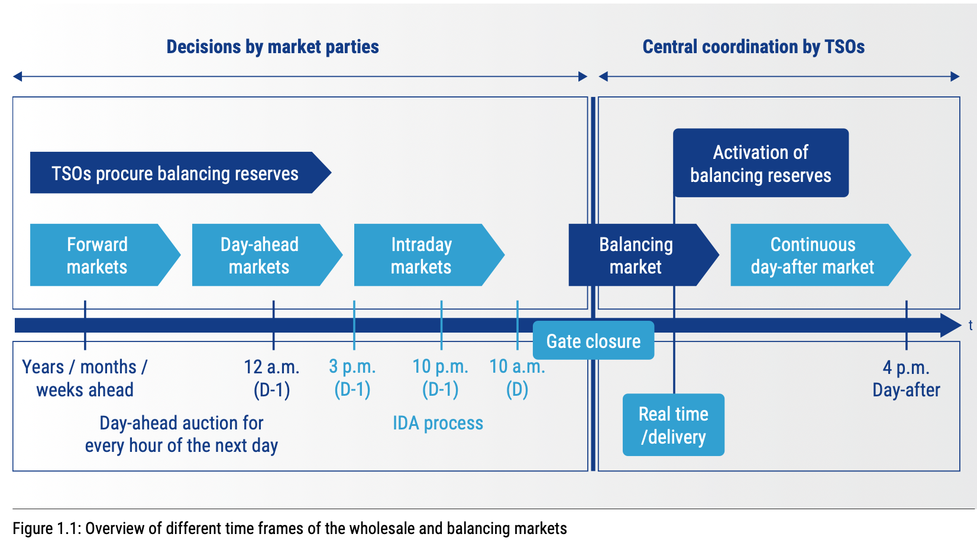
Figure 1: Overview of different time frames of the wholesale and balancing markets — ENTSO-E Market Report 2025

Typical energy trading markets and timeframes:
When it comes to the value derived in energy trading, these normally are focused on the short-term (bearing in mind, the bulk of energy supply might have already been procured by an energy supplier 3 months to years ahead). These markets (limited to energy suppliers and licensed operators) include:
- Day-Ahead Market: One day prior to delivery (D-1), Balancing Responsible Parties (BRPs) submit hourly energy bids. The result is a binding economic dispatch schedule based on forecasted demand and the merit order of bids. Transmission System Operators (TSOs) ensure sufficient cross-border capacity is available to support these trades.
- Intraday Market: Following the day-ahead clearance, TSOs recalculate cross-zonal transmission capacities (e.g., IDA2 and IDA3). Power exchanges use these updates to enable trading adjustments across bidding zones up to one hour before delivery.
- Balancing Mechanism: After gate closure, TSOs assume responsibility for real-time supply and demand matching to keep system frequency within the synchronous operating range. Balancing Service Providers (BSPs) offer reserves to activate based on system needs.

Flexibility Trading
Flexibility trading leverages the capacity of Distributed Energy Resources (DERs)* and can cover:
- Demand-side response (DSR) mechanisms (turn up means using excess network energy to increase energy uses in the DER/energy assets or charging a battery; turn down means reducing demand or discharging a battery). This can be at either the DNO/DSO level or TSO level in markets such as Demand Flexibility Services.
- Participation in ancillary services (e.g., fast frequency response, reserve services, voltage response) to respond to other grid constraints such as network voltage or frequency drops. This is normally responded to within sub-second timeframes and requires battery energy storage systems directly controlled in response to these markets.
* E.g. residential EV chargers (8–10 kW), commercial HVAC systems, and industrial refrigeration.

Role of Aggregators or FSPs
Middleware entities, commonly referred to as aggregators, can act as facilitators gathering individual flexible demand-side. Acting as facilitators between end-users and markets / grid operators, aggregators can collect and manage the end-user’s flexibility in the utilization of energy resources and combining it into a system asset. The scope can vary from participation in the provision of ancillary services, including load frequency control, which can be used by other power system entities, to the scheduling of resources while considering economic and environmental objectives. Since individual resources cannot contribute to flexibility services on their own due to limited capacity and controllability, this aggregation plays an essential role.
Once a portfolio of flexible energy resources is built, the aggregator can adopt different approaches to manage those resources to address various objectives. The main difficulties lay on the definition of appropriate regulatory frameworks and the creation of conditions for the massification of energy flexibility services (Mlecnik et al., 2020).
There are two main definitions of aggregators:
- Demand aggregators that negotiate more advantageous contracts with retailers on behalf of a large group of consumers by making the most of the scale effect. They can also be known as energy brokers.
- Aggregators that combine multiple energy loads from different consumers or assets within a building. They can also be known as creating virtual power plants.
These service providers may aggregate portfolios to maximise revenue gains since certain markets have minimum entry thresholds of 1MW or 3MW etc. These entities group multiple behind-the-meter assets (e.g., residential loads) to form coordinated portfolios. They enable smaller assets to participate in markets through demand response programs offering upfront or performance-based incentives.

Grid Management
It is important to understand voltage levels when providing flexibility services since the TSO operates at 400kV to 132 kV sub-station level; and the DSO/DNO at 132kV or below – usually, 11kV. At this level, energy assets are usually large-scale battery or DERs or commercial and industrial customers. At the domestic level, large-scale aggregation of home EV chargers, as an example, whilst at the 230/ 240 Voltage level, can have impact at the 11kV in aggregation.

Energy Markets Case studies
The variety of energy and flexibility markets is illustrated in the following global case studies.

Costa Rica:
In Costa Rica, a tariff Structure exists for industrial/commercial sectors that segments the day into Peak, Off-Peak, and Night hours to incentivize load shifting. In addition, aligning with the National Decarbonization Plan, companies certifying an Energy Management System under ISO 50001 receive preferential rates (e.g., TMT-b Tariff).

India:
Advanced digital solutions ensure real‑time interoperability with grid operation systems, while the adoption of blockchain‑based certification and smart contracts guarantees secure, transparent, and tamper‑proof settlement of both technical performance and economic remuneration.
India is undergoing a structural shift from passive distribution management to active demand flexibility, driven by the dual challenges of high renewable energy penetration and surging peak cooling loads. While traditional Time-of-Use (ToU) tariffs have long served as the primary mechanism for demand management, the landscape is rapidly maturing through the following pillars:
- Regulatory Transition: India is moving beyond voluntary measures toward mandatory Demand Flexibility Portfolio Obligations (DFPO). State regulators, most notably in Maharashtra, have introduced formal regulations setting quantified flexibility targets—such as a 7% flexible demand goal to be achieved over five years—which effectively treat demand-side resources as dispatchable grid assets (MERC, 2024).
- Active Grid Management: Distribution companies are evolving into Distribution System Operators (DSOs). In this role, they act as neutral coordinators—much like a traffic controller—who balance and integrate local energy sources like rooftop solar, batteries, and electric vehicles to keep the local grid stable and support energy trading (IIT Delhi et al., 2023).
- Technological Leapfrogging: Supported by a massive national smart meter rollout, India is prioritizing Automated Demand Response (ADR) to bypass the limitations of manual behavioral programs. Evidence from a 2025 pilot in Delhi demonstrated that ADR can achieve load reductions of up to 78% for specific residential appliances, proving that automation provides a more reliable and scalable resource for grid stability than manual intervention (AEEE & Schneider Electric, 2025).
- Market Enablers: New frameworks are defining the role of Flexibility Service Providers (FSPs) and third-party aggregators. These entities are authorized to pool diverse loads—ranging from residential ACs to EV fleets—into tradeable portfolios, allowing small-scale consumers to participate in grid balancing and frequency response services (AEEE, 2022; IIT Delhi et al., 2023).
- Incentive Dynamics: Recent behavioral studies in urban India suggest that for automated systems, the level of financial incentive has a negligible effect on the load reduction achieved once the "convenience barrier" is removed. This suggests that the value of DR in India lies more in seamless automation and identifying habitual energy wastage than in high-payout incentive structures (Khanna et al., 2024).

United Kingdom:
The DFS is a National Level (TSO) service introduced in Winter 2022/23, albeit local DNO level markets had become into operation a few years earlier. This service requests energy users to scale back consumption during grid constraint periods. Registered providers submit weekly baseline and settlement data via an assessment platform, with operational baselines calculated using the P376 industry methodology.
The ancillary services market, also operated by the UK National Grid ESO, where the TSO procures these services to maintain safe, efficient grid operation. Participants apply through tenders (years or day ahead), with technology eligibility dictated by service requirements. Common services are:
- Frequency Response maintains system frequency at ~50 (or 60) Hz (deviations >1% risk damage). Services operate on a second-by-second basis using fast-ramping assets like batteries, controlled by inverters.
- Capacity markets are where reliable sources of energy such as battery and demand side response measures can be provided as an alternative to power stations
- Voltage Regulation keeps voltage within 5% of standard levels (e.g., 400 kV, 275 kV, 132 kV) to ensure stability.

Italy DSO level
The RomeFlex project is a pilot initiative developed by the DSO for the City of Rome, aimed at enabling and operationalizing local flexibility services on the medium‑ and low‑voltage distribution network. RomeFlex is designed to support the transition toward active distribution networks and smart grids, capable of accommodating increasing electrification, DER, and non‑programmable renewable generation. The project establishes Rome as a large‑scale real‑world testbed for advanced DSO‑driven flexibility procurement and activation mechanisms.
From a market design perspective, RomeFlex introduces a two‑layer local flexibility market architecture managed in cooperation with the Italian energy market operator (GME). The framework combines long‑term capacity auctions, through which Balancing Service Providers (BSPs) are remunerated for committing the availability of flexibility resources over periods of approximately one year, with short‑term operational markets (Local Day Ahead – LDA, and Local Intra‑Day – LID). These short‑term market sessions allow the DSO to procure specific flexibility products - both upward and downward - in response to forecasted network needs, such as congestion management and voltage control, while enabling BSPs to improve their economic bids or participate opportunistically even if not awarded in the long‑term auction phase.
On the technological side, RomeFlex relies on a fully digitalized and automated end‑to‑end infrastructure covering market operation, service activation, measurement, and settlement. The platform supports the participation of a wide spectrum of distributed resources - including small residential assets and large industrial installations - either individually or in aggregated form.

Italy TSO level
Italy (TSO – Terna, 2021 pilot for reactive power): In Italy, where reactive power provision has traditionally been mandated rather than openly traded, the TSO (Terna) launched a pilot program to competitively procure voltage regulation services (reactive power support) on the transmission network. In 2021–2022, Terna held auctions to contract power plants – including thermal generators and wind farms connected to the high-voltage grid – that were not already obliged by grid codes to provide reactive support. Winning bidders received three-year contracts with an annual availability payment (a premium in €/MVAr per year) in exchange for upgrading their facilities and delivering reactive power (absorbing or injecting MVAr) on request. This formal procurement, authorized by Italy’s regulator (ARERA) under Resolution 300/2017, aimed to expand the pool of resources capable of voltage control in line with EU requirements (ENTSO-E “Requirements for Generators” code) and to evaluate a future market-based approach to reactive power flexibility. Each contracted unit underwent pre-qualification testing and is continuously monitored; Terna verifies that the resource’s reactive power output and local voltage response match the instructed set-points during service activation, ensuring the promised MVAr support is delivered when needed.

IESO (Ontario, Canada) – The Industrial Conservation Initiative
The Industrial Conservation Initiative (ICI) is a cost-allocation mechanism run by Ontario, Canada’s Independent Electricity System Operator (IESO). Rather than dispatching or paying participants, it reallocates a non-commodity charge (Global Adjustment (GA)) according to each customer's share of the province's five highest-demand hours (“coincident peaks”) over a 12-month base period.
Participants are targeted by load size (termed “Class A”) and qualify by average monthly maximum demand, ranging from over 5 MW (auto-enrolled) down to 500 kW for manufacturing and greenhouse operations. A customer's metered load during the five coincident peak hours divided by the province-wide total in those hours (Peak Demand Factor (PDF)) sets their share of GA cost for the following year. Because GA can be 60–70% of a large industrial bill, a meaningful PDF reduction flows straight through to lower total cost. These cost reductions can be in the range of $350,000 - $400,000 per sustained 1 MW reduction across all five coincident peaks. Such significant cost benefits prove to provide the grid with significant capacity benefits. Response to these events is estimated to reduce summer peak demand in Ontario by around 2,000 MW, nearly 10% of grid demand.
What makes ICI distinctive as an M&V problem is that it informs participation, rather than defining it:
- The five peak hours are confirmed after the fact, and can fall on any non-holiday weekday (typically hot summer afternoons). They are not reliably predictable more than a day ahead.
- Participants forecast likely peak hours (via the IESO's public Peak Tracker or third-party prediction services) and act on their own standing cost exposure rather than a dispatch signal (Implicit Baseline).
- M&V of performance during predicted peak hours allows customers to understand and forecast their energy costs. It also informs curtailment strategies and tolerance as the opportunity cost of lost production can also be quite significant.
Because the exact peak hour is uncertain, most participants run a tiered curtailment strategy: low-disruption shedding (non-essential lighting, secondary HVAC) on any forecast day, and deeper, production-affecting curtailment reserved for days they are confident will land in the top five, weighing avoided GA cost against the cost of lost production.

Settlement of trades - considerations
Flexibility events might occur once a day, several times a day, or not at all, according to the market procurement mechanism.

Procurement contracts
Much like energy markets, or indeed, financial markets, flexibility trading is moving towards shorter timeframes and windows. Trades can be set a day ahead and delivered on the day within a 2 - 4 hours window for call out. When a DNO/DSO/TSO models or predicts that there are many market providers that can compete, they are likely to use this mechanism.
Other contracts can be longer term in which the procurer pays for both availability and utilisation when a grid event is required. E.g. a short-term summer contract might require availability from Monday to Friday 9am to 5pm, with only say 10 actual events being called upon (usually when the weather is predicted to be at an extreme).
DERs that are traded into one market, but whose trade price is not accepted, might be placed into other energy and flexibility markets.
This is still an emerging marketplace and there is likely to be greater collaboration between the DNO/DSO and TSOs to allow multiple market stacking without causing conflicts.

Settlement of trades in multiple markets and with multiple parties
A consequence of multiple events stacked in multiple markets and with potentially multiple parties in aggregated trading portfolios, is robust baselines to use to settle trades.
Each procurer (DSO/DNO/TSO) will have their own methods and methodology for baselines and non-performance penalty clauses. In this guide, we can only make the reader aware of the baselines being used by the parties and ask the reader to consider consequences of stacking DERs in multiple energy and flexibility markets.
Usually, allowance is made for non-routine adjustments once a flexibility event has occurred. I.e. the drop (or increase) in kW delivered can be extracted from the baseline.
Shorter baseline periods are also used as a result – such as last 5 or 10 days (longer data may need to be retained since this is the last typical 5 or 10 days. E.g. the last 5 Mondays).
Gaming is also a consideration to procurers, where a provider of Flexibility deliberately increases the baseline prior to an event. However, this might be a legitimate reason for doing so, I.e. you are over-cooling a building prior to turning down the cooling at the required delivery time. Or indeed, once you have turned down cooling for the period of half an hour (or the required delivery timescale), then you have to increase the cooling after the event, to bring the room temperature conditions back to operating normal conditions.

Implementing Flexibility
This section provides users of this guide with some practical guidance on identifying and implementing flexibility in energy and flexibility markets.

Identifying Flexible Loads
A flexible asset / DER is an electrical energy using plant or equipment whose use can be time-shifted or reduced without compromising a facility’s needs. The type of flexible loads depends on the facility type e.g. residential, commercial or industrial, hospital, data centre, leisure centre etc. It is common for facilities, especially residential buildings, to be aggregated into the total demand of a set of facilities with flexible loads.
Typical DERs and assets might include:
- Residential – EV chargers and home battery energy storage devices. To have impact at an 11kV level or above, then series of EV chargers can be aggregated. These assets are usually maintained and controlled by energy suppliers that can place strategic tariffs to encourage users of EV chargers to either charge or stop charging.
- Commercial offices – Typical DERs are AHUs, electric heating and cooling, refrigeration, chillers, pumps and motors (non-critical to a facilities operation) etc.
- Industrial – large-scale industrial plant, HVAC, chillers, cooling, electric heating, etc.
- Hospitals – back-up generators (that need to be run for maintenance purposes, can be run at the same time as a flexibility event), battery energy storage, non-critical pumps/motors/ AHUs and HVAC.
- Leisure centres – Heating and cooling, AHUs, battery energy storage, ASHP, WSHP etc.
The following are suggested good sources of information that can be utilised for identify flexible loads for trading DERs in energy and flexibility markets.
- Half hourly data will support realistic assumptions around flexible loads
- Loads to be analysed at the summer and winter peaks should include recovery times
- Using weather files, the seasonal impact of flexibility can be established.
- Design philosophies, nameplate ratings, meter drawings, building data, AutoCAD drawings, O&M, plant schematics, metering schematics, operational control philosophies can be used.
- Modelling assumptions or building thermal models.
- Information on Building management systems
- Assessment of monitoring and controls needed or additional metering
- Review of any battery energy management systems or other renewable energy systems and their control philosophy.
Sources of flexibility should be non-critical to the building operations E.g. Battery, AHUs, refrigeration, thermal energy storage etc. Energy assets in this context are the various equipment, systems, and resources which are owned or accessed by end-users to produce, consume, or store energy that can be used for flexibility trading.
It’s important to understand that flexibility can be:
- Turning down non-critical items or equipment so that energy consumption is reduced. E.g., a DNO-procured service for 200kW of flexibility might comprise of 120kW of battery used behind the meter, and 80kW of equipment being turn off at the same time. This drop will be measured against a baseline or against a metered usage.
- Turning up demand through the absorption of excess energy from the grid. I.e. heating the pool a little warmer or charging the battery when there is excess grid energy.
- Using battery ‘behind the meter’ so that grid generated energy can be offset with generation at site. This is also sometimes referred to as load shifting where the battery is charged overnight at a cheaper tariff and used during the day when it is more expensive.
- Using battery ‘in front of the meter’ for more pooled or wider balancing reasons.
- Exporting to the grid, energy generation from battery where export licences exist. This may require connection upgrades to be made.
- Demand Peak response to avoid costly peak demand charges.

Flexibility metrics
To place a trade in flexibility markets, it is important to understand key flexibility metrics. Many DERs and energy assets could be assessed for the potential to trade, based on these criteria, as part of an energy audit of a facility. This would enable facilities to become VPPs.
- kW Flexibility: The amount, in kW, that can be provided as flexibility e.g. demand turn up or demand turn down. This value may change over seasons, for example, an ASHP might have a different coefficient of performance over the summer compared to the winter.
- Response time – how much notice is needed to respond to a market signal (one day ahead, 4 hours, two hours, 30 mins, 1 second, sub-second etc.).
- Run rate – how long the flexibility will need to be run for. The run rate is determined by how long an energy asset can be turned off, or indeed, generate energy onto the grid. E.g. a battery might have a one hour run rate, an Air Handling Unit might have half an hour. This all depends on the size of the battery (can be longer run rates), and the criticality of the supply. An Air handling unit might be calculated to be able to be turned off for only half an hour (usually the minimum in a market), before the Carbon Dioxide conditions erode and does not meet building air quality standard.
- Recovery time – how long does the facility have to recover to normal building operations before the next flexibility event can be run. The recovery time will determine time periods between one flexibility event, and the ability of another. E.g. a battery might need to be re-charged overnight with a cheaper tariff or be charged up directly by Solar PV if connected to such a system. An AHU might need say a period of 4 hours to bring the building up to normal operating conditions. During this time, the energy asset is unavailable for trading. Beware of the bounce back effect – which is the additional make-up energy used to bring the facility back to normal operating conditions.

Note: Please also consider start-up modes and whether frequent start/ stops will affect the maintenance of the plant and equipment. E.g. do pumps need priming. Can turn down work instead of turn down.

Revenue Potential
To determine the revenue potential, consider:
- The availability of energy markets (are you in a grid constraint zone)
- How many flex events are expected in the period the markets are open
- What are the market prices and number of competitors
- The development of a strategy that allows stacking without compromising delivery.
- Market deployment strategies to deploy into the next market, if an asset is not fulfilled.
- Choosing the markets are most attractive (local or national) since it might not be possible to enter into multiple markets at the same time
- The impact on the baseline if entering multiple markets - baselines might be reduced in one market following a flexibility event and therefore when averaging the last 5 days, this baseline will be lower than usual.
- Your ability to track baseline changes if an asset is fulfilled, and to ensure that flexibility can be delivered against baseline.

Trading in flexibility markets
To trade in a flexibility market, the procurer normally will ask for pre-qualification criteria to be achieved (hence an aggregator is normally used). There must also be a process in place, either manual or automatic, to respond to a market call. If operating in the Fast Frequency Response sub-second market, this will need to be a direct signal directly to the frequency inverter of a battery, since response time needed is sub-second. Otherwise, a manual process can also work if there are site staff available to turn off equipment (potentially turn up) in the timeframe needed.
Accompanying energy data is needed to demonstrate the kW drop or turn up during the flexibility event for settlement.

Summary of Flexibility Approach
To summarise, a good place to start is in the assessment of non-critical loads, and their ability to be controlled / responded to for a flexibility event call-up. The assessment of loads on site, could be as part of an energy audit. Once the loads are identified, assess their turn up / turn down potential, any seasonal variations, and an estimate of the total site kW potential. Some assumptions might need to be made on use to provide estimates of “High”, “Medium”, and “Low” flexibility over the seasons, as well as run rate and recovery times. Once these metrics have been identified, either work directly with the energy markets, or use the power of aggregation, an aggregator or FSP. Figure 2 below depicts this process.
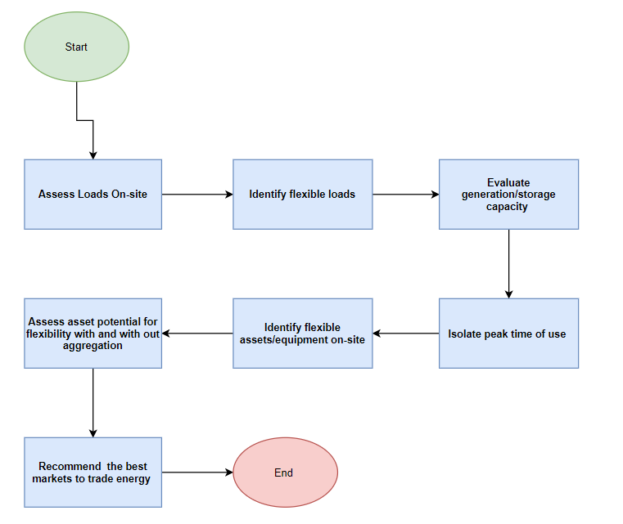
Figure 2: A typical process to apply for identifying flexibility potential for trading

.

Case Studies

BankEnergi and Market Optimisation
BankEnergi was contracted to undertake a study on 5 leisure centres with a City Council.
The aim of the study was to identify and understand flexible assets, costs entailed to make them tradeable in flexibility markets (local constraint and National markets), and what if any were the limitations and to ultimately provide the potential revenue that can be generated during different times of the year.
Such opportunities include:
- Peer to peer trading on capacity headroom
- DNO/DSO -procured flexibility (the local distribution network operator, SSEN procuring flexibility during a grid constraint event to prevent a brown out)
- National energy markets (a minimum aggregation size in a Balancing Mechanism of 1MW is needed)
The further aim of the study is to understand the recovery times of these flexible assets in the winter and summer peaks, given a 1 degree drop in temperatures. Whilst most facilities have wet and dry side (indoor pools), there was an outdoor pool that only operates from April to Sept and the Ice Rink is an Olympic standard ice rink with long operating hours late into the night (2 am on occasion) and a 6am start.
The flexibility that was identified was determined via building physics modelling that gave a seasonal range of variation (low, medium, high kW flex) for various energy consuming plant:
- Ice rink: a) chillers flexibility range 65 – 102kW and b) AHUs range from 32-51kW.
- Outdoor pool (April to Sept only) Battery 120kWe, WSHP range 120- 161 kW.
- Leisure centre 1 with wetside – Battery 120 kWe, AHUs 47-70kW, ASHP 19-28 kW.
- Leisure centre 2 with wetside – Battery 300 kWe. AC units 7kW, ASHP/AHU combined 33-77kW.
- Leisure centre 3 with wetside – Battery 180 kWe, AHUs 96- 118 kW. ASHP 88-108 kW.
kW flexibility was determined through thermal models using IES software and Transys for the pools and ice rink. With these models it was possible to determine the following run rates and recovery times:
- Ice rink (30/180 mins chillers, 120/60 AHUs).
- Outdoor pool – battery 60/90 mins. WSHP 120/300 mins.
- Leisure Centre 1 – Battery 60/90 mins, AHUs 120/90 mins, ASHP 120/330 mins.
- Leisure centre 2 – Battery 60/90 mins, AC units 60/90 mins. ASHP/AHU 120/90 mins.
- Leisure centre 3 – Battery 60/90mins, AHUs 120/90, ASHP 120/90.
The kW flexibility would have been noted against submeters as an explicit to a signal from the Market Platform of the DNO. Gaming was not considered, nor on the radar of the Council in the questions they asked for the consultancy work.
Due to the range of possible call up events, the total revenue for 30 events/ 30 hours were estimated to be £57k. Up to a max number of events of 150 events/ 150 hours of £140k per annum.
Flexibility revenues could only be derived when the flexibility markets were open. There was not enough aggregation to enter National markets at 1MW since the sites were split across 3 Grid supply points.

SSE and Demand Flexibility Service, Retail sector, National Markets
The UK National grid introduced DFS to reduce the demand at certain times during winter when commercial actions are insufficient to cover demand and upwards margins.
SSE Energy Solutions serves as a provider to deliver DFS. Last winter, we had several customers participate in the DFS where the customer is required to scale back their consumption when the energy supply is anticipated to be strained to alleviate pressure and maintain stability on the grid. This case study summarizes the outcome from one of our department store customers over a 1-hour participation.
The DFS methodology is an explicit process where baseline methodology strictly follows ESO standards. The participant delivered the DFS by turning off non-essential systems, mainly HVAC for the duration of the DFS. No site energy generation, the site was fully dependent on import.
This example includes a total of three sites, each with 2 import MPANs, and a DFS participation of two 30 minutes intervals a day.
This was under the solutions team, not the distribution side of the business.
A total of 865.5 kW was delivered to the grid for a duration of 1 hour (from 17:30 to 18:30).
Participation in this service is solely during the winter hence no seasonal variation is considered.
The participant delivered the DFS by turning off non-essential systems, mainly HVAC for the DFS duration. No site energy generation, fully dependent on import. Reduction (settlement) is calculated by measuring actual demand relative to a baseline. The difference between the baseline and the actual is credited as the delivery.
The delivery period was from 17:30 to 18:30 with a 30-minute participation window.
The baselines were explicit (responding to an external signal). The process strictly adheres to the guidelines and standards published by the ESO for selecting baseline and submitting settlement data. The baseline import meter read is taken a week before the DFS participation window to calculate the operational baseline according to the P376 industry methodology.
Providers submit customer Unit Meter Points daily or when there are changes to the portfolio, to the ESO via an API.

NYSERDA (New York) and DLM programme
Consolidated Edison (Con Edison) introduced the Dynamic Load Management (DLM) program as a strategic initiative designed to enhance grid reliability and efficiency through innovative demand response mechanisms.
The DLM program consists of two primary components:
- Term-DLM Program: A day-ahead peak shaving initiative where participants commit to reducing load during specified periods with at least 21 hours' notice. Contracts span 3 to 5 years, offering participants long-term price certainty.
- Auto-DLM Program: A rapid-response program requiring participants to provide load relief with just a 10-minute notice. This component is designed for critical peak load scenarios and also involves 3 to 5-year contracts.
A Key Differentiation from Conventional Demand Response Programs is that Traditional demand response programs, such as Con Edison's Commercial System Relief Program (CSRP), typically operate on shorter-term contracts and provide participants with less revenue certainty. The DLM program differentiates itself through:
- Long-Term Contracts: Offering 3 to 5-year agreements provides participants with predictable revenue streams, encouraging investment in advanced technologies like energy storage systems.
- Enhanced Performance Requirements: Particularly in the Auto-DLM program, the requirement for a 10-minute response time necessitates the deployment of sophisticated energy management solutions, ensuring rapid and reliable load relief.
- Higher Compensation but Stricter Performance Criteria: DLM programs provide higher incentives than CSRP or Distribution Load Relief Programs (DLRP), but they also impose stricter performance standards, requiring more reliable load reduction.
A critical component of the DLM program is its Performance Evaluation and Payments structure, which ensures that participants meet their contractual obligations. Participants are assessed based on their ability to deliver the committed load relief during events.
Penalties for Non-Performance include:
- Annual Reservation Payment Reduction: The annual reservation payment is directly tied to the participant’s Average Seasonal Performance Factor. If performance falls below expectations, the reservation payment is reduced accordingly.
- Financial Penalties for Poor Performance: If an aggregation’s Average Seasonal Performance Factor falls below zero, the participant may face financial penalties, which could be deducted from their earnings or invoiced separately.
- Termination for Chronic Underperformance: If a participant's performance remains consistently low, Con Edison reserves the right to terminate their aggregation contract early, forcing them to pay exit fees and forego future participation.
- Early Exit Fees: Participants wishing to reduce their committed load relief can do so by paying an Early Exit Fee, calculated as:
Early Exit Fee = Incentive Rate($/kW) × Deficient Quantity(kW) × Remaining Contract Years × 10%
This fee ensures that participants remain accountable for their commitments and cannot withdraw from the program without financial consequences.

Energy Flexibility in Agriculture – The AgriFlex Project, Portugal
In the agricultural sector, flexibility has not yet been sufficiently studied, and its real potential remains largely unknown. The increasing integration of renewable energy sources creates greater variability and uncertainty in electricity generation, making it necessary to align electricity demand more closely with production. Agriculture may offer relevant flexibility resources, including irrigation motors, water reservoirs, ventilation systems, refrigeration equipment, decentralised renewable energy generation and electricity storage. These resources can potentially be managed in a more flexible way, allowing this type of installations to adjust electricity consumption according to photovoltaic generation, electricity prices and grid needs
The AgriFlex project conducted between 01/06/2023 and 31/12/2025 focused on the role of energy flexibility in supporting the energy transition in the agricultural sector. One of the main objectives was to improve the competitiveness, resilience and sustainability of agricultural activities by promoting the use of renewable energy, increasing energy efficiency, reducing electricity costs and enabling farms to provide flexibility services to the electricity grid.
AgriFlex addressed the fact that many agricultural processes and loads, such as the ones related to irrigation, greenhouse climate control, refrigeration and other electricity-intensive activities, can potentially be managed in a more flexible way. The idea behind was that by adjusting energy consumption according to the availability of renewable generation, electricity prices or grid needs, agricultural consumers could contribute to a more efficient and sustainable energy system while also reducing the operating costs of this type of installations.
A central component of the project was the deployment of a pilot greenhouse for vegetable production in Coimbra, Portugal, incorporating agrivoltaic solutions that combine agricultural production with photovoltaic electricity generation and equipping the installation with intelligent control and monitoring capabilities. Solutions included flexible photovoltaic panels in the greenhouse with an installed capacity of 9.9 kW, and bifacial glass photovoltaic panels mounted on a rigid structure with an installed capacity of 8.2 kW.
The pilot site made it possible to test, monitor and assess the technical, economic and environmental performance of agrivoltaic systems under real agricultural conditions, while also supporting the identification of flexible loads, the analysis of operational strategies for activating flexibility, and the assessment of how agricultural energy consumption can be adjusted in response to renewable generation, electricity prices or grid needs.
In this project, and more specifically in the pilot site, a bottom-up approach was adopted to ensure that the assessment of flexibility was grounded in the real operating conditions of the facility. Different staff members were involved in the process, allowing the team to identify production-related, technical and operational constraints that could influence the activation of flexibility. In addition, more than 20 energy audits were carried out using dedicated measurement equipment, which enabled the development of load diagrams and provided a detailed understanding of the facility’s electricity consumption patterns. This information was essential to identify the most relevant flexible loads and to evaluate realistic options for adjusting their operation.
The wider adoption of flexibility in agriculture faces several barriers, including high investment costs, lack of incentives, bureaucracy, complex regulation, limited information, insufficient technical know-how and concerns about possible impacts on agricultural production. The successful implementation of agricultural flexibility will depend on clear remuneration mechanisms, administrative simplification, technical support and solutions that are compatible with production constraints.
Still in the context of this project, a complementary exploratory study was also carried out through two surveys conducted between October and December 2023: one addressed to agricultural producers and another to organisations representing the agricultural sector. The surveys analysed five dimensions of the energy transition: energy efficiency measures, decentralised renewable energy, flexibility practices, participation in energy markets and carbon markets.
The survey of agricultural producers found that electricity is mainly used for water pumping, lighting, heating, refrigeration and ventilation. Regarding flexibility and among the respondents, around 1/3 of producers reported that they already operate equipment during cheaper tariff periods. In addition, 3/5 stated that they would be willing to do so if the remuneration were attractive or if production were not affected. The main motivations for adopting flexibility-related measures were reducing the energy bill, reducing energy consumption, increasing farm competitiveness and protecting the environment. The main difficulties identified by producers were high investment costs, lack of incentives, bureaucracy, complex legislation that is not well adapted to agricultural activity, lack of information and the inadequacy of agricultural policies. These barriers suggest that the adoption of flexibility measures will depend not only on technical feasibility, but also on economic incentives, administrative simplification and better information for farmers.
The survey of agricultural organisations highlighted further challenges, noting that the energy transition is still a relatively recent issue for the sector.
More info: https://agriflex.webnode.pt

Integrating Flexibility studies with Energy Audits and ISO standards
An energy audit is a structured, systematic process used to evaluate energy consumption and patterns within an organization, aiming to identify opportunities for improved energy efficiency and reduced operational costs.
EN16247 – part 1 and ISO 50002 are international standards for Energy audits. They follow the ISO 50001:2018 standard that establishes the framework for an Energy Management System (EnMS), enabling organizations to monitor, measure, and continuously improve their energy performance using Energy Performance Indicators (EnPIs) and Energy Baselines (EnBs).
ISO 50002 complements this by providing practical guidelines for conducting energy audits, helping organizations identify, prioritize, and track opportunities for energy savings as part of their EnMS.
ISO 50047 further supports these efforts by outlining methodologies for energy savings determination. It helps organizations ensure that energy savings are calculated correctly, without double counting or errors, while integrating both operational and design improvements.
Together, these standards allow for comprehensive planning, monitoring, and verification, which is crucial for managing energy performance effectively and participating in energy markets and flexibility programs. These standards can support in:
- Assessment of Flexible Loads during an Energy Audit: An energy audit involves evaluating non-critical loads that can participate in demand response activities. During the data collection phase, facilities must identify flexible loads—such as HVAC systems or lighting—that can be adjusted to respond to energy market signals without disrupting operations.
- Measurement and Verification of Flexibility Impact: The ISO standards help integrate energy performance metrics (like EnPIs) with demand response actions. An energy audit ensures that baselines and indicators accurately reflect changes in consumption when flexibility events occur.
- Energy Savings Validation and Double Counting Prevention: ISO 50047 further supports this framework by providing guidelines on determining and validating energy savings in a way that avoids double counting. This is particularly critical when flexibility activities impact energy use, as it ensures that each improvement action is measured and accounted for correctly. ISO 50047 helps organizations to consistently and accurately report energy savings while participating in demand response and energy trading, providing a clear and reliable picture of the energy performance improvements.
- Planning and Control through an EnMS: Within the framework of ISO 50001, the creation of an Energy Management System (EnMS) involves continuous monitoring, which supports effective participation in flexibility programs. The identification of run times, recovery periods, and response times for energy assets is integrated into the operational planning processes outlined during an energy audit.
Whilst these standards touch points in regards to flexibility trading; none cover the basics or provide a framework around baselines that might be considered for flexibility, or indeed an approach that can be undertaken to assess flexibility metrics as part of an energy audit.

Measurement and Verification Approaches
I believe Chapter 4 would benefit from a broader review. Currently, implicit and explicit baseline methods are presented using different levels of detail and structure, with the implicit baseline described more clearly and comprehensively. I suggest aligning the two sections by applying a consistent content structure and level of depth. This will require some effort, and I agree it may be best addressed after the AI-assisted review.
There are two main perspectives when it comes to energy baselines for demand response during flexibility events:
- Implicit baselines are when end-users adjust DERs to optimise energy usage according to energy prices. Sometimes this classification is also known as ‘behind the meter’’, indicating that the activity is designed to improve efficiency and reduce internal operational costs, e.g. energy costs from load shifting.
- Explicit baselines are in response to a market driver or signal from a DNO/DSO/TSO where the facility owner will benefit from revenues for providing flexibility. This is sometimes known as ‘in front of the meter’ flexibility that impacts sub-stations and supply at 11kV or above (note: aggregated residential flexibility also falls into this category).
Figure 3 highlights the difference of behind-the-meter and front-of the meter flexibility assets. Individual facilities are represented in grey boxes, and each one has its own electricity meter. Flexibility assets can be generalized into the concept of flexible loads and battery energy storage systems, represented in blue boxes and green boxes respectively.
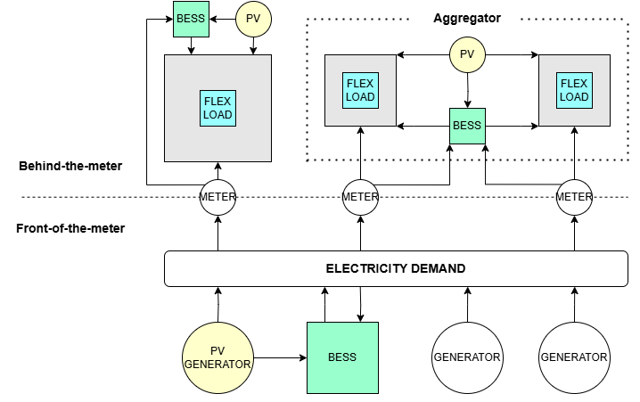
Figure 3: XXXXXXXXXX

The financial value of flexibility is usually determined by the market mechanism:
- Implicit (Cost Avoidance): Focuses on shifting load from high-tariff periods.
  - Calculation: (Baseline Cost) – (Actual Cost)
- Explicit (Revenue Generation): Focuses on responding to external market signals.
  - Calculation: (Delivered Flexibility kW) × (Duration) × (Contract Price)
Following a flexibility event, it might be necessary to also evaluate the increase in energy use or consumption post flexibility event to understand the full impact of energy and demand savings on the facility level. This is also known as the rebound or bounce back effect.

Standard Baselining Methodologies and examples for Implicit events
Implicit baselines would traditionally use IPMVP Options A to D to evaluate savings from behind the meter events.
- Option A – Key parameter measurement. Taking a spot measurement of a plant or equipment. This can help to verify the nameplate rating used in explicit events as well.
- Option B – All parameter measurement. Continuous measurement and logging at a retrofit level can support nomination baselines as well for explicit events. Can also support demand reduction and load shifting projects.
- Option C – Whole facility measurement can support recent history baselines and load or demand shifting.
- Option D – calibrated simulation models can support profiles and profiling of plant and equipment such as EV loads at aggregation and scale.
Examples predominantly focus on load-shifting where end-users benefit from an energy price differential, turning off equipment during peak loads and turning equipment back on during lower energy prices.
Alignment with ISO 50001: For behind-the-meter flexibility projects, continuous measurement (Option B or C) is generally more appropriate than spot measurements due to dynamic operating changes. These projects can qualify as valid energy performance improvements under ISO 50001 when linked to measurable objectives, EnPIs and baselines, supported by allocated resources integrated into management processes.

Example 1 – System use charges in UK
In the UK, the energy prices are determined by adding up the flat tariff and the Distribution Use of System Charge (DUoS). The DUoS charge varies by time of day and hence, are divided into three zone; Green zone being the cheapest, followed by the Amber zone, and then the Red zone being the most expensive. The green zone starts from midnight and ends at 6:30 am. This is followed by the amber zone which starts from 7:00 am up to 15:30 and the start again at 19:00 and ends at 23:30, and finally the Red zone starts from 16:00 ends at 18:30. These charges influence the electricity rates and hence, motivate energy users to render services like the DSR.
A flex service being provided by a BESS can rely on the electricity rates to charge the BESS or use the Heat Pump at times of low tariff and deliver flex services to the grid when the trading prices become high. The process of buying energy at cheaper rates and storing it for future usage when the tariff is high is known as an Energy arbitrage process.
To calculate the cost savings generated by flexibility event ‘behind the meter’, the energy price of the energy consumption/demand in the baseline period should be subtracted from the energy price of the consumption/demand in the reporting period.
Cost Savings = Baseline consumption* baseline energy price – Reporting period consumption* reporting period energy price.
Price adjustments from baseline period to flex delivery period might be required to determine the cost savings for any flex provided depending on the contract agreement for the flexibility service being provided.
Occasionally, in Western Europe, we have experienced the grid being supplied by 100% renewables and therefore the energy price has been incentivized for users to take energy from the grid. E.g. during the day-time, due to the higher penetration of renewables, the spot price could be significantly lower, which makes the overall electricity price, including taxes, lower compared to non-peak periods.

Example 2 – Peak demand shifting in a Cold Chain Storage, Mexico
This was a cold chain storage project where demand peak response and shifting the peak demand was primary purpose. Since demand charges were not so high, savings were on energy consumption. An ESCO style contract with incentives built in rates - Lower demand on peak hours with a recovery time for temperature being 2 hours.
Flexible load identification - critical equipment was not touched but HVAC bearing in mind a 4-hour demand response event. Facility therefore must have enough thermal cooling capacity. The supermarkets had comfort policy of 24 deg C, so not all HVAC was used. In total the following flexibility with seasonality was identified:
- Example 1 -Processing plant refrigeration -The maximum kW flexibility was either 247 kW or 350 kW depending on which compressor was turned off. Summer: run rate 2 hours, recovery time 0.5 hrs. Winter: run rate: 4 hours, recovery time 0.75 hrs.
- Example 2 - Distribution center refrigeration - The average kW flexibility was 148 kW in the summer and 232 kW in the winter. Summer: run rate 2 hours, recovery time 1.5 hrs. Winter: run rate: 4 hours, recovery time 1.5 hours.
- Example 3 - Supermarket – HVAC -The average kW flexibility was 86 kW both in summer and winter. Summer: run rate was 2 hours. Winter 4 hours. Recovery time doesn't apply because the store closes.
Flexibility was derived by initial estimates based on nominal power and the fraction of equipment that were to be turned off simultaneously during flexibility. Flexibility was expected to operate only Monday to Friday at peak hours: summer 8 to 10 pm (2 per day) and winter 6 to 10 pm (4 per day).
The following baselines were derived:
- Example 1: Sub-meter measurements for two compressors were taken for 5 days to determine the maximum demand and average consumption on each time-of-use-period. For the demand baseline, maximum demand of the compressor was measured and added it to the metered maximum demand on peak hours during that month reported by the utility. Verification of which compressor was actually turned off was made using ON/OFF status data. For the energy baseline, this was the total time the compressors were turned off by the system during the month multiplied by the average consumption. The result was adjusted based on the difference between the CDD modeled total energy consumption during the reporting month and when the initial measurements were made (e.g. if we measured in the summer, we adjusted down for winter months).
- Example 2: Similarly to example 1, retrofit isolated measurements for each condensing unit (22 units) were made over a one day. For the demand baseline, 15 min periods were used, at which the maximum monthly demand. This was added to the measured maximum demand of every condensing unit that was turned off during that period and to the metered maximum on-peak monthly demand reported by the utility.
- Example 3: Fixed measurements of aggregate HVAC energy consumption (all packaged units) were observed before and after demand response began. The energy baseline was determined by the previous year’s HVAC energy consumption data.
The main incentive was financial savings by reducing the retail rate demand charge for capacity that is based on the maximum monthly demand on peak hours. Rates were 17 to 20 £$ per kW. The energy savings are also considered at the peak hours rate of 0.1 £$ per kWh. Savings were also reported using the annual national carbon emission factor 0.423 tCO2e / MWh. (Carbon savings from demand response project were low compared to the demand charges).
In total, the following savings were achieved:
- Example 1: 3,500 kW/year (maximum demand reduction) - 300,000 kWh/year (energy savings) – 120 tCO2e - £ $75,000/year
- Example 2: 2,250 kW/year (maximum demand reduction) - 200,000 kWh/year (energy savings) - 80 tCO2e - £ 50,000/year
- Example 3: 1,000 kW/year (maximum demand reduction) – 100,000 kWh/year (energy savings) – 40 tCO2e - £ $25,000/year
Note: This time-of-use retail rate with demand charges applies to most end-users that have a demand of at least 100 kW. The utility (CFE) also participates in the wholesale markets as a generator (used to be a public monopoly) and controls transmission and distribution.

Example 3 – Integrating Implicit Flexibility in an Energy Performance Contract: Belesco (Belgium) Commercial offices in Portugal
The flexibility was derived from Energy Efficiency Measures - PV (existing and new), LED lighting, installation of variable speed drives, demand response - standby optimisation of ventilation units, smart heating and cooling. Flexibility was based on active control and using ToU tariffs (4 periods: Peak, Shoulder, Normal Off Peak and Super Off-Peak hours).
Electricity baselines were calculated using the ABEPeM tool (Active Building Energy Performance Modelling platform), which has a so-called flex model to create a baseline model and a reference model. They were checked/calibrated against 5-year historical measured data (from the meters).
Market driver was using extending existing Energy Performance Contracting business models for higher cost and CO2 savings, allowing customer projects to become more efficient and performant (incl. better TCO) and ESCOs to become flexibility aggregators and thus develop new business, using Time-of-Use (ToU) dynamic pricing.
Energy savings were calculated using standard national C02-intensity parameters. Pricing did not yet contain direct CO2-based components but only indirect ones (over the 4 time periods).
€ savings were +/- 8% from EE measures and an additional +/- 6% from Demand Response (2% by optimizing heating and cooling operation, while maintaining comfort requirements).
The unique feature was the integration into EPC models (with performance guarantees) turning it into an Active building Energy Performance Contracting or AEPC model with reward-penalty mechanism. This is an example of flexibility being used implicitly – without responding to a market signal from a DNO/DSO/TSO, but internal changes and controls to optimise revenue savings based on energy prices and tariffs.

Example 4 — Capturing Savings in Granular Peak Windows Using a Time-of-Week-and-Temperature (TOWT) Model: Power TakeOff’s Virtual Commissioning Program
Power TakeOff delivers its Virtual Commissioning® (VCx®) program to utilities across North America. The program targets energy-efficiency savings in traditionally hard to reach customer segments (e.g.commercial and institutional customers) through low- and no-cost operational measures. Measurement and verification of these savings is done with whole-facility, IPMVP Option C regression modeling. Typical Option C regression techniques are sufficient to verify overall program savings, but struggle to isolate how much of those savings occurred within a utility-defined coincident peak demand window.
This matters because a utility or system operator can only credit an EE program with capacity value, or calculate avoided transmission, distribution, and generation costs, using savings that are shown to coincide with the peak window specifically, not just aggregate annual savings. Several U.S. jurisdictions define these windows explicitly; the Pennsylvania TRM, for example, sets summer (June–Aug, non-holiday weekdays, 2–6 pm) and winter coincident peak periods aligned to PJM Interconnections avoided-cost patterns.
Rather than build a new model, VCx adapts the time-of-week-and-temperature (TOWT) regression framework Lawrence Berkeley National Laboratory (LBNL) originally developed for demand response baselines (Mathieu et al., 2011):
- The model is fit on hourly AMI data (the approach applies equally to finer intervals), using 168 time-of-week indicator variables (one for each hour of the week) along with relevant temperature variables.
- The 168 time-of-week terms are what make it work: a plain weather regression can normalize for temperature but flattens a building's daily and weekly rhythm, so it can't reproduce the operational ups and downs. The hour-of-week structure captures that shape, producing a weather-normalized counterfactual load shape rather than just a counterfactual total.
- Savings in any defined window are then isolated for relevant windows through calculating the difference between adjusted baseline and reporting period consumption in those hours only. Or even more conveniently through additional change variables included in the regression under a “pre-post” approach (Stewart, 2017).
The method is a natural fit for implicit baselines, which require an estimate of expected consumption across every hour of the reporting period rather than for a defined set of event hours, but it also shows promise for explicit events. As the savings model and method already adjusts for weather and can incorporate production or other operational drivers where the data exists, this approach can reduce the need for in-day baseline adjustments, and its independence from a hand-selected set of recent days makes it harder to game than a simple recent-history average.

Standard Baseline Methodologies and examples for Explicit events
Explicit baselines are where plant or equipment, aggregated or otherwise, is switched off in response to a market signal.
For this section we reference the Flexible Market Rule -Standard Baseline Methodology, (Elexon, April 2026). The document provides UK industry with a means to define baselines, and this is being adopted by the DNO/DSOs/TSOs in the UK.
The framework defines five distinct methods to calculate the baseline (what energy usage would have been) versus actual performance during an event:
- Asset Capacity: Assumes the participating DER operates at its full rated capacity during the flexibility event, irrespective of actual operational conditions.
- Fixed Reference: Uses a fixed daily profile derived from the observed energy behaviour of a representative group of DERs that represents normal operating behaviour or a DNO’s planning scenarios.
- Nomination baseline: Uses an estimated/expected set of meter values, provided by the Flexibility Services Provider (FSP), based on the expected or normal operation of the site / DER without any flexibility event, for a future availability window that then becomes a utilisation event.
- Recent History: Uses a set of recent, eligible days (i.e. excluding Event Days such as a day providing a flexibility service) preceding a utilisation event. This may also include correction factors such as within-day adjustments for weather variables or removal of outlier values.
- Zero: The baseline energy consumption or generation is set to zero, meaning no energy usage or production is assumed in the absence of the utilisation event.

Example 1 – Asset Capacity (ref FMR-SBM)
This methodology assumes the participating DER operates at its full rated capacity (no de-rating) during the flexibility event, irrespective of actual operational conditions. Worked examples of these principles are shown below for a Schedulable Generation DER which has a full rated export capacity of 5MW. In the example, the Generation DER has a Generation Turn Down contract for 2MW. The DER turns down generation from 5MW to 3MW and is paid for 2MW as the baseline was set at 5MW (i.e. the full rated capacity) and the measured power during the Service Window was 3MW.

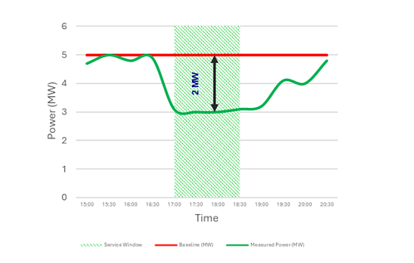
Asset name plate rating can typically be found on the motor itself of the operating device, or in the case of a battery, its kWh rated capacity. Care should be taken that the asset was operating at its full load conditions, or the asset capacity baseline will not be a true reflection of kW flexibility provided. I.e. an Air Source Heat Pump might be operating at half capacity in the summer. This method is akin to a deemed savings approach.

Example 2 – Fixed Reference
This methodology uses a fixed daily profile derived from the energy behaviour of a representative group of DERs that represents normal operating behaviour or from a DNO’s planning scenarios. In the example shown below, the baseline value represents a reference, non-smart charging behaviour for a large group of domestic EV charging points. It is this representative behaviour that is used to set the baseline value of -5MW to assess the level of Demand Turn Down provided by the DER. The measured output during the Service Window is -3MW, therefore it is deemed to have delivered a dispatched capacity of 2MW.
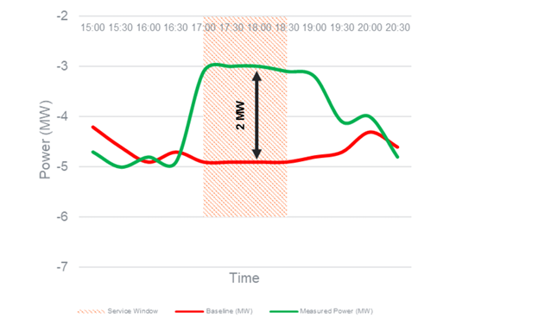
Typical examples would be an energy supplier providing flexibility from a residential area. The flexibility potential has been assessed using modelling and historic behavior consumption patterns. This method is akin to deemed savings approach.

Example 3 – Nomination Baseline
This methodology uses a proposed estimated/expected set of meter values/data, provided by the FSP, based on the expected or normal operation of the site / DER without any flexibility event, for a future availability window that then becomes a utilisation event.
Nomination values may differ over the Service Window or be a single value that is applied for the whole Service Window. As nomination baseline methodologies rely on FSPs to propose the values used, there will be accuracy standards that the DNO requires the FSP’s nominations to adhere to, to ensure the nominated values accurately reflect normal operating behaviour.
In the example shown below, a variable nomination value has been proposed by the FSP (-5MW for the earlier part of the Service Window and -4MW for the later part). In this scenario, the DER is paid for a dispatched capacity of 2MW of Demand Turn Down for the first part of the Service Window and a dispatched capacity of 1MW for the latter part.
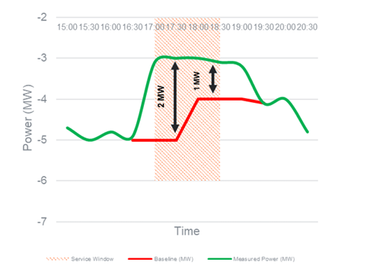

The above figure illustrates the variable delivery that has been nominated by an FSP.
Nomination baselines are recommended for energy using assets that are not influenced by weather, and where the flexibility being measured is less than 10% of the site’s maximum demand, since a whole facility approach (last 5- or 10-day history) may not work in terms of granularity.

Example 4 – Recent History
This methodology uses a set of recent, eligible days preceding a utilisation event and will complete an assessment based on the same time of day (i.e. 30-minute window) and type of day (i.e. working day or non-working day). This could be the last 5 or 10 similar days (e.g. the last 5 Mondays).
This is the more typical methodology used baseline that is also used by the Balancing Settlement Code (BSC) for the Balancing Mechanism in the wholesale market and includes within-day adjustment. It is also used by the UK’s TSO (NESO) for Demand Flexibility Service (DFS) and also for the Capacity Market for Demand Side Response (DSR) Capacity Market Units (CMUs).
Within day correction factors can include weather variables or removal of outlier values (typically defined as Event Days). Event Days can include activities such as delivery of Balancing Services, Virtual Trading, Site Outage, Equipment and/or Site Disconnection.
In the example shown below, a DER baseline of 4.5MW for a Service Window on a Friday is set based on the mean average of the 10 most recent working days, which weren’t Event Days. Weekends and the Purple coloured Thursday (which met the criteria to be defined as an Event Day) are therefore excluded from the calculation. The measured power during the Service Window was 2.5MW of generation, and therefore, the DER is paid for a dispatched capacity of 2MW of Generation Turn Down.
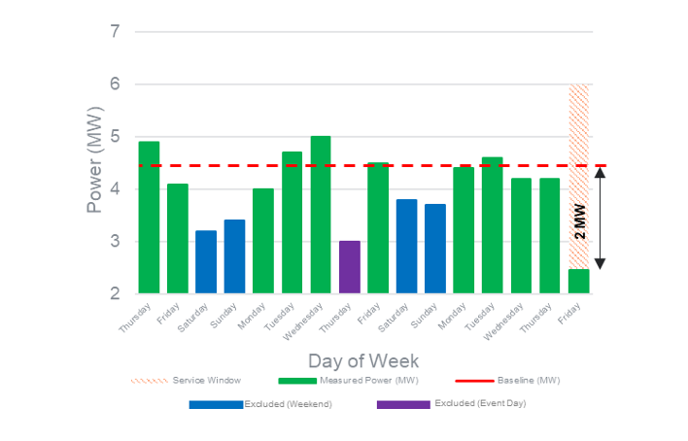

Enhanced example of recent history: NESO DFS market.
The first step to determining the baseline for explicit events is the selection of the reference days. Representative days (Y days) that precede the day ‘A’ of the actual flexibility event, should be of the same “category” as day A ( e.g. weekday, weekend day, public holiday etc.). Excluded days prior to the flexibility day ‘A’ might be:
- where another flexibility event has occurred
- an extreme of weather or a major change in the facility where a non-routine static factor adjustment might be necessary.
- Or dissimilar days (e.g. the baseline is built up of 5 working days, and the flexibility event is on a weekend).
The second step is to select 𝑋 reference days among 𝑌 representative days. They correspond to the X days for which the average net offtake of active power during the corresponding period of day A is the highest.
The third step is the determination of the quarter hourly baseline. The baseline value for each quarter hour is calculated as the average of the X values of the active power of the considered delivery point, measured at the same quarter hour over the X reference days.
The last step is the determination of the hourly baseline. To calculate the hourly baseline, the average of the quarter-hourly baseline profile is calculated.
The baseline energy consumption is calculated using the eligible days – days when there have been no DFS used. In calculating the baseline, the days are categorised into Working days (Monday – Friday) and Non-working days (Saturday, Sunday and bank holidays).
For working days: 10 most recent eligible days are selected to calculate the baseline.
For non-working days: 4 most recent eligible days are selected and the mean average of the 2 median days will be used to calculate the baseline.
Based on the selected days, the Actual Usage (kWh) for each selected eligible day is calculated as follows:
Day 1 import MPAN – Day 1 Export MPAN
Based on the actual usage, the unadjusted baseline is calculated by taking the average usage of the eligible days.
Unadjusted Baseline j = ∑n Actual Usage / n
where j is the jth Settlement Period and n is number of Eligible Days

Day type | From | To | Day 1 MPAN Total | Day 2 MPAN Total | ... | Day 10 MPAN Total | Unadjusted Baseline (kWh)
Working Day | 00:00 | 00:30 |  |  |  |  | = Average (Day 1 MPAN Total: Day 10 MPAN Total)
Working Day | 00:30 | 01:00
Working Day | .. | ..

X-of-Y and rolling average baselines are common methods that rely on historical metered data from end-use customers with flexible loads, managed by flexibility service providers. Control group baselines, which consist of load profiles from similar customers not participating in flexibility programs, can enhance the integrity of baselines for aggregated loads. However, improving baseline accuracy often requires a trade-off in simplicity, as more complex models, such as regression or other machine learning techniques, may be needed.
With the availability of sub-metering for distributed generation resources, meter-before-meter-after baselines are also used. In this approach, a static baseline is defined based on a meter reading taken just before flexibility activation. For non-controllable technologies, like solar PV and wind, a control group approach may improve baseline integrity but may not necessarily enhance accuracy. A more precise alternative is the comparable day baseline, selected by the flexibility service provider to reflect conditions similar to the activation day. However, given the potential for selection bias in this method, buyers may prefer more complex models that incorporate weather data to enhance accuracy.
For controllable technologies, such as Combined Heat and Power (CHP) systems, the approaches mentioned above may be vulnerable to manipulation by the operator, making them less reliable. In these cases, non-regression-based machine learning techniques can offer highly accurate and trustworthy estimates. Although more complex, these models are justified, particularly as the number of distributed CHP plants is relatively small, making model development feasible. Alternatively, a fixed zero baseline could be applied for backup generators, especially if these units are more numerous and provide flexibility.
For storage systems, the zero-baseline approach can also be applied. However, a more accurate estimate may be obtained by using a machine learning model to assess the counterfactual state of the battery.
Self-reported baselines are not recommended.

A note on adjustment factors:
Flexibility baselines could be affected by high values of energy consuming factors such as weather or extreme events. Usually, the 5- or 10-days baseline period does not necessitate adjustments to be made. If there are no influencing factors, then measurements of a baseline as a counterfactual and then the metered energy during a flexibility event, takes on the IPMVP principle of adjacent measurements, where no adjustments are made.
However, if the DER is impacted by the weather, then it may deliver less apparent flexibility if consideration is not given. This could be an ASHP, whose electrical efficiency changes during winter and summer. The kW flexibility should be considered based on CoP of the asset (which varies over the seasons) to provide more accurate forecasting. Extreme weather events during the baseline period (an outlier is plus or minus 3 standard deviations), can be a candidate for removal.
Other factors that can change during the nomination baseline period are static factors. These are non-routine events; and typically, this can be a flexibility event. When there are numerous markets being traded (e.g. at DNO/ DSO level, as well as TSO level), adjusting the baseline for static factor events can become an issue.
Other static factors can include the facility or generation size, the design, and operation of installed equipment, the production and occupancy level. Most of the information on static factors can be derived from facility logs, or EMS systems. For use in the development of baseline, only static factors that incur major changes in the preceding baseline period need to be identified, and evidenced in order to make non-routine adjustments.
To avoid gaming (please see section 4.2), the baseline period should ideally represent the typical operating mode of the facility, equipment or system where there is no flexibility event. I.e. this should be within the normal operating period immediately before the flexibility event happened.

Example 5 – Zero baseline:
The baseline energy consumption or generation for this methodology is set to zero, meaning no energy usage or production is assumed in the absence of the utilisation event. In the example shown below, the DER is deemed to have provided a dispatched capacity of 2MW through a Generation Turn Up service as the measured output during the Service Window was 2MW.
Typically, this could be a battery energy storage system that is fully charged and waiting to be discharged to provide flexibility turndown. Or, vice versa, a battery that is fully discharged, waiting to be charged up during a demand turn up event.
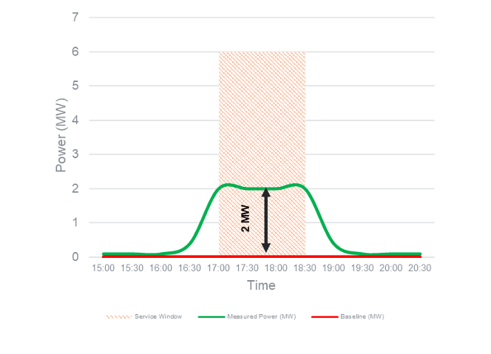
Enhanced example: BESS Italy
In grid‑flexibility projects involving batteries (BESS, EVs, aggregated DERs), SOC₀ and SOH are foundational state variables that condition both the physical feasibility of service delivery and the correctness of M&V outcomes.
SOC₀ (Initial State of Charge) defines the energy headroom available at the start of a flexibility activation window. SOC₀ is typically treated as a short‑term baseline variable and it is critical for event‑level correctness defining what is physically possible at activation start. If it is not measured, validated, and aligned with the model’s assumed SOC range, any discrepancy in delivered flexibility may be wrongly attributed to model error rather than to infeasible initial conditions.
Models that explicitly include SOC₀ can be verified event‑by‑event by comparing:
- predicted vs. measured energy trajectory,
- predicted vs. measured power saturation or early exhaustion.
Accounting for SOC₀ significantly improves short‑term accuracy (activation‑level):
- prevents overestimation of upward/downward flexibility,
- avoids false negatives in performance verification when batteries start near bounds.

SOH (State of Health) defines the structural capability of the battery, capturing capacity fade and internal resistance growth. It acts as a parametric constraint on maximum usable energy, efficiency, ramp rates, and degradation‑aware dispatch. SOH is critical for model credibility over time: it defines what is structurally achievable by the asset. Ignoring SOH implicitly assumes a “new battery”, leading to systematic model bias as assets age.
Models that explicitly include SOH allow longitudinal verification:
- drift in residuals can be attributed to degradation rather than stochastic noise,
- recalibration intervals can be justified quantitatively.
Accounting for SOH improves medium‑ to long‑term accuracy:
- avoids optimistic capacity assumptions,
- stabilizes performance metrics across reporting periods.
Empirically, SOC₀‑aware M&V reduces variance in event‑level verification, while SOH‑aware M&V reduces bias accumulation over time. Without SOC₀ and SOH, mathematical models may still be calibrated ex post, but they become non‑diagnostic: errors cannot be cleanly decomposed into control error, forecasting error, or asset limitation.
If SOC₀ or SOH are ignored under‑delivery may be incorrectly classified as non‑performance, and models may appear “inaccurate” when they are physically correct, and aggregators or asset owners may be penalized for degradation effects outside their control.

Typical DERs and Implicit /Explicit baseline types to consider.
In this section we align the typical DERs to the types of baselines that can be used in explicit and implicit events (see the table below) and some effects to consider..
Sector | Typical assets | Typical baseline / IPMVP options | Example of effect of flexibility
Cold generation e.g. in Supermarkets and food industry.  Cold chambers and distribution chains.  Food, chemical or industry. Plants and flower industry. | Fridges  Freezers | Recent history/ nomination.  Option B, all parameter measurement. | Changes in the temperature of the assets can affect the energy consumption. Consider also the effect of an increase in energy use and consumption post flexibility event.
HVAC in commercial offices. | ASHP  Electric heating or cooling | Recent history/ nomination.  Option C or Option B. | The temperature of the building changes.  Consider rebound effect.  Consider if carbon savings are being made if the carbon grid intensity is lower during time of actual use, and higher during the flexibility event.
Temperature control e.g. in leisure centres swimming pools, Industry processes | Pumps, cooling. | Recent history/ nomination.  Option C or Option B. | The temperature of the water / media changes. This might need to be raised to optimal temperature during the recovery phase.
Pumping and water movement activities, e.g. Irrigation systems  Water pumps  Treatment plants and desalination and other shiftable processes. | Pumping. | Recent history/ nomination.  Option C or Option B. | Use of cheaper tariffs – no change in overall energy consumption  Consider peak measurements to supplement energy consumption changes over a longer period of time .
Batteries and EVs | Storage via battery or EV battery. | Zero baseline, asset capacity or fixed reference.  Option B or C. | Manage the charge and discharge to adapt the consumption with the electricity prices.
Residential – large scale aggregation of e.g. 25,000 homes with devices enabled with IoT to control usage. | Washing machines, EV chargers. | Zero baseline, asset capacity or fixed reference.  Option C for each individual home, or modelling, Option D for a geographical area. | Consider the end uncertainty in the result when modelling large scale aggregation.

Operational Verification
Operational verification could be a useful tool in the prevention of gaming, especially by recording the conditions in the baseline period and comparing them to the reporting period or flexibility event. (Digital Twins could be another).
This can evidence that other key equipment and significant energy uses within the measurement boundary did not change during the flexibility event. I.e. that equipment was not deliberately turned to higher uses and consumption to raise (or lower) the baseline (lower in the case of demand turn up). Caution should be exercised however, if for example, pre-cooling actually was used purposefully prior to a flexibility event, that it is not considered gaming.
The same methods used in the IPMVP Core concepts for operational verification can also be used in this case.
Spot measurements can support the process to prove that assets were either turned on or off during baseline period development and during flexibility events, especially if there is concern around gaming.
OV approach | Typical flexibility application | Activities
Visual inspection | EV chargers not charging | View and verify that the vehicles are not charging.
Sample spot measurements | Individual assets not performing especially if the kW flexibility has been calculated incorrectly, or changes over seasons e.g. the kW electrical savings from an Air Source Heat pump in the summer is different to that in the winter. | Spot measurement of individual assets that make up an aggregated load in a building to determine actual kW rather than assumed. Like IPMVP Option A.
Short-term performance trending | Performance of assets may change depending on interoperability or interactive effects if multiple assets impact each other. E.g. The turn down of lighting in a building, increases heating demand, which then impacts the kW flexibility delivered from an Air Source Heat pump, | Short term metering on systems to identify system level changes over the year and in accordance with actual weather conditions. Like IPMVP Option B.
Data trending and control logic review | The overall building performance may vary according to actual heating or cooling demands. Component or system being monitored through a BMS can be monitored using independent meters to check back with BMS outputs. | Measurement periods may last from a few days to several months. Sub-meters, independent meters might be required

The use of facility logs
An Energy Management System (EMS) such as Building Management System (BMS) software can serve as a useful mean to prove facility performance in operational verification and thereby support baseline and nullify gaming. E.g. a DER’s operational status (ON/OFF Running status), and typical operating hours of plant and equipment are all usually recorded in a BMS.
In addition to the control and monitoring, the data access and storage feature of an BMS facilitates the acquiring of both site and system baseline information. EMS systems can store site data in various resolutions. This data can be in the form of energy data in kWh, battery charge and discharge times, site and system operating temperatures and many other parameters.
These features all facilitate the recording and storage of data for the purposes of baselines and settlement.

Common issues
The following issues can be encountered when defining a fixed baseline period for demand:
- Lack of historical data due to lack of meters
- Inadequate time resolution e.g. half hourly data
- Cost of acquiring data
- Whether facilities are aggregated, or there are remote / isolated flexibility assets such as in farming.
- Settlement of multiple trading portfolios and sites
- User behaviours and the potential of gaming
- Rebound / interactive effect
- Negative carbon or energy savings
The first five items on the list can be managed via metering (section 5). We will look the last four items in this section.

User behaviour
A behavioural perspective is important when assessing whether flexibility can actually work in practice. Previous work on energy behaviour from Lopes et al. shows that users are not just passive consumers of energy. Their habits, routines, level of knowledge, motivations and concerns influence whether energy efficiency and demand-response measures are accepted and used. This means that just owning flexible loads available is not enough. The success of flexibility also depends on whether people trust the technological solution, understand why it is being used, feel that it will not jeopardize their comfort, productivity or normal way of living and working. t also depends on the perceived cost of participation on flexibility markets and on whether the financial, operational or environmental benefits, are clear and meaningful to users.
This is especially relevant in operational environments, including agriculture, where energy use is closely linked to daily activities and production needs. Staff may be cautious about changing established routines if they think this could affect crop production, equipment performance, working conditions or service quality. For this reason, flexibility strategies should be developed with the people who operate the facilities, rather than being imposed only from a technical or management perspective.
The same applies to the residential and buildings sector, where flexibility measures can directly affect people’s comfort, routines and perception of control. In homes, offices, schools or commercial buildings, changes in heating, cooling, lighting, ventilation or EV charging may be technically possible, but they will only be accepted if users feel that their needs are being respected. For example, occupants may reject or override automated control strategies if they experience thermal discomfort, poor indoor air quality, reduced lighting levels or inconvenience in their daily activities. Therefore, flexibility in buildings should be designed around user comfort, clear communication, simple control options and transparent benefits, so that users see flexibility as a supportive solution rather than as a restriction.
In practice, this means combining technical monitoring with people engagement, training and clear feedback. This can help identify which loads can realistically be managed, when this can be done, and under which conditions. It also helps reduce resistance, because users can see that flexibility is not only a technical requirement, but something that can bring benefits without compromising the core activity.
Therefore, behavioural factors should be considered part of the flexibility resource itself. Flexibility trading will be more successful when control systems, tariffs and automation are aligned with user practices, organisational priorities and clear benefits. Simple rules, good communication, adequate incentives and evidence that comfort or production will not be harmed are essential to increase acceptance and reduce behavioural risk.

Infrastructure Readiness and Legacy Installations
In practice, older facilities can create real difficulties when trying to implement flexibility solutions. Many buildings, farms, industrial facilities or technical installations were not designed with monitoring, automation or flexibility in mind. In some situations, the main electrical boards do not have enough physical space to install auditing equipment, sensors, meters or actuators. An additional problem is poorly labeled circuits, electrical drawings missing or outdated, and wiring not always following current electrical standards. This makes it difficult to understand which equipment is connected to each circuit, which loads can be monitored separately, and which ones could realistically be managed.
For this reason, a flexibility project often needs an initial “clean-up” phase before any advanced control strategy can be applied. This may include checking the electrical installation, mapping circuits, improving labelling, identifying flexible assets and upgrading parts of the infrastructure. Although this can add time and cost to the project, it is essential to make sure that the flexibility solution is safe, reliable and technically feasible.
In older facilities, the challenge is therefore not only to find flexible loads, but also to understand whether the existing infrastructure is ready to support monitoring, control and participation in flexibility schemes.

Gaming
Gaming can be viewed on several levels:
- Sometimes a strategy used by the electricity system operators that consists on the modification their consumption patterns to obtain profit, by taking advantage of the system rules for balancing supply and demand on the grid. To maintain the grid balanced all time, the grid operator accepts bids from generators and consumers to increase or decrease the generation in case of shortage or excess of electricity. This is akin to influencing user behaviours. Market participants that benefit from gaming, take advantage of the difference in prices between the day ahead market and the real time market. In the first one, where the prices are more predictable, the generator underbid the generation, so when more generation is needed during the real time market, the same generator can submit another bid at a higher price, obtaining profit from this price difference.
- An FSP might deliberately increase baselines to support a kW drop in flexibility during a flexibility event. This is by increasing their energy consumption before a scheduled demand response event. If they do so, during the activation hour it appears as if they have reduced their consumption more than what they have done. Conversely, there could also be a logical reason for increasing the baseline, such as pre-cooling a building prior to a known flexibility call.
Gaming has a negative impact in the market, as it can create an artificial congestion on the grid, as their contribution in the real-time market does not solve the congestion. This leads to higher market costs, as these participants are being paid for reductions or increases in their generation, but due to the baseline modification, the real energy consumption is not changed. So, overall, gaming generates market inefficiencies, as no real flexibility is added to the grid when it is needed.
Improvements to the baseline calculation methods with the inclusion of operational verification can support / evidence where increases in baselines are justified. The pre-cooling events can also be considered as outliers and removed from the baseline calculations, with prior agreement with the market procurer.

Rebound effect
The rebound effect is a phenomenon where there is an increase in energy consumption following a flexibility event, also known as recovery period. This is to bring the facility back to normal operating conditions. Interactive effects can also occur at a whole facility level such as turning off a DER, impacts the performance of other equipment.
- E.g. turn off a chiller plant during a flexibility event, chilled water temperature drops, causing the room temperature to drop, and then local AC units then start up in response, negating the impact of site-wide kW drop. This is of concern when using asset capacity, fixed reference or zero baselines (deemed approach).
- E.g. turn of a chiller plant, and temperature drops. Post the flexibility event, the chiller needs to stay on for longer to make up the room temperature back to normal conditions.

Carbon savings
Generally, carbon savings are defined as either:
- Scope 1 emissions - e.g. on-site use of natural gas in gas boilers
- Scope 2 - e.g. use of electrical energy produced off-site power stations, or
- Scope 3 (supply chain) emissions.
Carbon savings under Scope 2 emissions might be evaluated by using real time carbon grid intensity factors to understand grid intensity during a flexibility event in countries where this data is available. In general, most countries produce at least annual carbon grid intensity factors that are regionalized based upon the nature and type of energy production, e.g. a state in Canada might produce hydropower and have lower emissions than a state that relies on coal-fired power stations.
Carbon savings may need be negative if the primary purpose is to respond to a financial market signal. However, increasingly, the grid is being constrained by an overproduction of Solar PV and Wind or other renewable energy. As such, strategies might be developed where energy is used at times of low carbon grid intensity, and to turn off equipment or have flexibility during these times where the carbon grid intensity is high. This type of flexibility could become important to a Net Zero Carbon future and is known as carbon flexing.
Finally, when considering placing a trade in flexibility markets, it is important to consider whether there will be a negative impact on energy prices during this trade. Often, the energy supply contract is directly between the facility owner and the energy supplier; a flexibility contract might be with a third party. A scenario could occur in which there are financial gains being made via a flexibility trade but financial losses in terms of energy prices.

Metering and controls
Effective metering and controls are fundamental for ensuring reliable measurement, verification, and optimization of flexible loads. Advanced metering infrastructure (AMI), interval metering, and automated controls facilitate real-time monitoring, demand response participation, and compliance with industry best practices. This section establishes best practices for metering and control strategies that align with load management programs, market settlements, and regulatory compliance.

Minimum Metering Standards for Load Management
To enable accurate measurement and verification of demand-side flexibility, metering infrastructure should ideally meet the following criteria:
- High-resolution data collection: Minimum 15-minute interval data is required for flexibility participation, while some programs may require data resolution down to sub one-minute intervals for frequency response and ancillary services.
- Bidirectional energy tracking: Meters must be capable of measuring both energy consumption and energy export for participants utilizing distributed energy resources.
- Revenue-grade accuracy: Meters should adhere to standards such as P375 revenue grade meters, ANSI C12.20 or IEC 62053-22 standards to ensure compliance with billing and settlement requirements.

Types of Meters for Flexible Load Applications
The choice of metering technology should align with the level of precision required for program participation and settlement calculations:
- Smart Meters (AMI Meters)
- Provide automated reporting and remote communication capability.
- Support demand response program participation through near real-time usage tracking.
- Interval Meters with Communication Capability
- Measure energy usage in increments of 15 minutes or less.
- Required for participation in demand response and flexibility programs where real-time data is necessary for verification.
- Submetering for End-Use Flexibility Tracking
- Allows for granular measurement of specific flexible loads (e.g., HVAC systems, refrigeration, battery storage).
- Supports baseline adjustments for more accurate demand reduction calculations.

Aggregated portfolios metering
Baselining will be completed at a Meterable Unit level rather than individual DER level. A Meterable Unit is the aggregated level used for settlement and may consist of either multiple DERs or a single DER, as shown in the examples below:
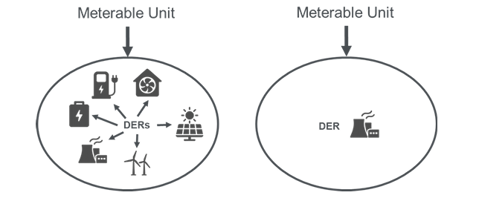
Ref: FMR-SBM, draft 2025.

Under the FMR- SBM draft, the following controls will be implemented:
- Non-Nomination baselined DERs (using the baselines of Asset Capacity, Zero or Fixed Reference) can be grouped into a single Meterable Unit, as all methodologies make use of static values, which are known in advance and are set by DNOs.
- Non-Nomination baselined DERs cannot be grouped into a Meterable Unit containing Nomination baselined DERs, as Nomination baselines use values which are submitted by the FSP and therefore, a Meterable Unit containing Nomination baselined DERs are subject to accuracy standards.
- If an FSP wishes to combine Non-Nomination baselined DERs with Nomination baselined DERs into a Meterable Unit, the FSP would be required to submit an Alternative Baseline Methodology requests to the DNO for all Non-Nomination baselined DERs to become Nomination baselined.
Note: In aggregated meterable units that contain multiple DERs, some DERs might be e.g. increasing in use, others might be decreasing since user behaviour is unpredictable especially at domestic level.

Data Communication and Integration Requirements
For load relief programs, metering data must be seamlessly integrated with market settlement systems and energy management platforms. Best practices include:
- Secure data transmission: All metered data should be encrypted and transmitted over secure networks using protocols such as TLS or MQTT.
- Standardized communication interfaces: Ensure interoperability with existing grid management systems through industry-standard protocols like Modbus, BACnet, or IEEE 2030.5.
- Real-time data accessibility: Participants should have access to their meter data through online portals or API integrations, facilitating performance tracking and verification.

Controls for Flexible Load Management

Automated Demand Response and Load Control Strategies
Efficient load control mechanisms enable participants to respond dynamically to grid events and market price signals. Common strategies include:
- Automated Demand Response (ADR):
- Enables direct load control in response to program dispatch signals.
- Supports OpenADR 2.0b standards for seamless integration with demand response aggregators.
- Building Energy Management System (BEMS) Optimization:
- Load scheduling based on real-time pricing and event notifications.
- Includes HVAC and lighting controls to shift or curtail demand.
- Battery Energy Storage Dispatch Optimization:
- Dynamic charging and discharging based on day-ahead and real-time market conditions.
- Supports participation in frequency regulation and peak demand reduction programs.

Use of Metering and Control for Verification and Settlement Processes
- Metered Event Comparison:
  - Load reduction is assessed by comparing actual metered consumption during an event with the pre-established baseline.
- Automated Performance Validation:
  - Control systems should log timestamps for load reductions, ensuring compliance with event participation requirements.
- Audit and Compliance Checks:
  - Periodic verification ensures continued adherence to program requirements and validates reported reductions.

Regulatory Compliance and Market Integration
For successful participation in flexibility programs, metering and control systems must comply with:
- Energy baseline and verification standards: Ensure alignment with industry guidelines.
- Program-specific settlement rules: Follow protocols for demand response program performance payments and penalty structures.
- Grid operator communication requirements: Ensure that control signals from system operators are received and executed in accordance with program specifications.

Cost of data acquisition
Storage of data from multiple trading portfolios can be expensive and unnecessary. Data storage and archiving strategies should be considered as part of the overall strategy for flexibility; to distinguish between what is required e.g. in particular for nomination baselines, where the last 5 typical days or 10 days is required (meaning, last 5 to 10 weeks’ worth of data) and what can be achieved.
In general, a well-designed metering and control strategy is essential for ensuring accurate demand response performance, compliance with regulatory requirements, and successful participation in flexibility programs. By leveraging real-time metering, automated control mechanisms, and standardized verification processes, market participants can maximize operational efficiency and optimize their contributions to grid reliability.

6.0 Uncertainty
Uncertainty is an inherent challenge in Measurement and Verification (M&V) of flexible loads, impacting the accuracy, reliability, and credibility of reported performance in energy management and market settlements. Effective uncertainty analysis ensures that flexibility providers, utilities, and market operators have confidence in the measured outcomes of demand response (DR), load shifting, and energy efficiency programs.

Sources of Uncertainty
Uncertainty in the measurement of flexibility delivered can arise and include:
- Measurement Uncertainty:
- Errors in metering devices, sensors, and data acquisition systems.
- Instrumentation drift over time affecting data reliability.
- Non-ideal placement of meters leading to erroneous load readings.
- Communication and transmission issues in Advanced Metering Infrastructure (AMI) and submetering systems.
- Baseline Uncertainty:
- Variability in pre-event energy consumption patterns due to weather, occupancy, or operational changes.
- Selection of inappropriate baseline models that fail to account for external influencing factors.
- Adjustments to historical energy data leading to potential over- or under-estimation of flexibility contributions.
- Operational and Behavioral Uncertainty:
- Human decision-making affecting flexible load performance (e.g., facility operators overriding control strategies).
- Variability in process loads that depend on production schedules or external demands.
- Misalignment between demand response dispatch signals and the actual operational capacity of flexible loads.
- Market and Settlement Uncertainty:
- Differences in the interpretation of flexibility event rules by aggregators and system operators.
- Inconsistencies in M&V methodologies used for energy market settlements.
- Changes in regulatory requirements impacting compensation and compliance standards.

Quantifying Uncertainty in Flexible Load Measurement
Uncertainty can be quantified through the following techniques:
- Meter Accuracy Ratings:
- Use of revenue-grade meters compliant with ANSI C12.20, IEC 62053-22, or equivalent standards to minimize device-related uncertainty.
- Periodic calibration of meters to maintain measurement integrity.
- Propagation of Uncertainty (ISO GUM - Guide to the Expression of Uncertainty in Measurement):
- The root sum square (RSS) method is used to combine uncertainty contributions from multiple sources.
- Sensitivity analysis is performed to evaluate the impact of metering errors on energy reduction estimates.
- Monte Carlo Simulation for Load Forecasting:
- Probabilistic models simulate different energy consumption scenarios to estimate confidence intervals for measured flexibility.
- Helps identify outlier events that may distort settlement calculations.

Evaluating Baseline Uncertainty
Baseline uncertainty is assessed using statistical and analytical techniques, including:
- Coefficient of Variation (CV) in Baseline Models:
- A high CV in baseline energy consumption data suggests increased variability and reduced reliability.
- A CV threshold of <20% is recommended for strong baseline stability.
- Baseline Adjustment Factor (BAF):
- Adjusts historical baselines for temperature, occupancy, or production variations.
- Recommended BAF techniques include:
- Regression-based weather normalization using degree-days.
- Adaptive learning algorithms that continuously refine baselines based on new data.
- Cross-validation Against Metered Data:
- Comparison of predicted vs. actual consumption using a Mean Absolute Percentage Error (MAPE) threshold.
- MAPE <10% is generally accepted for high-confidence baseline models.

Example of uncertainty in a nomination baseline
(Ref FMR – SBM, Draft 2025)
Accuracy assessments will be completed every month by the DNO, and the results will be reported to the Market Facilitator under the new rules to be implemented in the UK, July 2026.
The accuracy calculation assessment has been designed to account for the maximum usable swing in either direction (import to export and vice versa), constrained by any declared operational limitations (the Available Capacity), and assesses error levels in proportion to the Meterable Unit’s capacity, to ensure the measure reflects the relative scale of the Meterable Unit. These will be assessed against the Net % Error and the Absolute % Error.
Net % Error – Identify, over an assessment period, the average net error of a Meterable Unit to highlight whether on average, a Meterable Unit’s behaviour is consistently over or under an FSP’s Nomination values. A negative net error indicates Nominations are higher than the Meterable Unit’s normal behaviour, while a positive error indicates the Nominations are under the Meterable Unit’s normal behaviour.
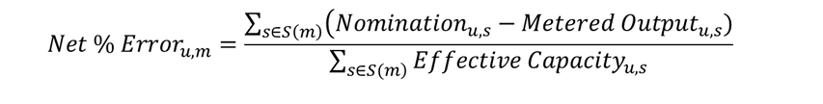
Absolute % Error – Identify performance of a Meterable Unit over an assessment period in absolute terms to mitigate the risk of positive and negative Net % Errors netting to give a false indication of accurate Nominations. The absolute error assessment provides a clear indication of accuracy over an assessment period.
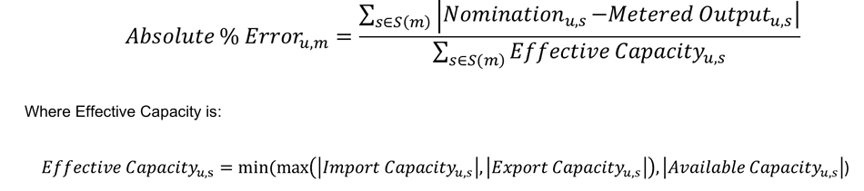
Where:
u = The Meterable Unit being assessed.
m = The month being analysed.
s ∈ S(m) = Each settlement period “s” within the month “m”
Nominationᵤ,ₛ = The Nomination submitted by the FSP for the Meterable Unit in MW at time “s”
Metered Outputᵤ,ₛ = The metered value in MW at time “s”
Import Capacityᵤ,ₛ = The fully rated import capacity of the Meterable Unit in MW at time “s”
Export Capacityᵤ,ₛ = The fully rated export capacity of the Meterable Unit in MW at time “s”
Available Capacityᵤ,ₛ = The declared available capacity for the Meterable Unit at time “s”

Thresholds for the measures will be set by the DNOs. Upon failure to meet these thresholds, the DNO will have the right to initiate a Nomination Performance Review.
E.g. a battery energy storage system (BESS) operating bi-directionally over the assessment period illustrates how the assessment of accuracy would work in practice. In the example, there are five periods under consideration (s1 to s5) in the table below, and the standard sign convention of export being a positive value and import being a negative value has been used.
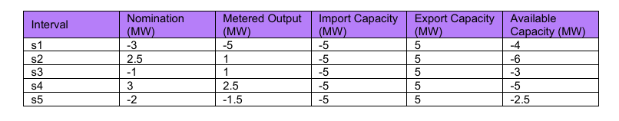
The Nomination (MW) less Metered Output (MW) for each period is aggregated to give a total of 1.5MW of the net error calculation.
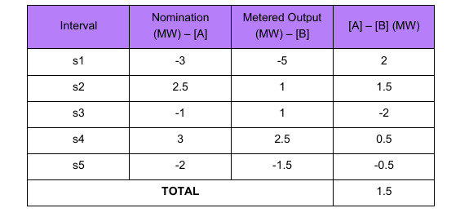
The absolute value of Nomination (MW) less Metered Output (MW) for each period is aggregated to give a total of 6.5MW of the absolute error calculation.
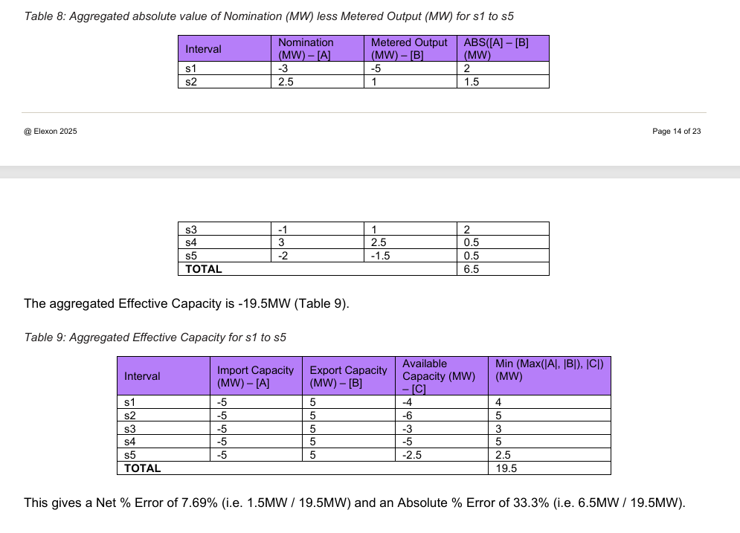

Mitigating and Managing Uncertainty
Best Practices for Reducing Measurement and Verification Uncertainty include:
- Enhanced Metering and Data Collection Standards:
- Require high-frequency data collection (≤5-minute intervals) for fast-acting flexibility resources.
- Implement redundancy in data acquisition (e.g., dual-meter setups for critical loads).
- Adaptive Baseline Modeling:
- Use dynamic baselining techniques rather than static historical averages to reduce baseline drift.
- Incorporate machine learning algorithms to refine predictions based on real-time data.
- Statistical Confidence Intervals in Settlement Calculations:
- Introduce 95% confidence interval analysis to account for variability in reported energy reductions.
- Require data smoothing techniques (e.g., moving averages) for event performance evaluations.
- Independent Third-Party Verification:
- Require audits and verification from certified M&V professionals to enhance credibility.
- Ensure compliance with ISO 50015 guidelines for energy performance validation.

Integrating Uncertainty Considerations into Energy Markets
Market settlements must incorporate standardized uncertainty thresholds to avoid overcompensation or underpayment. Recommendations include:
- ±5% error tolerance for metered load reduction verification.
- ±10% baseline variation allowance before requiring model adjustments.
- Application of penalty/reward structures based on deviation from expected performance.
(see example prior).
DNOs might implement performance reviews and sliding scale penalties for failure to meet certainty requirements.

Risk Mitigation Strategies for Market Participants
- Contractual Provisions for Uncertainty Allowance:
- Demand response contracts should define acceptable uncertainty limits and establish performance adjustment factors.
- Include force majeure clauses to account for uncontrollable operational disruptions.
- Regulatory Compliance Alignment:
- Ensure settlement methodologies comply with grid operator rules, regulatory frameworks, and M&V protocols.
- Regularly update M&V plans to reflect evolving energy market conditions.
Uncertainty is an unavoidable aspect of demand-side flexibility measurement, but through rigorous data collection, robust baseline modeling, and statistically sound verification methods, it can be effectively managed. A structured approach to quantifying, mitigating, and integrating uncertainty into market settlements ensures that flexible load participants are fairly compensated and that system operators maintain grid reliability.
By adhering to best practices and leveraging advanced data analytics, stakeholders can enhance transparency, reduce settlement disputes, and improve the reliability of demand response and flexibility programs.

References
International Performance Measurement and Verification Protocol (IPMVP), 2022.
ISO 50006:2014 - Energy Management Systems – Measuring Energy Performance.
ISO 50015:2014 - Measurement and Verification of Energy Performance Improvements.
EU Emissions Trading System (ETS) Reports.
U.S. Environmental Protection Agency (EPA) eGRID Database.
Asia-Pacific Carbon Reporting Standards.
Gade, P. A. V., Skjøtskift, T., Bindner, H. W., & Kazempour, J. (2022). Ecosystem for Demand-side Flexibility Revisited: The Danish Solution. Electricity Journal, 35(9), 107206. https://doi.org/10.1016/j.tej.2022.107206
Lampropoulos, I., van den Broek, M., van der Hoofd, E., Hommes, K., & van Sark, W. (2018a). A system perspective to the deployment of flexibility through aggregator companies in the Netherlands. Energy Policy, 118, 534–551. https://doi.org/10.1016/j.enpol.2018.03.073
Lampropoulos, I., van den Broek, M., van der Hoofd, E., Hommes, K., & van Sark, W. (2018b). A system perspective to the deployment of flexibility through aggregator companies in the Netherlands. Energy Policy, 118(July 2017), 534–551. https://doi.org/10.1016/j.enpol.2018.03.073
Mlecnik, E., Parker, J., Ma, Z., Corchero, C., Knotzer, A., & Pernetti, R. (2020). Policy challenges for the development of energy flexibility services. Energy Policy, 137(November 2019), 111147. https://doi.org/10.1016/j.enpol.2019.111147
Ribó-Pérez, D., Heleno, M., & Álvarez-Bel, C. (2021). The flexibility gap: Socioeconomic and geographical factors driving residential flexibility. Energy Policy, 153(March). https://doi.org/10.1016/j.enpol.2021.112282
Flexibility Market Rule, Standard Baseline Methods, draft 2025, produced by Energy Networks Association, UK.
AEEE & Schneider Electric (2025). Automated Demand Response Pilot in Delhi: Insights and Transferrable Learning to Scale-up Programme Designs. [Reference to uploaded file: automated-demand-response-pilot-in-delhi.pdf]
IIT Delhi, TERI, & IIT Kanpur (2023). Distribution System Operators (DSOs): Need, Frameworks, and Regulatory Considerations. [Reference to uploaded file: DSO-White-Paper.pdf]
Khanna, S., Martin, R., & Muûls, M. (2024). Leveraging automated demand response for the clean energy transition: Evidence from urban India. IGC Policy Brief. [Reference to uploaded file: Khanna et al. Policy Brief October 2024.pdf]
MERC (2024). Maharashtra Electricity Regulatory Commission (Demand Flexibility and Demand Side Management – Implementation Framework) Regulations, 2024. (Regulatory Notification).
AEEE (2022). Roadmap for Demand Flexibility in India. [Reference to uploaded file: Roadmap-for-Demand-Flexibility-in-India.pdf]
ARERA. (2025). Esiti dei progetti pilota per l’abilitazione di nuove risorse alla fornitura dei servizi ancillari globali e locali (Anni 2023–2024) (Relazione 343/2025/I/eel). Autorità di Regolazione per Energia Reti e Ambiente. https://www.arera.it/atti-e-provvedimenti/dettaglio/25/343-25
- Terna S.p.A. (2021). Avviso per gli operatori: Progetto pilota per la fornitura del servizio di regolazione di tensione. https://www.terna.it/it/sistema-elettrico/pubblicazioni/news-operatori/dettaglio/progetto-pilota-servizio-regolazione-tensione

Metering References:
International Performance Measurement and Verification Protocol (IPMVP), Efficiency Valuation Organization, 2022.
ISO 50006:2014 - Energy Management Systems – Measuring Energy Performance.
ISO 50015:2014 - Measurement and Verification of Energy Performance Improvements.
IEEE 2030.5 - Standard for Smart Energy Profile Application Protocol.
OpenADR 2.0b - Automated Demand Response Standard.

Uncertainty references:
International Performance Measurement and Verification Protocol (IPMVP), Efficiency Valuation Organization, 2022.
ISO 50006:2014 - Energy Management Systems – Measuring Energy Performance.
ISO 50015:2014 - Measurement and Verification of Energy Performance Improvements.
Guide to the Expression of Uncertainty in Measurement (GUM), JCGM 100:2008.
Monte Carlo Methods for Risk Analysis in Demand Response Programs, IEEE Transactions on Power Systems, 2023.

Behaviour Change references:
Inês F.G. Reis; Ivo Gonçalves; Marta A.R. Lopes; Carlos Henggeler Antunes. "A multi-agent system approach to exploit demand-side flexibility in an energy community". Utilities Policy 67 (2020): 101114-101114.
https://doi.org/10.1016/j.jup.2020.101114.
Marta A.R. Lopes; Carlos Henggeler Antunes; Kathryn B. Janda; Paulo Peixoto; Nelson Martins. "The potential of energy behaviours in a smart(er) grid: Policy implications from a Portuguese exploratory study". Energy Policy 90 (2016): 233-245. http://dx.doi.org/10.1016/j.enpol.2015.12.014.
Marta A.R. Lopes; Carlos Henggeler Antunes; Nelson Martins. "Towards more effective behavioural energy policy: An integrative modelling approach to residential energy consumption in Europe". Energy Research & Social Science 7 (2015): 84-98.https://doi.org/10.1016/j.erss.2015.03.004.
Lopes, M.A.R.; Antunes, C.H.; Martins, N.. "Energy behaviours as promoters of energy efficiency: A 21st century review". Renewable and Sustainable Energy Reviews 16 6 (2012): 4095-4104.
http://dx.doi.org/10.1016/j.rser.2012.03.034.
Karlin, B.; Lopes, M.A.R.; Ford, R.; Peffer, T.E.. "Energy efficiency: Behavioral contributions from around the globe". Energy Efficiency 11 7 (2018): 1561-1562. http://www.scopus.com/inward/record.url?eid=2-s2.0-85055252300&partnerID=MN8TOARS
Carlos Henggeler Antunes; Inês Soares; Ana Soares; Maria João Alves. "Optimizing flexibility rewards for aggregator–consumer interactions: a bilevel multi-follower approach". Energy (2026): https://doi.org/10.1016/j.energy.2026.140999.

Mathieu, J. L., Price, P. N., Kiliccote, S., & Piette, M. A. (2011). Quantifying changes in building electricity use, with application to demand response. IEEE Transactions on Smart Grid, 2(3), 507–518. https://doi.org/10.1109/TSG.2011.2145010 Stewart, J. (2017). Chapter 24: Strategic energy management (SEM) evaluation protocol. The Uniform Methods Project: Methods for Determining Energy-Efficiency Savings for Specific Measures. Golden, CO: National Renewable Energy Laboratory. https://www.nrel.gov/docs/fy17osti/68316.pdf

