ITEA Press release
  - PANORAMA supports the shift to open source
15 September, Helsinki – In the automotive domain, many similar control units are used, but different organisations often use heterogeneous functional domains, hardware and teams. This complicates collaboration, while this is very important as many stakeholders are involved. The ITEA project PANORAMA has created an open-source meta-model and framework that promotes collaboration on software and hardware development using heterogenous tools and practices and without losing control of one’s own data. Today, the PANORAMA project received the 2022 ITEA Award of Excellence in the category ‘Standardisation’ for this great achievement.

Tailored framework with a collaborative spirit
The PANORAMA project, led by Bosch, gathered 23 partners from Finland, Germany, Portugal, Sweden and Turkey to improve collaboration and to address the question ‘How can data be exchanged without giving away intellectual property?’. The solution lies in an open-source model to abstract information for control unit optimisation in the early stages of development. Thanks to the enhanced meta-model and related tool framework that were created by the project, heterogenous parties are able to design and develop heterogenous embedded hardware and software systems. Third-party tools can seamlessly be integrated into workflows using PANORAMA’s service architecture. An important aspect of the project is the capacity for parties to tailor the framework to their internal needs while still providing data to other parties.
PANORAMA arrives at a time when 81% of companies are consuming open-source products or services and 44% are contributing to upstream open-source projects. For this reason, the project focused on open-source collaboration in a business-friendly ecosystem. This approach has resulted in the emergence of a global community: partners in Europe, Asia, Africa and the Americas are already making use of PANORAMA, including the huge automotive and avionics markets of Germany, China and the USA. Clear benefits can be seen in maintainability (time reduction from 57 to 12 days), reliability (A grade for code quality from the industry standard SonarQube) and efficiency (reduction of local set-up of the installation and integration of several tools from eight hours to 0.8 hours).
In terms of standardisation, the PANORAMA consortium is now working on combining the physical simulation of the FMI/FMU standard with the project’s performance simulation to create more realistic simulation environments that account for timing within the hardware or environment. This is being pursued in close collaboration with VDA, the association that coordinates the structure of the German automotive industry and provides guidance on it. This will possibly lead to future European projects expanding on PANORAMA’s successes. Having already built up a large open-source community worldwide, the project has a strong foundation to continue reducing the costs and increasing the quality of software development both now and in the future.

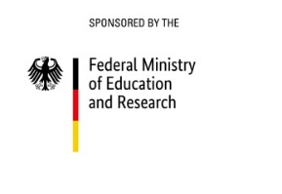
This project has received funding from:
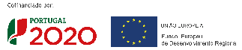
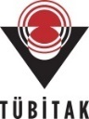

Note for editors, not for publication

For interview requests, questions and additional information about PANORAMA and ITEA, please contact:
PANORAMA Contact person ITEA Contact person
Jörg Teßmer Linda van den Borne-Toupet
joerg.tessmer@de.bosch.com linda.van.den.borne@itea4.org

PANORAMA project partners
https://itea4.org/project/panorma.html
https://www.panorama-research.org/

About ITEA
ITEA is the Eureka Cluster on software innovation, enabling a large international community to collaborate in funded projects that turn innovative ideas into new businesses, jobs, economic growth and benefits for society. https://itea4.org

