Press Release

A digital future for and built by industry
Digital Innovation Forum 2017
10 & 11 May, RAI, Amsterdam

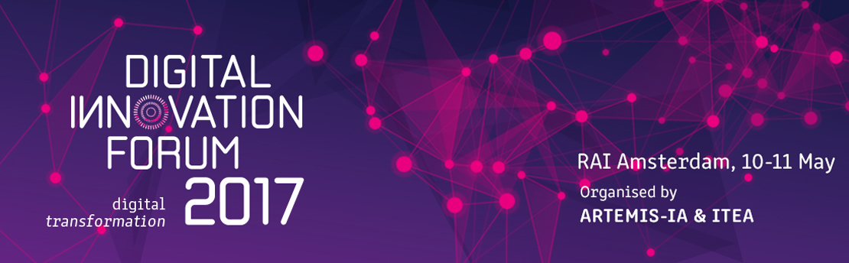

The digital transformation is in town on 10 and 11 May – get up close and personal to a paradigm shift that is changing industry and society irrevocably. Is it a threat to ‘life as we know it’ or is it an opportunity? The co-organisers of the event, ARTEMIS Industry Association and the EUREKA Cluster ITEA, believe that the digital transformation should be seen, and used, as an opportunity to create value for business and society. This is what the Digital Innovation Forum (DIF) 2017 is all about.

The new reality
The digital transformation is already well under way, bringing a new and wider variety of smarter products and services that will reshape the future and create new unprecedented opportunities. It is the new reality in a constantly changing and developing world in which digitalisation is personalising healthcare and 3D printing, is customising all kinds of products from cars to food. The Digital Innovation Forum intends to highlight the opportunities and benefits of Digital Innovation. The call for immediate and bold action to accelerate the digital transformation and seize business opportunities could not be clearer. ITEA Chairwoman Zeynep Sarilar is convinced that “digitalisation is not an option any more … it is the only way to do business with our current challenges. We invite not only the industrials, SMEs and public authorities but also venture capitalists and start-ups to our community to create an environment for discussion and ideas, and to broaden the scope to a more global participation.”

Opportunities and inspiration
Should people fear for their jobs? Will the ‘robots’ take over? Laila Gide, President of ARTEMIS Industry Association adds that the digital transformation is opening up new opportunities and creating new business models. “Take the example of robots, and other autonomous systems. They play a significant role in industry digitisation, interacting in, designing and shaping the process, supervising and controlling the output, thinking and collaborating on solutions. The upshot of this will ensure that citizens are happier with better jobs and learn new skills. So the question is not whether we should fear for our jobs but how can we change to take advantage of the opportunities afforded?” Opportunities presented in the Digital Innovation Forum to learn, to contribute, to explore, to inspire and be inspired.

Dynamic programme, full of innovation
The DIF 2017 presents an innovation-fuelled programme (https://dif2017.org/programme.html) with inspiring keynotes on Digital Transformation such as Henk Houten, Chief Technology Officer of Royal Philips, who addresses the ‘Digitalisation of Healthcare’ or Max Lemke, Head of Unit for Technologies and Systems for Digitising Industry at the European Commission’s DG CONNECT, who focuses on ‘Digitising European Industry Strategy’, and interactive panels on four emerging challenges for industry: Smart Energy, Smart Health, Smart Manufacturing and Smart Mobility. With over twenty experts leading discussions on the main innovation trends and sharing their insights on these four challenges, interaction with the audience will be both encouraged and important. On 11 May, both communities have own specific parallel sessions, with the ITEA Community session that includes the presentation of the ITEA Awards of Excellence and the Digital Transformation panel session organised by the ARTEMIS Industry Association.
The DIF 2017 will explicitly focus on supporting innovative SMEs and Start-ups by organising four parallel innovation sessions in which they can pitch their innovation to high-ranking juries composed of industry top executives and Venture Capitalists and a two-day innovation market in which they can exhibit their innovation to DIF attendees. In addition, there is a full-scale exhibition of some 60 booths that feature impressive Research & Innovation results along with a very real business impact showcased in ECSEL-JU, ITEA and H2020 projects, and in industry.
The DIF 2017 is supported by the Ministry of Economic Affairs and sponsored by the ECSEL Joint Undertaking, NXP, Thales and Philips.

Note for editors, not for publication:
For interview requests, questions and additional information about ARTEMIS Industry Association and/or ITEA, please contact:

ARTEMIS Industry Association contact person:
Iris Hamelink, Tel: +31 88 003 6188, iris.hamelink@artemis.ia.eu

ITEA Contact person:
Kay van Ham, Tel: +31 88 003 6136, kay.van.ham@itea3.org

ABOUT ARTEMIS Industry Association
ARTEMIS Industry Association strives for a leading position of Europe in Embedded Intelligence. The Association is a membership organization for the European R&I actors with more than 180 members and associates from all over Europe. The multidisciplinary nature of the membership provides an excellent network for the exchange of technology ideas, cross-domain fertilisation, as well as for large innovation initiatives.
ARTEMIS Industry Association believes that there are no sharp delineations between technologies, and that such technologies should not be considered in splendid isolation. These areas together will allow the rise of new innovative businesses that support the opportunities for value creation in several sectors that Embedded Intelligence creates. In an industrial context Cyber-Physical Systems encompasses a wider class of systems than Embedded Systems in their most narrow definition. Therefore, ARTEMIS-IA distinguishes three focus areas that together create this wider industrial context of Embedded Intelligence:
> Embedded and Cyber-Physical Systems,
>Internet of Things,
> Digital Platforms.
As private partner in ECSEL Joint Undertaking, ARTEMIS-IA supports formation of consortia and initiation of project proposals for joint collaboration and creates the meeting place where key industry players and other R&D&I actors identify strategic high priority topics for collaborative R&I projects.

More information about ARTEMIS:
www.artemis-ia.eu | www.ecsel.eu

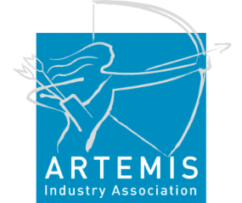

ABOUT ITEA
ITEA is the EUREKA Cluster programme supporting innovative, industry-driven, pre-competitive R&D projects in the area of Software-intensive Systems & Services (SiSS). SiSS are a key driver of innovation in Europe’s most competitive industries, such as automotive, communications, healthcare and aerospace.
There is a wide consensus that from now to 2030 change and disruption will be permanent features in society, with the way of living and doing business becoming fundamentally different from what it is today. Digital Technology has a major role to play in mastering the changes. And it is within this domain of Digital Technology that ITEA is addressing innovation in Software, IT Services, Internal IT and Embedded Software, collectively denoted as ‘Software innovation’. For Europe, an industry strong in Software Innovation is a prerequisite for maintaining global competitiveness and in securing high-value jobs in Digital Technology and in other, more traditional industries that are dependent on Digital Technology.
ITEA stimulates projects in an open community of large industry, SMEs, universities, research institutes and user organisations. As ITEA is a EUREKA Cluster, the community is founded in Europe based on the EUREKA principles and is open to participants worldwide.
Each year, ITEA issues a Call for projects starting with a two-day brokerage event. Each Call follows a two-step procedure, in which the quality of the project proposal is evaluated and improved, finally leading to a selection of high quality project proposals that receive the official ITEA label.
ITEA’s mission is to be the recognised partner for European industry, optimising support for companies and R&D actors active in ITEA projects in the area of SISS, thus making best use of funding made available by the ITEA supporting countries. Following the EUREKA structure, each ITEA project partner can apply for national funding in their own country – allowing a project idea to attract funding from all participating countries.

More information:
https://itea3.org

